Supplement

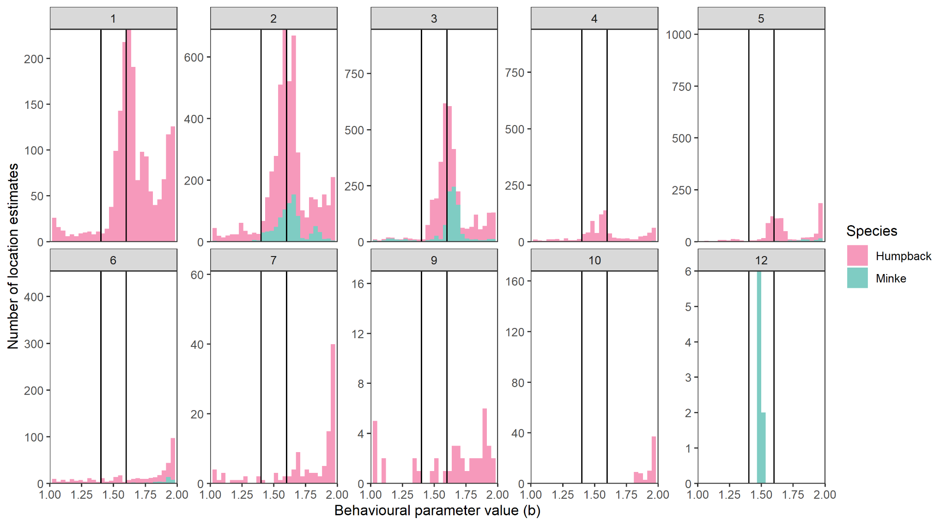

Supplementary Figure S1. Distribution, by month (panels) and species (colours), of behavioural parameter (b) values from the fitted behaviour-switching state-space models (Jonsen et al. 2005) fitted to humpback whale and minke whale satellite telemetry data. Black vertical lines indicate the 1.4 and 1.6 threshold used to classify ‘restricted’, ‘uncertain’, and ‘transit’ behaviour at a given location. Locations with b values 1.0 ≤ b ≥ 1.4 were classified as transit, 1.6 ≤ b ≥ 2.0 as restricted, and 1.4 < b > 1.6 as uncertain.

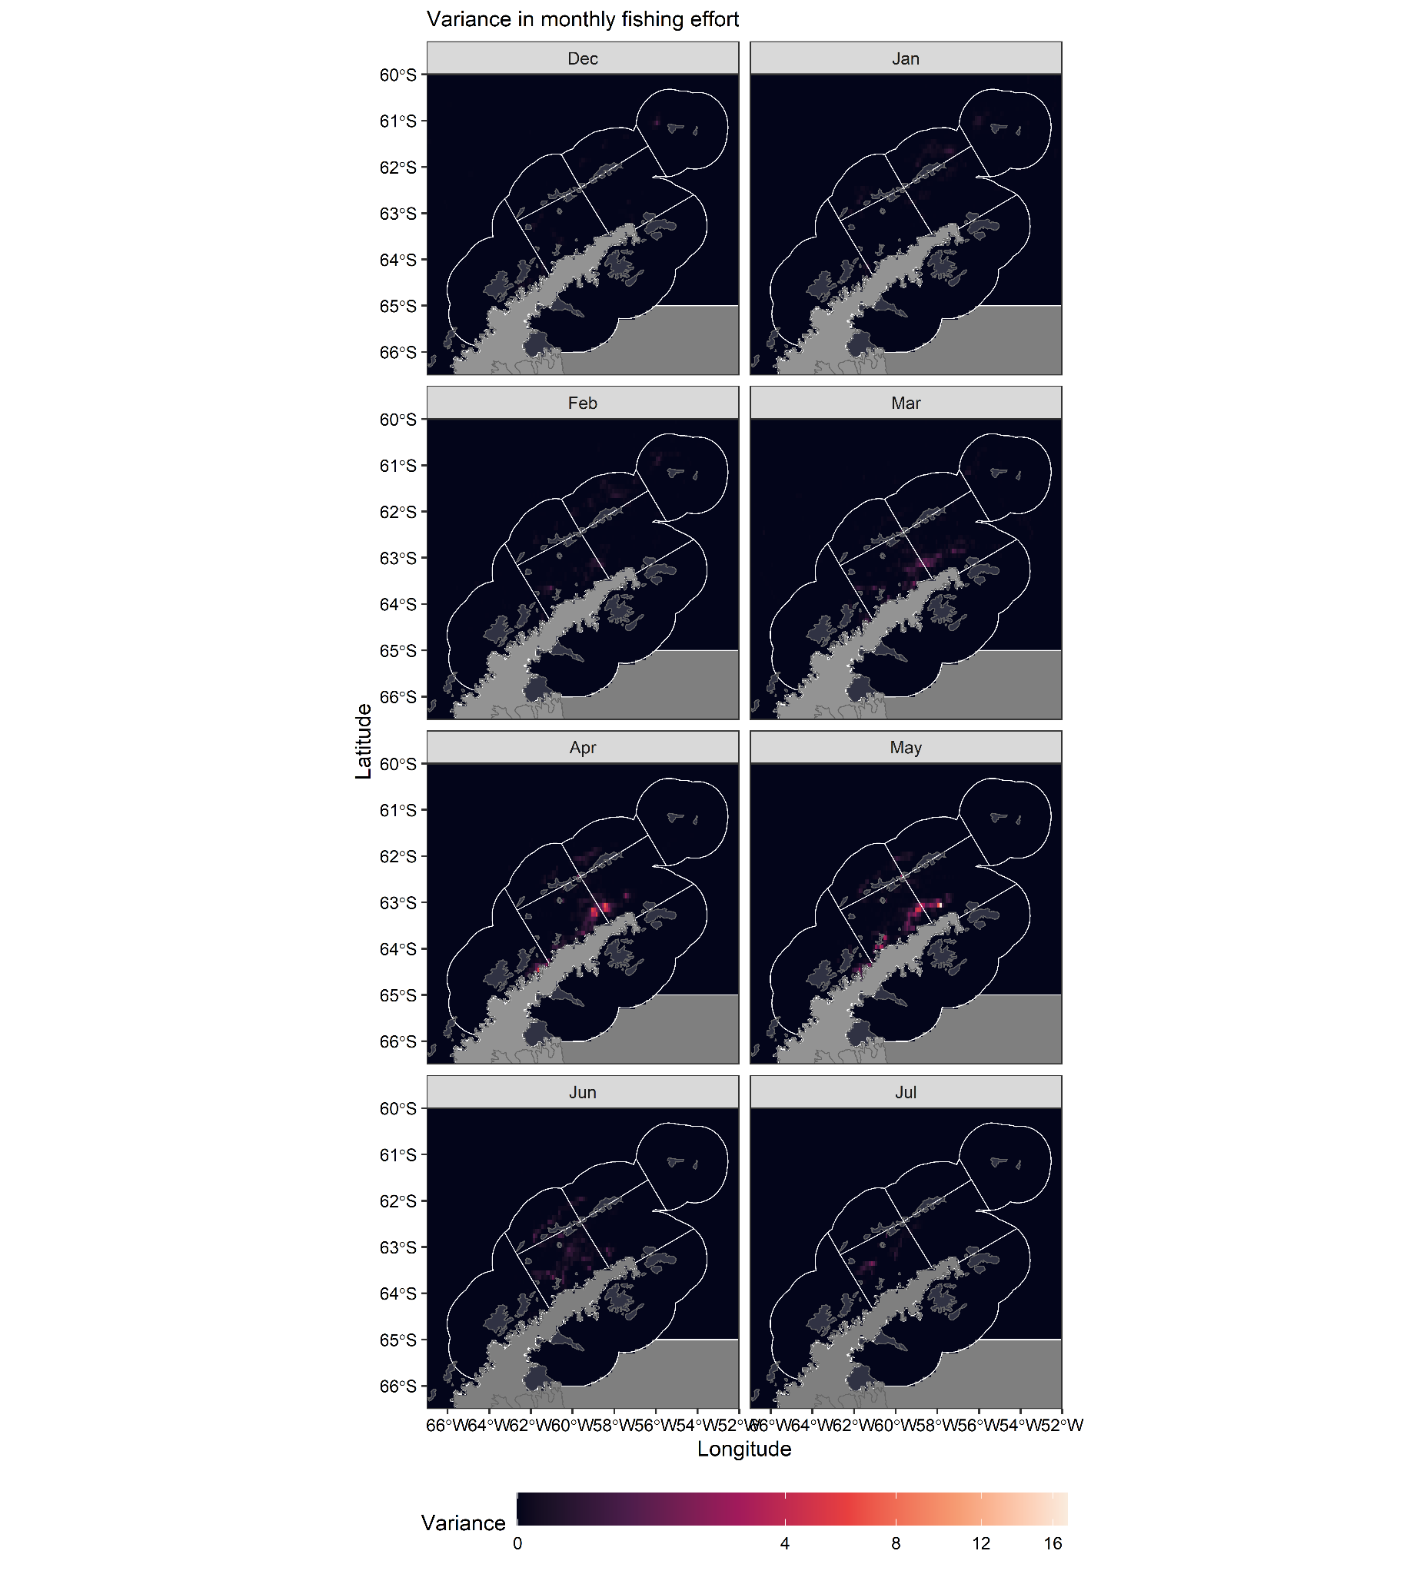

Supplementary Figure S2. Interannual variance in fishing effort. For each month, December-July, panels show the variance in fishing effort over the study period, December 2015-May 2020 (2016-2020 fishing seasons).

Supplementary Table S1. Details of the a) 58 humpback whale tracks and b) 19 minke whale tracks included in the study. PTT - Platform Transmitter Terminal.

PTT ID | Deployment region | Track start date and time | Track end date and time | Number or Argos location estimates
a) Humpback whale (Megaptera novaeangliae)
112692 | Western Antarctic Peninsula | 2012-01-03 17:34 | 2012-03-08 01:36 | 334
112704 | Western Antarctic Peninsula | 2012-01-03 19:56 | 2012-01-06 03:50 | 30
112705 | Western Antarctic Peninsula | 2012-01-19 10:24 | 2012-03-10 15:52 | 773
112699 | Western Antarctic Peninsula | 2012-01-27 01:16 | 2012-08-09 14:10 | 2902
112703 | Western Antarctic Peninsula | 2012-01-30 11:28 | 2012-03-08 14:11 | 409
112701 | Western Antarctic Peninsula | 2012-01-31 12:50 | 2012-04-21 02:40 | 970
123236 | Western Antarctic Peninsula | 2013-02-05 17:16 | 2013-03-28 13:05 | 1293
121210 | Western Antarctic Peninsula | 2013-02-05 18:58 | 2013-08-20 11:10 | 3752
121208 | Western Antarctic Peninsula | 2013-02-05 23:25 | 2013-02-27 07:32 | 149
123231 | Western Antarctic Peninsula | 2013-02-05 23:26 | 2013-02-14 07:05 | 107
123224 | Western Antarctic Peninsula | 2013-02-05 23:30 | 2013-06-27 11:01 | 2257
121212 | Western Antarctic Peninsula | 2013-02-06 17:01 | 2013-02-11 07:45 | 137
123232 | Western Antarctic Peninsula | 2013-02-06 17:03 | 2013-10-30 07:49 | 3732
112738 | Western Antarctic Peninsula | 2013-02-06 18:44 | 2013-04-11 13:16 | 1566
112737 | Western Antarctic Peninsula | 2013-02-06 18:48 | 2013-04-16 11:31 | 1814
121211 | Western Antarctic Peninsula | 2013-02-06 23:55 | 2013-03-16 12:46 | 977
112746 | Western Antarctic Peninsula | 2013-02-07 18:31 | 2013-04-09 17:42 | 1825
121207 | Western Antarctic Peninsula | 2013-02-12 17:42 | 2013-06-23 00:40 | 2632
131141 | Western Antarctic Peninsula | 2015-01-07 21:08 | 2015-01-31 19:20 | 759
131153 | Western Antarctic Peninsula | 2015-01-08 13:34 | 2015-02-12 06:31 | 1246
131151 | Western Antarctic Peninsula | 2015-01-08 15:15 | 2015-03-13 01:18 | 2397
131143 | Western Antarctic Peninsula | 2015-01-08 19:43 | 2015-03-24 18:05 | 1982
131144 | Western Antarctic Peninsula | 2015-01-09 00:43 | 2015-04-08 10:48 | 2319
131146 | Western Antarctic Peninsula | 2015-01-30 12:34 | 2015-03-15 09:06 | 1610
131147 | Western Antarctic Peninsula | 2015-01-31 00:41 | 2015-03-11 16:34 | 1623
131142 | Western Antarctic Peninsula | 2016-01-13 00:00 | 2016-02-18 19:41 | 1456
131159 | Western Antarctic Peninsula | 2016-01-13 00:02 | 2016-02-05 13:15 | 721
131158 | Western Antarctic Peninsula | 2016-01-13 07:56 | 2016-01-26 08:33 | 434
131162 | Western Antarctic Peninsula | 2016-01-13 09:14 | 2016-03-15 05:36 | 2200
131156 | Western Antarctic Peninsula | 2016-01-14 09:10 | 2016-03-01 19:10 | 1946
131115 | Western Antarctic Peninsula | 2016-02-26 13:20 | 2016-03-01 13:29 | 163
131116 | Western Antarctic Peninsula | 2016-02-26 21:28 | 2016-03-08 07:17 | 420
154187 | Western Antarctic Peninsula | 2016-03-21 20:05 | 2016-04-04 08:36 | 441
131111 | Western Antarctic Peninsula | 2016-03-23 01:01 | 2016-03-27 23:02 | 153
131130 | Western Antarctic Peninsula | 2016-04-25 17:53 | 2016-07-23 20:43 | 682
131132 | Western Antarctic Peninsula | 2016-04-25 20:03 | 2016-06-14 23:05 | 1107
131134 | Western Antarctic Peninsula | 2016-04-26 00:08 | 2016-05-13 03:12 | 566
131133 | Western Antarctic Peninsula | 2016-04-26 12:39 | 2016-07-31 11:28 | 2019
131136 | Western Antarctic Peninsula | 2016-04-26 13:25 | 2016-07-27 00:33 | 1858
131128 | Western Antarctic Peninsula | 2016-04-26 13:25 | 2016-04-28 07:22 | 47
131127 | Western Antarctic Peninsula | 2016-04-26 14:05 | 2016-08-05 21:28 | 2395
166128 | Western Antarctic Peninsula | 2017-05-03 18:46 | 2017-05-14 10:52 | 207
166127 | Western Antarctic Peninsula | 2017-05-03 20:24 | 2017-05-14 12:16 | 277
166125 | Western Antarctic Peninsula | 2017-05-04 14:50 | 2017-05-14 12:32 | 252
166123 | Western Antarctic Peninsula | 2017-05-04 19:44 | 2017-05-14 12:37 | 316
166126 | Western Antarctic Peninsula | 2017-05-04 19:44 | 2017-05-14 12:32 | 301
166124 | Western Antarctic Peninsula | 2017-05-04 19:52 | 2017-05-14 12:36 | 341
166122 | Western Antarctic Peninsula | 2017-05-05 02:38 | 2017-05-14 12:32 | 201
173525 | Western Antarctic Peninsula | 2018-02-26 13:39 | 2018-03-07 03:58 | 184
173528 | Western Antarctic Peninsula | 2018-02-26 15:05 | 2018-03-10 01:19 | 269
173531 | Western Antarctic Peninsula | 2018-02-26 15:19 | 2018-03-09 14:50 | 349
173530 | Western Antarctic Peninsula | 2018-02-28 12:13 | 2018-03-09 05:52 | 198
173524 | Western Antarctic Peninsula | 2018-02-28 12:16 | 2018-03-08 06:21 | 200
173523 | Western Antarctic Peninsula | 2018-02-28 13:19 | 2018-03-10 08:52 | 259
170328 | Western Antarctic Peninsula | 2018-02-28 22:17 | 2018-03-10 05:29 | 152
173519 | Western Antarctic Peninsula | 2018-03-06 20:50 | 2018-03-10 07:14 | 110
173526 | Western Antarctic Peninsula | 2018-03-06 20:51 | 2018-03-10 06:52 | 100
173522 | Western Antarctic Peninsula | 2018-03-06 22:27 | 2018-03-10 14:32 | 120
b) Minke whale (Balaenoptera bonaerensis)
112750 | Western Antarctic Peninsula | 2012-06-08 04:56 | 2013-08-08 00:14 | 2559
112745 | Western Antarctic Peninsula | 2012-06-09 04:35 | 2013-05-29 06:12 | 2301
112748 | Western Antarctic Peninsula | 2012-06-12 04:07 | 2013-02-25 18:43 | 192
112733 | Western Antarctic Peninsula | 2013-02-08 19:59 | 2013-02-10 06:05 | 34
112734 | Western Antarctic Peninsula | 2013-02-09 05:57 | 2013-02-22 07:48 | 320
112747 | Western Antarctic Peninsula | 2013-02-09 12:32 | 2013-05-30 23:33 | 1428
112736 | Western Antarctic Peninsula | 2013-02-09 12:32 | 2013-03-17 05:16 | 764
112731 | Western Antarctic Peninsula | 2013-02-09 18:12 | 2013-02-23 11:01 | 249
112732 | Western Antarctic Peninsula | 2013-02-25 01:35 | 2013-03-03 23:16 | 25
131101 | Western Antarctic Peninsula | 2013-12-15 12:42 | 2013-12-20 21:44 | 53
131107 | Western Antarctic Peninsula | 2014-02-12 20:32 | 2014-03-10 13:33 | 164
131108 | Western Antarctic Peninsula | 2015-02-23 18:13 | 2015-03-13 11:25 | 605
131117 | Weddell Sea | 2016-02-28 19:29 | 2016-03-15 04:14 | 328
131120 | Weddell Sea | 2016-02-28 22:36 | 2016-03-13 08:00 | 346
154184 | Weddell Sea | 2016-02-29 00:29 | 2016-03-05 12:57 | 15
131118 | Weddell Sea | 2016-03-02 02:28 | 2016-03-17 06:20 | 146
166116 | Western Antarctic Peninsula | 2017-03-01 14:57 | 2017-03-13 11:18 | 299
166118 | Western Antarctic Peninsula | 2017-03-01 19:52 | 2017-03-11 08:06 | 193
166115 | Western Antarctic Peninsula | 2017-03-02 06:33 | 2017-03-15 12:41 | 259

