**Supplementary Materials**

Supplementary Table 1. Summary of NORPAC net (150 µm mesh) sampling and sea-ice melt day derived by AMSR-2 at each station in the northern Bering Sea during July in 2017 and in 2018.



Supplementary Table 2. Summary of individual dry weight for copepods occurred in the northern Bering Sea during July in 2017 and in 2018. Category means the species summarized in each one (cf. Figure 9).



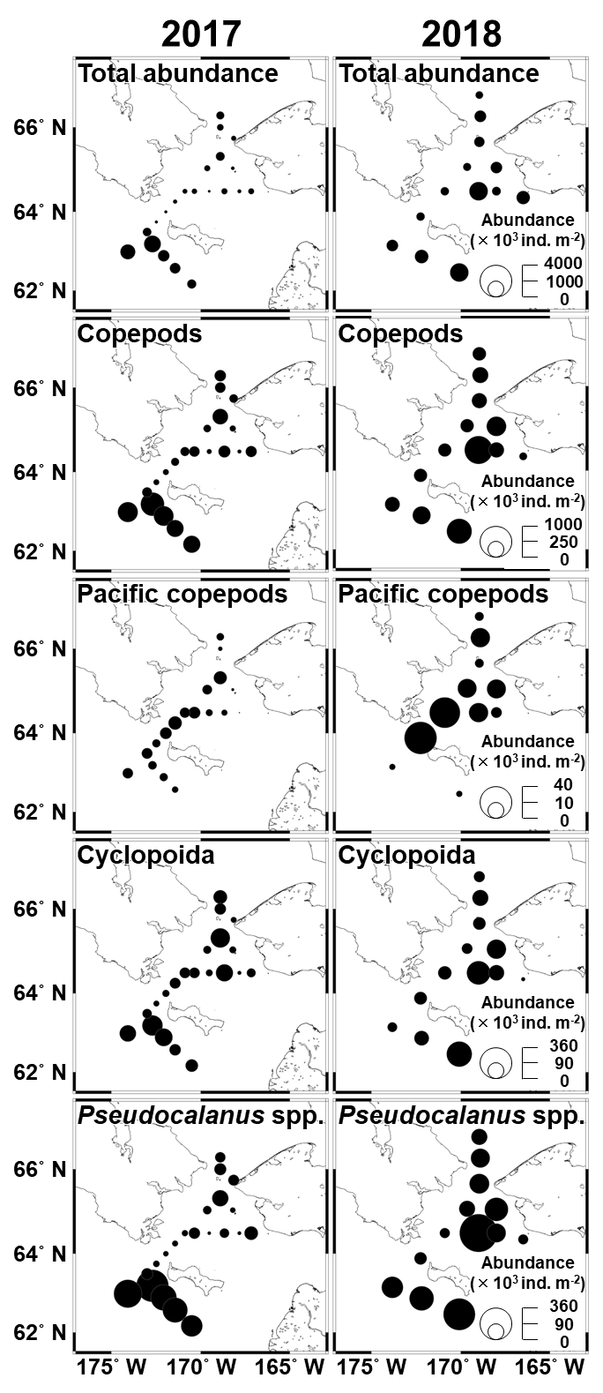

Supplementary Figure 1. Horizontal distribution of total zooplankton and dominant species abundance in the northern Bering Sea during July in 2017 and in 2018.

References

Castellani, C., Robinson, C., Smith, T., and Lampitt, R. S. (2005). Temperature affects respiration rate of *Oithona similis*. *Mar. Ecol. Prog. Ser.* 285, 129–135.

Kobari, T., Steinberg, D. K., Ueda, A., Tsuda, A., Silver, M. W., and Kitamura, M. (2008). Impacts of ontogenetically migrating copepods on downward carbon flux in the western subarctic Pacific Ocean. *Deep Sea Res. II* 55, 1648–1660.

Lee, H. W., Ikeda, T., and Ban, S. (2001). Metabolism, body composition (C and N) and estimated net growth efficiency of a calanoid copepod *Pseudocalanus newmani* raised at different temperatures in the laboratory. *Plankton Biol. Ecol.* 48, 114–120.

Mizdalski, E. (1988). Weight and length data of zooplankton in the Weddell Sea in austral spring 1986 (ANT V/3). *Ber. Polarforsch.* 55, 1–72.

Nakamura, A., Matsuno, K., Abe, Y., Shimada, H., and Yamaguchi, A. (2017). Length-weight relationships and chemical composition of the dominant mesozooplankton taxa/species in the subarctic Pacific, with special reference to the effect of lipid accumulation in Copepoda. *Zool. Stud.* 56:e13. doi: 10.6620/ZS.2017.56-13

Nishibe, Y., and Ikeda, T. (2008). Metabolism and elemental composition of four oncaeid copepods in the western subarctic Pacific. *Mar. Biol.* 153, 397–404.

Uye, S. I. (1982). Length-weight relationships of important zooplankton from the Inland Sea of Japan. *J. Oceanogr. Soc. Jpn.* 38, 149–158.