Supplementary Material:

Drivers of the North Aegean Sea ecosystem (Eastern Mediterranean) through time: insights from multidecadal retrospective analysis and future simulations

# A Ecopath Modelling Approach

In the Ecopath base model (Christensen & Walters 2004), trophic interactions among functional groups (FGs) are described by a set of linear equations, each one representing the total production *Pi* of each group *(i)*:

|  |  |
| --- | --- |
|  | (1) |

where *Bj* the biomass of group *(j)*, *M2ij* the predation mortality caused by group *(j)* on group *(i)*, *Yi* the fisheries’ catch, *Ei* the net migration rate, *BAi* the biomass accumulation rate, and *EEi* the Ecotrophic Efficiency of *(i)*. Ecotrophic Efficiency is the proportion of the production of group *(i)* which is utilized within the system or is exported due to catches or migration (Christensen & Walters 2004). Equation (1) can also be expressed as:

|  |  |
| --- | --- |
|  | (2) |

where *(P/B)i* is the production of *(i)* per unit of biomass and equals total mortality *Z* in steady-state ecosystems (Allen 1971), *(Q/B)i* the consumption of *(i)* per unit of biomass and *DCij* the proportion of *(i)* in the diet composition of predator *(j)* in terms of biomass. Energy balance for each functional group (FG) is ensured when consumption of group *(i)* equals production of *(i)*, respiration *(R)* by *(i)* and unassimilated food *(U/Q)i* of *(i)*. For each group the diet composition *(DC)*, the unassimilated food *(U/Q)i*, the catches (*Yi*), the exports (*Ei*) and three of the basic parameters *Bi*, *(P/B)i*, *(Q/B)i* and *EEi*, are required.

# B Updated Ecopath model

**Table S1.** Sources of information of the updated 1990s model (NAS1990 model). Different colours highlight changes to the parameterization compared to the previously published model for the 2000s (NAS2000 model; Tsagarakis et al. 2010): blue cells indicate parameters retained from the NAS2000 model, grey cells show parameters that are based on the information used in the NAS2000 model after modifications (e.g. restructuring of FGs, recalculation to account for changes in relative biomass within the groups etc), and green cells indicate new information.

|  | **Functional group** | **B** | **P/B** | **Q/B** | **Diet** | **Landings** |
| --- | --- | --- | --- | --- | --- | --- |
| **1** | **Phytoplankton** | Tsagarakis et al. (2010) | Tsagarakis et al. (2010) | - | - | - |
| **2** | **Microzooplankton** | Tsagarakis et al. (2010) | Tsagarakis et al. (2010) | Tsagarakis et al. (2010) | Tsagarakis et al. (2010) | - |
| **3** | **Mesozooplankton** | Tsagarakis et al. (2010) | Tsagarakis et al. (2010) | Tsagarakis et al. (2010) | Tsagarakis et al. (2010) | - |
| **4** | **Macrozooplankton** | (Frangoulis et al. 2017) | Tsagarakis et al. (2010) | Tsagarakis et al. (2010) | Tsagarakis et al. (2010) | - |
| **5** | **Gelatinous plankton** | Tsagarakis et al. (2010) | Tsagarakis et al. (2010) | Tsagarakis et al. (2010) | Tsagarakis et al. (2010) | - |
| **6** | **Small benthic crustaceans** | Tsagarakis et al. (2010) | Tsagarakis et al. (2010) | Tsagarakis et al. (2010) | Tsagarakis et al. (2010) | - |
| **7** | **Polychaetes** | Tsagarakis et al. (2010) | Tsagarakis et al. (2010) | Tsagarakis et al. (2010) | Tsagarakis et al. (2010) | - |
| **8** | **Shrimps** | Tsagarakis et al. (2010) | Tsagarakis et al. (2010) | Tsagarakis et al. (2010) | Based on Tsagarakis et al. (2010) | Data for 1991-93 (ELSTAT 2021) |
| **9** | **Crabs** | Tsagarakis et al. (2010) | from Tsagarakis et al. (2010), considering total catches and relative biomass in 1991-93 | Tsagarakis et al. (2010) | Based on Tsagarakis et al. (2010) | Data for 1991-93 (ELSTAT 2020) |
| **10** | **Norway lobster** | bottom trawl surveys (1991-93) (Labropoulou & Papaconstantinou 2004) | Tsagarakis et al. (2010) | Tsagarakis et al. (2010) | Based on Tsagarakis et al. (2010) | Data for 1991-93 (ELSTAT 2020) |
| **11** | **Bivalves & gastropods** | rearranged from Tsagarakis et al. (2010) | rearranged from Tsagarakis et al. (2010) | rearranged from Tsagarakis et al. (2010 | Tsagarakis et al. (2010) | Data for 1991-93 (ELSTAT 2020) |
| **12** | **Benthic invert. (no crustacea)** | rearranged from Tsagarakis et al. (2010) | rearranged from Tsagarakis et al. (2010) | rearranged from Tsagarakis et al. (2010 | Tsagarakis et al. (2010) | Data for 1991-93 (ELSTAT 2020) |
| **13** | **Benthic cephalopods** | bottom trawl surveys (1991-93) (Labropoulou & Papaconstantinou 2004) | rearranged from Tsagarakis et al. (2010), considering total catches and relative biomass in 1991-93 | rearranged from Tsagarakis et al. (2010), considering relative biomass in 1991-93 | Based on Tsagarakis et al. (2010) | Data for 1991-93 (ELSTAT 2020) |
| **14** | **Benthopelagic cephalopods** | bottom trawl surveys (1991-93) (Labropoulou & Papaconstantinou 2004) | rearranged from Tsagarakis et al. (2010), considering total catches and relative biomass in 1991-93 | rearranged from Tsagarakis et al. (2010), considering relative biomass in 1991-93 | Based on Tsagarakis et al. (2010) | Data for 1991-93 (ELSTAT 2020) |
| **15** | **Red mullets** | bottom trawl surveys (1991-93) (Labropoulou & Papaconstantinou 2004) | from Tsagarakis et al. (2010), considering total catches and relative biomass in 1991-93 | from Tsagarakis et al. (2010), considering relative biomass in 1991-93 | Based on Tsagarakis et al. (2010) | Data for 1991-93 (ELSTAT 2020) |
| **16** | **Anglerfish** | bottom trawl surveys (1991-93) (Labropoulou & Papaconstantinou 2004) | from Tsagarakis et al. (2010), considering total catches and relative biomass in 1991-93 | from Tsagarakis et al. (2010), considering relative biomass in 1991-93 | Based on Tsagarakis et al. (2010) | Data for 1991-93 (ELSTAT 2020) |
| **17** | **Flatfishes** | bottom trawl surveys (1991-93) (Labropoulou & Papaconstantinou 2004) | from Tsagarakis et al. (2010), considering total catches and relative biomass in 1991-93 | from Tsagarakis et al. (2010), considering relative biomass in 1991-93 | Based on Tsagarakis et al. (2010) | Data for 1991-93 (ELSTAT 2020) |
| **18** | **Blue whiting** | bottom trawl surveys (1991-93) (Labropoulou & Papaconstantinou 2004) | rearranged from Tsagarakis et al. (2010), considering total catches in 1991-93 | rearranged from Tsagarakis et al. (2010), considering relative biomass in 1991-93 | Based on Tsagarakis et al. (2010) | Data for 1991-93 (ELSTAT 2020) |
| **19** | **Other gadiformes** | bottom trawl surveys (1991-93) (Labropoulou & Papaconstantinou 2004) | rearranged from Tsagarakis et al. (2010), considering total catches and relative biomass in 1991-93 | rearranged from Tsagarakis et al. (2010), considering relative biomass in 1991-93 | Based on Tsagarakis et al. (2010) | Data for 1991-93 (ELSTAT 2020) |
| **20** | **Hake** | bottom trawl surveys (1991-93) (Labropoulou & Papaconstantinou 2004) | from Tsagarakis et al. (2010), considering total catches in 1991-93 | from Tsagarakis et al. (2010) | Based on Tsagarakis et al. (2010) | Data for 1991-93 (ELSTAT 2020) |
| **21** | **Demersal Fish 1** | bottom trawl surveys (1991-93) (Labropoulou & Papaconstantinou 2004) | from Tsagarakis et al. (2010), considering total catches and relative biomass in 1991-93 | from Tsagarakis et al. (2010), considering relative biomass in 1991-93 | Based on Tsagarakis et al. (2010) | Data for 1991-93 (ELSTAT 2020) |
| **22** | **Demersal Fish 2** | bottom trawl surveys (1991-93) (Labropoulou & Papaconstantinou 2004) | from Tsagarakis et al. (2010), considering total catches and relative biomass in 1991-93 | from Tsagarakis et al. (2010), considering relative biomass in 1991-93 | Based on Tsagarakis et al. (2010) | Data for 1991-93 (ELSTAT 2020) |
| **23** | **Demersal Fish 3** | bottom trawl surveys (1991-93) (Labropoulou & Papaconstantinou 2004) | from Tsagarakis et al. (2010), considering total catches and relative biomass in 1991-93 | from Tsagarakis et al. (2010), considering relative biomass in 1991-93 | Based on Tsagarakis et al. (2010) | Data for 1991-93 (ELSTAT 2020) |
| **24** | **Demersal Fish 4** | bottom trawl surveys (1991-93) (Labropoulou & Papaconstantinou 2004) | from Tsagarakis et al. (2010), considering total catches and relative biomass in 1991-93 | from Tsagarakis et al. (2010), considering relative biomass in 1991-93 | Based on Tsagarakis et al. (2010) | Data for 1991-93 (ELSTAT 2020) |
| **25** | **Benthopelagic Fish** | bottom trawl surveys (1991-93) (Labropoulou & Papaconstantinou 2004) | from Tsagarakis et al. (2010), considering relative biomass in 1991-93 | from Tsagarakis et al. (2010), considering relative biomass in 1991-93 | Based on Tsagarakis et al. (2010) | - |
| **26** | **Picarels and Bogue** | bottom trawl surveys (1991-93) (Labropoulou & Papaconstantinou 2004) | from Tsagarakis et al. (2010), considering total catches and relative biomass in 1991-93 | from Tsagarakis et al. (2010), considering relative biomass in 1991-93 | Based on Tsagarakis et al. (2010) | Data for 1991-93 (ELSTAT 2020) |
| **27** | **Sharks** | bottom trawl surveys (1991-93) (Labropoulou & Papaconstantinou 2004) | from Tsagarakis et al. (2010), considering total catches and relative biomass in 1991-93 | from Tsagarakis et al. (2010), considering relative biomass in 1991-93 | Based on Tsagarakis et al. (2010) | Data for 1991-93 (ELSTAT 2020) |
| **28** | **Rays & skates** | bottom trawl surveys (1991-93) (Labropoulou & Papaconstantinou 2004) | from Tsagarakis et al. (2010), considering total catches and relative biomass in 1991-93 | from Tsagarakis et al. (2010), considering relative biomass in 1991-93 | Based on Tsagarakis et al. (2010) | Data for 1991-93 (ELSTAT 2020) |
| **29** | **Anchovy** | Acoustic surveys (mean 2003-2019) | from Tsagarakis et al. (2010), considering total catches in 1991-93 | Based on Tsagarakis et al. (2010) | (Nikolioudakis et al. 2014) | Data for 1991-93 (ELSTAT 2020) |
| **30** | **Sardine** | Acoustic surveys (mean 2003-2019) | from Tsagarakis et al. (2010), considering total catches in 1991-93 | Based on Tsagarakis et al. (2010) | (Nikolioudakis et al. 2012) | Data for 1991-93 (ELSTAT 2020) |
| **31** | **Horse mackerel** | Acoustic surveys (mean 2003-2019) | from Tsagarakis et al. (2010), considering total catches and relative biomass in 1991-93 | from Tsagarakis et al. (2010), considering relative biomass in 1991-93 | Based on Tsagarakis et al. (2010) | Data for 1991-93 (ELSTAT 2020) |
| **32** | **Mackerel** | Acoustic surveys (mean 2003-2019) | from Tsagarakis et al. (2010), considering total catches and relative biomass in 1991-93 | from Tsagarakis et al. (2010), considering relative biomass in 1991-93 | Based on Tsagarakis et al. (2010) | Data for 1991-93 (ELSTAT 2020) |
| **33** | **Other small pelagic fish** | Acoustic surveys (mean 2003-2019) and bottom trawl surveys (1991-93) (Labropoulou & Papaconstantinou 2004) | from Tsagarakis et al. (2010), considering total catches and relative landings in 1991-93 | from Tsagarakis et al. (2010), considering relative biomass in 1991-93 | Based on Tsagarakis et al. (2010) | Data for 1991-93 (ELSTAT 2020) |
| **34** | **Medium pelagic fish** | Based on Tsagarakis et al. (2010) | Tsagarakis et al. (2010) | Tsagarakis et al. (2010) | Based on Tsagarakis et al. (2010) | Data for 1991-93 (ELSTAT 2020) |
| **35** | **Large pelagic fish** | (ICCAT 2007, 2008) | Tsagarakis et al. (2010) | Tsagarakis et al. (2010) | Based on Tsagarakis et al. (2010) | Data for 1991-93 (ELSTAT 2020) |
| **36** | **Loggerhead turtle** | Tsagarakis et al. (2010) | Tsagarakis et al. (2010) | Tsagarakis et al. (2010) | Tsagarakis et al. (2010) | - |
| **37** | **Sea birds** | Tsagarakis et al. (2010) | Tsagarakis et al. (2010) | Tsagarakis et al. (2010) | Tsagarakis et al. (2010) | - |
| **38** | **Dolphins** | Aerial estimates (Tsagarakis et al. 2021) | Tsagarakis et al. (2010) | Tsagarakis et al. (2010) | Based on Tsagarakis et al. (2010) | - |
| **39** | **Detritus** | Tsagarakis et al. (2010) | - | - | - | - |
| **40** | **Discards** |  | - | - | - | - |

**Table S2**. Diet matrix of the NAS1990 Ecopath model.

|  |  |  |  |  |  |  |  |  |  |  |  |  |  |  |  |  |  |  |
| --- | --- | --- | --- | --- | --- | --- | --- | --- | --- | --- | --- | --- | --- | --- | --- | --- | --- | --- |
|  | **Prey \ predator** | **2** | **3** | **4** | **5** | **6** | **7** | **8** | **9** | **10** | **11** | **12** | **13** | **14** | **15** | **16** | **17** | **18** |
| 1 | Phytoplankton | 0.650 | 0.500 | 0.150 | 0.150 | 0.020 |  |  |  |  |  |  |  |  |  |  |  |  |
| 2 | Microzooplankton | 0.050 | 0.250 | 0.150 | 0.150 |  |  |  |  |  |  |  |  |  |  |  |  |  |
| 3 | Mesozooplankton |  | 0.050 | 0.500 | 0.480 | 0.095 |  |  |  |  |  |  |  | 0.040 |  |  |  | 0.090 |
| 4 | Macrozooplankton |  |  | 0.050 | 0.050 |  |  | 0.062 | 0.005 | 0.241 |  |  | 0.036 | 0.094 | 0.030 |  | 0.080 | 0.350 |
| 5 | Jelatinous plankton |  |  |  | 0.070 |  |  |  |  |  |  |  |  |  |  |  |  | 0.008 |
| 6 | Small benthic crustaceans |  |  |  |  | 0.030 |  | 0.271 | 0.057 | 0.028 |  |  | 0.034 | 0.030 | 0.250 | 0.042 | 0.307 | 0.140 |
| 7 | Polychaetes |  |  |  |  | 0.018 | 0.040 | 0.188 | 0.405 | 0.022 | 0.020 | 0.020 | 0.057 | 0.060 | 0.180 | 0.039 | 0.152 | 0.033 |
| 8 | Shrimps |  |  |  |  |  |  | 0.010 |  | 0.100 |  |  | 0.025 | 0.018 | 0.040 | 0.020 | 0.070 | 0.121 |
| 9 | Crabs |  |  |  |  |  |  |  | 0.010 | 0.073 |  |  | 0.155 | 0.007 | 0.020 | 0.010 | 0.050 | 0.020 |
| 10 | Norway lobster |  |  |  |  |  |  |  | 0.006 |  |  |  | 0.004 | 0.000 |  | 0.010 |  |  |
| 11 | Bivalves & gastropods |  |  |  |  | 0.012 | 0.020 | 0.109 | 0.134 | 0.059 | 0.013 | 0.013 | 0.227 | 0.020 | 0.029 | 0.045 | 0.100 |  |
| 12 | Benthic invert. (no crustacea) |  |  |  |  | 0.016 | 0.025 | 0.141 | 0.175 | 0.076 | 0.017 | 0.017 | 0.296 | 0.025 | 0.041 | 0.059 | 0.090 |  |
| 13 | Benthic cephalopods |  |  |  |  |  |  | 0.014 |  | 0.006 |  |  | 0.029 | 0.047 |  | 0.150 | 0.005 | 0.018 |
| 14 | Benthopelagic cephalopods |  |  |  |  |  |  | 0.001 |  |  |  |  | 0.001 | 0.021 |  | 0.004 |  | 0.001 |
| 15 | Red mullets |  |  |  |  |  |  |  |  |  |  |  |  | 0.010 |  | 0.018 | 0.009 |  |
| 16 | Anglerfish |  |  |  |  |  |  |  |  |  |  |  | 0.007 | 0.000 |  | 0.020 |  |  |
| 17 | Flatfishes |  |  |  |  |  |  | 0.002 | 0.007 |  |  |  | 0.010 | 0.010 |  | 0.060 | 0.012 |  |
| 18 | Blue whiting |  |  |  |  |  |  |  |  |  |  |  | 0.004 | 0.015 |  | 0.045 | 0.009 | 0.001 |
| 19 | Other gadiformes |  |  |  |  |  |  |  |  |  |  |  | 0.004 | 0.005 |  | 0.055 | 0.005 |  |
| 20 | Hake |  |  |  |  |  |  |  |  |  |  |  | 0.005 | 0.004 |  | 0.087 |  |  |
| 21 | DemeFish1 |  |  |  |  |  |  | 0.002 | 0.003 |  |  |  | 0.010 | 0.008 |  |  | 0.023 | 0.013 |
| 22 | DemeFish2 |  |  |  |  |  |  |  |  |  |  |  |  | 0.007 |  | 0.065 | 0.004 |  |
| 23 | DemeFish3 |  |  |  |  |  |  |  | 0.003 |  |  |  | 0.040 | 0.022 |  | 0.110 | 0.041 | 0.007 |
| 24 | DemeFish4 |  |  |  |  |  |  |  | 0.003 |  |  |  | 0.023 | 0.013 |  | 0.011 | 0.023 | 0.011 |
| 25 | Benthopelagic Fish |  |  |  |  |  |  |  |  |  |  |  |  | 0.015 |  | 0.083 |  | 0.095 |
| 26 | Picarels and Bogue |  |  |  |  |  |  |  |  |  |  |  | 0.013 | 0.010 |  | 0.018 |  | 0.005 |
| 27 | Sharks |  |  |  |  |  |  |  |  |  |  |  | 0.010 | 0.002 |  | 0.004 |  |  |
| 28 | Rays & skates |  |  |  |  |  |  |  |  |  |  |  | 0.010 | 0.000 |  | 0.005 |  |  |
| 29 | Anchovy |  |  |  |  |  |  |  |  |  |  |  |  | 0.300 |  | 0.015 | 0.020 | 0.040 |
| 30 | Sardine |  |  |  |  |  |  |  |  |  |  |  |  | 0.110 |  |  |  |  |
| 31 | Horse mackerel |  |  |  |  |  |  |  |  |  |  |  |  | 0.020 |  | 0.025 |  |  |
| 32 | Mackerel |  |  |  |  |  |  |  |  |  |  |  |  | 0.020 |  |  |  |  |
| 33 | Other Small pelagic fishes |  |  |  |  |  |  |  |  |  |  |  |  | 0.066 |  |  |  |  |
| 34 | Medium pelagic fish |  |  |  |  |  |  |  |  |  |  |  |  |  |  |  |  |  |
| 35 | Large pelagic fishes |  |  |  |  |  |  |  |  |  |  |  |  |  |  |  |  |  |
| 36 | Loggerhead turtle |  |  |  |  |  |  |  |  |  |  |  |  |  |  |  |  |  |
| 37 | Sea birds |  |  |  |  |  |  |  |  |  |  |  |  |  |  |  |  |  |
| 38 | Dolphins |  |  |  |  |  |  |  |  |  |  |  |  |  |  |  |  |  |
| 39 | Detritus | 0.300 | 0.200 | 0.150 | 0.100 | 0.804 | 0.815 | 0.140 | 0.172 | 0.385 | 0.900 | 0.900 |  |  | 0.410 |  |  | 0.030 |
| 40 | Discards |  |  |  |  | 0.005 |  | 0.005 | 0.010 | 0.010 |  |  |  |  |  |  |  | 0.017 |
|  | Import |  |  |  |  |  | 0.100 | 0.055 | 0.010 |  | 0.050 | 0.050 |  |  |  |  |  |  |
|  | Sum | 1.000 | 1.000 | 1.000 | 1.000 | 1.000 | 1.000 | 1.000 | 1.000 | 1.000 | 1.000 | 1.000 | 1.000 | 1.000 | 1.000 | 1.000 | 1.000 | 1.000 |

**Table S2** (continued)

|  |  |  |  |  |  |  |  |  |  |  |  |  |  |  |  |  |  |  |  |  |
| --- | --- | --- | --- | --- | --- | --- | --- | --- | --- | --- | --- | --- | --- | --- | --- | --- | --- | --- | --- | --- |
| **FG** | **19** | **20** | **21** | **22** | **23** | **24** | **25** | **26** | **27** | **28** | **29** | **30** | **31** | **32** | **33** | **34** | **35** | **36** | **37** | **38** |
| 1 |  |  |  |  |  |  |  |  |  |  |  | 0.013 |  |  | 0.014 |  |  |  |  |  |
| 2 |  |  |  |  |  |  |  | 0.010 |  |  |  | 0.010 |  |  |  |  |  |  |  |  |
| 3 | 0.035 | 0.008 | 0.050 |  |  | 0.017 | 0.390 | 0.729 |  |  | 0.950 | 0.947 | 0.583 | 0.320 | 0.683 |  |  |  |  |  |
| 4 | 0.242 | 0.080 | 0.068 | 0.024 | 0.010 |  | 0.389 | 0.075 | 0.080 | 0.040 | 0.030 | 0.010 | 0.170 | 0.210 | 0.110 | 0.007 | 0.002 |  |  |  |
| 5 | 0.008 |  |  |  |  |  |  |  | 0.012 |  |  |  | 0.030 | 0.094 |  | 0.012 |  | 0.045 |  |  |
| 6 | 0.200 | 0.070 | 0.650 | 0.030 | 0.240 | 0.100 | 0.180 | 0.145 | 0.025 | 0.026 | 0.020 | 0.020 | 0.190 | 0.141 | 0.180 | 0.015 |  |  |  |  |
| 7 | 0.060 | 0.020 | 0.075 | 0.020 | 0.360 | 0.400 | 0.010 | 0.041 | 0.174 | 0.080 |  |  |  | 0.015 | 0.010 |  |  |  |  |  |
| 8 | 0.155 | 0.070 | 0.070 | 0.068 | 0.080 | 0.005 | 0.010 |  | 0.110 | 0.080 |  |  | 0.002 | 0.020 |  |  | 0.005 |  |  | 0.001 |
| 9 | 0.030 |  |  | 0.065 | 0.030 | 0.010 | 0.010 |  | 0.004 | 0.100 |  |  |  |  |  |  |  | 0.168 |  |  |
| 10 |  | 0.001 |  |  |  |  |  |  |  | 0.010 |  |  |  |  |  |  |  |  |  |  |
| 11 | 0.010 | 0.010 | 0.010 | 0.005 | 0.090 | 0.200 |  |  | 0.140 | 0.030 |  |  |  | 0.005 |  |  |  | 0.219 |  |  |
| 12 | 0.030 | 0.013 | 0.010 | 0.006 | 0.110 | 0.266 | 0.010 |  | 0.170 | 0.070 |  |  |  | 0.015 |  |  |  | 0.286 |  |  |
| 13 | 0.016 | 0.066 |  | 0.115 | 0.011 |  |  |  | 0.070 | 0.012 |  |  |  |  |  | 0.002 |  |  |  | 0.110 |
| 14 | 0.005 | 0.051 |  | 0.021 | 0.001 |  | 0.001 |  | 0.018 | 0.003 |  |  | 0.001 | 0.008 |  | 0.045 | 0.190 |  | 0.003 | 0.089 |
| 15 | 0.010 | 0.008 |  | 0.015 |  |  |  |  | 0.015 | 0.035 |  |  |  |  |  | 0.005 |  |  |  |  |
| 16 |  |  |  |  |  |  |  |  | 0.008 |  |  |  |  |  |  |  |  |  |  |  |
| 17 | 0.010 | 0.030 | 0.007 | 0.020 | 0.001 |  |  |  | 0.025 | 0.045 |  |  |  |  |  |  |  |  |  | 0.010 |
| 18 | 0.001 | 0.004 |  | 0.020 |  |  |  |  | 0.015 | 0.040 |  |  |  | 0.010 |  | 0.002 |  |  |  | 0.013 |
| 19 | 0.001 | 0.004 |  | 0.017 |  |  |  |  | 0.011 | 0.030 |  |  |  | 0.010 |  |  |  |  |  | 0.024 |
| 20 |  | 0.038 |  | 0.004 |  |  |  |  |  | 0.010 |  |  |  |  |  |  | 0.004 |  |  | 0.062 |
| 21 | 0.015 | 0.011 | 0.012 | 0.007 | 0.010 |  |  |  |  | 0.020 |  |  |  |  |  |  | 0.004 |  |  |  |
| 22 |  | 0.028 |  | 0.025 | 0.001 |  |  |  |  | 0.010 |  |  |  |  |  |  | 0.026 |  |  | 0.037 |
| 23 | 0.015 | 0.037 | 0.020 | 0.095 | 0.016 |  |  |  |  | 0.040 |  |  | 0.001 | 0.010 |  |  |  |  |  | 0.015 |
| 24 | 0.011 | 0.017 | 0.018 | 0.052 | 0.010 |  |  |  |  | 0.025 |  |  |  | 0.010 |  |  |  |  |  | 0.003 |
| 25 | 0.063 | 0.028 |  | 0.106 | 0.008 |  |  |  | 0.002 | 0.007 |  |  | 0.010 | 0.013 |  |  | 0.004 |  |  | 0.049 |
| 26 | 0.001 | 0.040 |  | 0.030 | 0.011 |  |  |  |  | 0.021 |  |  |  |  |  | 0.011 | 0.001 |  |  | 0.014 |
| 27 |  |  |  |  |  |  |  |  | 0.003 |  |  |  |  |  |  |  |  |  |  |  |
| 28 |  |  |  |  |  |  |  |  | 0.003 |  |  |  |  |  |  |  |  |  |  |  |
| 29 | 0.010 | 0.220 |  | 0.170 |  |  |  |  | 0.060 | 0.180 |  |  | 0.007 | 0.060 |  | 0.647 | 0.524 |  | 0.092 | 0.314 |
| 30 | 0.005 | 0.070 |  | 0.070 |  |  |  |  | 0.015 | 0.010 |  |  | 0.004 | 0.026 |  | 0.136 | 0.090 |  | 0.051 | 0.146 |
| 31 |  | 0.015 |  | 0.015 |  |  |  |  |  | 0.010 |  |  |  | 0.003 |  | 0.001 | 0.040 |  | 0.001 | 0.026 |
| 32 |  | 0.015 |  |  |  |  |  |  |  | 0.005 |  |  |  |  |  | 0.019 | 0.029 |  |  | 0.019 |
| 33 |  | 0.046 |  |  |  |  |  |  |  | 0.021 |  |  | 0.002 | 0.030 |  | 0.088 | 0.081 |  | 0.033 | 0.068 |
| 34 |  |  |  |  |  |  |  |  |  |  |  |  |  |  |  | 0.010 |  |  |  |  |
| 35 |  |  |  |  |  |  |  |  |  |  |  |  |  |  |  |  |  |  |  |  |
| 36 |  |  |  |  |  |  |  |  |  |  |  |  |  |  |  |  |  |  |  |  |
| 37 |  |  |  |  |  |  |  |  |  |  |  |  |  |  |  |  |  |  | 0.000 |  |
| 38 |  |  |  |  |  |  |  |  |  |  |  |  |  |  |  |  |  |  |  |  |
| 39 | 0.050 |  | 0.010 |  | 0.011 |  |  |  | 0.030 | 0.032 |  |  |  |  | 0.003 |  |  |  |  |  |
| 40 | 0.017 |  |  |  |  |  |  |  | 0.010 | 0.008 |  |  |  |  |  |  |  | 0.282 | 0.205 |  |
| Import |  |  |  |  |  | 0.002 |  |  |  |  |  |  |  |  |  |  |  |  | 0.615 |  |
| Sum | 1.000 | 1.000 | 1.000 | 1.000 | 1.000 | 1.000 | 1.000 | 1.000 | 1.000 | 1.000 | 1.000 | 1.000 | 1.000 | 1.000 | 1.000 | 1.000 | 1.000 | 1.000 | 1.000 | 1.000 |

**Table S3.** FGs with the ten higher EE values before balancing.

|  |  |
| --- | --- |
| **Functional group** | **EE** |
| 25. Benthopelagic Fish | 3.493 |
| 14. Benthopelagic cephalopods | 2.642 |
| 8. Shrimps | 2.319 |
| 24. DemeFish4 | 1.786 |
| 9. Crabs | 1.783 |
| 10. Norway lobster | 1.783 |
| 26. Picarels and Bogue | 1.732 |
| 31. Horse mackerel | 1.596 |
| 7. Polychaetes | 1.231 |
| 13. Benthic cephalopods | 1.208 |

# C. Ecosim development

The official catches reported by the Hellenic Statistical Authority (ELSTAT 2021) after 2016 include estimates of a large number of small vessels (< 20 hp), contrary to what practiced in the past. For 2016, the catches were provided by ELSTAT separately (i) for the fraction of the fleet monitored up to 2015 and (ii) for the small vessels additionally reported after 2016. This addition led to a ~12% increase in the total catches of the study area (i.e. subdivision no 14 of ELSTAT), which is relatively low compared to most of the regional subdivisions of the Greek Seas. Therefore, to deal with the issue of the altered methodology in official catch statistics, a retrospective increase in the catches of the period 1993-2015 was applied to the time series used in Ecosim.

**Table S4.** Time series used to fit the model and their sources of information. MEDITS: bottom trawl surveys for the period 1994-2020 (with gaps in 2002, 2007, 2009-2012, 2015, 2017) (Spedicato et al. 2019); MEDIAS: acoustic surveys for the years 2003-2006, 2008, 2013, 2014, 2016, 2019 and 2020 (Leonori et al. 2021); ELSTAT: Hellenic Statistical Authority (data available for the years 1994-2019)(ELSTAT 2021).

| **Functional group** | **Relative Biomass** | **Catch** |
| --- | --- | --- |
| 8.Shrimps |  | ELSTAT |
| 9.Crabs |  | ELSTAT |
| 10.Norway lobster |  | ELSTAT |
| 13.Benthic cephalopods | MEDITS | ELSTAT |
| 14.Benthopelagic cephalopods | MEDITS | ELSTAT |
| 15.Red mullets | MEDITS | ELSTAT |
| 16.Anglerfish | MEDITS | ELSTAT |
| 17.Flatfishes | MEDITS | ELSTAT |
| 18.Blue whiting |  | ELSTAT |
| 19.Other gadiformes | MEDITS | ELSTAT |
| 20.Hake | MEDITS | ELSTAT |
| 21.DemeFish1 | MEDITS | ELSTAT |
| 22.DemeFish2 | MEDITS | ELSTAT |
| 23.DemeFish3 | MEDITS | ELSTAT |
| 24.DemeFish4 | MEDITS | ELSTAT |
| 26.Picarels and Bogue | MEDITS | ELSTAT |
| 27.Sharks | MEDITS | ELSTAT |
| 28.Rays & skates | MEDITS | ELSTAT |
| 29.Anchovy | MEDIAS | ELSTAT |
| 30.Sardine | MEDIAS | ELSTAT |
| 31.Horse mackerel |  | ELSTAT |
| 32.Mackerel |  | ELSTAT |
| 33.Other Small pelagic fish |  | ELSTAT |
| 34.Medium pelagic fish |  | ELSTAT |
| 35.Large pelagic fish |  | ELSTAT |

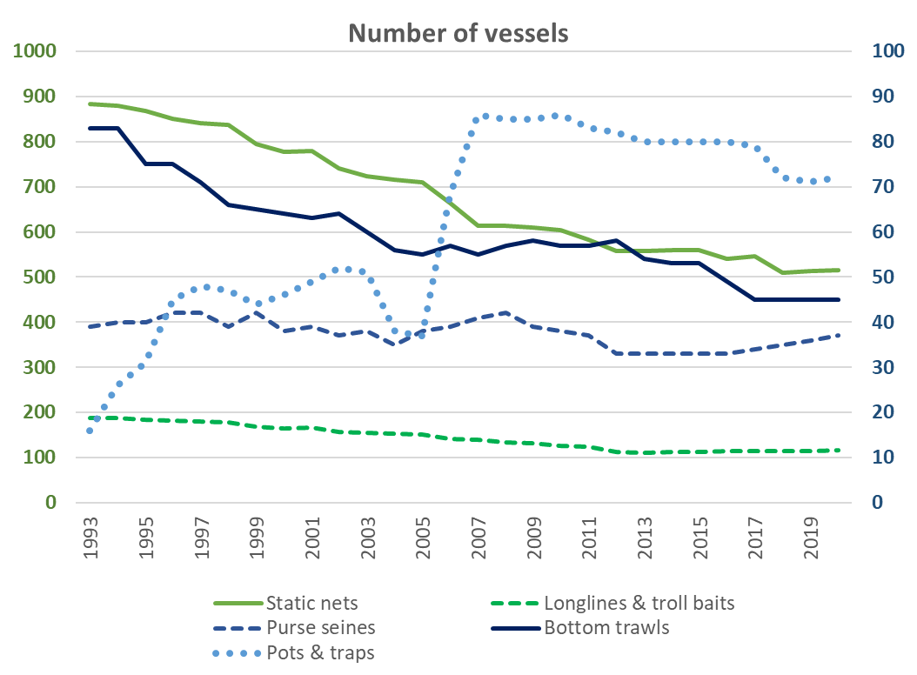

**Figure S1.** Number of vessels per gear during the hindcast period (1993-2020). Left y-axis (green colours): Static nets and Longlines & troll baits; Right y-axis (blue colours): Pots & traps, Purse seines and Bottom trawls.

**Table S5.** Weighted average Temperature (oC) tolerance range (minimum, maximum), preference range (10th and 90th percentiles) and estimated optimum temperature for 28 functional groups with thermal responses included in Ecosim. Temperature environmental responses were applied in Ecosim using a piecewise Gaussian shape with different left and right standard deviation (SD) values.

| **Functional group** | **Min** | **Pref Min**  **(10th)** | **Pref Max**  **(90th)** | **Max** | **optimum** | **SD**  **left** | **SD**  **right** |
| --- | --- | --- | --- | --- | --- | --- | --- |
| 8.Shrimps | 11.05 | 19.10 | 28.06 | 32.26 | 23.58 | 4.3 | 2.5 |
| 9.Crabs | 0.17 | 10.44 | 19.79 | 28.77 | 15.11 | 4.2 | 4.1 |
| 10.Norway lobster | 4.66 | 10.00 | 19.26 | 22.14 | 14.63 | 3 | 2.9 |
| 13.Benthic cephalopods | 6.40 | 13.00 | 24.32 | 27.67 | 18.66 | 3.6 | 3.1 |
| 14.Benthopelagic cephalopods | 5.92 | 14.34 | 25.73 | 29.43 | 20.03 | 3.7 | 3.2 |
| 15.Red mullets | 6.49 | 10.94 | 21.46 | 27.90 | 16.20 | 3.2 | 3.6 |
| 16.Anglerfish | 2.16 | 10.59 | 19.95 | 28.86 | 15.27 | 4 | 4 |
| 17.Flatfishes | 7.71 | 13.19 | 22.37 | 28.04 | 17.78 | 3 | 3.1 |
| 18.Blue whiting | -0.57 | 8.82 | 19.26 | 22.81 | 14.04 | 4 | 3.4 |
| 19.Other gadiformes | 1.86 | 10.12 | 19.70 | 26.55 | 14.91 | 3.9 | 3.6 |
| 20.Hake | 7.00 | 10.08 | 23.00 | 24.51 | 16.54 | 3.6 | 3.5 |
| 21.DemeFish1 | 5.78 | 11.68 | 20.38 | 26.93 | 16.03 | 3 | 3.1 |
| 22.DemeFish2 | 7.57 | 13.12 | 23.85 | 29.52 | 18.48 | 3.5 | 3.5 |
| 23.DemeFish3 | 13.94 | 16.75 | 21.77 | 24.36 | 19.26 | 1.7 | 1.7 |
| 24.DemeFish4 | 12.39 | 16.34 | 21.33 | 23.89 | 18.83 | 1.9 | 1.7 |
| 25. Benthopelagic Fish | 10.61 | 14.18 | 22.41 | 26.24 | 18.29 | 3 | 3 |
| 26.Picarels and Bogue | 14.46 | 17.64 | 21.75 | 23.30 | 19.69 | 1.7 | 1.3 |
| 27.Sharks | 0.30 | 10.27 | 19.94 | 28.33 | 15.11 | 4.2 | 4.1 |
| 28.Rays & skates | 3.09 | 11.14 | 21.11 | 28.00 | 16.13 | 4 | 3.8 |
| 29.Anchovy | 7.25 | 10.19 | 26.32 | 30.52 | 18.26 | 5.5 | 5.3 |
| 30.Sardine | -1.13 | 10.32 | 20.26 | 24.75 | 15.29 | 4.2 | 3.5 |
| 31.Horse mackerel | 9.06 | 13.69 | 20.78 | 24.73 | 17.24 | 2.5 | 2.4 |
| 32.Mackerel | 6.63 | 12.12 | 23.39 | 26.90 | 17.76 | 3.7 | 3 |
| 33.Other small pelagic fish | 10.01 | 17.53 | 27.10 | 31.32 | 22.32 | 3.8 | 2.8 |
| 34.Medium pelagic fish | 3.28 | 16.15 | 27.70 | 31.90 | 21.92 | 6 | 3.3 |
| 35.Large pelagic fish | 2.26 | 13.12 | 27.53 | 31.73 | 20.33 | 5.5 | 3.4 |
| 36.Loggerhead turtle | 4.97 | 15.32 | 27.80 | 32.00 | 21.56 | 5 | 3.3 |
| 38.Dolphins | -1.19 | 13.17 | 28.07 | 30.43 | 20.62 | 6.8 | 3.1 |

**Table S6.** Ranges as Coefficient of variance (CV) for principal base parameters B, P/B, Q/B, and Dirichlet multipliers for Diet, used in the Monte-Carlo simulations

|  |  |  |  |  |  |
| --- | --- | --- | --- | --- | --- |
|  | **Functional group** | **Biomass CV** | **P/B CV** | **Q/B CV** | **Diet;**  **Dirichlet multiplier** |
| 1 | Phytoplankton | 0.25 | 0.1 | 0.1 |  |
| 2 | Microzooplankton | 0.2 | 0.1 | 0.1 | 30 |
| 3 | Mesozooplankton | 0.2 | 0.1 | 0.1 | 30 |
| 4 | Macrozooplankton | 0.2 | 0.1 | 0.1 | 30 |
| 5 | Jelatinous plankton | 0.25 | 0.1 | 0.1 | 30 |
| 6 | Small benthic crustaceans | 0.2 | 0.1 | 0.1 | 30 |
| 7 | Polychaetes | 0.25 | 0.1 | 0.1 | 30 |
| 8 | Shrimps | 0.2 | 0.1 | 0.1 | 30 |
| 9 | Crabs | 0.2 | 0.1 | 0.1 | 30 |
| 10 | Norway lobster | 0.2 | 0.1 | 0.1 | 30 |
| 11 | Bivalves & gastropods | 0.25 | 0.1 | 0.1 | 30 |
| 12 | Benthic invert. (no crustacea) | 0.25 | 0.1 | 0.1 | 30 |
| 13 | Benthic cephalopods | 0.2 | 0.1 | 0.1 | 30 |
| 14 | Benthopelagic cephalopods | 0.2 | 0.1 | 0.1 | 30 |
| 15 | Red mullets | 0.2 | 0.1 | 0.1 | 30 |
| 16 | Anglerfish | 0.2 | 0.1 | 0.1 | 30 |
| 17 | Flatfishes | 0.2 | 0.1 | 0.1 | 30 |
| 18 | Blue whiting | 0.2 | 0.1 | 0.1 | 30 |
| 19 | Other gadiformes | 0.2 | 0.1 | 0.1 | 30 |
| 20 | Hake | 0.2 | 0.1 | 0.1 | 30 |
| 21 | DemeFish1 | 0.2 | 0.1 | 0.1 | 30 |
| 22 | DemeFish2 | 0.2 | 0.1 | 0.1 | 30 |
| 23 | DemeFish3 | 0.2 | 0.1 | 0.1 | 30 |
| 24 | DemeFish4 | 0.2 | 0.1 | 0.1 | 30 |
| 25 | Benthopelagic Fish | 0.2 | 0.1 | 0.1 | 30 |
| 26 | Picarels and Bogue | 0.2 | 0.1 | 0.1 | 30 |
| 27 | Sharks | 0.2 | 0.1 | 0.1 | 30 |
| 28 | Rays & skates | 0.2 | 0.1 | 0.1 | 30 |
| 29 | Anchovy | 0.2 | 0.1 | 0.05 | 30 |
| 30 | Sardine | 0.2 | 0.1 | 0.05 | 30 |
| 31 | Horse mackerel | 0.2 | 0.1 | 0.1 | 30 |
| 32 | Mackerel | 0.2 | 0.1 | 0.1 | 30 |
| 33 | Other Small pelagic fishes | 0.25 | 0.1 | 0.1 | 30 |
| 34 | Medium pelagic fish | 0.4 | 0.1 | 0.1 | 30 |
| 35 | Large pelagic fishes | 0.25 | 0.1 | 0.1 | 30 |
| 36 | Loggerhead turtle | 0.25 | 0.1 | 0.1 | 30 |
| 37 | Sea birds | 0.2 | 0.1 | 0.1 | 30 |
| 38 | Dolphins | 0.2 | 0.1 | 0.1 | 30 |

# D Ecopath results



**Figure S2**. Ecopath flow diagram. Circles are scaled according to the biomass of each FG. Pelagic and benthic/demersal FGs are positioned in the left and right side respectively.

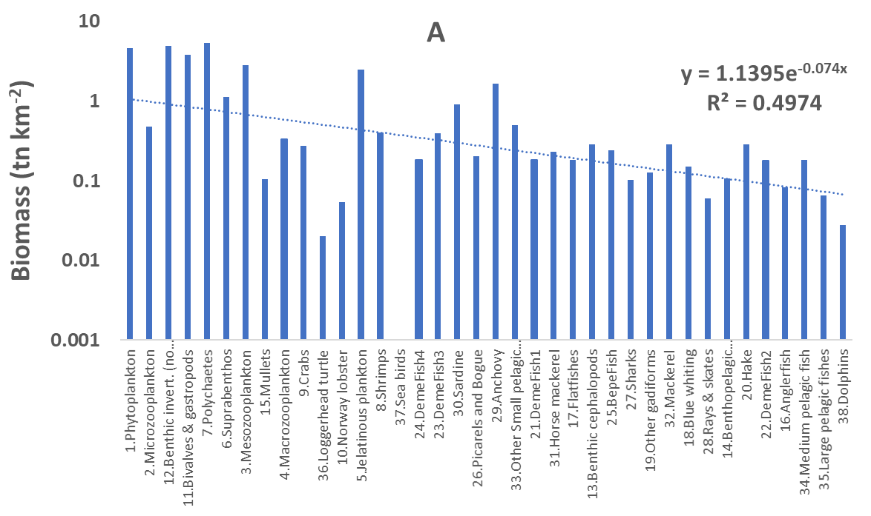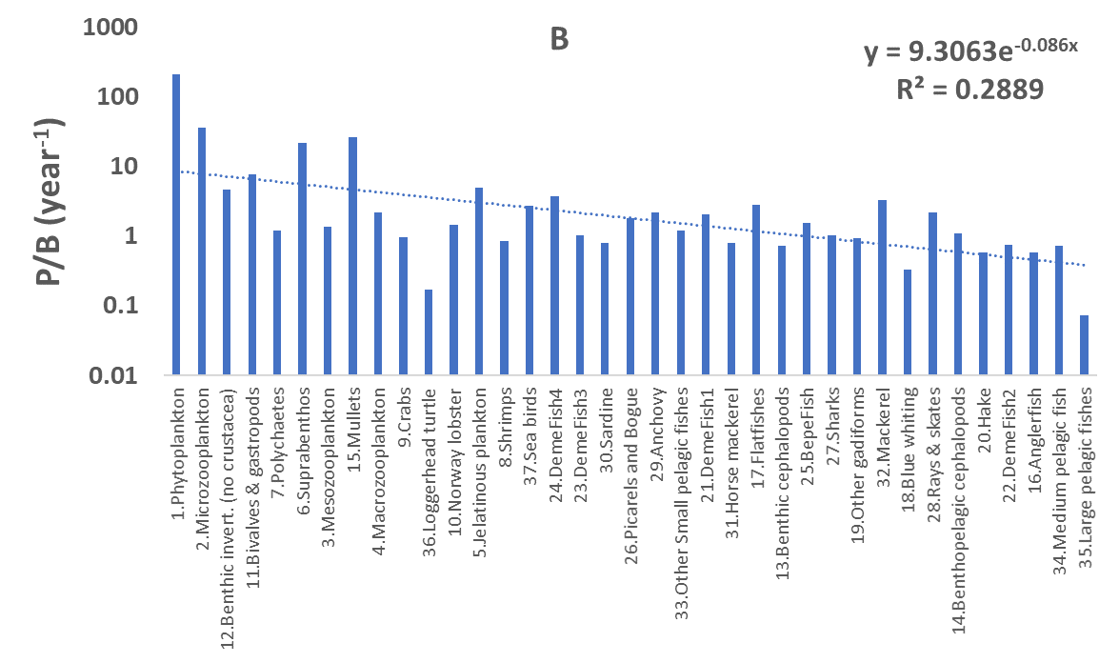

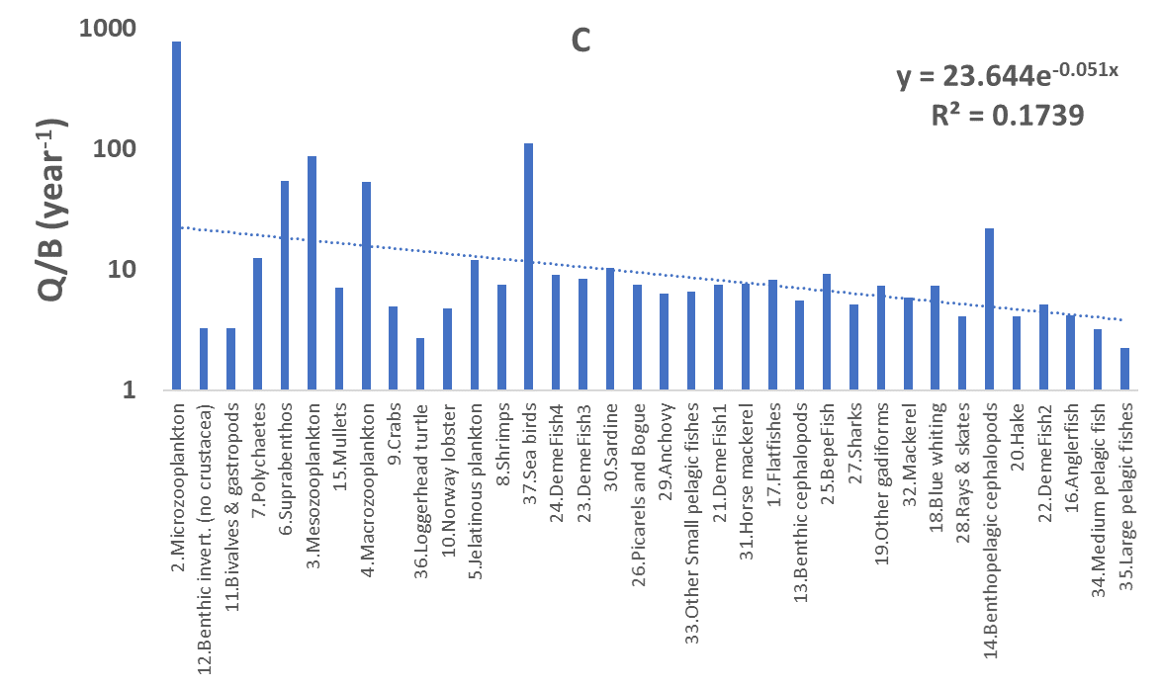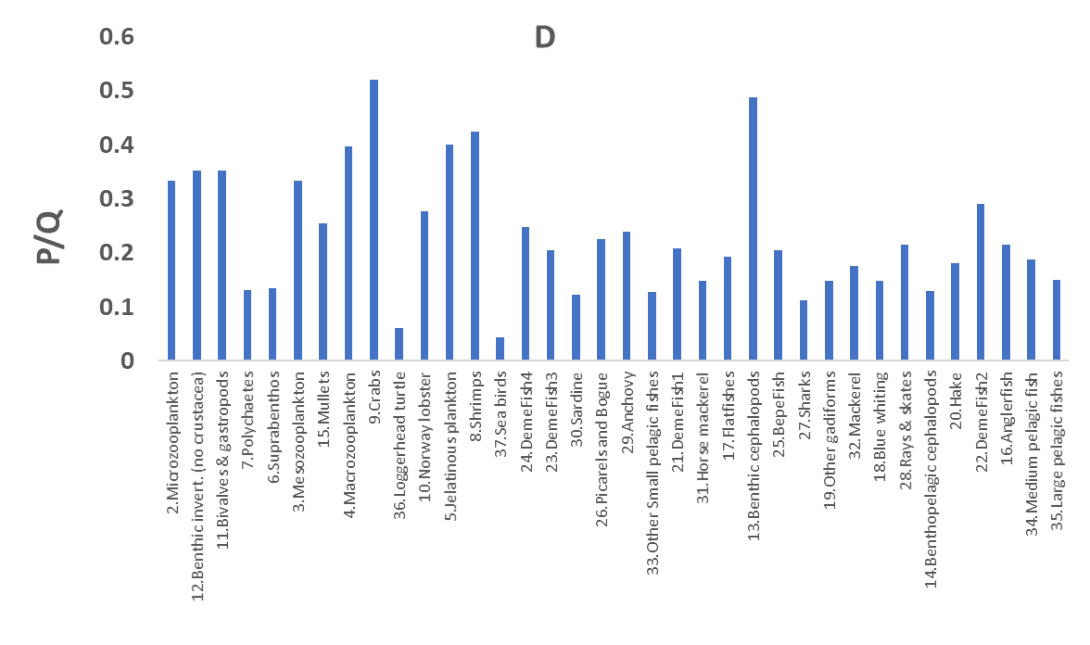

**Figure S3.** PREBAL diagnostics. Graphical representation of the FG’s biomass (A), production on biomass ratio (P/B) (B), consumption on biomass ratio (Q/B) (C) with increasing trophic levels, on a logarithmic scale. Production on consumption (P/Q) (D) is also shown.

**Table S7.** Statistics and indices of the Ecopath model

|  |  |  |
| --- | --- | --- |
| **Parameter** | **Value** | **Units** |
| Sum of all consumption | 869.69 | t/km2/year |
| Sum of all exports | 274.73 | t/km2/year |
| Sum of all respiratory flows | 269.52 | t/km2/year |
| Sum of all flows into detritus | 567.24 | t/km2/year |
| Total system throughput | 1981.19 | t/km2/year |
| Sum of all production | 797.04 | t/km2/year |
| Mean trophic level of the catch | 3.499 |  |
| Gross efficiency (catch/net p.p.) | 0.0048 |  |
| Calculated total net primary production | 535.47 | t/km2/year |
| Total primary production/total respiration | 1.987 |  |
| Net system production | 265.95 | t/km2/year |
| Total primary production/total biomass | 16.11 |  |
| Total biomass/total throughput | 0.017 |  |
| Total biomass (excluding detritus) | 33.23 | t/km2 |
| Total catch | 2.579 | t/km2/year |
| Connectance Index | 0.320 |  |
| System Omnivory Index | 0.204 |  |
| Ecopath pedigree | 0.64 |  |
| Measure of fit, t* | 4.857 |  |
| Shannon diversity index | 2.697 |  |
| L-index | 0.0785 |  |
| Psust | 0.253 |  |
| Mean transfer efficiency (TE) | 17.66 | % |
| TE from primary producers | 17.83 | % |
| TE from detritus | 17.46 | % |
| Primary production required to sustain the fishery (PPR, considering PP) | 9.724 | % |
| Primary production required to sustain the fishery (PPR, considering detritus) | 7.683 | % |
| Finn's cycling index (of total throughput) (FCI) | 14.68 | % |
| Finn's mean path length (PL) | 3.639 |  |

**Table S8**. Mortality indices per FG

|  | **Functional group** | **Prod/biom or Z** | **Fishing mort. rate (F)** | **Predation mort. rate (/year)** | **Other mort. rate (/year)** | **F/Z: Fishing mort. / total mort.** | **Proportion natural mort.** |
| --- | --- | --- | --- | --- | --- | --- | --- |
| 1 | Phytoplankton | 117.3 | 0 | 81.134 | 36.166 | 0 | 1 |
| 2 | Microzooplankton | 258.847 | 0 | 182.586 | 76.261 | 0 | 1 |
| 3 | Mesozooplankton | 29.185 | 0 | 23.691 | 5.494 | 0 | 1 |
| 4 | Macrozooplankton | 21.073 | 0 | 19.323 | 1.750 | 0 | 1 |
| 5 | Jelatinous plankton | 4.836 | 0 | 0.944 | 3.892 | 0 | 1 |
| 6 | Small benthic crustaceans | 7.315 | 0 | 7.175 | 0.140 | 0 | 1 |
| 7 | Polychaetes | 1.633 | 0 | 1.565 | 0.068 | 0 | 1 |
| 8 | Shrimps | 3.18 | 0.063 | 3.013 | 0.105 | 0.020 | 0.980 |
| 9 | Crabs | 2.56752 | 0.014 | 2.460 | 0.093 | 0.006 | 0.994 |
| 10 | Norway lobster | 1.318 | 0.484 | 0.404 | 0.430 | 0.367 | 0.633 |
| 11 | Bivalves & gastropods | 1.148 | 0.000 | 1.129 | 0.019 | 0.000 | 1.000 |
| 12 | Benthic invert. (no crustacea) | 1.148 | 0 | 1.124 | 0.024 | 0 | 1 |
| 13 | Benthic cephalopods | 2.683 | 0.492 | 2.112 | 0.079 | 0.183 | 0.817 |
| 14 | Benthopelagic cephalopods | 2.858447 | 0.392 | 2.425 | 0.042 | 0.137 | 0.863 |
| 15 | Red mullets | 1.799 | 0.684 | 0.916 | 0.199 | 0.380 | 0.620 |
| 16 | Anglerfish | 0.904 | 0.146 | 0.275 | 0.483 | 0.162 | 0.838 |
| 17 | Flatfishes | 1.598 | 0.383 | 1.090 | 0.125 | 0.240 | 0.760 |
| 18 | Blue whiting | 1.1 | 0.183 | 0.911 | 0.006 | 0.166 | 0.834 |
| 19 | Other gadiformes | 1.1 | 0.254 | 0.839 | 0.007 | 0.231 | 0.769 |
| 20 | Hake | 0.745 | 0.308 | 0.429 | 0.008 | 0.414 | 0.586 |
| 21 | DemeFish1 | 1.551 | 0.446 | 1.003 | 0.102 | 0.288 | 0.712 |
| 22 | DemeFish2 | 1.494 | 0.663 | 0.702 | 0.128 | 0.444 | 0.556 |
| 23 | DemeFish3 | 1.713 | 0.256 | 1.242 | 0.215 | 0.149 | 0.851 |
| 24 | DemeFish4 | 2.223 | 0.406 | 1.537 | 0.280 | 0.182 | 0.818 |
| 25 | Benthopelagic Fish | 1.9 | 0 | 1.874 | 0.026 | 0 | 1 |
| 26 | Picarels and Bogue | 1.69 | 0.665 | 0.905 | 0.120 | 0.394 | 0.606 |
| 27 | Sharks | 0.578 | 0.132 | 0.230 | 0.215 | 0.229 | 0.771 |
| 28 | Rays & skates | 0.875 | 0.297 | 0.336 | 0.242 | 0.339 | 0.661 |
| 29 | Anchovy | 1.518333 | 0.299 | 1.197 | 0.022 | 0.197 | 0.803 |
| 30 | Sardine | 1.27693 | 0.577 | 0.691 | 0.009 | 0.452 | 0.548 |
| 31 | Horse mackerel | 1.12649 | 0.619 | 0.485 | 0.022 | 0.550 | 0.450 |
| 32 | Mackerel | 1.03 | 0.711 | 0.312 | 0.007 | 0.690 | 0.310 |
| 33 | Other Small pelagic fishes | 0.83 | 0.077 | 0.735 | 0.018 | 0.093 | 0.907 |
| 34 | Medium pelagic fish | 0.61 | 0.428 | 0.032 | 0.150 | 0.701 | 0.299 |
| 35 | Large pelagic fishes | 0.335 | 0.327 | 0 | 0.008 | 0.976 | 0.024 |
| 36 | Loggerhead turtle | 0.164 | 0.011 | 0 | 0.153 | 0.065 | 0.935 |
| 37 | Sea birds | 4.782 | 0 | 0.039 | 4.743 | 0 | 1 |
| 38 | Dolphins | 0.083 | 0.008 | 0 | 0.075 | 0.093 | 0.907 |

# E Ecosim results

**Table S9**. Calibration of trophic interactions. Vulnerabilities of predators ≠2 were estimated by the model routines.

|  |  |  |  |
| --- | --- | --- | --- |
| **Functional group** | **vulnerability** | **FG** | **vulnerability** |
| 2.Microzooplankton | 1 | 21.DemeFish1 | 1 |
| 3.Mesozooplankton | 2 | 22.DemeFish2 | 3.484 |
| 4.Macrozooplankton | 1 | 23.DemeFish3 | 2.313 |
| 5.Gelatinous plankton | 13.108 | 24.DemeFish4 | 30.469 |
| 6. Small benthic crustaceans | >1000 | 25. Benthopelagic Fish | >1000 |
| 7.Polychaetes | 1 | 26.Picarels and Bogue | 1.504 |
| 8.Shrimps | 1 | 27.Sharks | 1 |
| 9.Crabs | 2 | 28.Rays & skates | 1 |
| 10.Norway lobster | 2.205 | 29.Anchovy | 1 |
| 11.Bivalves & gastropods | 1 | 30.Sardine | 2.008 |
| 12.Benthic invert. (no crustacea) | 1 | 31.Horse mackerel | 3.621 |
| 13.Benthic cephalopods | 1.996 | 32.Mackerel | 2.225 |
| 14.Benthopelagic cephalopods | 1 | 33.Other Small pelagic fish | 1 |
| 15.Red mullets | 1 | 34.Medium pelagic fish | >1000 |
| 16.Anglerfish | 1 | 35.Large pelagic fish | >1000 |
| 17.Flatfishes | 2.495 | 36.Loggerhead turtle | 2 |
| 18.Blue whiting | 2.487 | 37.Sea birds | 1 |
| 19.Other gadiformes | >1000 | 38.Dolphins | 1 |
| 20.Hake | 1 |  |  |

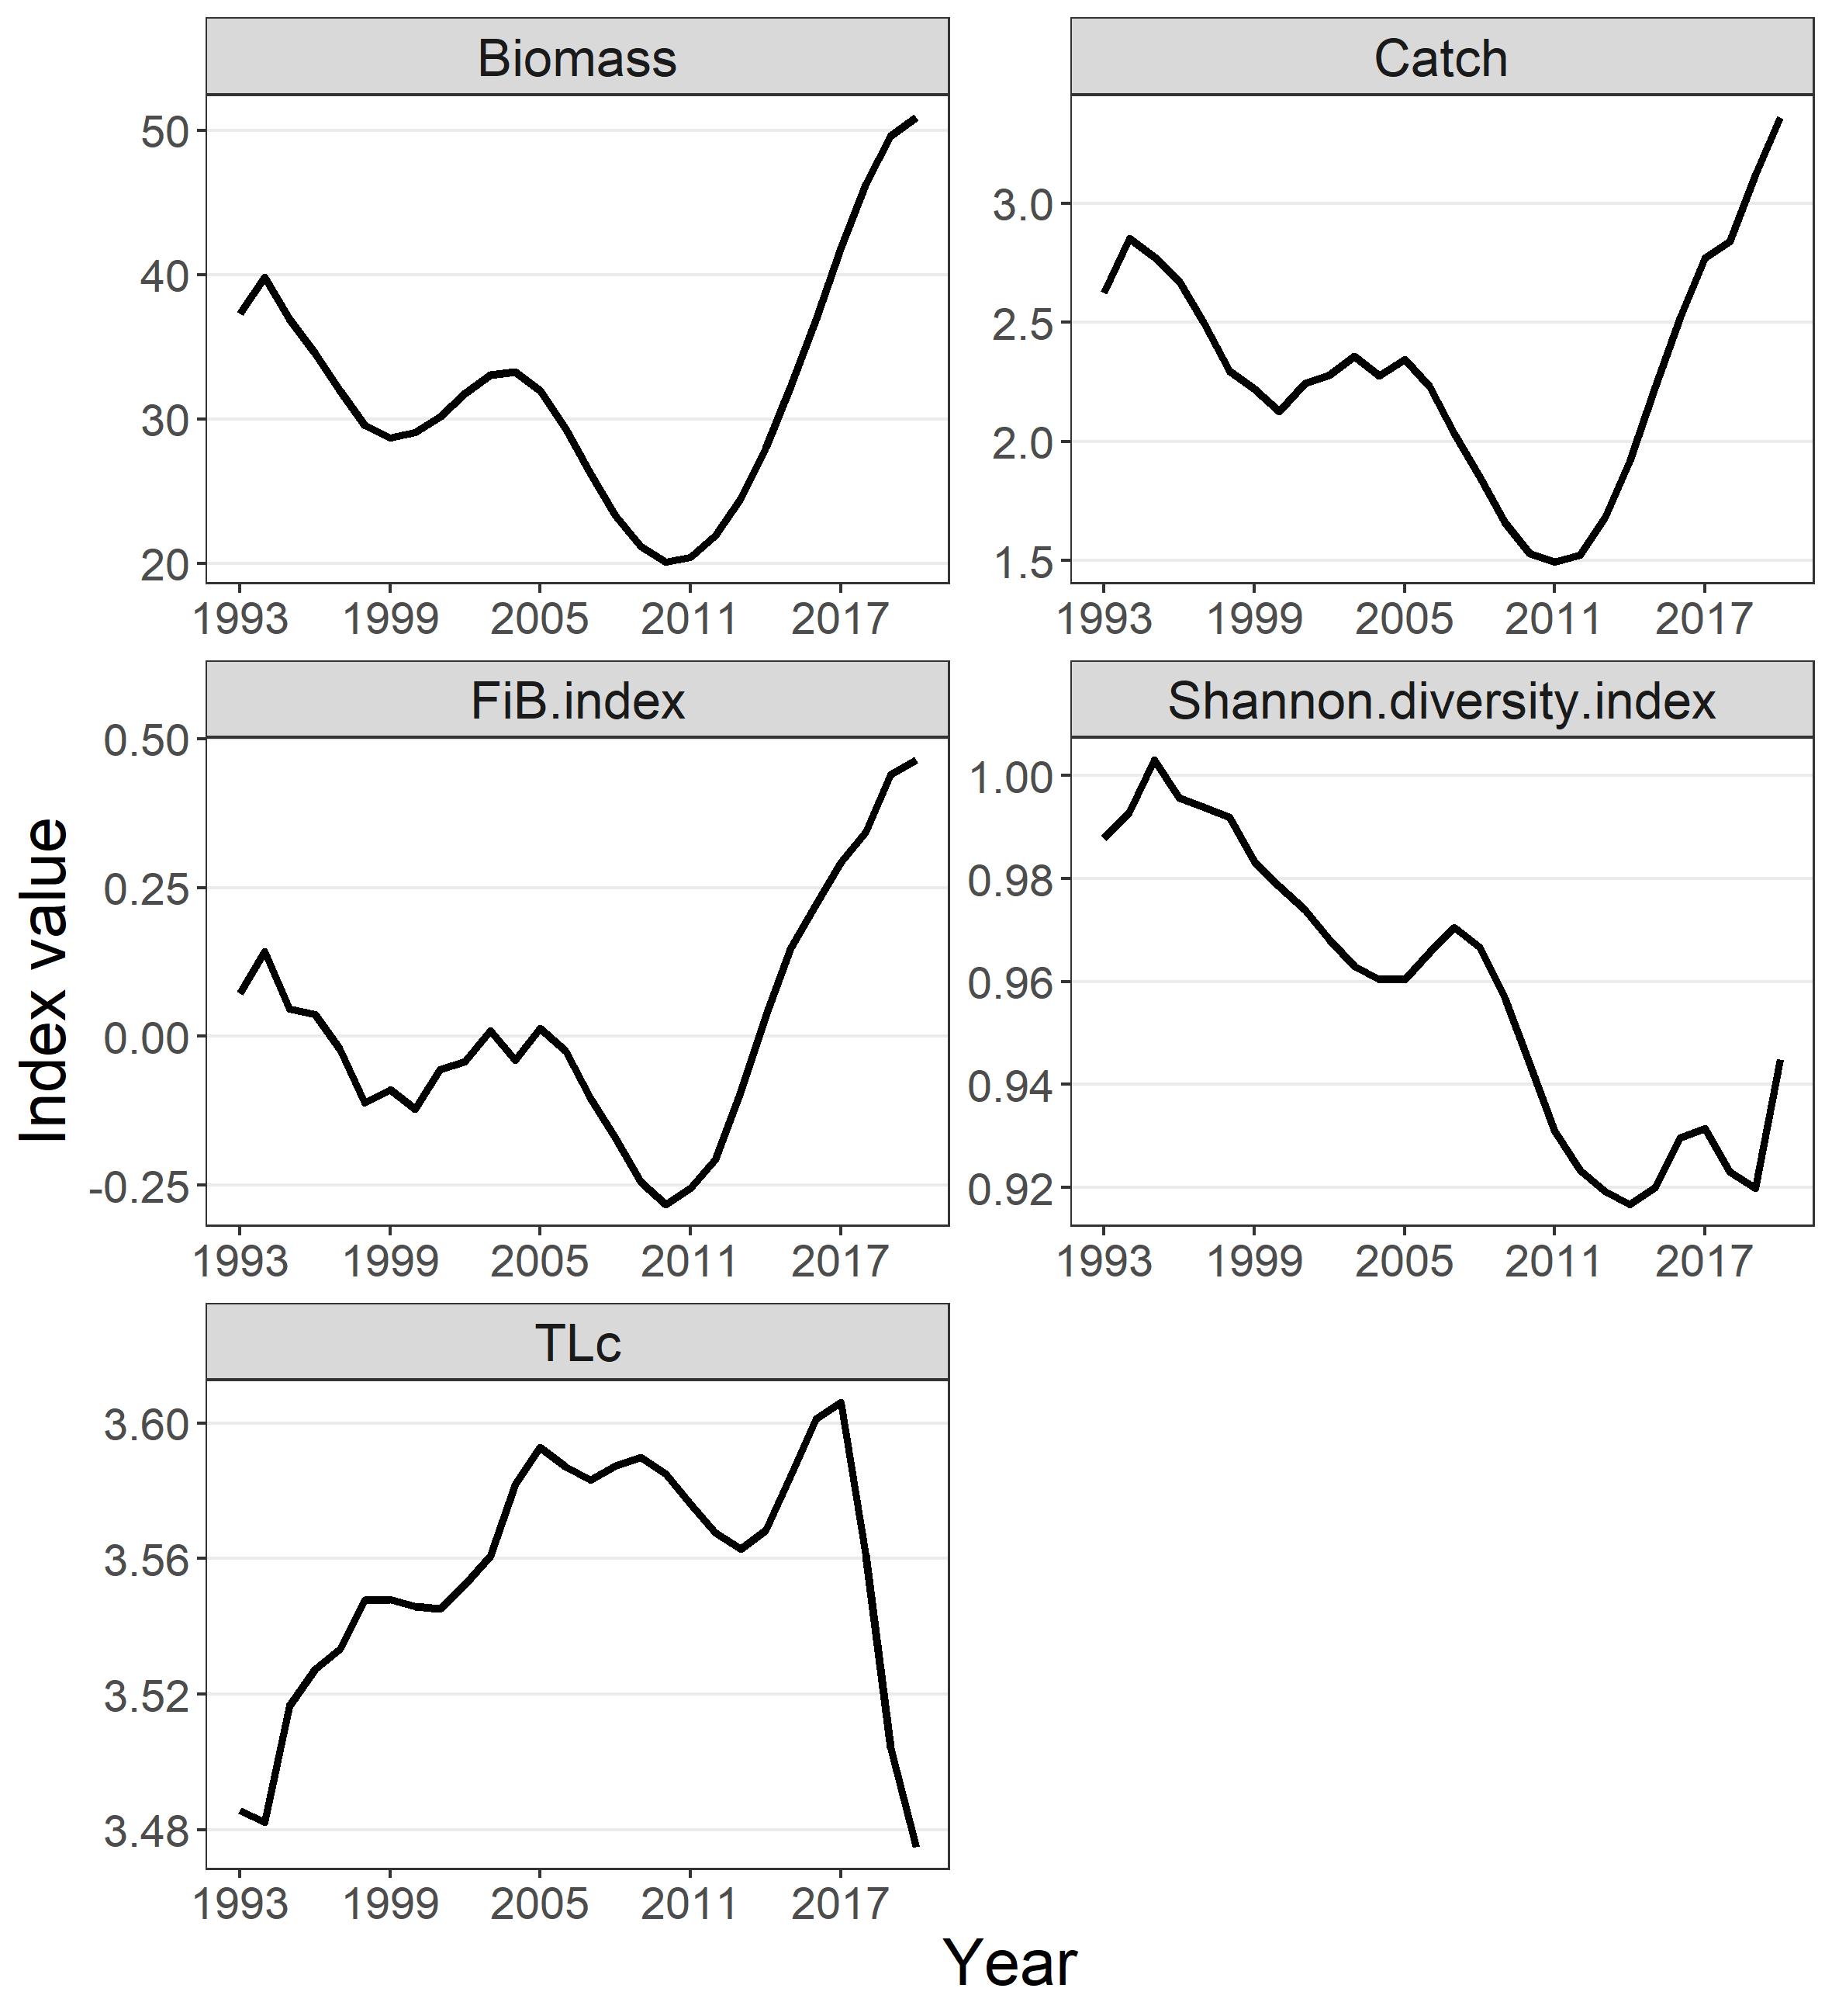

**Figure S4**. Trends of ecosystem indicators during the hindcast period. FiB.index: Fishing-in-Balance index; TLc: mean Trophic Level of the catch. Biomass in t*km-2; Catch in t*km-2*y-1.

**Table S10.** Differences (%) in biomasses in 2030 for each FG under each scenario compared to the baseline scenario.

|  |  |  |  |  |  |  |  |  |  |
| --- | --- | --- | --- | --- | --- | --- | --- | --- | --- |
|  | **Functional group** | **RCP45** | **RCP85** | **PP+5%** | **PP-5%** | **FE25** | **FE10** | **ENV** | **ENV_FE10** |
| 1 | Phytoplankton | -0.1% | -0.1% | 2.4% | -2.4% | 0.6% | 0.3% | -2.5% | -2.3% |
| 2 | Microzooplankton | 0.0% | 0.0% | 1.8% | -1.8% | 1.0% | 0.4% | -1.8% | -1.3% |
| 3 | Mesozooplankton | 0.9% | 0.8% | 1.3% | -1.3% | -3.1% | -1.4% | -0.4% | -1.9% |
| 4 | Macrozooplankton | 0.5% | 0.6% | 1.5% | -1.6% | -0.5% | -0.3% | -1.0% | -1.4% |
| 5 | Gelatinous plankton | 1.9% | 1.7% | 5.1% | -5.1% | -4.3% | -1.9% | -3.2% | -5.1% |
| 6 | Small benthic crustaceans | -12.1% | -11.2% | 4.7% | -4.7% | 12.9% | 5.6% | -16.4% | -11.0% |
| 7 | Polychaetes | 2.0% | 2.0% | 2.0% | -2.0% | -1.4% | -0.6% | -0.1% | -0.6% |
| 8 | Shrimps | -3.2% | -2.7% | 1.3% | -1.3% | 2.7% | 1.1% | -4.5% | -3.5% |
| 9 | Crabs | -7.2% | -5.9% | 0.7% | -0.7% | -7.3% | -3.2% | -7.8% | -11.4% |
| 10 | Norway lobster | -18.7% | -16.9% | 3.3% | -3.2% | 29.6% | 12.0% | -21.7% | -10.3% |
| 11 | Bivalves & gastropods | 1.9% | 1.8% | 2.0% | -2.1% | -1.3% | -0.6% | -0.2% | -0.8% |
| 12 | Benthic invert. (no crustacea) | 1.9% | 1.8% | 2.0% | -2.1% | -1.3% | -0.6% | -0.2% | -0.8% |
| 13 | Benthic cephalopods | -4.4% | -3.8% | 1.9% | -2.0% | 24.0% | 10.1% | -6.4% | 3.5% |
| 14 | Benthopelagic cephalopods | 0.3% | 0.6% | 1.2% | -1.2% | 7.1% | 2.8% | -0.9% | 1.7% |
| 15 | Red mullets | -3.3% | -2.8% | 1.7% | -1.7% | 2.1% | 0.9% | -5.0% | -4.1% |
| 16 | Anglerfish | 3.2% | 3.3% | 1.7% | -1.7% | 0.0% | -0.2% | 1.4% | 1.4% |
| 17 | Flatfishes | -8.5% | -7.5% | 2.5% | -2.5% | 12.3% | 5.1% | -10.9% | -5.9% |
| 18 | Blue whiting | -5.2% | -3.1% | 3.1% | -3.1% | -14.3% | -5.7% | -8.4% | -14.2% |
| 19 | Other gadiformes | -29.1% | -30.5% | 5.5% | -5.3% | 7.7% | 3.3% | -33.0% | -31.7% |
| 20 | Hake | 1.5% | 1.6% | 1.4% | -1.4% | 8.0% | 3.2% | 0.1% | 3.3% |
| 21 | DemeFish1 | -8.1% | -7.6% | 2.0% | -2.0% | 9.8% | 4.2% | -10.1% | -6.0% |
| 22 | DemeFish2 | 8.5% | 8.3% | 2.8% | -2.8% | 4.3% | 2.1% | 5.5% | 7.9% |
| 23 | DemeFish3 | -1.3% | -2.1% | 2.9% | -2.9% | 2.4% | 1.0% | -4.0% | -3.1% |
| 24 | DemeFish4 | 15.9% | 13.8% | 4.1% | -4.1% | -4.7% | -2.2% | 11.6% | 9.2% |
| 25 | Benthopelagic Fish | 5.5% | 5.5% | 3.3% | -3.2% | -20.1% | -7.7% | 2.1% | -4.5% |
| 26 | Picarels and Bogue | 9.0% | 6.1% | 2.6% | -2.6% | 40.2% | 17.5% | 6.3% | 20.4% |
| 27 | Sharks | -1.8% | -1.0% | 0.8% | -0.8% | 0.2% | 0.0% | -2.6% | -2.7% |
| 28 | Rays & skates | -1.2% | -1.0% | 1.1% | -1.1% | 2.7% | 1.0% | -2.4% | -1.5% |
| 29 | Anchovy | 0.6% | 0.5% | 1.3% | -1.3% | -2.5% | -1.2% | -0.7% | -1.9% |
| 30 | Sardine | -5.9% | -4.8% | 2.3% | -2.3% | 44.8% | 20.5% | -8.2% | 12.5% |
| 31 | Horse mackerel | -10.7% | -11.5% | 3.1% | -3.1% | 268.7% | 71.7% | -13.5% | 48.7% |
| 32 | Mackerel | -1.7% | -1.9% | 2.1% | -2.1% | 674.5% | 127.9% | -3.7% | 119.3% |
| 33 | Other small pelagic fish | -2.4% | -2.2% | 1.5% | -1.5% | 1.0% | 0.4% | -3.9% | -3.5% |
| 34 | Medium pelagic fish | 2.7% | 2.8% | 1.2% | -1.2% | 159.4% | 46.7% | 1.5% | 48.7% |
| 35 | Large pelagic fish | 0.2% | 0.2% | 0.2% | -0.2% | 99.0% | 31.7% | 0.0% | 31.7% |
| 36 | Loggerhead turtle | 3.2% | 2.9% | 0.8% | -0.8% | -5.6% | -2.7% | 2.3% | -3.0% |
| 37 | Sea birds | 5.3% | 5.2% | 0.6% | -0.5% | 8.4% | 3.5% | 4.6% | 2.6% |
| 38 | Dolphins | 2.1% | 0.9% | 1.4% | -1.3% | 9.0% | 2.7% | 0.6% | 3.4% |
| 39 | Detritus | 1.3% | 1.2% | 2.2% | -2.2% | -1.1% | -0.5% | -1.0% | -1.5% |
| 40 | Discards | 11.5% | 10.6% | 0.0% | 0.0% | 0.0% | 0.0% | 11.2% | 1.5% |
|  | Total (living FGs) | 0.7% | 0.7% | 2.6% | -2.6% | -0.2% | -0.1% | -1.9% | -2.0% |

**Table S11.** Differences (%) in average biomasses in the period 2046-2050 for each FG under each scenario compared to the baseline scenario.

|  |  |  |  |  |  |  |  |  |  |
| --- | --- | --- | --- | --- | --- | --- | --- | --- | --- |
|  | **Functional group** | **RCP45** | **RCP85** | **PP+5%** | **PP-5%** | **FE25** | **FE10** | **ENV** | **ENV_FE10** |
| 1 | Phytoplankton | -0.2% | -0.5% | 6.9% | -6.9% | 0.4% | 0.2% | -7.2% | -7.0% |
| 2 | Microzooplankton | 0.5% | 1.1% | 5.0% | -5.1% | 1.2% | 0.7% | -4.6% | -4.1% |
| 3 | Mesozooplankton | 1.7% | 4.4% | 4.2% | -4.1% | -1.6% | -0.9% | -1.4% | -2.8% |
| 4 | Macrozooplankton | -0.1% | -0.6% | 4.4% | -4.3% | -0.1% | -0.3% | -5.0% | -5.2% |
| 5 | Gelatinous plankton | 2.9% | 7.3% | 15.6% | -15.0% | -3.8% | -1.6% | -11.7% | -13.5% |
| 6 | Small benthic crustaceans | -23.1% | -56.1% | 9.9% | -10.5% | -4.5% | -3.9% | -41.7% | -39.3% |
| 7 | Polychaetes | 2.3% | 8.1% | 6.5% | -6.4% | 0.6% | 0.8% | -2.2% | -2.6% |
| 8 | Shrimps | -10.6% | -22.7% | 3.1% | -3.4% | -0.2% | -0.7% | -17.4% | -16.5% |
| 9 | Crabs | -25.9% | -47.9% | 0.8% | -1.1% | -3.6% | -2.4% | -29.4% | -31.8% |
| 10 | Norway lobster | -44.7% | -74.7% | 8.8% | -9.1% | 20.3% | 8.0% | -54.2% | -45.6% |
| 11 | Bivalves & gastropods | 2.7% | 8.7% | 6.6% | -6.5% | 0.6% | 0.8% | -2.0% | -2.4% |
| 12 | Benthic invert. (no crustacea) | 2.7% | 8.6% | 6.6% | -6.5% | 0.6% | 0.8% | -1.9% | -2.4% |
| 13 | Benthic cephalopods | 7.1% | 5.3% | -0.7% | -0.2% | 49.4% | 17.0% | 1.4% | 15.7% |
| 14 | Benthopelagic cephalopods | 0.8% | 1.8% | 2.4% | -2.5% | -4.1% | 2.0% | -2.4% | -1.0% |
| 15 | Red mullets | -7.0% | -16.7% | 3.9% | -4.1% | 0.1% | -0.6% | -14.3% | -13.5% |
| 16 | Anglerfish | 2.8% | 21.1% | 9.6% | -8.7% | -2.4% | 2.1% | 2.2% | 1.2% |
| 17 | Flatfishes | -3.8% | -28.8% | -0.1% | -1.6% | 9.7% | -0.4% | -17.5% | -13.3% |
| 18 | Blue whiting | 23.8% | 17.0% | -1.4% | 1.6% | -23.2% | -10.4% | 22.3% | 7.1% |
| 19 | Other gadiformes | -68.2% | -89.4% | 24.0% | -21.9% | -29.2% | -4.6% | -78.6% | -79.1% |
| 20 | Hake | 11.4% | 18.0% | 1.5% | -1.6% | 1.5% | 2.5% | 8.5% | 10.5% |
| 21 | DemeFish1 | -14.5% | -40.4% | 2.1% | -3.0% | -1.2% | -2.9% | -27.1% | -24.6% |
| 22 | DemeFish2 | 103.5% | 201.9% | 6.6% | -4.8% | 23.3% | 12.3% | 110.4% | 111.6% |
| 23 | DemeFish3 | 31.1% | 24.7% | 2.7% | -4.2% | 2.0% | -2.8% | 17.3% | 18.3% |
| 24 | DemeFish4 | 154.9% | 240.7% | 0.7% | -3.0% | 24.8% | 3.8% | 141.2% | 139.0% |
| 25 | Benthopelagic Fish | 6271.7% | 10738.5% | -69.6% | 191.8% | -15.4% | -50.6% | 7159.9% | 6250.4% |
| 26 | Picarels and Bogue | 10.2% | 6.7% | 7.5% | -8.2% | 15.2% | 6.7% | -1.7% | 6.8% |
| 27 | Sharks | -8.8% | -10.3% | 4.2% | -3.7% | -1.7% | 0.9% | -11.1% | -10.6% |
| 28 | Rays & skates | -10.4% | -14.5% | 5.2% | -4.9% | -6.6% | -0.4% | -14.9% | -14.7% |
| 29 | Anchovy | 0.1% | 1.1% | 3.9% | -3.8% | -2.4% | -1.1% | -3.4% | -4.6% |
| 30 | Sardine | -19.8% | -36.5% | 7.3% | -7.5% | 23.2% | 17.6% | -27.2% | -9.1% |
| 31 | Horse mackerel | -54.2% | -75.6% | 22.0% | -20.2% | 392.3% | 202.7% | -66.2% | 33.5% |
| 32 | Mackerel | -16.8% | -27.2% | 16.2% | -14.9% | 52753.2% | 1396.2% | -30.3% | 943.7% |
| 33 | Other small pelagic fish | -7.6% | -16.9% | 3.3% | -3.6% | -2.9% | -1.9% | -14.4% | -14.2% |
| 34 | Medium pelagic fish | 7.4% | 13.5% | 9.8% | -9.6% | 1549.9% | 242.4% | -3.3% | 231.1% |
| 35 | Large pelagic fish | 1.6% | 2.6% | 0.8% | -0.9% | 908.9% | 152.9% | 0.7% | 154.0% |
| 36 | Loggerhead turtle | 1.0% | 15.4% | 3.7% | -3.4% | -2.6% | -1.2% | -1.2% | -4.5% |
| 37 | Sea birds | -3.1% | 12.2% | 1.5% | -1.7% | -6.2% | 1.2% | -5.4% | -3.8% |
| 38 | Dolphins | 3.8% | 17.1% | 6.2% | -5.5% | -4.4% | 3.9% | 2.8% | 4.1% |
| 39 | Detritus | 3.8% | 9.5% | 6.7% | -6.6% | 0.9% | 0.7% | -1.4% | -1.7% |
| 40 | Discards | 0.0% | 38.1% | 0.0% | 0.0% | 0.0% | 0.0% | 0.0% | 0.0% |
|  | Total (living FGs) | 1.4% | 3.5% | 8.0% | -7.9% | 1.0% | 0.5% | -5.9% | -5.9% |

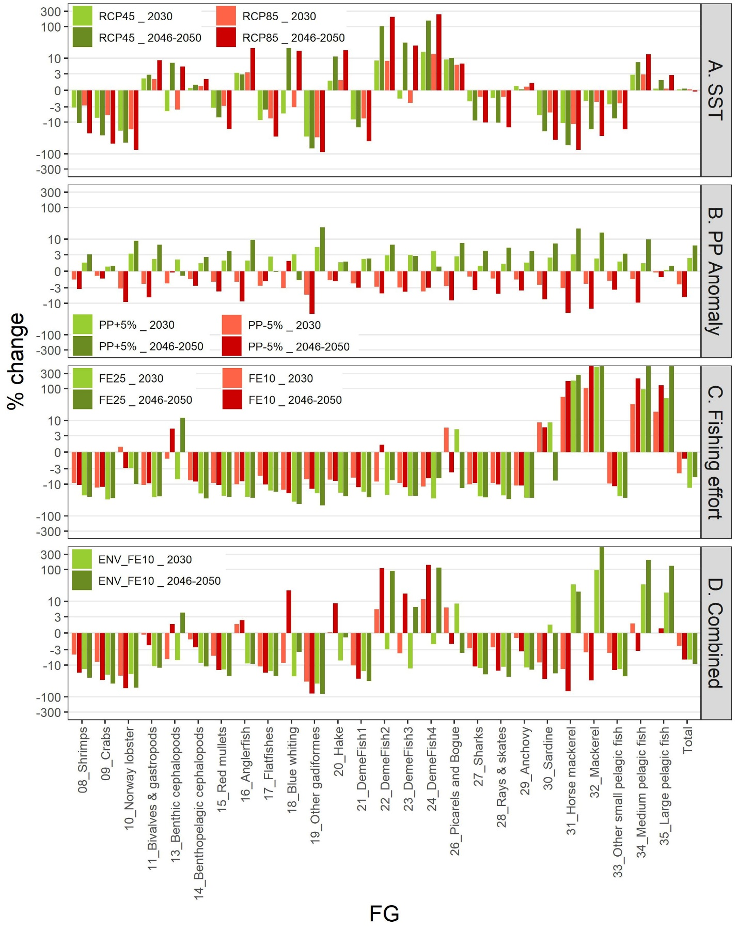

**Figure S5**. Graphical representation of differences (%) in catches in 2030 and average catches in the period 2046-2050 for each FG under each scenario compared to the baseline scenario.

**Table S12.** Differences (%) in catches in 2030 for each FG under each scenario compared to the baseline scenario

|  |  |  |  |  |  |  |  |  |  |
| --- | --- | --- | --- | --- | --- | --- | --- | --- | --- |
|  | **Functional group** | **RCP45** | **RCP85** | **PP+5%** | **PP-5%** | **FE25** | **FE10** | **ENV** | **ENV_FE10** |
| 8 | Shrimps | -3.2% | -2.7% | 1.3% | -1.3% | -23.0% | -9.0% | -4.5% | -13.2% |
| 9 | Crabs | -7.2% | -5.9% | 0.7% | -0.7% | -30.4% | -12.9% | -7.8% | -20.3% |
| 10 | Norway lobster | -18.7% | -16.9% | 3.3% | -3.2% | -2.8% | 0.8% | -21.7% | -19.3% |
| 11 | Bivalves & gastropods | 1.9% | 1.8% | 2.0% | -2.1% | -26.0% | -10.5% | -0.2% | -10.7% |
| 13 | Benthic cephalopods | -4.4% | -3.8% | 1.9% | -2.0% | -7.0% | -1.0% | -6.4% | -6.9% |
| 14 | Benthopelagic cephalopods | 0.3% | 0.6% | 1.2% | -1.2% | -19.7% | -7.5% | -0.9% | -8.4% |
| 15 | Red mullets | -3.3% | -2.8% | 1.7% | -1.7% | -23.4% | -9.2% | -5.0% | -13.7% |
| 16 | Anglerfish | 3.2% | 3.3% | 1.7% | -1.7% | -25.0% | -10.1% | 1.4% | -8.8% |
| 17 | Flatfishes | -8.5% | -7.5% | 2.5% | -2.5% | -15.8% | -5.4% | -10.9% | -15.3% |
| 18 | Blue whiting | -5.2% | -3.1% | 3.1% | -3.1% | -35.8% | -15.2% | -8.4% | -22.7% |
| 19 | Other gadiformes | -29.1% | -30.5% | 5.5% | -5.3% | -19.2% | -7.0% | -33.0% | -38.5% |
| 20 | Hake | 1.5% | 1.6% | 1.4% | -1.4% | -19.0% | -7.1% | 0.1% | -7.1% |
| 21 | DemeFish1 | -8.1% | -7.6% | 2.0% | -2.0% | -17.7% | -6.2% | -10.1% | -15.4% |
| 22 | DemeFish2 | 8.5% | 8.3% | 2.8% | -2.8% | -21.8% | -8.2% | 5.5% | -2.9% |
| 23 | DemeFish3 | -1.3% | -2.1% | 2.9% | -2.9% | -23.2% | -9.1% | -4.0% | -12.8% |
| 24 | DemeFish4 | 15.9% | 13.8% | 4.1% | -4.1% | -28.5% | -12.0% | 11.6% | -1.8% |
| 26 | Picarels and Bogue | 9.0% | 6.1% | 2.6% | -2.6% | 5.1% | 5.7% | 6.3% | 8.3% |
| 27 | Sharks | -1.8% | -1.0% | 0.8% | -0.8% | -24.8% | -10.0% | -2.6% | -12.4% |
| 28 | Rays & skates | -1.2% | -1.0% | 1.1% | -1.1% | -23.0% | -9.1% | -2.4% | -11.3% |
| 29 | Anchovy | 0.6% | 0.5% | 1.3% | -1.3% | -26.9% | -11.0% | -0.7% | -11.7% |
| 30 | Sardine | -5.9% | -4.8% | 2.3% | -2.3% | 8.6% | 8.5% | -8.2% | 1.3% |
| 31 | Horse mackerel | -10.7% | -11.5% | 3.1% | -3.1% | 176.5% | 54.5% | -13.5% | 33.8% |
| 32 | Mackerel | -1.7% | -1.9% | 2.1% | -2.1% | 480.9% | 105.1% | -3.7% | 97.4% |
| 33 | Other small pelagic fish | -2.4% | -2.2% | 1.5% | -1.5% | -24.2% | -9.6% | -3.9% | -13.2% |
| 34 | Medium pelagic fish | 2.7% | 2.8% | 1.2% | -1.2% | 94.5% | 32.0% | 1.5% | 33.8% |
| 35 | Large pelagic fish | 0.2% | 0.2% | 0.2% | -0.2% | 49.2% | 18.5% | 0.0% | 18.5% |
|  | Total | 0.1% | 0.1% | 2.2% | -2.2% | -13.2% | -4.4% | -2.1% | -6.5% |

**Table S13.** Differences (%) in average catches in the period 2046-2050 for each FG under each scenario compared to the baseline scenario

|  |  |  |  |  |  |  |  |  |  |
| --- | --- | --- | --- | --- | --- | --- | --- | --- | --- |
|  | **Functional group** | **RCP45** | **RCP85** | **PP+5%** | **PP-5%** | **FE25** | **FE10** | **ENV** | **ENV_FE10** |
| 8 | Shrimps | -10.6% | -22.7% | 3.1% | -3.4% | -25.2% | -10.6% | -17.4% | -24.8% |
| 9 | Crabs | -25.9% | -47.9% | 0.8% | -1.1% | -27.7% | -12.1% | -29.4% | -38.6% |
| 10 | Norway lobster | -44.7% | -74.7% | 8.8% | -9.1% | -9.8% | -2.8% | -54.2% | -51.0% |
| 11 | Bivalves & gastropods | 2.7% | 8.7% | 6.6% | -6.5% | -24.6% | -9.3% | -2.0% | -12.1% |
| 13 | Benthic cephalopods | 7.1% | 5.3% | -0.7% | -0.2% | 12.1% | 5.3% | 1.4% | 4.2% |
| 14 | Benthopelagic cephalopods | 0.8% | 1.8% | 2.4% | -2.5% | -28.1% | -8.2% | -2.4% | -10.9% |
| 15 | Red mullets | -7.0% | -16.7% | 3.9% | -4.1% | -24.9% | -10.6% | -14.3% | -22.1% |
| 16 | Anglerfish | 2.8% | 21.1% | 9.6% | -8.7% | -26.8% | -8.1% | 2.2% | -9.0% |
| 17 | Flatfishes | -3.8% | -28.8% | -0.1% | -1.6% | -17.7% | -10.4% | -17.5% | -22.0% |
| 18 | Blue whiting | 23.8% | 17.0% | -1.4% | 1.6% | -42.4% | -19.4% | 22.3% | -3.6% |
| 19 | Other gadiformes | -68.2% | -89.4% | 24.0% | -21.9% | -46.9% | -14.2% | -78.6% | -81.2% |
| 20 | Hake | 11.4% | 18.0% | 1.5% | -1.6% | -23.9% | -7.8% | 8.5% | -0.6% |
| 21 | DemeFish1 | -14.5% | -40.4% | 2.1% | -3.0% | -25.9% | -12.6% | -27.1% | -32.1% |
| 22 | DemeFish2 | 103.5% | 201.9% | 6.6% | -4.8% | -7.5% | 1.1% | 110.4% | 90.4% |
| 23 | DemeFish3 | 31.1% | 24.7% | 2.7% | -4.2% | -23.5% | -12.5% | 17.3% | 6.5% |
| 24 | DemeFish4 | 154.9% | 240.7% | 0.7% | -3.0% | -6.4% | -6.5% | 141.2% | 115.1% |
| 26 | Picarels and Bogue | 10.2% | 6.7% | 7.5% | -8.2% | -13.6% | -4.0% | -1.7% | -3.9% |
| 27 | Sharks | -8.8% | -10.3% | 4.2% | -3.7% | -26.3% | -9.2% | -11.1% | -19.6% |
| 28 | Rays & skates | -10.4% | -14.5% | 5.2% | -4.9% | -29.9% | -10.4% | -14.9% | -23.2% |
| 29 | Anchovy | 0.1% | 1.1% | 3.9% | -3.8% | -26.8% | -11.0% | -3.4% | -14.1% |
| 30 | Sardine | -19.8% | -36.5% | 7.3% | -7.5% | -7.6% | 5.9% | -27.2% | -18.2% |
| 31 | Horse mackerel | -54.2% | -75.6% | 22.0% | -20.2% | 269.2% | 172.4% | -66.2% | 20.2% |
| 32 | Mackerel | -16.8% | -27.2% | 16.2% | -14.9% | 39539.9% | 1246.6% | -30.3% | 839.3% |
| 33 | Other small pelagic fish | -7.6% | -16.9% | 3.3% | -3.6% | -27.2% | -11.7% | -14.4% | -22.8% |
| 34 | Medium pelagic fish | 7.4% | 13.5% | 9.8% | -9.6% | 1137.5% | 208.1% | -3.3% | 198.0% |
| 35 | Large pelagic fish | 1.6% | 2.6% | 0.8% | -0.9% | 656.7% | 127.6% | 0.7% | 128.6% |
|  | Total | 0.2% | -0.2% | 6.3% | -6.4% | -5.9% | -1.0% | -6.5% | -9.0% |

# References

Allen RR (1971) Relation between production and biomass. Journal of Fisheries Research Board of Canada 28:1573–1581.

Christensen V, Walters CJ (2004) Ecopath with Ecosim: methods, capabilities and limitations. Ecological Modelling 172:109–139.

ELSTAT (2021) Quantity of fish landed by fishing area and fishing tools. http://www.statistics.gr

Frangoulis C, Grigoratou M, Zoulias T, Hannides CCS, Pantazi M, Psarra S, Siokou I (2017) Expanding zooplankton standing stock estimation from meso- to metazooplankton: A case study in the N. Aegean Sea (Mediterranean Sea). Continental Shelf Research 149:151–161.

ICCAT (2008) 2007 Mediterranean Swordfish stock assessment session. Col Vol Sci Pap ICCAT 62:951–1038.

ICCAT (2007) Report of the 2006 Atlantic Bluefin Tuna stock assessment session. Col Vol Sci Pap ICCAT 60:652–880.

Labropoulou M, Papaconstantinou C (2004) Community structure and diversity of demersal fish assemblages: the role of fishery. Scientia Marina 68:215–226.

Leonori I, Tičina V, Giannoulaki M, Hattab T, Iglesias M, Bonanno A, Costantini I, Canduci G, Machias A, Ventero A, Somarakis S, Tsagarakis K, Bogner D, Barra M, Basilone G, Genovese S, Juretić T, Gašparević D, Felice AD (2021) The history of hydroacoustic surveys on small pelagic fishes in the European Mediterranean Sea. Mediterranean Marine Science.

Nikolioudakis N, Isari S, Pitta P, Somarakis S (2012) Diet of sardine Sardina pilchardus: an ‘end-to-end’ field study. Marine Ecology Progress Series 453:173–188.

Nikolioudakis N, Isari S, Somarakis S (2014) Trophodynamics of anchovy in a non-upwelling system: direct comparison with sardine. Marine Ecology Progress Series 500:215–229.

Spedicato MT, Massutí E, Mérigot B, Tserpes G, Jadaud A, Relini G (2019) The MEDITS trawl survey specifications in an ecosystem approach to fishery management. Scientia Marina 83:9–20.

Tsagarakis K, Coll M, Giannoulaki M, Somarakis S, Papaconstantinou C, Machias A (2010) Food-web traits of the North Aegean Sea ecosystem (Eastern Mediterranean) and comparison with other Mediterranean ecosystems. Estuarine, Coastal and Shelf Science 88:233–248.

Tsagarakis K, Panigada S, Machias A, Giannoulaki M, Foutsi A, Pierantonio N, Paximadis G (2021) Trophic interactions in the “small pelagic fish - dolphins - fisheries” triangle: Outputs of a modelling approach in the North Aegean Sea (Eastern Mediterranean, Greece). Ocean & Coastal Management:105474.