SUPPLEMENTARY MATERIAL

ID | Date | Attachment duration (hh:mm) | Number of dives | Dive rate (dives h⁻¹)
1 * | 07/09/2007 | 02:30 | 12 | 4.8
2 * | 07/09/2007 | 06:53 | 99 | 14.4
3 | 21/08/2009 | 02:48 | 32 | 11.4
4 | 28/05/2014 | 09:57 | 96 | 9.6
5 | 02/06/2014 | 08:41 | 87 | 10.0
6 | 19/06/2014 | 09:19 | 74 | 7.9
7 | 30/06/2014 | 06:06 | 67 | 11.0
8 | 02/07/2014 | 22:15 | 154 | 6.9
9 | 08/06/2015 | 21:32 | 141 | 6.5
10 | 18/06/2015 | 05:10 | 22 | 4.3
11 | 02/05/2016 | 10:13 | 54 | 5.3
12 | 17/04/2017 | 37:35 | 157 | 4.2
13 | 18/04/2017 | 18:05 | 46 | 2.5
14 | 29/05/2017 | 17:11 | 94 | 5.5
15 | 29/05/2017 | 16:19 | 137 | 8.4
16 | 16/06/2017 | 22:52 | 326 | 14.3
17 | 16/06/2017 | 10:05 | 95 | 9.4
18 | 22/06/2017 | 39:21 | 295 | 7.5
19 | 22/06/2017 | 41:03 | 254 | 6.2
20 | 29/06/2017 | 02:13 | 37 | 16.7
21 | 29/06/2017 | 39:03 | 347 | 8.9
Supplementary Table S1: Summary of the tagging data and measured diving behaviour for the 21 fin whales used in the analysis.

* Suction cup attachment deployments. Remaining tags were attached using umbrella darts.

Supplementary Table S2: Standard deviation and proportion of variance explained by each component of the Principal Component Analysis.
 | PC1 | PC2 | PC3 | PC4 | PC5 | PC6 | PC7 | PC8 | PC9 | PC10
Standard deviation | 2.016 | 1.700 | 1.207 | 0.814 | 0.652 | 0.588 | 0.321 | 0.169 | 0.143 | 0.060
Proportion of variance | 0.406 | 0.289 | 0.146 | 0.066 | 0.042 | 0.035 | 0.010 | 0.003 | 0.002 | 0.000
Cumulative proportion | 0.406 | 0.695 | 0.841 | 0.907 | 0.950 | 0.984 | 0.995 | 0.998 | 0.999 | 1.000
Supplementary Table S3: Variable loadings of the principal components used as input in the cluster analysis.

Variable | PC1 | PC2 | PC3
Bottom depth range | 0.453826 | 0.024966 | -0.23347
Bottom depth SD | 0.446588 | 0.011537 | -0.23128
Dive duration | 0.406475 | 0.065561 | 0.383825
Bottom duration | 0.394739 | 0.259977 | -0.01406
Bottom time proportion | 0.372112 | 0.277253 | -0.27553
Mean bottom depth | 0.147043 | -0.5163 | 0.26044
Ascent rate | 0.095709 | -0.47182 | -0.24965
Maximum depth | 0.267663 | -0.45141 | 0.235024
Descent rate | 0.034791 | -0.3951 | -0.41784
Post-dive duration | 0.177362 | 0.037904 | 0.555511

Supplementary Table S4: Results of the linear mixed-effects models (LS=long non-active shallow, SA=shallow active, DE=deep exploratory, DA=deep active, VAR=variable). Significant results are shown in bold.
 | Estimate | Std. Error | t-value | P-value
Maximum depth ~ dive type * diel
Intercept | 3.740 | 0.037 | 100.404 | 0.000
LS | -0.563 | 0.036 | -15.799 | 0.000
SA | 0.004 | 0.050 | 0.086 | 0.932
DE | 0.940 | 0.030 | 30.960 | 0.000
DA | 0.900 | 0.032 | 28.125 | 0.000
VAR | 0.374 | 0.031 | 12.099 | 0.000
Diel night | -0.029 | 0.048 | -0.608 | 0.543
LS_night | 0.143 | 0.057 | 2.509 | 0.012
SA_night | 0.074 | 0.057 | 1.284 | 0.199
DE_night | -0.258 | 0.062 | -4.152 | 0.000
DA_night | -0.250 | 0.051 | -4.879 | 0.000
VAR_night | -0.104 | 0.044 | -2.350 | 0.019
Number of dives ~ dive type * diel
Intercept | 2.391 | 0.215 | 11.110 | 0.000
LS | -0.301 | 0.273 | -1.104 | 0.271
SA | -1.260 | 0.308 | -4.086 | 0.000
DE | 0.327 | 0.265 | 1.236 | 0.219
DA | 0.381 | 0.269 | 1.417 | 0.159
VAR | 0.608 | 0.265 | 2.296 | 0.023
Diel night | 0.939 | 0.318 | 2.949 | 0.004
LS_night | -1.166 | 0.450 | -2.590 | 0.011
SA_night | 0.699 | 0.480 | 1.458 | 0.147
DE_night | -2.174 | 0.471 | -4.614 | 0.000
DA_night | -1.436 | 0.487 | -2.946 | 0.004
VAR_night | -1.515 | 0.444 | -3.410 | 0.001
Surface periods ~ diel
Intercept | 3.703 | 0.077 | 47.957 | < 2e-16
Diel night | 0.434 | 0.136 | 3.189 | 0.004
Periods <15m ~ diel
Intercept | 3.983 | 0.057 | 70.480 | < 2e-16
Diel night | 0.320 | 0.100 | 3.220 | 0.003

Supplementary Table S5: Time-activity budgets of all tagged whales. %D=number of dives of each type as a proportion of the total number of dives (number of dives of each type in brackets); %DT= time allocated to each dive type as a proportion of total diving time; %TT=time allocated to each dive type as a proportion of total tag attachment. Time spent in surface periods and shallower than 15 m were calculated as a proportion of total tag attachment.
Whale ID |  | Shallow exploratory | Long non-active | Shallow active | Deep exploratory | Deep active | Variable | Surface periods | Time spent <15 m
1 | % D  % DT  % TT | 45.5 (5)  45.1  9.1 | 45.5 (5)  50.7  10.2 | 9.1 (1)  4.3  0.9 | 0 (0)  0  0 | 0 (0)  0  0 | 0 (0)  0  0 | 79.8 | 91.8
2 | % D  % DT  % TT | 56.1 (55)  47.4  27.3 | 24.5 (24)  30.0  17.3 | 10.2 (10)  9.4  5.4 | 6.1 (6)  8.0  4.6 | 2.0 (2)  3.6  2.1 | 1.0 (1)  1.5  0.9 | 42.3 | 65.7
3 | % D  % DT  % TT | 22.6 (7)  15.6  11.0 | 29.0 (9)  28.2  19.8 | 9.7 (3)  8.0  5.6 | 12.9 (4)  13.8  9.7 | 0 (0)  0  0 | 25.8 (8)  34.4  24.1 | 29.8 | 52.0
4 | % D  % DT  % TT | 32.6 (31)  19.8  11.2 | 16.8 (16)  20.7  11.7 | 10.5 (10)  7.5  4.2 | 9.5 (9)  9.7  5.5 | 12.6 (12)  16.9  9.5 | 17.9 (17)  25.4  14.4 | 43.5 | 57.8
5 | % D  % DT  % TT | 23.3 (20)  12.0  8.1 | 5.8 (5)  4.1  2.8 | 4.7 (4)  2.9  2.0 | 30.2 (26)  30.9  20.8 | 12.8 (11)  16.8  11.3 | 23.3 (20)  33.3  22.4 | 32.7 | 42.5
6 | % D  % DT  % TT | 5.5 (4)  3.4  2.0 | 21.9 (16)  19.7  11.7 | 0 (0)  0  0 | 28.8 (21)  28.4  16.8 | 21.9 (16)  26.4  15.6 | 21.9 (16)  22.1  13.1 | 40.8 | 58.8
7 | % D  % DT  % TT | 15.2 (10)  7.1  4.8 | 0 (0)  0  0 | 1.5 (1)  0.3  0.2 | 51.5 (34)  55.2  37.3 | 25.8 (17)  30.7  20.7 | 6.1 (4)  6.7  4.5 | 32.5 | 41.6
8 | % D  % DT  % TT | 35.5 (54)  22.5  8.7 | 5.3 (8)  5.4  2.1 | 8.6 (13)  6.3  2.4 | 23.7 (36)  28.3  10.9 | 17.1 (26)  25.9  10.0 | 9.9 (16)  11.6  4.5 | 61.4 | 71.4
9 | % D  % DT  % TT | 19.3 (27)  6.7  3.2 | 2.9 (4)  1.8  0.9 | 11.4 (16)  7.0  3.3 | 23.6 (33)  32.0  15.2 | 30.7 (43)  41.4  19.7 | 12.1 (17)  11.0  5.3 | 52.4 | 59.5
10 | % D  % DT  % TT | 0 (0)  0  0 | 4.8 (1)  3.8  2.2 | 0 (0)  0  0 | 14.3 (3)  12.7  7.2 | 23.8 (5)  26.9  15.2 | 57.1 (12)  56.6  32.1 | 43.4 | 54.6
11 | % D  % DT  % TT | 1.9 (1)  0.2  0.1 | 3.8 (2)  1.5  1.1 | 3.8 (2)  1.0  0.8 | 3.8 (2)  2.2  1.6 | 5.7 (3)  7.8  5.6 | 81.1 (43)  87.2  63.1 | 27.6 | 44.0
12 | % D  % DT  % TT | 9.7 (15)  3.6  1.7 | 23.9 (37)  20.5  9.9 | 1.9 (3)  0.8  0.4 | 4.5 (7)  3.1  1.5 | 7.7 (12)  8.5  4.1 | 52.3 (81)  63.5  30.8 | 51.5 | 62.3
13 | % D  % DT  % TT | 18.2 (8)  6.3  1.4 | 11.4 (5)  10.7  2.4 | 0 (0)  0  0 | 13.6 (6)  14.0  3.2 | 18.2 (8)  22.9  5.2 | 38.6 (17)  46.0  10.4 | 77.4 | 86.4
14 | % D  % DT  % TT | 16.3 (15)  7.3  3.5 | 15.2 (14)  14.8  7.0 | 2.2 (2)  0.8  0.4 | 20.7 (19)  23.1  10.9 | 7.6 (7)  9.9  4.7 | 38.0 (35)  44.0  20.9 | 52.6 | 62.7
15 | % D  % DT  % TT | 32.4 (44)  20.1  11.0 | 21.3 (29)  25.3  13.8 | 11.0 (15)  7.0  3.8 | 14.0 (19)  17.6  9.6 | 10.3 (14)  15.3  8.4 | 11.0 (15)  14.7  8.0 | 45.4 | 57.9
16 | % D  % DT  % TT | 28.3 (92)  11.1  7.8 | 4.3 (14)  6.1  4.3 | 28.0 (91)  21.8  15.3 | 7.7 (25)  12.1  8.5 | 15.7 (51)  24.4  17.2 | 16.0 (52)  24.6  17.2 | 29.7 | 43.2
17 | % D  % DT  % TT | 29.8 (28)  7.3  4.4 | 5.3 (5)  6.5  3.9 | 5.3 (5)  2.0  1.2 | 11.7 (11)  13.8  8.3 | 27.7 (26)  34.6  20.9 | 20.2 (19)  35.7  21.6 | 39.7 | 54.3
18 | % D  % DT  % TT | 23.6 (69)  11.4  5.8 | 5.5 (16)  5.6  2.9 | 13.0 (38)  9.0  4.6 | 11.0 (32)  12.8  6.5 | 21.9 (64)  27.7  14.2 | 25.0 (73)  33.5  17.1 | 48.9 | 59.4
19 | % D  % DT  % TT | 18.0 (45)  8.9  4.1 | 8.4 (21)  9.0  4.1 | 3.2 (8)  2.1  1.0 | 15.6 (39)  16.4  7.5 | 30.4 (76)  36.9  16.8 | 24.4 (61)  26.7  12.2 | 54.4 | 64.5
20 | % D  % DT  % TT | 58.3 (21)  40.3  30.9 | 0 (0)  0  0 | 2.8 (1)  4.1  3.1 | 30.6 (11)  44.5  34.1 | 5.6 (2)  7.3  5.6 | 2.8 (1)  3.7  2.9 | 23.4 | 41.2
21 | % D  % DT  % TT | 29.9 (103)  13.2  7.1 | 6.1 (21)  7.8  4.2 | 17.4 (60)  12.5  6.7 | 9.0 (31)  15.4  8.3 | 17.4 (60)  23.2  12.5 | 50.1 (69)  27.9  15.0 | 46.2 | 63.0

Supplementary Figure S1: A) An example of a dive showing a ‘shoulder’ during the descent phase. B) The same dive after the manual correction was applied to each dive phase (A=Ascent, B=Bottom, D=Descent).
B)
A)
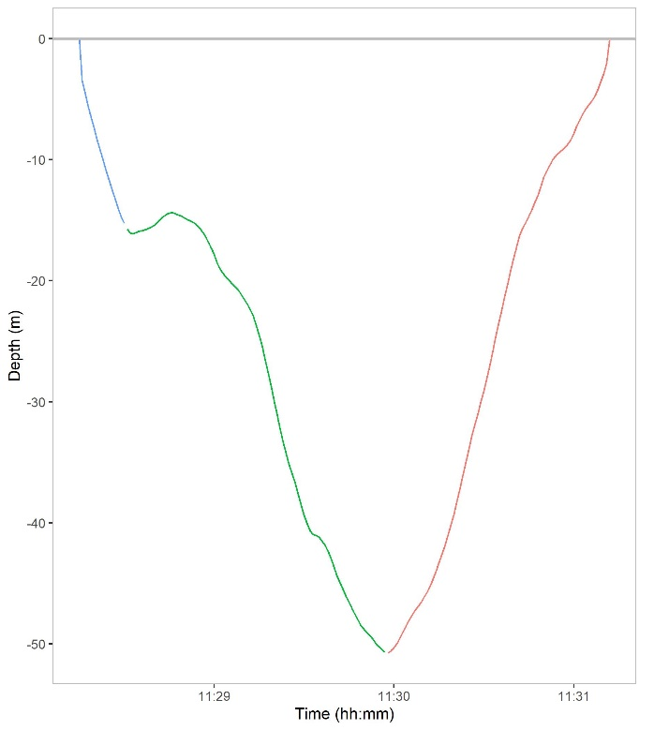
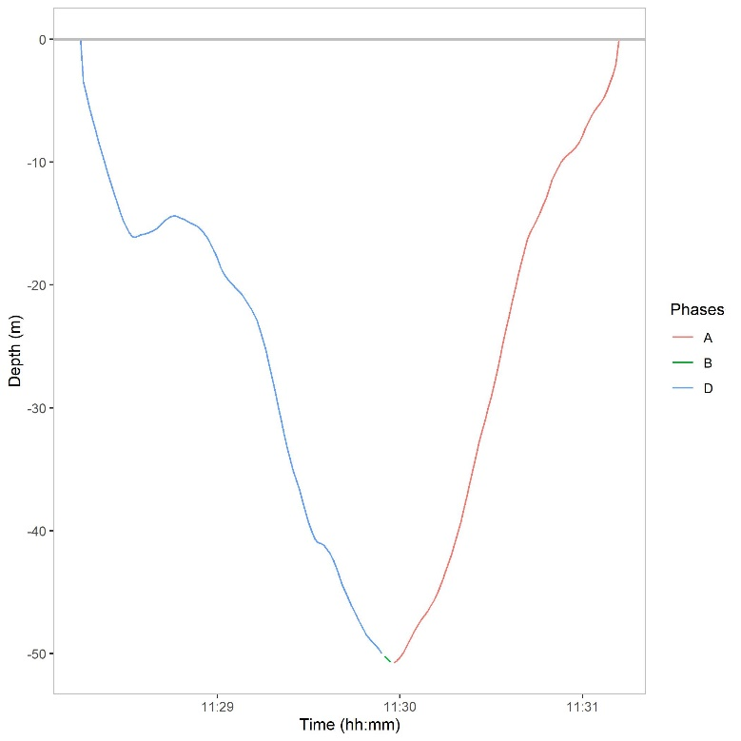

Supplementary Figure S2: An example of each dive shape (A=Ascent, B=Bottom, D=Descent) repeatedly found in the dive profiles of tagged whales: (A) V-shaped, (B) square, (C) dives with vertical excursions at depth and (D) square-root.
B)
A)
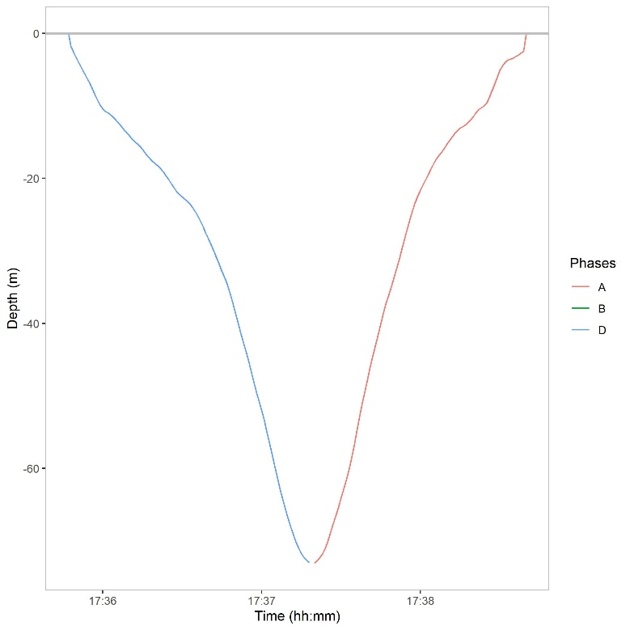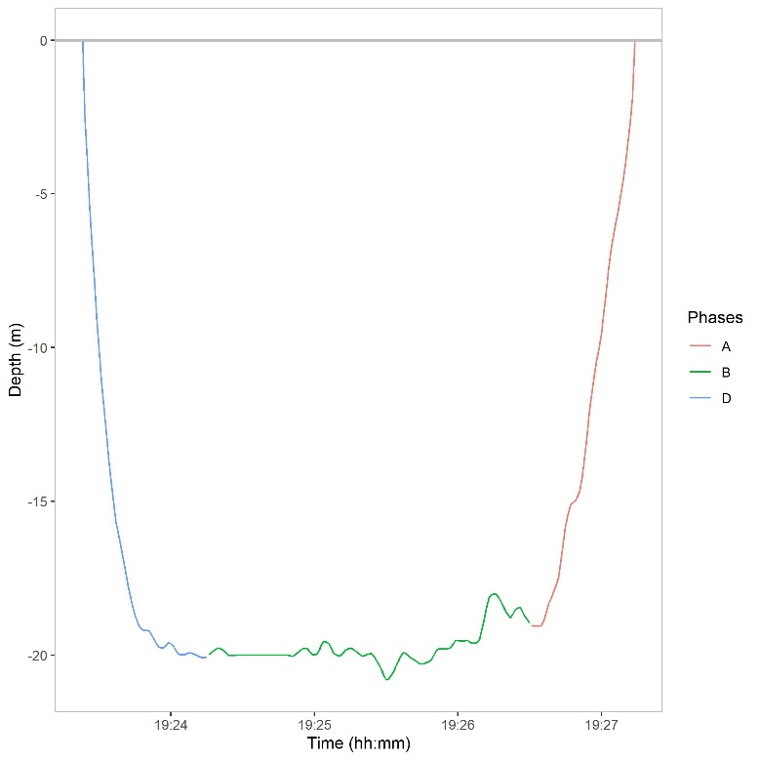

D)
C)
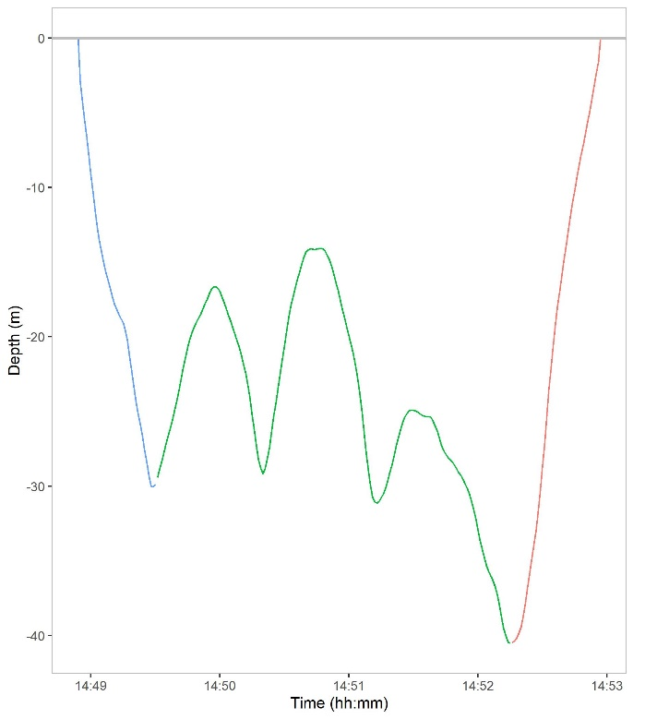
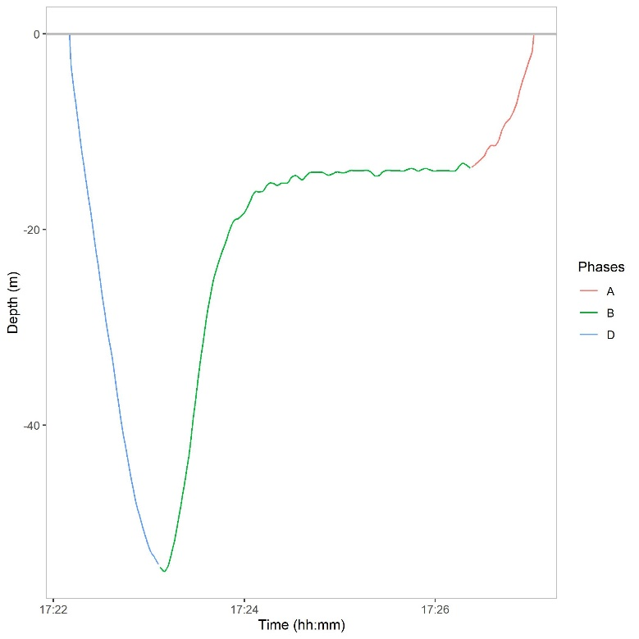

Supplementary Figure S3: Hourly median values (line), 25 and 75% quartiles (box) and standard errors (whiskers) of maximum dive depth.
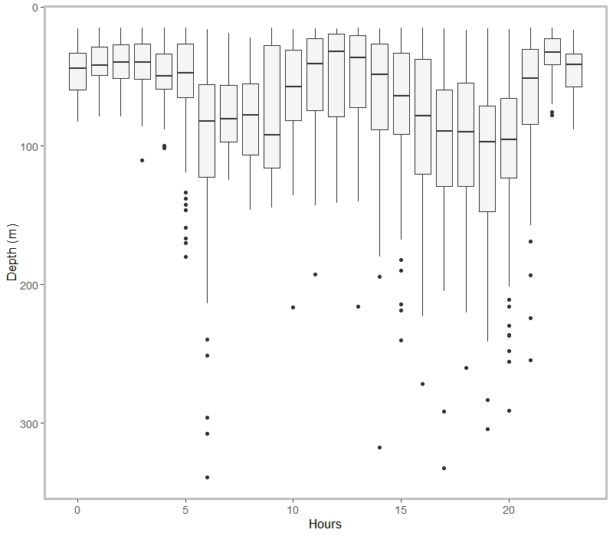

Supplementary Figure S4: Median values (line), 25 and 75% quartiles (box) and standard errors (whiskers) of the number of dives of each type performed by whales in both diel periods (day and night).
