Supplemental Materials
Table S1. Breeding season tracking effort and colony size for 43 tracking datasets (see Tables 1 and 2 for site locations and species names). Number of locations excludes positions obtained at the colony (see methods). Colony sizes reported are the most recent estimates available from the Canadian Wildlife Service (CWS) database or other sources. Years: "-" between years indicates continuous tracking of individuals across multiple years, whereas "/" indicates new deployments each year. Tag type: ptt = platform terminal transmitter (a.k.a. satellite tag), vhf = very high frequency radio transmitter, gps = global positioning system, gps.ptt = satellite-linked gps tag, gls = global location sensing.
 |  |  | Tracking effort |  |  |  |  |  | Colony size
Species group | Species | Site | Years | Tag type | Birds (n) | Bird tracking days (n) | No. of locations (n) |  | No. breeding pairs | Survey year | Colony data source
Seaducks | COEI | Bird | 2014 | ptt | 9 | 173 | 804 |  | 75 | 2013 | CWS database
 | COEI | West Brother | 2014 | ptt | 3 | 35 | 86 |  | 27 | 2013 | CWS database
 | COEI | Metinic | 2012 | ptt | 4 | 60 | 122 |  | 150 | 2015 | B. Allan, pers. comm.
 | COEI | Flag | 2010 | ptt | 4 | 37 | 86 |  | 250 | 2016 | B. Allan, pers. comm.
Terns | ROST | Country | 2003/2004 | vhf | 8 | 23 | 28 |  | 27 | 2011 | CWS database
 | ROST | North Brother | 2016 | gps | 7 | 46 | 1,136 |  | 50 | 2016 | CWS database
 | COTE | Country | 2003/2004 | vhf | 14 | 35 | 41 |  | 731 | 2011 | CWS database
 | COTE | Machias Seal | 2005 | vhf | 14 | 23 | 27 |  | 660 | 2000 | CWS database
 | ARTE | Country | 2003/2004 | vhf | 13 | 27 | 30 |  | 1,017 | 2016 | CWS database
 | ARTE | Machias Seal | 2005 | vhf | 12 | 26 | 28 |  | 2000 | 1998 | CWS database
Gulls | GBBG | Devil's | 2016 | gps | 3 | 29 | 464 |  | 154 | 2013 | CWS database
 | GBBG | Sable | 2013-2016 | gps/ptt | 9 | 372 | 1,733 |  | 472 | 2012 | Ronconi et al. 2016
 | HERG | Gull | 2015-2016 | gps | 8 | 853 | 45,555 |  | 1,608 | 2011 | Bond et al. 2016
 | HERG | Kent | 2015-2016 | gps | 13 | 1,023 | 40,566 |  | 5,900 | 2001 | Ronconi & Wong 2003
 | HERG | Brier | 2014-2016 | gps | 16 | 1,325 | 45,792 |  | 2,400 | 2013 | CWS database
 | HERG | Sable | 2012-2016 | gps.ptt | 8 | 958 | 13,276 |  | 951 | 2012 | Ronconi et al. 2016
 | BLKI | Gull | 2016 | gps | 8 | 150 | 9,422 |  | 6,450 | 2015 | CWS database
Auks | BLGU | Country | 2015/2016 | gps | 5 | 17 | 503 |  | *579 | 2012 | CWS database
 | BLGU | Kent | 2016 | gps | 2 | 7 | 128 |  | *256 | 2001 | Ronconi & Wong 2003
 | RAZO | Gannet | 2015 | gps | 6 | 22 | 3,154 |  | 14,300 | 2007 | CWS database
 | RAZO | Bicquette | 2015/2016 | gps | 11 | 139 | 4,860 |  | 84 | 2016 | J.-F. Rail, pers. comm.
 | RAZO | Gros Pot | 2016 | gps | 3 | 27 | 418 |  | **1315 | 2011 | J.-F. Rail, pers. comm.
 | RAZO | Gros Pelerin | 2015/2016 | gps | 20 | 144 | 7,646 |  | **358 | 2006 | J.-F. Rail, pers. comm.
 | RAZO | Machias Seal | 2014/2015 | gps | 12 | 58 | 1,498 |  | 3,290 | 2015 | CWS database
 | ATPU | Gannet | 2015 | gps | 3 | 10 | 2,044 |  | 34,600 | 1999 | CWS database
 | ATPU | Gull | 2016 | gps | 11 | 41 | 3,934 |  | 118,400 | 2012 | CWS database
 | ATPU | Machias Seal | 2014/2015 | gps | 12 | 40 | 1,124 |  | 7,838 | 2011 | CWS database
 | TBMU | Gannet | 2015 | gps | 9 | 35 | 3,320 |  | 1,480 | 2007 | CWS database
 | COMU | Gannet | 2015 | gps | 6 | 21 | 2,384 |  | 17,600 | 2007 | CWS database
 | COMU | Funk | 2014 | gps | 9 | 41 | 20,082 |  | 472,000 | 2009 | Wilhelm et al. 2015
 | COMU | Cabot | 2016 | gps | 6 | 35 | 7,985 |  | 9,900 | 2009 | CWS database
 | COMU | Gull | 2010/2011 | gps | 10 | 22 | 5,104 |  | 9,900 | 2012 | CWS database
Gannet | NOGA | Funk | 2003/2005 | gps | 26 | 56 | 32,741 |  | 10,150 | 2013 | CWS database
 | NOGA | Bonaventure | 2003/2014 | gps | 46 | 1,023 | 124,294 |  | 59,600 | 2009 | Rail et al. 2013
 | NOGA | Baccalieu | 2009 | gps | 6 | 19 | 5,936 |  | 3,092 | 2013 | CWS database
Storm- | LESP | Baccalieu | 2013/2014 | gls | 19 | 186 | 284 |  | 2,023,000 | 2013 | CWS database
petrels | LESP | Gull | 2013/2014 | gls | 23 | 294 | 427 |  | 180,000 | 2006 | Hedd et al. in press
 | LESP | Middle Lawn | 2014/2015 | gls | 19 | 237 | 381 |  | 8,773 | 2006 | CWS database
 | LESP | Grand Colombier | 2015 | gls | 2 | 31 | 54 |  | 384,000 | 2008 | CWS database
 | LESP | Country | 2012/2013 | gls | 16 | 197 | 348 |  | 11,990 | 2013 | CWS database
 | LESP | Bird | 2013 | gls | 10 | 183 | 327 |  | 1,000 | 2013 | Hedd et al. 2018
 | LESP | Kent | 2013/2014 | gls | 32 | 462 | 916 |  | 25,000 | 2001 | Hedd et al. 2018
 | LESP | Bon Portage | 2012/2013/2014/2015 | gls | 43 | 749 | 1,373 |  | 50,000 | 2001 | Oxley 1999
Totals | 14 | 23 | 2009 thru 2016 |  | 520 | 9,291 | 390,461
*number of individuals; **converted from individuals using multiplier of 0.75

References:
Rail, J.-F., L. Champoux, R. A., Lavoie and G. Chapdelaine (2013) Monitoring of the population and contamination of the Northern Gannet in Quebec, 1966–2009. Technical Report Series No. 528. Canadian Wildlife Service, Quebec Region, Environment Canada, ix +75 pages + appendices.
Oxley J.R. (1999) Nesting distribution and abundance of Leach’s Storm-petrel (Oceanodroma leucorhoa) on Bon Portage Island, Nova Scotia. MSc Thesis, Acadia University.
Hedd, A., I.L. Pollet, R.A. Mauck, C.M. Burke, M.L. Mallory, L.A. McFarlane Tranquilla, W.A. Montevecchi, G.J. Robertson, R.A. Ronconi, D. Shutler, S.I. Wilhelm, N.M. Burgess (2018) Foraging areas, offshore habitat use, and colony overlap by incubating Leach’s storm-petrels Oceanodroma leucorhoa in the Northwest Atlantic. PLoS ONE 13(5): e0194389. https://doi.org/10.1371/journal.pone.0194389
Ronconi, R.A., J.R. Stephens, Z.J. Crysler, I.L Pollet, D.T. Fife, A.G. Horn, P.D. Taylor (2016) Distribution, abundance and trends of gulls and terns breeding on Sable Island, Nova Scotia, Canada. Waterbirds, 39(Special Publication 1): 44-56.
Wilhelm, S.I., J.-F. Rail, P.M. Regular, C. Gjerdrum, G.J. Robertson (2016) Large-scale changes in abundance of breeding Herring Gulls (Larus argentatus) and Great Black-backed Gulls (Larus marinus) relative to reduced fishing activities in Southeastern Canada. Waterbirds 39(Special Publication 1): 136-142.
Bond, A.L., S.I. Wilhelm, G.J. Robertson, S. Avery-Gomm (2016) Differential declines among nesting habitats of breeding Herring Gulls (Larus argentatus) and Great Black-backed Gulls (Larus marinus) in Witless Bay, Newfoundland and Labrador, Canada. Waterbirds 39(Special Publication 1): 143-151.
Ronconi, R.A. & S.N.P. Wong (2003) Estimates of changes in seabird numbers in the Grand Manan Archipelago, New Brunswick, Canada. Waterbirds 26: 462-472.

Figures S1. Smoothed density estimates of telemetry locations with respect to distance from nest (upper panels) and distance to shoreline (lower panels) for seabird species tracked in Atlantic Canada (see Figure 4 of main text for Atlantic puffin and herring gull). Density estimates are scaled from 0 to 1 for each study colony, whereby 1 is the distance at which the highest density of locations occurs. Dashed vertical lines show 99th percentile of distance measurements (Table 3).

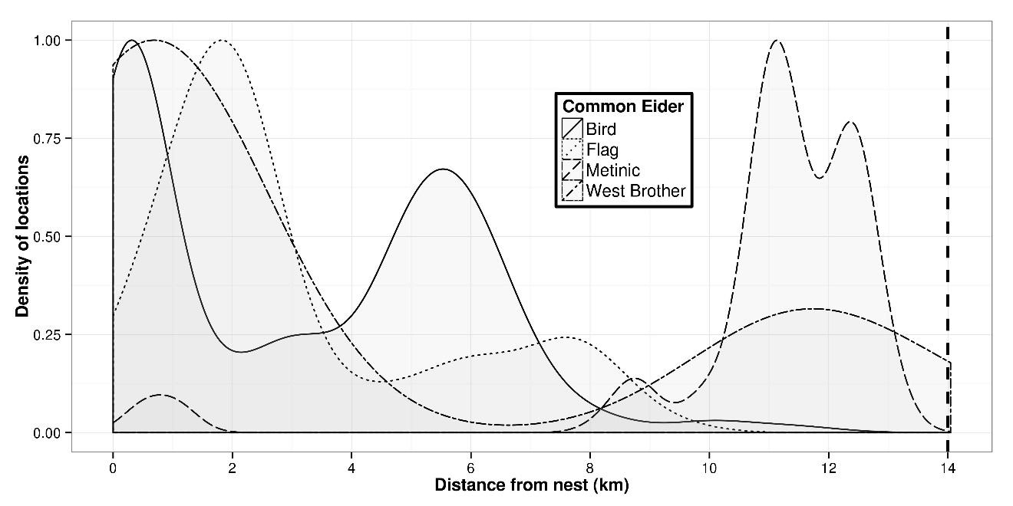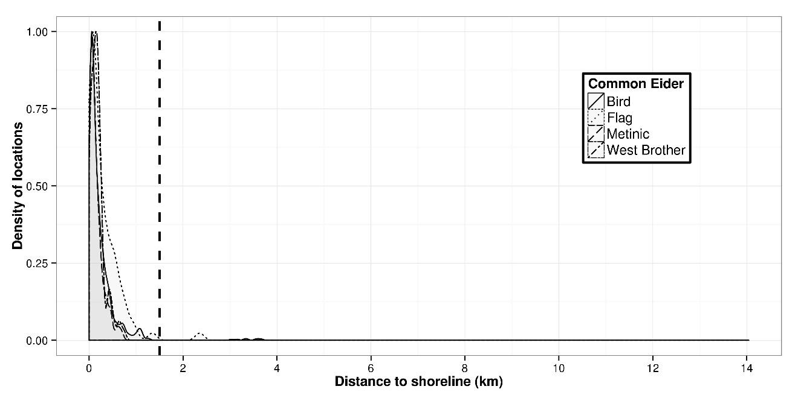

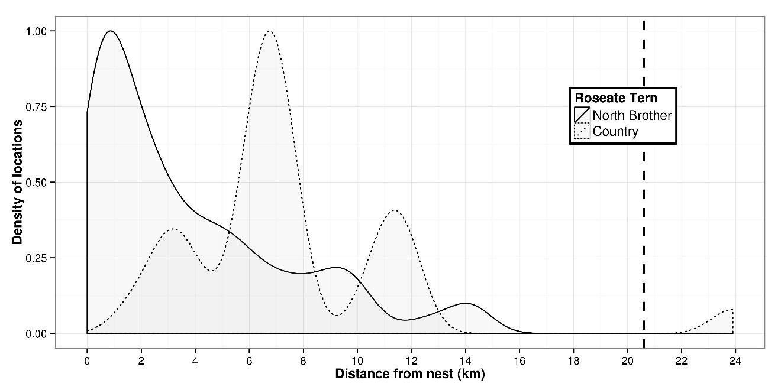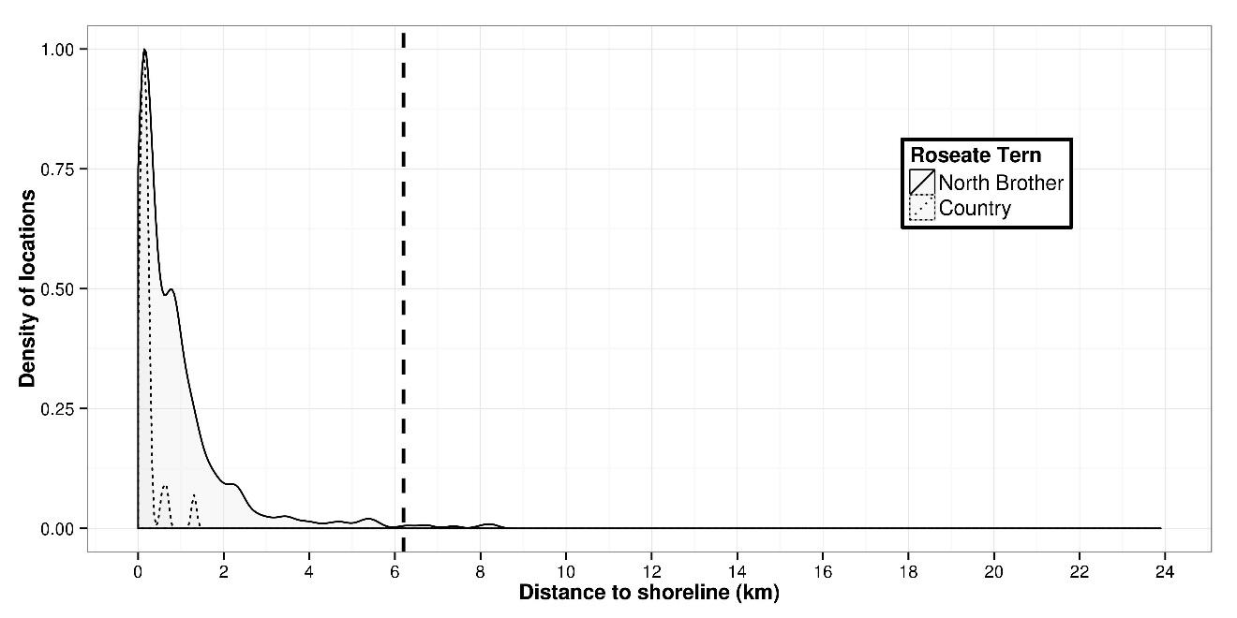

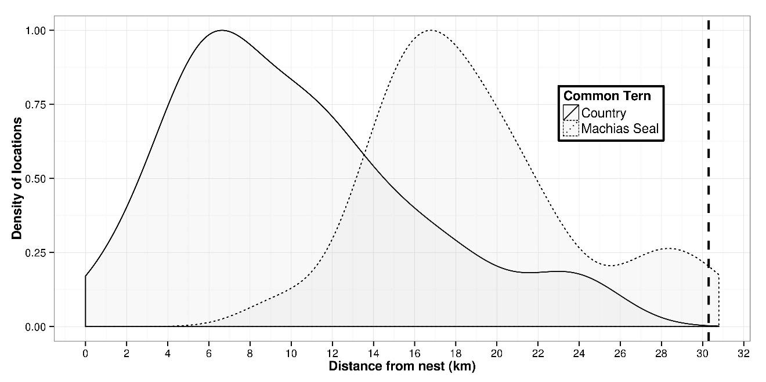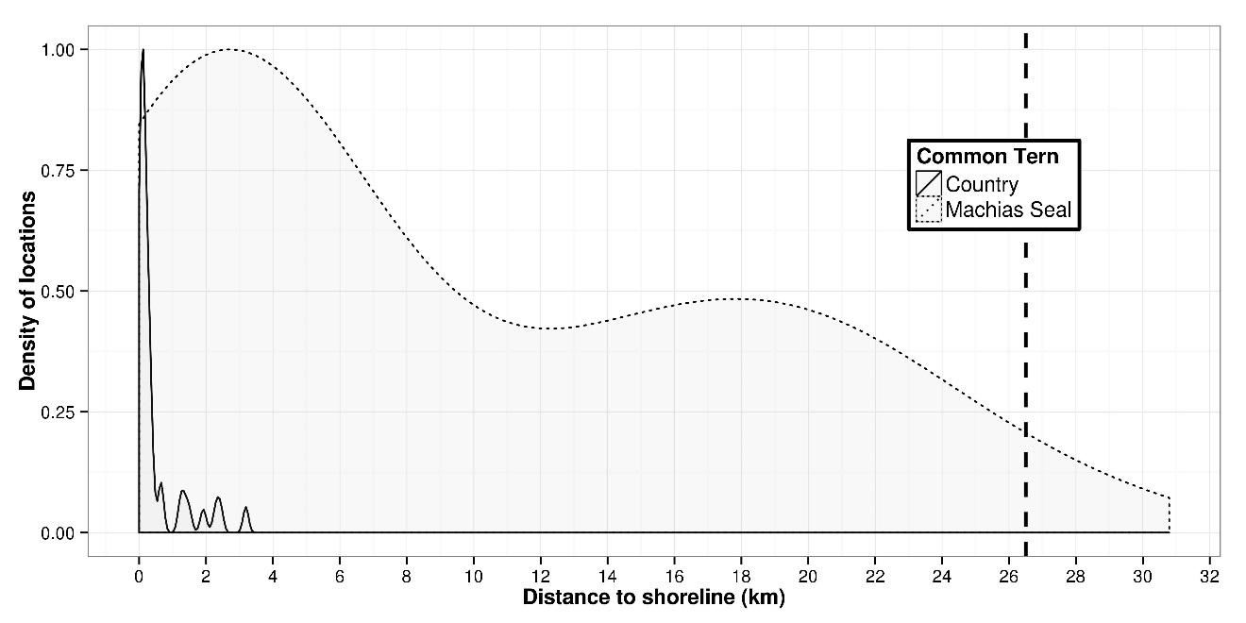
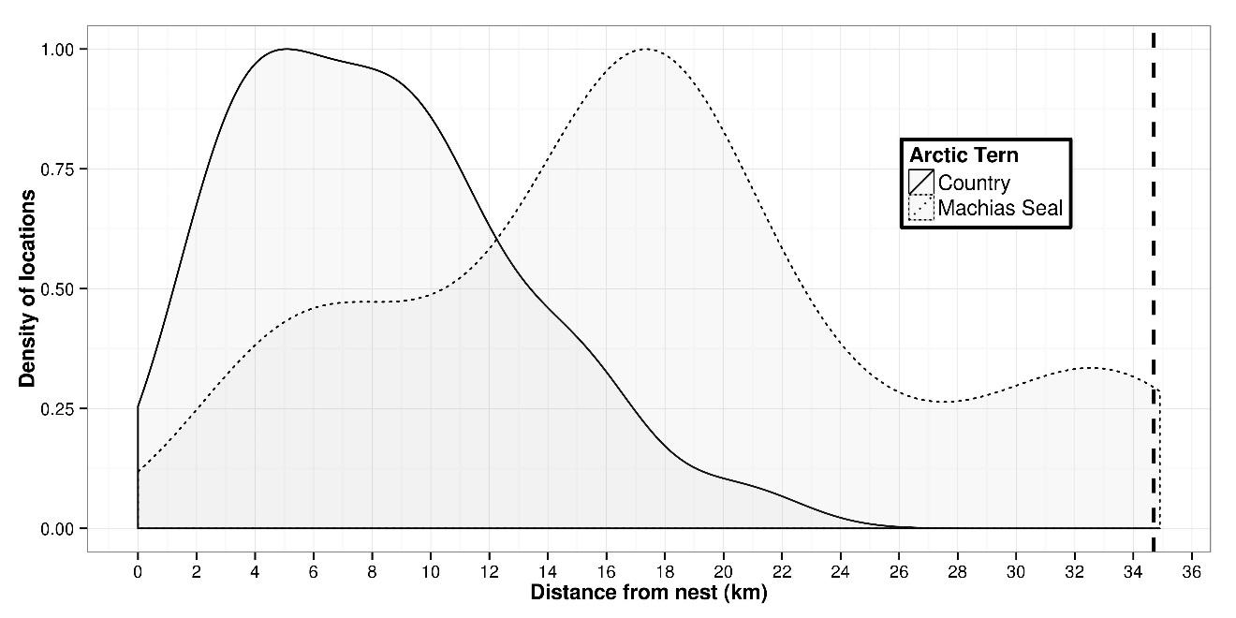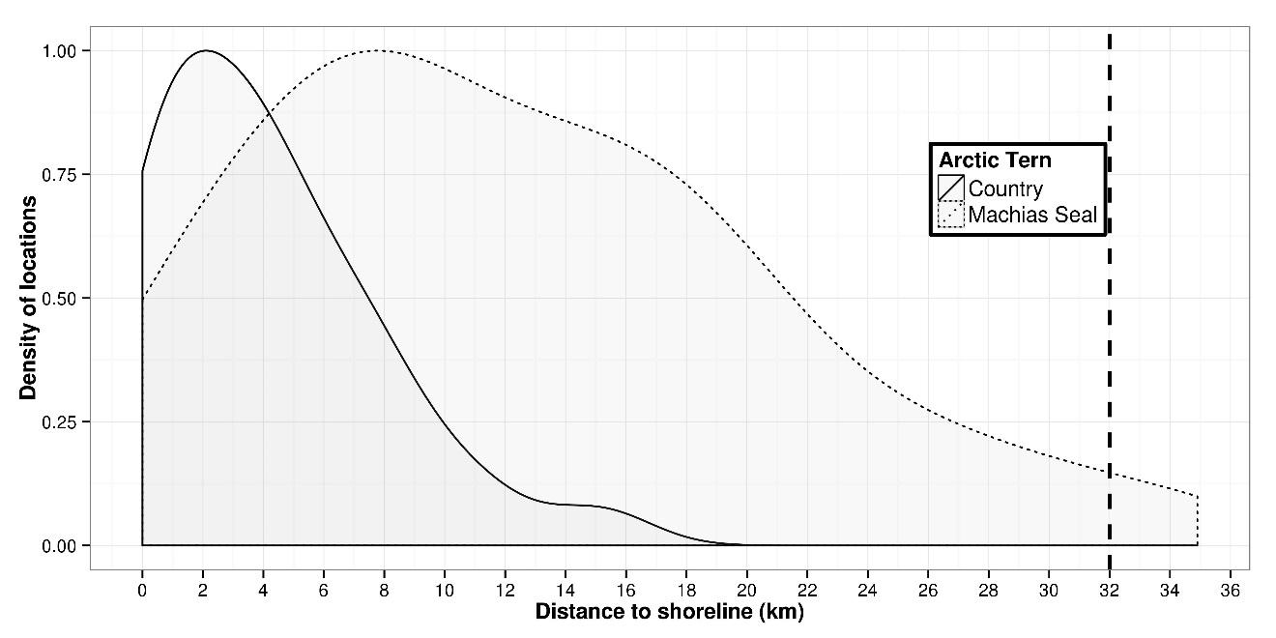

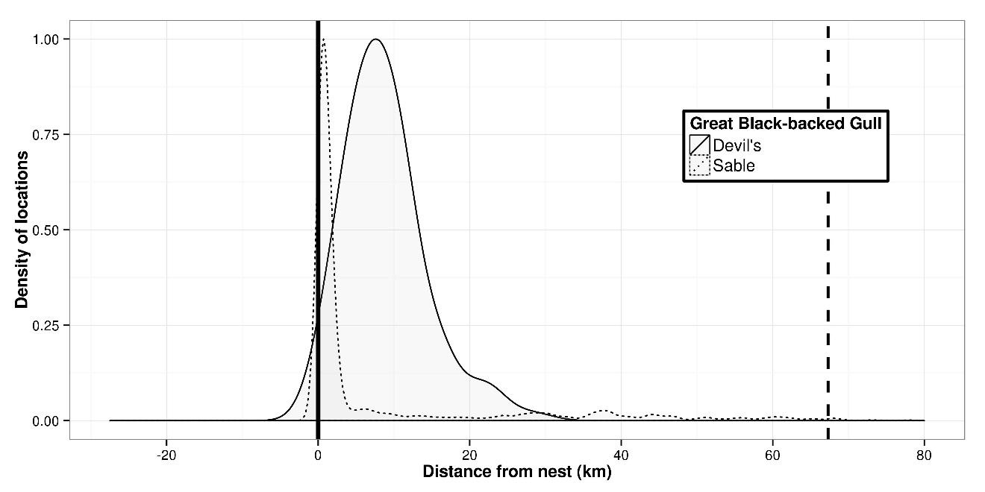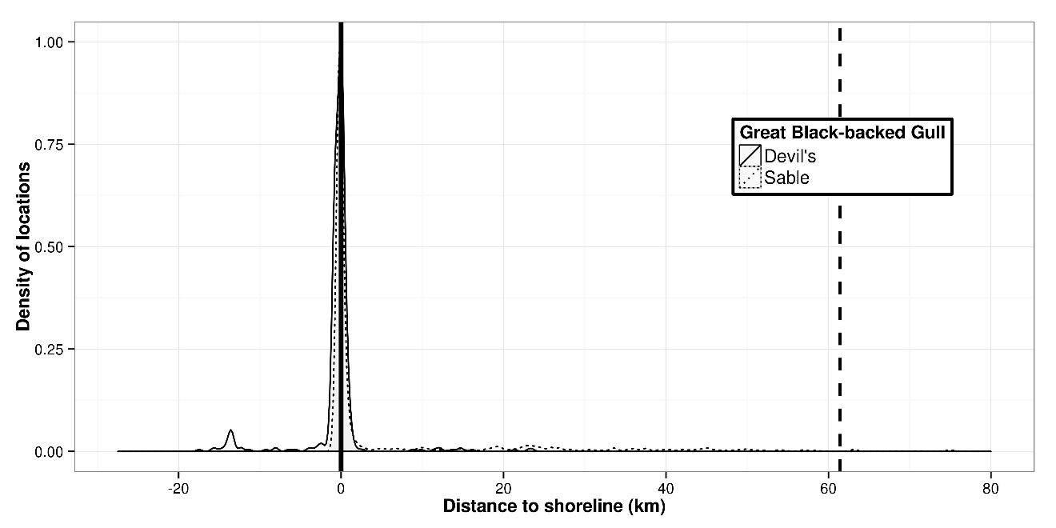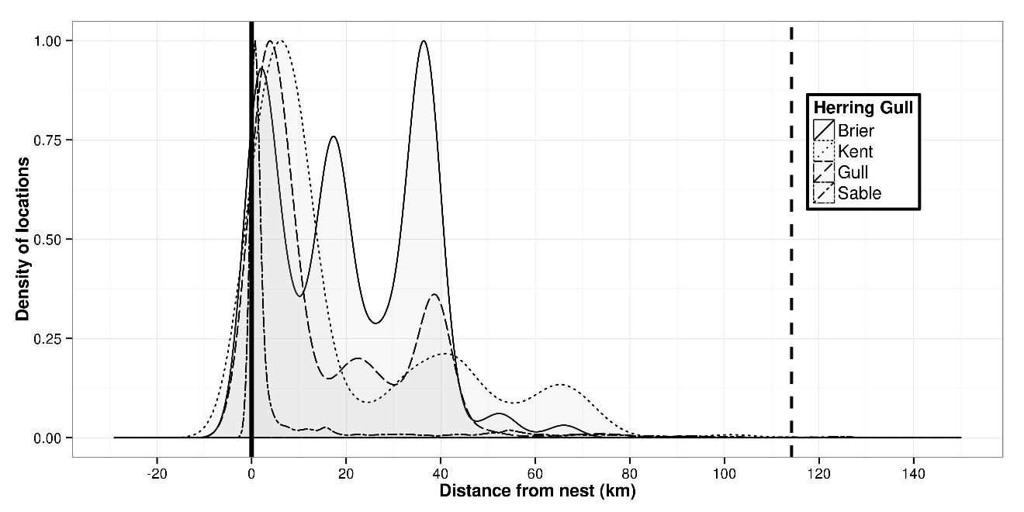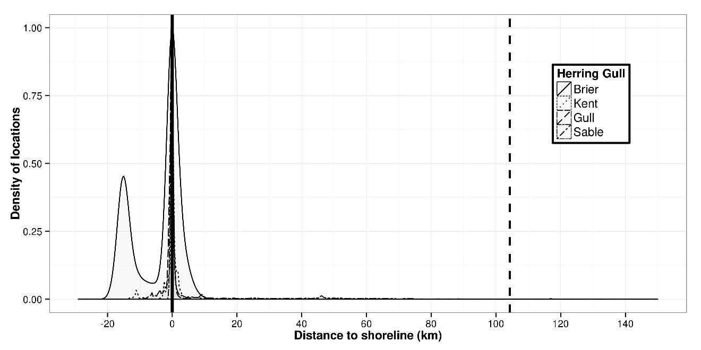
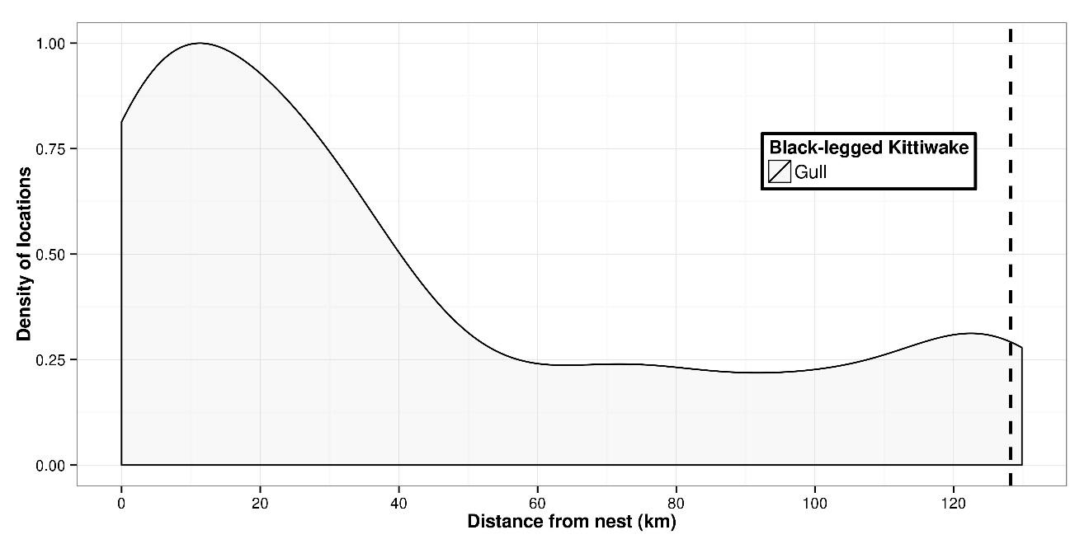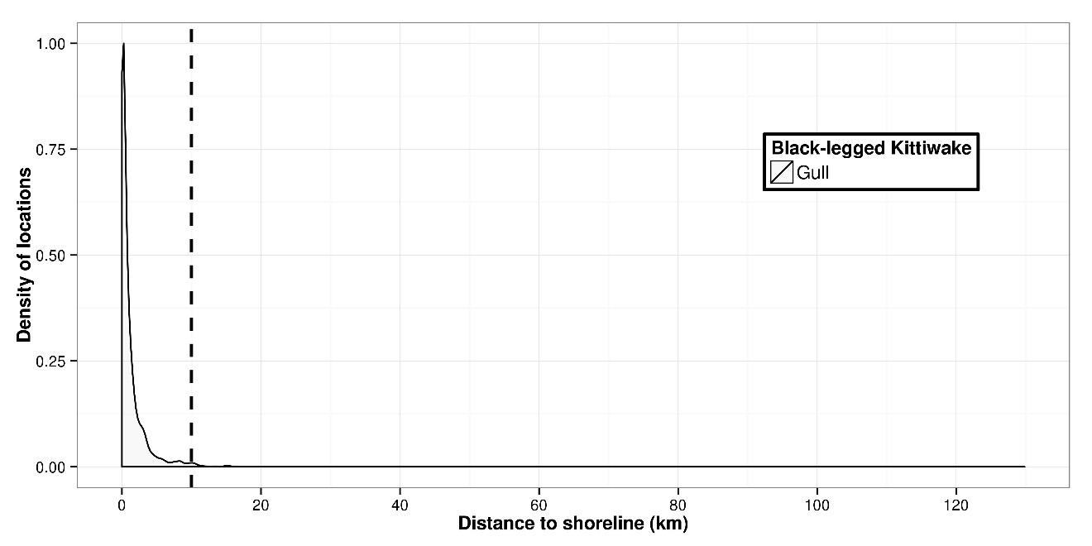
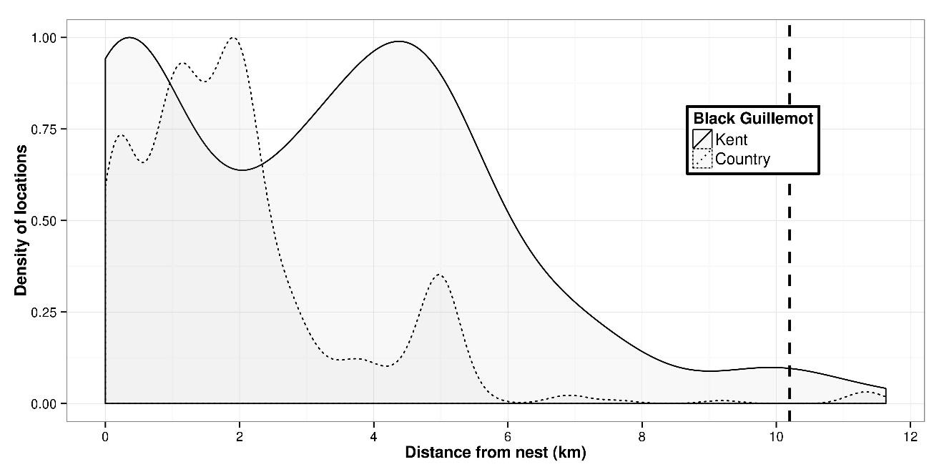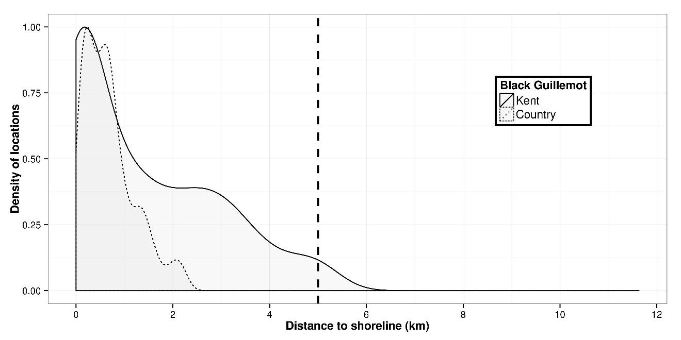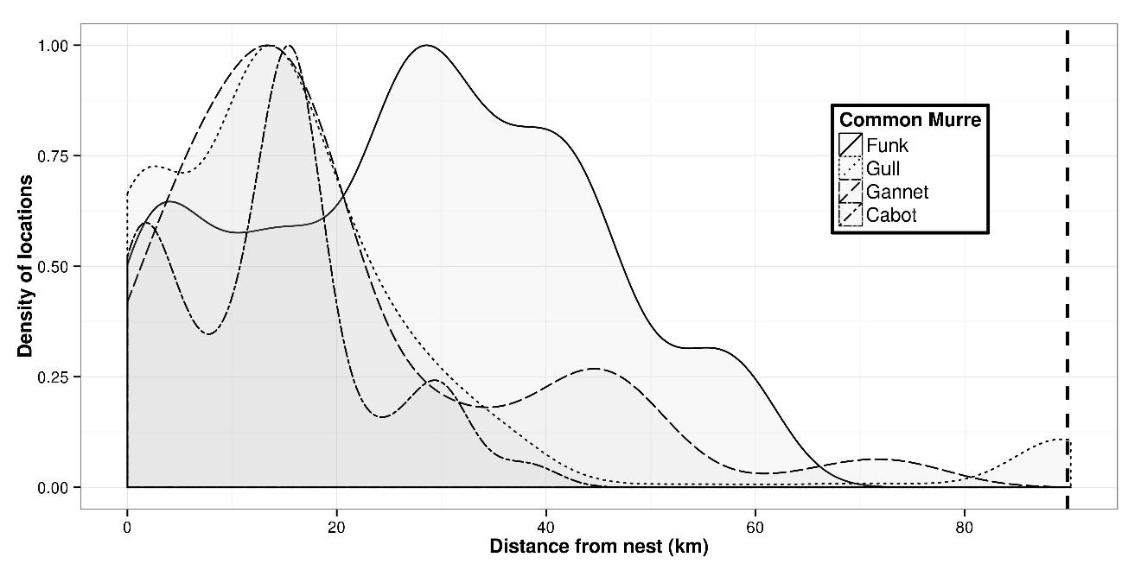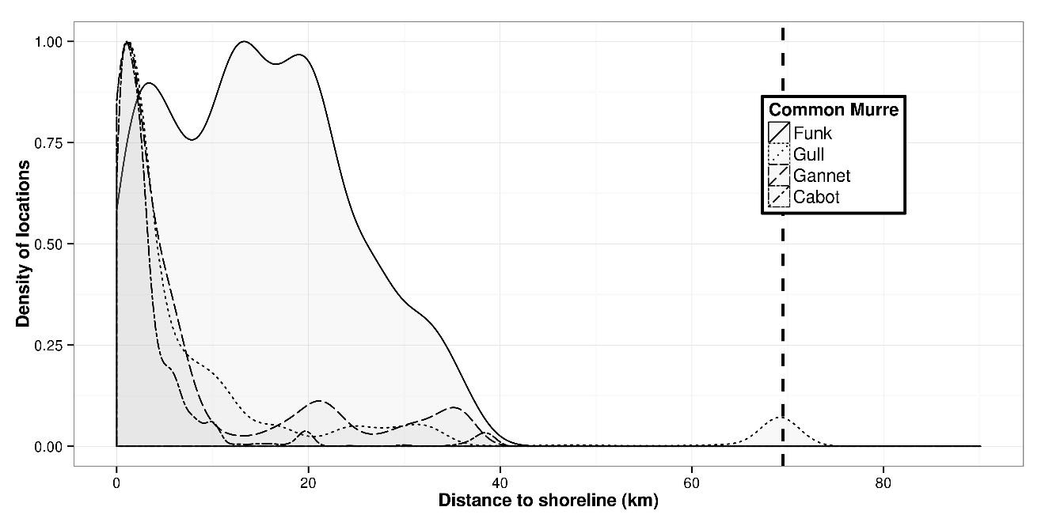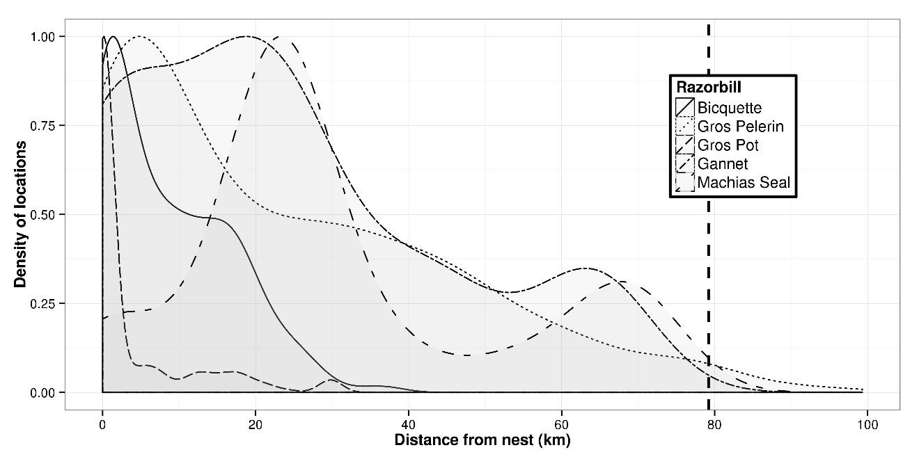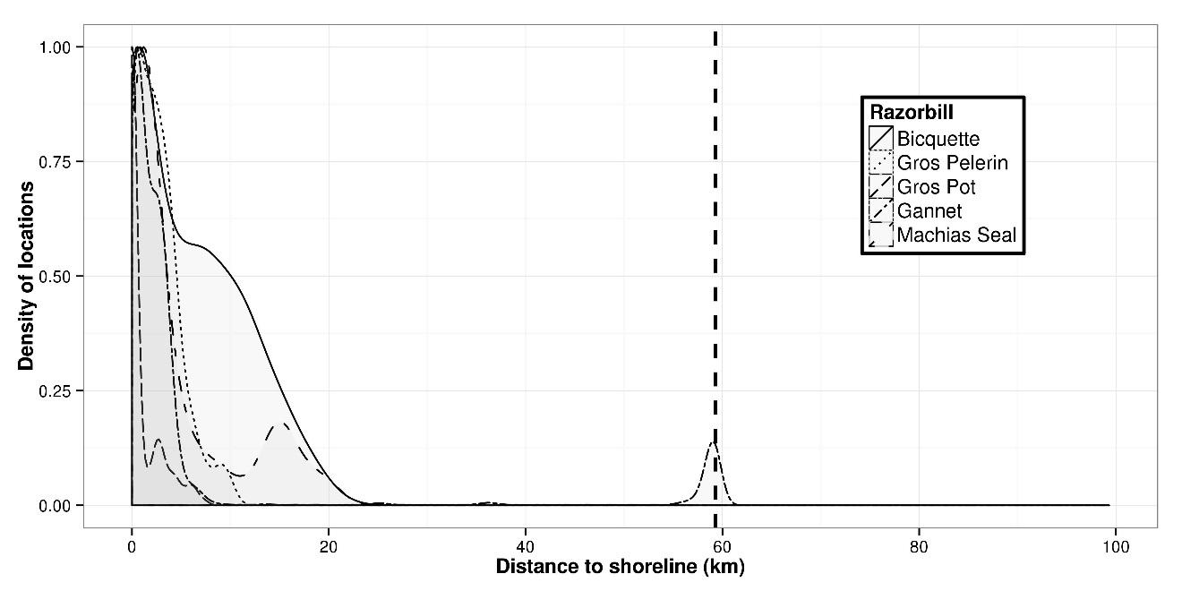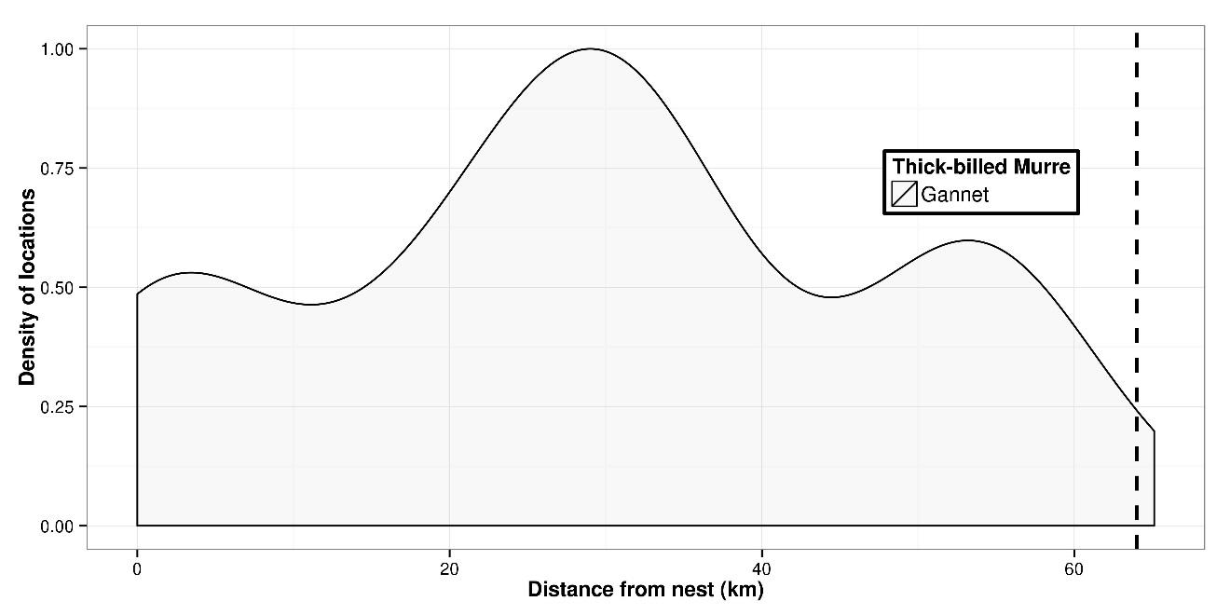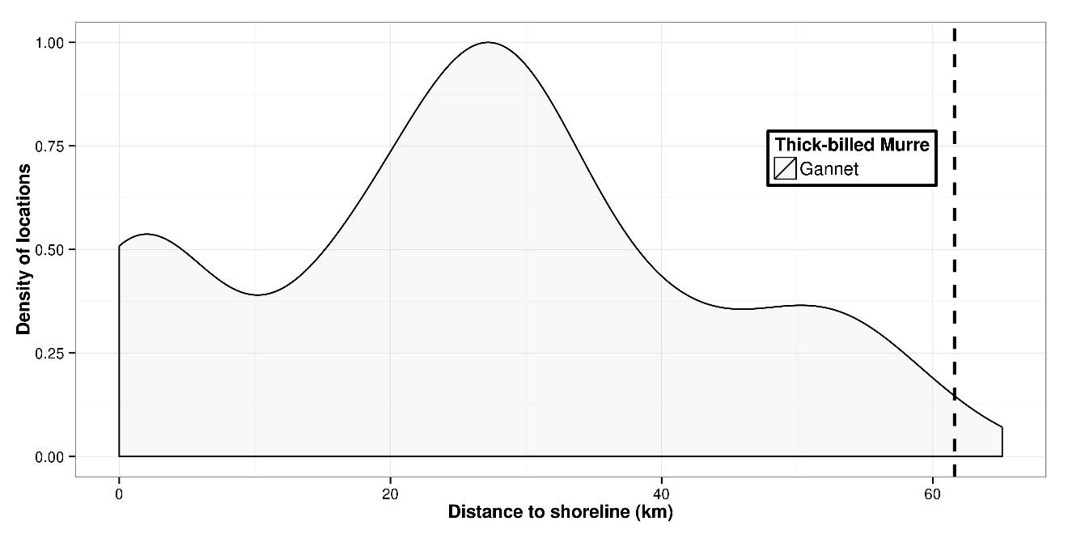
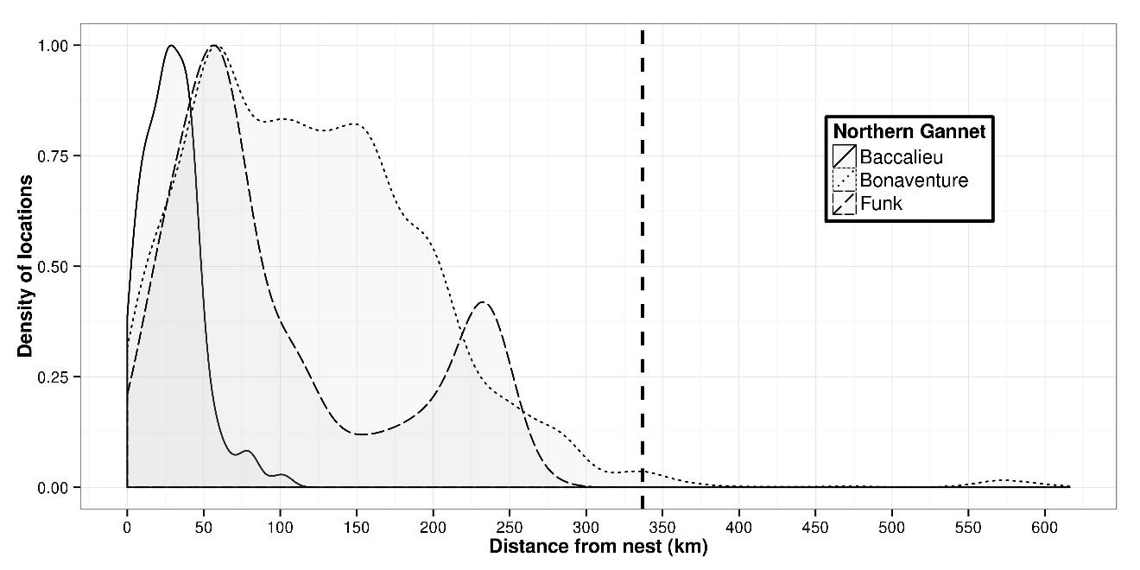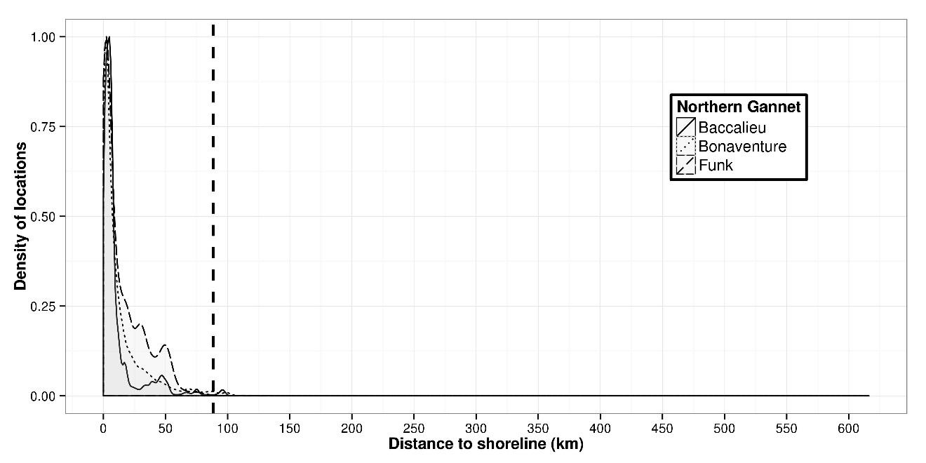
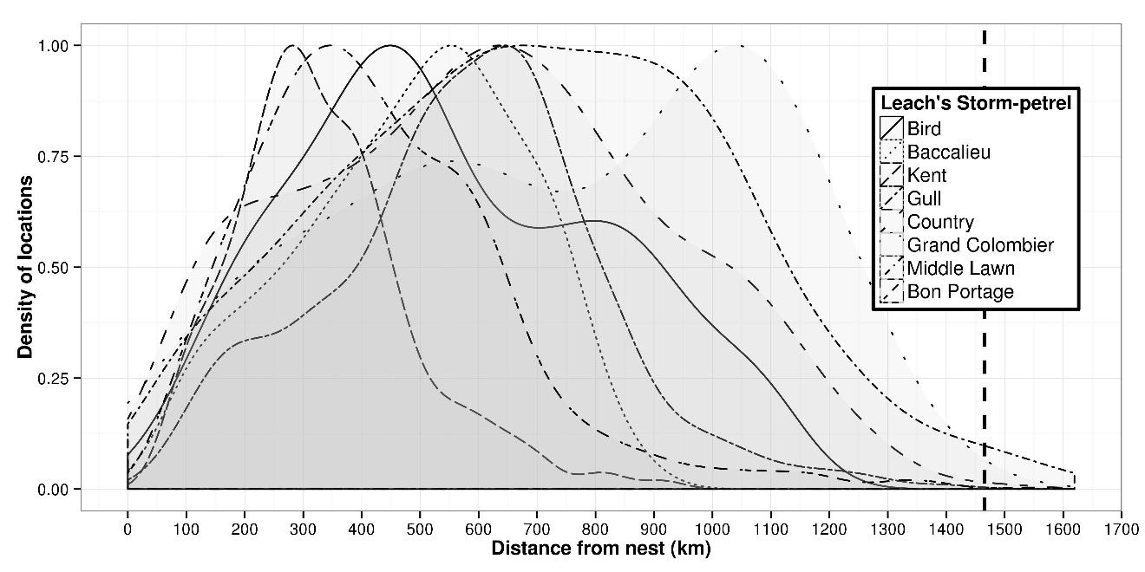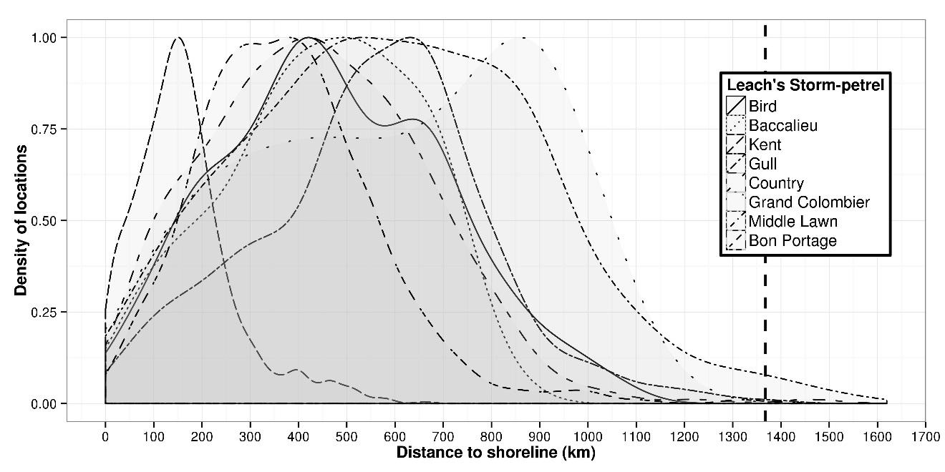

Figures S2. Predictive models of the region-wide distribution of seabird abundance around breeding colonies for Atlantic puffin (e), black-legged kittiwake (f), common eider (g), great black-backed gull (h), Leach’s storm-petrel (i), razorbill (j), roseate tern (k), thick-billed murre (l), and common and arctic tern (m). Boosted regression trees (BRTs) were used to model the relative density of tracking locations. BRT models were then used to predict abundance distribution, using maximum colony size (based on census data gathered between 1996 and 2016) for each colony, and a kernel smoother applied to estimate abundance distribution region-wide.
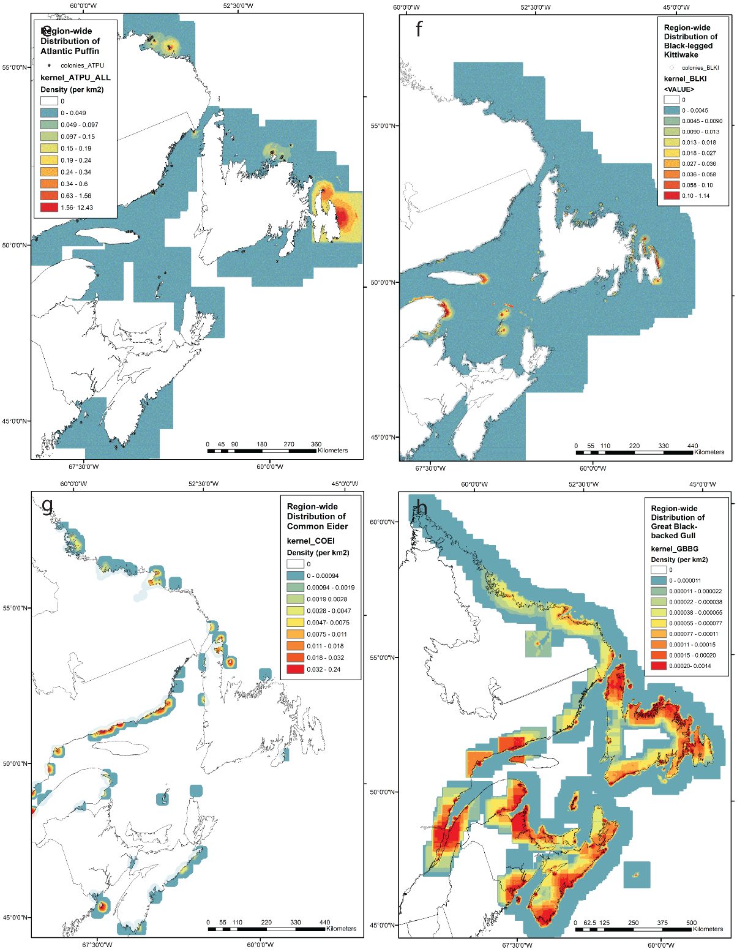

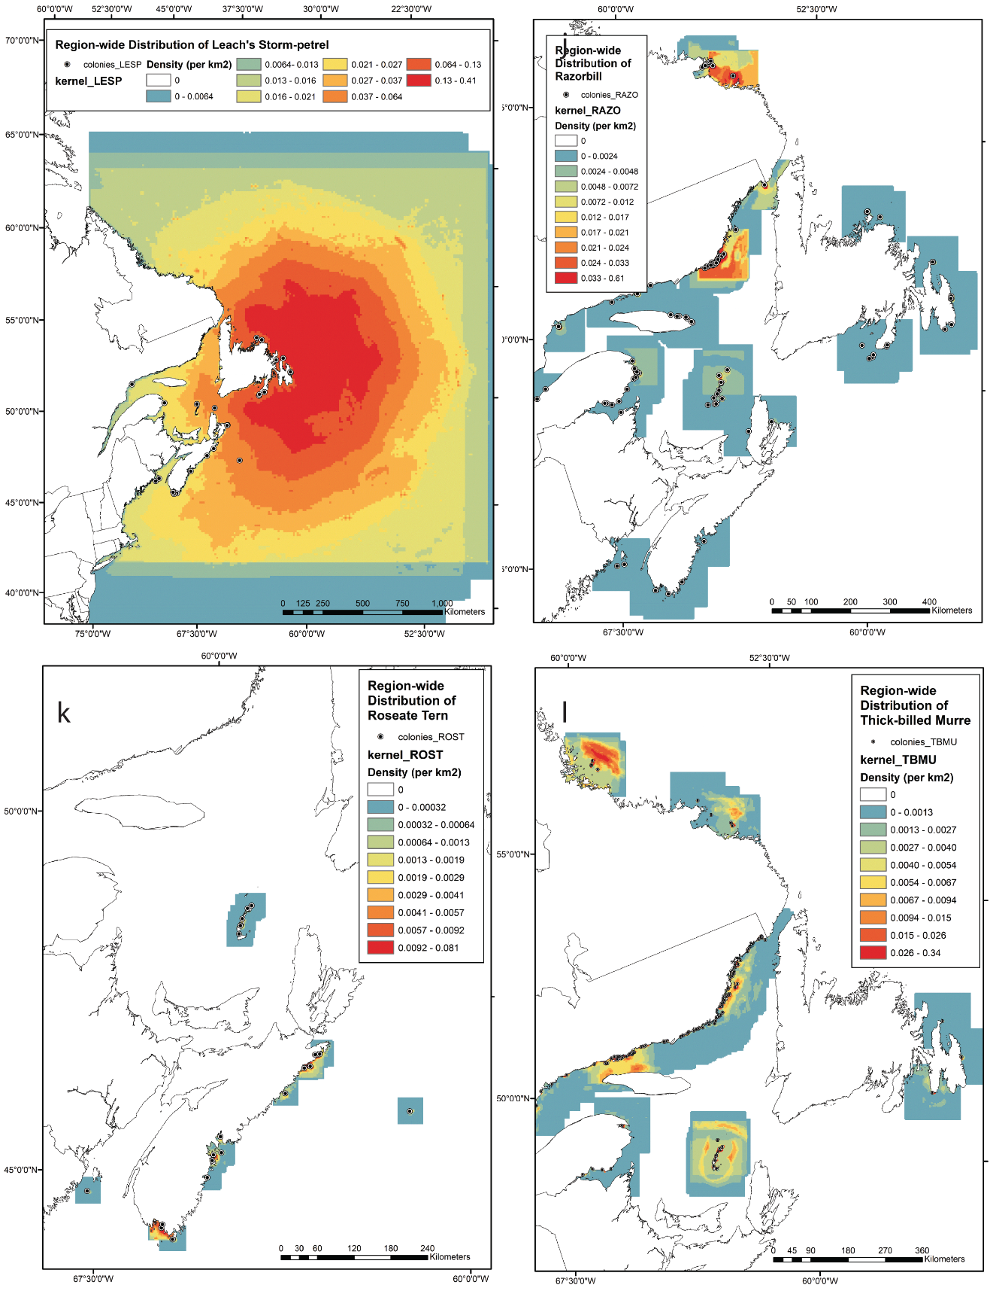
Figure S2 (cont’d).

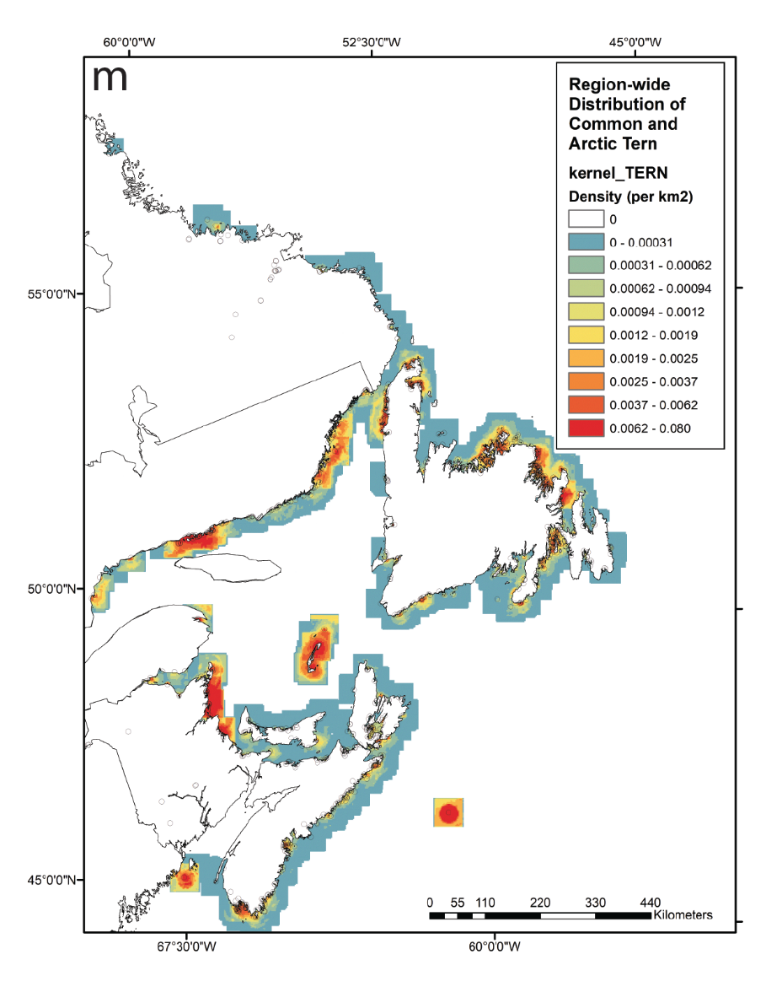

Figure S2 (cont’d).

