Supplementary materials for “An open workflow to gain insights about low-likelihood high impact weather events from initialised predictions”

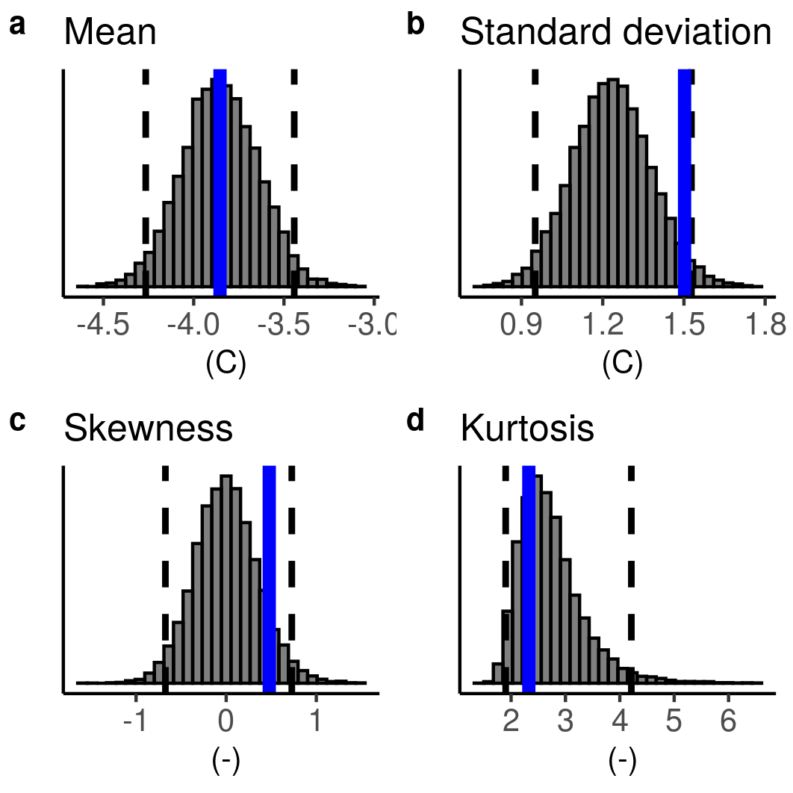
Supplementary Figure 1: The outcome of the fidelity test after applying a mean bias adjustment for the Siberia case study. As in Figure 8 e-h, the distribution characteristics of SEAS5 March-May temperature hindcasts over Siberia are compared with ERA5.

