Supplementary Material

Climate-Change Refugia for the Bubblegum Coral Paragorgia arborea in the Northwest Atlantic

S. Wang^{1†}, F.J. Murillo^{1†}, E. Kenchington^{1*}
¹Bedford Institute of Oceanography, Department of Fisheries and Oceans, Ocean Ecology Section, Dartmouth, Nova Scotia, Canada
† These authors share first authorship
* Correspondence:
Ellen Kenchington
Ellen.Kenchington@dfo-mpo.gc.ca

Contents
1 Supplementary Figures and Tables 2
1.1 Supplementary Figures 2
1.2 Supplementary Tables 26
2 Supplementary Text 36
2.1 Topographic Derivate Layers Used in Random Forest Species Distribution Models of Paragoria arborea 36
2.2 Comparison of Ocean Models for Particle Tracking Experiments 41
2.3 Assessment of the Impact of Response Curves in Regional vs. Basin-Scale Models Under Climate Change Projections 46

Supplementary Figures and Tables

Supplementary Figures
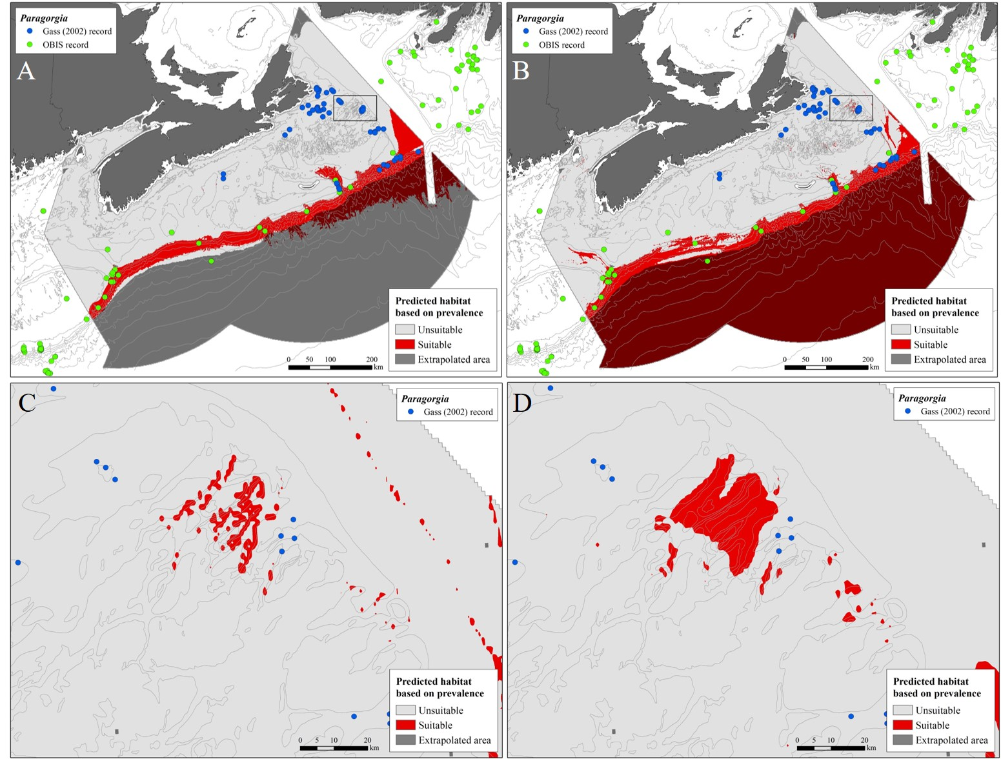

Supplementary Figure 1. Location of Paragorgia spp. records from Gass (2002) (blue) and OBIS (green) used to evaluate geographic transferability of the species distribution models (SDMs): A) Records shown against the predictions based on prevalence (0.036) from the present-day RF model constructed using the 8 environmental variables employed with climate projections; B) Records shown against predictions based on prevalence from the present-day GAM; C) Expanded view of the area delimited by the rectangle in B); D) Expanded view of the same area, shown against predictions based on prevalence (0.036) from the RF model using all 47 environmental predictors (Supplementary Figure 2). (Note: the combined shadings indicating extrapolated areas of predicted suitable habitat appear dark red).

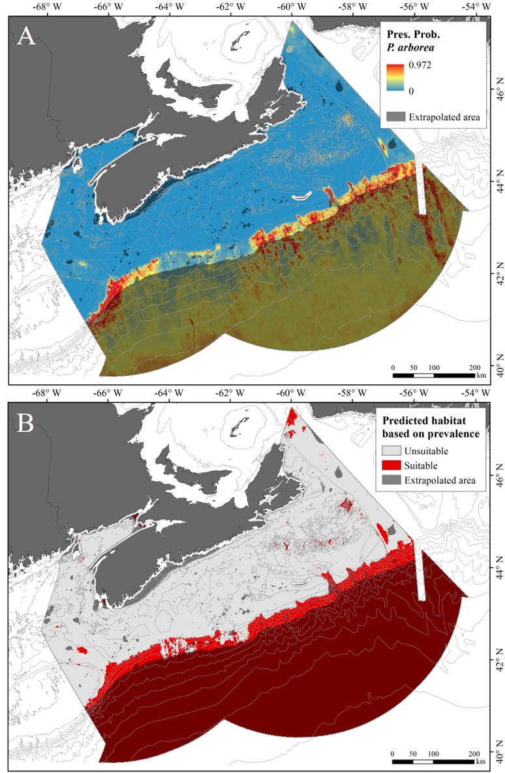
Supplementary Figure 2. A) Relative likelihood of occurrence of Paragorgia arborea under present-day conditions, based on RF model constructed using 47 environmental predictors; B) Predicted distribution of suitable and unsuitable habitat following a prevalence threshold of 0.036 (Note: the combined shadings indicating extrapolated areas of predicted suitable habitat appear dark red; extrapolated areas along the coast can be distinguished from the land by the white outline created by the 5km buffer zone around all land).
Importance
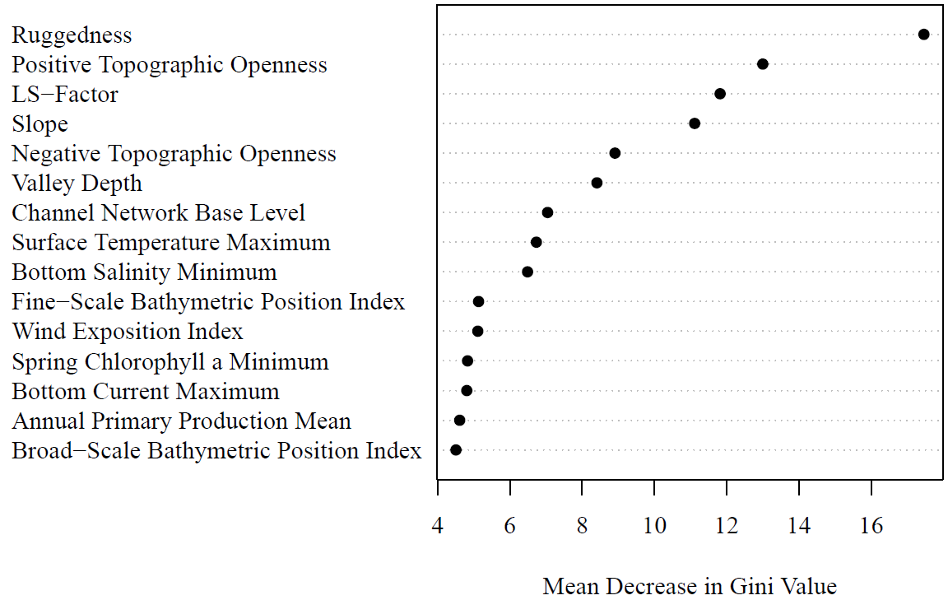
Supplementary Figure 3. Plot of mean decrease in Gini Value for the top 15 variables in the RF model constructed using the 47 environmental predictors under present-day conditions, indicating their relative importance.

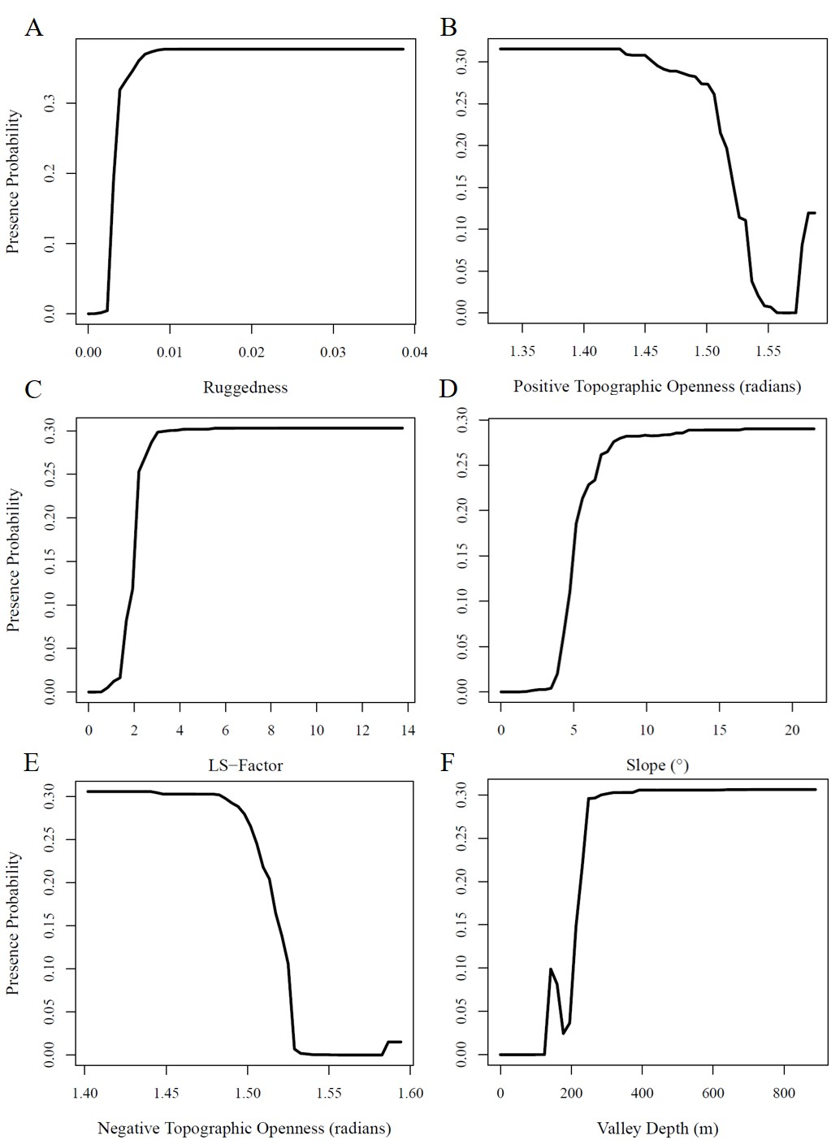
Supplementary Figure 4. Response curves showing the partial dependence of the probability of presence on the top 6 predictors (Supplementary Figure 3) identified in the RF model constructed using the 47 environmental predictors.

Importance
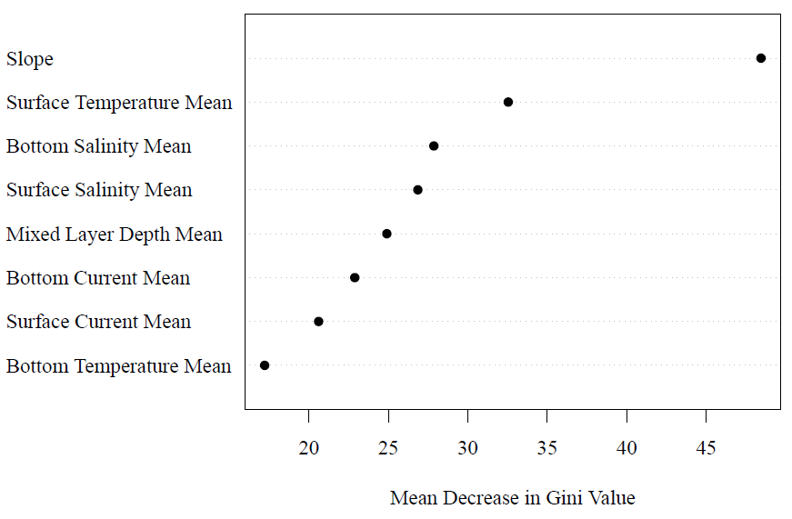
Supplementary Figure 5. Plot of mean decrease in Gini Value for the predictors in the RF model constructed using only these 8 variables under present-day conditions, indicating their relative importance.

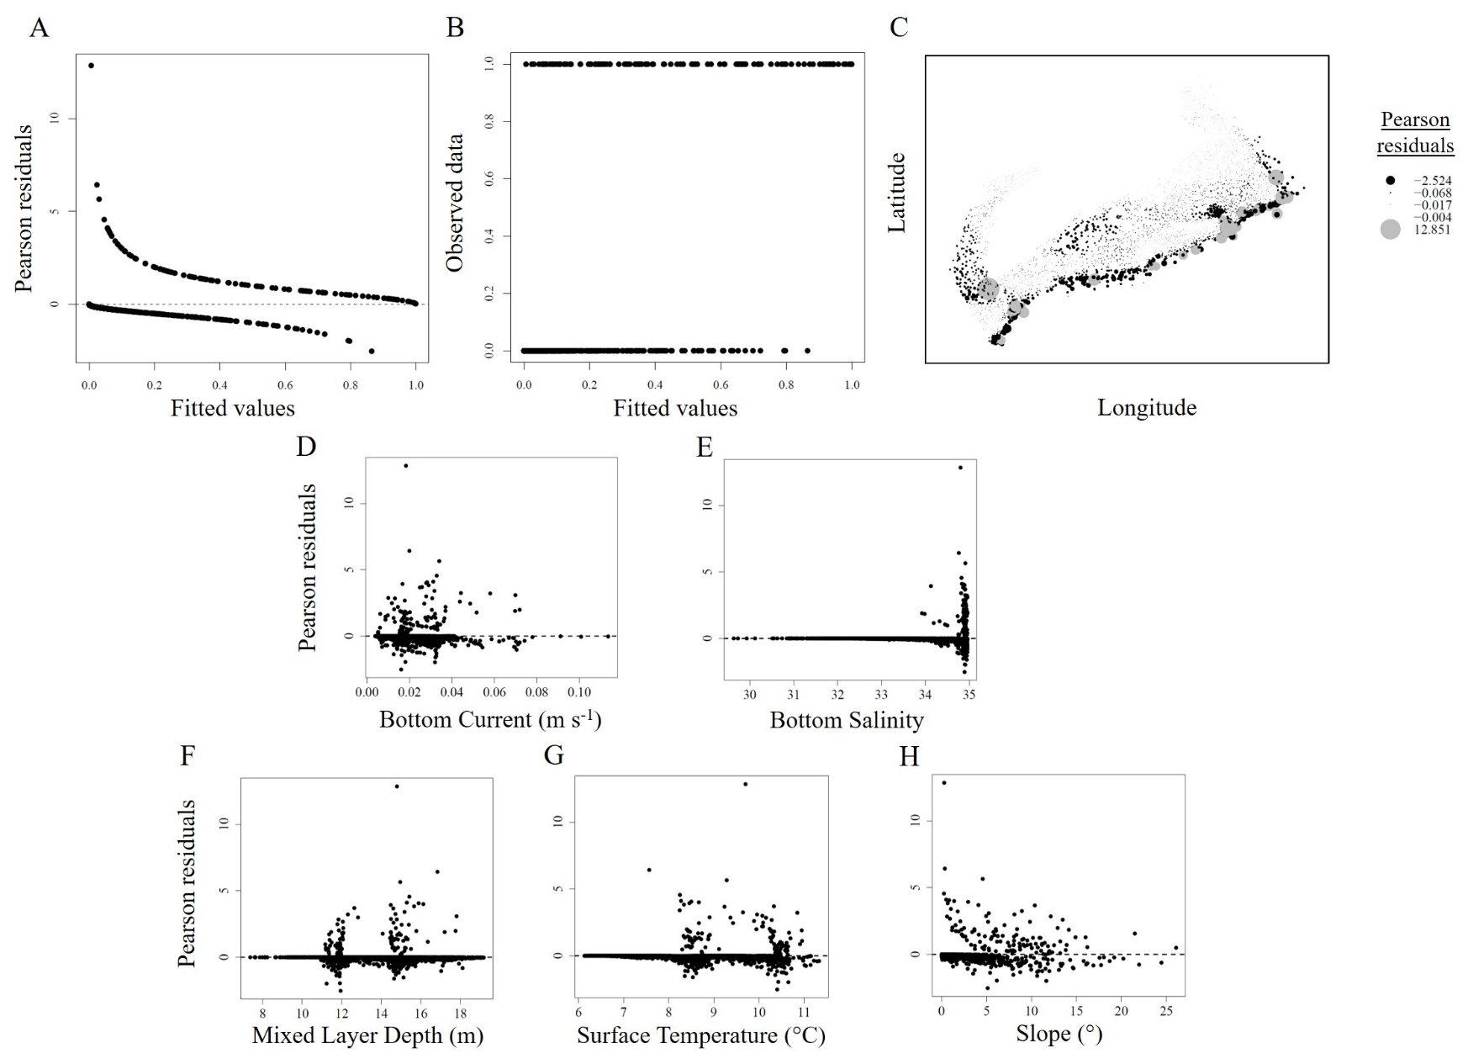
Supplementary Figure 6. Diagnostic plots of the GAM applied to present-day conditions: A) Fitted values versus Pearson residuals; B) Fitted values versus observed values; C) Spatial autocorrelation of residuals; D-H) Residuals versus covariates included in the model.

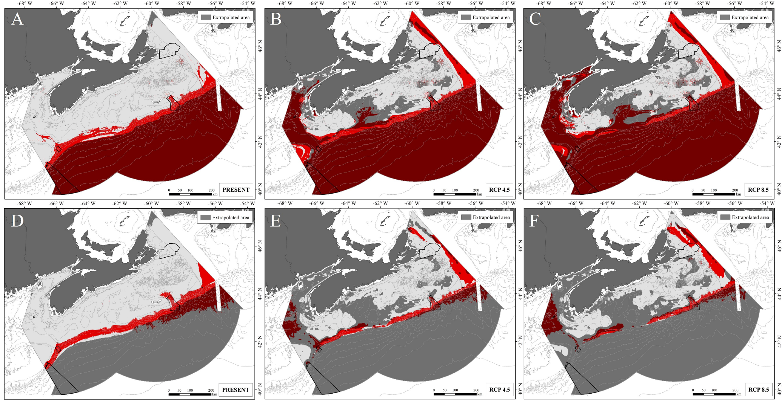
Supplementary Figure 7. Predicted and projected distribution of suitable habitat (red) for Paragorgia arborea following a prevalence threshold of 0.036, from RF models (A-C) and GAMs (D-E), constructed using 8 environmental predictors under present-day (A, D), and either RCP 4.5 (B, E) or RCP 8.5 (C, F) climate projections for 2046−2065. The six conservation areas within the offshore extent of the study area are shown in black outline (see Figure 2 for place names).

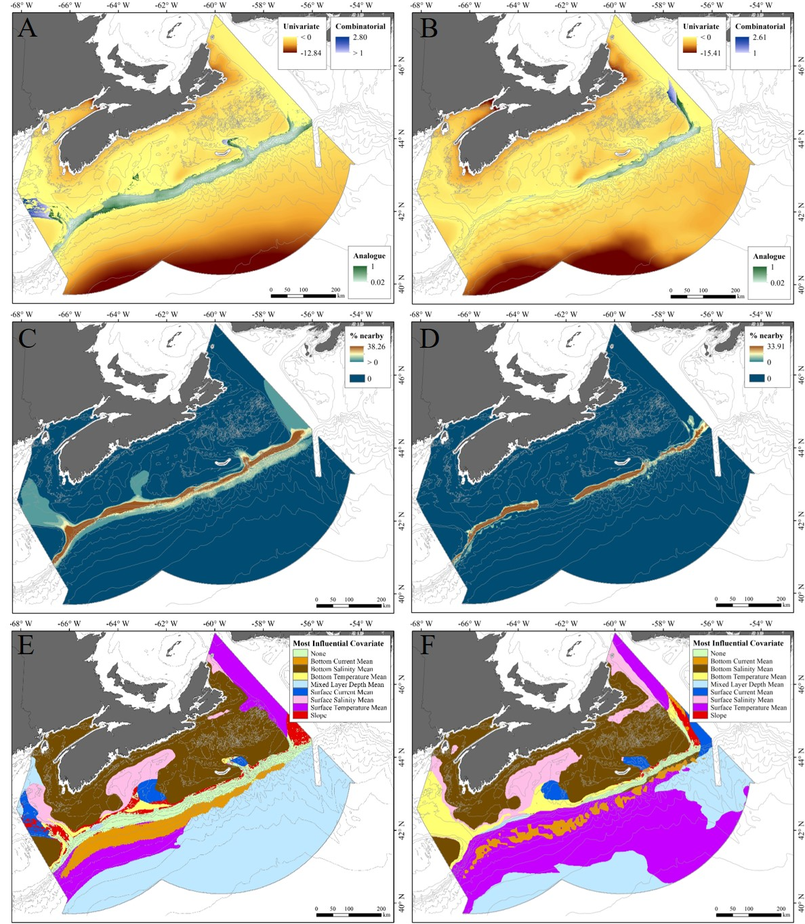
Supplementary Figure 8. Mapped extrapolation diagnostics for the 8 environmental predictors used in modeling effects of climate projections constructed using presence-only distribution data, displayed under present-day conditions (A, C, E), and RCP 4.5 climate projections for 2046−2065 (B, D, F): A, B) Univariate and combinatorial extrapolation, as measured by the ExDet tool in the dsmextra package; C, D) Percentage of data nearby (% Nearby); E, F) Distribution of the covariate which diverges most strongly from analogous conditions (Areas shaded in green have no covariate or combinations of covariates outside the coverage of the reference data).
.
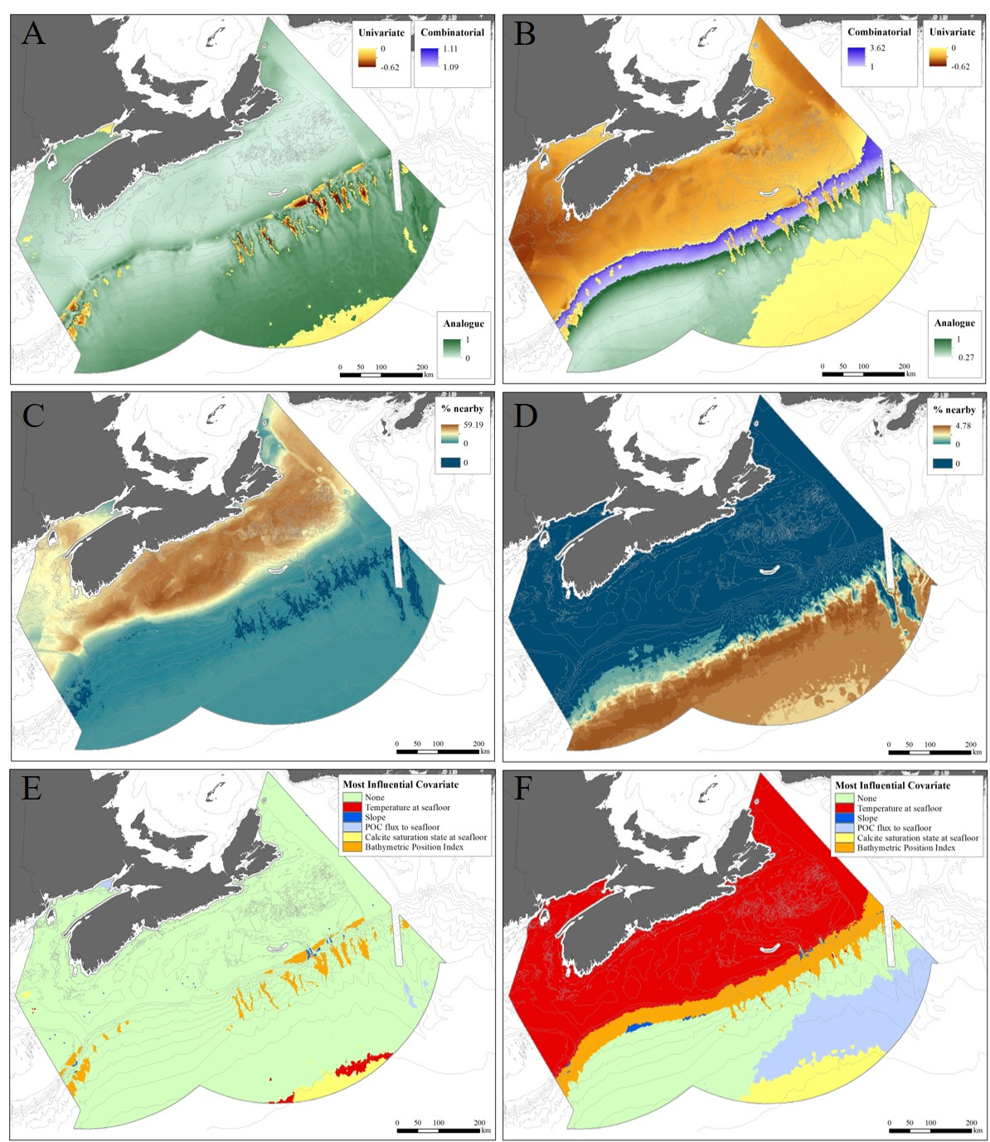
Supplementary Figure 9. Mapped extrapolation diagnostics for the 5 input covariates used by Morato et al. (2020) constructed using both presence and absence data, when applied to our study area under present-day conditions (A, C, E) and RCP 8.5 climate projections for 2100 (B, D, F): A, B) Univariate and combinatorial extrapolation, as measured by the ExDet tool in the dsmextra package; C, D) Percentage of data nearby (% Nearby); E, F) Distribution of the covariate which diverges most strongly from analogous conditions (Areas shaded in green have no covariate or combinations of covariates outside the coverage of the reference data).

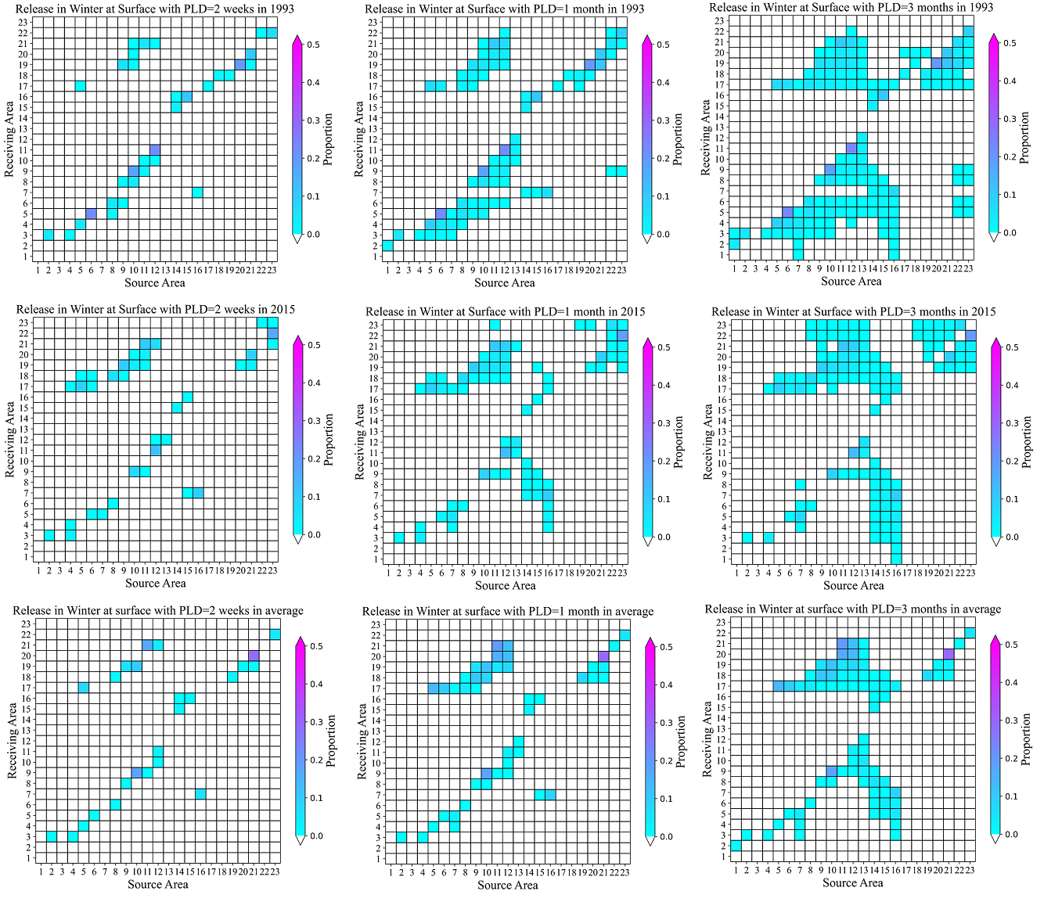
Supplementary Figure 10. Proportions of virtual particles released from each source box (see: Supplementary Table 4, Figure 3 of main text) that pass over or terminate in each source box (termed: “Receiving Area”), during 2-week (left column), 1-month (centre column) and 3-months (right column) for surface releases in winter 1993 (upper row), winter 2015 (middle row) and with monthly-averaged winter currents (lower row) derived from BNAM, with K_{h} applied. Shading on the major diagonal indicates the proportion of particles in the source box at the end of the PLD.
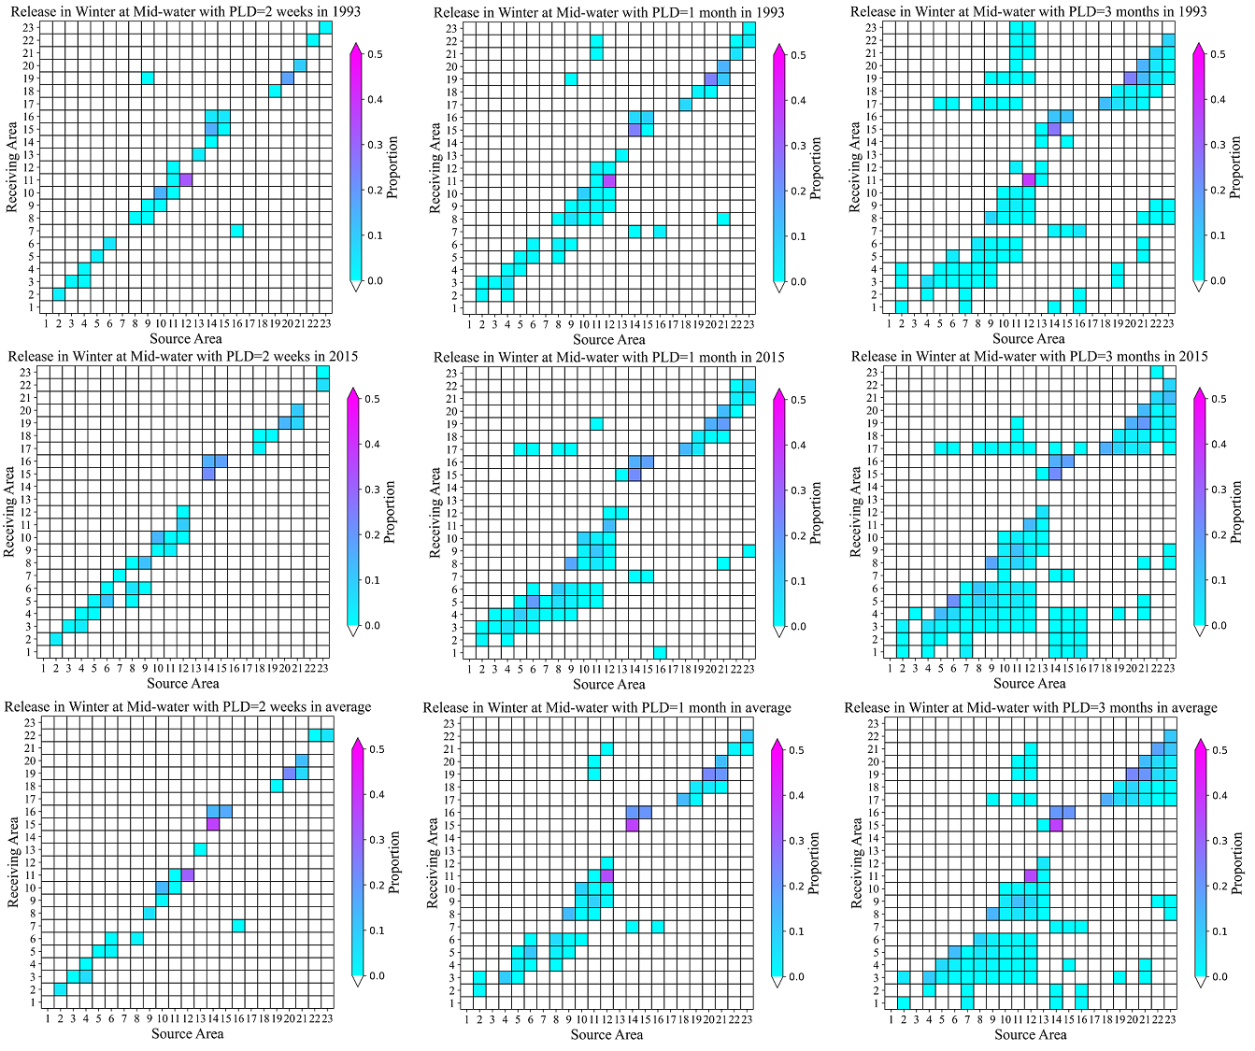
Supplementary Figure 11. Proportions of virtual particles released from each source box (see: Supplementary Table 4, Figure 3 of main text) that pass over or terminate in each source box (termed: “Receiving Area”), during 2-week (left column), 1-month (centre column) and 3-months (right column) for mid-water releases in winter 1993 (upper row), winter 2015 (middle row) and with monthly-averaged winter currents (lower row) derived from BNAM, with K_{h} applied. Shading on the major diagonal indicates the proportion of particles in the source box at the end of the PLD.

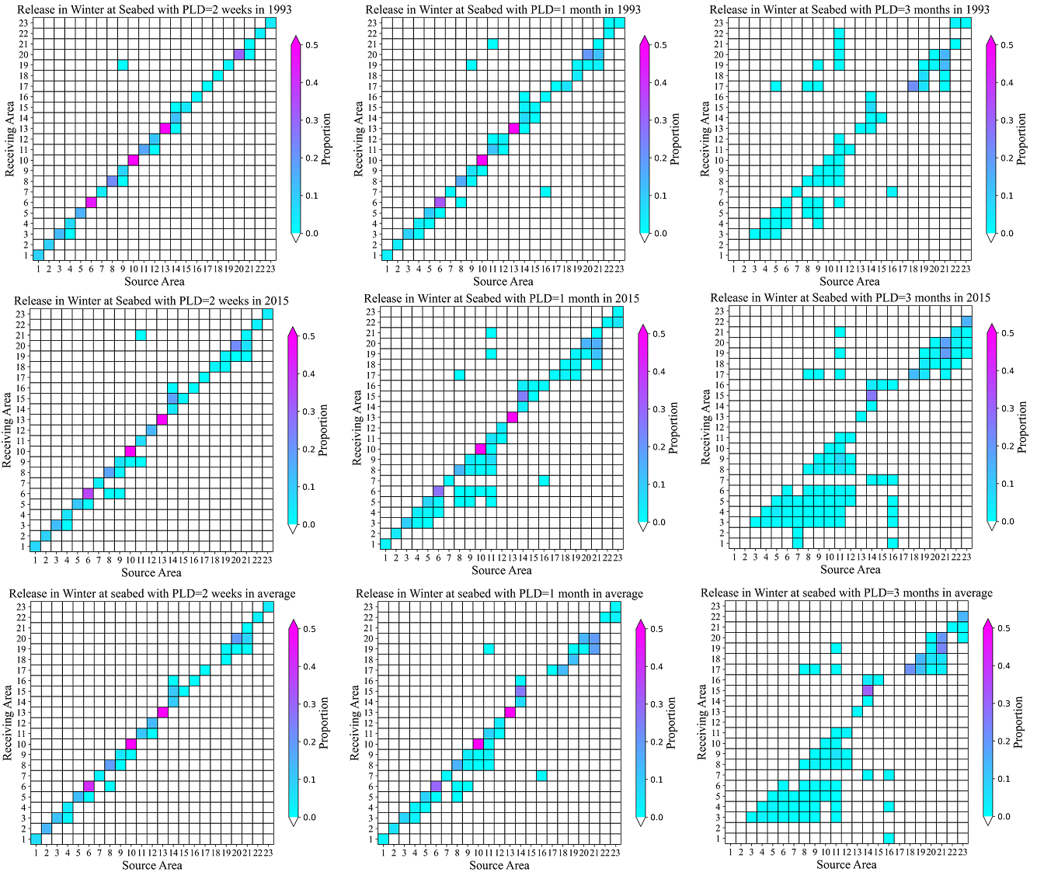
Supplementary Figure 12. Proportions of virtual particles released from each source box (see: Supplementary Table 4, Figure 3 of main text) that pass over or terminate in each source box (termed: “Receiving Area”), during 2-week (left column), 1-month (centre column) and 3-months (right column) for seabed releases in winter 1993 (upper row), winter 2015 (middle row) and with monthly-averaged winter currents (lower row) derived from BNAM, with K_{h} applied. Shading on the major diagonal indicates the proportion of particles in the source box at the end of the PLD.
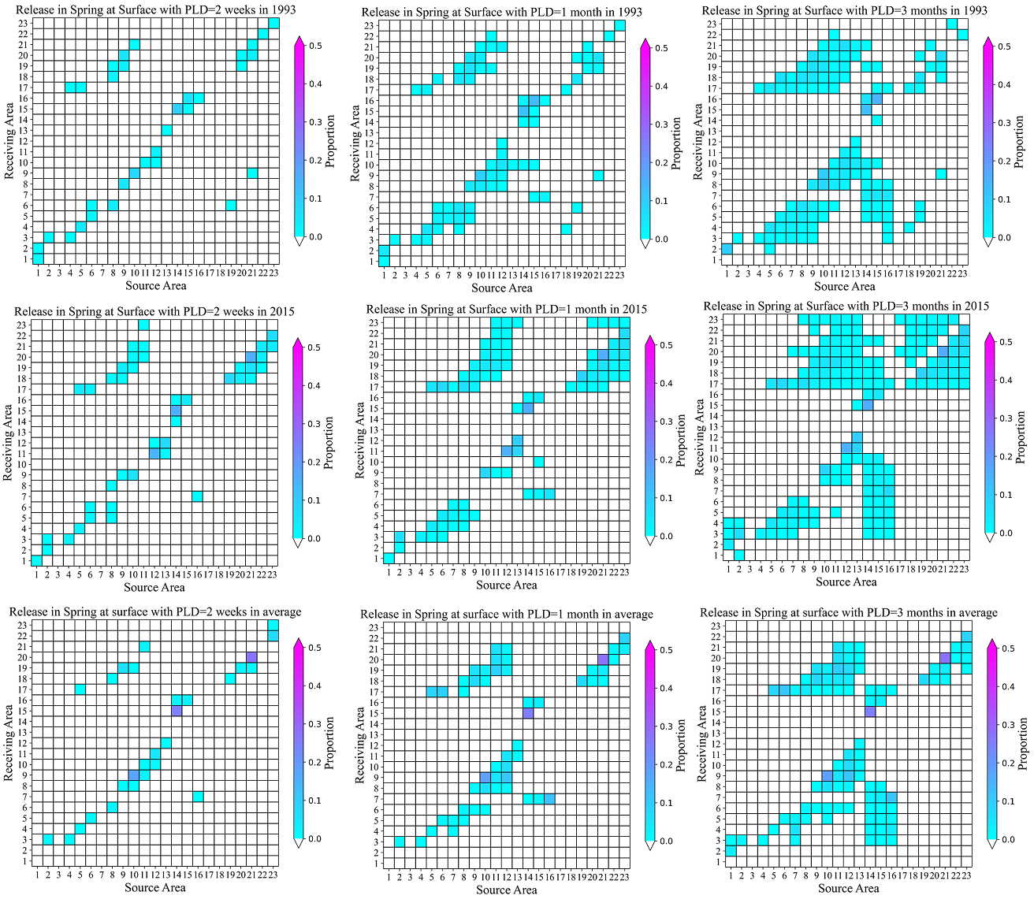
Supplementary Figure 13. Proportions of virtual particles released from each source box (see: Supplementary Table 4, Figure 3 of main text) that pass over or terminate in each source box (termed: “Receiving Area”), during 2-week (left column), 1-month (centre column) and 3-months (right column) for surface releases in spring 1993 (upper row), spring 2015 (middle row) and with monthly-averaged spring currents (lower row) derived from BNAM, with K_{h} applied. Shading on the major diagonal indicates the proportion of particles in the source box at the end of the PLD.

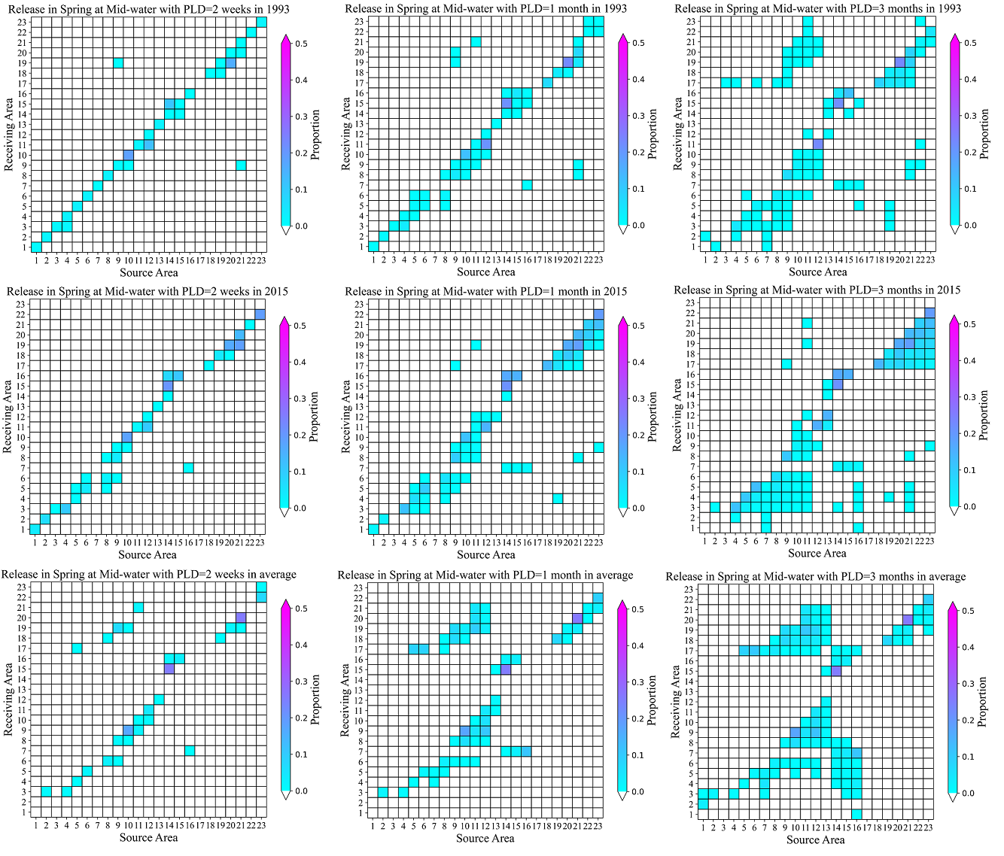
Supplementary Figure 14. Proportions of virtual particles released from each source box (see: Supplementary Table 4, Figure 3 of main text) that pass over or terminate in each source box (termed: “Receiving Area”), during 2-week (left column), 1-month (centre column) and 3-months (right column) for mid-water releases in spring 1993 (upper row), spring 2015 (middle row) and with monthly-averaged spring currents (lower row) derived from BNAM, with K_{h} applied. Shading on the major diagonal indicates the proportion of particles in the source box at the end of the PLD.
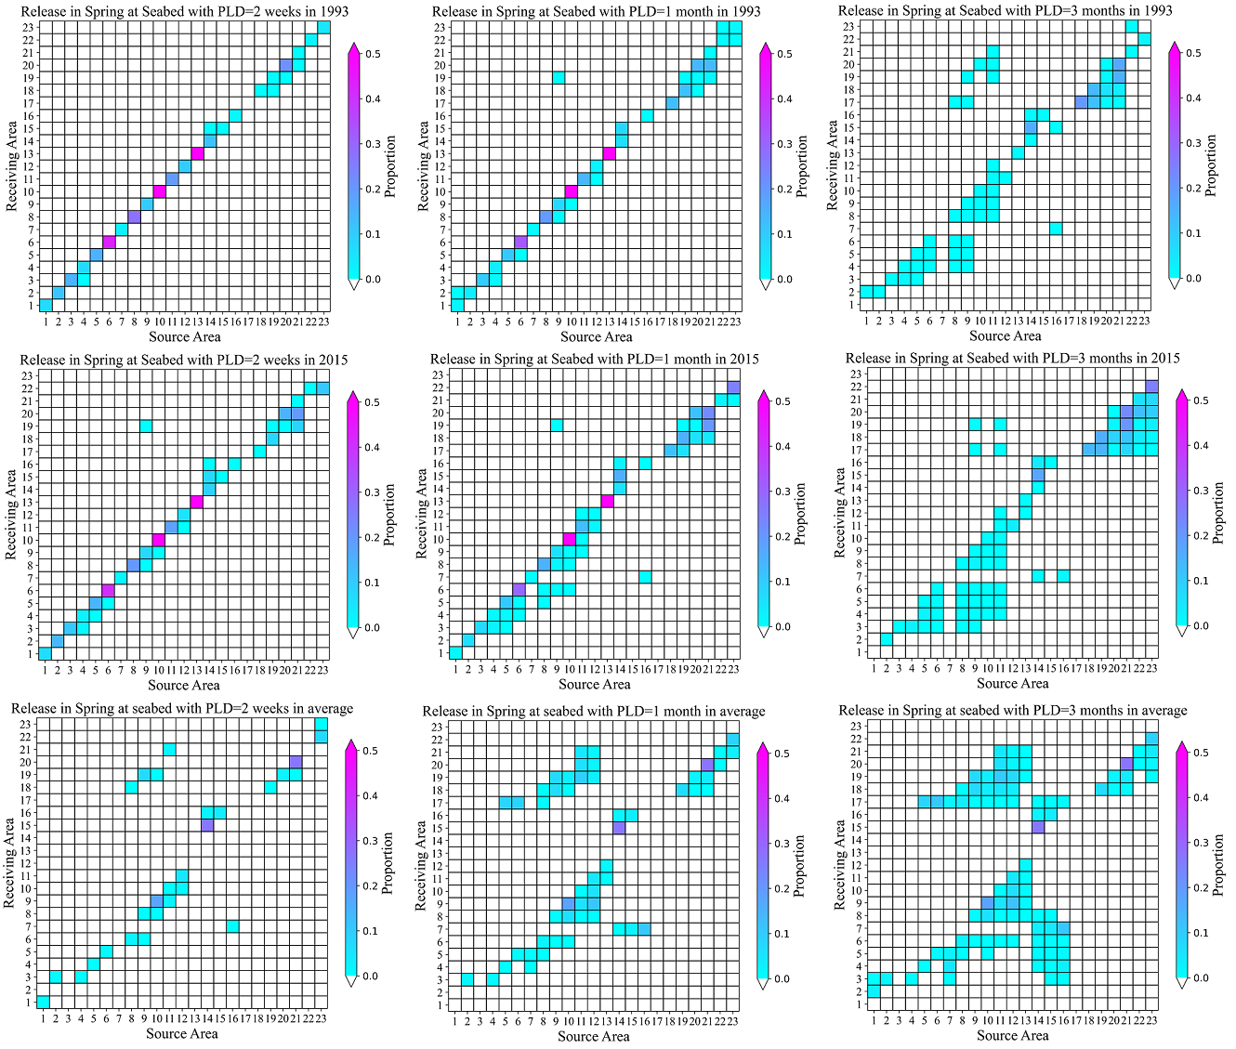
Supplementary Figure 15. Proportions of virtual particles released from each source box (see: Supplementary Table 4, Figure 3 of main text) that pass over or terminate in each source box (termed: “Receiving Area”), during 2-week (left column), 1-month (centre column) and 3-months (right column) for seabed releases in spring 1993 (upper row), spring 2015 (middle row) and with monthly-averaged spring currents (lower row) derived from BNAM, with K_{h} applied. Shading on the major diagonal indicates the proportion of particles in the source box at the end of the PLD.
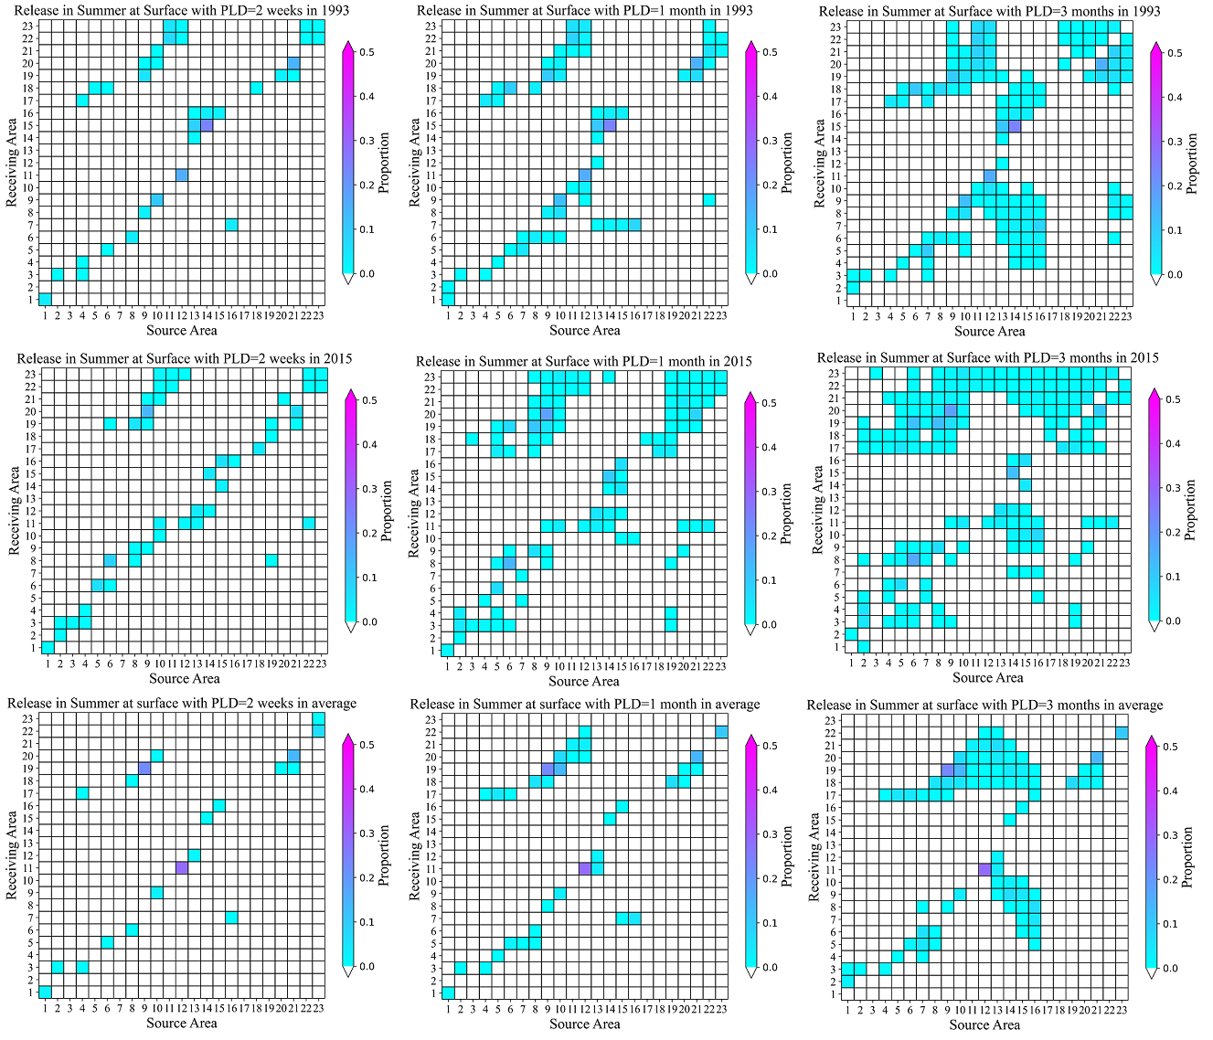
Supplementary Figure 16. Proportions of virtual particles released from each source box (see: Supplementary Table 4, Figure 3 of main text) that pass over or terminate in each source box (termed: “Receiving Area”), during 2-week (left column), 1-month (centre column) and 3-months (right column) for surface releases in summer 1993 (upper row), summer 2015 (middle row) and with monthly-averaged summer currents (lower row) derived from BNAM, with K_{h} applied. Shading on the major diagonal indicates the proportion of particles in the source box at the end of the PLD.
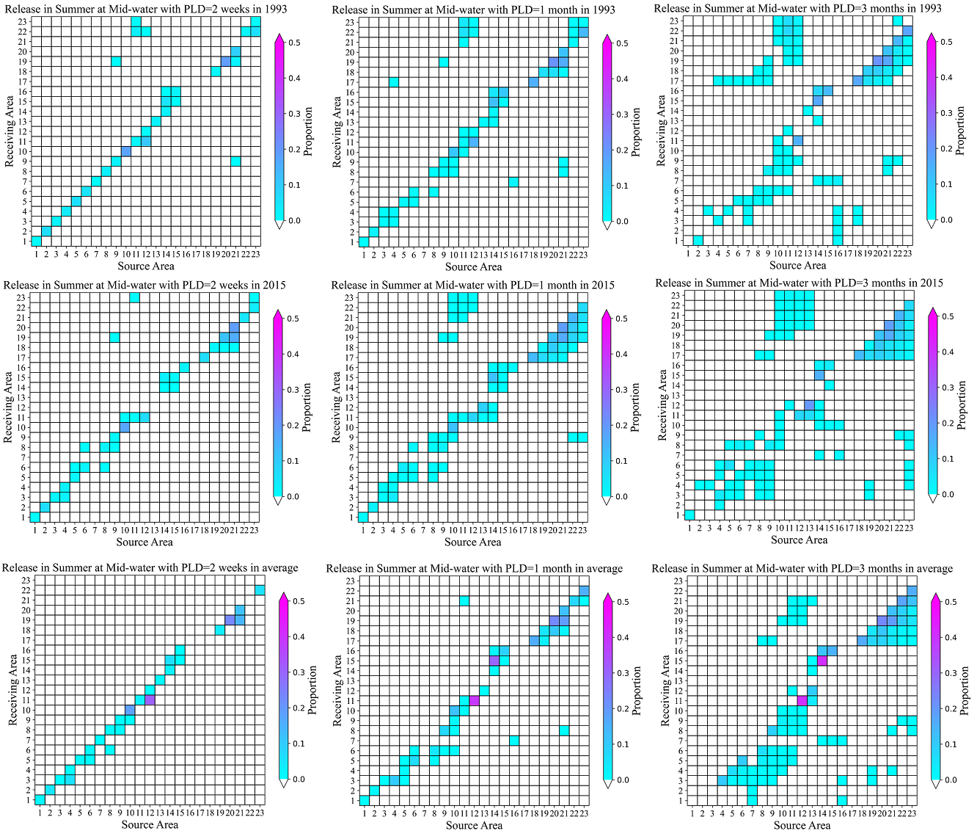
Supplementary Figure 17. Proportions of virtual particles released from each source box (see: Supplementary Table 4, Figure 3 of main text) that pass over or terminate in each source box (termed: “Receiving Area”), during 2-week (left column), 1-month (centre column) and 3-months (right column) for mid-water releases in summer 1993 (upper row), summer 2015 (middle row) and with monthly-averaged summer currents (lower row) derived from BNAM, with K_{h} applied. Shading on the major diagonal indicates the proportion of particles in the source box at the end of the PLD.

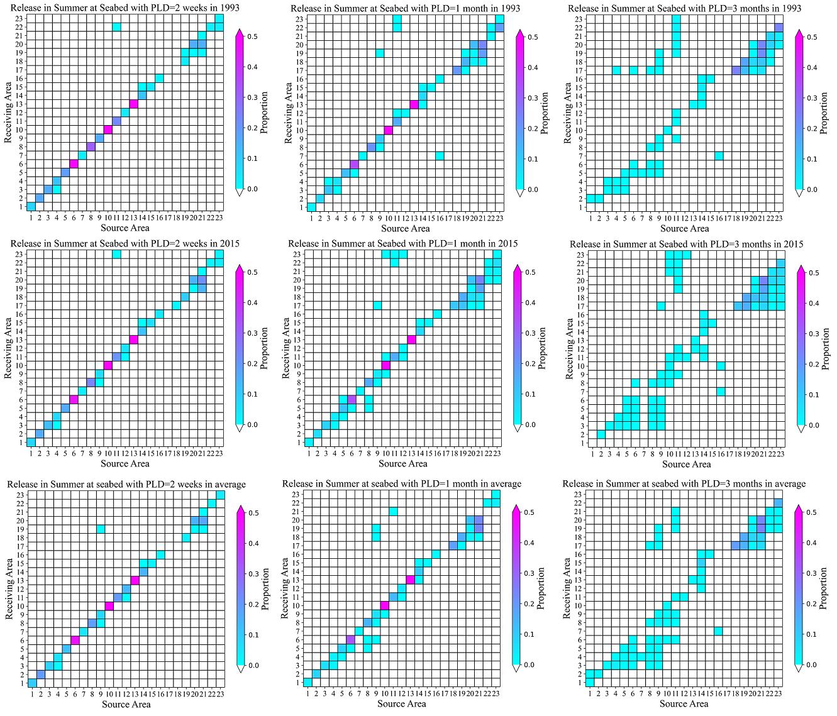
Supplementary Figure 18. Proportions of virtual particles released from each source box (see: Supplementary Table 4, Figure 3 of main text) that pass over or terminate in each source box (termed: “Receiving Area”), during 2-week (left column), 1-month (centre column) and 3-months (right column) for seabed releases in summer 1993 (upper row), summer 2015 (middle row) and with monthly-averaged summer currents (lower row) derived from BNAM, with K_{h} applied. Shading on the major diagonal indicates the proportion of particles in the source box at the end of the PLD.
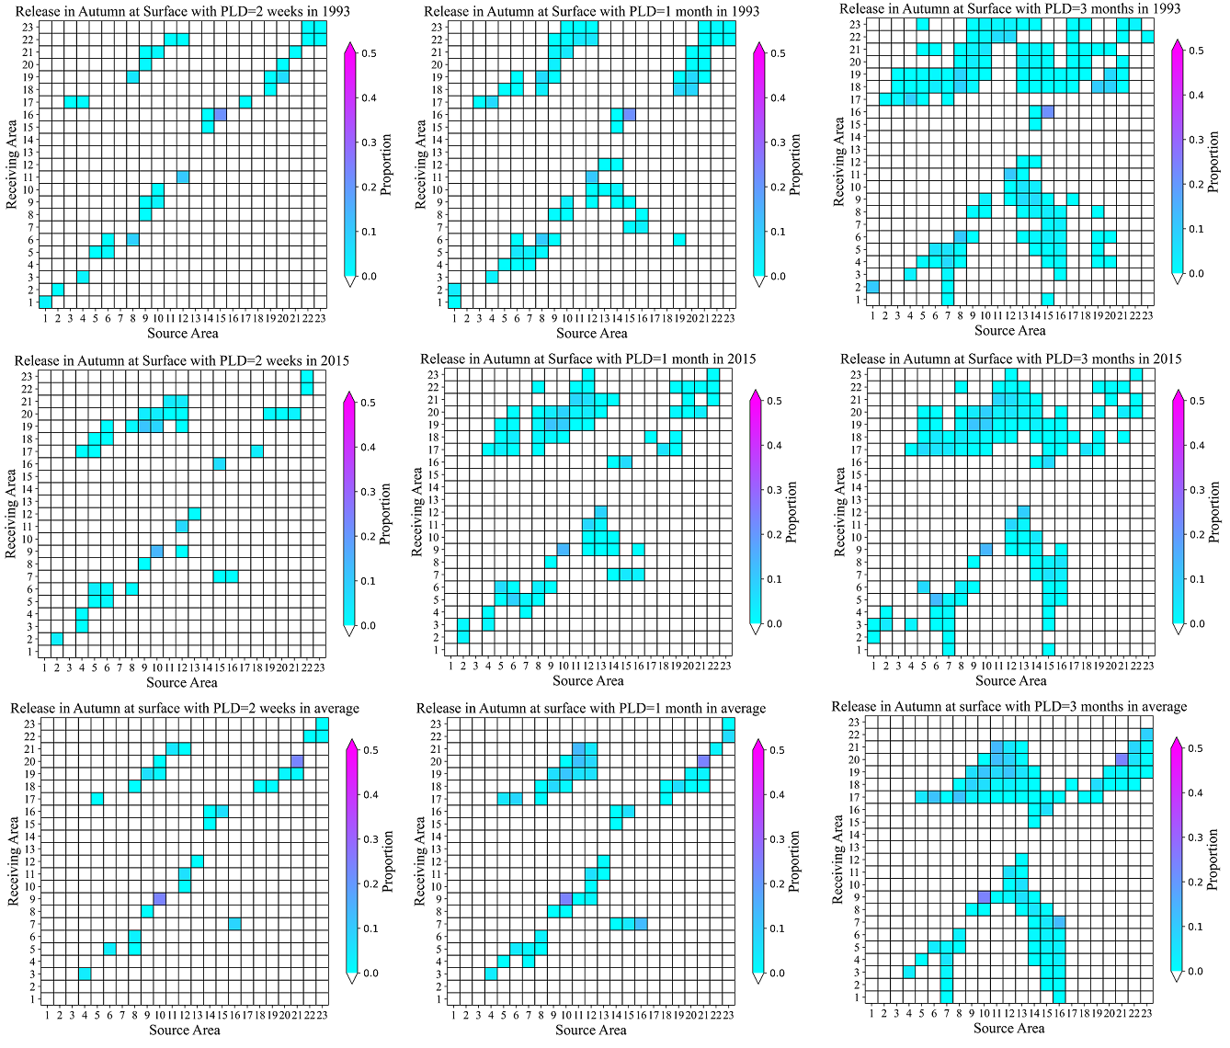
Supplementary Figure 19. Proportions of virtual particles released from each source box (see: Supplementary Table 4, Figure 3 of main text) that pass over or terminate in each source box (termed: “Receiving Area”), during 2-week (left column), 1-month (centre column) and 3-months (right column) for surface releases in autumn 1993 (upper row), autumn 2015 (middle row) and with monthly-averaged autumn currents (lower row) derived from BNAM, with K_{h} applied. Shading on the major diagonal indicates the proportion of particles in the source box at the end of the PLD.

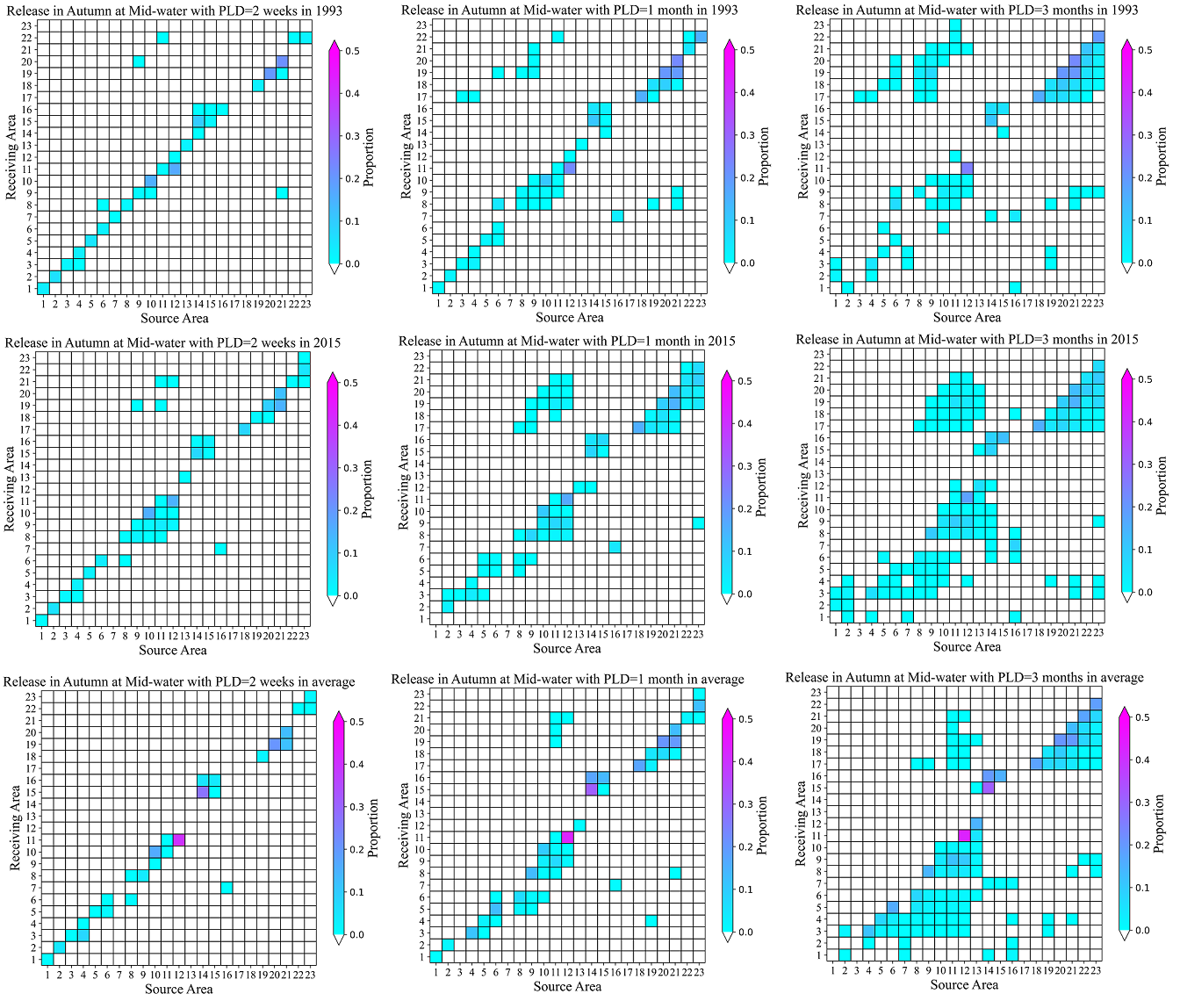
Supplementary Figure 20. Proportions of virtual particles released from each source box (see: Supplementary Table 4, Figure 3 of main text) that pass over or terminate in each source box (termed: “Receiving Area”), during 2-week (left column), 1-month (centre column) and 3-months (right column) for mid-water releases in autumn 1993 (upper row), autumn 2015 (middle row) and with monthly-averaged autumn currents (lower row) derived from BNAM, with K_{h} applied. Shading on the major diagonal indicates the proportion of particles in the source box at the end of the PLD.

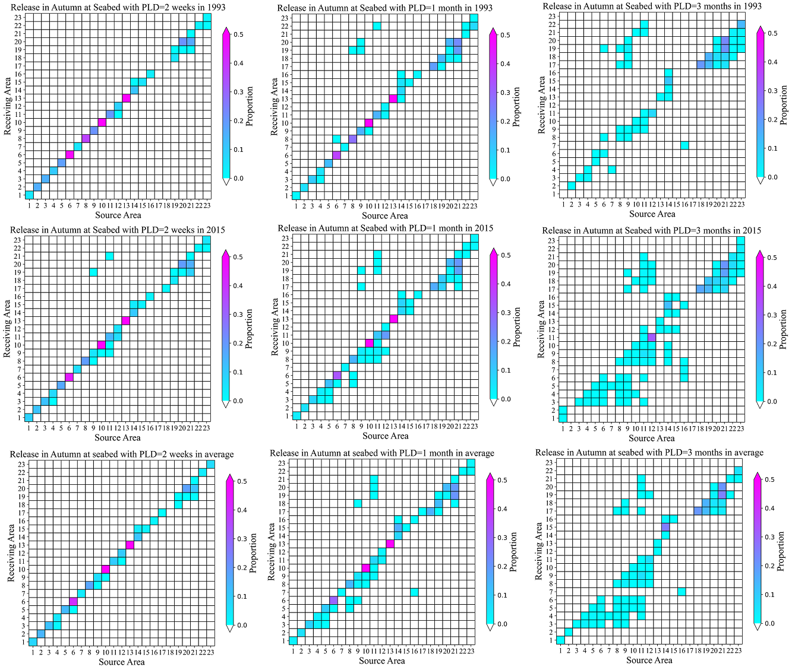

Supplementary Figure 21. Proportions of virtual particles released from each source box (see: Supplementary Table 4, Figure 3 of main text) that pass over or terminate in each source box (termed: “Receiving Area”), during 2-week (left column), 1-month (centre column) and 3-months (right column) for seabed releases in autumn 1993 (upper row), autumn 2015 (middle row) and with monthly-averaged autumn currents (lower row) derived from BNAM, with K_{h} applied. Shading on the major diagonal indicates the proportion of particles in the source box at the end of the PLD.

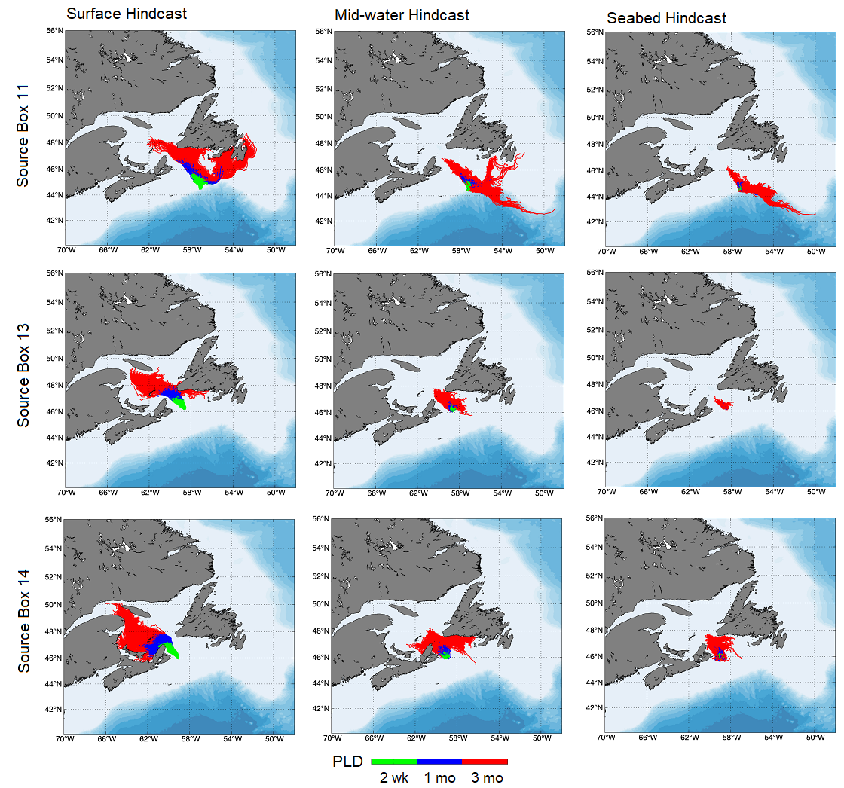
Supplementary Figure 22. Hindcast tracks of virtual particles released in spring from Source Box 11 (upper row), Source Box 13 (middle row) and Source Box 14 (lower row) at the surface (left column), mid-water (centre column) and the seabed (right column) with monthly-averaged currents derived from BNAM, with K_{h} applied.

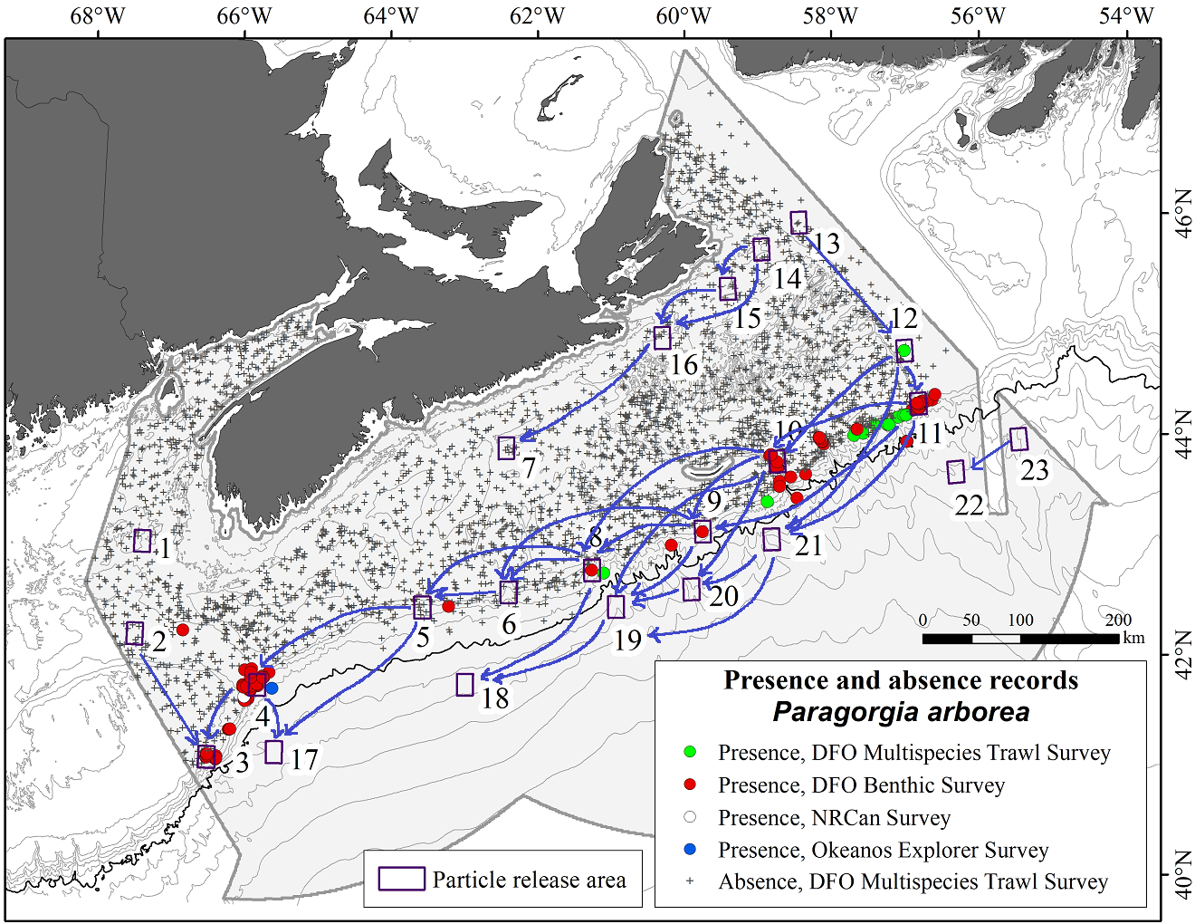

Supplementary Figure 23. Connectivity network based on LPT simulations with 2-week PLD, showing the 32 connections (blue arrows) made between source boxes, combining all four seasons and three release depths, overlain with presence and absence data. Arrows are symbolic representations of connections, not the trajectories travelled.

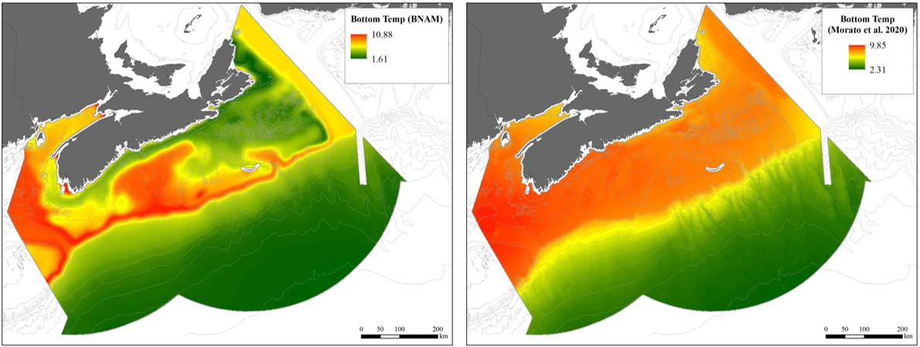

Supplementary Figure 24. Comparison of spatial precision of two ocean models: Left): Distribution of the environmental predictor Bottom Temperature Mean (◦C) for 1990–2015, extracted from BNAM and used in this study to predict present-day distribution of P. arborea; Right: Distribution of the environmental predictor Bottom Temperature (◦C; present-day 1951–2000) from the Earth System Grid Federation Peer-to-Peer System. Note that the BNAM model captures the effects on bottom temperature of continental-shelf bathymetry, including various banks, basins and channels.

Supplementary Tables
Supplementary Table 1. Summary of models used in mapping the distributions of Paragorgia arborea and its habitat, and in examination of connectivity amongst habitat areas.
Analytical Tool | Time-Frame | Variables | Purpose (bracketed numbers refer to SDM number 1-6 in Column 1) | Relevance to MPA Network Design
Species Distribution Models (SDM)
- Random Forest | Present-day | 47 environmental predictors | Spatial mapping of species distribution | Assessment of representativity of currently closed areas
- Random Forest | Present-day | Top 6 environmental predictors (1) | Improved spatial mapping of species distribution
- Random Forest | Present-day | 8 environmental predictors | Reference for models using climate change projections (4)
- Random Forest | 2046−2065 | 8 environmental predictors | Predicted species distribution under climate projections | Assessment of climate-change resilience of closed areas
- GAM | Present-day | 8 environmental predictors | Reference for models using climate change projections (6) | Assessment of representativity of closed areas
- GAM | 2046−2065 | 8 environmental predictors | Predicted species distributions under climate projections | Assessment of climate-change resilience of closed areas
Species Distribution Model Evaluation
 | Present-day | Gass (2002) and OBIS response variables | Evaluation of model performance (1, 3, 5) using independent data
Extrapolation diagnostics | Present-day | 47, 6, 8 environmental predictors | Identification of non-analogous environments (1, 2, 3) | Spatial assessment of reliability of distribution models
Extrapolation diagnostics | 2046−2065 | 8 environmental predictors | Identification of analogous environments (4) under climate projections | Identification of potential climate refugia
Extrapolation diagnostics | Present-day | 5 environmental predictors | Evaluation of Morato et al. (2020) variables in Offshore Scotian Shelf planning area
Extrapolation diagnostics | 2100 | 5 environmental predictors | Evaluation of Morato et al. (2020) variables in Offshore Scotian Shelf planning area under climate projections
Biophysical Connectivity Models
3-D Lagrangian Particle Tracking | Present-day | Long-term and annual monthly averages | Evaluation of predicted habitat distributions (1, 2, 4); Identification of connectivity and retention among closed areas | Assessment of connectivity, adequacy and viability of closed areas

Supplementary Table 2. Environmental predictors used in the RF models for the spatial mapping of species distribution under present-day conditions. (BNAM: Bedford Institute of Oceanography North Atlantic Model; BPI: Bathymetric Position Index; CHS_ABC: Canadian Hydrographic Service Atlantic Bathymetry Compilation; DFO: Department of Fisheries and Oceans Canada; lat: latitude; long: longitude; Max: maximum; Min: minimum; N/A: not applicable; RSU-BIO: Remote Sensing Unit at the Bedford Institute of Oceanography).
Variable | Variable Type | Metric | Unit | Native Resolution | Source
Slope | Terrain | N/A | degrees | 15" lat/long | CHS_ABC
BPI (fine scale) | Terrain | N/A | standardized index | 15" lat/long | CHS_ABC
BPI (broad-scale) | Terrain | N/A | standardized index | 15" lat/long | CHS_ABC
Eastness | Terrain | N/A | radians | 15" lat/long | CHS_ABC
Northness | Terrain | N/A | radians | 15" lat/long | CHS_ABC
Ruggedness | Terrain | N/A | standardized index | 15" lat/long | CHS_ABC
Channel Network Base Level | Terrain | N/A | m | 15" lat/long | CHS_ABC
Channel Network Distance | Terrain | N/A | m | 15" lat/long | CHS_ABC
Valley Depth | Terrain | N/A | m | 15" lat/long | CHS_ABC
Relative Slope Position | Terrain | N/A | standardized index | 15" lat/long | CHS_ABC
LS-Factor | Terrain | N/A | standardized index | 15" lat/long | CHS_ABC
Positive and Negative Openness | Terrain | N/A | radians | 15" lat/long | CHS_ABC
Wind Exposition Index | Terrain | N/A | standardized index | 15" lat/long | CHS_ABC
Bottom salinity | Physical Oceanography | Min | N/A | 1/12º lat/long | BNAM
Bottom temperature | Physical Oceanography | Max, Min, Range | ºC | 1/12º lat/long | BNAM
Bottom current speed | Physical Oceanography | Max, Min | m s⁻¹ | 1/12º lat/long | BNAM
Surface salinity | Physical Oceanography | Range | N/A | 1/12º lat/long | BNAM
Surface temperature | Physical Oceanography | Max, Range | ºC | 1/12º lat/long | BNAM
Surface current speed | Physical Oceanography | Max, Min | m s⁻¹ | 1/12º lat/long | BNAM
Annual Chlorophyll a | Biological Oceanography | Max, Range | mg m⁻³ | 9 km | RSU-BIO
Spring Chlorophyll a | Biological Oceanography | Max, Mean, Min | mg m⁻³ | 9 km | RSU-BIO
Fall Chlorophyll a | Biological Oceanography | Max, Min | mg m⁻³ | 9 km | RSU-BIO
Fall Primary Production | Biological Oceanography | Max, Mean, Min, Range | mg C m⁻² day⁻¹ | 9 km | RSU-BIO
Spring Primary Production | Biological Oceanography | Max, Mean, Min, Range | mg C m⁻² day⁻¹ | 9 km | RSU-BIO
Summer Primary Production | Biological Oceanography | Max, Mean, Min, Range | mg C m⁻² day⁻¹ | 9 km | RSU-BIO
Annual Primary Production | Biological Oceanography | Max, Mean, Min, Range | mg C m⁻² day⁻¹ | 9 km | RSU-BIO
Bottom Fishing Effort | Bottom Fishing Effort | NA | percentages | 1 km | DFO

Supplementary Table 3. Summary of LPT experiments performed to examine connectivity among the source boxes. K_{h} = area-specific horizontal diffusivity constant (wk = week; mo = month).

Ocean Model | Period | Season | Pelagic Larval Duration (PLD) | K_{h} (m² s⁻¹)
BNAM | 1993 | Winter | 2 wk, 1 mo, 3 mo | 52.1
BNAM | 1993 | Spring | 2 wk, 1 mo, 3 mo | 52.1
BNAM | 1993 | Summer | 2 wk, 1 mo, 3 mo | 52.1
BNAM | 1993 | Autumn | 2 wk, 1 mo, 3 mo | 52.1
BNAM | 2015 | Winter | 2 wk, 1 mo, 3 mo | 52.1
BNAM | 2015 | Spring | 2 wk, 1 mo, 3 mo | 52.1
BNAM | 2015 | Summer | 2 wk, 1 mo, 3 mo | 52.1
BNAM | 2015 | Autumn | 2 wk, 1 mo, 3 mo | 52.1
BNAM | 1990–2015 | Winter | 2 wk, 1 mo, 3 mo | 52.1
BNAM | 1990–2015 | Spring | 2 wk, 1 mo, 3 mo | 52.1
BNAM | 1990–2015 | Summer | 2 wk, 1 mo, 3 mo | 52.1
BNAM | 1990–2015 | Autumn | 2 wk, 1 mo, 3 mo | 52.1

Supplementary Table 4. Source boxes for particle seeding in LPT modeling (SDM = species distribution model).
Source box No. | Geographic Designation | Rationale(s) for Selection of Source box | Objective(s)
1 |  | Presence predicted in future scenario, Jordan Basin Conservation Area, presence of Primnoa resedaeformis another gorgonian coral | Enhance interpretation of SDMs, Evaluate connectivity associated with closed areas
2 |  | Presence predicted in future scenario, presence of Primnoa resedaeformis another gorgonian coral | Enhance interpretation of SDMs
3 |  | Known occurrence records, Corsair and Georges Canyons Conservation Area | Enhance interpretation of SDMs, Evaluate connectivity associated with closed areas
4 |  | Known occurrence records, Northeast Channel Coral Conservation Area | Enhance interpretation of SDMs, Evaluate connectivity associated with closed areas
5 | Upper Slope | Slope area of low probability of occurrence in SDMs | Enhance interpretation of SDMs
6 | Upper Slope | Slope area of high probability of occurrence in SDMs | Enhance interpretation of SDMs
7 | Inner Scotian Shelf | Old records from fisheries (Gass, 2002), low probability of occurrence in SDMs | Evaluate historic records, Enhance interpretation of SDMs
8 | Upper Slope | Known occurrence records | Enhance interpretation of SDMs
9 | Upper Slope | Known occurrence records | Enhance interpretation of SDMs
10 | Upper Slope | Known occurrence records, Gully Marine Protected Area | Enhance interpretation of SDMs, Evaluate connectivity associated with closed areas
11 | Upper Slope | Known occurrence records, Lophelia Coral Conservation Area | Enhance interpretation of SDMs, Evaluate connectivity associated with closed areas
12 | 12 | High probability of occurrence in SDMs | Enhance interpretation of SDMs
13 | Inner Scotian Shelf | St. Anns Bank MPA, predicted presence in future scenario | Enhance interpretation of SDMs
14 | Inner Scotian Shelf | St. Anns Bank MPA, historic records from fisher interviews (Gass, 2002) | Evaluate historic records, Enhance interpretation of SDMs
15 | Inner Scotian Shelf | Shallow historic records (eastern Scotian Shelf) from fisher interviews (Gass, 2002) | Evaluate historic records, Enhance interpretation of SDMs
16 | Inner Scotian Shelf | Shallow historic records (eastern Scotian Shelf) from fisher interviews (Gass, 2002) | Evaluate historic records, Enhance interpretation of SDMs
17 | Deep Slope | Down-slope of known occurrence records, Extrapolated medium probability prediction area >2000 m in some SDMs | Enhance interpretation of SDMs
18 | Deep Slope | Down-slope of known occurrence records, Extrapolated high probability prediction area > 2000 m in some SDMs | Enhance interpretation of SDMs
19 | Deep Slope | Extrapolated high probability prediction area >2000m in some SDM models | Enhance interpretation of SDMs
20 | Deep Slope | Down-slope of known occurrence records, Extrapolated high probability prediction area > 2000 m in some SDMs | Enhance interpretation of SDMs
21 | Deep Slope | Extrapolated high probability prediction area > 2000 m in some SDMs | Enhance interpretation of SDMs
22 | Deep Slope | Extrapolated high probability prediction area > 2000 m in some SDMs | Enhance interpretation of SDMs
23 | Deep Slope | Extrapolated high probability prediction area > 2000 m in some SDMs | Enhance interpretation of SDMs
Additional Objectives:
1–4 | Fundian and NE Channel | Influenced by deep inflow of warm, saline, nutrient-rich Warm Slope Water (WSW) through Northeast Channel and mixing of Gulf of Maine water | Influence of currents
5, 6, 8–11 | Upper Slope | Influenced by the Shelf-Break Current | Influence of currents
7, 13–16 | Inner Scotian Shelf | Influenced by cool, fresh Scotian Shelf water transported by the Nova Scotia Current | Influence of currents
17–23 | Deep Slope | Influenced by Labrador Sea Water (LSW) | Influence of currents

Supplementary Table 5. Means and standard deviations, in the grid cells with Paragorgia arborea presence records (N=115), of each environmental predictor in the suite of 47 used in RF modeling. Variables are listed in alphabetical order. Units are as in Supplementary Table 2.
Variable | Mean ± SD
- Annual Chlorophyll a Maximum | 1.086 ± 0.143
- Annual Chlorophyll a Range | 0.532 ± 0.137
- Annual Primary Production Maximum | 1200.607 ± 76.011
- Annual Primary Production Mean | 708.85 ± 31.404
- Annual Primary Production Minimum | 310.719 ± 21.665
- Annual Primary Production Range | 890.274 ± 61.968
- Bottom Current Maximum | 0.043 ± 0.019
- Bottom Current Minimum | 0.008 ± 0.006
- Bottom Fishing Effort | 4.773 ± 19.6
- Bottom Salinity Minimum | 34.736 ± 0.283
- Bottom Temperature Maximum | 6.079 ± 1.342
- Bottom Temperature Minimum | 4.743 ± 0.575
- Broad-scale BPI | 97.282 ± 228.462
- Channel Network Base Level | -801.006 ± 396.925
- Channel Network Distance | 243.423 ± 204.089
- Eastness | 0.366 ± 0.534
- Fall Chlorophyll a Maximum | 1.369 ± 0.473
- Fall Chlorophyll a Minimum | 0.501 ± 0.058
- Fall Primary Production Maximum | 640.98 ± 61.487
- Fall Primary Production Mean | 539.332 ± 37.547
- Fall Primary Production Minimum | 440.942 ± 31.071
- Fall Primary Production Range | 200.299 ± 58.134
- Fine-scale BPI | -12.964 ± 387.379
- LS-Factor | 3.648 ± 2.889
- Negative Openness | 1.513 ± 0.036
- Northness | -0.347 ± 0.594
- Positive Openness | 1.51 ± 0.049
- Relative Slope Position | 0.503 ± 0.001
- Ruggedness | 0.006 ± 0.006
- Slope | 7.284 ± 4.637
- Spring Chlorophyll a Maximum | 1.83 ± 0.516
- Spring Chlorophyll a Mean | 1.097 ± 0.107
- Spring Chlorophyll a Minimum | 0.683 ± 0.102
- Spring Primary Production Maximum | 1110.889 ± 121.504
- Spring Primary Production Mean | 846.527 ± 67.857
- Spring Primary Production Minimum | 620.533 ± 54.507
- Spring Primary Production Range | 490.223 ± 79.125
- Summer Primary Production Maximum | 982.539 ± 73.896
- Summer Primary Production Minimum | 718.702 ± 32.171
- Summer Primary Production Range | 262.999 ± 65.714
- Surface Current Maximum | 0.296 ± 0.084
- Surface Current Minimum | 0.052 ± 0.025
- Surface Salinity Range | 1.556 ± 0.114
- Surface Temperature Maximum | 18.824 ± 0.797
- Surface Temperature Range | 17.113 ± 0.194
- Valley Depth | 215.724 ± 175.048
- Wind Exposition Index | 1.024 ± 0.055

Supplementary Table 6. Accuracy measures for RF models and GAMs constructed using Paragorgia arborea presence/absence data and present-day values of 8 environmental predictors.

Model | Cross-validation | AUC | Sensitivity | Specificity | TSS
RF | 10-fold | 0.98+0.01 | 0.97 | 0.90 | 0.88
 | Spatial block | 0.97+0.01 | 0.97 | 0.88 | 0.86
GAM | 10-fold | 0.97+0.02 | 0.92 | 0.90 | 0.82
 | Spatial block | 0.89+0.12 | 0.42 | 0.92 | 0.34

Supplementary Table 7. Probability of occurrence of Paragorgia arborea, at locations from which the species has been reported in records not used during model construction, predicted by three different models of the species’ present-day distribution. (Latitude and longitude in decimal degrees. The RF models are identified as: RF 47 var, for the model built using all 47 predictors, and RF 8 var, for the model constructed with only the 8 variables used when modelling future distributions. Habitats were classed as suitable or unsuitable using prevalence of 0.036 as the cut-off. *Indicates a record of Paragorgia sp. All others were recorded as P. arborea.)
Data Source | Latitude (DD) | Longitude (DD) | Prob. RF (47 var) | Prob. RF (8 var) | Prob. GAM | Habitat Class
Gass (2002) | 44.4917 | 57.1167 | 0.694 | 0.762 | 0.604 | Suitable
Gass (2002) | 43.9833 | 59.0583 | 0.604 | 0.530 | 0.385 | Suitable
Gass (2002) | 44.3417 | 57.6333 | 0.200 | 0.450 | 0.543 | Suitable
Gass (2002) | 44.4667 | 57.2333 | 0.554 | 0.376 | 0.553 | Suitable
Gass (2002) | 44.4500 | 57.1167 | 0.500 | 0.350 | 0.329 | Suitable
Gass (2002) | 44.3167 | 57.5167 | 0.194 | 0.312 | 0.378 | Suitable
Gass (2002) | 44.5667 | 56.5667 | 0.190 | 0.292 | 0.180 | Suitable
Gass (2002) | 44.0000 | 59.0750 | 0.392 | 0.236 | 0.267 | Suitable
Gass (2002) | 44.4167 | 57.3000 | 0.064 | 0.128 | 0.267 | Suitable
Gass (2002) | 43.9000 | 59.0167 | 0.408 | 0.124 | 0.191 | Suitable
Gass (2002) | 43.8667 | 59.0000 | 0.198 | 0.064 | 0.042 | Suitable
Gass (2002) | 44.2333 | 57.7667 | 0.114 | 0.038 | 0.127 | Suitable
Gass (2002) | 44.2667 | 62.4667 | 0.016 | 0.010 | 0.012 | Unsuitable
Gass (2002) | 45.9833 | 59.0333 | 0.002 | 0.010 | 0.000 | Unsuitable
Gass (2002) | 45.5333 | 59.8000 | 0.008 | 0.008 | 0.000 | Unsuitable
Gass (2002) | 45.5833 | 59.5333 | 0.006 | 0.006 | 0.000 | Unsuitable
Gass (2002) | 45.7667 | 58.8500 | 0.000 | 0.004 | 0.000 | Unsuitable
Gass (2002) | 45.4500 | 59.4000 | 0.002 | 0.004 | 0.000 | Unsuitable
Gass (2002) | 44.1667 | 62.4667 | 0.000 | 0.002 | 0.007 | Unsuitable
Gass (2002) | 45.7333 | 58.8167 | 0.000 | 0.002 | 0.000 | Unsuitable
Gass (2002) | 45.6083 | 59.3667 | 0.000 | 0.002 | 0.000 | Unsuitable
Gass (2002) | 45.7083 | 59.8333 | 0.000 | 0.002 | 0.000 | Unsuitable
Gass (2002) | 45.1083 | 57.5667 | 0.002 | 0.000 | 0.005 | Unsuitable
Gass (2002) | 45.1250 | 57.7250 | 0.008 | 0.000 | 0.001 | Unsuitable
Gass (2002) | 45.0667 | 57.9667 | 0.000 | 0.000 | 0.000 | Unsuitable
Gass (2002) | 45.5583 | 58.2000 | 0.004 | 0.000 | 0.000 | Unsuitable
Gass (2002) | 45.0417 | 57.8333 | 0.000 | 0.000 | 0.000 | Unsuitable
Gass (2002) | 45.0667 | 57.8333 | 0.004 | 0.000 | 0.000 | Unsuitable
Gass (2002) | 45.7833 | 58.8833 | 0.000 | 0.000 | 0.000 | Unsuitable
Gass (2002) | 45.5500 | 58.1500 | 0.000 | 0.000 | 0.000 | Unsuitable
Gass (2002) | 45.5167 | 58.2000 | 0.000 | 0.000 | 0.000 | Unsuitable
Gass (2002) | 45.6000 | 58.1500 | 0.000 | 0.000 | 0.000 | Unsuitable
Gass (2002) | 45.5833 | 59.4750 | 0.004 | 0.000 | 0.000 | Unsuitable
Gass (2002) | 45.7250 | 59.3500 | 0.000 | 0.000 | 0.000 | Unsuitable
Gass (2002) | 45.6000 | 59.7000 | 0.006 | 0.000 | 0.000 | Unsuitable
Gass (2002) | 45.6417 | 59.5667 | 0.000 | 0.000 | 0.000 | Unsuitable
Gass (2002) | 45.6583 | 59.5500 | 0.006 | 0.000 | 0.000 | Unsuitable
Gass (2002) | 45.6250 | 59.5667 | 0.000 | 0.000 | 0.000 | Unsuitable
Gass (2002) | 45.5250 | 59.2000 | 0.000 | 0.000 | 0.000 | Unsuitable
Gass (2002) | 45.2000 | 60.4333 | 0.000 | 0.000 | 0.000 | Unsuitable
Gass (2002) | 46.0167 | 59.0833 | 0.000 | 0.000 | 0.000 | Unsuitable
Gass (2002) | 45.0833 | 60.5750 | 0.000 | 0.000 | 0.000 | Unsuitable
Gass (2002) | 45.6667 | 60.0167 | 0.000 | 0.000 | 0.000 | Unsuitable
Gass (2002) | 45.9667 | 59.2500 | 0.000 | 0.000 | 0.000 | Unsuitable
Gass (2002) | 45.9917 | 59.5000 | 0.002 | 0.000 | 0.000 | Unsuitable
Gass (2002) | 46.0500 | 59.5167 | 0.002 | 0.000 | 0.000 | Unsuitable
Gass (2002) | 46.0333 | 59.4750 | 0.000 | 0.000 | 0.000 | Unsuitable
Gass (2002) | 45.9000 | 59.5333 | 0.000 | 0.000 | 0.000 | Unsuitable
Gass (2002) | 46.0830 | 59.5500 | 0.000 | 0.000 | 0.000 | Unsuitable
Gass (2002) | 46.0500 | 59.5583 | 0.000 | 0.000 | 0.000 | Unsuitable
OBIS* | 41.9000 | 65.6830 | 0.820 | 0.790 | 0.698 | Suitable
OBIS* | 41.9000 | 65.6830 | 0.820 | 0.790 | 0.698 | Suitable
OBIS* | 42.0500 | 65.5330 | 0.784 | 0.760 | 0.635 | Suitable
OBIS* | 42.0500 | 65.5330 | 0.784 | 0.760 | 0.635 | Suitable
OBIS | 43.4170 | 60.0000 | 0.682 | 0.736 | 0.106 | Suitable
OBIS | 43.4170 | 60.0000 | 0.682 | 0.736 | 0.106 | Suitable
OBIS | 43.4170 | 60.0000 | 0.682 | 0.736 | 0.106 | Suitable
OBIS | 41.9000 | 65.7330 | 0.798 | 0.728 | 0.596 | Suitable
OBIS | 41.9000 | 65.7330 | 0.798 | 0.728 | 0.596 | Suitable
OBIS | 43.8000 | 59.0000 | 0.736 | 0.726 | 0.075 | Suitable
OBIS | 43.8000 | 59.0000 | 0.736 | 0.726 | 0.075 | Suitable
OBIS | 43.8000 | 59.0000 | 0.736 | 0.726 | 0.075 | Suitable
OBIS | 43.8000 | 59.0000 | 0.736 | 0.726 | 0.075 | Suitable
OBIS | 42.7670 | 63.2000 | 0.652 | 0.682 | 0.190 | Suitable
OBIS | 42.1670 | 65.6330 | 0.742 | 0.682 | 0.166 | Suitable
OBIS | 41.3330 | 66.0830 | 0.734 | 0.648 | 0.589 | Suitable
OBIS | 41.3330 | 66.0830 | 0.734 | 0.648 | 0.589 | Suitable
OBIS | 41.3330 | 66.0830 | 0.734 | 0.648 | 0.589 | Suitable
OBIS | 43.9000 | 58.6670 | 0.708 | 0.622 | 0.079 | Suitable
OBIS* | 41.5670 | 65.9000 | 0.718 | 0.486 | 0.550 | Suitable
OBIS* | 41.5670 | 65.9000 | 0.718 | 0.486 | 0.550 | Suitable
OBIS* | 41.5670 | 65.9000 | 0.718 | 0.486 | 0.550 | Suitable
OBIS | 44.0667 | 59.1000 | 0.606 | 0.476 | 0.294 | Suitable
OBIS | 44.0670 | 59.1000 | 0.606 | 0.476 | 0.294 | Suitable
OBIS | 43.0978 | 61.4047 | 0.490 | 0.382 | 0.266 | Suitable
OBIS | 42.3833 | 62.8333 | 0.076 | 0.344 | 0.000 | Suitable
OBIS | 42.3833 | 62.8333 | 0.076 | 0.344 | 0.000 | Suitable
OBIS | 42.3833 | 62.8333 | 0.076 | 0.344 | 0.000 | Suitable
OBIS | 42.3830 | 62.8330 | 0.076 | 0.344 | 0.000 | Suitable
OBIS | 42.3830 | 62.8330 | 0.076 | 0.344 | 0.000 | Suitable
OBIS | 43.0167 | 61.2500 | 0.340 | 0.290 | 0.255 | Suitable
OBIS* | 42.0500 | 65.7000 | 0.206 | 0.280 | 0.116 | Suitable
OBIS* | 42.0500 | 65.7000 | 0.206 | 0.280 | 0.116 | Suitable
OBIS* | 42.1000 | 65.7000 | 0.120 | 0.244 | 0.078 | Suitable
OBIS* | 42.1000 | 65.7000 | 0.120 | 0.244 | 0.078 | Suitable
OBIS | 44.5000 | 57.1333 | 0.116 | 0.158 | 0.088 | Suitable
OBIS | 44.5000 | 57.1330 | 0.116 | 0.158 | 0.088 | Suitable
OBIS | 42.0583 | 65.7333 | 0.124 | 0.034 | 0.066 | Suitable
OBIS | 41.9750 | 65.8750 | 0.008 | 0.006 | 0.013 | Unsuitable
OBIS | 44.5833 | 57.3333 | 0.000 | 0.004 | 0.000 | Unsuitable
OBIS | 44.5830 | 57.3330 | 0.000 | 0.004 | 0.000 | Unsuitable
OBIS | 43.0000 | 64.0000 | 0.002 | 0.000 | 0.000 | Unsuitable
OBIS* | 42.6000 | 65.8670 | 0.000 | 0.000 | 0.000 | Unsuitable
OBIS* | 42.6000 | 65.8670 | 0.000 | 0.000 | 0.000 | Unsuitable

Supplementary Table 8. Minima and maxima, in grid cells with recorded Paragorgia arborea presence, for each of the 8 environmental predictors used in modelling the species’ distribution under projected future conditions, presented separately for present-day conditions and RCP 4.5 climate projections for 2046–2065, also for the area west of 60◦W(N=57), for the area east of 60◦W (N=58), and for the whole study area (N=115) separately.
Location |  | Bottom Current (cm s⁻¹) | Bottom Salinity | Bottom Temperature (C) | Mixed Layer Depth (m) | Surface Current (cm s⁻¹) | Surface Salinity | Surface Temperature (C) | Slope (Degrees)
Present-Day Conditions
West of 60◦W | Minimum | 0.012 | 34.803 | 3.965 | 11.169 | 0.059 | 30.699 | 9.703 | 0.283
(N=57) | Maximum | 0.058 | 34.954 | 7.693 | 14.794 | 0.250 | 31.653 | 10.957 | 16.213
East of 60◦W | Minimum | 0.005 | 33.923 | 3.709 | 12.825 | 0.054 | 31.534 | 7.569 | 0.260
(N=58) | Maximum | 0.072 | 34.958 | 6.738 | 17.802 | 0.204 | 32.409 | 10.309 | 26.081
Total Area | Minimum | 0.005 | 33.923 | 3.709 | 11.169 | 0.054 | 30.699 | 7.569 | 0.260
(N=115) | Maximum | 0.072 | 34.958 | 7.693 | 17.802 | 0.250 | 32.409 | 10.957 | 26.081
2046–2065 RCP 4.5 Conditions
West of 60◦W | Minimum | 0.005 | 34.928 | 4.121 | 10.954 | 0.044 | 30.309 | 10.532 | 0.283
(N=57) | Maximum | 0.066 | 34.978 | 8.711 | 14.225 | 0.212 | 31.411 | 12.006 | 16.213
East of 60◦W | Minimum | 0.001 | 33.693 | 3.773 | 12.851 | 0.026 | 31.244 | 8.214 | 0.260
(N=58) | Maximum | 0.095 | 34.980 | 7.659 | 17.448 | 0.140 | 32.213 | 11.331 | 26.081
Total Area | Minimum | 0.001 | 33.693 | 3.773 | 10.954 | 0.026 | 30.309 | 8.214 | 0.260
(N=115) | Maximum | 0.095 | 34.980 | 8.711 | 17.448 | 0.212 | 32.213 | 12.006 | 26.081

Supplementary Text

Topographic Derivate Layers Used in Random Forest Species Distribution Models of Paragoria arborea
A suite of terrain variables to help explain the distribution of Paragorgia arborea in the Scotian Shelf bioregion was developed using ArcGIS Benthic Terrain Modeler (Wright et al., 2012; Walbridge et al., 2018) and the System for Automated Geoscientific Analyses (SAGA) software (Conrad et al., 2015). The variables Bathymetric Position Index (BPI), at fine- and broad-scales, Eastness, Northness and Ruggedness (Figure 1) were calculated using Benthic Terrain Modeler. The SAGA software was used to calculate Channel Network Base Level, Channel Network Distance, Valley Depth, Relative Slope Position, LS-Factor, Positive and Negative Topographic Openness, and the Wind Exposition Index (Figure 2). Default values were used unless otherwise stated. A bathymetric layer covering the entire study area was obtained from the Canadian Hydrographic Service Atlantic Bathymetry Compilation and used to calculate Slope. All terrain variables were derived from that depth raster (projected in a NAD 1983 UTM Zone 20◦N coordinate system), which has a native resolution cell size of 0.25 arc minutes or 463 m by approximately 350 m (≈0.16 km²) at the latitudes of our study area.
Bathymetric Position Index (BPI), a modification of the topographic position index (TPI) algorithm used in the terrestrial environments, is a measure of where a referenced location lies, in the vertical dimension, relative to other points in a surrounding annulus. BPI data sets are created through a neighborhood analysis function. Cells that are higher than the surrounding area take positive values. Therefore, seabed areas with positive BPI are generally ridges and associated features. Cells with negative BPI are lower than the surrounding area, typically in valleys and associated features. BPI values near zero can be found in either level areas, with near-zero slope, or else in areas of constant non-zero slope. Several sizes of neighborhood to use in quantifying BPI were examined for this study, both by inspection of data and through their application in preliminary RF models. For fine-scale BPI, an annulus with an inner radius of 4 cells and an outer radius of 8 cells (scale 3,305 m — outer radius multiplied by bathymetric resolution) was selected, whereas inner and outer radii of 4 and 64 cells (scale 26,437 m) were selected for broad-scale BPI.
Ruggedness (also called rugosity) measures seabed complexity as the variability in elevation at a selected scale. We used the vector ruggedness measure (VRM) of Sappington et al. (2007), calculated using a moving 3 x 3 grid-cell window (Walbridge et al., 2018), which equates to approximately 1.5 km² in our application. VRM captures variability in slope and aspect in a single ratio. Similar to BPI data, ruggedness relies, in part, on a neighborhood analysis. Several neighborhood sizes (3, 9, 17, 25, and 33 cells) were used in preliminary RF models and a neighborhood 17 cells wide was selected. Hence, our measure of ruggedness considers elevation variability across approximately 46 km², centered on the midpoint of the relevant cell. The index is a dimensionless value that ranges from 0 (flat) to 1 (most rugged). In natural settings, values are typically small (≤ 0.2: Sappington et al., 2007). In our study area, the grid cells with known presence of P. arborea had mean values of 0.006 (± 0.006 SD) for VRM and the maximum value was 0.05.
Following Kenchington et al. (2019) two channel networks with their associated terrain layers were created limiting channels to Strahler orders of three and five. The lower Strahler order channel network includes smaller ‘streams’, hence delineating finer topographic features. However, terrain variables associated to the channel network of order five had higher importance in preliminary RF models, and therefore only those were used in the final model. Relative Slope Position combines information from the channel network, the resulting values ranging from downslope 0.0, along the lines of channel lines, to upslope 1.0, on ridge lines. Valley Depth is calculated as the difference between the elevation of the location of interest and that of an interpolated minimum ridge level. In our study area, the grid cells with known P. arborea presence had mean values of 215.724 m (± 175.048 m SD).
LS-Factor, a dimensionless combination of slope length and steepness (gradient over the length), predicts erosion potential in terrestrial environments and, in marine contexts, reflects the potential stability of sediment deposits, hence the likelihood of exposed hard substrata through reduced sedimentation. In terrestrial applications, LS-Factor is linked to the Universal Soil Loss Equation and represents the ratio of soil loss on a given slope length and steepness to the soil loss from a unit slope that has a length of 22.13 m and a steepness of 9%, where all other conditions are the same. That reference condition is given a value of 1.0 with values of zero to unity representing conditions with less erosion, and values greater than 1.0 representing more erosive conditions. In our study area, the grid cells with known P. arborea presence had LS-Factor values of 3.648 ± 2.889, while the maximum was 23.12 (Figure 2).
Positive and Negative Topographic Openness (Yokoyama et al., 2002) provide information on how prominent or sheltered an area is in relation to surrounding bathymetry. They are calculated as the angle, upwards from the nadir or downwards from the zenith respectively, of the steepest slope around the point of interest, within a specified search radius. The positive index is high for convex topographic forms, such as ridges, while the negative index is high for concave forms, such as gullies or channels. Topographic Openness was calculated using default values, including 8 directions and a search radius of 10 km. Figure 3 shows a close up of the mapped values for two canyons on the eastern Scotian Slope, The Gully and Shortland Canyon, in relation to the distribution of P. arborea. High Positive Topographic Openness in each canyon reflects the steep walls, rising above all points that are below rim depth. In contrast, Negative Topographic Openness only has high values along canyon walls. Its values are low over the canyon floor, where the only downslope is the shallow dip of the thalweg towards the abyssal plain. In our study area, the grid cells with known P. arborea presence had mean (SD) values of 1.51 (± 0.049 SD) for Positive Topographic Openness and 1.513 (± 0.036 SD) for Negative Topographic Openness. Since Topographic Openness is measured in radians from the vertical axis, those mean values represent slopes of approximately 14° from the horizontal.
In the terrestrial environments for which it was developed, the dimensionless Wind Exposition Index captures large-scale wind exposure, with links to precipitation. Values below 1.0 indicate wind-shadowed areas, whereas values above unity indicate areas exposed to wind. In the marine environment, this variable may reflect exposure to bottom currents. In our study area, where the Index was calculated over a search distance of 300 km, the grid cells with known P. arborea presence had mean (SD) values of 1.024 (± 0.055 SD).
Slope, obtained from Beazley et al. (2021), was determined using the same depth raster as the terrain variables, using the ‘slope’ tool in the ArcGIS Spatial Analyst toolbox calculated over a 3 × 3 grid cell window (Figure 4). It is defined as the maximum change in elevation over the distance between the cell and its eight neighbors and identifies the steepest downhill descent from the cell.
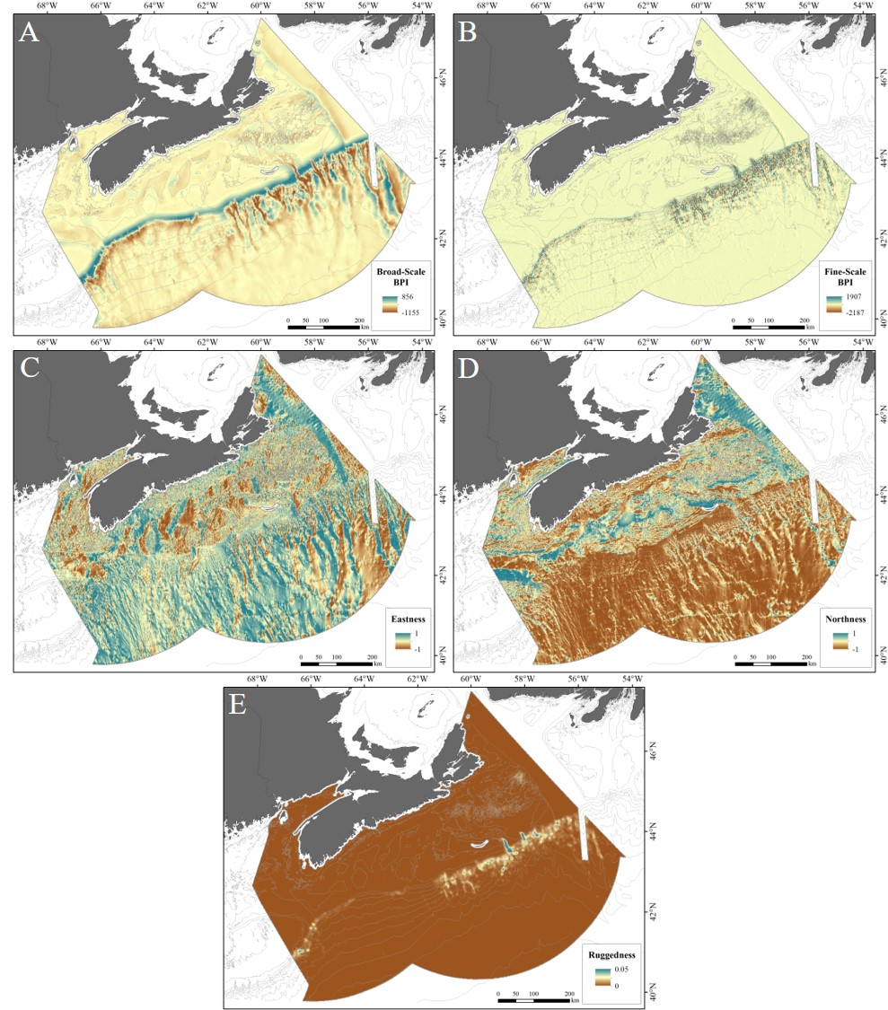
Figure 1. Maps of some terrain variables in the study area. A) Broad-Scale BPI; B) Fine-Scale BPI; C) Eastness; D) Northness; E) Ruggedness (VRM).
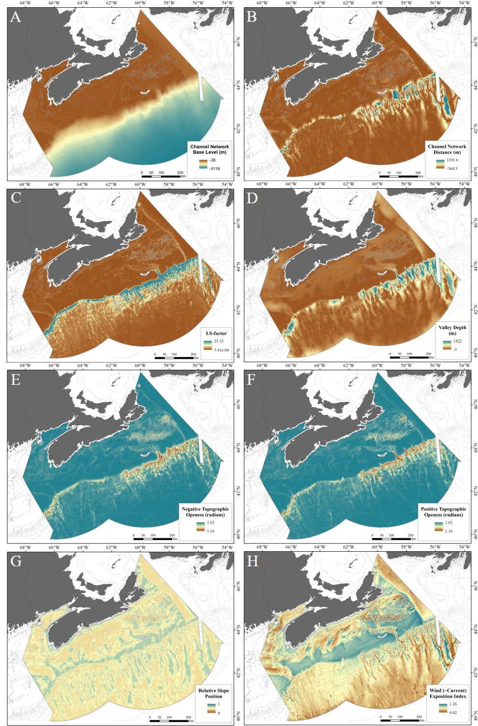
Figure 2. Maps of some terrain variables in the study area. A) Channel Network Base Level; B) Channel Network Distance; C) LS-Factor; D) Valley Depth; E) Negative Topographic Openness; F) Positive Topographic Openness; G) Relative Slope Position; H) Wind Exposition Index.
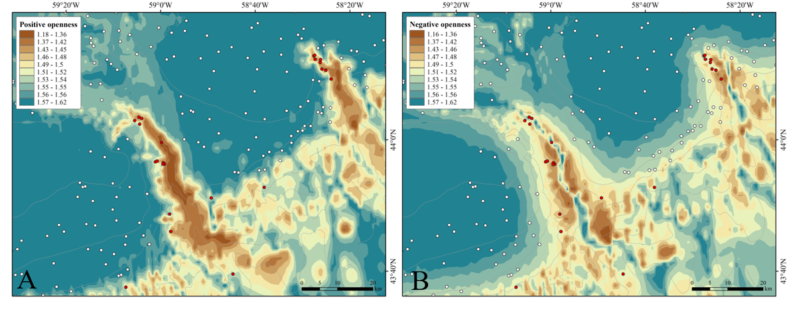 Figure 3. Close-up views of A) Positive Topographic Openness, and B) Negative Topographic Openness, overlain with records of the occurrence of P. arborea (red dots) and its assumed absence (white dots). The portion of the study area shown includes The Gully (centre) and Shortland Canyon (right).
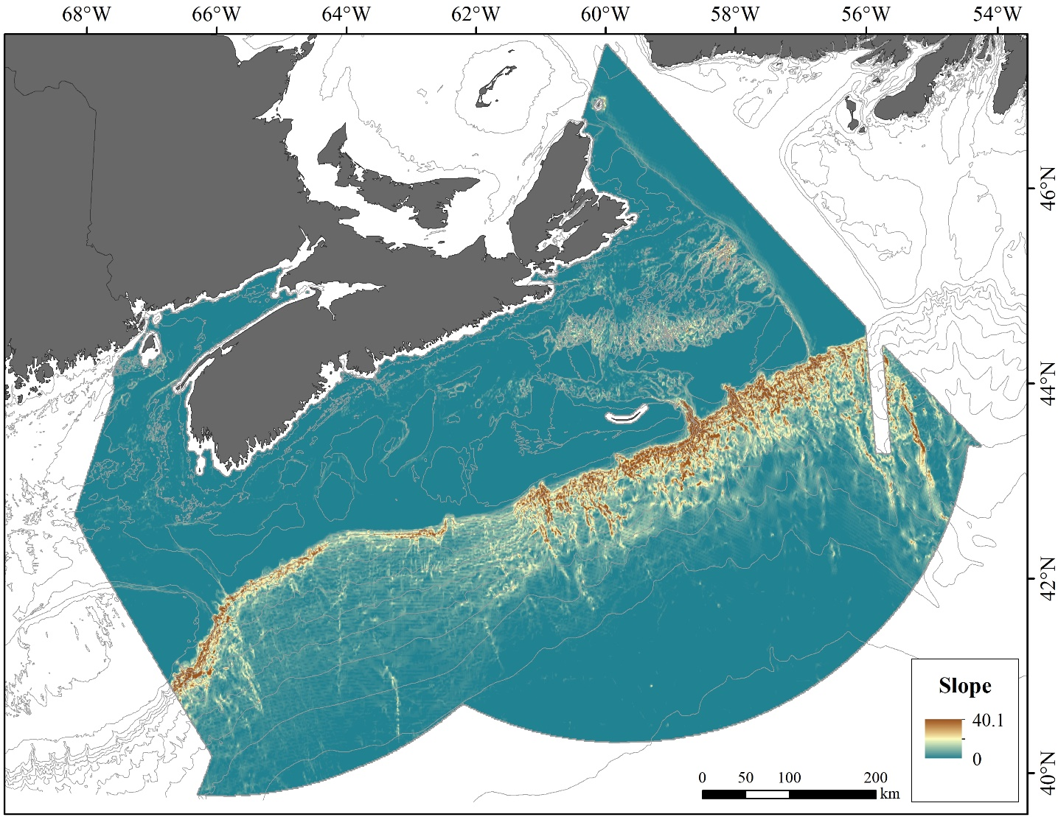
Figure 4. Map of Slope in the study area highlighting the steep slopes along the shelf break and along the wall of the Laurentian Channel (see Figure 2 of main text for placenames).
References
Beazley, L., Kenchington, E., Murillo, F.J., Brickman, D., Wang, Z., Davies, A.J., Roberts, E.M., and Rapp, H.T. (2021). Data from: Climate change winner in the deep sea? Predicting the impacts of climate change on the distribution of the glass sponge Vazella pourtalesii. Mendeley Data, V1. http://dx.doi.org/10.17632/vm4bjn7g74.1
Conrad, O., Bechtel, B., Bock, M., Dietrich, H., Fischer, E., Gerlitz, L., et al. (2015). System for Automated Geoscientific Analyses (SAGA) v. 2.1.4, Geosci. Model Dev. 8, 1991–2007. doi:10.5194/gmd-8-1991-2015
Kenchington, E., Lirette, C., Murillo, F.J., Beazley, L., and Downie, A.-L. (2019). Vulnerable Marine Ecosystems in the NAFO Regulatory Area: Updated Kernel Density Analysis of Vulnerable Marine Ecosystem Indicators. NAFO SCR Doc. 19/058, Serial No. N7030, 68 p. https://www.nafo.int/Portals/0/PDFs/sc/2019/scr19-058.pdf
Sappington, J.M., Longshore, K.M., and Thompson, D.B. (2007). Quantifying landscape ruggedness for animal habitat analysis: A case study using bighorn sheep in the Mojave Desert. J. Wildl. Manag. 71, 1419–1426.
Walbridge, S., Slocum, N., Pobuda, M., and Wright, D.J. (2018). Unified geomorphological analysis workflows with Benthic Terrain Modeler. Geosciences 8, 94. doi:10.3390/geosciences8030094
Wright, D.J., Pendleton, M., Boulware, J., Walbridge, S., Gerlt, B., Eslinger, D., et al. (2012). ArcGIS Benthic Terrain Modeler (BTM), v. 3.0, Environmental Systems Research Institute, NOAA Coastal Services Center, Massachusetts Office of Coastal Zone Management. http://esriurl.com/5754 [Accessed October 4, 2021].
Yokoyama, R., Shirasawa, M., Pike, R.J. (2002). Visualizing topography by openness: A new application of image processing to digital elevation models. Photogramm. Eng. Remote Sensing 68, 251–266.

Comparison of Ocean Models for Particle Tracking Experiments
Because LPT results depend on the underlying oceanographic model, the outputs from BNAM-based tracking, used in our study, were compared with those of alternative simulations drawn from the Global Ocean Physics Reanalysis (GLORYS) model (Wang et al., 2021). Both models have been validated using observational data (Wang et al., 2018; Lellouche et al., 2021) but their available outputs differ, GLORYS12VI products being available as daily-mean, monthly-mean and pluri-annual-climatology-mean values from 1993-2019 (Fernandez and Lellouche, 2021). We therefore selected a single year, 2010, and the winter season for inter-model comparisons. Particle trajectories at the surface, where faster current velocities are expected to maximize connectivities, were obtained using 5-day- and monthly-averaged products from BNAM and compared with ones using the daily-averaged products from GLORYS12V1. The diffusivity constant was applied in BNAM to partially compensate for the time-averaging (Wang et al., 2021) but was not required with the daily-averaged outputs from the GLORYS12V1 model. Particles were released daily for 90 days from within each of the 23 source boxes (Supplementary Table 4).
The simulation experiments (Table 1) performed using the two averaging periods (monthly and 5-day) for the currents derived from BNAM showed a more diffuse pattern in the particle trajectories for the shorter averaging period (Figure 1) as expected, since the loss of variability through averaging is reduced. However, the number and strength of the connections between source boxes were similar among simulations and became increasingly so with increased PLD (Figure 2). The simulations using BNAM current outputs show connectivity among source boxes in the deeper water areas of the Scotian Slope (upper slope areas 5, 6, 8–11, deep-slope areas 17–23) and among source boxes on the Scotian Shelf (areas 7, 13–16). Only when PLD was extended to 3 months did the simulations using GLORYS12VI products show those same broad patterns, and then with fewer connections among the slope stations, and among the shelf stations. Retention was not common with any of the simulations, even with a PLD of two weeks.
Table 1. Summary of LPT experiments performed to evaluate the influence of the choice of ocean model on particle trajectories and connectivity. Particles were released at the surface within each source box, during the winter of 2010.

Ocean Model | Averaging Period | Surface Release PLD | K_{h} (m² s⁻¹)
BNAM | Month | 2 wk | 52.1
BNAM | Month | 1 mo | 52.1
BNAM | Month | 3mo | 52.1
BNAM | 5-day | 2 wk | 52.1
BNAM | 5-day | 1 mo | 52.1
BNAM | 5-day | 3mo | 52.1
BNAM | 5-day | 2 wk | 0
BNAM | 5-day | 1 mo | 0
BNAM | 5-day | 3mo | 0
GLORYS12VI | Daily | 2 wk | 0
GLORYS12VI | Daily | 1 mo | 0
GLORYS12VI | Daily | 3mo | 0

The number of particles connecting with simulations using the BNAM 5-day mean current and K_{h}=0 m² s⁻¹ were similar (although with more connections) to the simulations using the GLORYS12VI current outputs with daily mean current and K_{h}=0 m² s⁻¹. Adding diffusivity increased connectivity as expected (compare BNAM 5-day simulations with and without K_{h}, Figure 2).
With zero K_{h}, LPT simulations based on BNAM 5-day mean currents and those based on GLORYS12VI daily mean currents generated similar numbers of particles that moved among source boxes, though more source boxes were connected with the former. However, adding positive horizontal diffusivity (K_{h}) in BNAM increased connectivity, as expected (Figure 2).

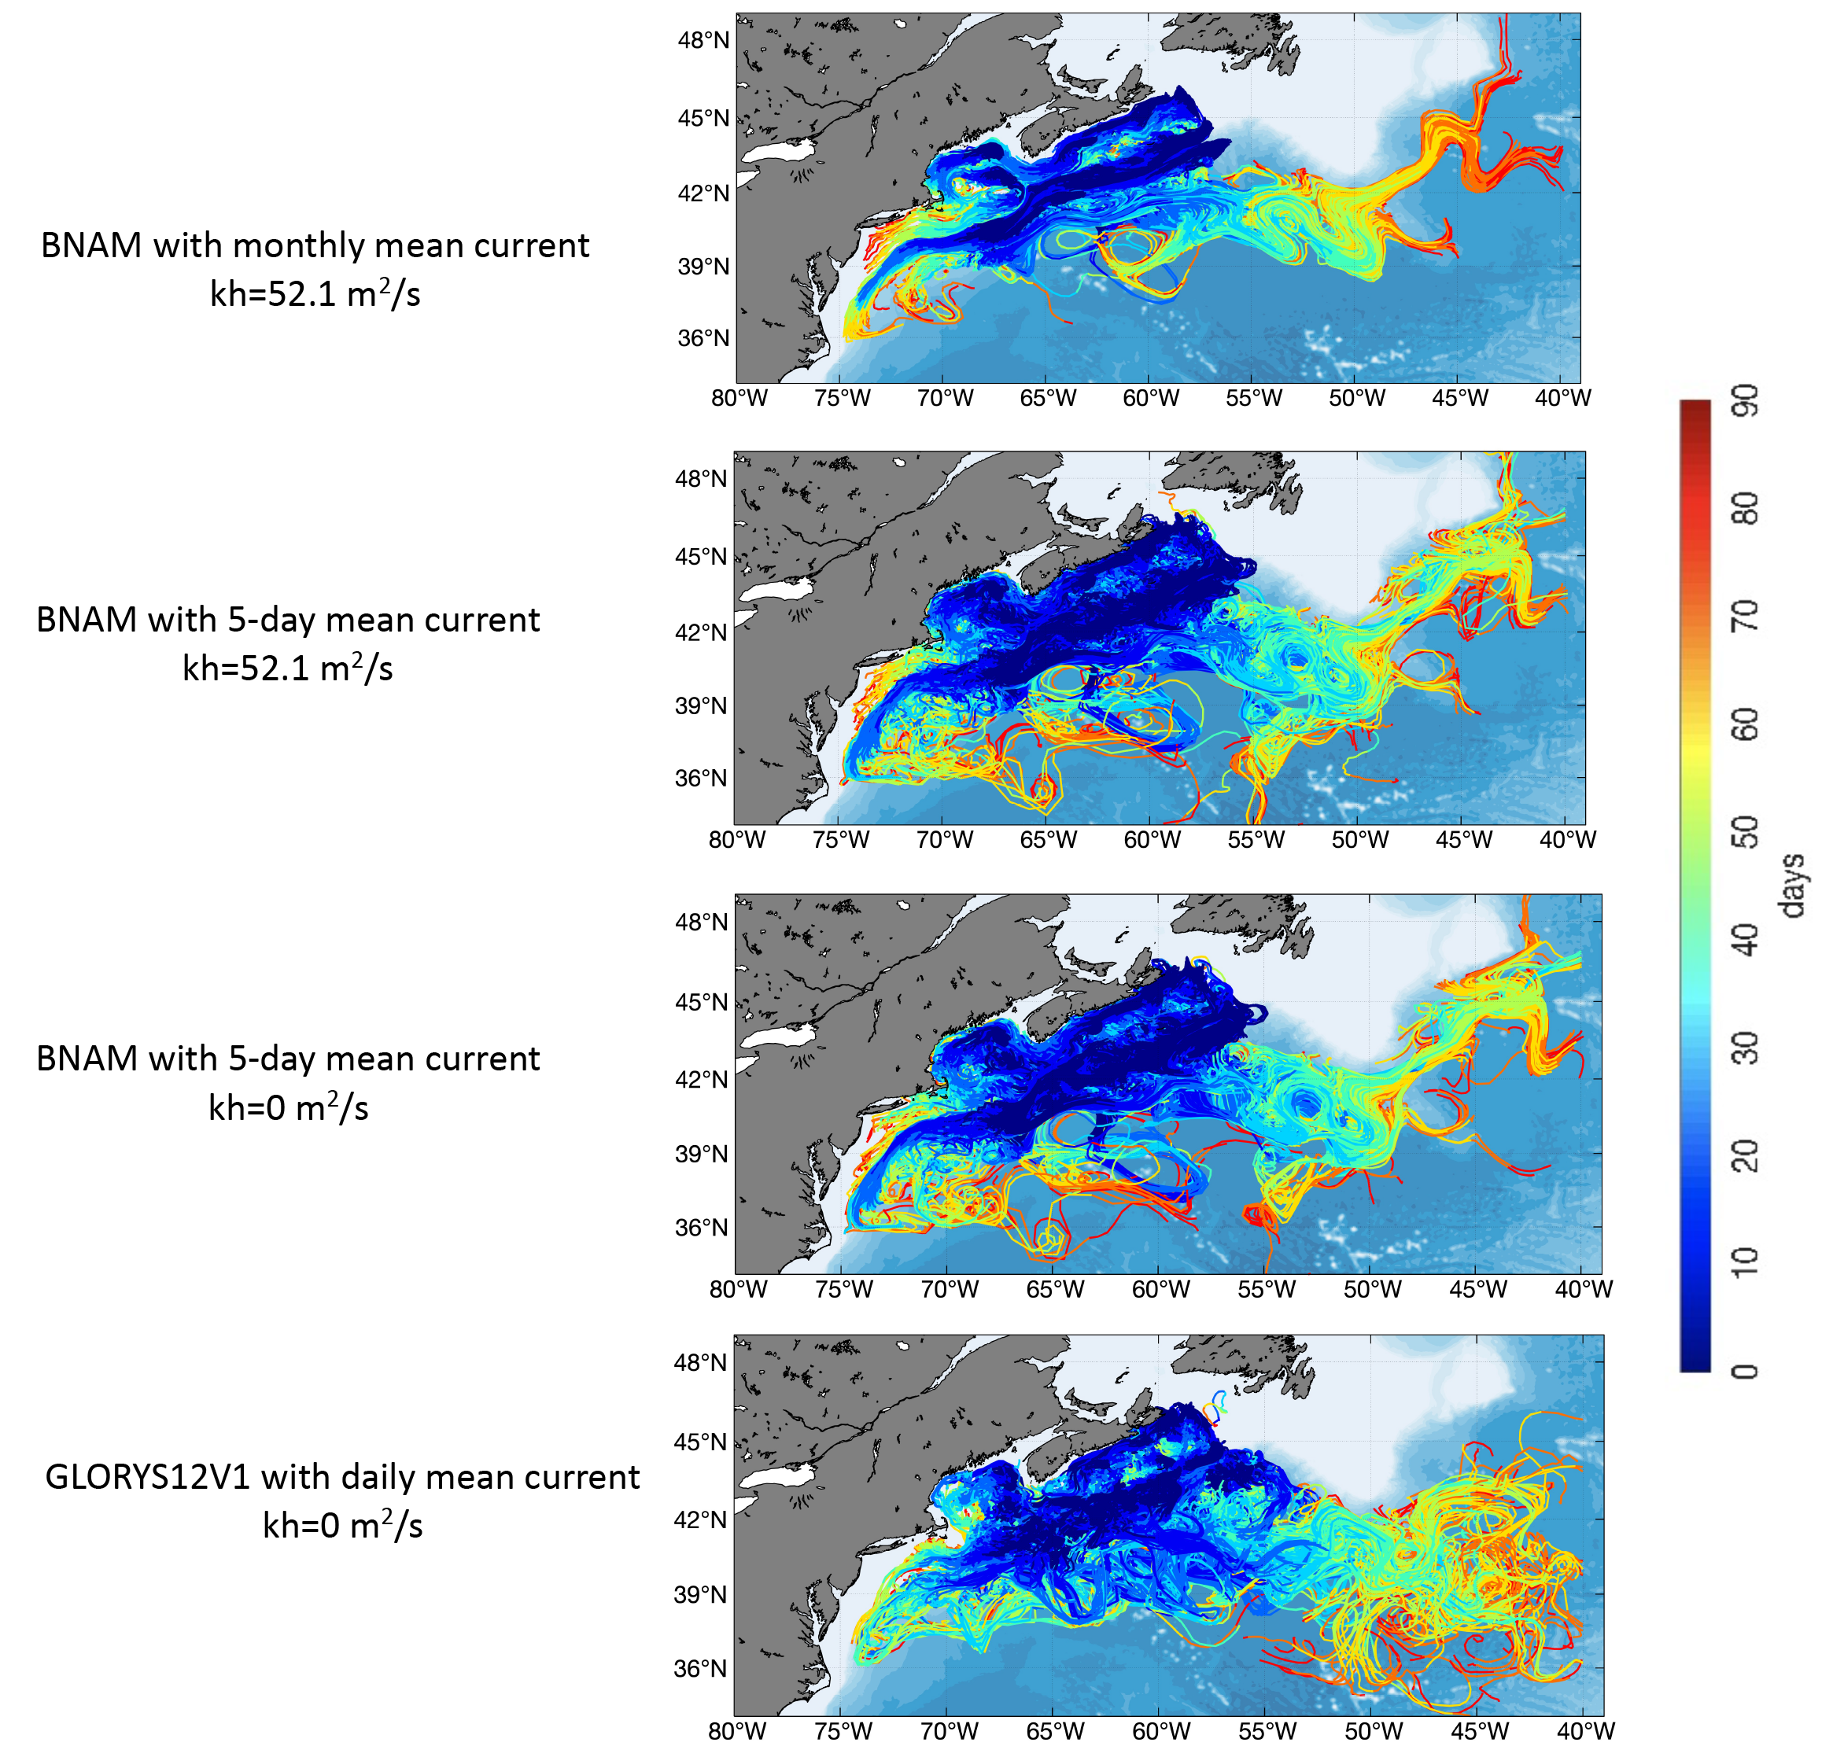
Figure 1. Particle trajectories over 90 days for surface releases during winter 2010 within each of the 23 source boxes, using alternative ocean models (BNAM and GLORYS12VI), and averaging periods (see Table 1).

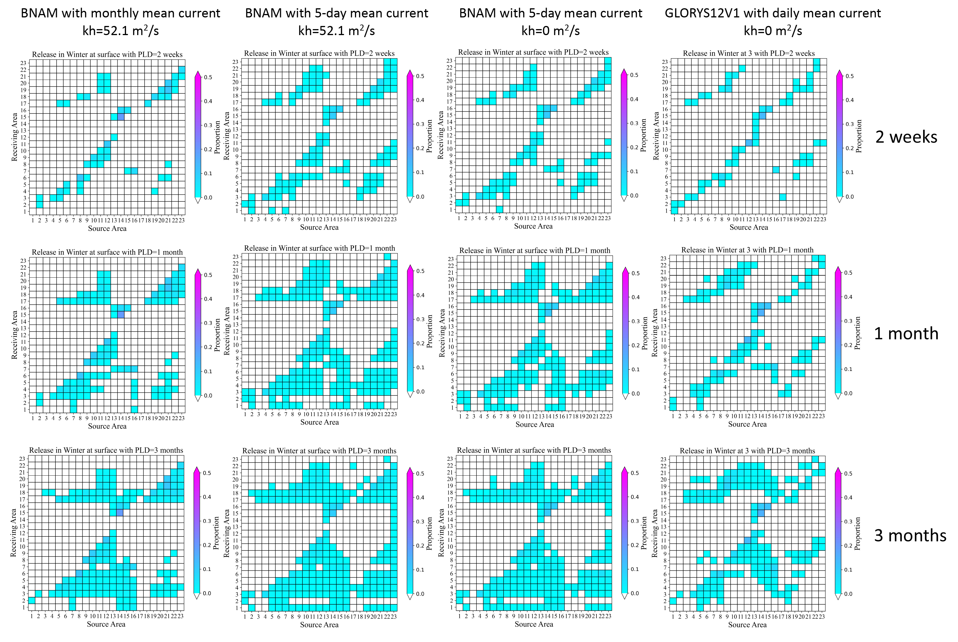
Figure 2. Proportions of virtual particles released at the surface of each source box (see: Supplementary Table 4, Figure 3 of main text) that pass over or terminate in each source box (termed: “Receiving Area”), during 2-week (upper row), 1-month (middle row) and 3-months (lower row) in winter 2010, using alternative ocean models (BNAM and GLORYS12VI), and averaging periods for the currents (see Table 1). A diffusivity constant (K_{h}) was applied in the models using BNAM ocean currents. Shading on the major diagonal indicates particle retention in the source box at the end of the PLD.

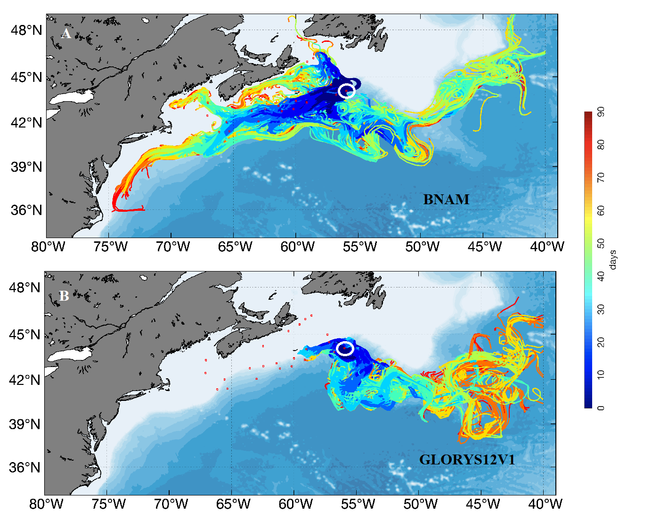

Figure 3. Trajectories over 90 days of particles released at the surface of Source Box 23 (white circle) during winter 2010 using alternative ocean models: A) BNAM with 5-day mean currents; B) GLORYS12VI with daily-averaged currents. No diffusivity constant (K_{h}) was applied to either simulation. Locations of other source boxes are outlined in red.

Specific differences among the ocean model products are evident in the connectivity matrices. For example, Source Box 23 was connected to four other source boxes in simulations based on GLORYS12VI products but to 17 with LPT models based on BNAM products (Figures 1, 2, 3). Other differences were seen in connections made by particles released from Source Boxes 20, 21 and 22. Closer examination of the particle trajectories of releases from Source Box 23 found that GLORYS12VI indicated surface currents very different from those calculated by BNAM in that particular area. BNAM generated results consistent with the known oceanography of the region, with initial southwesterly advection by the Shelf Break Current particularly evident, though often followed by entrainment into the Warm Slope Water and subsequent transport to the east (Figure 3). In contrast, GLORYS12VI suggested that most of the water was initially advected towards the southeast – contrary to field evidence (Figure 3). As GLORYS12VI, in contrast to BNAM, has not been tested against observational data from the deep-slope portion of our study area, we relied on BNAM for the LPT modelling reported in our main text.

References
Fernandez, E., and Lellouche, J.M. (2021). Product User Manual For the Global Ocean Physical Reanalysis product GLOBAL_REANALYSIS_ PHY_001_030. Issue 1.2. EU Copernicus Marine Service – Public Ref: CMEMS-GLO-PUM-001-030.
Lellouche, J.-M., Bourdallé-Badie, R., Bricaud, C., Melet, A., and Garric, G. (2021). The Copernicus global 1/12° oceanic and sea ice reanalysis. Abstract retrieved from the Canadian Meteorological and Oceanographic Society (CMOS) 2021 Scientific Congress, Session 860 Developing Ocean Modelling Capacity in Canada - Part 1 ID: 10948.
Wang, S., Kenchington, E., Wang, Z., and Davies, A.J. (2021). Life in the fast lane: Modeling the fate of glass sponge larvae in the Gulf Stream. Front. Mar. Sci. 8:701218. doi: 10.3389/fmars.2021.701218
Wang, Z., Brickman, D., and Greenan, B.J.W. (2019). Characteristic evolution of the Atlantic Meridional Overturning Circulation from 1990 to 2015: An eddy-resolving ocean model study. Deep Sea Res. I 149, 103056. doi: 10.1016/j.dsr.2019.06.002
Wang, Z., Lu, Y., Greenan, B., and Brickman, D. (2018). BNAM: An eddy-resolving North Atlantic Ocean model to support ocean monitoring. Can. Tech. Rep. Hydrogr. Ocean Sci. 327: vii + 18p.

Assessment of the Impact of Response Curves in Regional vs. Basin-Scale Models Under Climate Change Projections
The distributions of the response data-sets (presences and assumed absences of Paragorgia arborea) used in our study and that of Morato et al. (2020) are mapped in Figure 1 in relation to calcite saturation state (an important environmental predictor in their basin-scale modelling), as it exists under present-day conditions. All of the records of P. arborea presence used in our modelling fall within a narrow range of calcium saturation.
This variable was not included in our principal modelling because of the limited observational data available for our region but we added it to an additional RF model along with our suite of 8 predictors used for our projections to future climate conditions. That produced a bimodal response curve for calcite saturation state at the seabed (Figure 2A), with one peak, comprising records located in the Northeast Channel, at saturation states between 3.1 and 3.4 and the other, with values below 2.7, containing mainly records from the eastern Scotian Slope (Figure 2C). In our study area, probability of P. arborea presence curve increases with low values of calcite saturation. In contrast, the modelling of Morato et al. (2020) led to a response curve with a single peak, at values between 2 and 4, which predicts low probabilities for values below 2 (Figure 2B).
That marked contrast was partly an artifact arising from the use of pseudo-absences and the compilation of data across the North Atlantic. At that basin scale, there are large areas of seabed with low levels of calcite saturation and no P. arborea, though for reasons unconnected with calcite availability. Thus, Morato et al. (2020) found that 2.52% of their total P. arborea presences and 32% of the absences were in locations with calcite saturation < 2.4. In contrast, in our study 3.48% of the presences but only 0.42% of absences had such low saturation, a dichotomy which leads to the very different response curves. Thus, our study area is projected to have calcite saturation < 2.4 in future (Figure 2D) using the results of the basin-scale study. Combining that result with the response curve from our model leads to an improbable projection of a very high probability of P. arborea presence across most of our study area (Figure 2E), reversing the (also unrealistic) conclusion of Morato et al. (2020). Similar results were seen with the POC flux variable when we treated it in the same way, which was the second most important variable in the Morato et al. (2020) RF models.

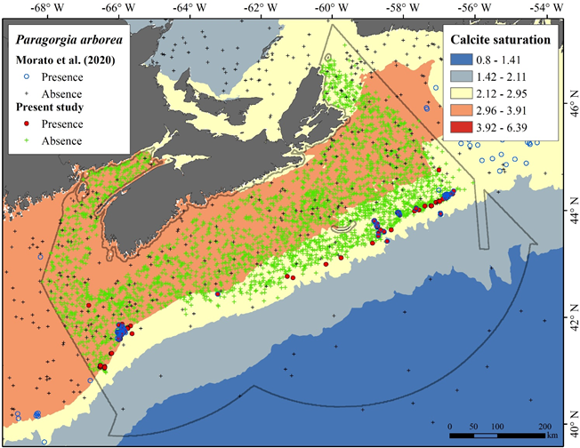

Figure 1. Calcite saturation state at the seafloor under present-day conditions as reported in the basin-scale study of Morato et al. (2020). Red filled circles indicate locations of P. arborea records and green crosses those of assumed absences in our response data. Blue open circles indicate the location of presences and black crosses those of pseudo-absences used in the Morato et al. (2020) study.

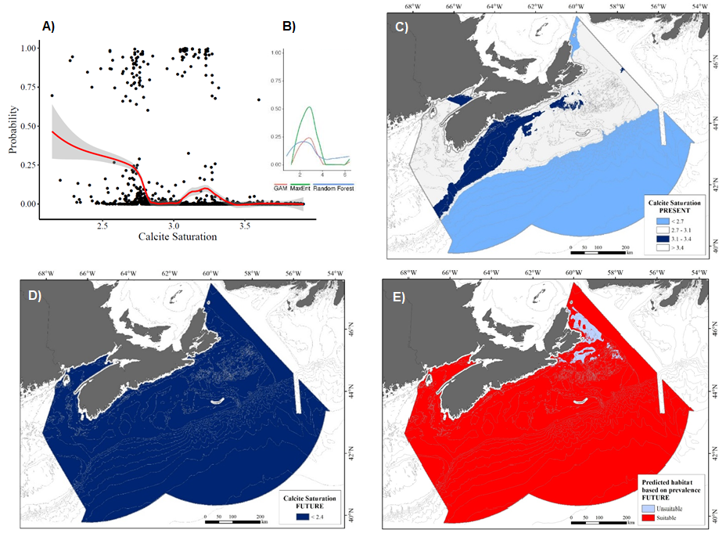

Figure 2. A) Response curve to calcite saturation state at the seabed (obtained from Morato et al (2020) clipped to our study area) for Paragorgia arborea, as determined by RF modelling using the 8 environmental predictors in combination with calcite saturation, and response data from our study; B) Extract from Supplementary Figure S6b of Morato et al. (2020) showing response curves for calcite saturation state at the seafloor for P. arborea as determined by the three different modelling approaches: GAM, maximum entropy model (Maxent) and RF modelling; C) Distribution of calcite saturation at the seabed in the study area under present-day conditions using predictor data from Morato et al. (2020) clipped to our study area (shades of blue indicate the two peaks in A); D) Projected distribution of calcite saturation in the study area under 2100 conditions, from Morato et al. (2020) clipped to our study area; E) Projected distribution of P. arborea habitat, using the RF model with the 8 environmental predictors and calcite saturation state at the seabed.
References
Morato, T., González-Irusta, J.-M., Dominguez-Carrió, C., Wei, C.-L., Davies, A., Sweetman, A. K., et al. (2020). Climate-induced changes in the suitable habitat of cold-water corals and commercially important deep-sea fishes in the North Atlantic. Glob. Change Biol. 26, 2181–2202.

https://resources.marine.copernicus.eu/?option=com_csw&view=details&product_id=GLOBAL_REANALYSIS_PHY_001_030 [Accessed October 6, 2021]

