Supplementary Online Material
for

Upscaling methane flux from plot level to eddy covariance tower domains in five Alaskan tundra ecosystems

Yihui Wang¹, Fengming Yuan², Kyle A. Arndt³, Jianzhao Liu⁴, Liyuan He¹, Yunjiang Zuo⁴, Donatella Zona¹, David A. Lipson¹, Walter C. Oechel¹, Daniel M. Ricciuto², Stan D. Wullschleger², Peter E. Thornton², and Xiaofeng Xu^{1*}

1. Department of Biology, San Diego State University, San Diego, CA, USA,

2. Environmental Sciences Division, Oak Ridge National Laboratory, Oak Ridge, TN, USA,

3. Earth Systems Research Center, Institute for the Study of Earth, Oceans, and Space, University of New Hampshire, Durham, NH, USA,

4. Key Laboratory of Wetland Ecology and Environment, Northeast Institute of Geography and Agroecology, Chinese Academy of Sciences, Changchun, Jilin, China

Corresponding author: X.X: xxu@sdsu.edu

This file contains Figure S1-S19 and Table S1-S5.

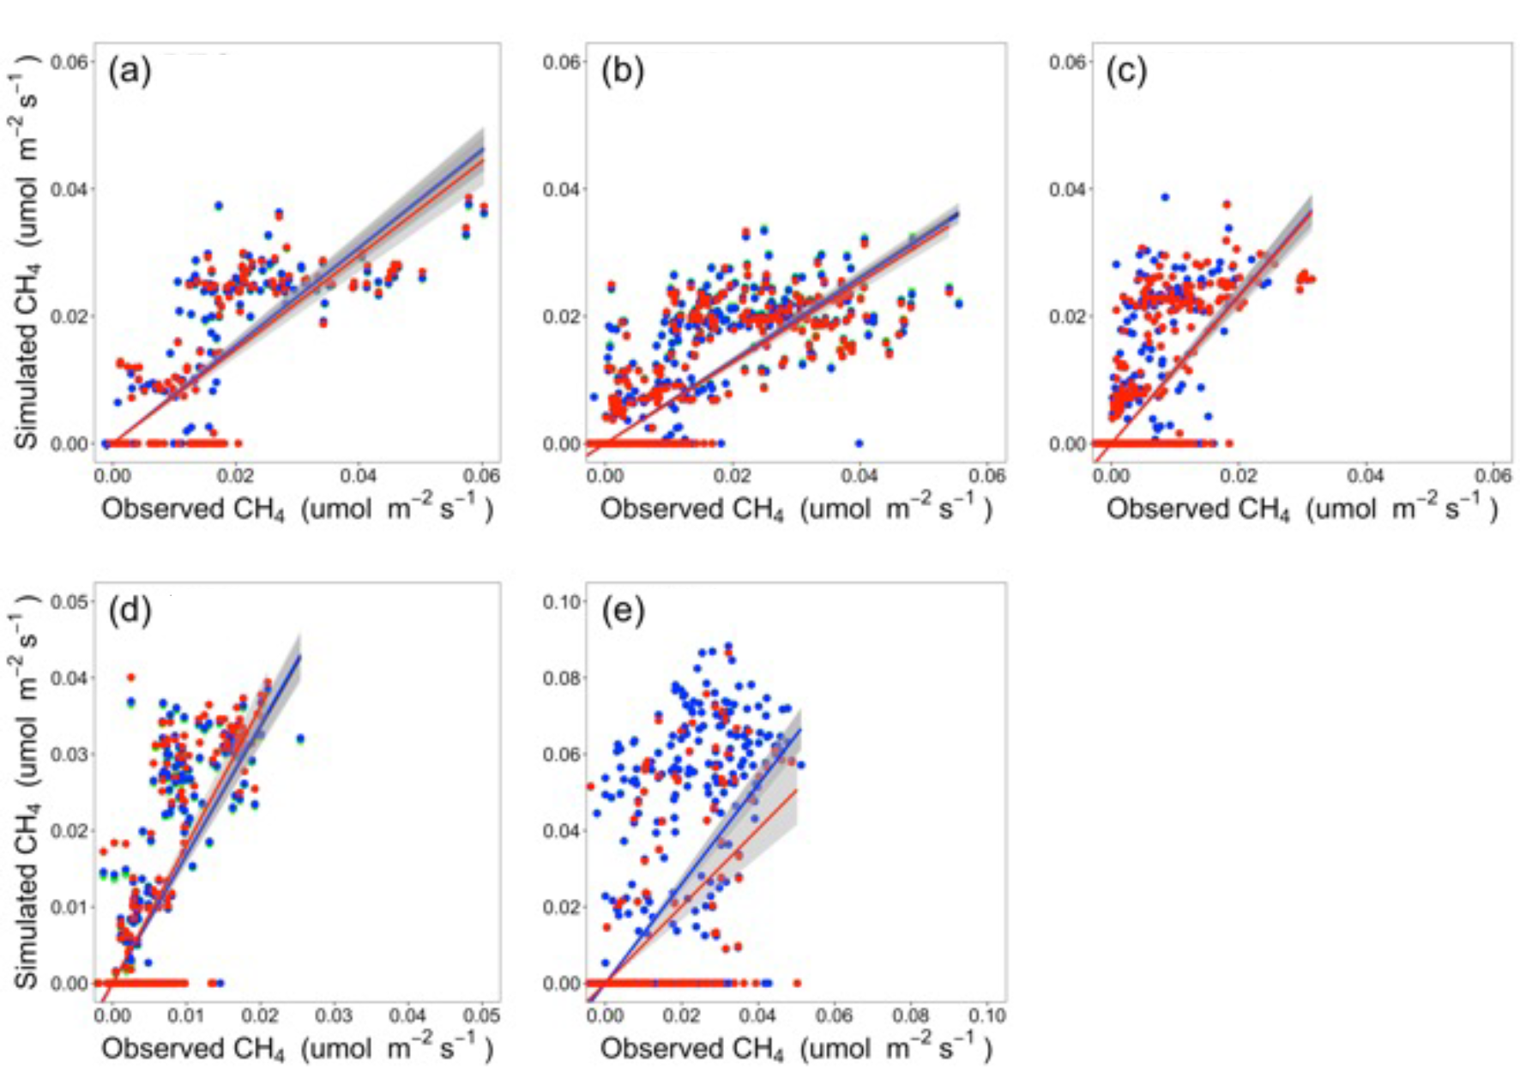
Figure S1. Scatter plots of observed versus simulated CH₄ flux for (a) US-Beo, (b) US-Bes, (c) US-Brw, (d) US-Atq, and (e) US-Ivo in 2013-2015 with linear lines of best fit (no interception) and 95% confidence interval for regression line shaded gray. The green lines and points indicate the relationship between observed fluxes and upscaled fluxes using the homogeneous footprint (HF) algorithm overlapped by blue lines and points. The blue lines and points indicate the relationship between observed fluxes and upscaled fluxes using the gradient footprint (GF) algorithm. The red lines and points indicate the relationship between observed fluxes and upscaled fluxes using dynamic footprint (DF) algorithm. Most of green lines and points were overlapped by the blue lines and points.

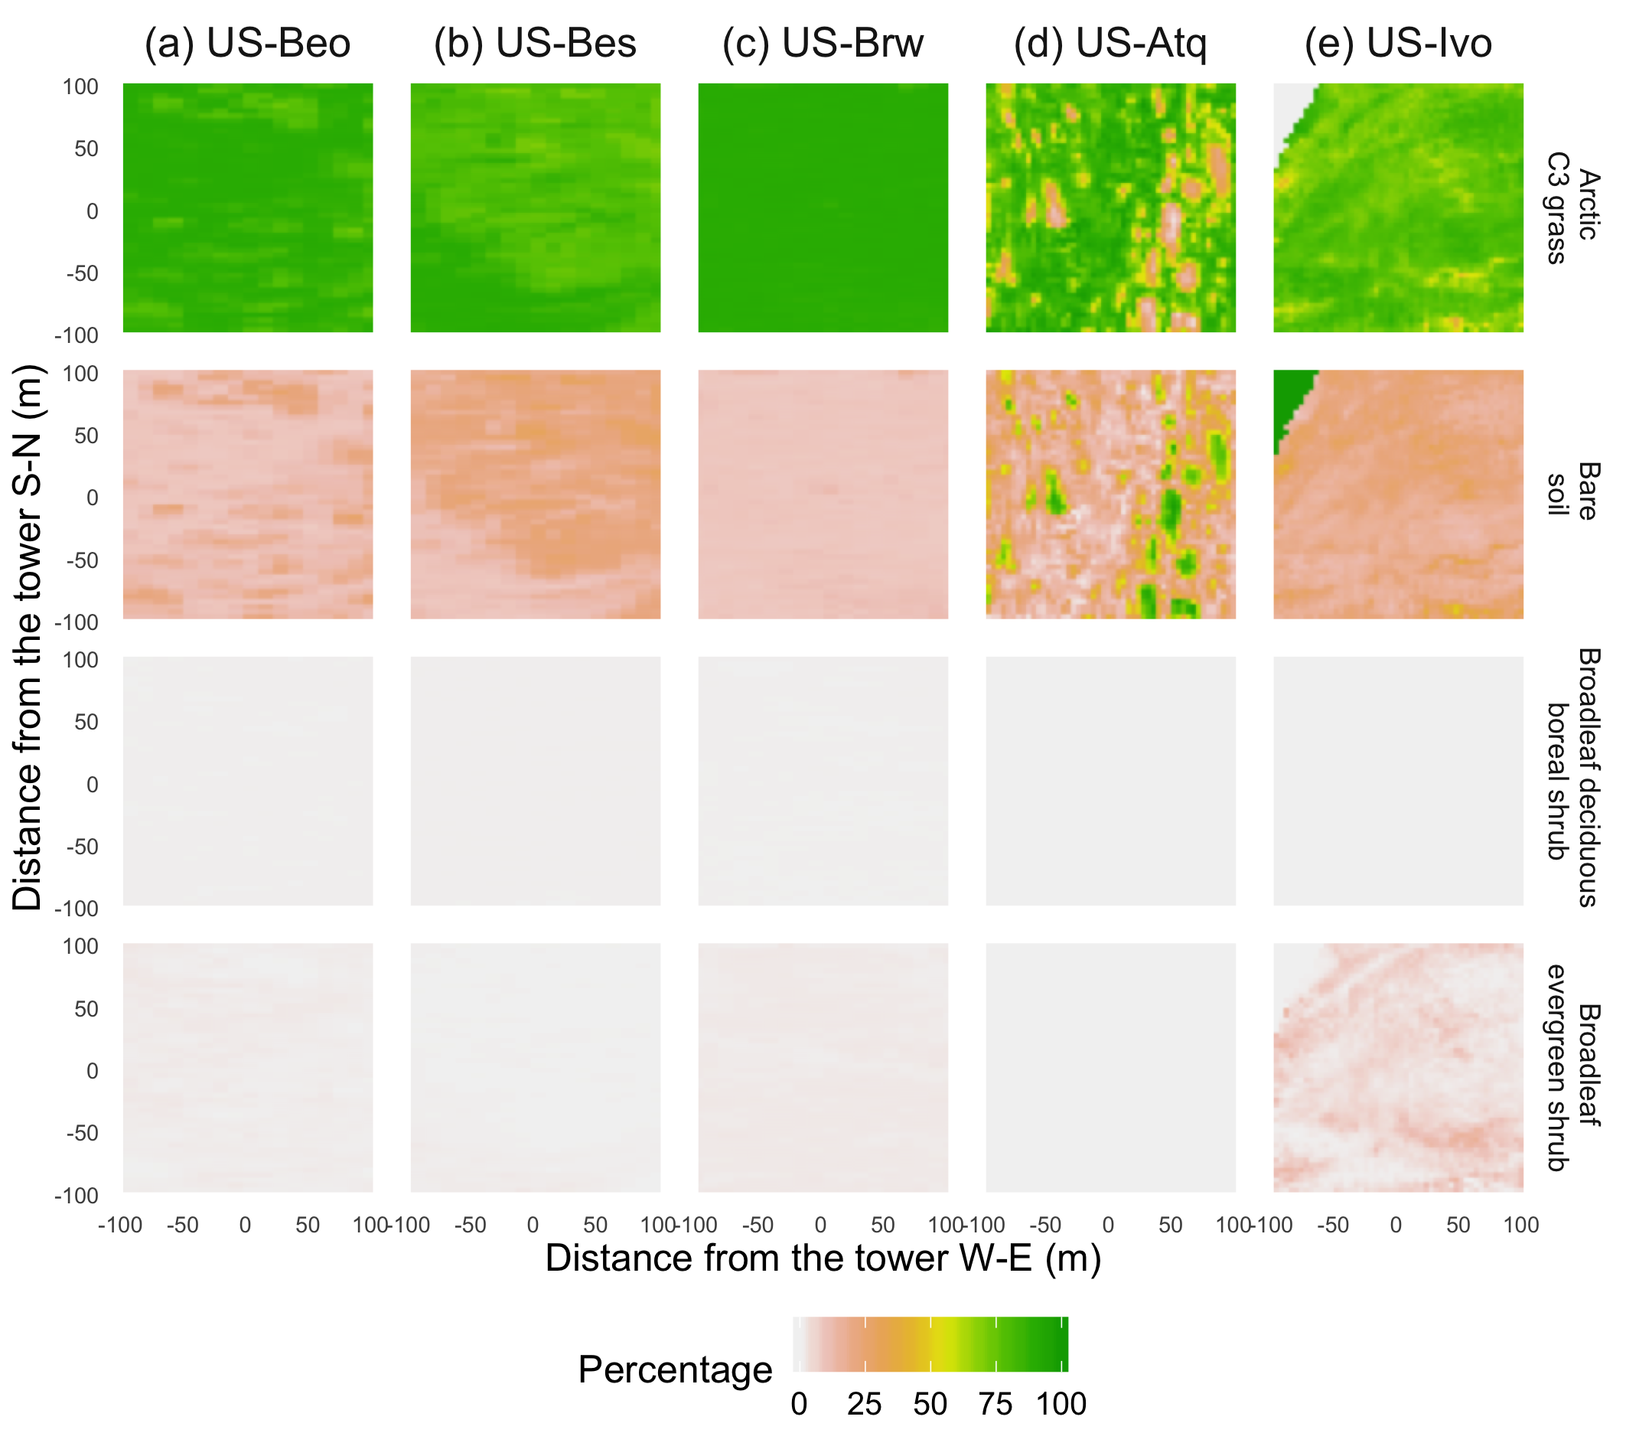

Figure S2. Vegetation maps of four plant functional types defined in the CLM-Microbe model in an area of 200 m × 200 m for all study sites

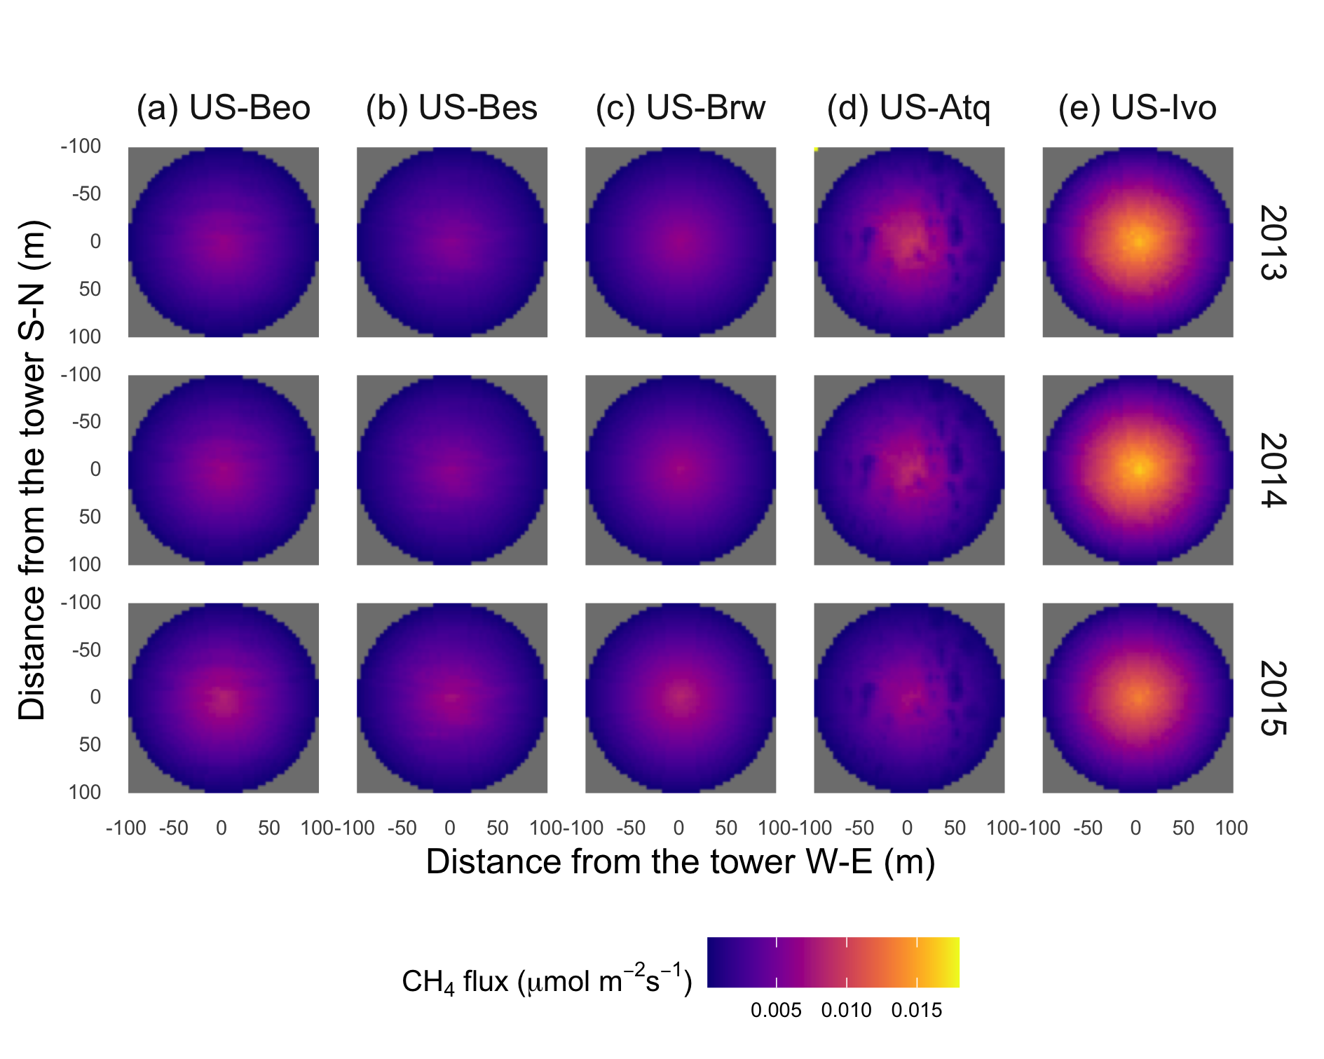

Figure S3. Spatial patterns of upscaled CH₄ emission rates based on the “gradient” footprint (GF) algorithm in an area of 200 m × 200 m from 2013 to 2015 for all study sites

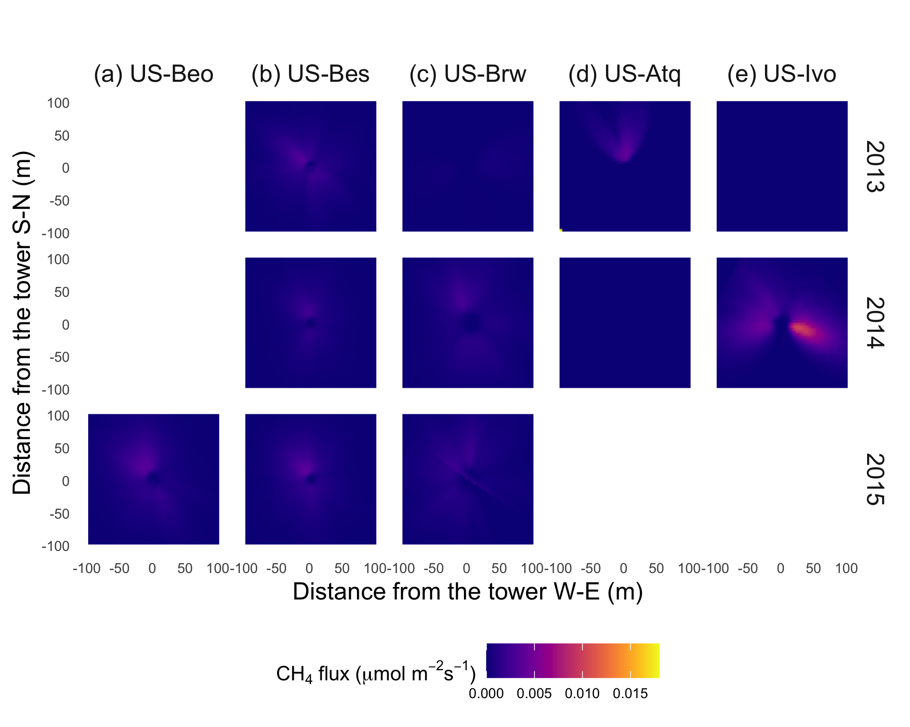

Figure S4. Spatial patterns of upscaled CH₄ emission rates based on the “dynamic” footprint (DF) algorithm in an area of 200 m × 200 m from 2013 to 2015 for all study sites

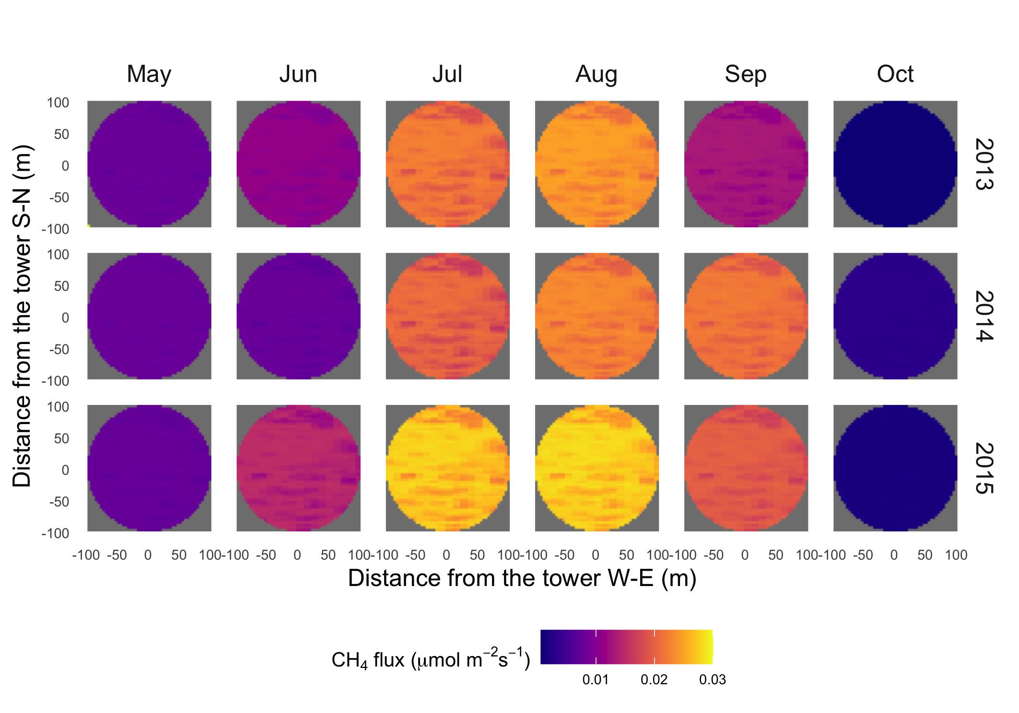
Figure S5. Spatial distribution of upscaled CH₄ flux using the homogeneous footprint (HF) algorithm for each month in 2013-2015 for US-Beo (flux was zero in January, February, March, April, November, and December)

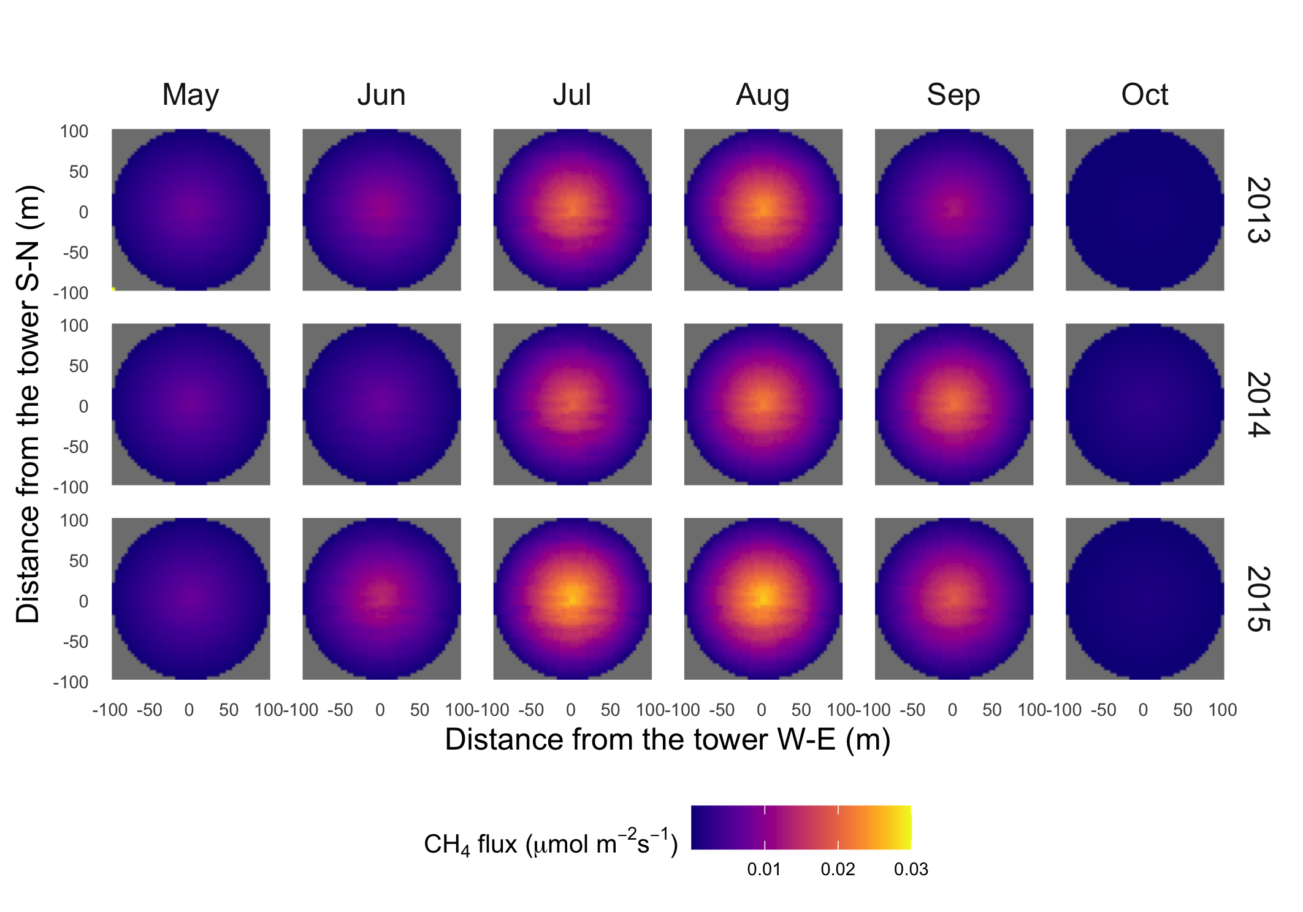
Figure S6. Spatial distribution of upscaled CH₄ flux using the gradient footprint (GF) algorithm for each month in 2013-2015 for US-Beo (flux was zero in January, February, March, April, November, and December)

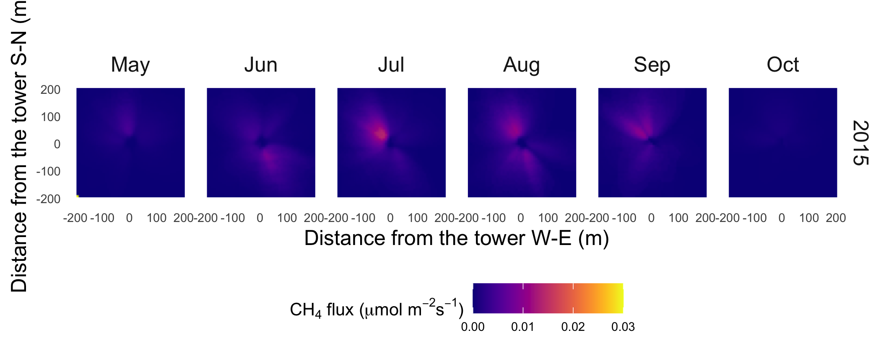
Figure S7. Spatial distribution of upscaled CH₄ flux using the dynamic footprint (DF) algorithm for each month in 2015 for US-Beo (flux was zero in January, February, March, April, November, and December)

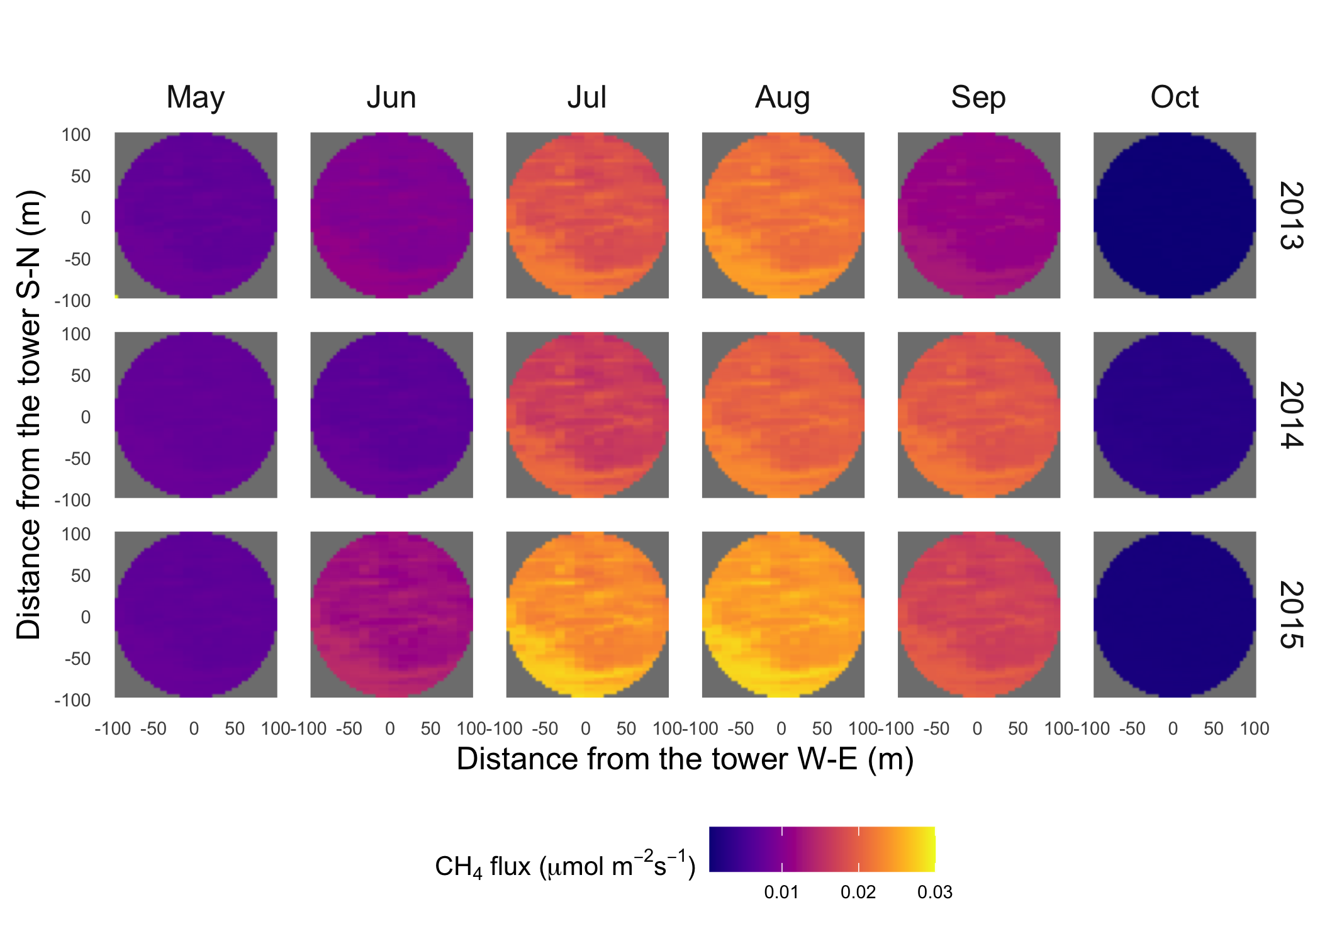
Figure S8. Spatial distribution of upscaled CH₄ flux using the homogeneous footprint (HF) algorithm for each month in 2013-2015 for US-Bes (flux was zero in January, February, March, April, November, and December)

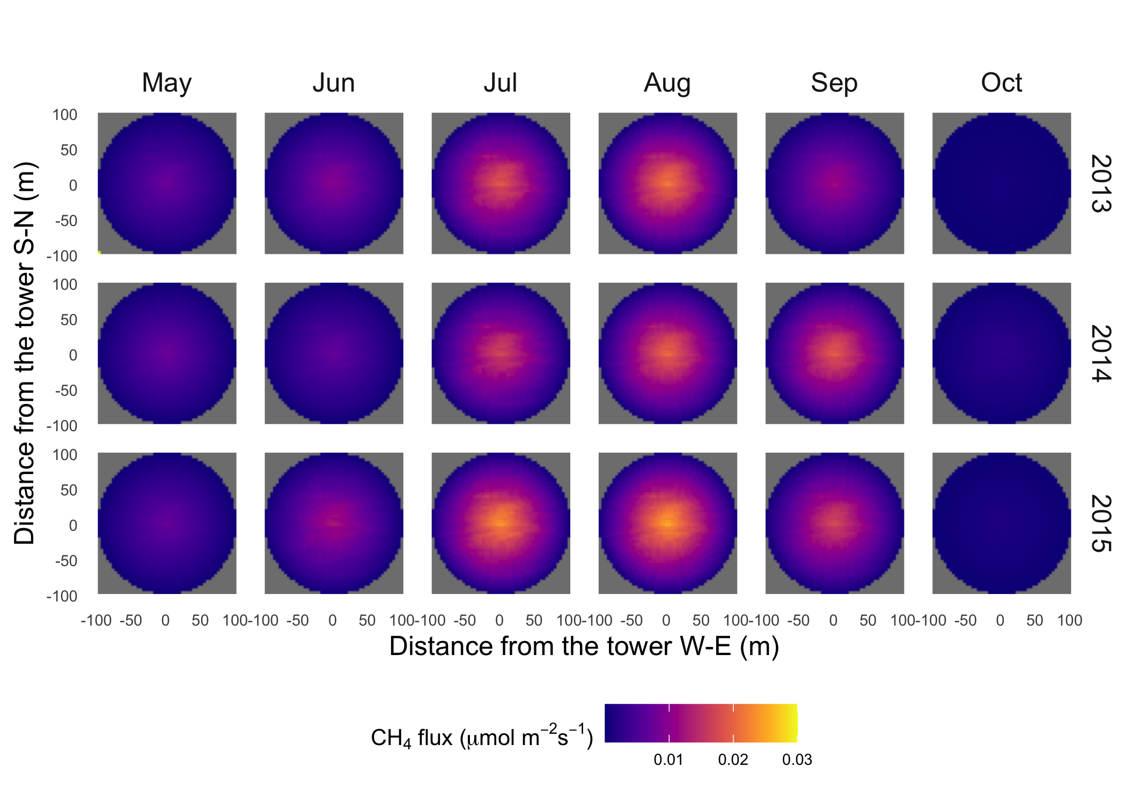
Figure S9. Spatial distribution of upscaled CH₄ flux using the gradient footprint (GF) algorithm for each month in 2013-2015 for US-Bes (flux was zero in January, February, March, April, November, and December)

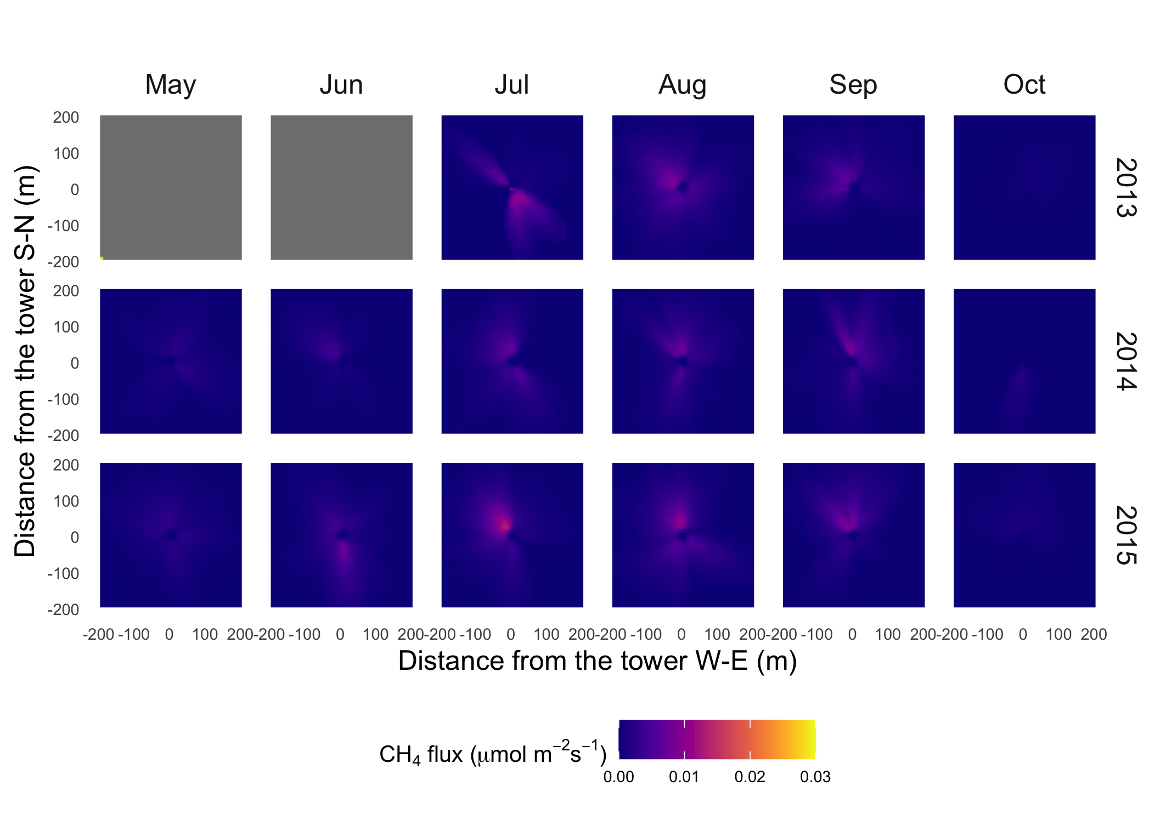
Figure S10. Spatial distribution of upscaled CH₄ flux using the dynamic footprint (DF) algorithm for each month in 2013-2015 for US-Bes (flux was zero in January, February, March, April, November, and December)

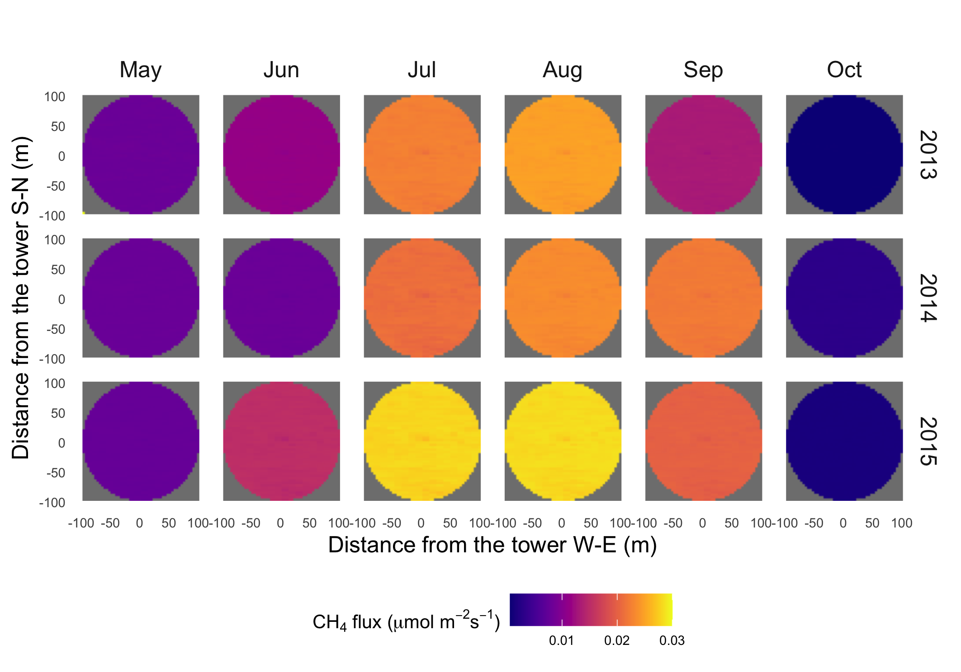
Figure S11. Spatial distribution of upcaled CH₄ flux using the homogeneous footprint (HF) algorithm for each month in 2013-2015 for US-Brw (flux was zero in January, February, March, April, November, and December)

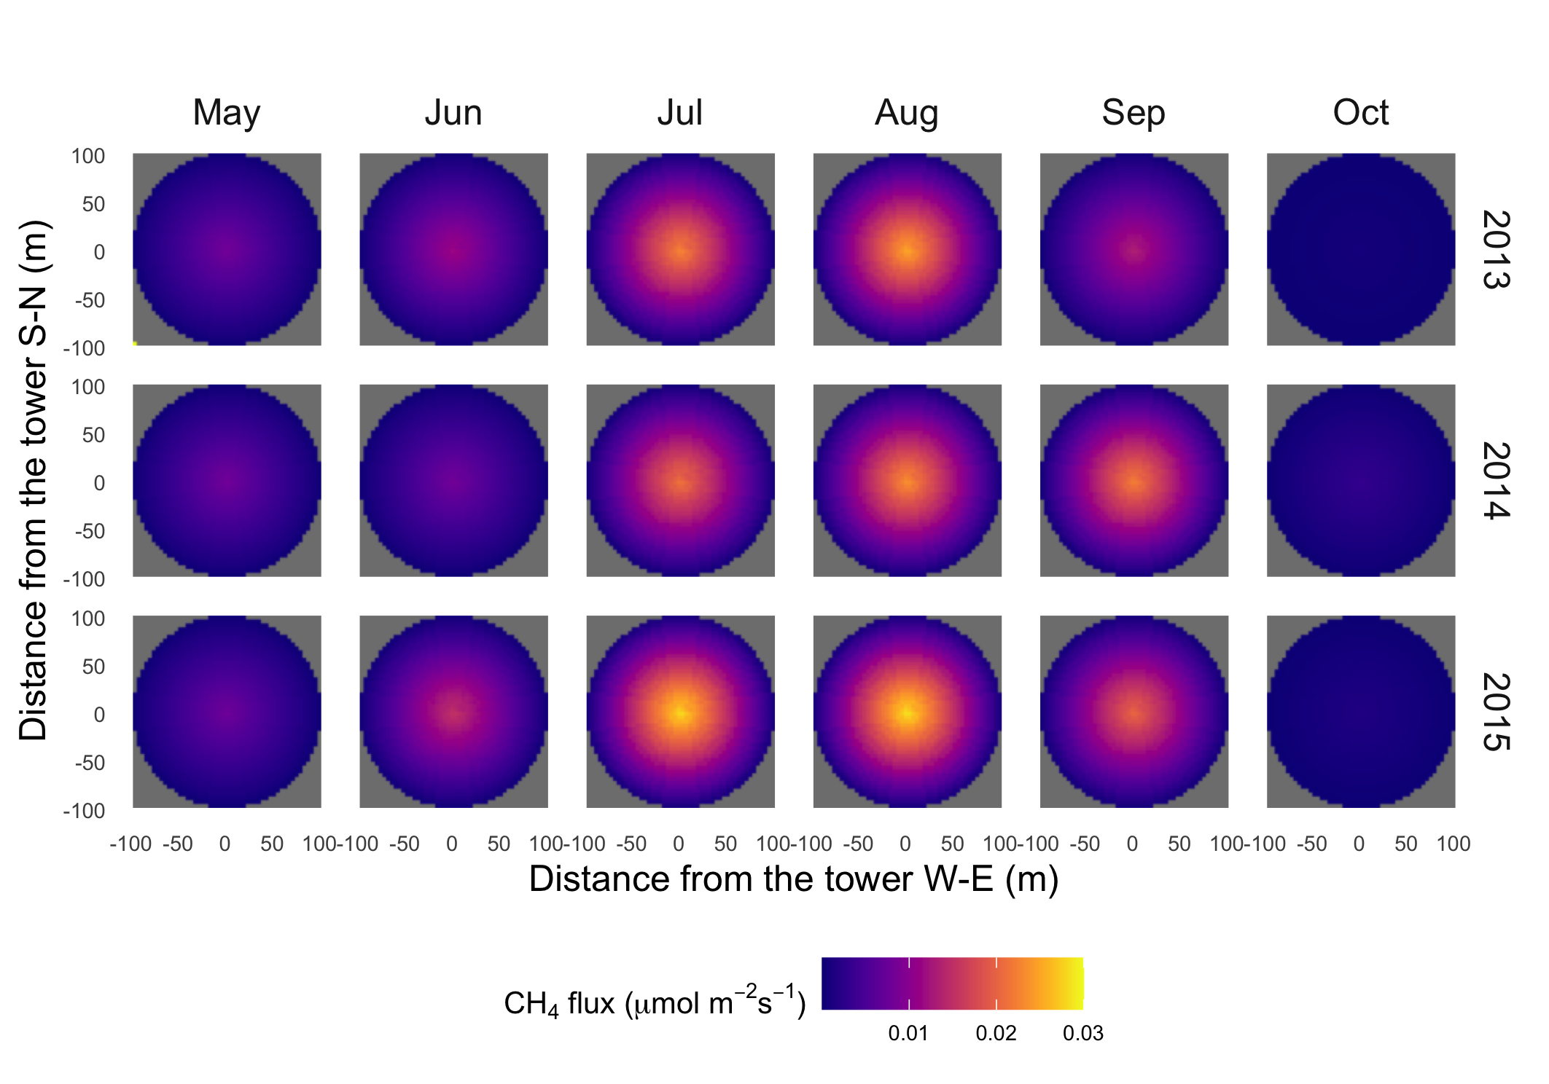
Figure S12. Spatial distribution of upscaled CH₄ flux using the gradient footprint (GF) algorithm for each month in 2013-2015 for US-Brw (fluxes were zero in January, February, March, April, November, and December)

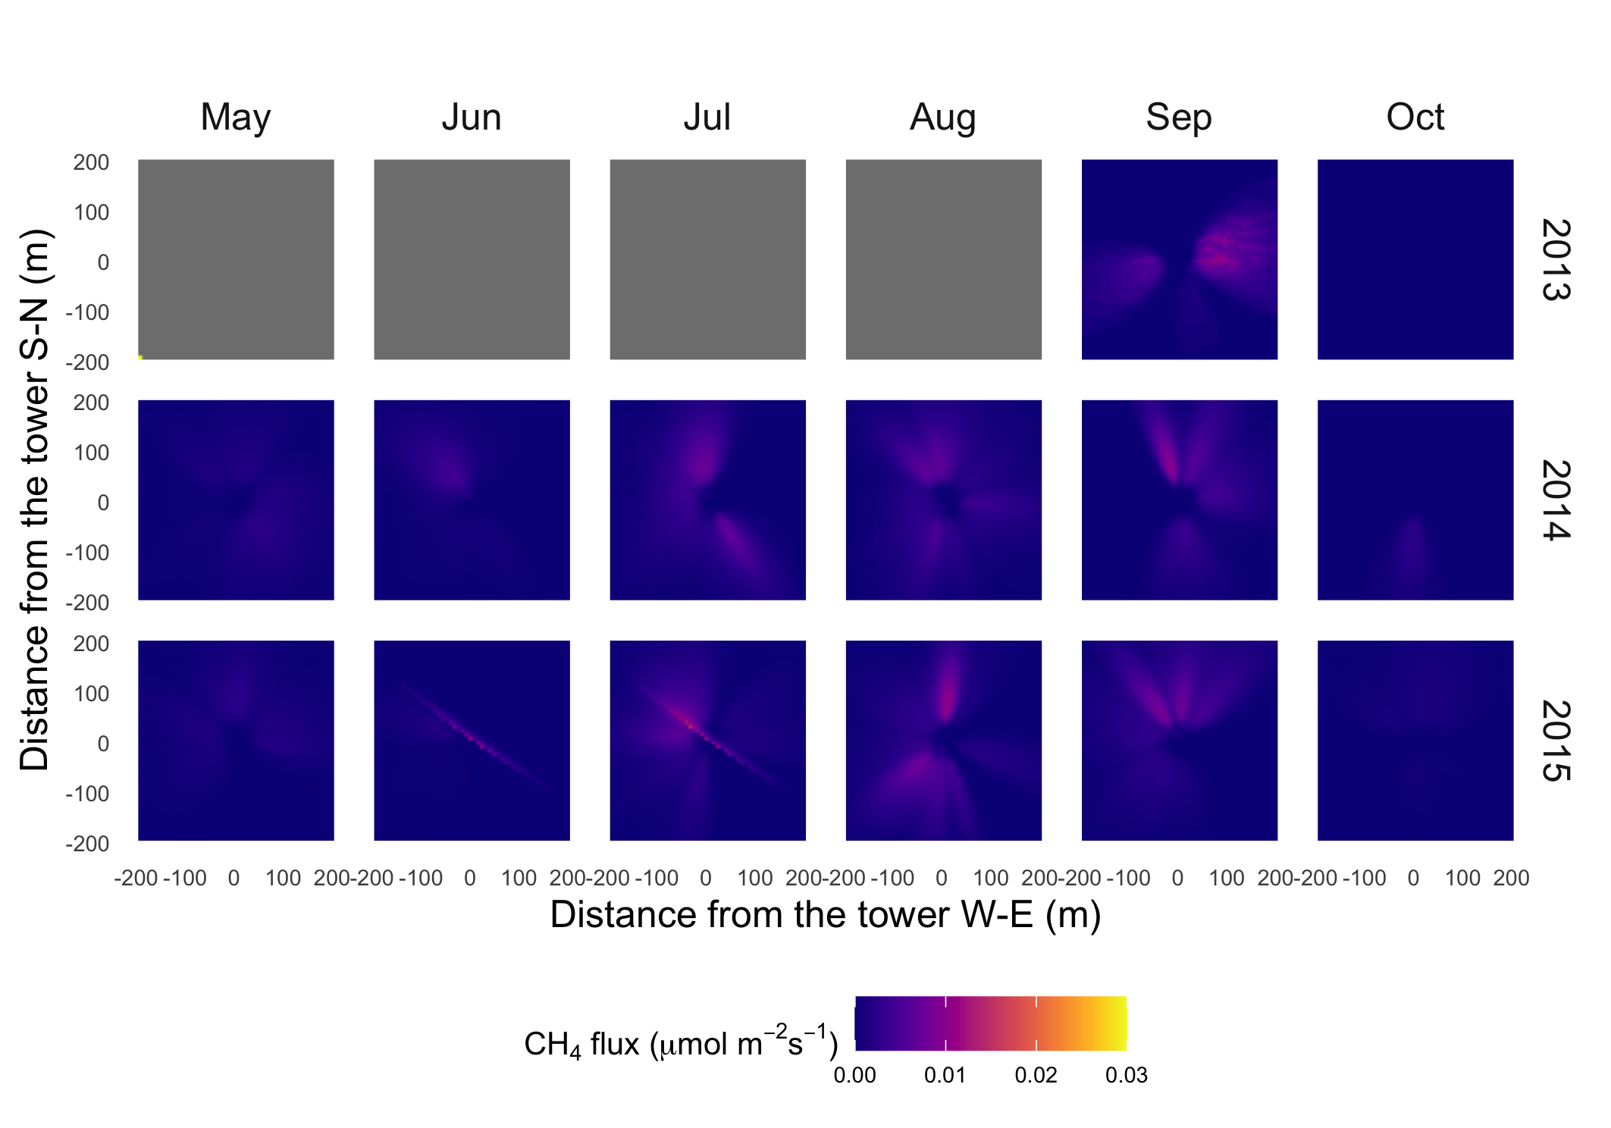
Figure S13. Spatial distribution of upscaled CH₄ flux using the dynamic footprint (DF) algorithm for each month in 2013-2015 for US-Brw (flux was zero in January, February, March, April, November, and December)

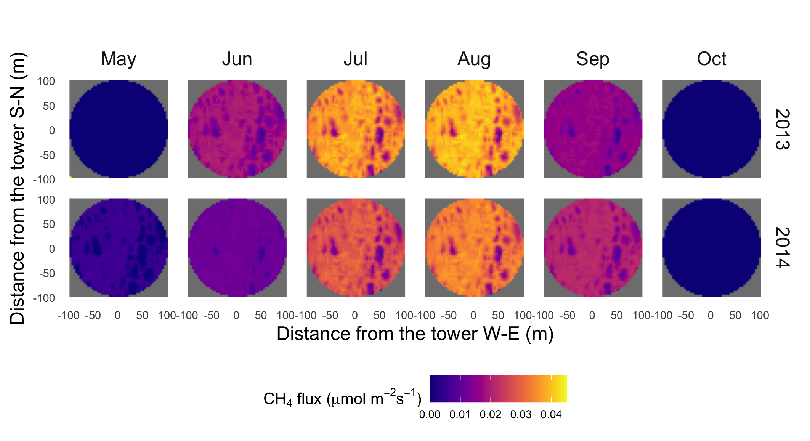
Figure S14. Spatial distribution of upscaled CH₄ flux using the homogeneous footprint (HF) algorithm for each month in 2013-2014 for US-Atq (flux was zero in January, February, March, April, November, and December)

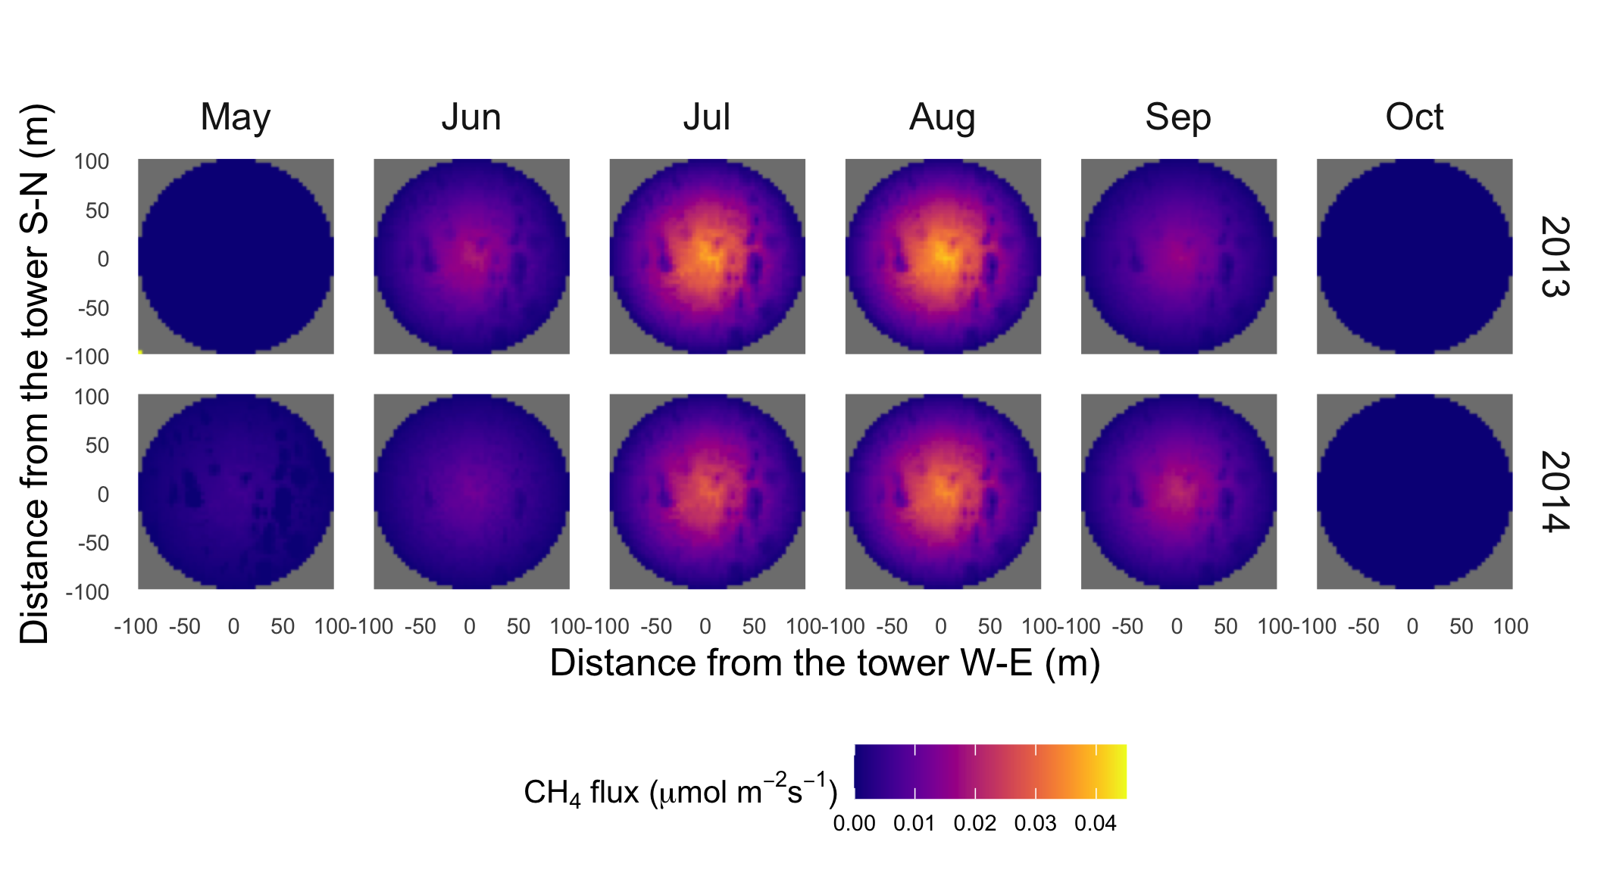
Figure S15. Spatial distribution of upscaled CH₄ flux using the gradient footprint (GF) algorithm for each month in 2013-2014 for US-Atq (flux was zero in January, February, March, April, November, and December)

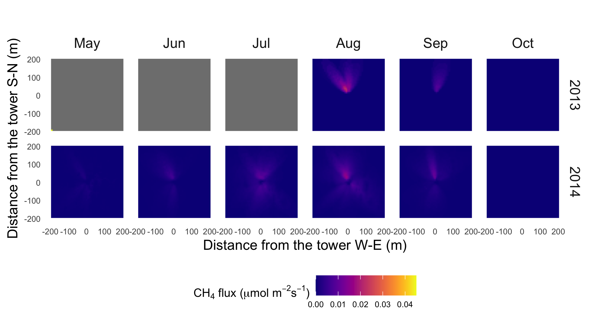
Figure S16. Spatial distribution of upscaled CH₄ flux using the dynamic footprint (DF) algorithm for each month in 2013-2014 for US-Atq (flux was zero in January, February, March, April, November, and December)

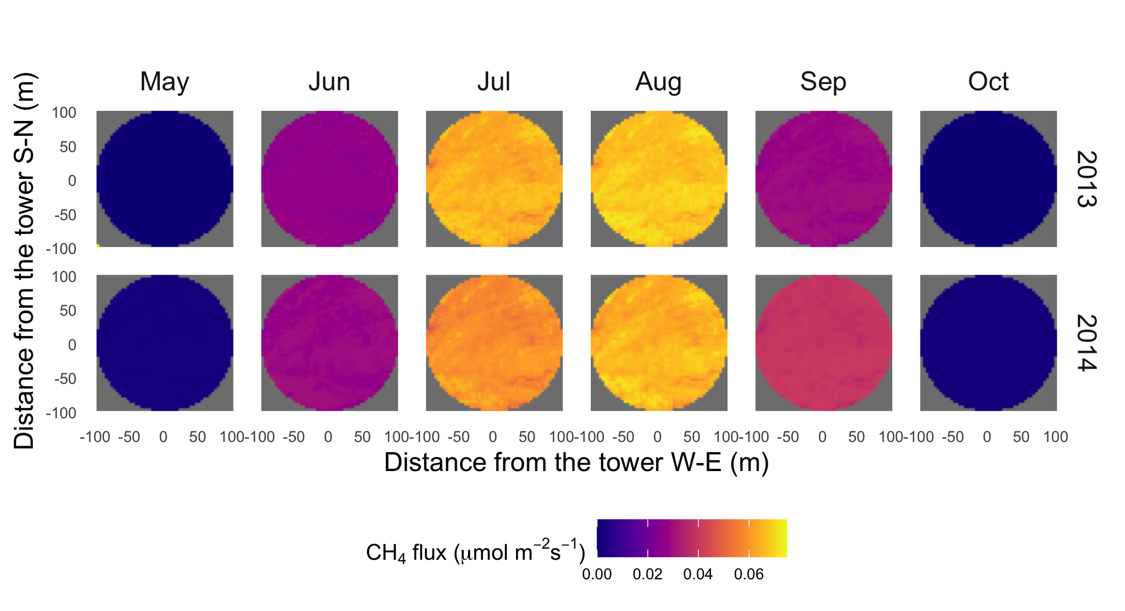
Figure S17. Spatial distribution of upscaled CH₄ flux using the homogeneous footprint (HF) algorithm for each month in 2013-2014 for US-Ivo (flux was zero in January, February, March, April, November, and December)

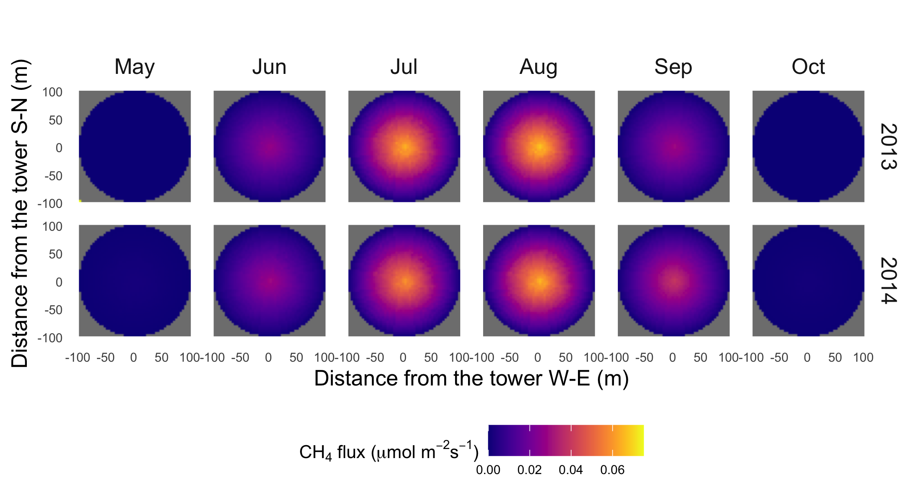
Figure S18. Spatial distribution of upscaled CH₄ flux using the gradient footprint (GF) algorithm for each month in 2013-2014 for US-Ivo (flux was zero in January, February, March, April, November, and December)

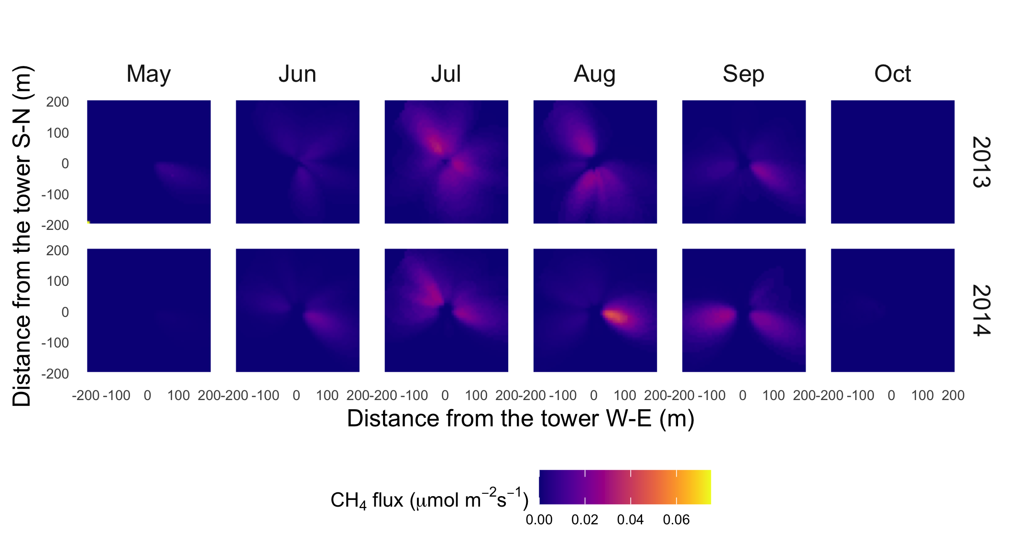
Figure S19. Spatial distribution of upscaled CH₄ flux using the dynamic footprint (DF) algorithm for each month in 2013-2014 for US-Ivo (flux was zero in January, February, March, April, November, and December)

Table S1. Coefficients for calculating SOC concentrations at five study sites
Sites | Coefficients
 | a | β
US-Beo | 44.35 | 0.008
US-Bes | 44.35 | 0.008
US-Brw | 44.35 | 0.008
US-Atq | 51.678 | -0.002
US-Ivo | 51.761 | -0.007

Table S2 Annual averages and variations (mean±sd) of upscaled CH₄ flux using the homogeneous footprint algorithm (HF), gradient footprint algorithm (GF) and dynamic footprint algorithm (DF) for all study sites in 2013-2015 (Unit: µmol ·m⁻² ·s⁻¹, n.a.: not available)

Footprint | Site | 2013 | 2014 | 2015
 | US-Beo | 0.014±0.008 | 0.014±0.007 | 0.017±0.009
 | US-Bes | 0.015±0.009 | 0.016±0.007 | 0.018±0.009
HF | US-Brw | 0.015±0.009 | 0.016±0.008 | 0.019±0.010
 | US-Atq | 0.020±0.016 | 0.018±0.012 | n.a.
 | US-Ivo | 0.036±0.030 | 0.037±0.025 | n.a.
 | US-Beo | 0.013±0.008 | 0.014±0.006 | 0.017±0.008
 | US-Bes | 0.015±0.009 | 0.016±0.007 | 0.019±0.010
GF | US-Brw | 0.015±0.009 | 0.016±0.008 | 0.019±0.010
 | US-Atq | 0.020±0.016 | 0.018±0.012 | n.a.
 | US-Ivo | 0.036±0.030 | 0.037±0.025 | n.a.
 | US-Beo | 0.017±0.006 | 0.014±0.006 | 0.017±0.008
 | US-Bes | n.a. | n.a. | 0.020±0.009
DF | US-Brw | 0.005±0.006 | 0.016±0.008 | 0.020±0.009
 | US-Atq | 0.020±0.014 | 0.019±0.012 | n.a.
 | US-Ivo | 0.051±0.024 | 0.040±0.021 | n.a.

Table S3 Coefficients for upscaled CH₄ flux using the homogeneous footprint algorithm (HF), gradient footprint algorithm (GF) and dynamic footprint algorithm (DF) compared with observed fluxes for all study sites (RMSE: root mean square error and NNSE: the Normalized Nash-Sutcliffe Efficiency)
Coefficient | Site | HF | GF | DF
 | US-Beo | 0.511 | 0.512 | 0.526
 | US-Bes | 0.633 | 0.631 | 0.629
R² | US-Brw | 0.427 | 0.427 | 0.427
 | US-Atq | 0.607 | 0.605 | 0.610
 | US-Ivo | 0.209 | 0.209 | 0.210
 | US-Beo | 0.011 | 0.011 | 0.010
 | US-Bes | 0.009 | 0.009 | 0.009
RMSE | US-Brw | 0.008 | 0.008 | 0.008
 | US-Atq | 0.010 | 0.010 | 0.011
 | US-Ivo | 0.023 | 0.023 | 0.023
 | US-Beo | 0.621 | 0.623 | 0.631
 | US-Bes | 0.693 | 0.690 | 0.688
NNSE | US-Brw | 0.397 | 0.397 | 0.397
 | US-Atq | 0.237 | 0.232 | 0.214
 | US-Ivo | 0.241 | 0.242 | 0.244

Table S4 Spatial averages and spatial variations (mean±sd) of upscaled CH₄ flux using the homogeneous footprint algorithm (HF), gradient footprint algorithm (GF) and dynamic footprint algorithm (DF) for all study sites in 2013-2015 (Unit: µmol ·m⁻² ·s⁻¹, n.a.: not available)

Footprint | Site | 2013 | 2014 | 2015
 | US-Beo | 0.0051±0.0027 | 0.0054±0.0028 | 0.0064±0.0033
 | US-Bes | 0.0047±0.0025 | 0.0050±0.0026 | 0.0059±0.0030
HF | US-Brw | 0.0053±0.0028 | 0.0057±0.0029 | 0.0067±0.0034
 | US-Atq | 0.0069±0.0037 | 0.0062±0.0034 | n.a.
 | US-Ivo | 0.0125±0.0065 | 0.0129±0.0067 | n.a.
 | US-Beo | 0.0018±0.0017 | 0.0019±0.0018 | 0.0023±0.0021
 | US-Bes | 0.0016±0.0015 | 0.0017±0.0016 | 0.0020±0.0018
GF | US-Brw | 0.0019±0.0017 | 0.0020±0.0018 | 0.0024±0.0021
 | US-Atq | 0.0025±0.0023 | 0.0022±0.0021 | n.a.
 | US-Ivo | 0.0044±0.0040 | 0.0046±0.0042 | n.a.
 | US-Beo | 0.0005±0.0006 | 0.0005±0.0006 | 0.0005±0.0006
 | US-Bes | 0.0004±0.0005 | 0.0003±0.0004 | 0.0004±0.0006
DF | US-Brw | 0.0001±0.0001 | 0.0005±0.0004 | 0.0004±0.0004
 | US-Atq | 0.0002±0.0006 | 0.0004±0.0006 | n.a.
 | US-Ivo | 0.0017±0.0017 | 0.0012±0.0016 | n.a.

Table S5. Pearson’s correlation coefficients (r_{p}) for relationships of vegetation composition, soil temperature, soil water content (top 2 cm), elevation with up-scaled CH₄ flux using the homogeneous footprint algorithm (HF), gradient footprint algorithm (GF) and dynamic footprint algorithm (DF) for all study sites (Bold indicates | r_{p} | > 0.2 and P <0.05, *: <0.05, and **: < 0.01)
Footprint | Site | Bare soil  (%) | Arctic C3 grass (%) | Soil temperature (K) | Soil water content (m³ m⁻³) | Elevation (m)
HF | US-Beo | -0.387** | 0.385** | 0.055** | 0.054** | 0.172**
 | US-Bes | -0.488** | 0.488** | 0.265** | 0.249** | 0.263**
 | US-Brw | -0.073** | 0.068** | 0.009 | 0.009 | -0.007
 | US-Atq | -0.718** | 0.718** | -0.060** | -0.058** | 0.166**
 | US-Ivo | -0.290** | 0.305** | -0.053** | 0.052** | 0.030
GF | US-Beo | -0.276** | 0.284** | 0.232** | 0.229** | 0.116**
 | US-Bes | 0.175** | -0.171** | -0.242** | -0.210** | -0.367**
 | US-Brw | -0.009 | 0.051** | 0.025 | 0.037* | 0.134**
 | US-Atq | -0.305** | 0.305** | 0.120** | 0.100** | -0.010
 | US-Ivo | -0.031 | 0.028** | 0.035* | -0.083** | 0.072**
DF | US-Beo | -0.270** | 0.265** | 0.070** | 0.064** | 0.093**
 | US-Bes | 0.182** | -0.180** | -0.229** | -0.200** | -0.301**
 | US-Brw | -0.062** | 0.064** | 0.107** | 0.105** | 0.177**
 | US-Atq | -0.280** | 0.280** | 0.049 | 0.029 | -0.369**
 | US-Ivo | 0.039 | 0.192** | 0.101** | 0.048* | 0.022

