SUPPLEMENTAL MATERIAL 1

Figure S1. Popular search terms relating to diet strategies for modulating the gut microbiome and their relative popularity from 1 August 2020 to 31 August 2021, provided by Google Trends.

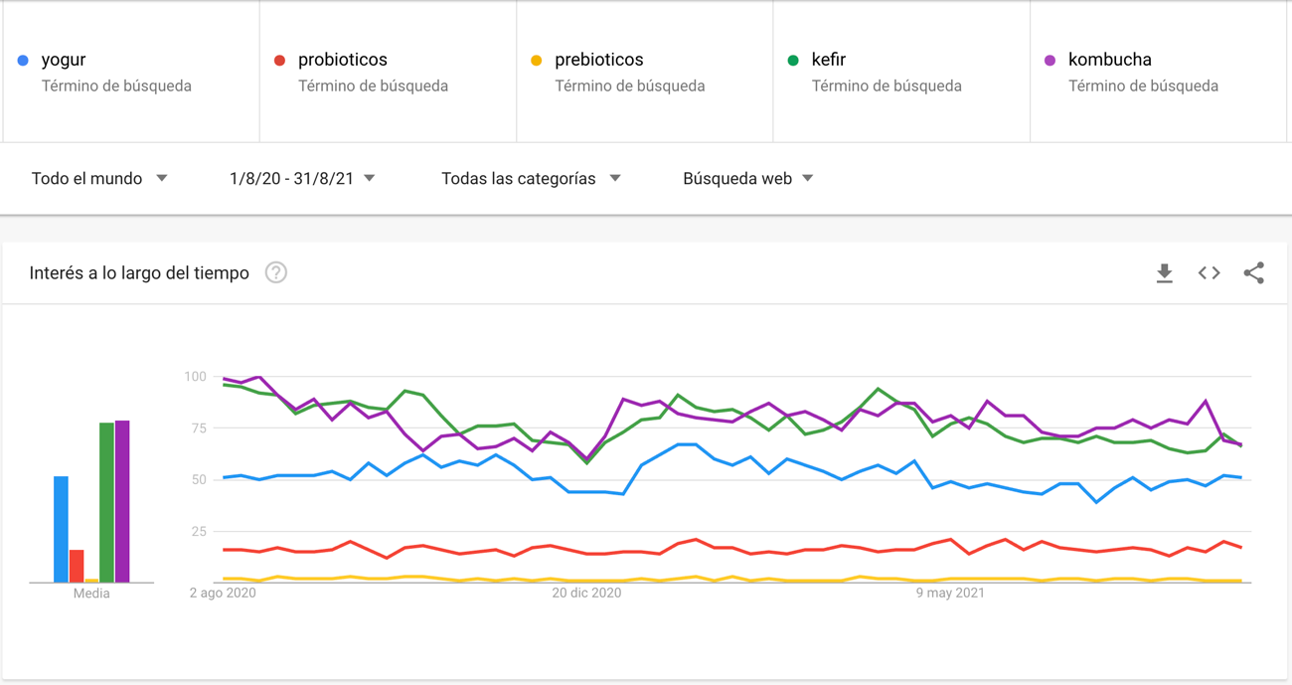

Figure S2. Popular search terms relating to diet strategies for modulating the gut microbiome and their relative popularity from 1 January 2010 to 31 August 2021, provided by Google Trends.

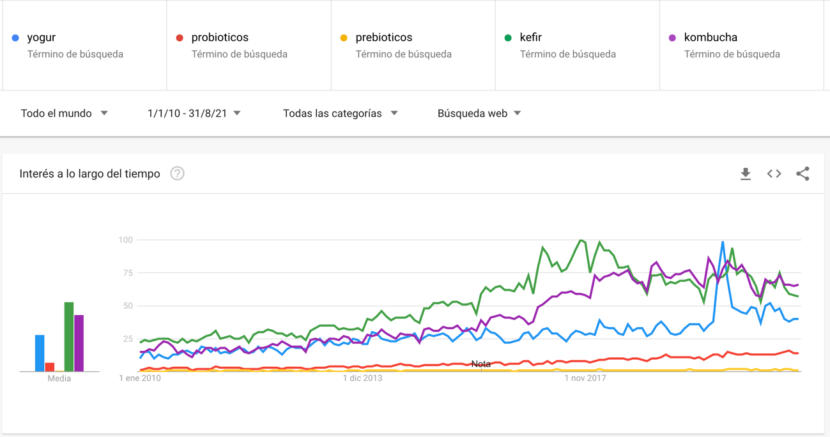

Figure S3. Differences in the relative popularity of search terms with or without accents.

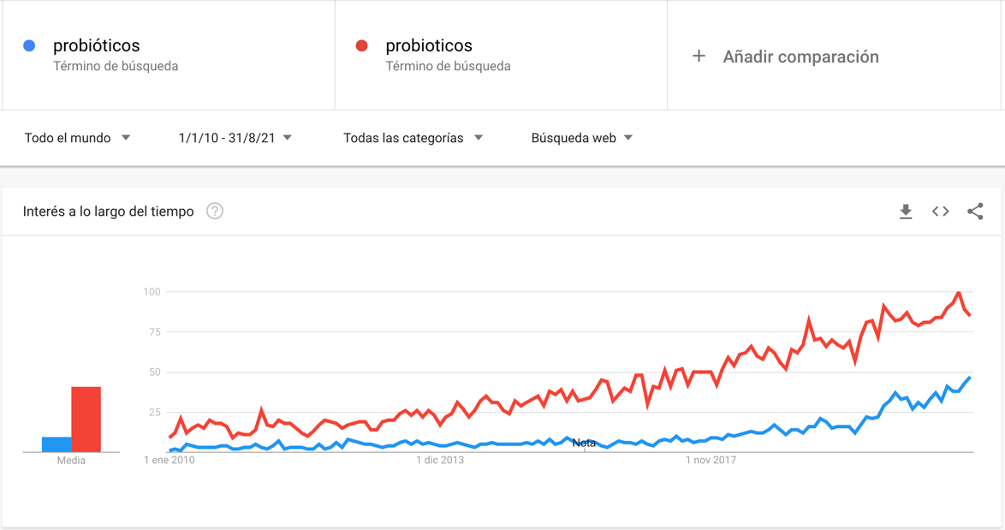

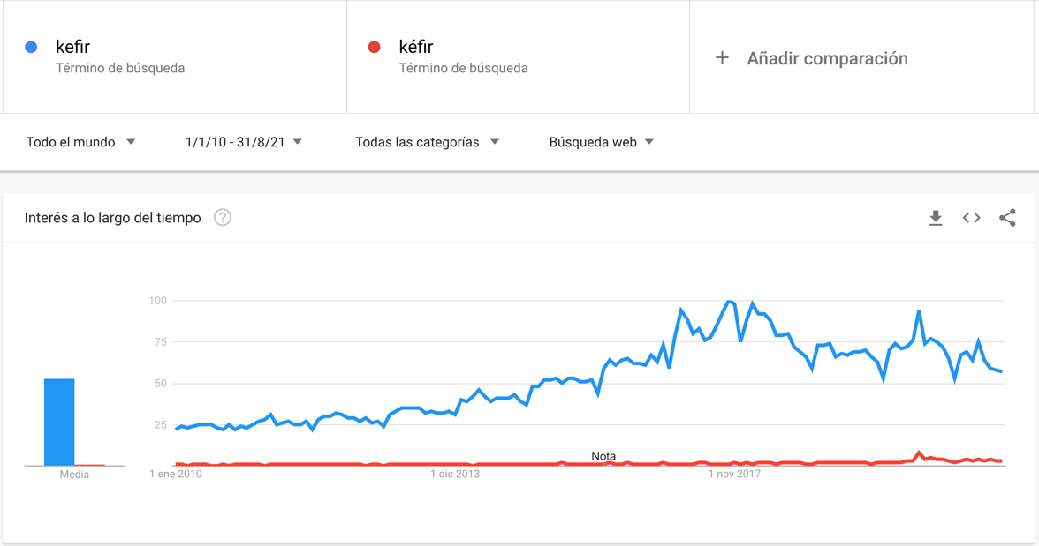

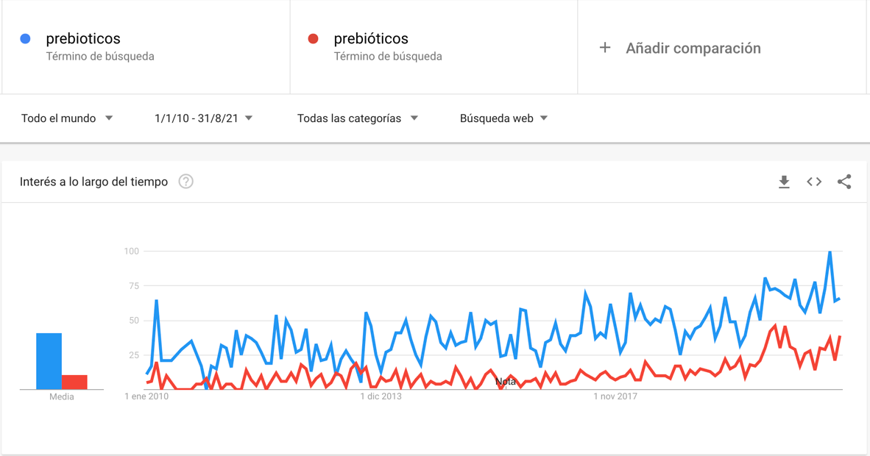

Figure S4. Questions related to dietary interventions of interest that people ask on Google, provided by AnswerThePublic.
Note that the colour gradient of the dots in results is indicative of the popularity (and not necessarily the search volume) of search terms within each question branch at the time the report was run.

S4A. Probiotics.

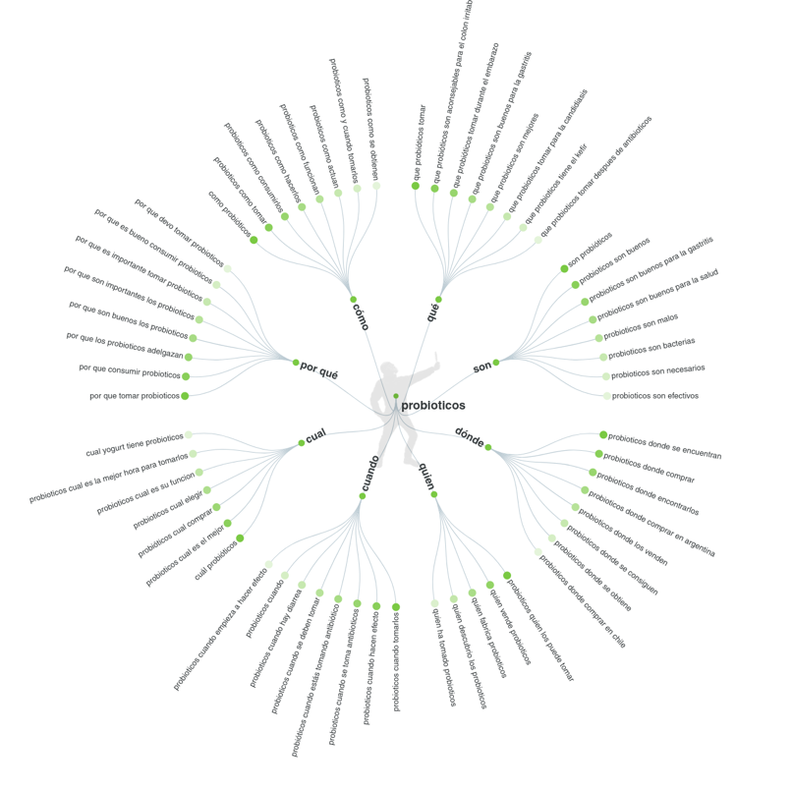
S4B. Yoghurt.

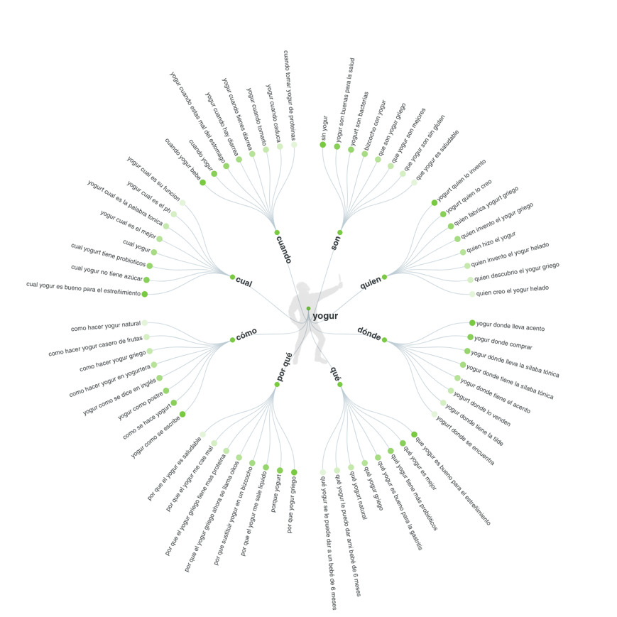
S4C. Kefir.

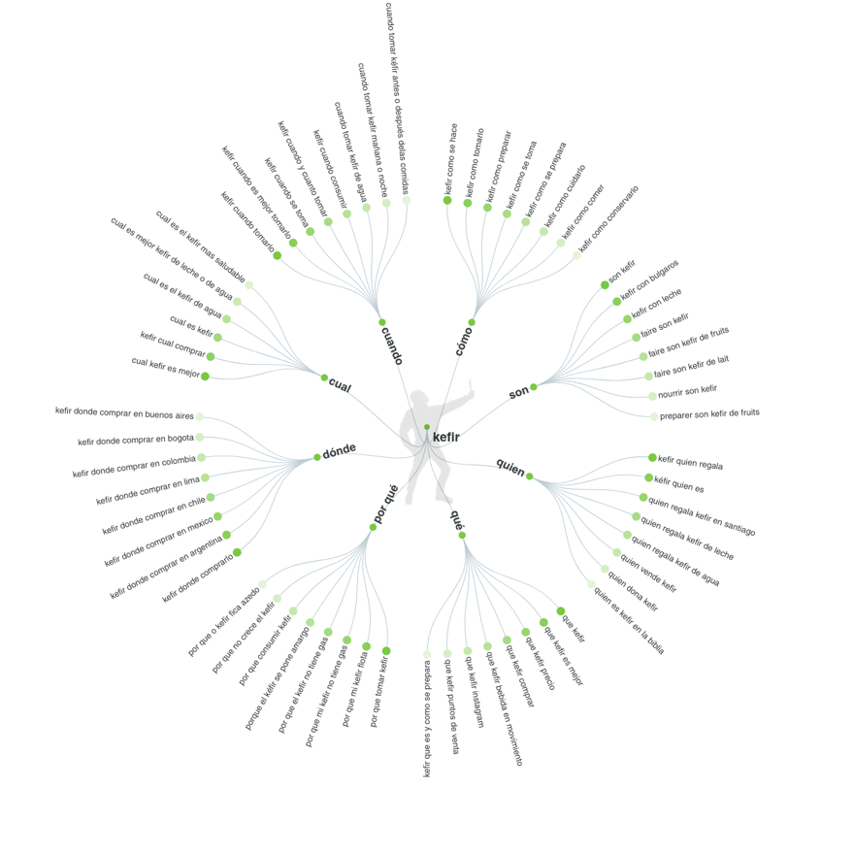

S4D. Kombucha.

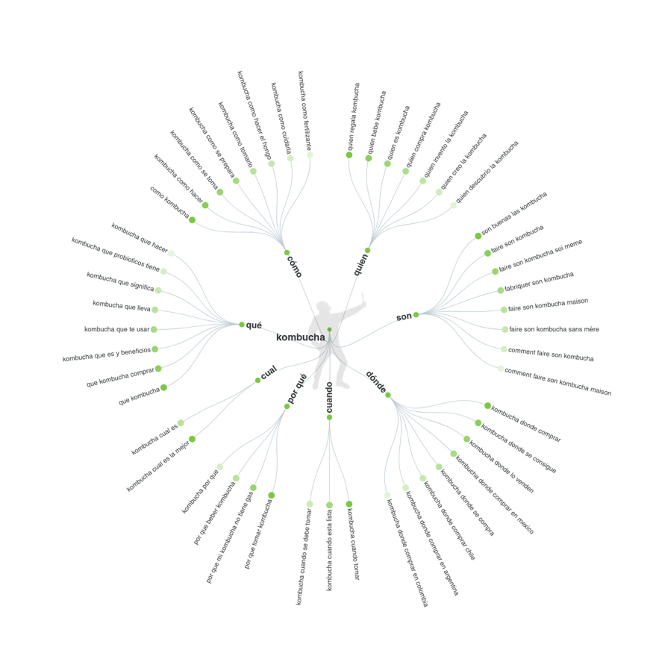

S4E. Fibre.

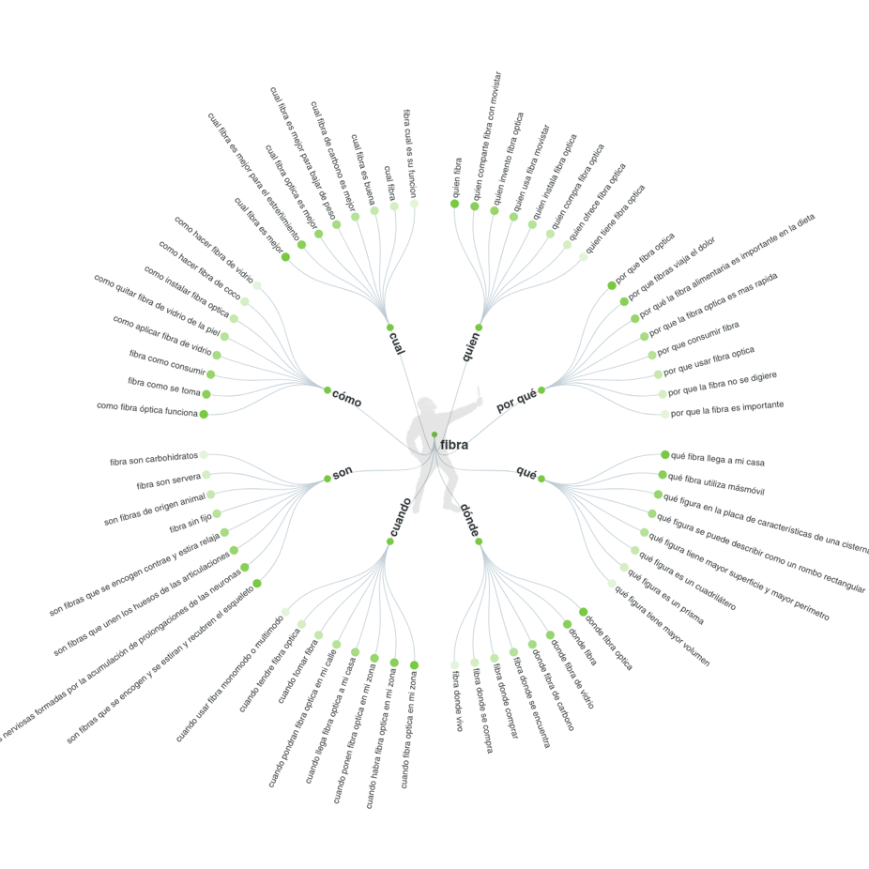

S4F. Prebiotics.

