Supplementary material:
Life-history genotype explains variation in migration activity in Atlantic salmon (Salmo salar).

Petri T. Niemelä, Ines Klemme, Anssi Karvonen, Pekka Hyvärinen, Paul V. Debes, Jaakko Erkinaro, Marion Sinclair-Waters, Victoria L. Pritchard, Laura Härkönen, Craig R. Primmer

Glossary:
Supplementary Table 1……………………………..Page 3
Supplementary Table 2……………………………..Page 4
Supplementary Table 3……………………………..Page 6
Supplementary Table 4……………………………..Page 7
Supplementary Table 5……………………………..Page 8
Supplementary Figure 1……………………………..Page 9
Supplementary Figure 2……………………………..Page 10
Supplementary Figure 3……………………………..Page 11
Supplementary Figure 3……………………………..Page 12

Supplementary Table 1. Parameter estimates for additive and dominance models for downstream acitivity when body condition is added as a covariate in the migrant fish model. We present fixed parameter estimates (i.e. β) with standard error (i.e. SE) and P-values and, random parameter estimates (i.e. standard deviation = σ) with 95% credible intervals (i.e. CI). Genotypes modeled as: vgll3*EE = 1, vgll3*EL = 0, vgll3*LL = -1. Condition was defined as the residuals from the model: weight~length+lenth² (weight and length were measured directly after the experimental period: see methods for more detail).

Migratory phenotype | Downstream
Fixed effects | β (SE) | P
Intercept | 2.435 (0.319) | >0.001
vgll3_ADDITIVE | 0.074 (0.035) | 0.036
Sex¹ | -0.001 (0.047) | 0.989
vgll3_DOMINANCE | 0.086 (0.058) | 0.139
Condition | -0.049 (0.0220) | 0.027
vgll3_ADDITIVE:Sex¹ | -0.113 (0.047) | 0.016
vgll3_DOMINANCE:Sex¹ | -0.077 (0.162) | 0.346
Condition:Sex¹ | -0.068 (0.030) | 0.024
Random Effects | σ (95% CI)
Individual | 0.407 (0.380, 0.436)
Date | 1.574 (1.227, 2.020)
Pool | 0.297 (0.198, 0.447)
Cross | 0.212 (0.090, 0.500)
Mother | 0.025 (<0.001, >10.00)
Father | 0.122 (0.063, 0.234)
Hour | 0.266 (0.199, 0.355)
¹ Reference sex is Female

Supplementary Table 2. Data scale predictions and hourly distance moved in meters for vgll3 and sex effects on activity. Predictions are extracted from models presented in Table 1. The conversion to meters was done by multiplying the activity estimates by 6.54, i.e. the distance between two adjacent antennae at the center of the pool.

 | FEMALE |  | MALE
 | Upstream activity (SE) | Meters/hour | Upstream activity (SE) | Meters/hour
Migrant fish
LL | 1.89 (0.58) | 12.3 | 1.96 (0.61) | 12.8
EL | 1.98 (0.61) | 13.0 | 1.85 (0.57) | 12.1
EE | 2.08 (0.64) | 13.6 | 1.74 (0.54) | 11.4
Non-migrant fish
LL | 0.44 (0.11) | 2.9 | 0.36 (0.09) | 2.3
EL | 0.41 (0.10) | 2.7 | 0.37 (0.09) | 2.4
EE | 0.39 (0.09) | 2.5 | 0.38 (0.09) | 2.5
 | Downstream activity (SE) | Meters/hour | Downstream activity (SE) | Meters/hour
Migrant fish
LL | 11.24 (3.58) | 73.5 | 12.02 (3.83) | 78.6
EL | 12.00 (3.80) | 78.5 | 11.26 (3.56) | 73.6
EE | 12.80 (4.08) | 83.7 | 10.54 (3.36) | 68.9
Non-migrant fish
LL | 1.94 (0.46) | 12.7 | 1.59 (0.37) | 10.4
EL | 1.85 (0.42) | 12.1 | 1.67 (0.38) | 10.9
EE | 1.77 (0.42) | 11.6 | 1.76 (0.41) | 11.5
 | Total activity (SE) | Meters/hour | Total activity (SE) | Meters/hour
Migrant fish
LL | 15.57 (4.79) | 101.8 | 16.59 (5.09) | 108.5
EL | 16.61 (5.07) | 108.6 | 15.52 (4.74) | 101.5
EE | 17.71 (5.45) | 115.8 | 14.52 (4.46) | 95.0
Non-migrant fish
LL | 3.10 (0.69) | 20.2 | 2.53 (0.56) | 16.6
EL | 2.95 (0.63) | 19.3 | 2.66 (0.56) | 17.4
EE | 2.81 (0.62) | 18.4 | 2.80 (0.61) | 18.3

Supplementary Table 3. Parameter estimates for a model where a vgll3-date interaction is fitted as a random effect for the model presented in Table 1. We present fixed parameter estimates (i.e. β) standard errors (i.e. SE) and P-values. As the results were qualitatively the same across all three behaviours, we present here only the estimates for downstream activity.

Migratory fish | Downstream activity
Fixed effects | β (SE) | P
Intercept | 2.447 (0.317) | <0.001
vgll3_ADDITIVE | 0.087 (0.038) | 0.022
Sex¹ | -0.022 (0.049) | 0.647
vgll3_DOMINANCE | 0.111 (0.060) | 0.063
vgll3_ADDITIVE:Sex¹ | -0.133 (0.048) | 0.006
vgll3_DOMINANCE:Sex¹ | -0.126 (0.085) | 0.136
Random Effects | σ | r
Individual | 0.424
Date | 1.574
vgll3_ADDITIVE | 0.054 | -0.61
Stream | 0.290
Crossing group | 0.202
Mother | 0.054
Father | 0.106
Hour | 0.266
¹ Reference sex is Female

Supplementary Table 4. Parameter estimates for additive and dominance models for upstream and downstream movement for migrants when date and hour are added as covariates. We present fixed parameter estimates (i.e. β) with standard error (i.e. SE) and P-values and, random parameter estimates (i.e. standard deviation = σ) with 95% credible intervals (i.e. CI). Genotypes modeled as: vgll3*EE = 1, vgll3*EL = 0, vgll3*LL = -1.

Migrant fish | Upstream |  | Downstream
Fixed effects | β (SE) | P | β (SE) | P
Intercept | 0.055 (0.112) | 0.623 | 1.502 (0.134) | <0.001
vgll3_ADDITIVE | 0.059 (0.029) | 0.042 | 0.074 (0.037) | 0.047
Date | 0.075 (<0.001) | <0.001 | 0.090 (<0.001) | <0.001
Hour | 0.008 (<0.001) | <0.001 | 0.010 (<0.001) | <0.001
Sex¹ | -0.027 (0.039) | 0.497 | -0.008 (0.050) | 0.880
vgll3_DOMINANCE | 0.072 (0.048) | 0.134 | 0.106 (0.061) | 0.082
vgll3_ADDITIVE:Sex¹ | -0.119 (0.039) | 0.002 | -0.140 (0.049) | 0.005
vgll3_DOMINANCE:Sex¹ | -0.091 (0.068) | 0.181 | -0.138 (0.086) | 0.110
Random Effects | σ (95% CI) |  | σ (95% CI)
Individual | 0.335 (0.312, 0.360) |  | 0.428 (0.400, 0.459)
Stream | 0.284 (0.195, 0.415) |  | 0.325 (0.220, 0.479)
Cross | 0.151 (0.066, 0.342) |  | 0.185 (0.081, 0.422)
Mother | 0.054 (0.016, 0.179) |  | 0.063 (0.017, 0.233)
Father | 0.089 (0.041, 0.194) |  | 0.122 (0.062, 0.242)

Supplementary Table 5. Parameter estimates for vgll3 and sex effects on onset of migration. We present fixed parameter estimates (i.e. β) standard errors (i.e. SE) and P-values. Onset of migration was defined as date when the downstream movement reached 120 stream rounds day⁻¹ (i.e. 5 rounds hour⁻¹) among migrant fish (see methods).
 | Onset of migration
Fixed effects | β (SE) | P
Intercept | 15.092 (0.143) | <0.001
vgll3_ADDITIVE | -0.006 (0.178) | 0.971
Sex¹ | -0.353 (0.198) | 0.076
vgll3_ADDITIVE:Sex¹ | -0.208(0.243) | 0.391
¹ Reference sex is female

Supplementary Figure 1. Photos of the ring-shaped experimental streams. Fish did not have access to the center pool in the middle of each ring-shaped stream, i.e. fish only occupied the outer ring of the stream. The picture at the bottom captures one of the four RFID-antennas in a stream covering the bottom, sides and top of the water bed in the stream. Photo credits: Ines Klemme.
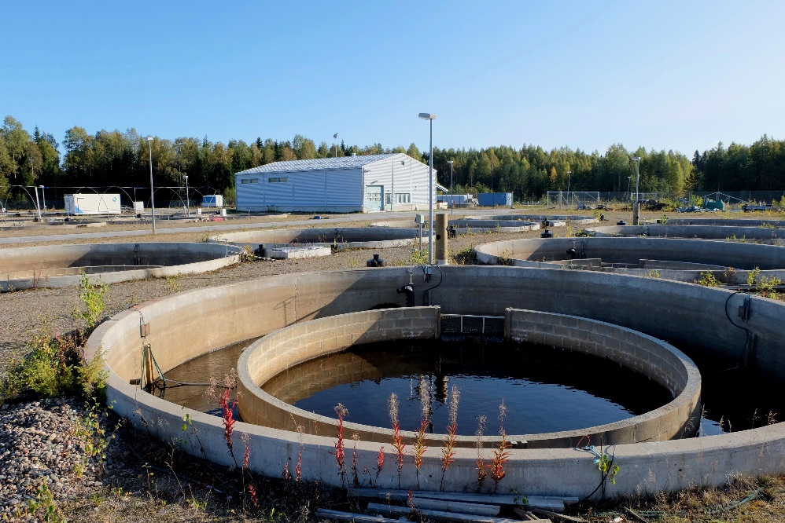
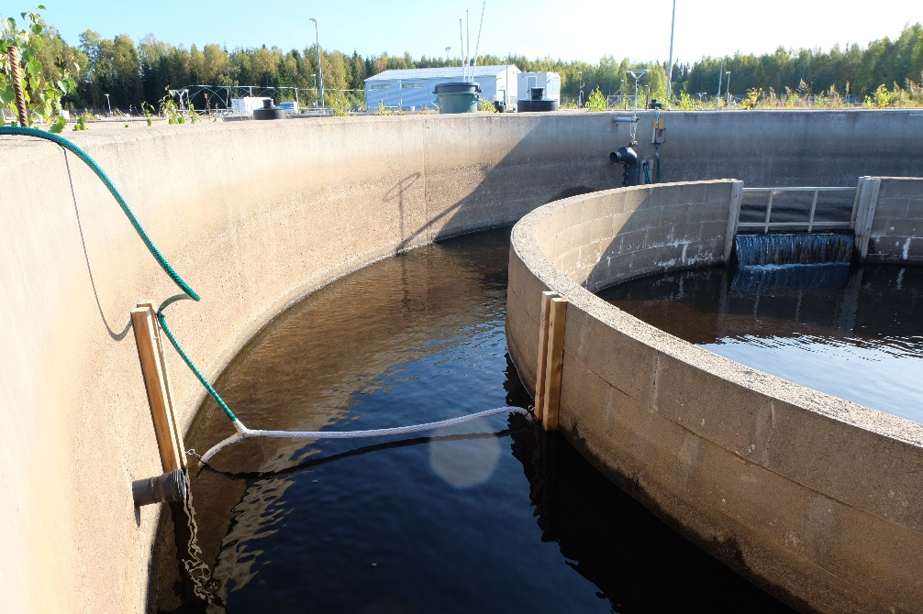

Supplementary Figure 2. Best linear unbiased predictors (i.e. BLUPs) for downstream activity for each date. BLUPs are presented separately for migrant (i.e. smolt) and non-migrant (i.e. parr) fish. BLUPs for each date are extracted from models presented in Table 1. As the results were qualitatively the same across all three behaviours, we present here only the BLUPs for downstream activity.

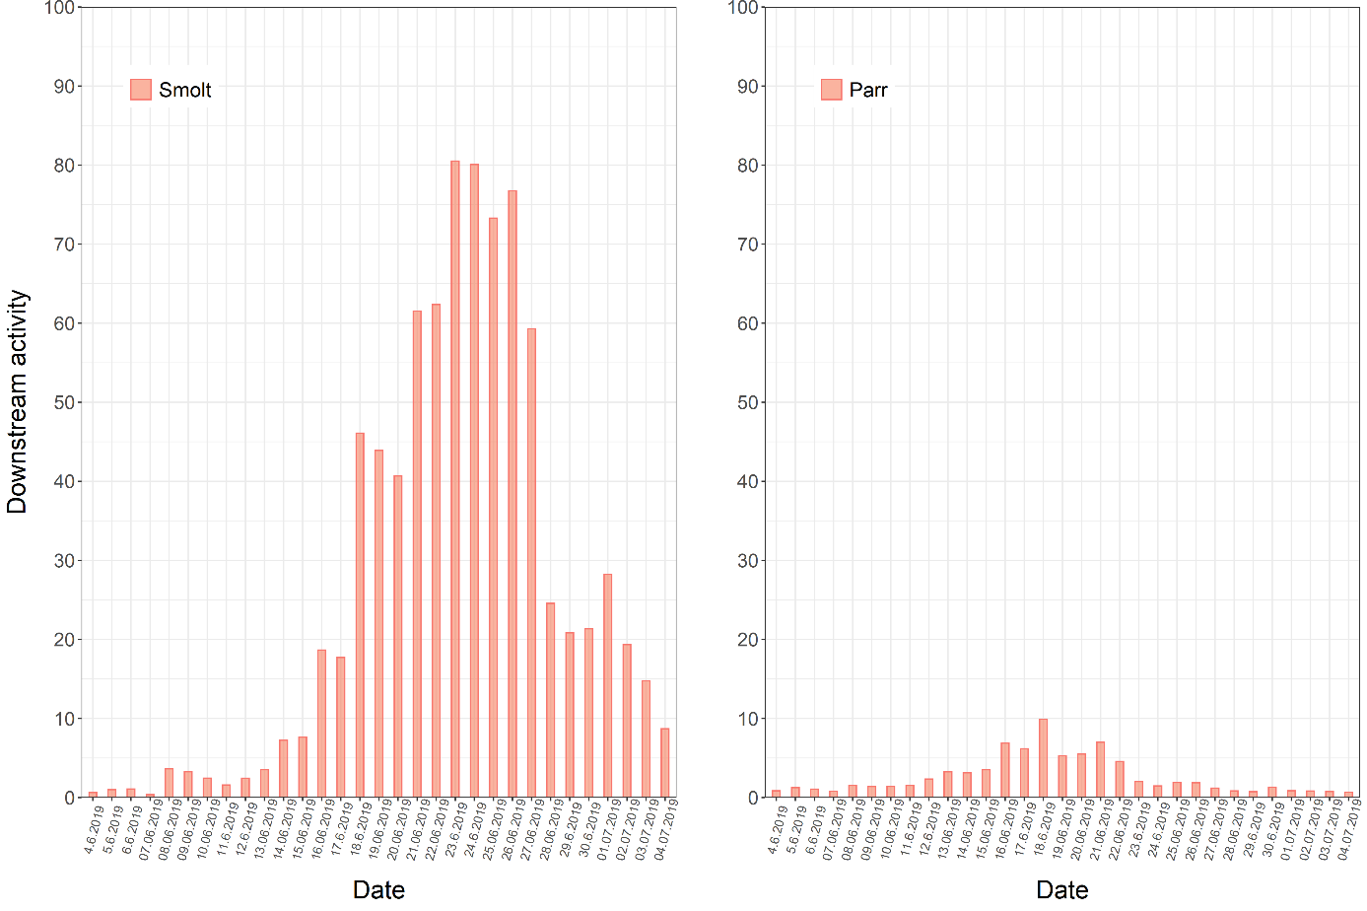

Supplementary Figure 3. Linear predictions for sex-specific effects of body condition on recorded activity. Shaded areas represent standard errors around the predictions. The predictions are derived from model estimates presented in Supplementary Table 1. As the results were qualitatively the same across all three behaviours, we present here only the predictions for downstream activity. Condition (X-axis) was defined as the residuals from the model: weight~length+lenth² (weight and length were measured directly after the experimental period: see methods for more detail). In the X-axis, negative values refer to lower condition while positive values refer to higher condition.

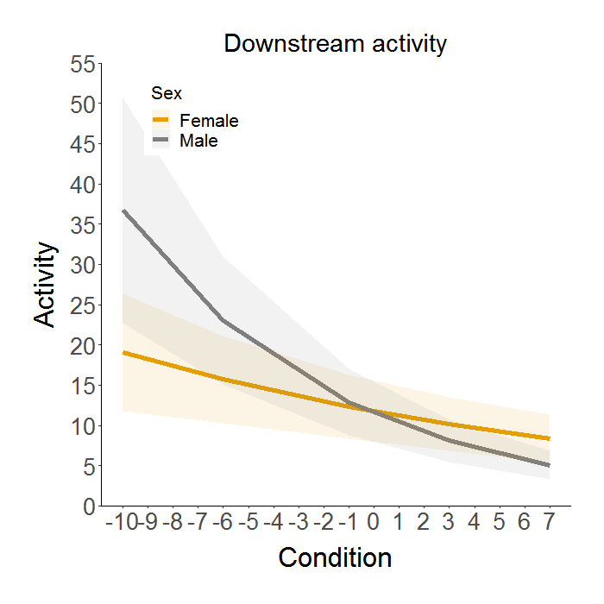

Supplementary Figure 4. Linear prediction for the effect of vgll3 genotype on condition among migrants. The shaded area represent standard errors around the prediction. The predictions are calculated from estimates delivered by a model: condition ~ vgll3_additive + Sex + (1|Stream) + (1|mother) + (1|father). Other random effects, as present in the main models, were omitted since only one condition measurement per individual was obtained (thus among-individual, date and hour variation are not present). In the Y-axis, negative values refer to lower condition while positive values refer to higher condition. Condition was defined as the residuals from the model: weight~length+lenth² (weight and length were measured directly after the experimental period: see methods for more detail).

