Supplementary Material
Supplementary Table 1. Synoptic data from the field campaigns performed during fall, winter, and spring, including measurements of temperature (Temp), salinity (Sal), pH@25= Spectrophotometric pH, total alkalinity (A_{T}), chlorophyll-a (Chl-a), nitrate, phosphate and silicic acid. Distance (Km) 0 was the closest station to the glacier.
Data (YYYY/MM/DD) | Lat (°) | Long (°) | Distance (km) | Depth (m) | Temp (°c) | Sal | pH@25 | A_{T}  (μmolkg⁻¹) | Chl-a  (mg m⁻³) | Nitrate (µm) | Phosphate (µm) | Silicic acid (µm)
2018-03-20 | -53.7 | -72.62 | 2.18 | 0.5 | 6.07 | 24.4 | 7.72 | 1647 | 0.55 | 5.8 | 0.8 | 0.3
2018-03-20 | -53.70 | -72.62 | 2.18 | 10 | 7.98 | 29.6 | 7.73 | 1973 | 0.55 | 7.3 | 1 | 1.6
2018-03-20 | -53.7 | -72.62 | 2.18 | 25 | 7.75 | 30.1 | 7.68 | 1974 | 0.4 | 8 | 1 | 1.9
2018-03-20 | -53.7 | -72.62 | 2.18 | 50 | 7.41 | 30.6 | 7.44 | 2047 | 0.02 | 14.1 | 1.8 | 4.5
2018-03-20 | -53.68 | -72.62 | 4.33 | 5 | 7.9 | 29.2 | 7.74 | 1954 | 0.45 | 6.6 | 0.8 | 1
2018-03-20 | -53.68 | -72.62 | 4.33 | 10 | 7.97 | 29.6 | 7.71 | 1935 | 0.5 | 7 | 0.9 | 1.3
2018-03-20 | -53.68 | -72.62 | 4.33 | 25 | 7.88 | 30 | 7.71 | 1959 | 0.4 | 7.9 | 1 | 1.4
2018-03-20 | -53.68 | -72.62 | 4.33 | 50 | 7.66 | 30.2 | 7.63 | 2023 | 0.04 | 9.9 | 1.2 | 1.5
2018-03-20 | -53.67 | -72.58 | 9.03 | 0.5 | 7.43 | 26.3 | 7.74 | 1749 | 0.44 | 6 | 0.7 | 0.3
2018-03-20 | -53.67 | -72.58 | 9.03 | 10 | 7.96 | 29.6 | 7.71 | 1860 | 0.48 | 6.9 | 0.8 | 1.2
2018-03-20 | -53.67 | -72.58 | 9.03 | 25 | 7.95 | 30 | 7.71 | 1994 | 0.22 | 7.5 | 1 | 1.3
2018-03-20 | -53.68 | -72.56 | 10.7 | 0.5 | 7.85 | 28.9 | 7.71 | 1942 | 0.29 | 6.5 | 0.7 | 0
2018-03-21 | -53.68 | -72.56 | 10.7 | 5 | 8.15 | 29.9 | 7.71 | 1948 | 0.32 | 6.7 | 0.7 | 0.5
2018-03-21 | -53.68 | -72.56 | 10.7 | 10 | 8.22 | 30 | 7.71 | 2002 | 0.25 | 6.9 | 0.8 | 0
2018-03-21 | -53.68 | -72.56 | 10.7 | 25 | 8.38 | 30.4 | 7.72 | 2011 | 0.25 | 7.1 | 0.8 | 0
2018-03-21 | -53.68 | -72.56 | 10.7 | 50 | 8.3 | 30.5 | 7.71 | 2016 | 0.18 | 7.3 | 0.8 | 0.6
2018-03-21 | -53.67 | -72.51 | 14 | 0.5 | 8.02 | 28.6 | 7.73 | 1917 | 0.47 | 6 | 0.7 | 0.2
2018-03-21 | -53.67 | -72.51 | 14 | 5 | 8.09 | 29.6 | 7.73 | 1948 | 0.47 | 6.8 | 0.7 | 0.6
2018-03-21 | -53.67 | -72.51 | 14 | 10 | 8.32 | 30.1 | 7.74 | 2007 | 0.41 | 6.9 | 0.8 | 0
2018-03-21 | -53.67 | -72.51 | 14 | 25 | 8.43 | 30.4 | 7.74 | 1993 | 0.32 | 6.9 | 0.8 | 0
2018-03-21 | -53.67 | -72.51 | 14 | 50 | 8.33 | 30.5 | 7.75 | 2034 | 0.25 | 7 | 0.8 | 0
2018-03-21 | -53.68 | -72.39 | 22.3 | 0.5 | 8.72 | 29.6 | 7.73 | 1991 | 0.28 | 5.9 | 0.7 | 0
2018-03-21 | -53.68 | -72.39 | 22.3 | 5 | 8.62 | 29.9 | 7.75 | 1999 | 0.34 | 6.3 | 0.7 | 0.6
2018-03-21 | -53.68 | -72.39 | 22.3 | 10 | 8.54 | 30 | 7.74 | 2009 | 0.31 | 6.6 | 0.8 | 0
2018-03-21 | -53.68 | -72.39 | 22.3 | 25 | 8.43 | 30.5 | 7.7 | 2006 | 0.36 | 6.9 | 0.9 | 0
2018-03-21 | -53.68 | -72.39 | 22.3 | 50 | 8.35 | 30.5 | 7.73 | 2019 | No Data | 6.9 | 0.9 | 0
2018-08-24 | -53.72 | -72.62 | 0 | -0.5 | 4.46 | 25.49 | 7.66 | 1643 | 0.07 | 4.7 | No Data | 5.4
2018-08-24 | -53.72 | -72.62 | 0 | -5 | 7.1 | 29.37 | 7.68 | 1992 | 0.13 | 5.9 | No Data | 4.7
2018-08-24 | -53.72 | -72.62 | 0 | -10 | 7.27 | 29.96 | 7.66 | 2040 | 0.04 | 7.2 | No Data | 4.7
2018-08-24 | -53.72 | -72.62 | 0 | -25 | 7.34 | 30.27 | 7.66 | 2052 | 0.01 | 7.6 | No Data | 4.7
2018-08-24 | -53.72 | -72.62 | 0 | -50 | 7.36 | 30.37 | 7.64 | 2053 | 0.01 | 8.3 | No Data | 4.2
2018-08-24 | -53.71 | -72.62 | 1.47 | -0.5 | 5.47 | 27.19 | 7.68 | 1876 | 0.13 | 2.4 | No Data | 4.3
2018-08-24 | -53.71 | -72.62 | 1.47 | -5 | 6.81 | 29.35 | 7.68 | 2014 | 0.12 | 4.8 | No Data | 4.3
2018-08-24 | -53.71 | -72.62 | 1.47 | -10 | 7.01 | 30.02 | 7.71 | 2051 | 0.08 | 5.3 | No Data | 4.3
2018-08-24 | -53.71 | -72.62 | 1.47 | -25 | 7.2 | 30.33 | 7.66 | 2056 | 0.03 | 4.3 | No Data | 5.5
2018-08-24 | -53.71 | -72.62 | 1.47 | -50 | 7.24 | 30.36 | 7.7 | 2055 | 0.01 | 4.5 | No Data | 3.2
2018-08-24 | -53.67 | -72.61 | 6.04 | -0.5 | 6.29 | 29.25 | 7.65 | 1868 | 0.09 | 3 | No Data | 3.4
2018-08-24 | -53.67 | -72.61 | 6.04 | -5 | 6.79 | 29.86 | No Data | No Data | 0.06 | 3.2 | No Data | 3.8
2018-08-24 | -53.67 | -72.61 | 6.04 | -10 | 6.98 | 30.1 | 7.68 | 2047 | 0.04 | 3.5 | No Data | 3.9
2018-08-24 | -53.67 | -72.61 | 6.04 | -25 | 7.1 | 30.23 | 7.68 | 2023 | 0.04 | 3.8 | No Data | 3.9
2018-08-24 | -53.67 | -72.61 | 6.04 | -50 | 7.22 | 30.29 | 7.71 | 2039 | 0.01 | 4 | No Data | 4.8
2018-08-24 | -53.67 | -72.58 | 9.03 | -0.5 | 5.82 | 28.12 | 7.65 | 1876 | 0.05 | 3 | No Data | 3.7
2018-08-24 | -53.67 | -72.58 | 9.03 | -5 | 6.88 | 29.8 | 7.68 | 2022 | 0.05 | 3.1 | No Data | 3.9
2018-08-24 | -53.67 | -72.58 | 9.03 | -10 | 6.99 | 30.15 | 7.68 | 2015 | 0.12 | 3.3 | No Data | 4.2
2018-08-24 | -53.67 | -72.58 | 9.03 | -25 | 7.13 | 30.34 | 7.66 | 2020 | 0.04 | 4.7 | No Data | 4.3
2018-08-24 | -53.67 | -72.58 | 9.03 | -50 | 7.15 | 30.35 | 7.68 | 2046 | 0.01 | 4.8 | No Data | 4.3
2018-08-24 | -53.67 | -72.56 | 10.01 | -0.5 | 6.71 | 29.67 | 7.68 | 2000 | 0.02 | 3.6 | No Data | 3.1
2018-08-24 | -53.67 | -72.56 | 10.01 | -5 | 7.02 | 30.33 | 7.68 | 2030 | 0.03 | 3.8 | No Data | 3.6
2018-08-24 | -53.67 | -72.56 | 10.01 | -10 | 7.06 | 30.6 | 7.68 | 2060 | 0.02 | 4.3 | No Data | 4.2
2018-08-24 | -53.67 | -72.56 | 10.01 | -25 | 7.07 | 30.6 | 7.68 | 2059 | 0.02 | No Data | No Data | No Data
2018-08-24 | -53.67 | -72.56 | 10.01 | -50 | 7.13 | 30.62 | 7.7 | 2063 | 0.01 | 4.6 | No Data | 4.5
2018-08-25 | -53.67 | -72.49 | 15.6 | -0.5 | 6.92 | 30.11 | 7.71 | 2034 | 0.03 | 3.4 | No Data | 4.2
2018-08-25 | -53.67 | -72.49 | 15.6 | -5 | 6.98 | 30.39 | 7.71 | 2032 | 0.02 | 3.6 | No Data | 3
2018-08-25 | -53.67 | -72.49 | 15.6 | -10 | 6.98 | 30.48 | 7.7 | 2054 | 0.03 | 3.7 | No Data | 4.3
2018-08-25 | -53.67 | -72.49 | 15.6 | -25 | 7.02 | 30.56 | 7.68 | 2057 | 0.02 | 4.2 | No Data | 3.7
2018-08-25 | -53.67 | -72.49 | 15.6 | -50 | 7.03 | 30.56 | 7.71 | 2061 | 0.02 | 4.8 | No Data | 2.7
2018-12-05 | -53.71 | -72.62 | 1.47 | -0.5 | 7.08 | 20.8 | 7.72 | 1373 | 0.79 | 5.6 | 0.6 | 3.4
2018-12-05 | -53.71 | -72.62 | 1.47 | -5 | 7.07 | 30.1 | 7.96 | 1970 | 3.23 | 6.5 | 0.7 | 1.2
2018-12-05 | -53.71 | -72.62 | 1.47 | -10 | 7.07 | 31.2 | 7.7 | 2035 | 2.85 | 10 | 0.9 | 3.4
2018-12-05 | -53.71 | -72.62 | 1.47 | -25 | 7.06 | 31.2 | 7.64 | 2050 | 0.24 | 10.1 | 1.2 | 3.6
2018-12-05 | -53.71 | -72.62 | 1.47 | -50 | 7.08 | 31.1 | 7.64 | 2053 | 0.14 | 12 | 1.3 | 4.5
2018-12-05 | -53.67 | -72.61 | 6.3 | -0.5 | 8.72 | 23.8 | 7.8 | 1580 | 1.32 | 3.7 | 0.4 | 1.2
2018-12-05 | -53.67 | -72.61 | 6.3 | -5 | 8.16 | 30.3 | 7.86 | 2005 | 3.09 | 8.7 | 0.8 | 0.7
2018-12-05 | -53.67 | -72.61 | 6.3 | -10 | 8.15 | 30.8 | 7.74 | 2036 | 2.47 | 9.2 | 0.8 | 1.5
2018-12-05 | -53.67 | -72.61 | 6.3 | -25 | 8.12 | 30.9 | 7.71 | 2047 | 1.15 | 10.7 | 1 | 3.4
2018-12-05 | -53.67 | -72.61 | 6.3 | -50 | 8.01 | 30.9 | 7.68 | 2056 | 0.31 | 12.9 | 1.1 | 4.5
2018-12-05 | -53.67 | -72.58 | 9.03 | -0.5 | 8.07 | 26.3 | 7.72 | 1733 | 2.78 | 5.8 | 0.4 | 2.8
2018-12-05 | -53.67 | -72.58 | 9.03 | -5 | 8.03 | 29.6 | 7.79 | 1948 | 1.56 | 6.9 | 0.4 | 1.3
2018-12-05 | -53.67 | -72.58 | 9.03 | -10 | 8 | 30.8 | 7.79 | 2019 | 1.56 | 9.7 | 0.8 | 1.9
2018-12-05 | -53.67 | -72.58 | 9.03 | -25 | 7.95 | 31.3 | 7.72 | 2053 | 0.92 | 10.4 | 0.9 | 3.1
2018-12-05 | -53.67 | -72.58 | 9.03 | -50 | 7.89 | 32 | 7.72 | 2060 | 0.56 | 12.1 | 1 | 4.4
2018-12-05 | -53.67 | -72.54 | 11.4 | -0.5 | 7.55 | 28.1 | 7.72 | 1851 | 2.35 | 7.2 | 0.4 | 2
2018-12-05 | -53.67 | -72.54 | 11.4 | -5 | 7.54 | 31 | 7.71 | 2038 | 1.75 | 9.9 | 0.7 | 2
2018-12-05 | -53.67 | -72.54 | 11.4 | -10 | 7.54 | 31.5 | 7.72 | 2080 | 0.6 | 11.7 | 0.9 | 2
2018-12-05 | -53.67 | -72.54 | 11.4 | -25 | 7.54 | 31.4 | 7.71 | 2078 | 0.8 | 11.6 | 0.9 | 2.4
2018-12-05 | -53.67 | -72.54 | 11.4 | -50 | 7.55 | 31.5 | 7.72 | 2078 | 1.35 | 8.3 | 0.7 | 2.9
2018-12-05 | -53.67 | -72.49 | 15.6 | -0.5 | 7.67 | 30.1 | 7.73 | 2017 | 1.73 | 9.5 | 0.8 | 2.8
2018-12-05 | -53.67 | -72.49 | 15.6 | -5 | 7.67 | 31.8 | 7.73 | 2072 | 2.42 | 8.2 | 0.6 | 1.1
2018-12-05 | -53.67 | -72.49 | 15.6 | -10 | 7.66 | 31.8 | 7.73 | 2074 | 1.35 | 9 | 0.8 | 1.9
2018-12-05 | -53.67 | -72.49 | 15.6 | -25 | 7.65 | 31.8 | 7.75 | 2081 | 1.17 | 11.3 | 0.9 | 2.3
2018-12-05 | -53.67 | -72.49 | 15.6 | -50 | 7.64 | 32 | 7.74 | 2082 | 1.06 | 13.6 | 0.9 | 2.9

Supplementary Table 2. Regression coefficients for surface npCO₂-%DO, npCO₂-Salinity and pCO₂-Temperature relationships. Data from the mooring deployed at 10 ± 1 m Seno Ballena fjord from March–December 2018.

Seasonal | npCO₂ - %DO |  | npCO₂ - Salinity |  | pCO₂ - Temperature
 | R² | P | R² | P | R² | P
Fall | 0.006 | >0.0001 | 0.033 | <0.0001 | 0.003 | >0.0001
Winter | 0.004 | >0.0001 | 0.037 | <0.0001 | 0.415 | <0.0001
Spring | 0.479 | <0.0001 | 0.303 | <0.0001 | 0.013 | >0.0001

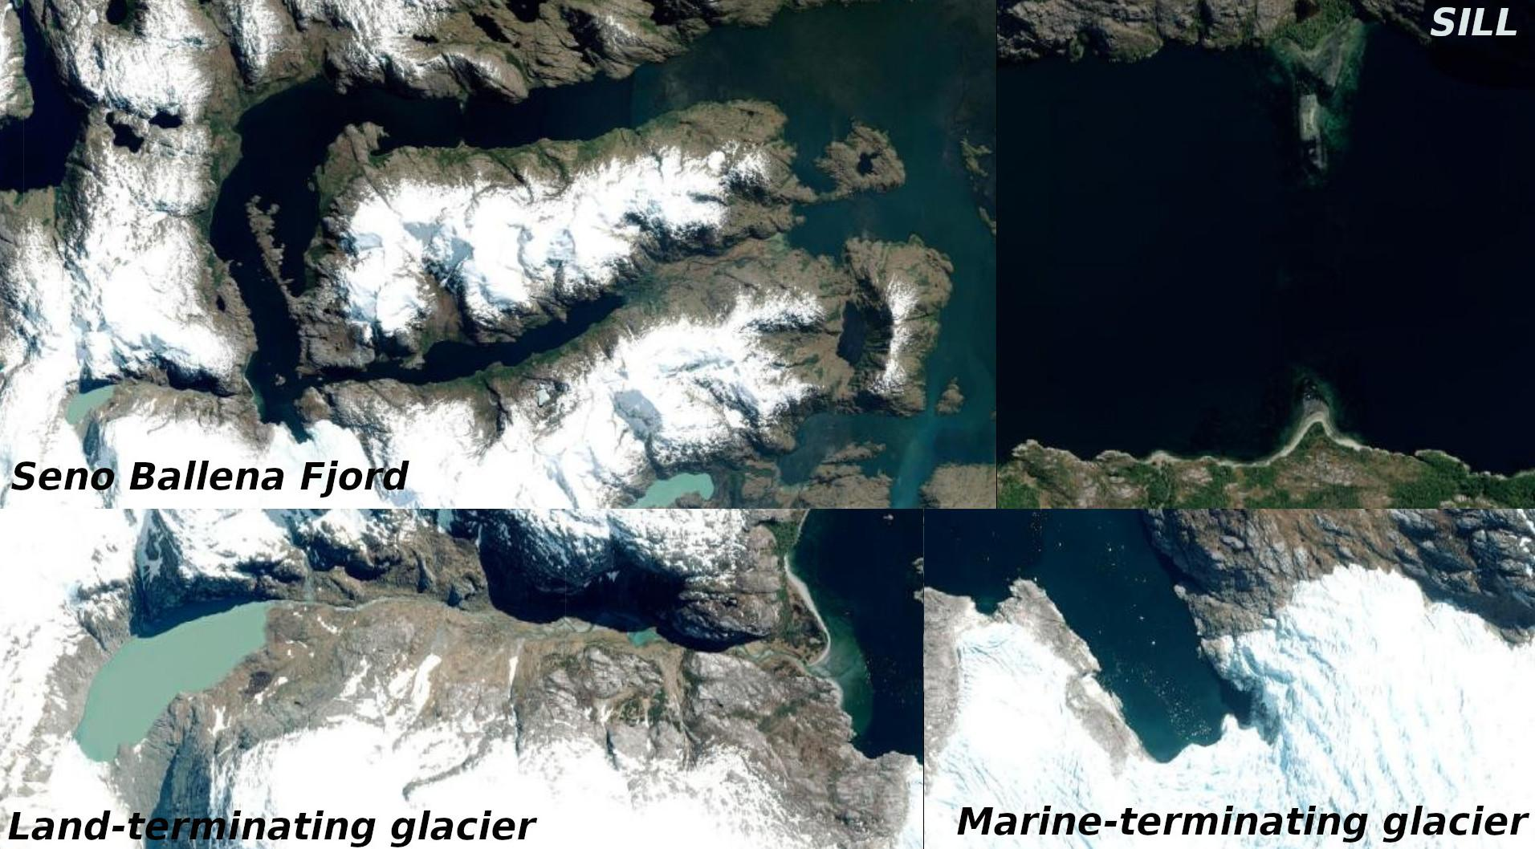
Supplementary Figure 1. Satellite view of the marine and land terminating of the Santa Ines glacier and the sill in the Seno Ballena fjord. Source: Esri, Maxar, GeoEye, Earthstar Geographics, CNES/Airbus DS, USDA, USGS, AeroGRID, IGN, and the GIS User Community (accessed 22 April 2021 at https://landlook.usgs.gov/landlook/viewer.html).

Supplementary Figure 2. T-S diagram the information from the campaigns oceanography from the Seno Ballena Fjord and mixing triangles (STW=Subtropical Water, SAAW = Subantarctic Water; ESSW = Equatorial Subsurface Water; AAIW = Antarctic Intermediate Water; PDW = Pacific Deep Water). MSAAW= Modified Sub-Antarctic Waters mass and EW = Estuarine Water. Our data do not fit the triangles of mixture. However, they were close to the SAAW point. The water mass of the Seno ballena Fjord originates from SAAW that enters the Magellan Strait and mixes with freshwater (FW) and produces this wide range of variability in the parameters of temperature and salinity.

Supplementary Figure 3. T-S diagram of time series from Seno Ballena Fjord and end-member of water-mass: ISSW₁ (Inner Surface Source Water), IBSW₂ (Inner Bottom Source Water), MSAAW₁ (Modified Subantarctic Water).
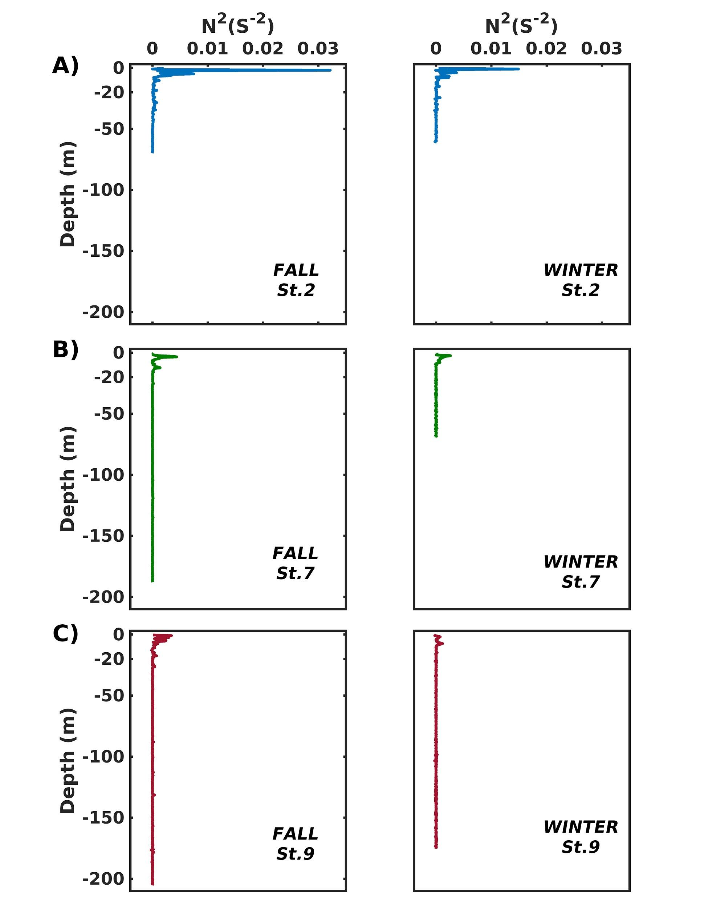

Supplementary Figure 4. Vertical profiles of Brunt-Väisälä frequency for fall and winter, 2018. (A) blue-line, (B) green-line (C) red-line corresponds to one sampling station in the inner sill, outer sill, and off-shelf sections, respectively.

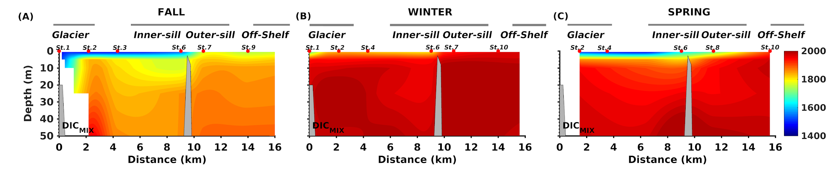
Supplementary Figure 5. Vertical distribution of dissolved inorganic carbon of mixture (DIC_{mix}; A-C) along the Seno Ballena Fjord transect, during austral fall, winter, and spring 2018. Red markers correspond to synoptic sampling stations and grey horizontal lines indicate the extent of each section of the fjord.
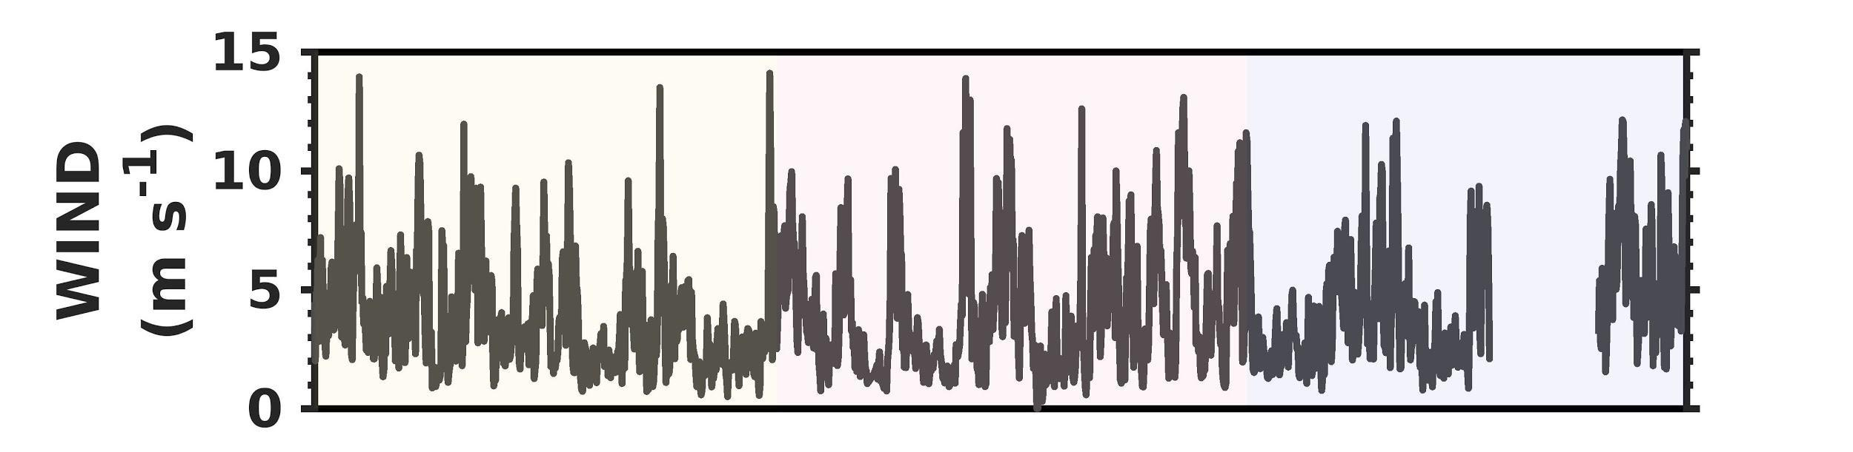

Supplementary Figure 6. Records of speed wind were obtained during the study period at a meteorological station near the study area (Chile Meteorological Directorate, Alberto Hurtado School station, Coordinates: -53.16694S°, -70.94528W°), registered from March to December 2018 at the Seno Ballena fjord.

Supplementary Table 3. Statistical description (minimum, maximum, standard deviation, mean) of physical and chemical parameters obtained from the mooring located outside of sill at 10 ± 1 m in Seno Ballena Fjord.

Season |  | Sal | Temp  (°C) | pCO₂  (µatm) | pH | Ω_{Ar} | O₂  (µmol kg⁻¹)
Fall | Min | 28.7 | 7.8 | 240 | 8.0 | 0.9 | 291
 | Max | 30.5 | 8.6 | 431 | 8.1 | 2.0 | 474
 | SD | 0.2 | 0.2 | 26 | 0.0 | 0.1 | 22
 | Mean | 30.1 | 8.3 | 385 | 8.0 | 1.3 | 316
Winter | Min | 29.3 | 6.7 | 365 | 8.0 | 1.2 | 240
 | Max | 30.2 | 8.3 | 433 | 8.1 | 2.4 | 913
 | SD | 0.2 | 0.4 | 10 | 0.0 | 0.2 | 72
 | Mean | 29.9 | 7.4 | 398 | 8.0 | 1.4 | 343
Spring | Min | 29.2 | 6.6 | 167 | 8.0 | 1.3 | 237
 | Max | 30.0 | 7.7 | 471 | 8.3 | 4.0 | 681
 | SD | 0.2 | 0.2 | 47 | 0.1 | 0.3 | 39
 | Mean | 29.8 | 7.2 | 365 | 8.1 | 1.6 | 343

Supplementary Table 4. Process contributions to Changes in pCO₂. ΔpCO₂ is the difference of pCO₂ between the $t_{n+1}$ and $t_{n}$; positive (or negative) values denote the increase (or decrease) months average each day.

Months |  | Mix | Bio | Gas | Tempe
March | ΔpCO₂ (μatm) | 24.68 | 26.39 | 22.76 | 0.05
April | ΔpCO₂ (μatm) | 30.13 | 31.62 | 30.72 | 0.07
May | ΔpCO₂ (μatm) | 22.68 | 24.62 | 22.90 | -0.03
Jun | ΔpCO₂ (μatm) | 10.86 | 10.78 | 11.25 | -0.21
July | ΔpCO₂ (μatm) | -1.27 | -2.15 | -1.31 | -0.48
Agos | ΔpCO₂ (μatm) | -1.09 | -0.73 | -0.62 | -0.09
Sept | ΔpCO₂ (μatm) | -5.42 | -4.72 | -5.47 | -0.02
Oct | ΔpCO₂ (μatm) | -11.16 | -4.77 | -9.95 | 0.02
Nov | ΔpCO₂ (μatm) | -17.13 | -20.40 | -21.81 | 0.29
Dec | ΔpCO₂ (μatm) | -17.22 | -20.05 | -17.30 | -0.10

