Supplementary material

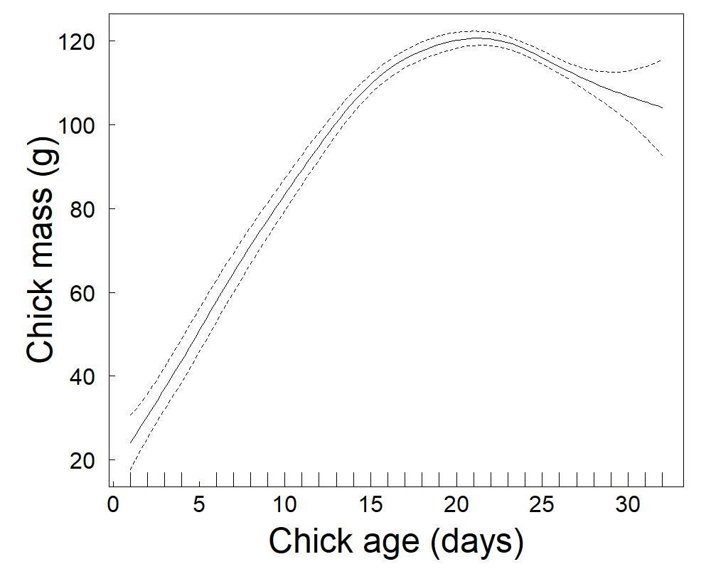

Figure SM-1. Growth rate of little auk chicks at Hornsund (data from 2006-2020). Results show the predicted relationships and associated confidence interval from a generalized additive model.
Table SM-1. Temporal changes in the proportion of Atlantic prey in the little (chick) diet in three Svalbard fjords (Hornsund, Isfjorden and Kongsfjorden). Data (n=1149) are from 2005-2020 (with some years missing for some fjords). Results are from beta regression models (see methods for details). Trend stands for “linear trend”. In (a), np represents the number of estimated parameters, AIC is the Akaike’s Information criterion, ΔAIC is the difference between the AIC of a given model and the lowest AIC of all models considered and R² represents the proportion of explained variation by each model. Models in bold are the ones with the lowest AIC. Table (b) represents the intercept and slope estimates (logit scale) from this model including a Trend×Fjord interaction, along with the test statistics and associated p-values.

Model | np | AIC | ΔAIC | R²
% Atlantic prey~1 | 1 | -1522.62 | 78.03 | -
% Atlantic prey ~Fjord | 3 | -1556.34 | 44.31 | 0.03
% Atlantic prey ~Trend | 2 | -1562.42 | 38.23 | 0.06
% Atlantic prey ~Trend+ Fjord | 4 | -1599.88 | 0.77 | 0.09
% Atlantic prey ~Trend+ Fjord +Trend×Fjord | 6 | -1600.65 | 0.00 | 0.10

Variables | Estimate | SE | z | p
Intercept-Hornsund | -2.06 | 0.13 | -16.14 | <0.001
Intercept-Isfjorden | -2.05 | 0.14 | -14.18 | <0.001
Intercept-Kongsfjorden | -1.56 | 0.16 | -10.00 | <0.001
Trend-Hornsund | 0.04 | 0.01 | 3.69 | <0.001
Trend-Isfjorden | 0.06 | 0.01 | 5.58 | <0.001
Trend-Kongsfjorden | 0.03 | 0.01 | 2.40 | 0.016

(a)
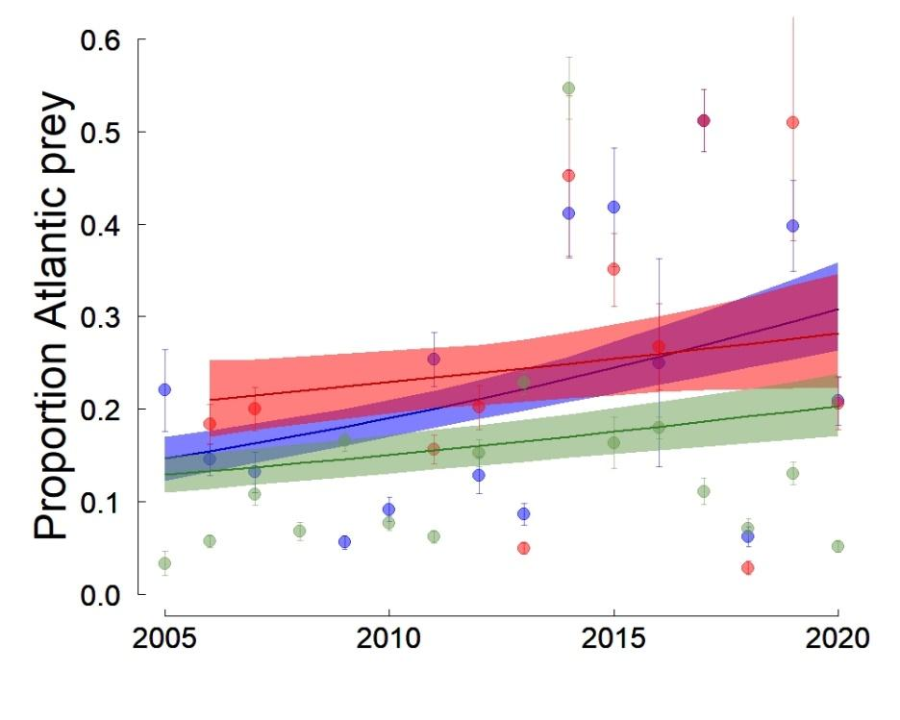
(b)
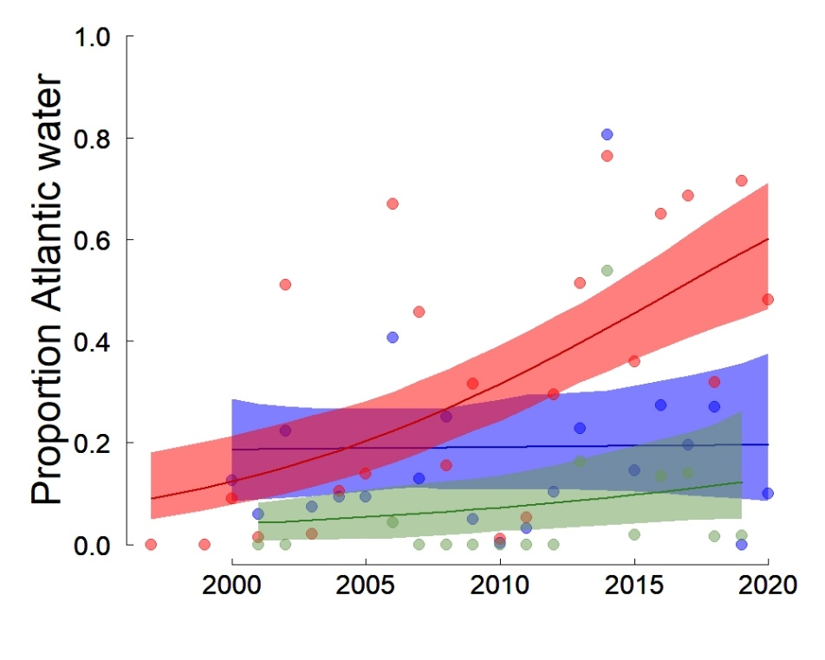
Figure SM-2. Temporal trend in the proportion of Atlantic prey in the little auk chick diet (a) and in the Atlantic water Index (b) in three Svalbard fjords (green: Hornsund, blue: Isfjorden, red: Kongsfjorden). The lines are the predicted relationships from beta regressions. The shaded areas represent the bootstrapped 95% confidence intervals of the predicted values.
Table SM-2. Effect of the proportion of Atlantic water in three Svalbard fjords (Hornsund, Isfjorden and Kongsfjorden) on the proportion of Atlantic prey in the little auk chick diet when accounting for a potential linear trend. Data (n=1022) are from 2005-2020 (with some years missing for some fjords). Results are from beta regression models (see methods for details). np represents the number of estimated parameters, AIC is the Akaike’s Information criterion, ΔAIC is the difference between the AIC of a given model and the lowest AIC of all models considered and R² represents the proportion of explained variation by each model. Model in bold is the one with the lowest AIC.

Model | np | AIC | ΔAIC | R²
%Atlantic prey ~ Trend+ Fjord + Trend × Fjord | 6 | -1236.23 | 152.51 | 0.07
%Atlantic prey ~ Atlantic water + Fjord + Atlantic water × Fjord | 6 | -1355.91 | 32.83 | 0.19
%Atlantic prey ~ Atlantic water + Trend + Colony + Trend × Fjord | 7 | -1349.52 | 39.22 | 0.21
%Atlantic prey ~ Atlantic water + Trend + Fjord + Atlantic water × Fjord | 7 | -1367.83 | 20.91 | 0.22
%Atlantic prey ~ Atlantic water + Trend + Fjord + Atlantic water × Fjord + Trend × Fjord | 9 | -1388.74 | 0.00 | 0.24

Table SM-3. Effect of the mean annual proportion of Atlantic prey on body mass of adult little auks breeding in three Svalbard fjords (Hornsund, Isfjorden and Kongsfjorden) when accounting for a potential linear trend. Data (n=738) are from 2005-2020 (with some years missing for some fjords). Results are from beta regression models (see methods for details). np represents the number of estimated parameters, AIC is the Akaike’s Information criterion, ΔAIC is the difference between the AIC of a given model and the lowest AIC of all models considered and R² represents the proportion of explained variation by each model. Model in bold is the one with the lowest AIC.

Model | np | AIC | ΔAIC | R²
Body Mass ~ Body size | 2 | 5441.14 | 4.54 | 0.18
Body Mass ~ Body size + Trend | 3 | 5442.14 | 5.54 | 0.18
Body Mass ~ Body size + %Atlantic prey (annual mean) | 3 | 5436.60 | 0.00 | 0.19
Body Mass ~ Body size + %Atlantic prey (annual mean) + Trend | 4 | 5438.56 | 1.96 | 0.19

Table SM-4. Effect of the mean annual proportion of Atlantic prey on little auk chick survival (a) and growth rate (b) in Hornsund, Svalbard when accounting for a potential linear trend. Results are from linear models with a Binomial residual distribution and a logit link function (a) and from generalized least-square models with a Gaussian residual distribution and using maximum likelihood (see methods for details). np represents the number of estimated parameters, AIC is the Akaike’s Information criterion, ΔAIC is the difference between the AIC of a given model and the lowest AIC of all models considered and R² represents the proportion of explained variation by each model.

- Chick survival (up to 21 days; n=695)
Model | np | AIC | ΔAIC | R²
Chick survival ~ 1 | 1 | 438.29 | 12.35 | -
Chick survival ~ %Atlantic prey (annual mean) | 2 | 428.41 | 2.47 | 0.02
Chick survival ~ Trend | 2 | 436.88 | 10.94 | <0.01
Chick survival ~ %Atlantic prey (annual mean) + Trend¹ | 3 | 425.94 | 0.00 | 0.02

- Chick growth rate (n=405)
Model | np | AIC | ΔAIC | R²
Growth rate ~ 1 | 1 | 1602.60 | 7.62 | -
Growth rate ~ Trend | 2 | 1601.47 | 6.49 | <0.01
Growth rate ~ %Atlantic prey (annual mean) | 2 | 1595.71 | 0.73 | 0.04
Growth rate ~ %Atlantic prey (annual mean) + Trend² | 3 | 1594.98 | 0.00 | 0.03

¹: results indicate a slight negative trend (significant at the 5% level: p=0.04) in chick survival at Hornsund during the study period (slope of the linear trend ± SE = -0.07 ± 0.03 on a logit scale), independent of the changes in chick diet (slope of the %Atlantic prey ± SE = -8.8 ± 2.4 on a logit scale)
²: results indicate a slight negative trend in chick growth rate at Hornsund during the study period (slope of the linear trend ± SE = -0.02 ± 0.01) but not significant at the 5% level (p=0.07)

Table SM-5. Temporal changes in the proportion of Atlantic water in three Svalbard fjords (Hornsund, Isfjorden and Kongsfjorden). Data (n=58) are from 1997-2020 (with some years missing for some fjords). Results are from beta regression models (see methods for details). Trend stands for “linear trend”. In (a), np represents the number of estimated parameters, AIC is the Akaike’s Information criterion, ΔAIC is the difference between the AIC of a given model and the lowest AIC of all models considered and R2 represents the proportion of explained variance by each model. Model in bold is the one with the lowest AIC. Table (b) represents the intercept and slope estimates from this best model (logit scale), along with the test statistics and associated p-values. The proportion of Atlantic water was, on average, higher in Kongsfjorden (0.38 ± 0.26 SD) than in Isfjorden (0.19 ± 0.20 SD) or Hornsund (0.12 ± 0.20 SD) when considering only the years where data were available for all three fjords (2001, 2002 and 2008-2019). These proportions showed large inter-annual fluctuations that were partly synchronous between colonies (Pearson’s correlation between Hornsund and Isfjorden: n=14, r=0.78, p<0.001 ; between Hornsund and Kongsfjorden: n=14, r=0.64, p=0.01 and between Isfjorden and Kongsfjorden: n=21, r=0.57, p=0.007). Despite this synchrony in (short-term) inter-annual fluctuations, the long-term trend differed among fjords and the proportion of Atlantic water only increased significantly in Kongsfjorden but not in the two other fjords, Isfjorden and Hornsund.

Model | np | AIC | ΔAIC | R²
%Atlantic water~1 | 1 | -63.39 | 15.53 | -
% Atlantic water ~Fjord | 3 | -67.82 | 11.10 | 0.11
% Atlantic water ~Trend | 2 | -65.66 | 13.26 | 0.10
% Atlantic water ~Trend+ Fjord | 4 | -76.18 | 2.74 | 0.30
% Atlantic water ~Trend+ Fjord +Trend× Fjord | 6 | -78.92 | 0.00 | 0.34

Variables | Estimate | SE | z | p
Intercept-Hornsund | -2.93 | 0.86 | -3.41 | <0.001
Intercept-Isfjorden | -1.42 | 0.52 | -2.73 | 0.006
Intercept-Kongsfjorden | -2.42 | 0.45 | -5.37 | <0.001
Trend-Hornsund | 0.05 | 0.05 | 1.06 | 0.29
Trend-Isfjorden | 0.003 | 0.03 | 0.09 | 0.93
Trend-Kongsfjorden | 0.12 | 0.03 | 4.04 | <0.001

