Supplementary Information

Tree locations and characteristics

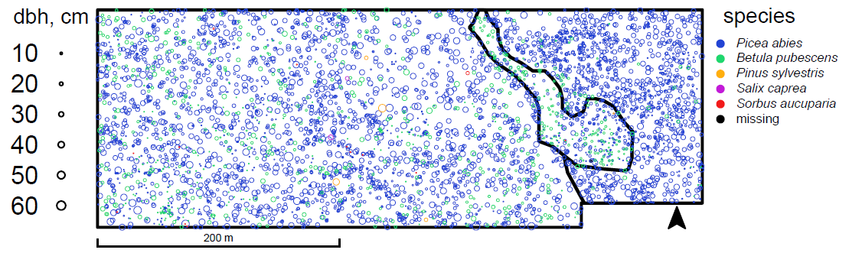
FIGURE S1 Live tree locations, diameters and species within the plot.

Aspatial statistics
TABLE S1 Basic statistics of the trees in the West, calculated by tree species and status, all stems included for trees with multiple stems (e.g. sprouts).
 | Picea abies |  |  | Betula pubescens |  |  | all
 | live | dead | all | live | dead | all | live | dead | all
number of stems | 2686 | 384 | 3070 | 1220 | 163 | 1383 | 3927 | 557 | 4484
stems ha⁻¹ | 413 | 59 | 472 | 188 | 25 | 213 | 604 | 86 | 690
proportion of stems (%) | 59.9 | 8.6 | 68.5 | 27.2 | 3.6 | 30.8 | 87.6 | 12.4 | 100.0
basal area (m²ha⁻¹) | 13.2 | 3.4 | 16.6 | 1.8 | 0.4 | 2.3 | 15.1 | 3.8 | 19.0
proportion of basal area (%) | 69.8 | 17.7 | 87.5 | 9.5 | 2.4 | 11.9 | 79.8 | 20.2 | 100.0
volume (m³ha⁻¹) | 96.1 | 25.3 | 121.4 | 10.1 | 2.5 | 12.6 | 106.9 | 28.0 | 134.9
proportion of volume (%) | 71.2 | 18.7 | 89.9 | 7.5 | 1.9 | 9.4 | 79.2 | 20.8 | 100.0
mean DBH (cm) | 16.9 | 24.7 | 17.9 | 7.6 | 13.5 | 8.3 | 14.0 | 21.2 | 14.9
maximum DBH (cm) | 61.0 | 51.1 | 61.0 | 38.6 | 32.0 | 38.6 | 61.0 | 51.1 | 61.0
coefficient of variation of DBH | 0.65 | 0.44 | 0.63 | 1.05 | 0.52 | 0.98 | 0.79 | 0.53 | 0.76
mean height (m) | 10.9 | 3.2 | 9.8 | 7.6 | 1.5 | 6.4 | 10.3 | 2.7 | 9.1
maximum height (m) | 26.2 | 22.0 | 26.2 | 19.1 | 16.2 | 19.1 | 26.2 | 22.0 | 26.2
coefficient of variation of height | 0.52 | 1.58 | 0.62 | 0.58 | 1.46 | 0.75 | 0.54 | 1.65 | 0.66

TABLE S2 Basic statistics of the trees in the stream area, calculated by tree species and status, all stems included for trees with multiple stems (e.g. sprouts).
 | Picea abies |  |  | Betula pubescens |  |  | all
 | live | dead | all | live | dead | all | live | dead | all
number of stems | 271 | 94 | 365 | 168 | 25 | 193 | 442 | 120 | 562
stems ha⁻¹ | 551 | 191 | 742 | 341 | 51 | 392 | 898 | 244 | 1142
proportion of stems (%) | 48.2 | 16.7 | 64.9 | 29.9 | 4.4 | 34.3 | 78.6 | 21.4 | 100.0
basal area (m²ha⁻¹) | 4.8 | 1.8 | 6.6 | 2.2 | 0.6 | 2.8 | 7.0 | 2.4 | 9.4
proportion of basal area (%) | 50.8 | 19.3 | 70.2 | 23.3 | 6.0 | 29.3 | 74.3 | 25.7 | 100.0
volume (m³ha⁻¹) | 26.0 | 10.2 | 36.2 | 10.2 | 2.9 | 13.1 | 36.2 | 13.3 | 49.6
proportion of volume (%) | 52.5 | 20.6 | 73.1 | 20.5 | 5.9 | 26.4 | 73.1 | 26.9 | 100.0
mean DBH (cm) | 8.1 | 9.0 | 8.3 | 7.2 | 10.1 | 7.6 | 7.7 | 9.3 | 8.1
maximum DBH (cm) | 34.0 | 32.0 | 34.0 | 23.1 | 26.8 | 26.8 | 34.0 | 32.0 | 34.0
coefficient of variation of DBH | 0.83 | 0.71 | 0.80 | 0.77 | 0.62 | 0.75 | 0.81 | 0.69 | 0.78
mean height (m) | 5.3 | 2.8 | 4.6 | 5.7 | 1.2 | 5.0 | 5.4 | 2.4 | 4.7
maximum height (m) | 19.2 | 10.3 | 19.2 | 12.3 | 4.7 | 12.3 | 19.2 | 10.3 | 19.2
coefficient of variation of height | 0.71 | 1.07 | 0.80 | 0.54 | 0.87 | 0.66 | 0.65 | 1.14 | 0.76

TABLE S3 Basic statistics of the trees in the East, calculated by tree species and status, all stems included for trees with multiple stems (e.g. sprouts).
 | Picea abies |  |  | Betula pubescens |  |  | all
 | live | dead | all | live | dead | all | live | dead | all
number of stems | 1401 | 218 | 1619 | 50 | 7 | 57 | 1451 | 225 | 1676
stems ha⁻¹ | 774 | 120 | 895 | 28 | 4 | 31 | 802 | 124 | 926
proportion of stems (%) | 83.6 | 13.0 | 96.6 | 3.0 | 0.4 | 3.4 | 86.6 | 13.4 | 100.0
basal area (m²ha⁻¹) | 17.3 | 3.5 | 20.8 | 0.4 | 0.1 | 0.4 | 17.7 | 3.6 | 21.3
proportion of basal area (%) | 81.4 | 16.6 | 97.9 | 1.7 | 0.4 | 2.1 | 83.1 | 16.9 | 100.0
volume (m³ha⁻¹) | 116.7 | 23.7 | 140.3 | 1.8 | 0.6 | 2.4 | 118.5 | 24.2 | 142.7
proportion of volume (%) | 81.7 | 16.6 | 98.3 | 1.3 | 0.4 | 1.7 | 83.0 | 17.0 | 100.0
mean DBH (cm) | 13.9 | 17.4 | 14.4 | 11.2 | 15.2 | 11.7 | 13.8 | 17.3 | 14.3
maximum DBH (cm) | 49.3 | 42.2 | 49.3 | 23.6 | 27.8 | 27.8 | 49.3 | 42.2 | 49.3
coefficient of variation of DBH | 0.69 | 0.49 | 0.66 | 0.57 | 0.42 | 0.55 | 0.69 | 0.49 | 0.66
mean height (m) | 8.9 | 3.7 | 8.2 | 6.6 | 1.3 | 6.0 | 8.8 | 3.7 | 8.1
maximum height (m) | 23.3 | 19.3 | 23.3 | 11.8 | 2.8 | 11.8 | 23.3 | 19.3 | 23.3
coefficient of variation of height | 0.58 | 1.29 | 0.66 | 0.51 | 0.80 | 0.61 | 0.58 | 1.30 | 0.66

Diameter distributions
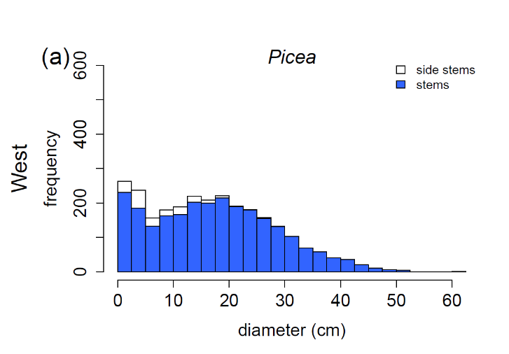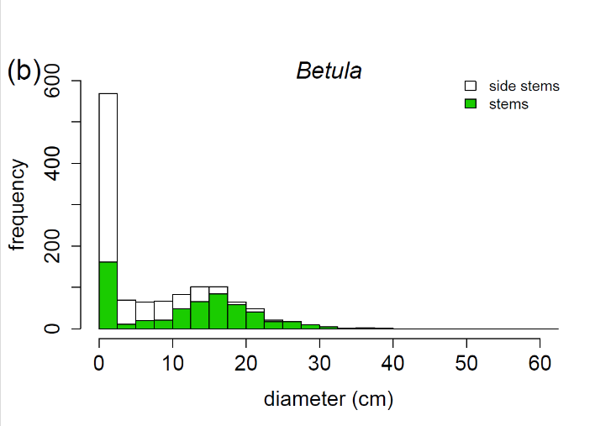
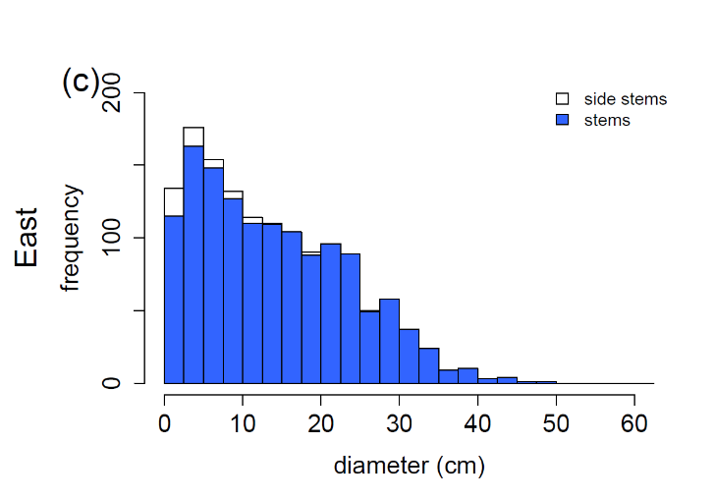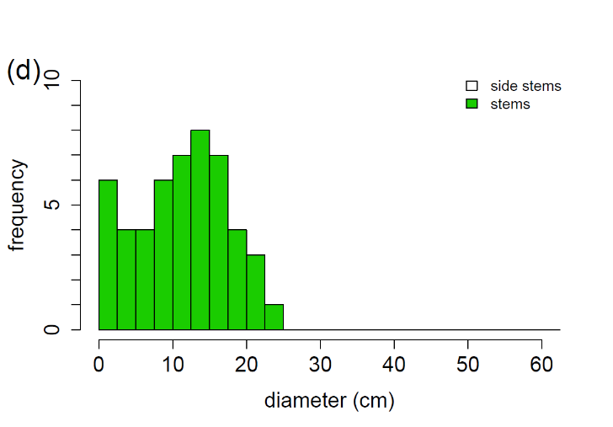
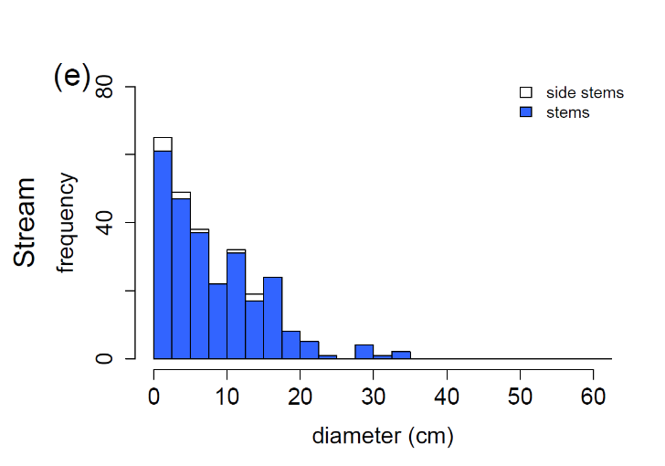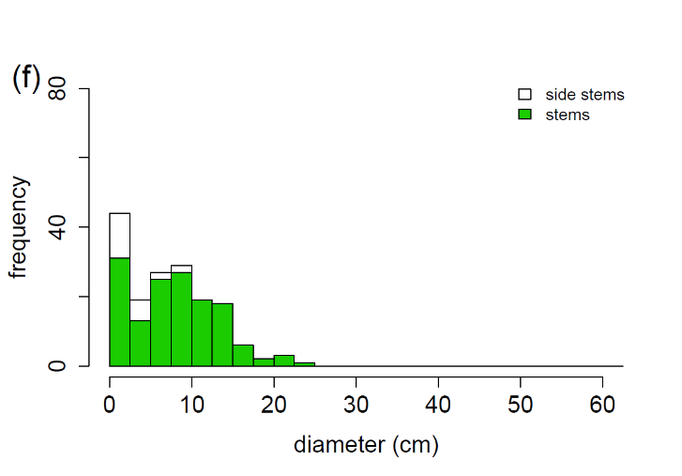

FIGURE S2 Diameter distributions of live (a) Picea abies in the West, (b) Betula pubescens in the West, (c) P. abies in the East, (d) B. pubescens in the East, (e) P. abies in the stream area and (f) B. pubescens in the stream area, and the proportion of vegetative side stems, e.g. sprouts. Note the differing scales in the y-axes.

Growing space distributions
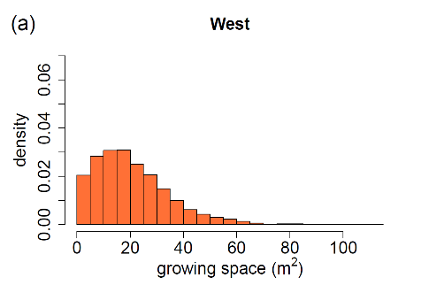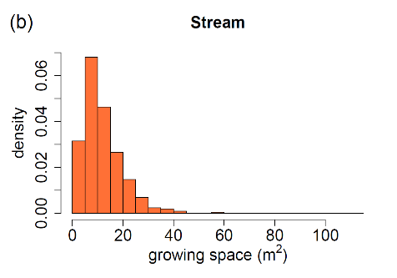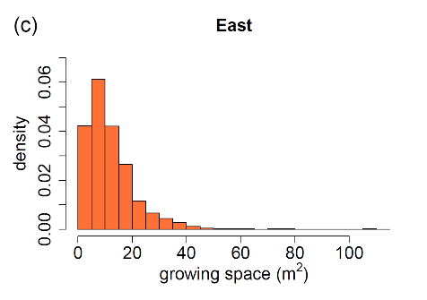
FIGURE S3 Distribution of area potentially available for individual trees calculated as Voronoi polygon area for the subplots of the study plot: (a) the West, (b) the stream area (c) the East. Calculated from tree locations treated as points in a plane. the Voronoi polygon of each tree is defined as the planar area within which the tree is the closest tree of all. To adjust the scales between the plots. the frequency distributions have been divided with the number of observations to make their surface areas equal to one.

