SUPPLEMENTARY FIGURE S1 | Alignment and phylogenic tree of CgNIX and CgFUNDC1 with NIXs and FUNDC1s from other species, respectively. (A) Black shadow indicated identical residues and gray shadow indicated similar residues in the aligned amino acids. (B) The numbers at the forks indicated the bootstrap. Proteins analyzed were listed below: Cg, Crassostrea gigas NIX (XP_011445562.1); Hs, Homo sapiens NIX (AAC00022.1); Mm, Mus musculus NIX (NP_033890.1); Xl, Xenopus laevis NIX (XP_018080653.1); Gg, Gallus gallus NIX (XP_421829.3); Dr, Danio rerio NIX (P_005173025.1); Pv, Penaeus vannamei NIX (ROT69101.1); My, Mizuhopecten yessoensis NIX (XP_021364080.1); Ce, Caenorhabditis elegans, NIX (AAC31574.1); Cv, Crassostrea virginica NIX (XP_022339578.1). (C) Black shadow indicated identical residues and gray shadow indicated similar residues in the aligned amino acids. (D) The numbers at the forks indicated the bootstrap. Proteins analyzed were listed below: Cg, C. gigas FUNDC1 (XP_034329090.1); Hs, H. sapiens FUNDC1 (NP_776155.1); Mm, M. musculus FUNDC1 (NP_001300674.1); Gg, G. gallus FUNDC1 (NP_001263292.1); Dr, D. rerio FUNDC1 (NP_609362.1); Ce, C. elegans FUNDC1 (NP_496404.1); Pv, Penaeus vannamei FUNDC1 (XP_027235525.1); Dm, Drosophila melanogaster FUNDC1 (NP_609362.1); My, M. yessoensis FUNDC1 (XP_021379239.1); Cv, C. virginica FUNDC1 (XP_022289087.1).

SUPPLEMENTARY FIGURE S2 | Alignment and phylogenic tree of CgPHB2 and CgCardiolipin with PHB2s and Cardiolipins from other species, respectively. (A) Black shadow indicated identical residues and gray shadow indicated similar residues in the aligned amino acids. (B) The numbers at the forks indicated the bootstrap. Proteins analyzed were listed below: Cg, C. gigas PHB2 (XP_011427916.2); Hs, H. sapiens PHB2 (EAW88699.1); Mm, M. musculus PHB2 (NP_031557.2); Bt, Bos taurus PHB2 (NP_001039663.1); Xt, Xenopus tropicalis PHB2 (NP_001016551.1); Dr, D. rerio PHB2 (AAH59510.1); Sp, Strongylocentrotus purpuratus PHB2 (XP_030842735.1); Dm, D. melanogaster PHB2 (NP_725831.2); Pv, P. vannamei PHB2 (ROT61873.1); My, M. yessoensis PHB2 (XP_021372589.1); Cv, C. virginica PHB2 (XP_022346063.1); Ce, C. elegans PHB2 (CCD66149.1). (C) Black shadow indicated identical residues and gray shadow indicated similar residues in the aligned amino acids. (D) The numbers at the forks indicated the bootstrap. Proteins analyzed were listed below: Cg, C. gigas Cardiolipin (XP_011439682.2); Hs, H. sapiens Cardiolipin (NP_001120930.1); Mm, M. musculus Cardiolipin (XP_006500075.1); Gg, G. gallus Cardiolipin (XP_015139409.2); Xl, X. laevis Cardiolipin (NP_001090462.1); Dr, D. rerio Cardiolipin (NP_998096.1); Ce, C. elegans Cardiolipin (NP_001022547.1); Pv, P. vannamei Cardiolipin (XP_027223270.1); Dm, D. melanogaster Cardiolipin (NP_001262969.1); My, M. yessoensis Cardiolipin (XP_021379957.1); Cv, C. virginica Cardiolipin (XP_022333659.1).

SUPPLEMENTARY FIGURE S3 | Alignment and phylogenic tree of CgP62 with P62s from other species. (A) Black shadow indicated identical residues and gray shadow indicated similar residues in the aligned amino acids. (B) The numbers at the forks indicated the bootstrap. Proteins analyzed were listed below: Cg, C. gigas P62 (XP_011452145.1); Hs, H. sapiens P62 (AAH01874.1); Mm, M. musculus P62 (NP_035148.1); Gg, G. gallus P62 (XP_001233249.2); Dr, D. rerio P62 (NP_001299842.1); Dm, D. melanogaster P62 (NP_476700.1); Pv, P. vannamei P62 (ROT64427.1); My, M. yessoensis P62 (OWF55631.1); Cv, C. virginica P62 (XP_022327687.1).

SUPPLEMENTARY FIGURE S4 | Alignment and phylogenic tree of CgOPTN with OPTNs from other species. (A) Black shadow indicates identical residues and gray shadow indicates similar residues in the aligned amino acids. (B) The numbers at the forks indicated the bootstrap. Proteins analyzed were listed below: Cg, C. gigas OPTN (XP_034306379.1), Hs, H. sapiens OPTN (NP_001093327.1); Mm, M. musculus OPTN (NP_001154896.1); Dr, D. rerio OPTN (NP_001014366.1); Bd, Bactrocera dorsalis OPTN (JAC42003.1); Bt, B. taurus OPTN (NP_001029774.1); Xt, X. tropicalis OPTN (XP_017947826.1); Pv, P. vannamei OPTN (ROT84077.1); My, M. yessoensis OPTN (OWF48322.1); Cv, C. virginica OPTN (XP_022302308.1); Sp, S. purpuratus OPTN (XP_783059.2).
SUPPLEMENTARY FIGURE S5 | Alignment and phylogenic tree of CgVDAC2 with VDAC2s from other species. (A) Black shadow indicates identical residues, and gray shadow indicates similar residues in the aligned amino acids. (B) The numbers at the forks indicated the bootstrap. Proteins analyzed are listed below: Cg, C. gigas VDAC2 (NP_001292225.1); Hs, H. sapiens VDAC2 (NP_001171712.1); Mm, M. musculus VDAC2 (NP_035825.1); Bt, B. taurus VDAC2 (DAA29533.1); Dm, D. melanogaster VDAC2 (NP_001033899.1); Dr, D. rerio VDAC2 (NP_955879.1); Xl, X. laevis (NP_001089399.1); Pv, P. vannamei VDAC2 (XP_027213642.1); Sp, S. purpuratus VDAC2 (XP_030834916.1); My, M. yessoensis VDAC2 (XP_021351930.1); Cv, C. virginica VDAC2 (XP_022316203.1); Ce, C. elegans VDAC2 (NP_501211.1).

SUPPLEMENTARY FIGURE S6 | Alignment and phylogenic tree of CgMFN2 with MFN2s from other species. (A) Black shadow indicated identical residues, and gray shadow indicated similar residues in the aligned amino acids. (B) The numbers at the forks indicated the bootstrap. Proteins analyzed were listed below: Cg, C. gigas MFN2 (XP_011449174.2); Hs, H. sapiens MFN2 (NP_001121132.1); Mm, M. musculus MFN2 (NP_001272849.1); Bt, B. taurus MFN (NP_001177198.1); Xt, X. tropicalis MFN2 (XP_031760947.1); Dr, D. rerio MFN2 (NP_001121726.1); Sp, S. purpuratus MFN2 (XP_030847518.1); My, M. yessoensis MFN2 (XP_021353688.1); Cv, C. virginica MFN2 (XP_022336819.1); Pc, P. canaliculata MFN2 (XP_025082569.1); Ce, C. elegans MFN2 (NP_495161.1).

SUPPLEMENTARY FIGURE S7 | Alignment and phylogenic tree of CgMPP and CgPARL with MPPs and PARLs from other species, respectively. (A) Black shadow indicated identical residues, and gray shadow indicated similar residues in the aligned amino acids. (B) The numbers at the forks indicated the bootstrap. Proteins analyzed are listed below: Cg, C. gigas MPP (XP_034304795.1); Hs, H. sapiens MPP (XP_005250774.1); Mm, M. musculus MPP (NP_082707.1); Bt, B. taurus MPP (NP_001029785.1); Xt, X. tropicalis MPP (NP_001039103.1); Bd, B. dorsalis MPP (JAC42427.1); Dr, D. rerio MPP (NP_001012514.1); Sp, S. purpuratus MPP (XP_011678827.1); My, M. yessoensis MPP (XP_021344019.1); Cv, C. virginica MPP (XP_022302542.1); Pv, P. vannamei MPP (XP_027214917.1); Bg, Biomphalaria glabrata MPP (XP_013078886.1); Ce, C. elegans MPP (NP_501576.2). (C) Black shadow indicated identical residues, and gray shadow indicated similar residues in the aligned amino acids. (D) The numbers at the forks indicated the bootstrap. Proteins analysed were listed below: Cg, C. gigas PARL (XP_011419537.2); Hs, H. sapiens PARL (NP_061092.3); Mm, M. musculus PARL (NP_001005767.1); Bt, B. taurus PARL (ABG81447.1); Dr, D. rerio PARL (NP_001014320.1); Dm, D. melanogaster PARL (NP_001286324.1); Pv, P. vannamei PARL (XP_027229585.1); Sp, S. purpuratus PARL (XP_781024.2); My, M. yessoensis PARL (XP_021365722.1); Cv, C. virginica PARL (XP_022343884.1); Ce, C. elegans PARL (NP_491125.4).

SUPPLEMENTARY TABLE S1 | The sequence features of genes in the mitophagy pathway.
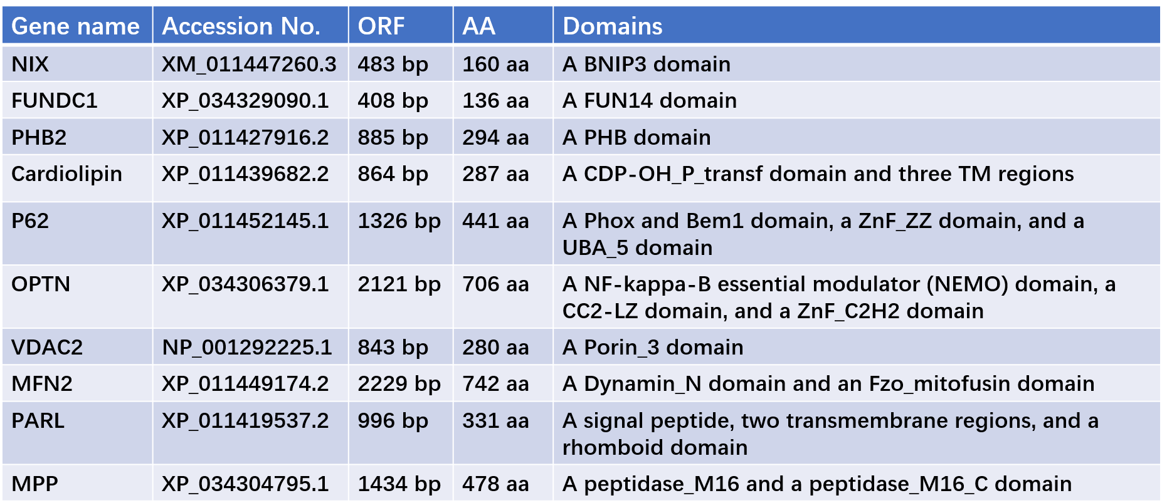

SUPPLEMENTARY TABLE S2 | The tissue distribution of genes in oysters.
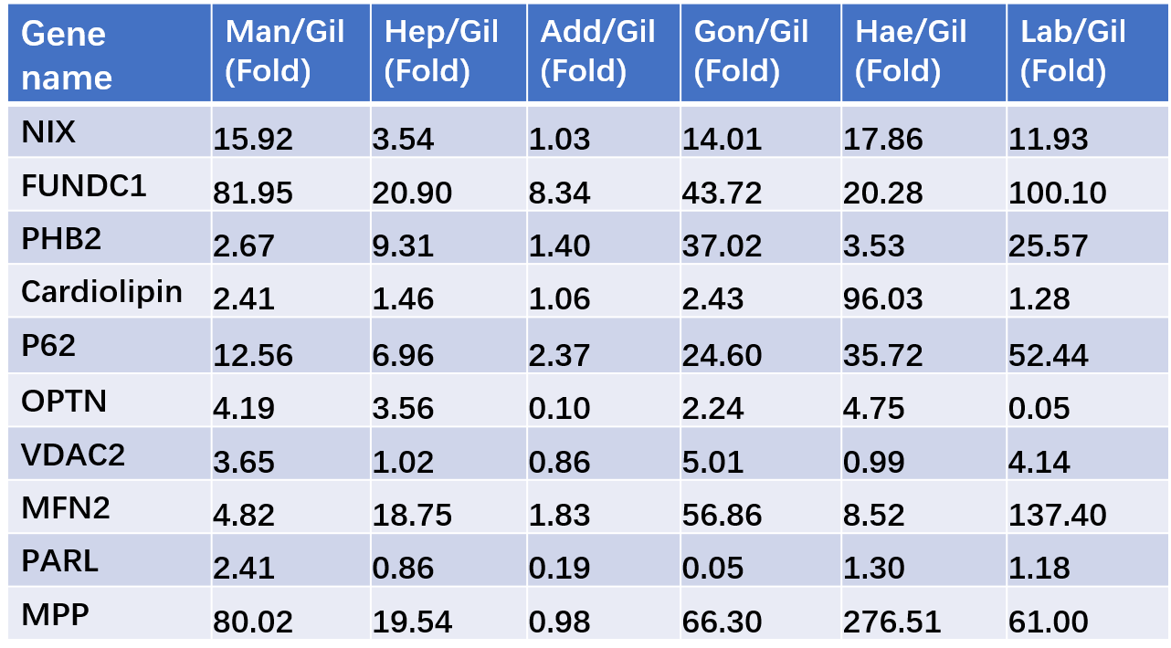
Man: mantle; Gil: gills; Hep: hepatopancreas; Add: adductor muscle; Gon: gonad; Hae: haemocytes; Lab: labial palps.

SUPPLEMENTARY TABLE S3 | Sequences of the primers used in this study.
Primer | Sequence (5'-3')
Clone primers
CgNIX-F | ATGGCGTCTGTGTCAAAACAG
CgNIX-R  CgFUNDC1-F  CgFUNDC1-R  CgPHB2-F  CgPHB2-R  CgP62-F  CgP62-R  CgVDAC2-F  CgVDAC2-R  CgMFN2-F  CgMFN2-R  CgPARL-F  CgPARL-R  CgMPP-F  CgMPP-R  CgOPTN-F | GATGCTCAACTTGTTACTTCC  ATGACACACAAGAGGGATAAG  TCTTCCAGTGTCAGCTGTTCA  ATGGATCCCAAGAAATTGAAA  TCGTCTCTTCAGATTCTC  ATGTCACTTACTGTAAAAGCA  GGCCATGAAGCCGCCATCAGG  ATGGCTCCCCCGACATATGGT  GGCCTCGAAGTCCAGACCGAG  ATGTCAGGAAAATTAGACAAA  ATCTTTTGGACCCAAAAA  ATGCTAGGATCTTTGTTAATT  TCCACTAAAAACACTGCA  ATGTCGTCTCGACTGTTGGGA  TGAGTCTCAGCCAGTAGAACTC  ATGAATGGAGCCCACACGCCC
CgOPTN-R | GGTCATGTCCTGGTCGATACA
RT-PCR primers
CgNIX-RT-F  CgNIX-RT-R | GGATCTGGAATCGAGCGGAA  TTGGGCTGTGAGGACTCTTG
CgFUNDC1-RT-F  CgFUNDC1-RT-R  CgPHB2-RT-F  CgPHB2-RT-R  CgCardiolipin-RT-F  CgCardiolipin-RT-R  CgOPTN-RT-F  CgOPTN-RT-R  CgVDAC2-RT-F | TCATCGGCGGAGTATCAGGA  GCTGTGCAATCTGAAGAACCA  CCTCCCAACTTATTACAC  TCAACTTCAAAAATCCAG  TTTGGCTGTTAAACTCGGCG  CGTATGTCTGACGACTGGGG  GGCTGTCCCTGAAGAGTT  CTGCTTCTCTGTCTCCGT  GCTCGTGAAAGGATTGAAACT
CgVDAC2-RT-R | TTGGTGTGAATGGTAAAG
CgMFN2-RT-F | ACCAGTTTGAGATTGCGT
CgMFN2-RT-R | ATGAGTCCGTAGAGGGCT
CgMPP-RT-F | TGCGTCCTTACAGCACACAAC
CgMPP-RT-R | CCTACATCAATCCACAAACCC
CgPARL-RT-F | AGGGTTTCTCTCCTCTTTCAG
CgPARL-RT-R | GCAACGCAAGGATACCTGACT
CgP62-RT-F | AAGCTGCAGACAGATGGACC
CgP62-RT-R | CTTGGCTCTGGTCTGGATGG
CgEF-RT-F | AGTCACCAAGGCTGCACAGAAAG
CgEF-RT-R | TCCGACGTA TTTCTTTGCGATGT

