Supplementary Material

Supplementary Figures
Figure S1. Structures of new family esterase. a Superimposition of the modeled structure of Est33 and its 7 homologs. The eight structures are colored in red (Est33), blue (WP_090184031), yellow (WP_217858764), plum (WP_157710783), teal (WP_083349625), yellow-green (WP_027613488), red-orange (WP_210710674), and orange (WP_008372319). b the structure of the active site of Est33, the catalytic triad, Ser⁹⁴ (nucleophile), Asp²⁰⁵ (charge-relay), and His²³³ (proton carrier) are indicated, distances between catalytic Ser and His, His and Asp of Est33 were 2.90 Å, 2.99 Å, respectively.

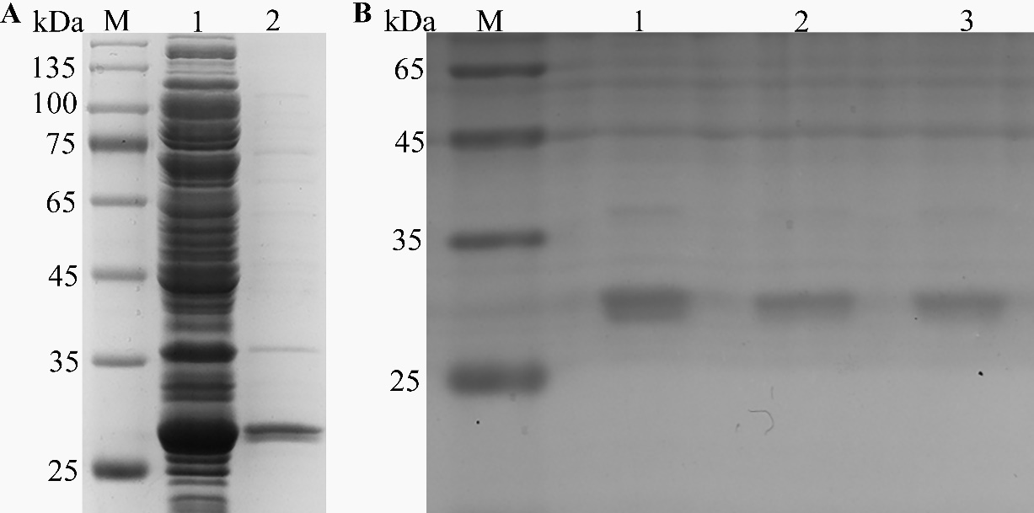
Figure S2. SDS-PAGE analysis of Est33 and the variants. Lane M, protein molecular mass marker; a Lane 1, total protein from E. coli with IPTG induction of Est33; Lane 2, purified Est33. b Lane 1-3, purified S94A, D205A, and H233A variants, respectively.

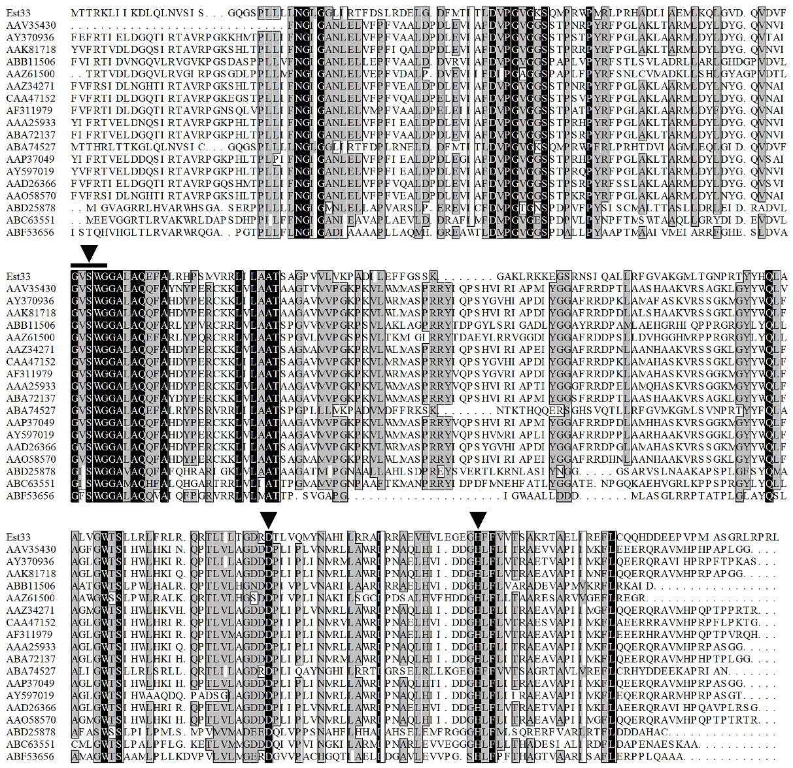
Figure S3. Sequence alignment of Est33 and proteins from PHA_depolymerase_arom family. Identical residues are shown in white on a black background, and similar residues (homology ≥75%) are on a grey background. Black triangle indicates residues forming the catalytic triad Ser, Asp and His. Black squares indicate conserved motifs.

Supplementary Tables
Table S1. Primers used in this study.
primers | sequence
est33F | AAGAAGGAGATATACATatgacaacgcgcaaactgatcattaaª
est33R | TCGAGTGCGGCCGCAAGCTTgagcaggcgtggccttagcctgc
S94A-F | GATGTGTTCGGCGTGGCTTGGGGCGGTGCATTG^{b}
S94A-R | CAATGCACCGCCCCAAGCCACGCCGAACACATC
D205A-F | CTCACCGGCGACCGCGCCACCCTGGTACAGATG
D205A-R | CATCTGTACCAGGGTGGCGCGGTCGCCGGTGAG
H233A-F | CTGGAGGGTGAGGGGGCTTTTTTCGTGGTCACC
H233A-R | GGTGACCACGAAAAAAGCCCCCTCACCCTCCAG
ª Uppercase letters indicate the nucleotides pairing with the vector sequence. Lowercase letters indicate the esterase gene sequence. ^{b} The mutated site were shown in underline and italic. F, R in the name of primers means forward and reverse, respectively.
Table S2. Kinetic parameters of esterase Est33 for pNPC2ª.
Enzyme | K_{m}  (μM) | V_{max}  (μM/min/mg) | k_{cat}  (s⁻¹) | k_{cat}/K_{m}  (s⁻¹mM⁻¹)
Est33 | 275±8 | 1949±44 | 1.04±0.02 | 3.78
ª Kinetic parameters were measured in triplicate using pNPC2 as substrate at 30 °C in Tris-HCl buffer (50 mM, pH 7.5). Results shown are means ±SD.
Table S3. Esterases sequences used in the phylogenetic analysis.
Organisms | UniProt or Genbank Accession No. | Family
Proteus vulgaris | Q52614 | Ⅰ
Pseudomonas fluorescens | O68310 | Ⅰ
Pseudomonas aeruginosa | P95419 | Ⅰ
Salmonella typhimurium | AAC38796.1 | Ⅱ
Photorhabdus luminescens | CAA47020.1 | Ⅱ
Streptomyces albus | Q59798 | Ⅲ
Streptomyces sp. | Q56008 | Ⅲ
Moraxella sp. (strain TA144) | P19833 | Ⅲ
Dehalococcoidia bacterium | A0A2E5LY74 | Ⅳ
Pseudomonas sp. B11-1 | O52270 | Ⅳ
Moraxella sp. (strain TA144) | P24484 | Ⅳ
Psychrobacter immobilis | Q02104 | Ⅴ
Moraxella sp. (strain TA144) | P24640 | Ⅴ
Sulfolobus acidocaldarius | O73957 | Ⅴ
Arthrospira platensis | Q53415 | Ⅵ
Pseudomonas fluorescens | Q53547 | Ⅵ
Bacillus subtilis (strain 168) | P37967 | Ⅶ
Streptomyces coelicolor (strain ATCC BAA-471) | Q9RKZ7 | Ⅶ
Pseudarthrobacter oxydans | Q01470 | Ⅶ
Streptomyces anulatus | O87861 | Ⅷ
Pseudomonas fluorescens | Q53403 | Ⅷ
Arthrobacter globiformis | Q44050 | Ⅷ
Lysobacter sp. Root494 | A0A0Q7Q3S1 | Ⅸ
Paucimonas lemoignei | Q939Q9 | Ⅸ
Shewanella halifaxensis (strain HAW-EB4) | B0TLS4 | Ⅸ
Thermotoga sp. RQ7 | A0A0B5KXQ5 | Ⅹ
Thermotoga maritima (strain ATCC 43589 ) | Q9WYH1 | Ⅹ
Trichodesmium erythraeum (strain IMS101) | UPI00003C9FC4 | Ⅺ
Rhodopirellula baltica (strain SH1) | UPI00001ACC08 | Ⅺ
Colwellia psychrerythraea | UPI000056E257 | Ⅺ
Marinomonas sp. MED121 | UPI0000690BA8 | Ⅻ
uncultured bacterium | B1PZ93 | Ⅻ
Clostridium acetobutylicum | UPI00000CA890 | Ⅻ
Geobacillus stearothermophilus | Q06174 | XIII
Alkalihalobacillus pseudofirmus (strain OF4) | D3FY90 | XIII
Thermoanaerobacterium | UPI0001B0C2CD | XIV
Caldanaerobacter subterraneus | UPI00000D6E2D | XIV
Bacillus sp. (strain H-257) | P82597 | XV
Geobacillus thermodenitrificans | G3JWZ2 | XV
uncultured bacterium | K7QE06 | XV
Xanthomonas euvesicatoria | UPI00005CE776 | XVI
Saccharothrix espanaensis | UPI00028BB641 | XVI
Stenotrophomonas maltophilia | S4TNY8 | XVI
Arsenicicoccus sp. oral taxon 190 | UPI00067D7D19 | XVII
Dermatophilus congolensis | UPI0004203A07 | XVII
Janibacter sp. R02 | A0A1S5R222 | XVII
Solibacillus silvestris | UPI0002045A9D | XVIII
Lysinibacillus manganicus | UPI000531A963 | XVIII
Stenotrophomonas maltophilia | UPI000710186B | XIX
Stenotrophomonas maltophilia | A0A218L045 | XIX
Stenotrophomonas pavanii | UPI00088576A2 | XIX
Streptomyces sp. NRRL WC-3753 | KPC70032.1 | XX
Streptomyces viridosporus ATCC 14672 | EFE68124.1 | XX
Streptomyces rochei | BBC94648.1 | XX
Pseudomonas sp. URIL14HWK12:I6 | WP 027613488 | XXI
Pseudomonas arsenicoxydans | WP 090184031 | XXI
Pseudomonas sp. In5 | WP 054613993 | XXI
unclassified Pseudomonas | WP 169370552 | XXI
Pseudomonas sp. PB120 | WP 157710783 | XXI
Pseudomonas sp. E5-12 | MZ717198 Est33 | XXI

