Supplementary Materials
¹H NMR (400 MHz, DMSO-d₆) spectrum for compound 1a
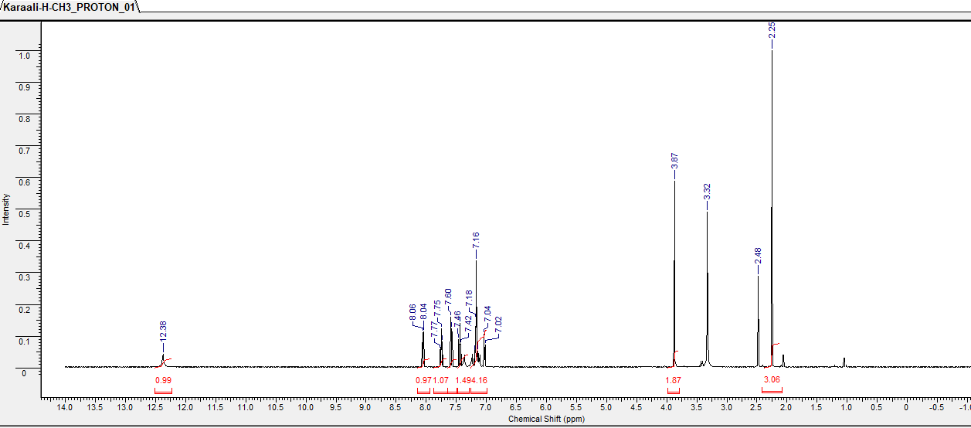
¹³C NMR (APT, 100 MHz, DMSO-d₆) δ (ppm) spectrum for compound 1a
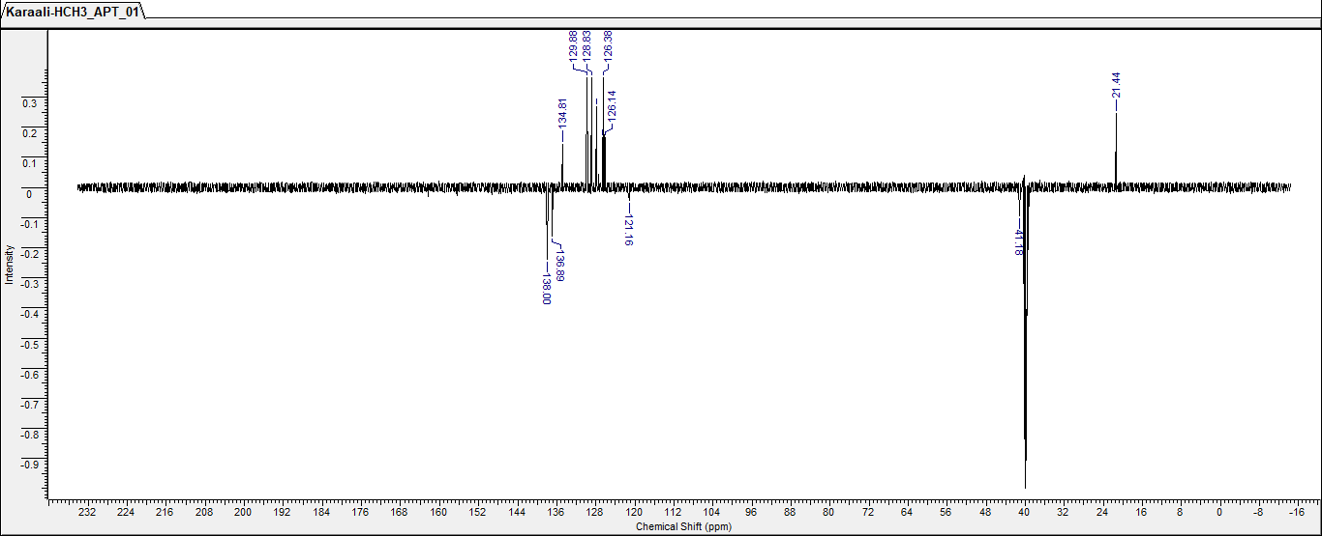

¹H NMR (400 MHz, DMSO-d₆) spectrum for compound 1b
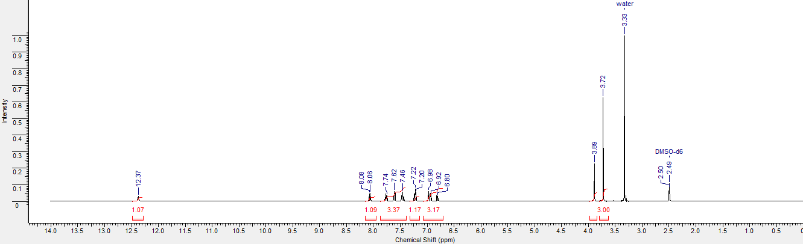
¹H NMR (400 MHz, DMSO-d₆) spectrum for compound 2a

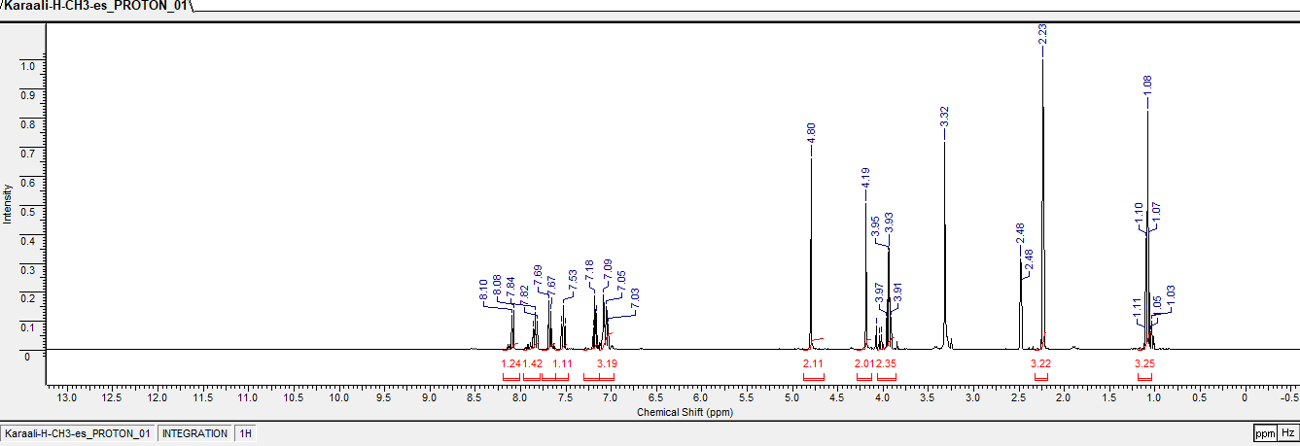
¹³C NMR (APT, 100 MHz, DMSO-d₆) δ (ppm) spectrum for compound 2a

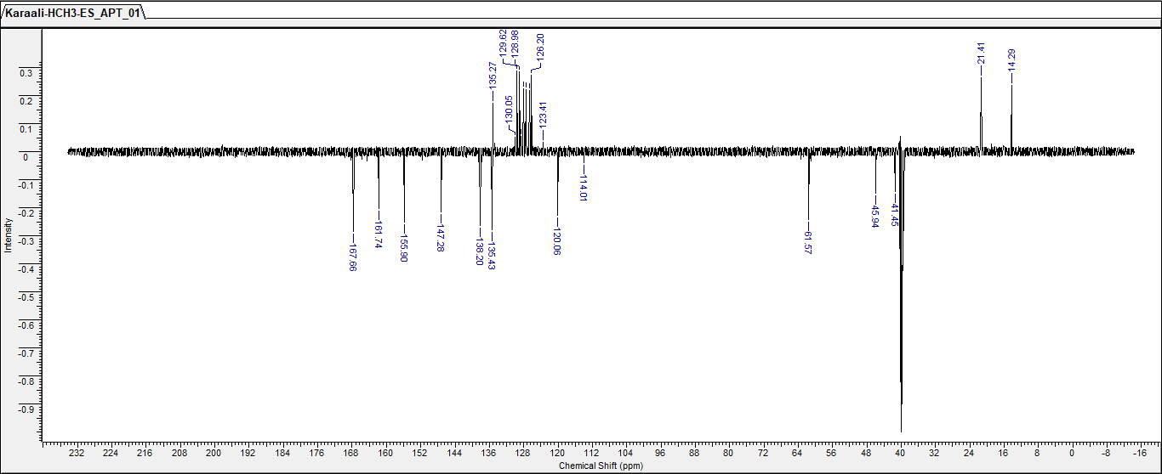
¹H NMR (400 MHz, DMSO-d₆) spectrum for compound 2b
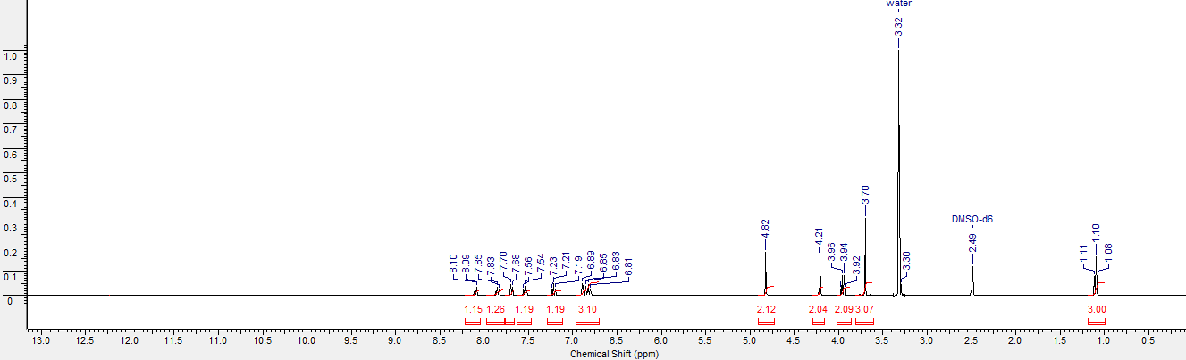
¹³C NMR (APT, 100 MHz, DMSO-d₆) δ (ppm) spectrum for compound 2b

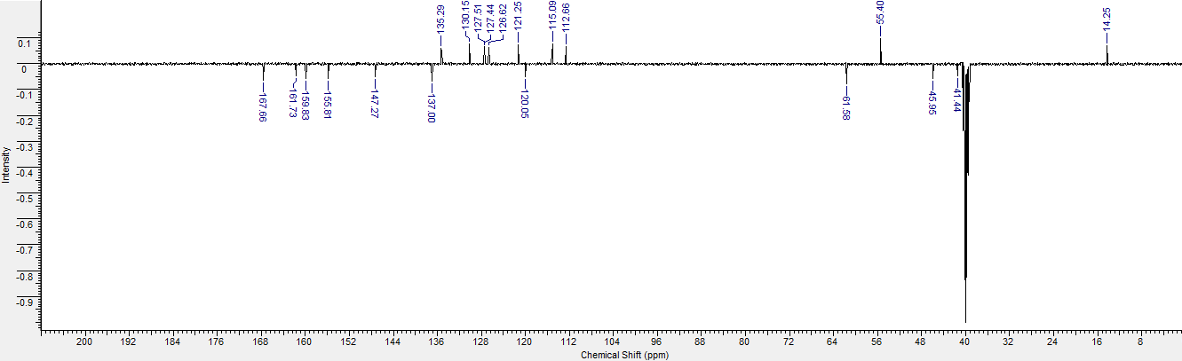
¹H NMR (400 MHz, DMSO-d₆) spectrum for compound 3a
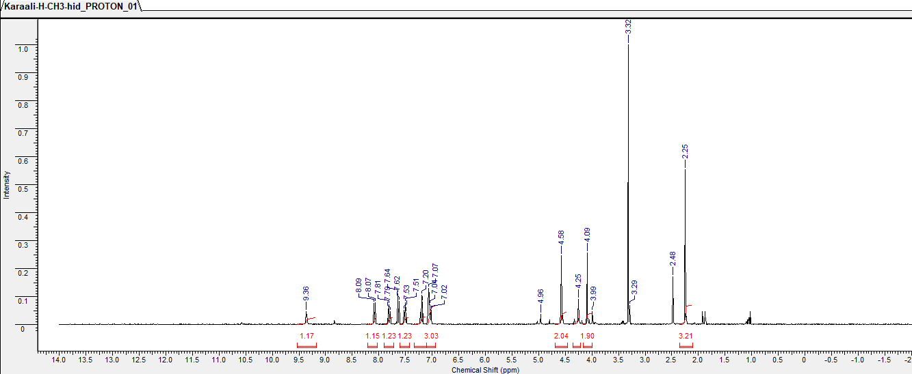
¹³C NMR (APT, 100 MHz, DMSO-d₆) δ (ppm) spectrum for compound 3a

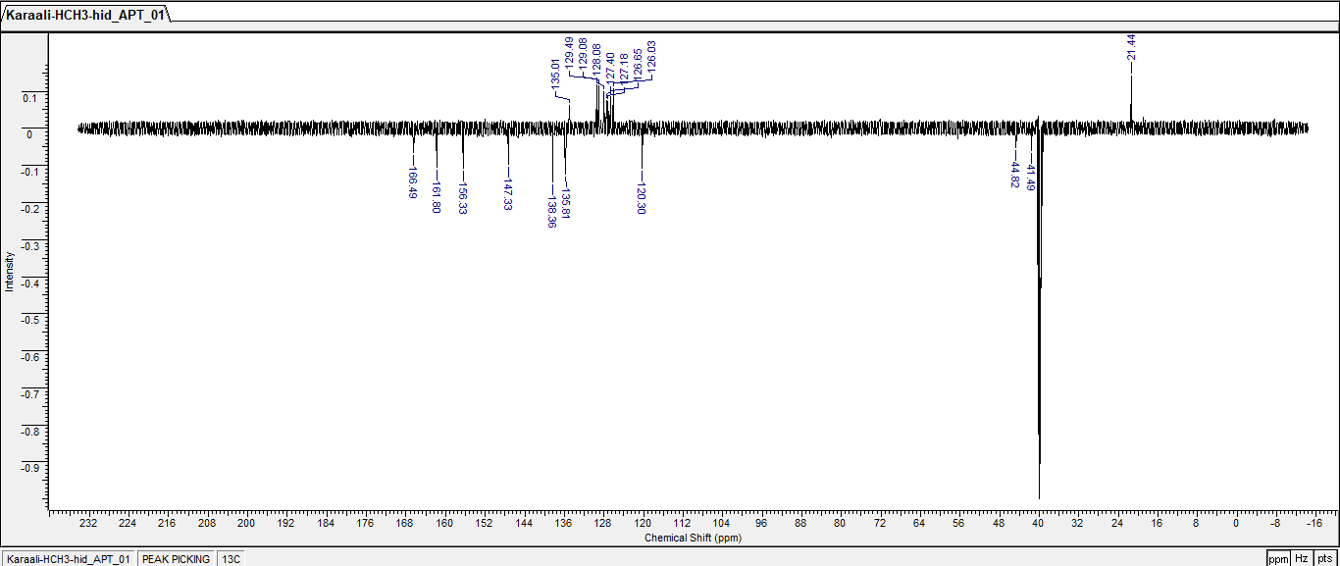
¹H NMR (400 MHz, DMSO-d₆) spectrum for compound 3b
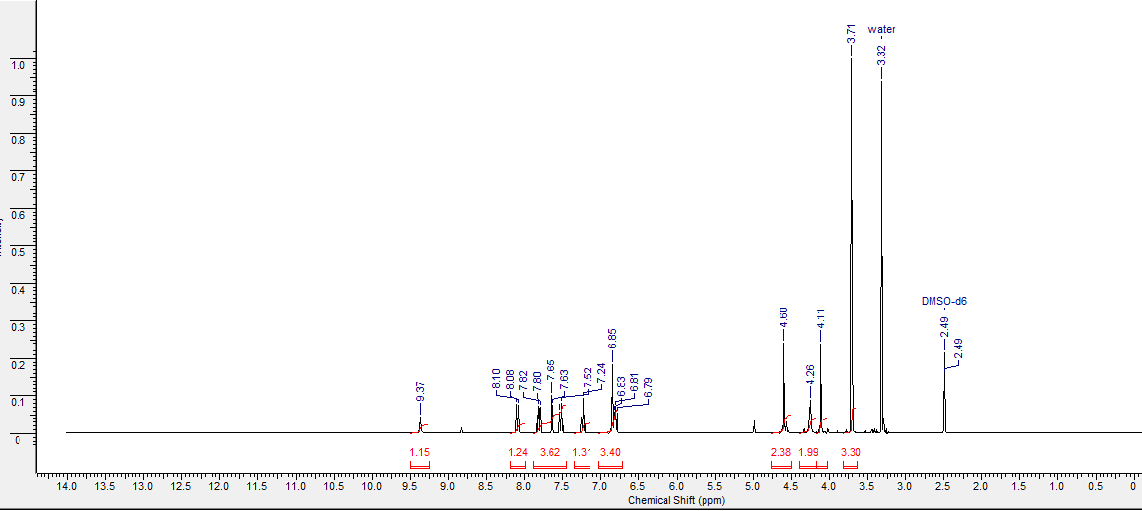
¹³C NMR (APT, 100 MHz, DMSO-d₆) δ (ppm) spectrum for compound 3b

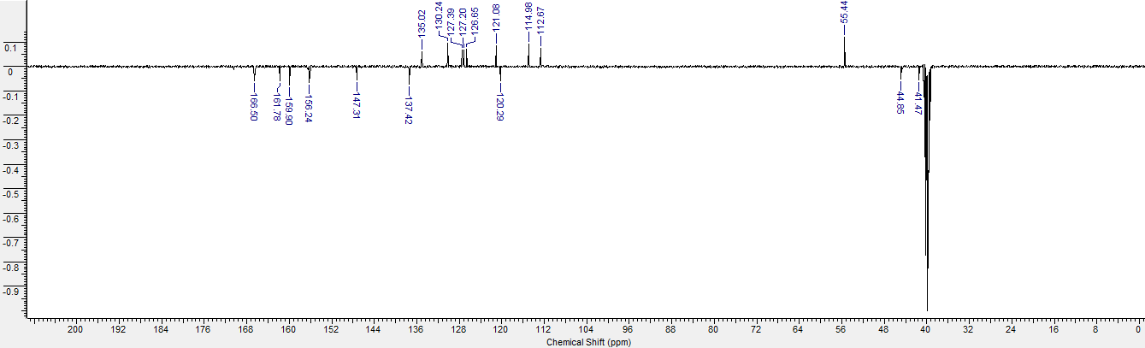
¹H NMR (400 MHz, DMSO-d₆) spectrum for compound 4a
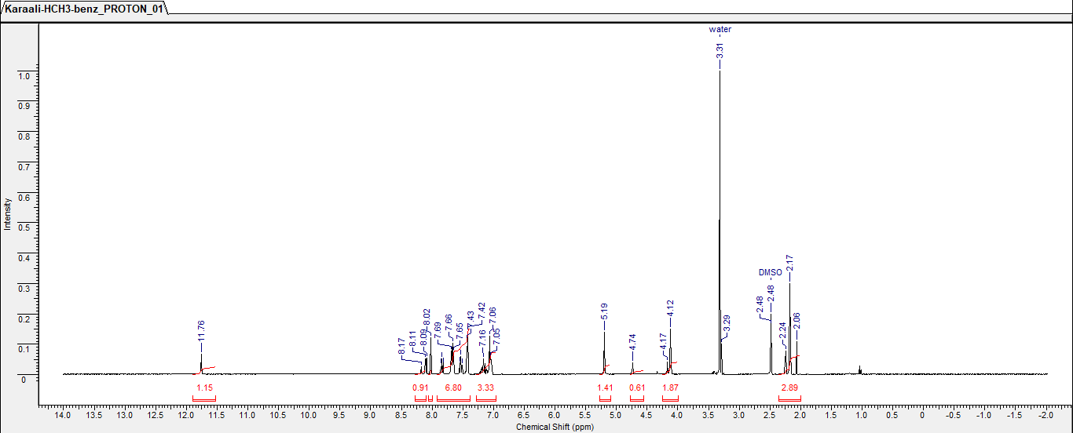
¹³C NMR (APT, 100 MHz, DMSO-d₆) δ (ppm) spectrum for compound 4a
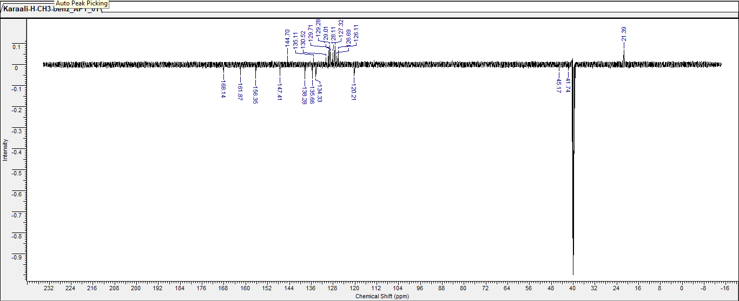
¹H NMR (400 MHz, DMSO-d₆) spectrum for compound 4b
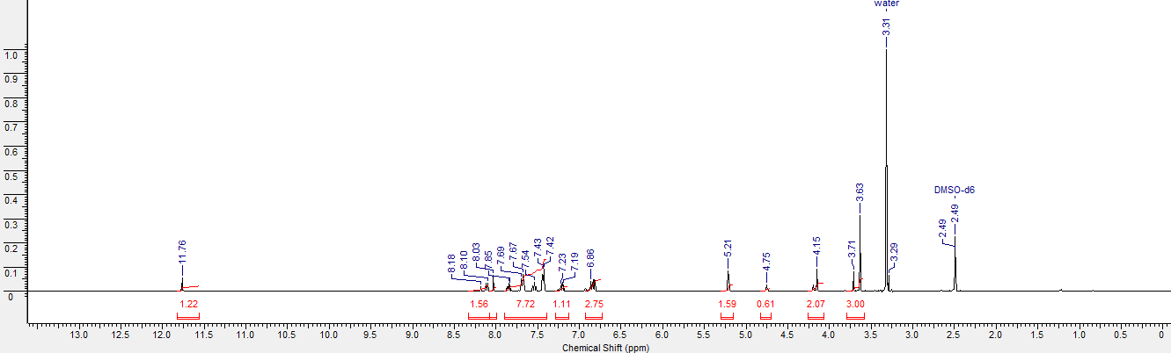
¹³C NMR (APT, 100 MHz, DMSO-d₆) δ (ppm) spectrum for compound 4b
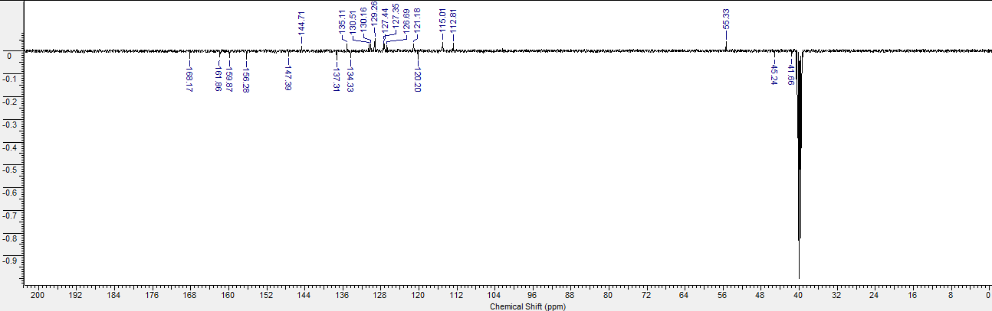

¹H NMR (400 MHz, DMSO-d₆) spectrum for compound 5a
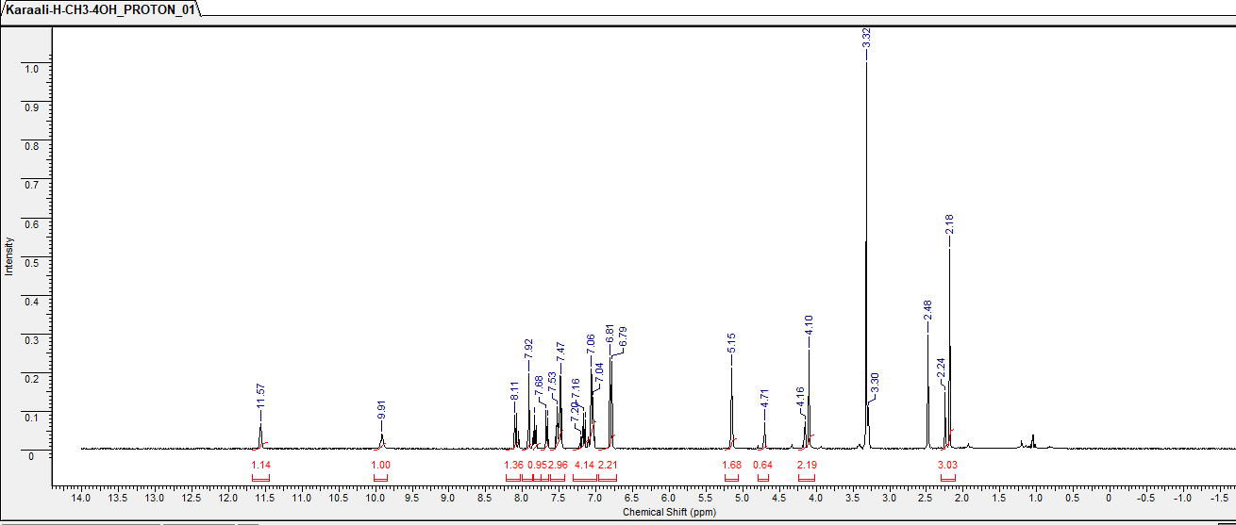
¹³C NMR (APT, 100 MHz, DMSO-d₆) δ (ppm) spectrum for compound 5a
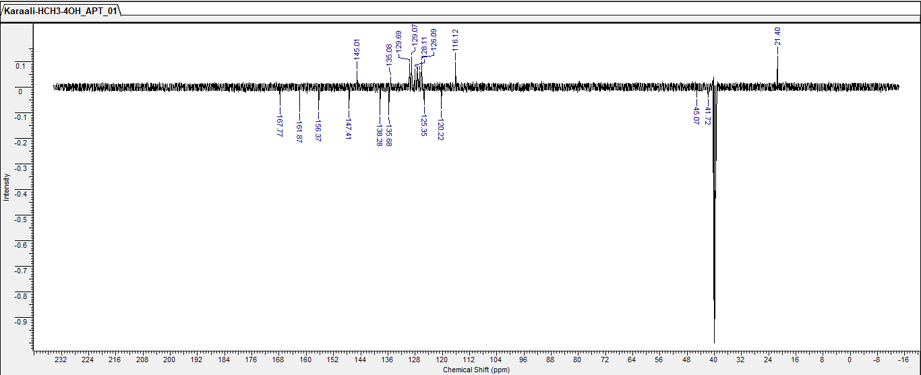
¹H NMR (400 MHz, DMSO-d₆) spectrum for compound 5b
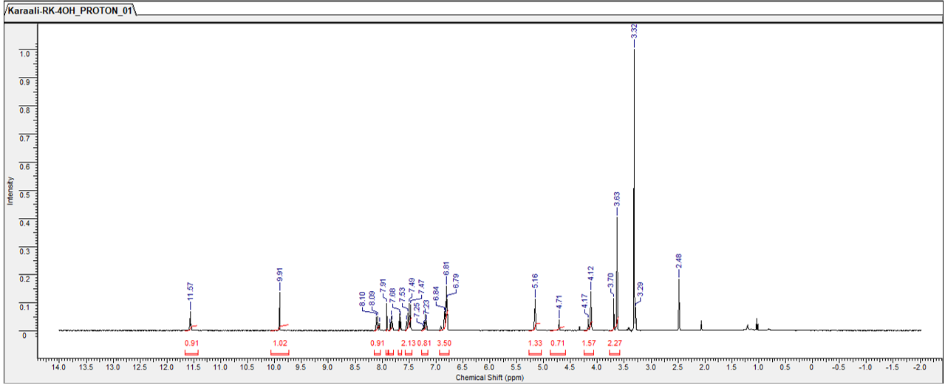
¹³C NMR (APT, 100 MHz, DMSO-d₆) δ (ppm) spectrum for compound 5b
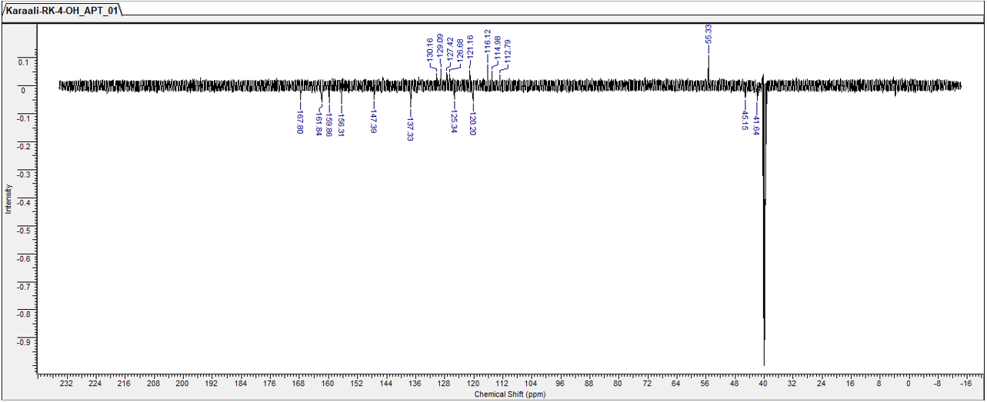

¹H NMR (400 MHz, DMSO-d₆) spectrum for compound 6a
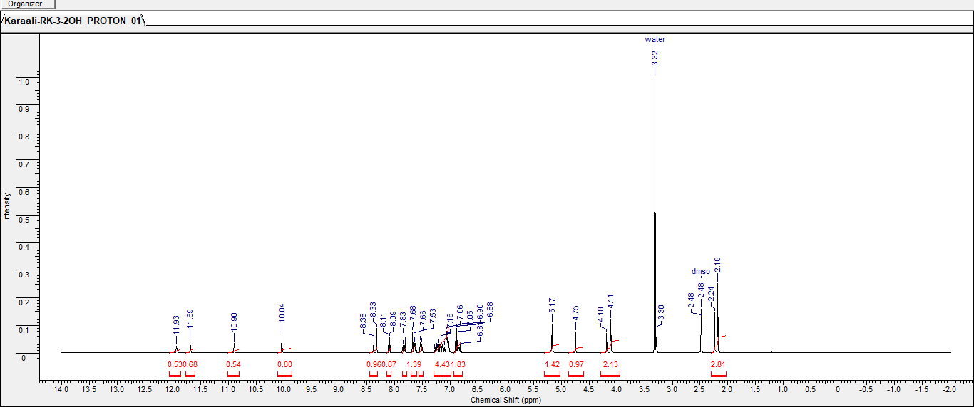
¹³C NMR (APT, 100 MHz, DMSO-d₆) δ (ppm) spectrum for compound 6a
