Supplementary materials

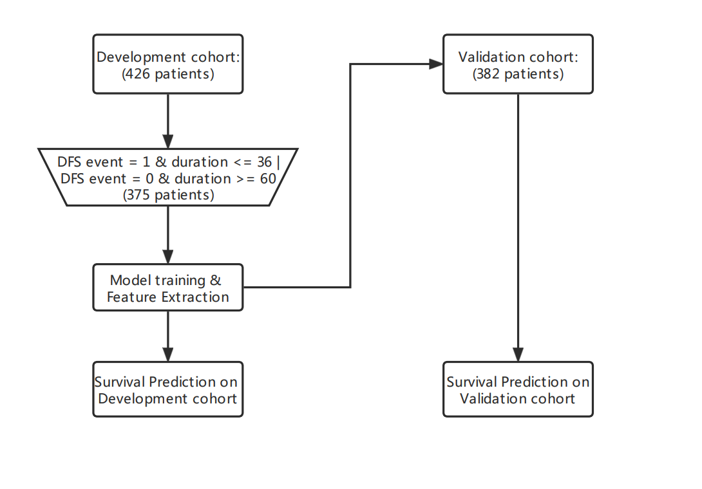
Supplementary Figure 1. Schematic flow chart of the study procedure

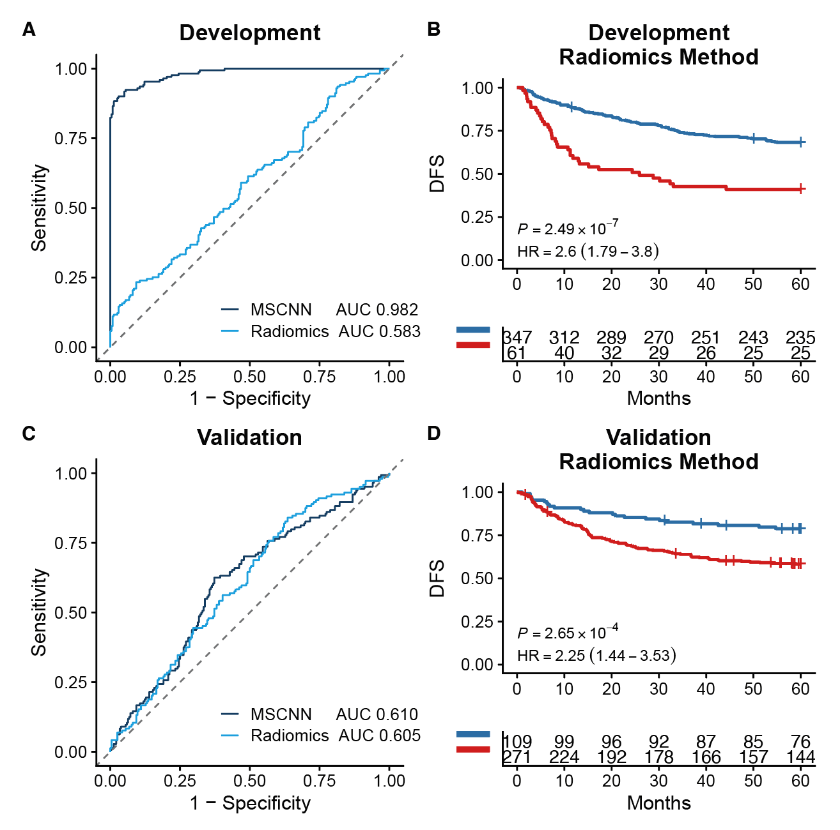
Supplementary Figure 2. MSDL Method vs. Radiomics Method. Kaplan-Meier curves for high recurrence risk and low recurrence risk patients predicted by Radiomics method in the development cohort (B) and validation cohort (D). Comparison between

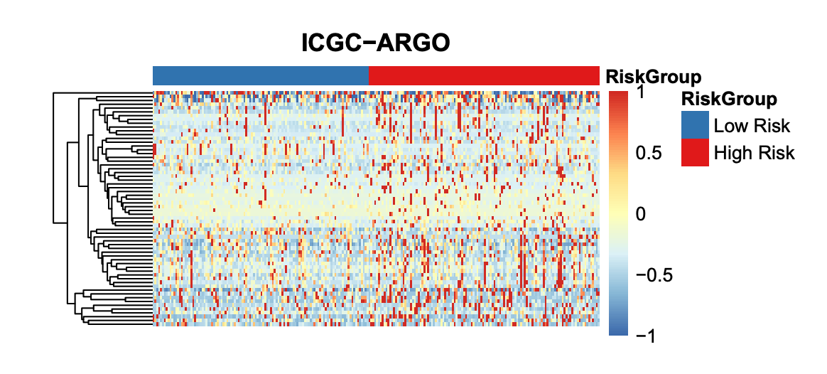
Supplementary Figure 3. Heatmap of different expression genes between high and low risk group

Supplementary Table 1. The risk groups and CT signature of CRC patients in this study.
TuominID | Cohort | CT-signature | Risk_group | Gene-Data
A028 | Development | 0.9994 | High Risk | No
A029 | Development | 0.9999 | High Risk | No
A055 | Development | 0.0431 | Low Risk | No
A057 | Development | 0.9998 | High Risk | No
A054 | Development | 0.0361 | Low Risk | No
A058 | Development | 0.0086 | Low Risk | No
A051 | Development | 0.0629 | Low Risk | No
A062 | Development | 0.5374 | High Risk | No
A063 | Development | 0.0434 | Low Risk | No
A064 | Development | 0.2336 | Low Risk | No
A065 | Development | 0.4640 | Low Risk | No
A056 | Development | 0.0642 | Low Risk | No
A066 | Development | 0.9998 | High Risk | No
A060 | Development | 1.0000 | High Risk | No
A061 | Development | 0.0327 | Low Risk | No
A030 | Development | 0.9997 | High Risk | No
A031 | Development | 0.0473 | Low Risk | No
A033 | Development | 0.0544 | Low Risk | No
A032 | Development | 0.1827 | Low Risk | No
A034 | Development | 0.2906 | Low Risk | No
A036 | Development | 0.9994 | High Risk | No
A039 | Development | 0.9998 | High Risk | No
A040 | Development | 0.0403 | Low Risk | No
A041 | Development | 0.9997 | High Risk | No
A043 | Development | 0.9991 | High Risk | No
A035 | Development | 0.9991 | High Risk | No
A037 | Development | 0.0800 | Low Risk | No
A046 | Development | 0.4452 | Low Risk | No
A048 | Development | 0.1267 | Low Risk | No
A042 | Development | 0.1322 | Low Risk | No
A044 | Development | 0.0280 | Low Risk | No
A045 | Development | 0.5189 | High Risk | No
A047 | Development | 0.9998 | High Risk | No
A050 | Development | 0.0788 | Low Risk | No
A053 | Development | 0.9998 | High Risk | No
A052 | Development | 0.9999 | High Risk | No
A067 | Development | 0.9983 | High Risk | No
A106 | Development | 0.0393 | Low Risk | No
A107 | Development | 0.4767 | Low Risk | No
A111 | Development | 0.0179 | Low Risk | Yes
A112 | Development | 0.2121 | Low Risk | No
A113 | Development | 0.9980 | High Risk | Yes
A114 | Development | 0.2132 | Low Risk | No
A110 | Development | 0.0265 | Low Risk | No
A109 | Development | 0.0289 | Low Risk | No
A117 | Development | 0.0244 | Low Risk | No
A119 | Development | 0.0335 | Low Risk | Yes
A116 | Development | 0.1758 | Low Risk | No
A120 | Development | 0.0277 | Low Risk | No
A122 | Development | 0.0193 | Low Risk | No
A001 | Development | 0.0596 | Low Risk | No
A002 | Development | 1.0000 | High Risk | Yes
A121 | Development | 0.9997 | High Risk | No
A118 | Development | 0.0196 | Low Risk | No
A071 | Development | 0.0355 | Low Risk | No
A070 | Development | 0.0297 | Low Risk | No
A069 | Development | 1.0000 | High Risk | No
A072 | Development | 0.0285 | Low Risk | No
A068 | Development | 0.9999 | High Risk | No
A074 | Development | 0.0396 | Low Risk | No
A077 | Development | 0.0380 | Low Risk | No
A076 | Development | 0.9965 | High Risk | No
A078 | Development | 0.0720 | Low Risk | No
A073 | Development | 0.0103 | Low Risk | No
A079 | Development | 0.0484 | Low Risk | No
A080 | Development | 0.9948 | High Risk | No
A075 | Development | 0.4236 | Low Risk | No
A083 | Development | 0.9966 | High Risk | No
A085 | Development | 0.0409 | Low Risk | No
A082 | Development | 0.0289 | Low Risk | No
A086 | Development | 0.0245 | Low Risk | No
A087 | Development | 0.0763 | Low Risk | No
A084 | Development | 0.0266 | Low Risk | No
A088 | Development | 0.0284 | Low Risk | No
A089 | Development | 0.0368 | Low Risk | No
A081 | Development | 0.9438 | High Risk | No
A092 | Development | 0.0364 | Low Risk | No
A094 | Development | 0.9999 | High Risk | No
A091 | Development | 0.9996 | High Risk | No
A096 | Development | 0.9999 | High Risk | No
A097 | Development | 0.0433 | Low Risk | No
A095 | Development | 0.9997 | High Risk | No
A099 | Development | 0.0949 | Low Risk | No
A100 | Development | 0.1271 | Low Risk | No
A098 | Development | 0.1813 | Low Risk | No
A102 | Development | 0.0300 | Low Risk | No
A101 | Development | 0.0384 | Low Risk | No
A103 | Development | 0.8581 | High Risk | No
A104 | Development | 0.0366 | Low Risk | No
A124 | Development | 0.9999 | High Risk | No
A125 | Development | 0.0224 | Low Risk | No
A123 | Development | 0.0203 | Low Risk | Yes
A126 | Development | 0.2738 | Low Risk | No
A022 | Development | 0.0562 | Low Risk | Yes
A142 | Development | 0.0198 | Low Risk | No
A145 | Development | 0.1086 | Low Risk | Yes
A143 | Development | 0.9995 | High Risk | No
A144 | Development | 0.9987 | High Risk | Yes
A146 | Development | 1.0000 | High Risk | Yes
A141 | Development | 0.0202 | Low Risk | No
A147 | Development | 0.0199 | Low Risk | Yes
A150 | Development | 0.0192 | Low Risk | No
A153 | Development | 0.0758 | Low Risk | Yes
A154 | Development | 0.0720 | Low Risk | Yes
A155 | Development | 0.0378 | Low Risk | Yes
A148 | Development | 0.0702 | Low Risk | Yes
A151 | Development | 0.0512 | Low Risk | Yes
A149 | Development | 0.2958 | Low Risk | Yes
A152 | Development | 0.0945 | Low Risk | Yes
A127 | Development | 0.1107 | Low Risk | No
A129 | Development | 0.2952 | Low Risk | No
A130 | Development | 0.0447 | Low Risk | No
A128 | Development | 0.1325 | Low Risk | No
A131 | Development | 0.0331 | Low Risk | No
A049 | Development | 1.0000 | High Risk | No
A132 | Development | 0.1006 | Low Risk | No
A003 | Development | 0.0155 | Low Risk | No
A133 | Development | 0.9996 | High Risk | No
A134 | Development | 0.9993 | High Risk | No
A135 | Development | 0.0324 | Low Risk | No
A137 | Development | 0.1152 | Low Risk | Yes
A136 | Development | 0.9990 | High Risk | Yes
A139 | Development | 0.0394 | Low Risk | No
A138 | Development | 0.0388 | Low Risk | No
A140 | Development | 0.9994 | High Risk | No
A157 | Development | 0.4539 | Low Risk | No
A158 | Development | 0.9987 | High Risk | No
A159 | Development | 0.9999 | High Risk | Yes
A160 | Development | 0.9964 | High Risk | Yes
A162 | Development | 0.0678 | Low Risk | Yes
A156 | Development | 0.0529 | Low Risk | Yes
A230 | Development | 0.0571 | Low Risk | No
A231 | Development | 0.1473 | Low Risk | No
A232 | Development | 0.9999 | High Risk | No
A233 | Development | 0.0119 | Low Risk | Yes
A234 | Development | 0.9996 | High Risk | Yes
A236 | Development | 0.0282 | Low Risk | Yes
A239 | Development | 0.0704 | Low Risk | Yes
A240 | Development | 0.0364 | Low Risk | Yes
A241 | Development | 0.0456 | Low Risk | No
A237 | Development | 1.0000 | High Risk | No
A238 | Development | 0.9999 | High Risk | Yes
A243 | Development | 0.0357 | Low Risk | No
A244 | Development | 0.0157 | Low Risk | No
A242 | Development | 0.0372 | Low Risk | No
A013 | Development | 0.2000 | Low Risk | No
A014 | Development | 0.0655 | Low Risk | Yes
A235 | Development | 0.8138 | High Risk | Yes
A012 | Development | 0.9989 | High Risk | Yes
A246 | Development | 1.0000 | High Risk | No
A253 | Development | 0.0667 | Low Risk | No
A254 | Development | 0.0321 | Low Risk | No
A245 | Development | 0.0415 | Low Risk | No
A258 | Development | 1.0000 | High Risk | No
A247 | Development | 0.0610 | Low Risk | No
A256 | Development | 1.0000 | High Risk | No
A257 | Development | 0.9999 | High Risk | No
A259 | Development | 0.0775 | Low Risk | No
A260 | Development | 0.0580 | Low Risk | No
A023 | Development | 0.0572 | Low Risk | No
A251 | Development | 0.0266 | Low Risk | Yes
A250 | Development | 0.9991 | High Risk | No
A252 | Development | 0.9996 | High Risk | Yes
A255 | Development | 0.9999 | High Risk | Yes
A248 | Development | 0.0467 | Low Risk | Yes
A163 | Development | 0.9991 | High Risk | Yes
A164 | Development | 0.0667 | Low Risk | Yes
A165 | Development | 0.9997 | High Risk | Yes
A166 | Development | 0.9999 | High Risk | Yes
A168 | Development | 0.9999 | High Risk | Yes
A006 | Development | 0.0651 | Low Risk | Yes
A170 | Development | 0.9733 | High Risk | No
A171 | Development | 0.0482 | Low Risk | No
A172 | Development | 0.0228 | Low Risk | No
A174 | Development | 0.9998 | High Risk | No
A173 | Development | 0.0347 | Low Risk | Yes
A176 | Development | 0.0338 | Low Risk | No
A175 | Development | 0.0452 | Low Risk | No
A177 | Development | 0.1485 | Low Risk | No
A167 | Development | 0.0799 | Low Risk | Yes
A161 | Development | 0.0296 | Low Risk | Yes
A169 | Development | 0.0349 | Low Risk | No
A180 | Development | 0.1290 | Low Risk | Yes
A181 | Development | 0.0276 | Low Risk | No
A183 | Development | 0.0429 | Low Risk | No
A184 | Development | 0.0329 | Low Risk | No
A182 | Development | 0.0264 | Low Risk | No
A186 | Development | 0.1366 | Low Risk | No
A178 | Development | 0.1284 | Low Risk | No
A008 | Development | 0.0196 | Low Risk | Yes
A189 | Development | 0.0666 | Low Risk | No
A190 | Development | 0.9998 | High Risk | No
A191 | Development | 0.9999 | High Risk | No
A192 | Development | 0.0339 | Low Risk | No
A193 | Development | 0.1784 | Low Risk | Yes
A194 | Development | 0.9997 | High Risk | No
A185 | Development | 0.0354 | Low Risk | No
A187 | Development | 0.9998 | High Risk | No
A188 | Development | 0.9996 | High Risk | No
A196 | Development | 0.9983 | High Risk | No
A195 | Development | 0.0504 | Low Risk | No
A199 | Development | 0.0133 | Low Risk | Yes
A202 | Development | 0.0216 | Low Risk | No
A201 | Development | 0.0326 | Low Risk | No
A197 | Development | 0.0142 | Low Risk | No
A204 | Development | 0.9993 | High Risk | Yes
A205 | Development | 0.0367 | Low Risk | No
A206 | Development | 0.0607 | Low Risk | No
A021 | Development | 0.9976 | High Risk | No
A208 | Development | 1.0000 | High Risk | No
A209 | Development | 0.9998 | High Risk | No
A210 | Development | 1.0000 | High Risk | No
A212 | Development | 0.0602 | Low Risk | No
A211 | Development | 0.0432 | Low Risk | No
A214 | Development | 0.0361 | Low Risk | No
A216 | Development | 0.2100 | Low Risk | Yes
A010 | Development | 0.0453 | Low Risk | Yes
A207 | Development | 0.2839 | Low Risk | No
A213 | Development | 0.0508 | Low Risk | No
A219 | Development | 0.0331 | Low Risk | No
A215 | Development | 0.0210 | Low Risk | Yes
A217 | Development | 1.0000 | High Risk | No
A220 | Development | 0.9995 | High Risk | No
A011 | Development | 0.0887 | Low Risk | Yes
A221 | Development | 0.9994 | High Risk | Yes
A222 | Development | 0.0220 | Low Risk | No
A218 | Development | 0.0856 | Low Risk | Yes
A223 | Development | 0.9986 | High Risk | Yes
A224 | Development | 1.0000 | High Risk | Yes
A226 | Development | 0.0347 | Low Risk | Yes
A225 | Development | 0.0343 | Low Risk | Yes
A227 | Development | 0.0339 | Low Risk | No
A228 | Development | 0.9997 | High Risk | No
A229 | Development | 0.4415 | Low Risk | No
A261 | Development | 0.0445 | Low Risk | No
A262 | Development | 0.0313 | Low Risk | Yes
A263 | Development | 0.1385 | Low Risk | No
A331 | Development | 0.0391 | Low Risk | No
A332 | Development | 0.9982 | High Risk | No
A324 | Development | 0.9999 | High Risk | No
A333 | Development | 0.0297 | Low Risk | No
A334 | Development | 0.0221 | Low Risk | No
A335 | Development | 0.0783 | Low Risk | No
C073 | Development | 0.0208 | Low Risk | No
B086 | Development | 0.0242 | Low Risk | No
C074 | Development | 0.6907 | High Risk | No
B087 | Development | 0.0886 | Low Risk | No
A329 | Development | 0.0671 | Low Risk | No
C072 | Development | 0.0109 | Low Risk | No
A265 | Development | 0.0594 | Low Risk | Yes
A266 | Development | 0.0243 | Low Risk | Yes
A267 | Development | 0.1873 | Low Risk | No
A015 | Development | 0.0180 | Low Risk | Yes
A016 | Development | 0.0366 | Low Risk | Yes
A269 | Development | 0.9996 | High Risk | No
A276 | Development | 0.9995 | High Risk | Yes
A277 | Development | 0.0161 | Low Risk | Yes
A278 | Development | 1.0000 | High Risk | Yes
A275 | Development | 0.9997 | High Risk | No
A264 | Development | 0.9930 | High Risk | No
A279 | Development | 0.0167 | Low Risk | No
A017 | Development | 0.0681 | Low Risk | Yes
A280 | Development | 0.1405 | Low Risk | Yes
A281 | Development | 0.0217 | Low Risk | Yes
A282 | Development | 0.0107 | Low Risk | Yes
A283 | Development | 0.0145 | Low Risk | Yes
A270 | Development | 0.9999 | High Risk | No
A271 | Development | 0.0322 | Low Risk | No
A272 | Development | 0.9999 | High Risk | No
A273 | Development | 0.8414 | High Risk | No
A274 | Development | 0.0178 | Low Risk | No
A285 | Development | 1.0000 | High Risk | Yes
A286 | Development | 0.9825 | High Risk | Yes
A287 | Development | 0.0436 | Low Risk | Yes
A284 | Development | 0.0353 | Low Risk | Yes
A294 | Development | 0.0407 | Low Risk | Yes
A295 | Development | 0.0199 | Low Risk | Yes
A293 | Development | 0.0417 | Low Risk | Yes
A297 | Development | 0.0424 | Low Risk | Yes
A296 | Development | 0.9960 | High Risk | Yes
A289 | Development | 0.4113 | Low Risk | No
A290 | Development | 0.0208 | Low Risk | Yes
A298 | Development | 0.9995 | High Risk | Yes
A300 | Development | 0.1075 | Low Risk | Yes
A301 | Development | 0.0287 | Low Risk | Yes
A291 | Development | 0.6541 | High Risk | Yes
A299 | Development | 0.1238 | Low Risk | Yes
A292 | Development | 0.1395 | Low Risk | No
A304 | Development | 0.0084 | Low Risk | Yes
A303 | Development | 0.9999 | High Risk | Yes
A307 | Development | 0.0609 | Low Risk | No
A308 | Development | 0.0304 | Low Risk | Yes
A302 | Development | 0.0200 | Low Risk | Yes
A314 | Development | 0.0809 | Low Risk | No
A288 | Development | 0.9997 | High Risk | No
A313 | Development | 0.0294 | Low Risk | No
A315 | Development | 0.0544 | Low Risk | No
A312 | Development | 0.9998 | High Risk | Yes
A018 | Development | 0.7554 | High Risk | No
A318 | Development | 0.1923 | Low Risk | Yes
A316 | Development | 0.9999 | High Risk | Yes
A320 | Development | 0.0336 | Low Risk | Yes
A317 | Development | 0.9982 | High Risk | No
A319 | Development | 0.9945 | High Risk | Yes
A020 | Development | 0.9997 | High Risk | Yes
A309 | Development | 0.7788 | High Risk | Yes
A311 | Development | 0.7510 | High Risk | Yes
A322 | Development | 0.1681 | Low Risk | Yes
A019 | Development | 1.0000 | High Risk | Yes
A310 | Development | 0.9998 | High Risk | Yes
A328 | Development | 0.9995 | High Risk | Yes
A330 | Development | 0.9999 | High Risk | No
A326 | Development | 0.9999 | High Risk | Yes
A323 | Development | 1.0000 | High Risk | Yes
A325 | Development | 1.0000 | High Risk | Yes
A321 | Development | 0.4079 | Low Risk | Yes
A327 | Development | 0.0862 | Low Risk | Yes
C075 | Development | 0.9996 | High Risk | No
B090 | Development | 0.8387 | High Risk | No
C076 | Development | 0.9999 | High Risk | No
B091 | Development | 0.9999 | High Risk | No
B088 | Development | 0.0468 | Low Risk | No
C158 | Development | 0.0616 | Low Risk | No
C160 | Development | 0.0605 | Low Risk | No
B108 | Development | 0.1093 | Low Risk | No
C162 | Development | 0.1007 | Low Risk | No
C163 | Development | 0.0530 | Low Risk | No
C169 | Development | 0.9999 | High Risk | No
C167 | Development | 0.1615 | Low Risk | No
B110 | Development | 0.0207 | Low Risk | No
B111 | Development | 0.9998 | High Risk | No
B112 | Development | 0.0261 | Low Risk | No
C121 | Development | 0.9994 | High Risk | No
A339 | Development | 0.9999 | High Risk | No
C171 | Development | 0.0251 | Low Risk | No
C170 | Development | 0.0514 | Low Risk | No
C161 | Development | 0.0219 | Low Risk | No
A340 | Development | 0.9997 | High Risk | No
C173 | Development | 0.9999 | High Risk | No
C174 | Development | 0.0529 | Low Risk | No
B106 | Development | 0.0363 | Low Risk | No
C155 | Development | 0.0446 | Low Risk | No
C157 | Development | 0.0794 | Low Risk | No
A338 | Development | 0.9999 | High Risk | Yes
A349 | Development | 0.9998 | High Risk | No
A341 | Development | 0.1177 | Low Risk | No
A342 | Development | 0.9998 | High Risk | Yes
C178 | Development | 0.8561 | High Risk | No
B114 | Development | 0.9999 | High Risk | No
A350 | Development | 1.0000 | High Risk | No
A352 | Development | 0.9998 | High Risk | Yes
A347 | Development | 0.0578 | Low Risk | No
A351 | Development | 1.0000 | High Risk | Yes
A354 | Development | 0.0400 | Low Risk | Yes
A355 | Development | 0.0518 | Low Risk | No
A356 | Development | 0.0183 | Low Risk | No
B117 | Development | 0.9999 | High Risk | No
C148 | Development | 0.9986 | High Risk | No
A348 | Development | 0.0710 | Low Risk | No
C077 | Development | 0.0552 | Low Risk | No
C078 | Development | 0.0201 | Low Risk | No
B089 | Development | 0.9954 | High Risk | No
C082 | Development | 0.0238 | Low Risk | No
C085 | Development | 0.9924 | High Risk | No
B085 | Development | 0.0315 | Low Risk | No
C086 | Development | 0.0428 | Low Risk | No
C087 | Development | 0.9995 | High Risk | No
C088 | Development | 0.0488 | Low Risk | No
C080 | Development | 0.0526 | Low Risk | No
B094 | Development | 0.9999 | High Risk | No
B093 | Development | 0.7890 | High Risk | No
C092 | Development | 0.0874 | Low Risk | No
C093 | Development | 0.0563 | Low Risk | No
C090 | Development | 0.0273 | Low Risk | No
C094 | Development | 0.0376 | Low Risk | No
B095 | Development | 0.0443 | Low Risk | No
C096 | Development | 0.0438 | Low Risk | No
B092 | Development | 0.1590 | Low Risk | No
C098 | Development | 0.0372 | Low Risk | No
B096 | Development | 0.9993 | High Risk | No
C099 | Development | 0.0388 | Low Risk | No
C101 | Development | 0.0408 | Low Risk | No
C100 | Development | 0.0345 | Low Risk | No
C091 | Development | 0.0292 | Low Risk | No
C104 | Development | 0.9996 | High Risk | No
B098 | Development | 0.0449 | Low Risk | No
C103 | Development | 0.0183 | Low Risk | No
C107 | Development | 0.9999 | High Risk | No
C108 | Development | 0.9998 | High Risk | No
C106 | Development | 0.0424 | Low Risk | No
C105 | Development | 0.9998 | High Risk | No
B100 | Development | 0.0594 | Low Risk | No
C112 | Development | 0.0513 | Low Risk | No
C111 | Development | 0.0439 | Low Risk | No
C109 | Development | 0.9998 | High Risk | No
C110 | Development | 0.0799 | Low Risk | No
B099 | Development | 0.0262 | Low Risk | No
C113 | Development | 0.8127 | High Risk | No
C115 | Development | 0.9997 | High Risk | No
C117 | Development | 0.9998 | High Risk | No
C081 | Development | 0.9999 | High Risk | No
C116 | Development | 0.0313 | Low Risk | No
C114 | Development | 0.9999 | High Risk | No
C120 | Development | 0.0302 | Low Risk | No
C123 | Development | 0.9999 | High Risk | No
C127 | Development | 0.1023 | Low Risk | No
A336 | Development | 0.9999 | High Risk | No
C128 | Development | 0.0363 | Low Risk | No
C136 | Development | 0.0320 | Low Risk | No
A337 | Development | 0.0199 | Low Risk | No
A268 | Development | 0.9999 | High Risk | No
B102 | Development | 0.0265 | Low Risk | No
B101 | Development | 0.0568 | Low Risk | No
B103 | Development | 0.9998 | High Risk | No
C138 | Development | 0.0181 | Low Risk | No
B104 | Development | 0.0617 | Low Risk | No
B105 | Development | 0.9993 | High Risk | No
C154 | Development | 0.0329 | Low Risk | No
C152 | Development | 0.0237 | Low Risk | No
C151 | Development | 0.9999 | High Risk | No
C156 | Development | 0.9999 | High Risk | No
B107 | Development | 0.5289 | High Risk | No
C153 | Development | 1.0000 | High Risk | No
C140 | Development | 0.9079 | High Risk | No
C141 | Development | 0.0623 | Low Risk | No
C143 | Development | 0.0540 | Low Risk | No
B120 | Validation | 0.9928 | High Risk | No
A361 | Validation | 0.9994 | High Risk | No
B122 | Validation | 0.0350 | Low Risk | No
B124 | Validation | 0.0447 | Low Risk | Yes
B123 | Validation | 0.3732 | Low Risk | No
A362 | Validation | 0.0126 | Low Risk | No
A364 | Validation | 0.5713 | High Risk | No
A357 | Validation | 0.1964 | Low Risk | Yes
A358 | Validation | 0.4958 | Low Risk | No
A360 | Validation | 0.8989 | High Risk | No
B118 | Validation | 0.5881 | High Risk | No
A359 | Validation | 0.0523 | Low Risk | Yes
B113 | Validation | 0.9974 | High Risk | No
B119 | Validation | 0.0676 | Low Risk | No
A249 | Validation | 0.9962 | High Risk | No
C046 | Validation | 0.0803 | Low Risk | No
C047 | Validation | 0.9209 | High Risk | No
C050 | Validation | 0.0711 | Low Risk | No
C048 | Validation | 0.9817 | High Risk | No
C049 | Validation | 0.8723 | High Risk | No
C043 | Validation | 0.1826 | Low Risk | No
C045 | Validation | 0.8562 | High Risk | No
C053 | Validation | 0.0318 | Low Risk | No
A389 | Validation | 0.2938 | Low Risk | No
C054 | Validation | 0.0248 | Low Risk | No
C059 | Validation | 0.6686 | High Risk | No
C055 | Validation | 0.0679 | Low Risk | No
C056 | Validation | 0.7912 | High Risk | No
C060 | Validation | 0.0861 | Low Risk | No
C051 | Validation | 0.7209 | High Risk | No
C052 | Validation | 0.0478 | Low Risk | No
C061 | Validation | 0.7232 | High Risk | No
C062 | Validation | 0.9953 | High Risk | No
C064 | Validation | 0.0583 | Low Risk | No
C057 | Validation | 0.0661 | Low Risk | No
C347 | Validation | 0.0360 | Low Risk | No
C065 | Validation | 0.0355 | Low Risk | No
C345 | Validation | 0.1431 | Low Risk | No
C351 | Validation | 0.3212 | Low Risk | No
C063 | Validation | 0.6984 | High Risk | No
A365 | Validation | 0.2726 | Low Risk | No
A368 | Validation | 0.0215 | Low Risk | No
B001 | Validation | 0.1845 | Low Risk | No
B002 | Validation | 0.9856 | High Risk | No
A343 | Validation | 0.9982 | High Risk | Yes
A367 | Validation | 0.4357 | Low Risk | No
A372 | Validation | 0.7820 | High Risk | Yes
A373 | Validation | 0.1519 | Low Risk | Yes
A371 | Validation | 0.9971 | High Risk | No
A370 | Validation | 0.9086 | High Risk | Yes
A374 | Validation | 0.1202 | Low Risk | No
C159 | Validation | 0.9947 | High Risk | No
B121 | Validation | 0.0233 | Low Risk | No
A369 | Validation | 0.1115 | Low Risk | No
A363 | Validation | 0.9922 | High Risk | No
B003 | Validation | 0.9859 | High Risk | No
A375 | Validation | 0.1021 | Low Risk | Yes
A376 | Validation | 0.9985 | High Risk | No
B004 | Validation | 0.1309 | Low Risk | No
A366 | Validation | 0.0978 | Low Risk | No
A377 | Validation | 0.3357 | Low Risk | Yes
A385 | Validation | 0.9338 | High Risk | Yes
A384 | Validation | 0.5829 | High Risk | No
A381 | Validation | 0.9457 | High Risk | No
B007 | Validation | 0.9983 | High Risk | No
C119 | Validation | 0.9019 | High Risk | No
A383 | Validation | 0.8568 | High Risk | Yes
B006 | Validation | 0.1269 | Low Risk | Yes
B012 | Validation | 0.0265 | Low Risk | No
B008 | Validation | 0.9813 | High Risk | No
B115 | Validation | 0.7476 | High Risk | No
B005 | Validation | 0.8857 | High Risk | Yes
B011 | Validation | 0.8731 | High Risk | Yes
B013 | Validation | 0.7493 | High Risk | No
B009 | Validation | 0.9667 | High Risk | No
B016 | Validation | 0.3905 | Low Risk | No
B014 | Validation | 0.3199 | Low Risk | Yes
B020 | Validation | 0.0893 | Low Risk | Yes
B015 | Validation | 0.6157 | High Risk | No
B017 | Validation | 0.1575 | Low Risk | Yes
B018 | Validation | 0.9572 | High Risk | Yes
B022 | Validation | 0.9941 | High Risk | Yes
B023 | Validation | 0.1804 | Low Risk | Yes
B021 | Validation | 0.8929 | High Risk | Yes
B024 | Validation | 0.9974 | High Risk | Yes
A379 | Validation | 0.1637 | Low Risk | No
A380 | Validation | 0.2590 | Low Risk | Yes
A378 | Validation | 0.8391 | High Risk | No
A382 | Validation | 0.0877 | Low Risk | No
A305 | Validation | 0.0725 | Low Risk | Yes
B029 | Validation | 0.4129 | Low Risk | Yes
B032 | Validation | 0.7404 | High Risk | Yes
B035 | Validation | 0.9716 | High Risk | Yes
B037 | Validation | 0.8772 | High Risk | Yes
B038 | Validation | 0.2891 | Low Risk | No
B040 | Validation | 0.0573 | Low Risk | Yes
B046 | Validation | 0.8984 | High Risk | Yes
B047 | Validation | 0.0390 | Low Risk | Yes
B025 | Validation | 0.1145 | Low Risk | No
B027 | Validation | 0.9340 | High Risk | No
B036 | Validation | 0.2595 | Low Risk | Yes
B049 | Validation | 0.9327 | High Risk | No
B041 | Validation | 0.9718 | High Risk | No
B048 | Validation | 0.2528 | Low Risk | Yes
B010 | Validation | 0.0349 | Low Risk | Yes
B028 | Validation | 0.0157 | Low Risk | No
B052 | Validation | 0.9994 | High Risk | No
B053 | Validation | 0.1791 | Low Risk | No
B055 | Validation | 0.0854 | Low Risk | No
B039 | Validation | 0.3811 | Low Risk | Yes
B051 | Validation | 0.7595 | High Risk | No
B054 | Validation | 0.9995 | High Risk | Yes
C236 | Validation | 0.0578 | Low Risk | No
B050 | Validation | 0.0956 | Low Risk | Yes
B056 | Validation | 0.9945 | High Risk | No
B057 | Validation | 0.9166 | High Risk | Yes
B058 | Validation | 0.0687 | Low Risk | No
B026 | Validation | 0.7345 | High Risk | Yes
B030 | Validation | 0.7081 | High Risk | No
B033 | Validation | 0.8428 | High Risk | Yes
B019 | Validation | 0.3754 | Low Risk | Yes
B031 | Validation | 0.4834 | Low Risk | No
B034 | Validation | 0.3869 | Low Risk | Yes
A353 | Validation | 0.7187 | High Risk | No
B061 | Validation | 0.9941 | High Risk | No
B062 | Validation | 0.0581 | Low Risk | No
B067 | Validation | 0.9153 | High Risk | Yes
B071 | Validation | 0.9453 | High Risk | Yes
A346 | Validation | 0.9988 | High Risk | Yes
B074 | Validation | 0.9912 | High Risk | No
B076 | Validation | 0.7427 | High Risk | No
B073 | Validation | 0.3202 | Low Risk | Yes
B077 | Validation | 0.9970 | High Risk | No
B079 | Validation | 0.7598 | High Risk | No
B075 | Validation | 0.1514 | Low Risk | Yes
B078 | Validation | 0.3543 | Low Risk | No
B081 | Validation | 0.1446 | Low Risk | Yes
C247 | Validation | 0.9918 | High Risk | No
B127 | Validation | 0.4910 | Low Risk | Yes
B080 | Validation | 0.1514 | Low Risk | Yes
B082 | Validation | 0.6832 | High Risk | Yes
B128 | Validation | 0.7048 | High Risk | Yes
B044 | Validation | 0.9919 | High Risk | Yes
B125 | Validation | 0.9955 | High Risk | Yes
B129 | Validation | 0.9980 | High Risk | Yes
C256 | Validation | 0.0175 | Low Risk | Yes
B042 | Validation | 0.4463 | Low Risk | No
B045 | Validation | 0.9988 | High Risk | Yes
B130 | Validation | 0.1245 | Low Risk | Yes
B133 | Validation | 0.6214 | High Risk | Yes
C253 | Validation | 0.1608 | Low Risk | No
B060 | Validation | 0.5130 | High Risk | No
A345 | Validation | 0.0256 | Low Risk | Yes
B064 | Validation | 0.1776 | Low Risk | No
B059 | Validation | 0.7944 | High Risk | Yes
B063 | Validation | 0.5930 | High Risk | Yes
B065 | Validation | 0.3984 | Low Risk | Yes
B066 | Validation | 0.0269 | Low Risk | Yes
B068 | Validation | 0.9852 | High Risk | No
B070 | Validation | 0.9996 | High Risk | No
B072 | Validation | 0.0891 | Low Risk | Yes
B069 | Validation | 0.8449 | High Risk | No
C242 | Validation | 0.0570 | Low Risk | No
B136 | Validation | 0.9998 | High Risk | Yes
B137 | Validation | 0.9077 | High Risk | Yes
B140 | Validation | 0.0605 | Low Risk | Yes
B134 | Validation | 0.0191 | Low Risk | No
B144 | Validation | 0.9972 | High Risk | No
B149 | Validation | 0.9582 | High Risk | Yes
B152 | Validation | 0.0285 | Low Risk | Yes
B145 | Validation | 0.0619 | Low Risk | No
B147 | Validation | 0.0188 | Low Risk | Yes
B146 | Validation | 0.3938 | Low Risk | Yes
B148 | Validation | 0.0903 | Low Risk | No
B151 | Validation | 0.3558 | Low Risk | Yes
B150 | Validation | 0.3464 | Low Risk | Yes
B153 | Validation | 0.9364 | High Risk | Yes
B156 | Validation | 0.5042 | High Risk | Yes
A386 | Validation | 0.9811 | High Risk | Yes
B154 | Validation | 0.4754 | Low Risk | No
C263 | Validation | 0.3667 | Low Risk | No
B155 | Validation | 0.1070 | Low Risk | Yes
B083 | Validation | 0.7926 | High Risk | No
C254 | Validation | 0.0377 | Low Risk | Yes
B135 | Validation | 0.2485 | Low Risk | Yes
B138 | Validation | 0.0175 | Low Risk | No
B141 | Validation | 0.1947 | Low Risk | No
B043 | Validation | 0.2748 | Low Risk | Yes
B143 | Validation | 0.5713 | High Risk | Yes
B139 | Validation | 0.9569 | High Risk | Yes
B142 | Validation | 0.8166 | High Risk | Yes
B157 | Validation | 0.9930 | High Risk | No
B158 | Validation | 0.6104 | High Risk | Yes
B159 | Validation | 0.0274 | Low Risk | No
B162 | Validation | 0.4925 | Low Risk | No
B167 | Validation | 0.9635 | High Risk | No
B170 | Validation | 0.2312 | Low Risk | No
B169 | Validation | 0.0487 | Low Risk | Yes
B174 | Validation | 0.0876 | Low Risk | No
B171 | Validation | 0.2614 | Low Risk | No
B172 | Validation | 0.3289 | Low Risk | No
B175 | Validation | 0.8723 | High Risk | No
B165 | Validation | 0.0282 | Low Risk | Yes
B176 | Validation | 0.9976 | High Risk | No
B173 | Validation | 0.8251 | High Risk | No
C068 | Validation | 0.7688 | High Risk | No
C069 | Validation | 0.5363 | High Risk | No
C066 | Validation | 0.0810 | Low Risk | Yes
C071 | Validation | 0.2735 | Low Risk | No
C002 | Validation | 0.9084 | High Risk | No
B177 | Validation | 0.0408 | Low Risk | Yes
C067 | Validation | 0.5791 | High Risk | No
C070 | Validation | 0.9167 | High Risk | No
B160 | Validation | 0.1884 | Low Risk | Yes
B164 | Validation | 0.0319 | Low Risk | No
C006 | Validation | 0.2106 | Low Risk | No
C003 | Validation | 0.9951 | High Risk | No
B166 | Validation | 0.0403 | Low Risk | No
B168 | Validation | 0.8971 | High Risk | Yes
B163 | Validation | 0.9966 | High Risk | No
C010 | Validation | 0.9447 | High Risk | No
C011 | Validation | 0.0397 | Low Risk | No
C012 | Validation | 0.0472 | Low Risk | No
C015 | Validation | 0.3007 | Low Risk | No
C016 | Validation | 0.9278 | High Risk | No
C014 | Validation | 0.5624 | High Risk | No
C017 | Validation | 0.1205 | Low Risk | No
C018 | Validation | 0.0303 | Low Risk | No
C019 | Validation | 0.0686 | Low Risk | No
C020 | Validation | 0.1066 | Low Risk | No
C022 | Validation | 0.9996 | High Risk | No
C024 | Validation | 0.2787 | Low Risk | No
C302 | Validation | 0.5432 | High Risk | No
C025 | Validation | 0.9803 | High Risk | No
C032 | Validation | 0.4893 | Low Risk | No
C028 | Validation | 0.7043 | High Risk | No
C026 | Validation | 0.1114 | Low Risk | No
C035 | Validation | 0.2344 | Low Risk | No
C021 | Validation | 0.1242 | Low Risk | No
C023 | Validation | 0.9952 | High Risk | No
C027 | Validation | 0.1375 | Low Risk | No
C037 | Validation | 0.9977 | High Risk | No
C030 | Validation | 0.8386 | High Risk | No
C004 | Validation | 0.3900 | Low Risk | No
C008 | Validation | 0.1834 | Low Risk | No
C013 | Validation | 0.9415 | High Risk | No
C005 | Validation | 0.7151 | High Risk | No
C007 | Validation | 0.9896 | High Risk | No
C009 | Validation | 0.4655 | Low Risk | No
C029 | Validation | 0.0361 | Low Risk | No
C031 | Validation | 0.9574 | High Risk | No
C039 | Validation | 0.9546 | High Risk | No
C038 | Validation | 0.2350 | Low Risk | No
C041 | Validation | 0.9355 | High Risk | No
C036 | Validation | 0.5410 | High Risk | No
C040 | Validation | 0.0387 | Low Risk | No
C042 | Validation | 0.3232 | Low Risk | No
C307 | Validation | 0.2258 | Low Risk | No
C033 | Validation | 0.9769 | High Risk | No
C044 | Validation | 0.0861 | Low Risk | No
B131 | Validation | 0.4148 | Low Risk | No
C001 | Validation | 0.8941 | High Risk | No
C034 | Validation | 0.0610 | Low Risk | No
C363 | Validation | 0.6943 | High Risk | Yes
C357 | Validation | 0.9028 | High Risk | No
B206 | Validation | 0.4480 | Low Risk | No
B207 | Validation | 0.9784 | High Risk | No
C631 | Validation | 0.2967 | Low Risk | Yes
B203 | Validation | 0.0588 | Low Risk | No
B209 | Validation | 0.3127 | Low Risk | No
B208 | Validation | 0.5090 | High Risk | No
B210 | Validation | 0.9966 | High Risk | No
B211 | Validation | 0.9591 | High Risk | No
B212 | Validation | 0.4641 | Low Risk | No
B213 | Validation | 0.1401 | Low Risk | No
B215 | Validation | 0.5955 | High Risk | No
B217 | Validation | 0.9053 | High Risk | No
B220 | Validation | 0.7923 | High Risk | No
B221 | Validation | 0.6898 | High Risk | No
B222 | Validation | 0.3758 | Low Risk | No
B219 | Validation | 0.1259 | Low Risk | No
B223 | Validation | 0.1179 | Low Risk | No
B216 | Validation | 0.6620 | High Risk | No
C672 | Validation | 0.0260 | Low Risk | Yes
B218 | Validation | 0.9983 | High Risk | No
B214 | Validation | 0.8199 | High Risk | No
C694 | Validation | 0.1127 | Low Risk | Yes
C058 | Validation | 0.2179 | Low Risk | No
C377 | Validation | 0.0687 | Low Risk | No
A390 | Validation | 0.9993 | High Risk | No
C374 | Validation | 0.0254 | Low Risk | No
C381 | Validation | 0.9445 | High Risk | No
C385 | Validation | 0.1770 | Low Risk | No
C391 | Validation | 0.1796 | Low Risk | No
C392 | Validation | 0.0290 | Low Risk | No
C396 | Validation | 0.0958 | Low Risk | No
C400 | Validation | 0.1955 | Low Risk | No
C409 | Validation | 0.8060 | High Risk | No
C418 | Validation | 0.0530 | Low Risk | No
C393 | Validation | 0.9965 | High Risk | No
C433 | Validation | 0.0650 | Low Risk | No
C436 | Validation | 0.6070 | High Risk | No
C444 | Validation | 0.1839 | Low Risk | No
C434 | Validation | 0.1265 | Low Risk | No
C456 | Validation | 0.3545 | Low Risk | No
C461 | Validation | 0.1328 | Low Risk | No
C460 | Validation | 0.1453 | Low Risk | No
C463 | Validation | 0.5041 | High Risk | No
C467 | Validation | 0.0348 | Low Risk | No
C424 | Validation | 0.3093 | Low Risk | No
C428 | Validation | 0.8879 | High Risk | Yes
C499 | Validation | 0.0831 | Low Risk | No
C495 | Validation | 0.1938 | Low Risk | No
C498 | Validation | 0.3303 | Low Risk | No
C503 | Validation | 0.0388 | Low Risk | No
C511 | Validation | 0.9819 | High Risk | No
C501 | Validation | 0.9949 | High Risk | No
C475 | Validation | 0.4351 | Low Risk | No
C488 | Validation | 0.0987 | Low Risk | No
C520 | Validation | 0.1097 | Low Risk | No
C507 | Validation | 0.9977 | High Risk | No
C509 | Validation | 0.1016 | Low Risk | No
C504 | Validation | 0.1222 | Low Risk | No
C515 | Validation | 0.7645 | High Risk | No
C526 | Validation | 0.1797 | Low Risk | No
C470 | Validation | 0.9919 | High Risk | No
C479 | Validation | 0.0285 | Low Risk | Yes
C474 | Validation | 0.5704 | High Risk | No
C522 | Validation | 0.0553 | Low Risk | No
C532 | Validation | 0.3156 | Low Risk | No
C528 | Validation | 0.6760 | High Risk | No
C549 | Validation | 0.2065 | Low Risk | No
C556 | Validation | 0.9051 | High Risk | No
B178 | Validation | 0.4240 | Low Risk | No
C513 | Validation | 0.8760 | High Risk | No
B182 | Validation | 0.5688 | High Risk | No
B184 | Validation | 0.9742 | High Risk | No
C530 | Validation | 0.5172 | High Risk | No
C540 | Validation | 0.8357 | High Risk | No
C543 | Validation | 0.2696 | Low Risk | No
B183 | Validation | 0.0608 | Low Risk | No
B185 | Validation | 0.0891 | Low Risk | No
B186 | Validation | 0.7309 | High Risk | No
B187 | Validation | 0.7044 | High Risk | No
B188 | Validation | 0.4949 | Low Risk | No
B189 | Validation | 0.4421 | Low Risk | No
B193 | Validation | 0.0740 | Low Risk | No
B192 | Validation | 0.4915 | Low Risk | No
B194 | Validation | 0.9542 | High Risk | No
B179 | Validation | 0.9996 | High Risk | No
B195 | Validation | 0.9872 | High Risk | No
B196 | Validation | 0.9893 | High Risk | No
B204 | Validation | 0.0442 | Low Risk | No
C118 | Validation | 0.3041 | Low Risk | No
B191 | Validation | 0.9804 | High Risk | No
B200 | Validation | 0.9107 | High Risk | No
B201 | Validation | 0.4933 | Low Risk | No
B202 | Validation | 0.0529 | Low Risk | No
B197 | Validation | 0.9908 | High Risk | No
C448 | Validation | 0.8102 | High Risk | No
B199 | Validation | 0.8145 | High Risk | No
B116 | Validation | 0.0275 | Low Risk | No
C833 | Validation | 0.9886 | High Risk | No
C757 | Validation | 0.0861 | Low Risk | No
C866 | Validation | 0.9973 | High Risk | Yes
C872 | Validation | 0.5868 | High Risk | Yes
B126 | Validation | 0.0502 | Low Risk | No
C795 | Validation | 0.1725 | Low Risk | Yes
D405 | Validation | 0.8758 | High Risk | Yes
D406 | Validation | 0.0665 | Low Risk | Yes
D408 | Validation | 0.8909 | High Risk | Yes
D407 | Validation | 0.6425 | High Risk | Yes
C960 | Validation | 0.3014 | Low Risk | Yes
C962 | Validation | 0.9921 | High Risk | Yes
C963 | Validation | 0.2435 | Low Risk | Yes
C964 | Validation | 0.1290 | Low Risk | Yes
C965 | Validation | 0.9488 | High Risk | Yes
C966 | Validation | 0.3589 | Low Risk | No
B132 | Validation | 0.8929 | High Risk | No
D413 | Validation | 0.6411 | High Risk | Yes
D411 | Validation | 0.7786 | High Risk | Yes
D412 | Validation | 0.9124 | High Risk | Yes

