Supplementary Material

Supplementary Data
Supplementary Material should be uploaded separately on submission. Please include any supplementary data, figures and/or tables. All supplementary files are deposited to FigShare for permanent storage and receive a DOI.
Supplementary material is not typeset so please ensure that all information is clearly presented, the appropriate caption is included in the file and not in the manuscript, and that the style conforms to the rest of the article. To avoid discrepancies between the published article and the supplementary material, please do not add the title, author list, affiliations or correspondence in the supplementary files.

Supplementary Figures and Tables
For more information on Supplementary Material and for details on the different file types accepted, please see here. Figures, tables, and images will be published under a Creative Commons CC-BY licence and permission must be obtained for use of copyrighted material from other sources (including re-published/adapted/modified/partial figures and images from the internet). It is the responsibility of the authors to acquire the licenses, to follow any citation instructions requested by third-party rights holders, and cover any supplementary charges.

Supplementary Figures

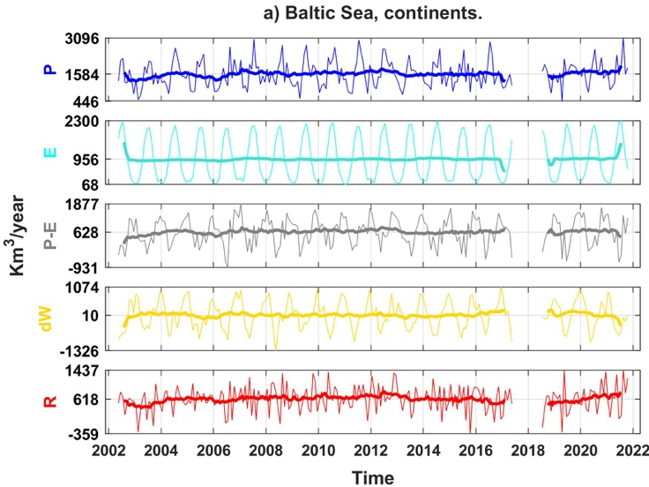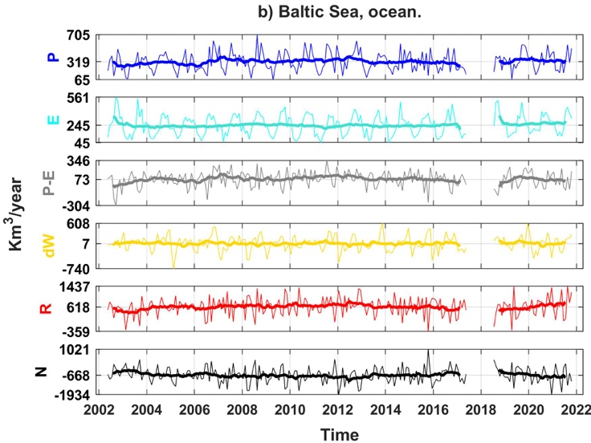
Supplementary Figure 1. Water transport time series in the extended Baltic Sea (Kattegat and Skagerrak straits are included) for both (a) continental drainage basins, and (b) ocean basins. Thick lines depict the 12-month moving average. Negative (positive) values of N correspond to Baltic Sea outflows (inflow).

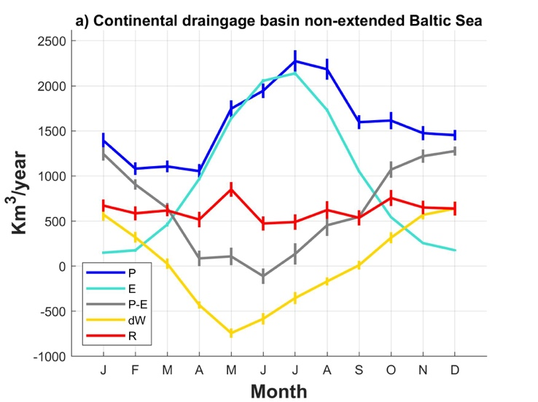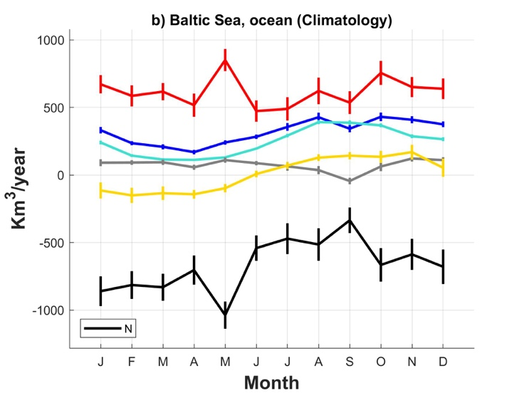
Supplementary Figure 2. Climatology (monthly averages) of signals shown in Supplementary Figure 1.

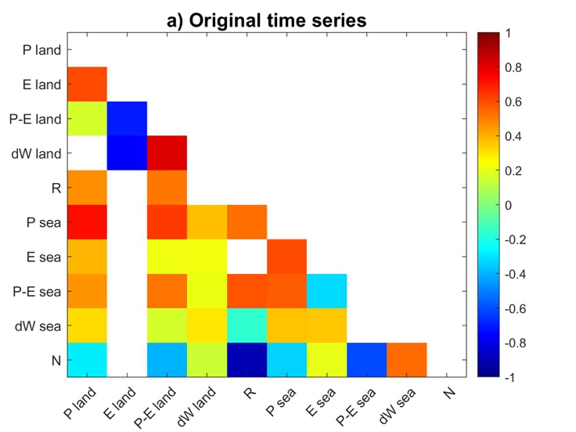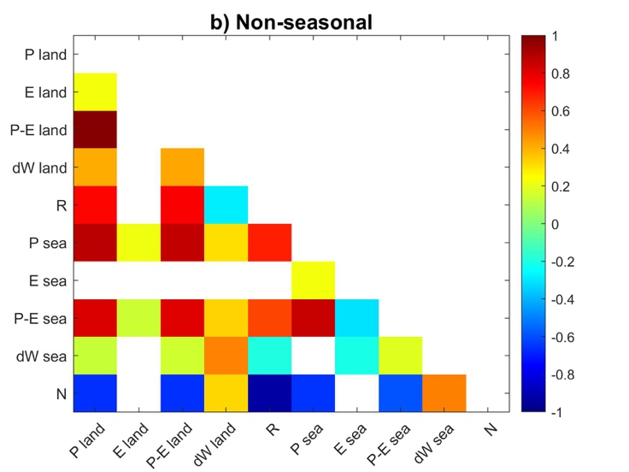
Supplementary Figure 3. Pearson correlation coefficients between (a) all seasonal signals shown in Supplementary Figure 1; and (b) all non-seasonal signals shown in Supplementary Figure 5.

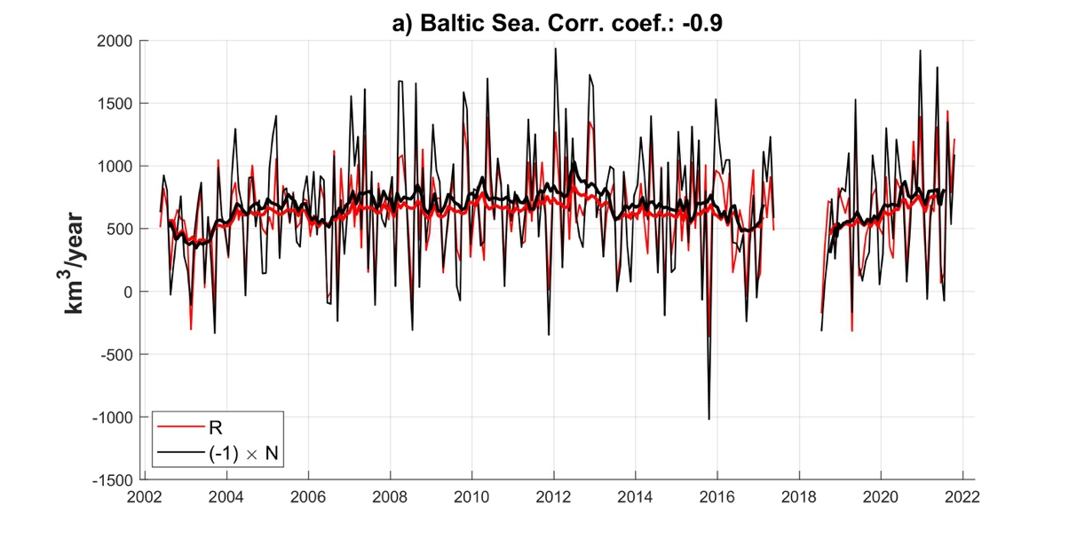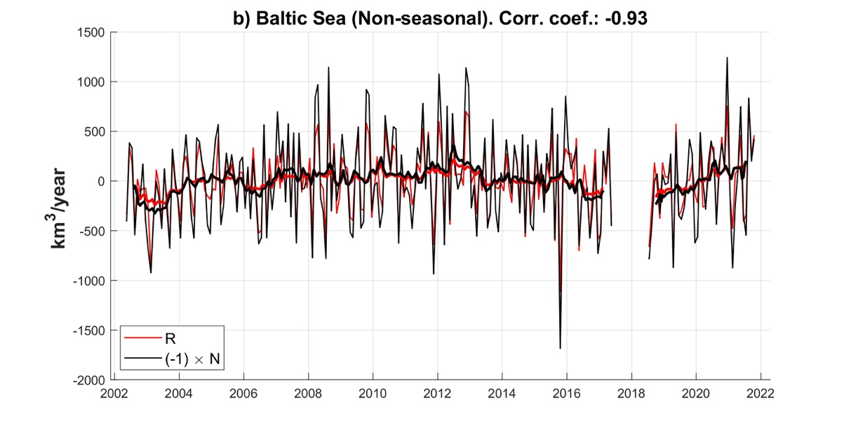
Supplementary Figure 4. Water transport from land to the Baltic Sea (red curve) and net outflow from the Baltic Sea (black curve). Black curve represents –N. As N is multiplied by –1, positive (negative) values of black curve represent above-average (below-average) flows. Correlations between R and N are negative in both cases.

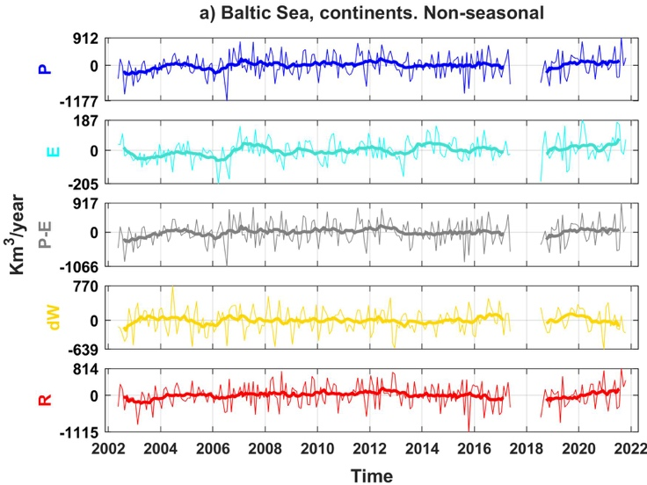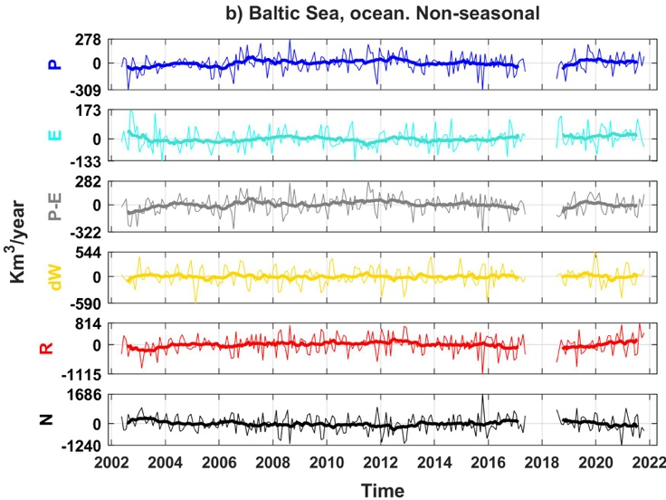
Supplementary Figure 5. Non-seasonal signal of WT components shown in Supplementary Figure 1.

