Supplementary Figures
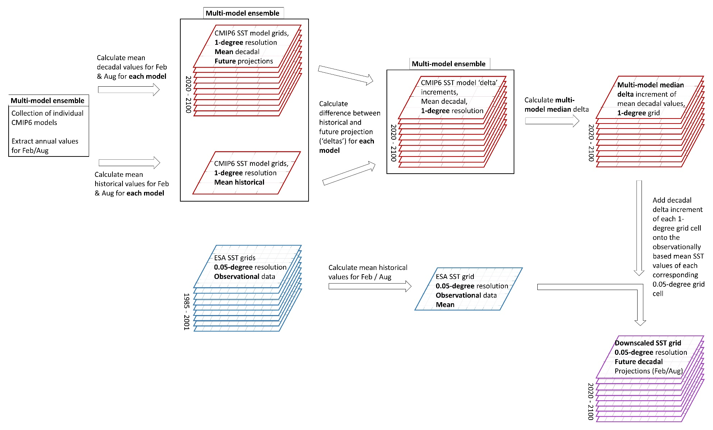
Supplementary Figure 1. Diagram of delta downscaling workflow

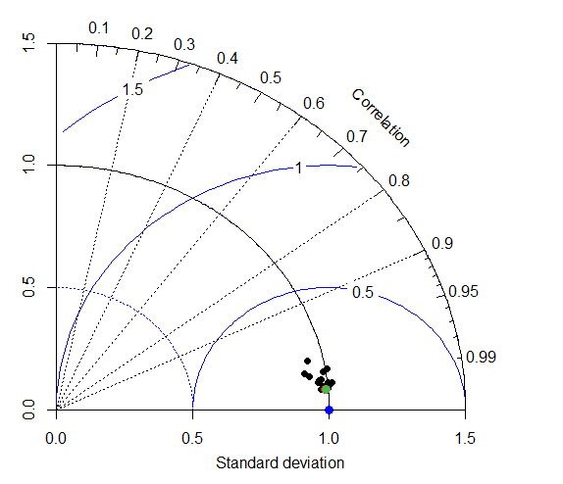
Supplementary Figure 2. Taylor diagram showing the correlation and SD among the 19 CMIP6 ensemble models for month of February, historical data (black dots, full list of ensemble models available in supplementary table 1), the multi-model median (green dot), the multi-model mean (red dot), and the observationally based empirical data (blue dot).

Supplementary figure 3. Global map of differences in SST between coarse CMIP6 multi-model median and downscaled data (multi-model median bias correction). Year shown is 2100 (February) with scenario SSP5-RCP8.5 values. It must be noted that the large differences in SST values located in the Northern Atlantic stem from bias correction of known biases associated with GCM models (refer to the Atlantic meridional overturning circulation (AMOC) cold bias as for example discussed in Moreno-Chamarro, Eduardo, et al. "Impact of increased resolution on long-standing biases in HighResMIP-PRIMAVERA climate models." Geoscientific Model Development 15.1 (2022): 269-289.). All differences in temperature come from bias correcting CMIP6 data by adding CMIP6 decadal SST deltas onto observationally based ESA SST data.

