Online Supporting Materials for

Gratitude is morally sensitive

Hongbo Yu¹, Yubo Zhou^{1,2}, Anne-Marie Nussberger³
¹ Department of Psychological & Brain Sciences, University of California Santa Barbara, Santa Barbara, CA 93106, USA
² Department of Psychology, University of Pennsylvania, Philadelphia, PA 19104, USA
³ Center for Humans and Machines, Max Planck Institute for Human Development, Berlin, 14195, Germany

Supplementary Methods
Vignettes used in the studies

Study 1

Vignettes for the American participants.

1. Knee issue
[Shared background] You are having a conversation with your friend and his partner, Tyler. You talk to them about your recent knee issue, which gives you sharp pain when you walk and especially up and down stairs. You tell them that you have booked an appointment with a doctor, but you have to wait for a couple of weeks. Your friend’s partner, Tyler, happens to be the receptionist in the same department as the doctor whom you have appointments with.

[immoral]
Hearing your complaints, Tyler suggests that she can help you by swapping you with another patient whose appointment is earlier. She says that this won’t be difficult for her.

[neutral]
Hearing your complaints, Tyler suggests that she can help you by assigning you to another doctor who has an earlier appointment available. She says that this won’t be difficult for her.

2. Purchasing ticket
[Shared background] Your favorite singer will be performing in a concert in your city. You really want to go but there is a long line for the ticket. In fact, people started queueing a day before and stayed in the line overnight. It seems that there is no chance that you can get a ticket. You mention this to your neighbor, Charlie, who recently got a job in the box office of the theatre.

[immoral]
Charlie says she can help you by offering you one of the tickets that are reserved for seniors and disabled audiences. She says that this won’t be difficult for her.

[neutral]
Charlie says she can help you by referring you to a lesser-known ticket broker, who is likely to have a few more tickets available. She says that this won’t be difficult for her.

Vignettes for the Chinese participants.

- Paying bill (original Chinese version)

[Shared background] 你正在公司附近的一家小餐馆边吃午饭边打电话与朋友聊天。过了一会儿，你看公司的午休时间快结束了，便起身走向收银台准备结账。但当你搜寻口袋时，惊讶地发现自己把钱包落在公司了。由于你平时也不怎么使用手机支付，所以也没有余额了。正当你尴尬地向电话里的朋友抱怨忘带钱付账，回公司拿钱又会造成下午上班迟到时，你发现这家店的收银员恰巧是你的邻居张志刚。虽然你和张志刚并不怎么熟悉，平时回家后也没怎么去拜访过这位邻居，但张志刚还是认出了你。

[Immoral]当张志刚听到了你和朋友的抱怨后，悄声告诉你说，他可以把你的这笔账做点手脚抹掉，这样你就可以先回公司上班了。张志刚说，他作为收银员，帮你这点忙不是什么难事，他自己也没有什么损失。

[Neutral]当张志刚听到了你和朋友的抱怨后，悄声告诉你说，他可以先帮你垫上这笔钱，之后你下班来还上就行，这样你就可以先回公司上班了。张志刚说，他作为收银员，帮你这点忙不是什么难事，他自己也没有什么损失。

(English translation)
[Shared background] You are having lunch at a local restaurant while chatting with a friend on the phone. After a while, you notice that your lunch break is almost over, so you run to the cashier to pay. When you search your pocket, you are surprised to find that you left your wallet at the office. Meanwhile, since you do not frequently use electronic payment, your electronic wallet has insufficient funds. Additionally, retrieving the wallet to pay for lunch might cause you to be late in getting back to work from your lunch break. When you complain about this dilemma to your friend, you notice that the cashier is your neighbor, Zhang Zhigang. Although you are not particularly familiar with Zhang Zhigang, and have never visited Zhang Zhigang after work, Zhang Zhigang still recognizes you. When Zhang Zhigang overhears your complaint to your friend.

[Immoral] Zhang whispers to you that he can ‘pull some strings’ and wave your bill, so you can go back to work. Zhang Zhigang says, as the cashier, it is not at all difficult for him to help, as it will be of no cost to him.

[neutral] Zhang whispers to you that he can pay your bill for the time being, and you can pay him back after work, so you can go back to work. Zhang Zhigang says, as the cashier, it is not at all difficult for him to help, as it will be of no cost to him.

- Recording lecture (original Chinese version)

[Shared background] 你正在参加为期一月的公司集体培训，其间时常需要学习不同的课程，并且最终需要参加结业的考试，考试的成绩会决定你在公司的升迁潜力。最近，授课的教室电子系统损坏，一时又无法修好，导致教师授课时无法正常使用投影仪与音响系统。以至于坐在后排的人往往无法听清看清培训的内容。而你恰巧就被安排坐在教室最后一排听课。于是你最近都无法听明白培训的内容，更别说参加考试了。有天课后，你与坐在身边的朋友抱怨没法听到培训的内容，你很担心因为这个原因而导致无法通过培训，从而影响到自己的升迁。恰巧此时，你的同事郑小明走过听到了你们的谈话。郑小明在你公司的另一个部门，你们平时也不是太熟悉，但是当他听说了你的困难后，

[Immoral] 就私下对你表示他可以把你和最前排一个同事的座位换一下，虽然这可能导致前排那个同事遭遇和你类似的困境。但郑小明说，由于他是负责安排这次培训的负责人，所以这对他不是什么难事，他自己也没有什么损失。

[Neutral] 就私下对你表示他可以向培训教师申请，帮你录下课程的视频音频，这样你可以回家以后再复习。但郑小明说，由于他是负责安排这次培训的负责人，所以这对他不是什么难事，他自己也没有什么损失。

(English translation)
[Shared background] You are attending a one-month corporate training. The training requires you to sit through several classes and ultimately take a test. The test score will determine your promotions in the company. Recently, the electronic system for the classroom broke. As such, the teacher cannot use the projector or sound system for the time being. Consequently, those who sit in the back of the classroom have difficulties perceiving the class content, and thus will likely perform poorly on the test. After class one day you complain to your friend that you cannot hear the content. You worry about failing the test because of the broken electronic system, and how this can affect your promotions in the company. Meanwhile, your co-worker Zheng Xiaomin, walks by and overhears your discussion with your friend. Zheng Xiaomin works in a different department in the company than you do, and you are not familiar with each other. However, when he hears about your difficulties.

[Immoral] Zheng whispers to you that he can switch your seat with that of somebody who sits in the front of the classroom, although it might cause that person to face the same difficulties as you. Zheng Xiaomin says, as the training supervisor, it is not at all difficult for him to help, as it will be of no cost to him.

[Neutral] Zheng whispers to you that he can help you apply for the recording of this course, so you can review it when you get home from class. Zheng Xiaomin says, as the training supervisor, it is not at all difficult for him to help, as it will be of no cost to him.

Study 2

Vignettes for the American participants.

1. Knee issue
[Shared background] You are having a conversation at a bar with your friend and his co-worker, Tyler.

[Immoral] You remember that your friend once told you that Tyler was an unfaithful person when it comes to relationships and had cheated on his ex-partner multiple times.

[Neutral] You remember that your friend once told you that Tyler was a fast learner when it comes to language and was fluent in a number of foreign languages.

[Shared ending] During the conversation, you talk to them about your recent knee issue, which gives you sharp pain when you walk and especially up and down stairs. You tell them that you have booked an appointment with a doctor, but you have to wait for a couple of weeks. Your friend’s co-worker, Tyler, happens to be the receptionist in the same department as the doctor whom you have appointments with. You are not particularly close, but after hearing your complaints, Tyler suggests that he can help you by assigning you to another doctor who has an earlier appointment available. He says that this won’t be difficult for him.

2. Purchasing ticket
[Shared background] Your favorite singer will be performing in a concert in your city. You really want to go but there is a long line for the ticket. In fact, people started queueing a day before and stayed in the line overnight. It seems that there is no chance that you can get a ticket. You mention this to your neighbor, Charlie, when you run into each other in a nearby parking lot.

[Immoral] The two of you are not particularly close, but you happen to know that Charlie is an unfaithful person when it comes to relationships and has cheated on his ex-partner multiple times.

[Neutral] The two of you are not particularly close, but you happen to know that Charlie is a fast learner when it comes to language and is fluent in a number of foreign languages.

[Shared ending] Upon hearing what you said about the concert, Charlie tells you that he recently got a job in the box office of the theater and knows some lesser-known ticket brokers. He says he can help you by referring you to these brokers, who are likely to have a few more tickets available. He says that this won’t be difficult for him.

Vignettes for the Chinese participants.

- Dog-sitting (original Chinese version)

[Shared background] 由于工作的原因，你最近独自一人搬到一座陌生的城市居住。为了不感到孤独，你养了一只宠物狗，每天你上下班都准时给它喂食。这天，你突然被老板派到外地出差，为期一周。刚进公司，你只能服从老板的差遣。回到自己的办公位上，你便和隔壁的同事王家禄提到了自己的烦恼，担心出差这段时间没人照顾你的宠物狗，毕竟你在这个城市没有亲人和朋友。

[Immoral] 你和王家禄并不熟，而且曾听闻他有些小偷小摸的习惯。

[Neutral] 你和王家禄并不熟悉，只是听闻过一些关于他的议论，说他是一个算数天才，可以快速心算出账目。

[Shared ending] 王家禄听到了你的烦恼后，提议说他可以暂时照顾你的狗。王家禄说，因为他自己家中本就养着一只，所以暂时帮你照顾你的宠物狗几天对他也不麻烦。

(English translation)
[Shared background] You recently moved to a new city for work. In order to avoid feeling lonely, you get a dog. You feed your dog every day before and after work. One day, your boss suddenly sends you to another city for a week of work. Since you are a new employee of the company, you feel that you must go along with this assignment. When you get back to your seat, you complain to your co-worker Wang Jialu. You mention that you are anxious about having nobody to take care of your dog when you are gone, as you have no relatives or friends to help you in the city.

[Immoral] You are not particularly familiar with Wang Jialu, but you have heard that he has a proclivity for petty theft.

[Neutral] You are not particularly familiar with Wang Jialu, but you know that he is a math genius.

[Shared ending] Upon hearing your complaint, Wang Jialu suggests that he can take care of your dog. Wang Jialu says it is not at all difficult for him to help, as he already has a dog at home.

- New software (original Chinese version)

[Shared background]你刚入职一家新公司，正准备大展拳脚。一天上午，你尝试用统计软件给老板做一个预算报表。但是你突然发现这个软件最近刚被升级过了，新版当中要完成这个预算报表所需的功能你不会用了。你询问隔壁工位的同事，结果他也没有用过新版，于是你有些担心地说，如果下午做不出来一定会给老板留下不好的印象。正当你无计可施时，公司里的技术员李子铭恰巧经过你的位子，听到了你和你同事的对话。

[Immoral] 你和李子铭并不熟悉，而且曾听闻他有些小偷小摸的习惯。

[Neutral] 你和李子铭并不熟悉，只是听闻过一些关于他的议论，说他是一个算数天才，可以快速心算出账目。

[Shared ending] 但是当李子铭听到了你因为新版软件功能不会使用而做不出报表时，就提出说他可以教你怎么做。李子铭说自己刚学习了新版的功能，而且马上就是午餐时间了，所以也不会耽误他的工作。

(English translation)
[Shared background] You recently joined a new company and are ready to make your mark. One morning, you try to make a budget statement for your boss using statistics software. Upon attempting this, you notice that the software has recently been upgraded, and you no longer know how to use the necessary functions for completing the budget statement. You ask your colleague who sits next to you for help, but it turns out that he isn’t familiar with the new edition either. You are worried that you might leave a bad impression on your boss if you can’t complete the budget statement this afternoon. As you run out of ideas, Ziming Li, a technician in the company, happens to pass by your seat and overhears your conversation with your colleague.

[Immoral] You don't know Li Ziming well, but you have heard that he has a proclivity for petty theft.

[Neutral] You don't know Li Ziming well, but you know that he is a math genius.

[Shared ending] When Li Ziming hears that you can’t make the budget statement because you don’t know how to use the new software, he offers to show you how to use it. Ziming Li says that he just learned the new software, and helping you wouldn’t interfere with his work, as it is now his lunch break.

Study 3

Vignettes for the American participants.

1. Knee issue
[Shared background] Bob is having a conversation with his friend and his friend’s partner, Tyler. Bob speaks to them about his recent knee issue, which gives him sharp pain when he walks and especially up and down stairs. Bob explains that he has booked an appointment with a doctor, but complains that he has to wait a couple of weeks before being seen. The friend’s partner, Tyler, happens to be a receptionist in the same department as the doctor whom Bob has scheduled an appointment with. Upon hearing Bob's complaint, Tyler suggests that he can help Bob by swapping his later appointment with another patient’s earlier appointment. Tyler says that this won't be difficult for him to do.

[Uneasy] Upon hearing this, Bob feels uneasy about Tyler's suggestion.

[Grateful] Upon hearing this, Bob feels grateful to Tyler for this suggestion.

[No particular feelings] Upon hearing this, Bob has no particular feelings about Tyler's suggestion.

2. Purchasing tickets
[Shared background] Bob’s favorite singer will be performing in a concert in his city. Bob really wants to go but there is a long line for the ticket. In fact, people started queueing a day before and stayed in the line overnight. It seems that there is no chance that he can get a ticket. Bob mentions this to his neighbor, Tyler, who recently gets a job in the box office of the theatre. Tyler says he can help Bob by offering him one of the tickets that are reserved for seniors and disabled audiences. Bob is neither senior nor disabled. Tyler says that this won’t be difficult for him.

[Uneasy] Upon hearing this, Bob feels uneasy about Tyler's suggestion.

[Grateful] Upon hearing this, Bob feels grateful to Tyler for this suggestion.

[No particular feelings] Upon hearing this, Bob has no particular feelings about Tyler's suggestion.

Vignettes for the Chinese participants.

- Bidding (original Chinese version)
[Shared background]赵复兴正代表公司去竞标一个项目，对方要求赵复兴出一份项目设计的方案报告。虽然赵复兴已经做了方案并且计算出了价格，但是他依旧不确定自己的方案较之其他竞标者是否有足够优势。有一次，赵复兴去对方公司联系时，恰巧遇上了自己的老同学周其成。他告诉周其成，自己为这个项目已经准备了很久，这个项目关系到自己的前途，如果要是没选上，他在公司也就没什么地位了。在听到了赵复兴的困难后，周其成说他可以把其他竞标团队的方案和报价偷偷给赵复兴看一下，虽然这样会损害到别的团队，但赵复兴就可以按照其他的人方案价格来修正自己的方案，从而更有把握拿到这个项目了。周其成说，他恰好负责收集每家竞标公司的方案，所以这对他来说不算难事，而且这么做对他也没什么损失。

[Grateful] 听到这个建议，赵复兴对周其成心生感激。
[Non-feeling] 听到这个建议，赵复兴心里并没有什么情绪反应。
[Uneasy] 听到这个建议，赵复兴内心感到不安。

(English translation)

[Shared background] Zhao Fuxing is representing his company to bid for a project. The other company asked Zhao Fuxing to provide a project budget report. Although Zhao has made a plan and calculated the budget, he is still not sure whether his plan has enough competitiveness over other bidders. Once, Zhao Fuxing went to the other company, happened to meet his old classmate Zhou Qicheng. He told Zhou that he had been preparing for this project for a long time and that if his design was not selected for the project, he would have no position in his company. After hearing Zhao Fuxing's difficulties, Zhou Qicheng said he could secretly take out the other bidding team's plan and offer Zhao Fuxing for review. Although this will harm the other teams, Zhao Fuxing can be in accordance with the other people's plan price to correct their own plan and guaranteed Zhao to get the project. Zhou says he happens to be in charge of collecting proposals from all bidders, so it's easy for him to do so, and he has no cost for doing this.

[Uneasy] Upon hearing this, Zhao Fuxing feels uneasy about Zhou Qicheng's suggestion.

[Grateful] Upon hearing this, Zhao Fuxing feels grateful to Zhou Qicheng for this suggestion.

[No particular feelings] Upon hearing this, Zhao Fuxing has no particular feelings about Zhou Qicheng's suggestion.

- Broken phone (original Chinese version)
[Shared background] 赵复兴买了一台手机，但是在使用中不小心摔在了地上。虽然外表完全没什么损伤，但手机屏幕再也打不开了。于是，赵复兴将手机带去商店维修。然而，由于赵复兴在购买时，没有包含手机保修，所以他现在要花很贵的维修费来修理手机。恰巧，他在店里遇上了自己以前的同事周其成。周其成现在在这家店里当手机销售。赵复兴向周其成抱怨，自己好不容易攒钱买了这台新手机，结果却要花那么多钱来维修，如此这个月自己又攒不下什么钱了。在听到了赵复兴的抱怨后，周其成说他可以把这台坏的手机和店里在卖的同款新手机偷偷调换一下，因为赵复兴的手机表面没有什么损坏，所以替换一下不会有人发现。而且，这样赵复兴就可以不用花钱维修了。周其成说，虽然这样做会给商店老板造成一些损失，但作为店里的手机销售员，这么做对他来说不算难事，对他自己来说也没有损失。.

[Grateful] 听到这个建议，赵复兴对周其成心生感激。
[Non-feeling] 听到这个建议，赵复兴心里并没有什么情绪反应。
[Uneasy] 听到这个建议，赵复兴内心感到不安。

(English translation)
[Shared background] Zhao Fuxing bought a cellphone. He accidentally dropped it on the ground and broke it. He brought it back to the store for repair. However, because Zhao Fuxing did not purchase insurance for his cellphone, he would have to spend a lot of money for the repair. Unexpectant, he met his former coworker, Zhou Qicheng, who works in the sale department of the store. Zhao Fuxing complained that he had saved money for this cellphone for a long time, but now he would have to spend a lot of money to repair it. Hearing the complaint, Zhou Qicheng told Zhao Fuxing that he could secretly swap Zhao’s phone with a new one in the store. This way, Zhao would not need to spend additional money to repair it. Zhou said, although his boss would suffer some financial loss, this would not cost himself anything. And as a sale person this would not be difficult for him to do.

[Uneasy] Upon hearing this, Zhao Fuxing feels uneasy about Zhou Qicheng's suggestion.

[Grateful] Upon hearing this, Zhao Fuxing feels grateful to Zhou Qicheng for this suggestion.

[No particular feelings] Upon hearing this, Zhao Fuxing has no particular feelings about Zhou Qicheng's suggestion.

Supplementary Results

Analysis of willingness to accept as a continuous variable

For Study 1, we ran a generalized mixed effect model, including condition as the predictor of interest and participants’ demographics (i.e., age, gender, highest level of education, socioeconomic status, studentship) as fixed effect covariates. The 4-level willingness to accept was included as the dependent variable. We also included country, participant, and vignette version as random intercepts. We found that participants were less likely to accept the help when it was morally problematic (B = -1.30±0.09, 95% CI [-1.47, -1.14], t = -15.18, p < 0.001). Including the Tesser Model’s antecedents of gratitude as additional covariates did not change the pattern of results (B = -1.05±0.09, 95% CI [-1.22, -0.87], t = -11.73, p < 0.001).

We ran a similar model for Study2. Here, we found that participants were less likely to accept the help when it was proposed by a morally problematic Helper (B = -0.53±0.07, 95% CI [-0.67, -0.40], t = -7.70, p < 0.001). Including the antecedents of gratitude in the Tesser Model and moral judgment of the helping act as additional fixed effect covariates did not change the pattern of results (B = -0.25±0.06, 95% CI [-0.37, -0.12], t = -3.85, p < 0.001). This was different from the corresponding finding we reported in the main text, where willingness to accept was transformed into a binary variable. Inspecting the distribution of the original score of willingness to accept for the Chinese sample, we noticed that participants were more likely to choose “3: More likely to accept than reject” in the morally problematic condition than the morally neutral condition, while they were more likely to choose “4: definitely accept” in the morally neutral condition than the morally problematic condition. When transformed into a binary variable, the difference between 3 and 4 vanished, therefore the effect of condition on this variable was weaker. This was consistent with our inference that Helpers’ moral traits might have a weaker effect on Recipients’ willingness to accept the Helper’s help.

Supplementary Tables

Table S1. Results of the serial mediation via moral character and benefit
Terms | Study 1  (B±s.e. [95% CI]) | Study 2  (B±s.e. [95% CI])
Mediation of moral character | 2.25±1.11 [0.44, 4.81] | 4.39±1.09 [2.27, 6.58]
Mediation of benefit | -0.96±0.82 [-2.92, 0.37] | 0.33±0.55 [-0.73, 1.48]
Serial mediation | 0.56±0.29 [0.10, 1.23] | 0.40±0.30 [-0.14, 1.07]
Direct effect | 2.76±2.57 [-2.29, 7.81] | 0.27±1.79 [-3.25, 3.80]
Total effect | 4.60±2.83 [-0.96, 10.17] | 5.40±1.65 [2.16, 8.63]
CI: confidence interval.

Table S2. Results of the serial mediation via moral character and Helper’s cost/effort
Terms | Study 1  (B±s.e. [95% CI]) | Study 2  (B±s.e. [95% CI])
Mediation of moral character | 2.29±1.06 [0.52, 4.61] | 4.33±1.05 [2.34, 6.45]
Mediation of cost/effort | -0.02±0.23 [-0.58, 0.46] | 0.02±0.13 [-0.27, 0.32]
Serial mediation | 0.01±0.11 [-0.22, 0.24] | -0.02±0.09 [-0.25, 0.12]
Direct effect | 2.76±2.57 [-2.29, 7.81] | 0.27±1.79 [-3.25, 3.80]
Total effect | 5.04±2.65 [-0.18, 10.27] | 4.60±1.59 [1.48, 7.72]
CI: confidence interval.
Supplementary Figures
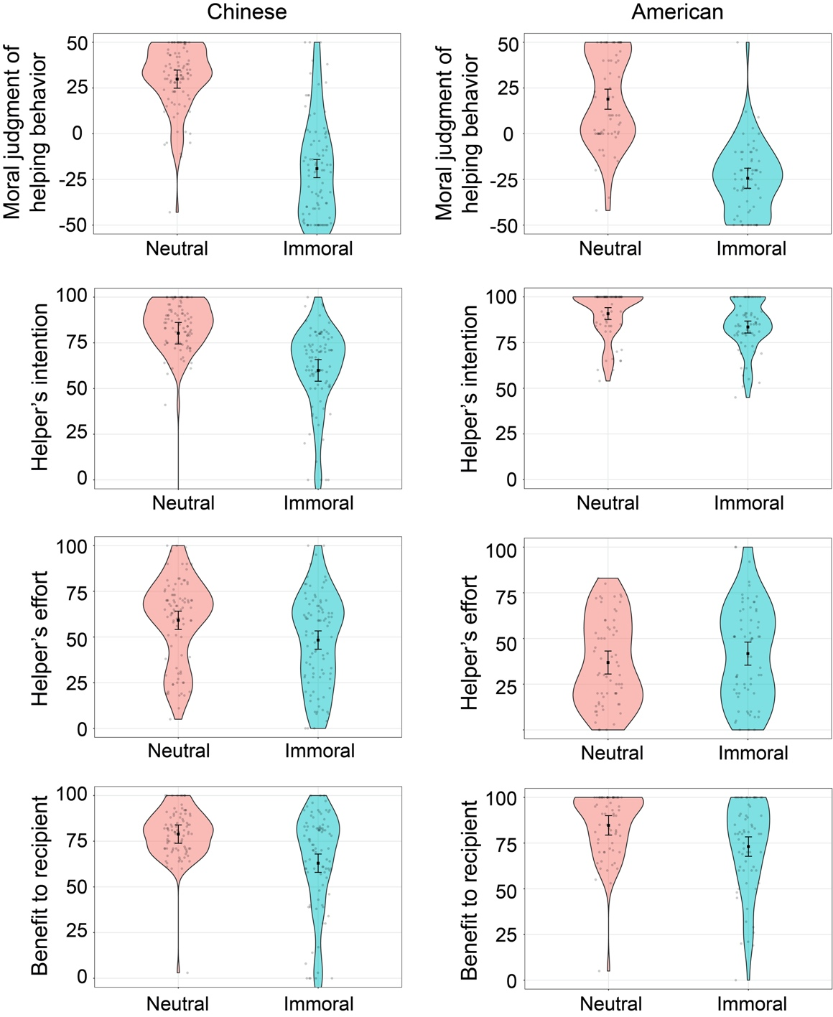
Figure S1. Vignette characteristics as a function of condition and country (Study 1).

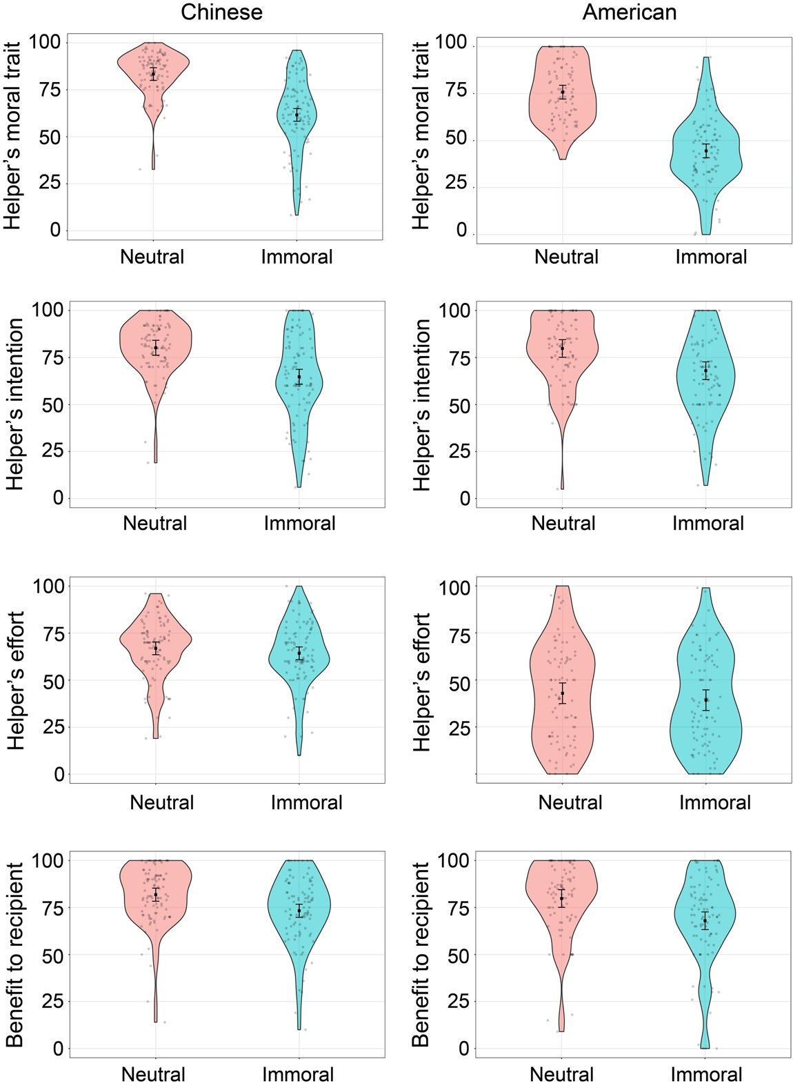
Figure S2. Vignette characteristics as a function of condition and country (Study 2).

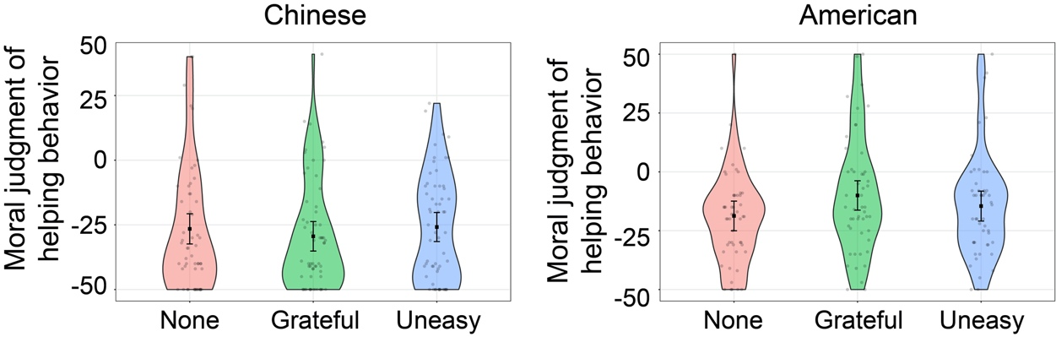
Figure S3. Vignette characteristics as a function of condition and country (Study 3).

