SUPPLEMENTARY MATERIAL

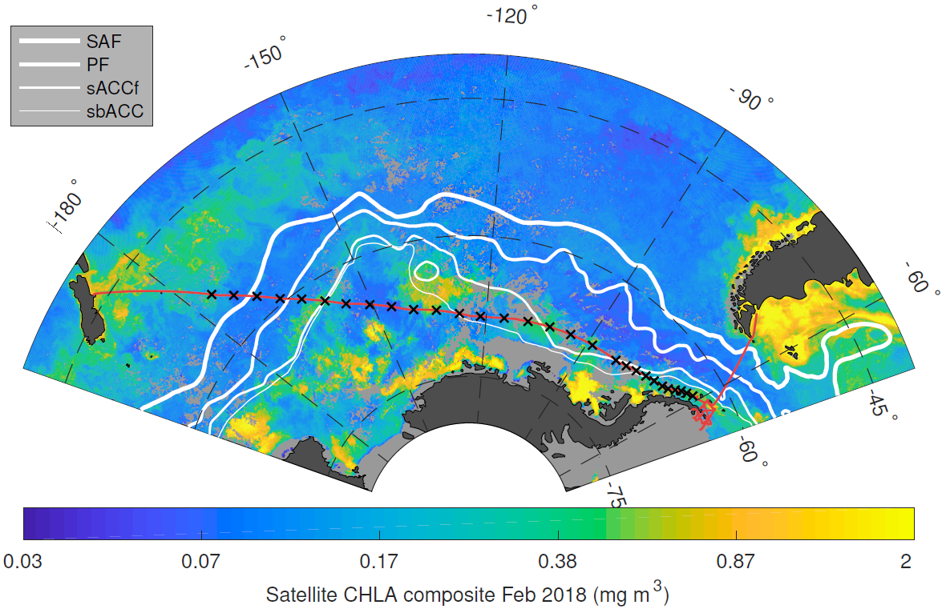
Supplementary figure 1: Oceanic fronts of Southern Ocean. SAF, Subantarctic Front; PF, Polar Front; sACCf, Southern Antarctic Circumpolar Current Front; sbACC, southern boundary Antarctic Circumpolar Current. The red line shows the cruise transect and the X denote sampling sites.

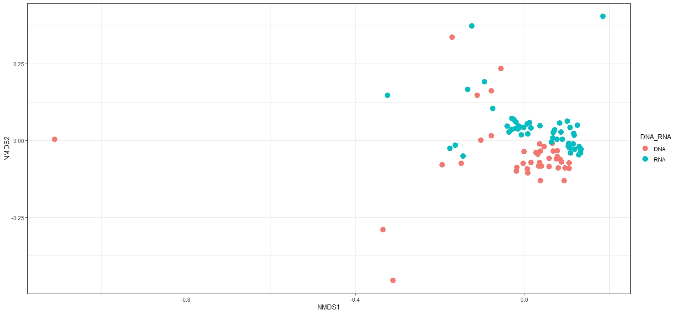
Supplementary Figure 2: Non-Metric Multidimensional Scaling ordination (NMDS) based on Bray-Curtis disimilarity of microbial communities identified across the seven zones. Colours represent 16S rRNA gene communities (red) and 16S rRNA-based communities (blue). Stress 0.15.

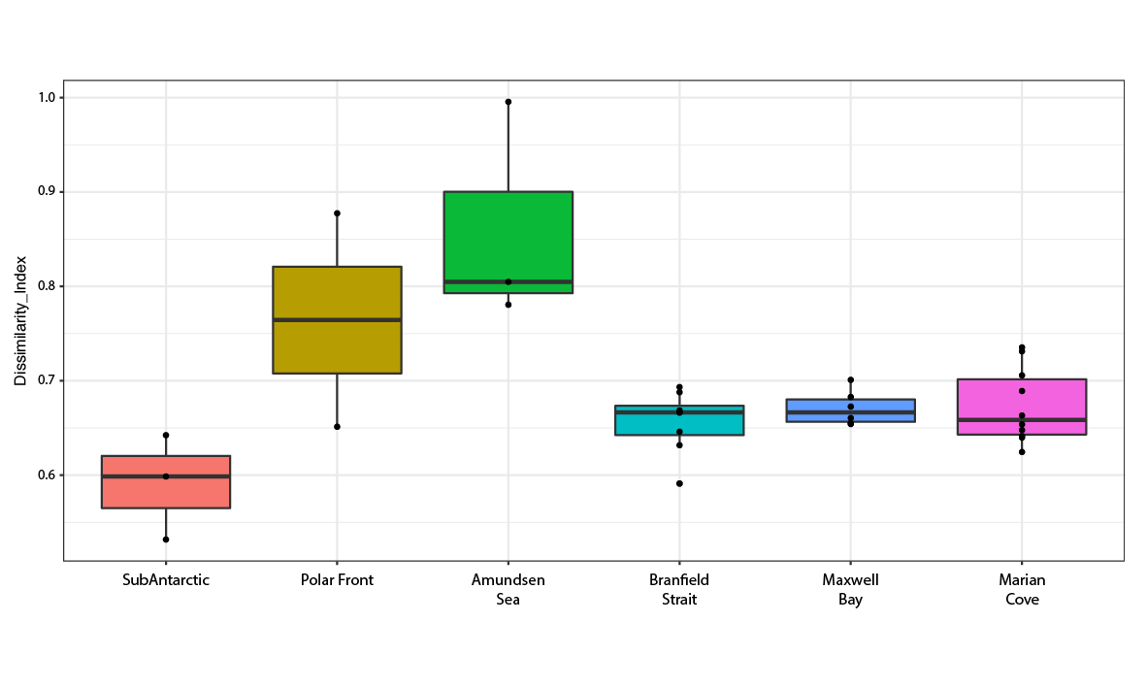

Supplementary Figure 3: Bray-Curtis dissimilarity between the 16S rRNA gene and 16S rRNA-based fractions for microbial communities sampled. Only samples for which both the DNA and RNA fractions were successfully amplified were considered for this analysis. Colors represent zones (Subantarctic, Polar Front, Amundsen Sea, Antarctic Peninsula, Bransfield Strait, Maxwell Bay and Marian Cove). The number of samples per zone used is as follows: Subantarctic= 3; Polar Front= 2; Amundsen Sea= 3; Bransfield Strait= 8, Maxwell Bay= 6; Marian Cove= 10.

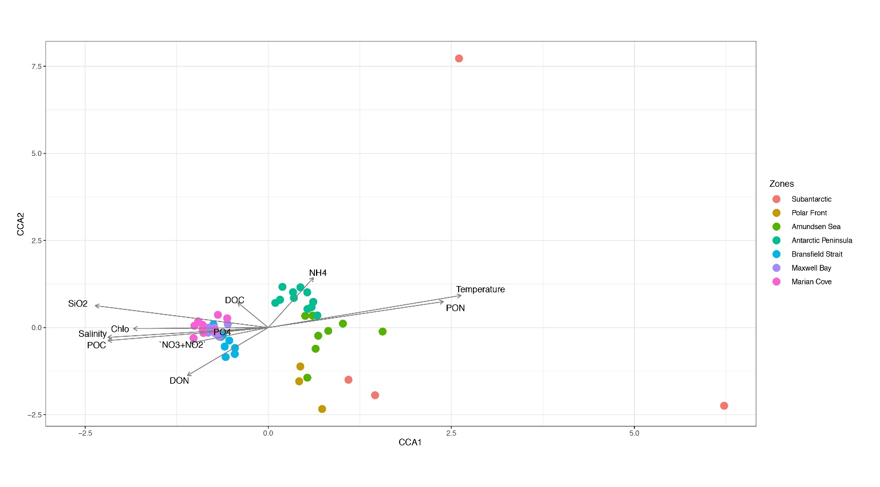
Supplementary Figure 4: Partial Canonical Correspondence Analysis (CCA) showing CCA1 and CCA2 plot of environmental and biological (OTU table) variables for the 16S rRNA-based community. Environmental variables correspond to temperature (°C), salinity (PSU), NH₄= ammonium, NO₂´+NO₃= inorganic nitrogen, Chla= total chlorophyll, SiO₂= silicic Acid, PO₄₌ phosphate, DOC= dissolved organic carbon, POC= particulate organic carbon, DON= dissolved organic nitrogen, PON= particulate organic nitrogen.

Supplementary Table 1: Number of sequences detected for bacterial and archaea assemblages in water samples across the Southern Ocean transect.

Location | Total Reads | RNA reads | DNA reads
Subantarctic | 192679 | 89818 | 102861
Polar Front | 205831 | 126987 | 78844
Amundsen Sea | 327900 | 303128 | 24772
Antarctic Peninsula | 434881 | 434881 | NO DATA
Bransfield Strait | 624113 | 261736 | 362377
Maxwell Bay | 510895 | 201339 | 309556
Marian Cove | 889268 | 471733 | 417535
Total Reads | 3185567 | 1889622 | 1089468

Supplementary table 2: Permutational Multivariate Analysis of Variance (PERMANOVA) examining the effects of the variables Depth (0-50 m) and Station (Subantarctic, Polar Front, Amundsen Sea, Antarctic Peninsula, Bransfield Strait, Maxwell Bay and Marian Cove) and 16S rRNA gene/ 16S rRNA-based in all the data set. Key to abbreviations and column headings: D.f, degrees of freedom; MS, mean square; F, F ratio; R², coefficient of determination; P, p-value. Significant results are in bold.
Source of variation | Df | MS | F | R2 | P
Zone | 6 | 0.682 | 2.517 | 0.070 | 0.001
depth | 3 | 0.264 | 0.974 | 0.009 | 0.498
16S rRNA gene vs 16S rRNA-based | 1 | 1.028 | 3.790 | 0.035 | 0.001

Supplementary table 3: Partial CCA
CCA all samples | Inertia | Proportion | CCA1 | % variation | CCA2 | % variation
 |  |  |  | CCA1 |  | CCA2
Total | 7.1388 | 100%
Geographic distance | 0.7028 | 10%
Environmental variables | 1.8948 | 27% | 0.49 | 7.6% | 0.262 | 4%
Unconstrained | 4.5412 | 63%

Supplementary table 4: partial CCA scores contrasting variables.
Variable | CCA1 | CCA2
Salinity | -0.661 | -0.085
Temperature | 0.795 | 0.279
Ammonium | 0.187 | 0.432
Inorganic Nitrogen | -0.321 | -0.134
Chlorophyll a | -0.555 | -0.010
Silicic Acid | -0.713 | 0.190
Phosphate | -0.172 | -0.036
Dissolved organic Carbon | -0.126 | 0.217
Particulate Organic Carbon | -0.661 | -0.113
Dissolved Organic Nitrogen | -0.333 | -0.416
Particulate Organic Nitrogen | 0.722 | 0.225

Supplementary table 5: Linear model geographic distance (Km) versus Abundance dissimilarity matrix (Bray-Curtis).
Zones combination | F-statistic | adjusted | p-value
 |  | R-squared
Subantarctic vs Polar Front | 78.370 | 0.876 | 0.000
Subantarctic vs Amundsen Sea | 6.803 | 0.158 | 0.014
Subantarctic vs Wes Antarctic Peninsula | 138.900 | 0.762 | 0.000
Polar Front vs Amundsen Sea | 14.010 | 0.361 | 0.001
Polar Front vs West Antarctic Peninsula | 37.780 | 0.534 | 0.000
Amundsen Sea vs West Antarctic Peninsula | 163.400 | 0.651 | 0.000
Bransfield Strait vs Subantarctic | 126.200 | 0.802 | 0.000
Bransfield Strait vs Polar Front | 15.230 | 0.382 | 0.001
Bransfield Strait vs Amundsen Sea | 107.100 | 0.628 | 0.000
Bransfield Strait vs West Antarctic Peninsula | 0.369 | -0.007 | 0.545
Bransfield Strait vs Maxwell Bay | 14.750 | 0.226 | 0.000
Bransfield Strait vs Marian Cove | 41.810 | 0.306 | 0.000
Maxwell Bay vs Subantarctic | 121.800 | 0.840 | 0.000
Maxwell Bay vs Polar Front | 18.180 | 0.503 | 0.001
Maxwell Bay vs Amundsen Sea | 141.700 | 0.750 | 0.000
Maxwell Bay vs West Antarctic Peninsula | 0.047 | -0.015 | 0.830
Maxwell Bay vs Marian Cove | 0.173 | -0.014 | 0.680
Marian Cove vs Subantarctic | 292.200 | 0.882 | 0.000
Marian Cove vs Polar Front | 18.850 | 0.381 | 0.000
Marian Cove vs Amundsen Sea | 193.500 | 0.709 | 0.000
Marian Cove vs West Antarctic Peninsula | 0.174 | -0.007 | 0.678

Supplemental table 6: Distribution of indicator microbial OTU in the 16S rRNA-based communities, among the seven provinces (IV >0.8 p =0.001; stat > 0.8).
 | N° Indicator | N° | Microbial Taxa |  | Abundance
Province | microbial | OTUs |  |  | %
 | OTUs | per Class | Class/ Order Level |  | per Province
Subantarctic | 53 | 10 | Alphaproteobacteria | Rhodobacterales | 17.22
 |  | 4 | Alphaproteobacteria | Rhodospirillales | 1.44
 |  | 4 | Alphaproteobacteria | Rickettsiales SAR116 | 2.3
 |  | 1 | Betaproteobacteria | Burkholderiales | 0.56
 |  | 5 | Cyanobacteria | SubsectionI | 56.43
 |  | 1 | Cytophagia | Cytophagales | 0.27
 |  | 1 | Deferribacteres | Deferribacterales SAR406 | 0.56
 |  | 1 | Deltaproteobacteria | Bdellovibrionales | 0.49
 |  | 1 | Fibrobacteria | Fibrobacterales | 0
 |  | 7 | Flavobacteriia | Flavobacteriales | 9.89
 |  | 3 | Gammaproteobacteria | Alteromonadales | 0.75
 |  | 6 | Gammaproteobacteria | Oceanospirillales | 6.25
 |  | 2 | Gammaproteobacteria | Vibrionales | 0.15
 |  | 1 | Opitutae | MB11C04 | 0.09
 |  | 1 | Opitutae | Puniceicoccales | 0.67
 |  | 2 | Phycisphaerae | Phycisphaerales | 1.22
 |  | 1 | Planctomycetacia | Planctomycetales | 0.08
 |  | 2 | Thermoplasmata | MGII | 1.56
Polar Front | 316 | 29 | Alphaproteobacteria | Rhodobacterales | 4.53
 |  | 6 | Alphaproteobacteria | Rhodospirillales | 1.66
 |  | 13 | Alphaproteobacteria | Rickettsiales SAR116 | 1.8
 |  | 7 | Alphaproteobacteria | SAR11 | 1.98
 |  | 3 | ARKICE-90 | uncultured | 1.24
 |  | 2 | Betaproteobacteria | Burkholderiales | 0.87
 |  | 1 | Betaproteobacteria | Methylophilales | 0.23
 |  | 5 | Cyanobacteria | SubsectionI | 0.23
 |  | 1 | Cytophagia | Cytophagales | 0
 |  | 2 | Deferribacteres | Deferribacterales SAR406 | 0.23
 |  | 1 | Deltaproteobacteria | Bdellovibrionales | 0
 |  | 2 | Deltaproteobacteria | SAR324 | 0.5
 |  | 1 | Fibrobacteria | Fibrobacterales | 0.09
 |  | 14 | Flavobacteriia | Flavobacteriales | 1.71
 |  | 48 | Gammaproteobacteria | Alteromonadales | 20.84
 |  | 5 | Gammaproteobacteria | KI89A | 4.11
 |  | 162 | Gammaproteobacteria | Oceanospirillales | 56.86
 |  | 2 | Gammaproteobacteria | Pseudomonadales | 0.78
 |  | 2 | Gammaproteobacteria | Thiotrichales | 1.84
 |  | 2 | Gammaproteobacteria | Vibrionales | 0
 |  | 1 | Opitutae | MB11C04 | 0.04
 |  | 1 | Opitutae | Puniceicoccales | 0
 |  | 2 | Phycisphaerae | Phycisphaerales | 0
 |  | 1 | Planctomycetacia | Planctomycetales | 0
 |  | 1 | Sphingobacteriia | Sphingobacteriales | 0.41
 |  | 2 | Thermoplasmata | MGII | 0
Amundsen Sea | 2 | 1 | Alphaproteobacteria | Rhodobacterales | 65.51
 |  | 1 | Gammaproteobacteria | Oceanospirillales | 35.48
West Antarctic Peninsula | 23 | 1 | Alphaproteobacteria | Caulobacterales | 10.63
 |  | 6 | Alphaproteobacteria | Rhodobacterales | 20.15
 |  | 3 | Flavobacteriia | Flavobacteriales | 18.64
 |  | 1 | Gammaproteobacteria | KI89A | 3.5
 |  | 12 | Gammaproteobacteria | Oceanospirillales | 47.05
Bransfield Strait | 3 | 1 | Alphaproteobacteria | Rickettsiales | 77.77
 |  | 1 | Flavobacteriia | Flavobacteriales | 11.11
 |  | 1 | Gammaproteobacteria | Oceanospirillales | 11.11
Maxwell Bay | 17 | 3 | Flavobacteriia | Flavobacteriales | 16.66
 |  | 8 | Gammaproteobacteria | Alteromonadales | 42.71
 |  | 2 | Gammaproteobacteria | Oceanospirillales | 9.375
 |  | 4 | Opitutae | Puniceicoccales | 31.25
Marian Cove | 281 | 1 | Actinobacteria | Propionibacteriales | 0.15
 |  | 7 | Alphaproteobacteria | Rhodobacterales | 1.04
 |  | 3 | Alphaproteobacteria | Rickettsiales SAR116 | 0.67
 |  | 3 | Alphaproteobacteria | SAR11 | 1.02
 |  | 1 | ARKICE-90 | uncultured | 0.19
 |  | 3 | Betaproteobacteria | Burkholderiales | 0.46
 |  | 2 | Betaproteobacteria | Methylophilales | 0.19
 |  | 2 | Cytophagia | Cytophagales | 0.65
 |  | 4 | Deferribacteres | Deferribacterales 406 | 1.02
 |  | 1 | Deltaproteobacteria | Desulfobacterales | 0.53
 |  | 1 | Deltaproteobacteria | Myxococcales | 0.12
 |  | 1 | Deltaproteobacteria | Syntrophobacterales | 0.48
 |  | 25 | Epsilonproteobacteria | Campylobacterales | 6.39
 |  | 10 | Flavobacteriia | Flavobacteriales | 3.3
 |  | 74 | Gammaproteobacteria | Alteromonadales | 26.8
 |  | 1 | Gammaproteobacteria | Incertae | 0.24
 |  | 126 | Gammaproteobacteria | Oceanospirillales | 52.47
 |  | 15 | Gammaproteobacteria | Thiotrichales | 4.13
 |  | 1 | SPOTSOCT00m83 |  | 0.13

Supplementary Table: geographic location of the main transect and geographic location of the zone divisions (sampling stations).
Global Transect | Latitud | Longitud
Christchurch NZ | 52° 14.371 120 S | 178° 4.22 W
West Antarctic Peninsula | 63° 23.711’ S | 61° 18.164’ W
Bransfield Strait | 62° 50.3990 S | 58° 12.0028 W
Marian Cove | 62° 12.8495 S | 58° 46.3919 W
Zones (sampling stations)
Subantarctic zone (SA) | 52° 14.2651 S | 59° 28.0279 S
Polar Front (PF) zone | 60° 57.023 S | 66° 12.1361 S
Amundsen Sea (AS) zone | 67° 9.2437 S | 67° 26.722 S
Antarctic Peninsula (WAP) zone | 67° 22.1291 S | 63° 24.9352 S
Bransfield Strait (BS) zone | 62° 50.3983 S | 62° 28.8008 S
Maxwell Bay (MB) zone | 62° 17.1021 S | 62° 13.8023 S
Marian Cove (MC) zone | 62° 13.0785’S | 62° 12.2998 S

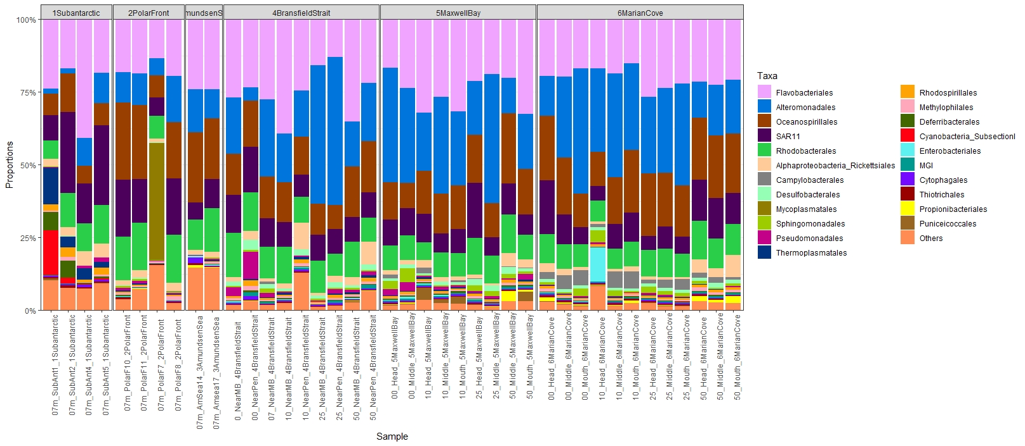
Supplementary figure 5: Relative abundance of taxonomical groups at the Order level in the 16S rRNA gene fraction of each zone in the depths sampled (0, 7, 10, 25 and 50 m).

