Supplementary materials
Identified lncRNAs functional modules and genes in Prediabetes with Hypertriglyceridemia by Weighted Gene Co-expression Network Analysis

Table S1. Number of lncRNAs contained in different modules
Module | Number |  | Module | Number
Black | 118 |  | Pink | 99
Blue | 232 |  | Purple | 81
Brown | 199 |  | Red | 120
Green | 124 |  | Salmon | 53
Greenyellow | 80 |  | Tan | 79
Grey | 20 |  | Turquoise | 323
Magenta | 84 |  | Yellow | 130

Table S2. Genes corresponding to significant different pathways by KEGG
Pathway | Genes | P-value
Alcoholism | HIST1H3J, HIST1H2AK, HDAC1, HIST1H2AI, CREB3, HIST1H2BN, HIST1H3H, HIST1H4K, HIST1H3I, HIST1H4L, HIST1H2BM, HIST1H2AL, HIST1H4J, HIST1H2BO, HIST1H2AJ, MAP2K1, HIST1H2BL, HIST1H2AM | <0.001
Systemic lupus erythematosus | HIST1H3J, HIST1H2AK, HIST1H2AI, HIST1H3H, HIST1H2BN, HIST1H4K, HIST1H3I, HIST1H4L, HIST1H2BM, HIST1H4J, HIST1H2BO, HIST1H2AJ, HIST1H2AL, HIST1H2BL, HIST1H2AM | <0.001
Viral carcinogenesis | HIST1H2BO, CREB3, TRAF3, HIST1H2BN, HIST1H4K, CHD4, HIST1H4L, HIST1H2BM, HIST1H2BL, HIST1H4J, HDAC1, NFKB2 | <0.001
NF-kappa B signaling pathway | BIRC3, TRAF3, BIRC2, NFKB2, LCK | 0.009
Transcriptional misregulation in cancer | BIRC3, HIST1H3J, ZEB1, NUPR1, HIST1H3I, HIST1H3H, HDAC1 | 0.012
TNF signaling pathway | BIRC3, CREB3, TRAF3, BIRC2, MAP2K1 | 0.018
NOD-like receptor signaling pathway | BIRC3, PSTPIP1, BIRC2 | 0.044

Table S3. Hub genes validated in the GSE130991
Rank | Name | P-value | Log2FoldChange
1 | MYC | 0.0212984 | -0.105
2 | HDAC1 | 0.1626976 | 0.0367
3 | HIST1H2BL | 0.9680966 | 0.00214
4 | HIST1H2BM | 0.0133764 | -0.148
4 | HIST1H2BO | 0.4308774 | -0.0389
6 | HIST1H2AJ | 0.1230534 | -0.0635
6 | HIST1H2BN | 0.3726903 | -0.0459
8 | GAPDH | 0.2890148 | 0.0696
8 | HIST1H4J | 0.8517497 | 0.0098
8 | HIST1H4K | --

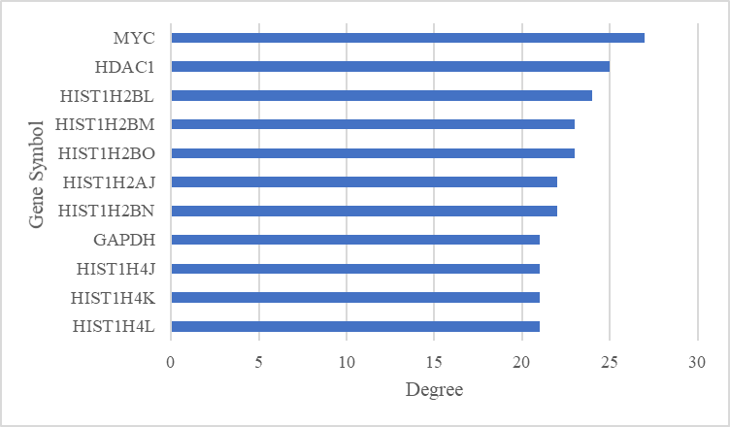
Fig. S1 The degree of the top 11 protein nodes.

