Supplementary Material

Supplementary Data

Supplementary Figures

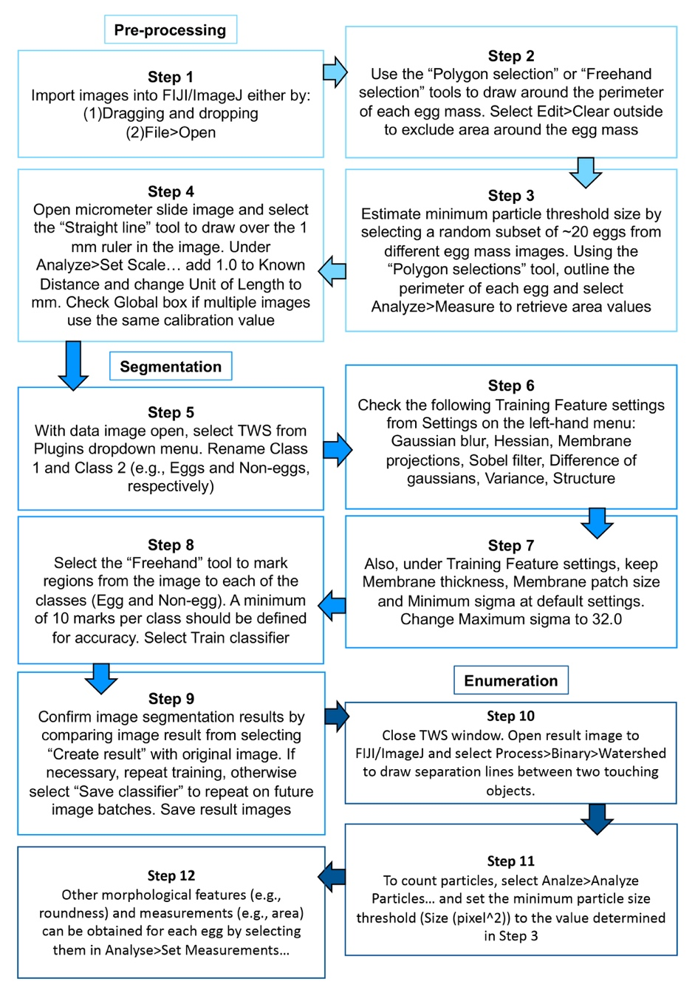
Supplementary Figure 1. Detailed semi-automated enumeration workflow from Pre-processing of images in Fiji/ImageJ (Steps 1-4) to Segmentation using the TWS in-built plugin (Steps 5-9) and finally Enumeration of eggs using the ‘Analyze particles…’ feature in Fiji/ImageJ (Steps 10-12).

