Supplementary material for
Ancient DNA reveals a southern presence of the Northeast Arctic cod during the Holocene
Lourdes Martínez-García¹*, Giada Ferrari¹, Anne Karin Hufthammer², Kjetill S. Jakobsen¹, Sissel Jentoft¹, James H. Barrett³, Bastiaan Star¹*

¹ Department of Biosciences, Centre for Ecological and Evolutionary Synthesis (CEES), University of Oslo, Blindernveien 31, NO-0371, Oslo, Norway
² The University Museum, Department of Natural History, University of Bergen, N-5020, Bergen, Norway
³ Department of Archaeology and Cultural History, NTNU University Museum, Erling Skakkes 47b, Trondheim, Norway

*Correspondence:
Lourdes Martínez-García: l.m.garcia@ibv.uio.no
Bastiaan Star: bastiaan.star@ibv.uio.no

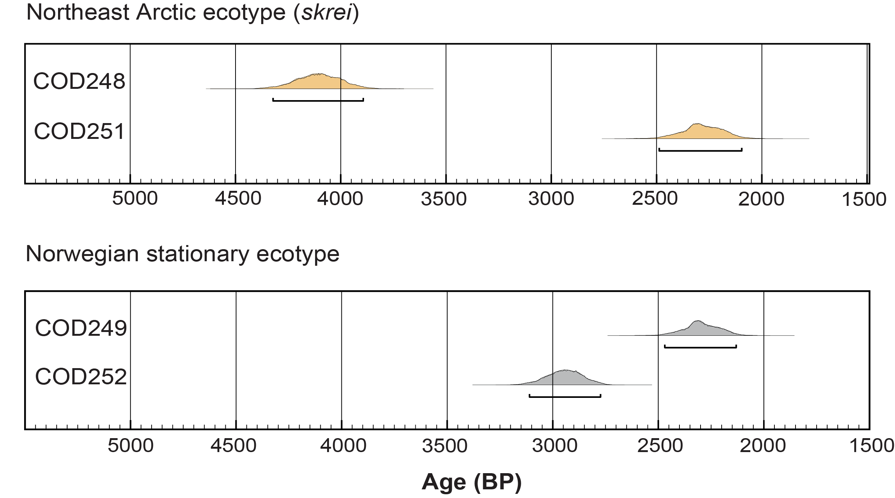
Figure S1. ¹⁴C age calibrations of four Atlantic cod specimens, both migratory (in orange) ecotype (skrei) and stationary (in grey) ecotype individuals, from the archaeological site Ruskeneset in the municipality of Bergen, west Norway. Specimen COD253 was not dated due to insufficient bone material.

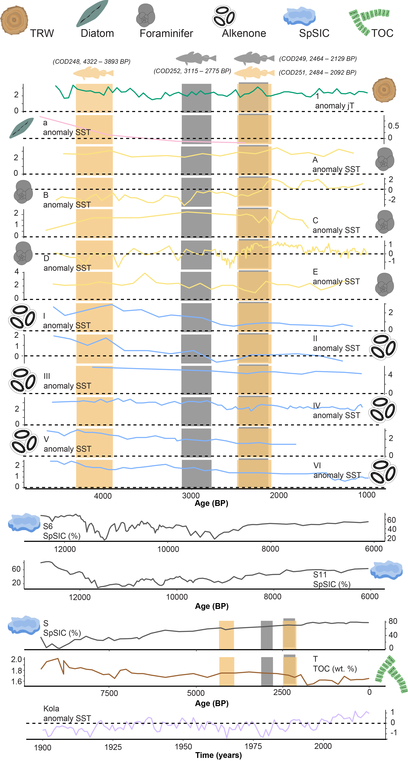

Figure S2. Historical (TRW, Diatom, Foraminifer, Alkenone, SpSIC and TOC) and modern (Kola) individual reconstructions between proxies showing distinct sea surface temperatures (SST), July temperatures (jT), SpSIC and TOC patterns across time. A dotted reference is shown in all temperature graphs at 0°C. Note the different ages for some of the panels. Tree-Ring (TRW), in green: 1 [1]. Diatom, in pink: a [2]. Foraminifer, in yellow: A, B, C, D, and E [3-5]. Alkenone, in blue: I, II, III, IV, V and VI [3, 6, 7]. SPSIC (%, different periods), in grey: S6, S11 [8], and S [9]. TOC (wt. %), in brown: T [9]. Kola section, in purple ([10] and http://www.pinro.ru). SST and jT anomalies for climate were calculated with respect to the long-term 1981-2010 average from their specific location (see electronic supplementary material for details on long-term means). ¹⁴C dating range (orange for skrei and grey for NCC) are shown for each ancient Atlantic cod (see figure 1b, electronic supplementary figure S1 and table S1). Fish illustrations were drawn by Geir Holm. Tree-ring, diatom, foraminifer, alkenone, sea ice and TOC illustrations were drawn by Lourdes Martínez-García.

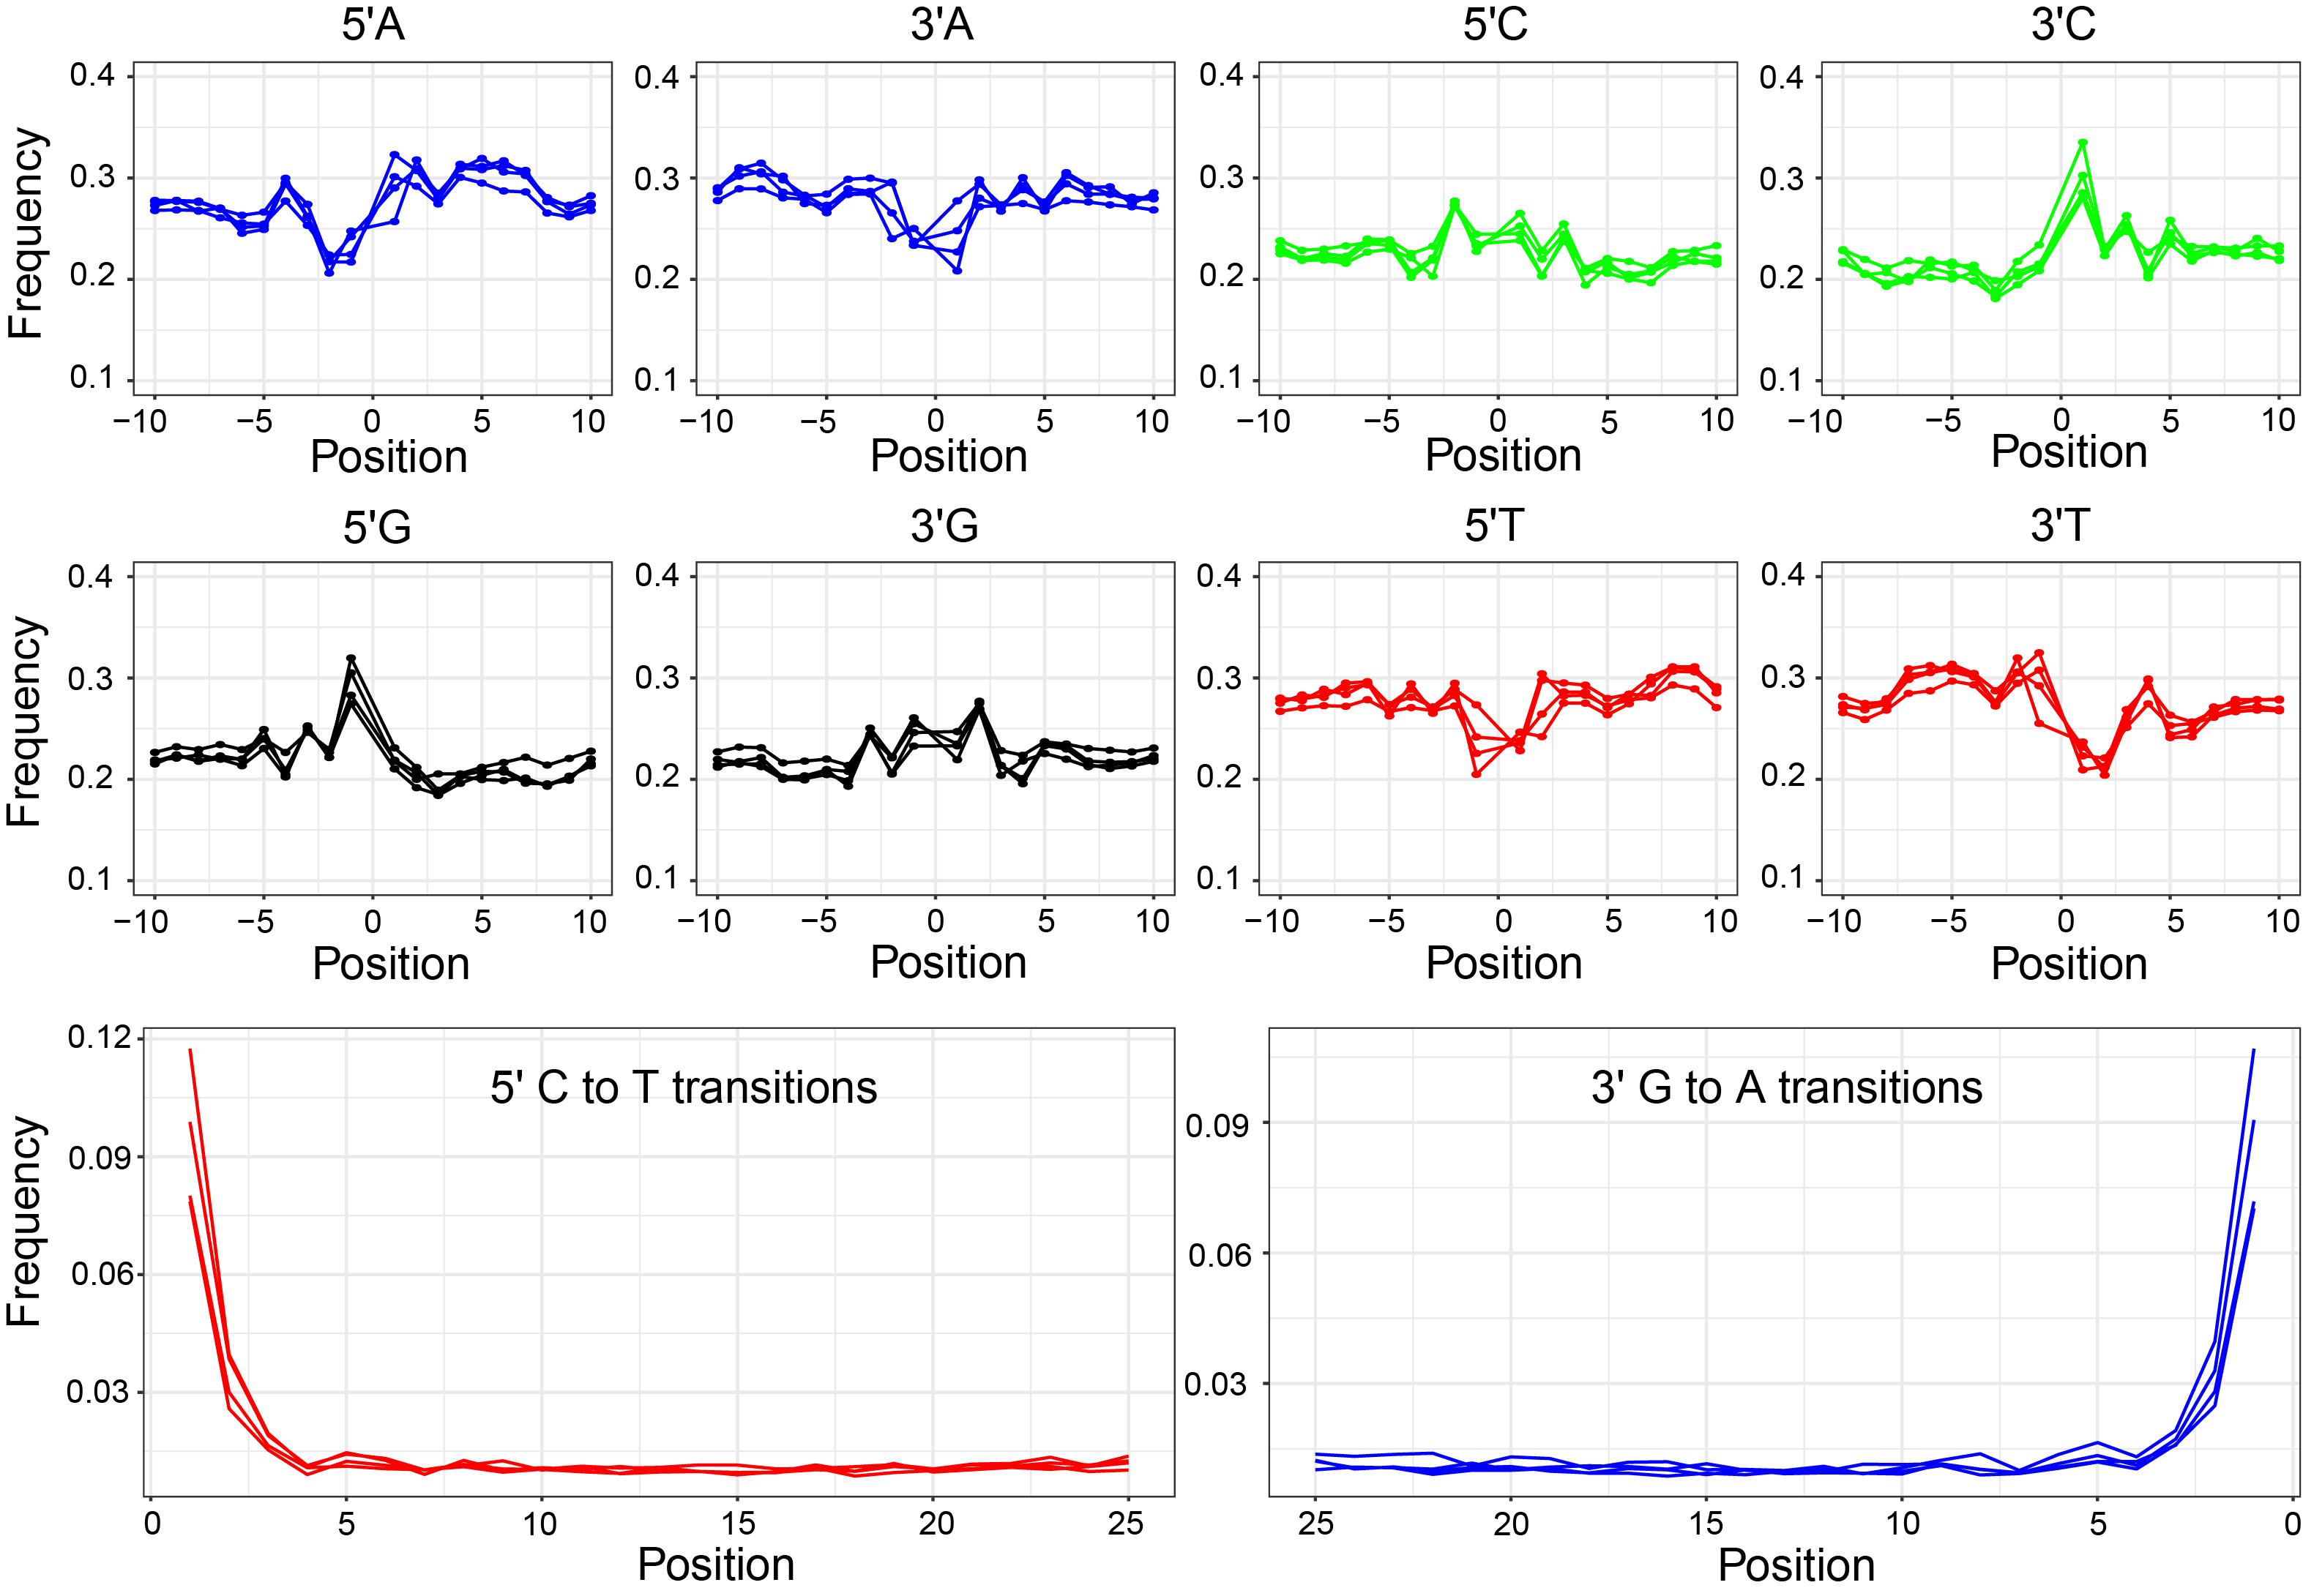
Figure S3. Typical fragmentation and misincorporations patterns of nucleotides of aDNA from sequencing data of five Atlantic cod specimens from Ruskeneset, west Norway. At the top, we show base frequencies. At the bottom, we show the increase in cytosine to thymine (C > T) misincorporations due to cytosine deamination at the 5′-end of DNA fragments and the corresponding increase of guanine to adenine (G > A) misincorporations at the 3′-end.

Table S1. Sample name, Accession Number, Location, Bone element, Estimated calibrated date (Date cal. BP, 95.4% probability), and genomic statistics for each Atlantic cod specimen. ‘-’ = not applicable. Specimens identified as skrei are bolded.

 |  | COD248 | COD249 | COD251 | COD252 | COD253
Accession Number |  | JS1 | JS1 | JS1 | JS1 | JS1
Locality |  | Ruskeneset | Ruskeneset | Ruskeneset | Ruskeneset | Ruskeneset
Bone element |  | Articular/Angular | Articular/Angular | Maxilla | Maxilla | Premaxilla
Date (cal. BP) |  | 4322 – 3893 | 2465 – 2129 | 2484 – 2092 | 3115 – 2775 | -
Total pair reads |  | 3,848,105 | 16,328,941 | 7,582,493 | 21,020,263 | 12,453,137
Mapped reads |  | 74,082 | 1,186,308 | 327,434 | 143,352 | 475,650
Clonality |  | 0.29 | 0.30 | 0.17 | 0.25 | 0.19
Endogenous DNA |  | 0.02 | 0.07 | 0.04 | 0.01 | 0.04
Average insert length (bp) |  | 69.72 | 47.66 | 44.70 | 40.38 | 46.24
Fold nuclear coverage |  | 0.008 | 0.088 | 0.023 | 0.009 | 0.034

All zooarchaeological material was sampled in 1914-16 at the archaeological site Ruskeneset in the municipality of Bergen, west Norway (60.23°N – 5.15°E) [11]. The zooarchaeological assemblage (bones) from Ruskeneset are in the osteological collections at the Natural History Department, the University Museum, University of Bergen, registered under the accession record JS1 = refers to Jordfunnet Skjelettmateriale no 1: Skeleton/bones found in soil.
For genomic statistics, we report total of pair reads, mapped reads toward the gadMor2 reference genome[12, 13], clonality, endogenous DNA content (unique, nonrepetitive fraction of reads aligned toward the reference genome), average insert length and fold nuclear coverage. Only one specimen is not shown after unsuccessful library results. Specimen COD253 was not dated due to insufficient bone material.

Table S2. Information of marine sediment cores used in the present study (see figure 1a for detailed information in the distribution of sites). ‘-’ = not applicable.

Proxy | Locality | Code | Latitude | Longitude | Season | Long-term average 1981-2010 (°C) | Reference | Download
Alkenone (U^{K’}37) | M23258 | I | 75 | 14 | Annual | 3.72 | [14, 15] | [16]
 | SVAIS-04 | II | 74.57 | 13.54 | Annual | 5.02 | [7] | [17]
 | PSh-5159N | III | 71.21 | 22.38 | Annual | 5.64 | [18] | [19]
 | MD95-2011 | IV | 66.58 | 7.38 | Annual | 8.74 | [20] | [21]
 | IOW225517 | V | 57.66 | 7.09 | Annual | 10.11 | [6] | [22]
 | IOW225514 | VI | 57.83 | 8.70 | Annual | 10.11 | [6] | [22]
Foraminifer | MSM055_723-2 | A | 79.16 | 5.34 | Annual | 0.74 | [4] | [23]
 | GIK23258-2 | B | 74.99 | 13.97 | Summer | 5.35 | [5] | [24]
 | PSh-5159N | C | 71.21 | 22.38 | Summer | 8.56 | [5] | [25]
 | MD95-2011 | D | 66.58 | 7.38 | Summer | 11.24 | [5] | [24]
 | MD99-2284 | E | 62.22 | 0.58 | Annual | 9.30 | [5, 26, 27] | [26]
Diatom | M23071 | a | 67.05 | 9.05 | Winter (February) | 6.34 | [2] | [2]
TRW | Tree-Ring | 1 | 66.70 | 14.35 | July | 10.65 | [1] | [28]
SpSIC | Spring Sea Ice Coverage | S | 78.40 | 32.42 | Spring | - | [9] | [9]
TOC | Total Organic Carbon | T | 78.40 | 32.42 | - | - | [9] | [9]

Table S3. Probability scores – scaled to one –indicating the assignation to migratory (skrei) or stationary (NCC) ecotype for each chromosomal inversion of Atlantic cod (i.e., LG1, LG2, LG7 and LG12). SNPs = matching divergent SNPs in each sample in comparison to the modern SNPs from main database from Ferrari, et al. [29]. Specimens identified as skrei are bolded. All genotypes segregate independently on four chromosomes. Haplotypes are associated with either ecotype (skrei or NCC) (for more details in the characterization of each ecotype see electronic supplementary material table S4).

Chromosomal Inversion | Skrei/NCC | COD248 | COD249 | COD251 | COD252 | COD253
LG1 | AA | 0.0 | 1.0 | 0.0 | 1.0 | 1.0
 | BB | 1.0 | 0.0 | 0.0 | 0.0 | 0.0
 | AB | 0.0 | 0.0 | 1.0 | 0.0 | 0.0
 | SNPs | 487 | 4619 | 1391 | 515 | 1871
LG2 | AA | 0.0 | 1.0 | 0.0 | 0.0 | 1.0
 | BB | 1.0 | 0.0 | 0.0 | 0.0 | 0.0
 | AB | 0.0 | 0.0 | 1.0 | 1.0 | 0.0
 | SNPs | 103 | 1103 | 335 | 107 | 409
LG7 | AA | 1.0 | 0.0 | 1.0 | 0.0 | 0.0
 | BB | 0.0 | 1.0 | 0.0 | 1.0 | 1.0
 | AB | 0.0 | 0.0 | 0.0 | 0.0 | 0.0
 | SNPs | 242 | 2464 | 782 | 249 | 983
LG12 | AA | 1.0 | 1.0 | 1.0 | 1.0 | 1.0
 | BB | 0.0 | 0.0 | 0.0 | 0.0 | 0.0
 | AB | 0.0 | 0.0 | 0.0 | 0.0 | 0.0
 | SNPs | 105 | 1042 | 237 | 102 | 423

Supplementary Methods

(a) Sample collection and age calibration
Ancient samples (n = 6) were retrieved in 1914-16 western Norway from the archaeological site Ruskeneset in the municipality of Bergen (60.23 N – 5.15 E) [11, 30]. Ruskeneset is a rock-shelter area close to tidal current channels which preserves evidence of human activities (e.g., bones, shells, and archaeological elements) dating back to the late Neolithic (3800-3400 years before present) and Bronze Age (3400-2900 years before present) [31]. Ruskeneset consists of two rock shelters (Ruskeneset I and II) that are generally treated as one location because no differences were found in the cultural layer [11]. During the Bronze Age the shelter would have been nearly inaccessible from land due to steep cliffs in both east and west, with easier access from the seaside by boat (N. Anfinset pers. comm.). Moreover, the fishing and hunting gear findings (e.g., harpoons, hooks, arrowheads, daggers) indicate this was a hunting and fishing station rather than a permanent coastal settlement particularly during the spring and summer [30]. Four specimens were dated using ¹⁴C (figure 1b, electronic supplementary material, figure S1 and table S1). Age calibration of the samples was calculated in OxCal v4.4.4 [32] using the Marine20 calibration curve [33]. We used slightly different ∆R values for the stationary (-164 ±29) and skrei (-144 ±46) ecotypes to account for differences in the marine reservoir effect given that these ecotypes feed either around the coast of Norway or in the Barents Sea (figure 1b and electronic supplementary material, figure S1) [33, 34].

(b) DNA extraction and library amplification
All ancient samples were processed in the aDNA laboratory at the University of Oslo under rigorous measures [35, 36] according to Ferrari, et al. [37]. Samples were extracted using the standard extraction protocol [38] and double-indexed sequencing libraries were built from 15 μl of DNA following the Meyer-Kircher protocol [39, 40] with the modifications described in Schroeder, et al. [41]. Ancient read data for five specimens were processed using PALEOMIX .2.13 [42]. Sequencing reads were trimmed, filtered and collapsed using AdapterRemoval v.2.1.7 [43], and aligned to the Atlantic cod gadMor2 nuclear genome [12, 13] using BWA backtrack v.0.7.12 [44] with a minimum quality score of 25. DNA postmortem damage was assessed using MapDamage v.2.0.9[45] (Figure S3) and the resulting BAM files were indexed with samtools v.1.9 [46].

(c) Genomic statistical analyses
Four different chromosomal inversions associated with migratory behaviour and temperature clines were investigated (LG1 (~17.1Mb), LG2 (~5.6Mb), LG7 (~9.4Mb) and LG12 (~13 Mb)) to determine the probability of the ancient Atlantic cod specimens to be skrei [47-51]. These chromosomal inversions differ in their affinity towards a particular geographic area as previously described in Star, et al. [52].

The BAMscorer pipeline[29] was used to assigned inversion haplotypes. First, the Atlantic cod reference SNP database from Ferrari, et al. [29] was used to associate divergent SNPs to different haplotypes. This reference SNP database includes 276 Atlantic cod individuals from three geographical locations (western Atlantic, eastern Atlantic and Baltic Sea) [53, 54] across the species’ range. Second, five ancient Atlantic cod specimens were compared to the reference dataset with score_bams with the following SNP loading cut-off percentages that were used for the reference data set (LG1 = 15% one sided, LG2 = 25%, LG7 = 25%, LG12 = 5%). Ancient specimens were identified as skrei or stationary Lofoten Coastal or stationary West Coastal individuals using the population specific chromosomal inversion frequencies obtained from Star, et al. [52] and Johansen, et al. [55] (figure 2 and electronic supplementary material, table S4).

(d) Reference paleoclimate data sets
The marine sea surface temperature (SST), July temperature (jT), spring sea-ice conditions (SpSIC) and total organic carbon (TOC, as a representation of primary productivity) datasets used in this study compile information from previously published temperature reconstructions from Norwegian coast, Scandinavia, and the northern Barents Sea (figure 1b and electronic supplementary material, figure S2). Reference SST datasets are based on three different proxies: alkenone (U^{K’}37), planktic foraminifer (based temperature from approximate 50 m depth) and diatom assemblages. Reference jT dataset is based on tree-ring width (TRW) data. Reference SpSIC is based on the seasonal sea ice biomarker IP₂₅, while TOC is based on the open water phytoplankton biomarkers brassicasterol and HBI III.

For alkenones data, we used three datasets as per Eldevik, et al. [3] (MD95-2011 [20, 21], M23258 [14-16] and PSh5159N [18, 56]), two datasets reported in Emeis, et al. [6] (IOW225514 [22] and IOW225517 [22]), and one dataset as per Rigual-Hernandez, et al. [7] (SVAIS-04 [17]). All alkenones datasets represent an annual seasonality. For foraminifer data, we used an annual dataset as per Eldevik, et al. [3] (MD99-2284 [5, 26, 27]), an annual dataset reported in Werner, et al. [4] (MSM055_723-2 [23]), and three summer datasets reported in Risebrobakken, et al. [5] (GIK23258-2 [24], MD95-2011 [24] and PSh-5159N [25]). For diatom data, we used a dataset reported in Koç, et al. [2] that represents winter (February) seasonality (Table S2).

For TRW data, we used a dataset reported in Helama, et al. [1] which includes continuous temperatures covering the land extension of Fennoscandia [28]. Despite of being a terrestrial temperature proxy, TRW was selected because tree growth is a reliable and sensitive proxy for climatic conditions (e.g., temperatures, precipitation, drought) [57]. Climate sensitivity of tree-rings in Scandinavia is generally greater than in other areas in the northern Hemisphere.

All SST data were used as originally published, while the jT reconstruction includes average July temperatures from 4500 BP to 1000 BP smoothed using a 50-year running mean. All temperatures are presented as an individual line for each sediment core for each proxy (figure1b) and as individual graphs (electronic supplementary material, figure S2) to avoid introducing uncertainty between proxies. Selection of alkenones, foraminifer and diatom assemblages, was based on the spatial coverage for spawning and feeding areas of skrei (i.e., Finnmark, Troms, Lofoten and Møre; see figure 1a), while SST and jT were selected based on the time period covered by our samples (ca. 4322 to 2092 cal BP). Only SST and jT information including the period of interest (ca. 4322 to 2092 cal BP) were included. Proxy-specific temperature anomalies were obtained in reference to the long-term average relative to the 1981-2010 period. The long-term SST average per site and the monthly mean from January to December 2021 (visualization of the temperature gradient in figure 1a was performed with ncdf4 [58], dplyr [59], lubridate [60], stringr [61], ggplot2 [62] and RColorBrewer [63] libraries in R [64]) was obtained from the NOAA Extended Reconstructed Sea Surface Temperature SST V5 [65]. The long-term jT average was obtained from the Global Historical Climatology and the Climate Anomaly Monitoring System Gridded 2m Temperature (Land) [66].

The SpSIC (%) and weight percentages of TOC (wt. %) were retrieved from a dataset reported in Berben, et al. [9]. For further comparisons, we included the SpSIC previously reported in Pieńkowski, et al. [8] which includes recent observations of persisting levels of seasonal sea-ice during the entire Holocene Thermal Maximum (6000–10000 cal. BP; electronic supplementary material, figure S2). SpSIC is an effective reflector of incoming solar radiation which regulates the oceanic temperature. As the sea-ice cover decreases, the solar radiation increases which is directly absorbed by the ocean and results in an increase of sea temperature. TOC offers an overview of the marine ecological environment (i.e., ocean primary production by autotrophic organisms).

Specific contemporaneous SST data from the Norwegian Sea was obtained from the Russian Kola section (the 0- to 200-m layer) as it is an adequate criterion for fluctuation in temperature across the entire spawning region of Atlantic cod [67]. Kola SST series were obtained from Bochkov [10] and the Polar Research Institute of Marine Fisheries and Oceanography (PINRO) website (http://www.pinro.ru). SST anomalies for all contemporaneous climate were calculated with respect to the long-term 1981-2010 average.
References

[1] Helama, S., Seppä, H., Bjune, A.E. & Birks, H.J.B. 2012 Fusing pollen-stratigraphic and dendroclimatic proxy data to reconstruct summer temperature variability during the past 7.5 ka in subarctic Fennoscandia. Journal of Paleolimnology 48, 275-286. (doi:10.1007/s10933-012-9598-1).
[2] Koç, N., Jansen, E. & Haflidason, H. 1993 Paleoceanographic reconstructions of surface ocean conditions in the Greenland, Iceland and Norwegian seas through the last 14 ka based on diatoms. Quaternary Science Reviews 12, 115-140.
[3] Eldevik, T., Risebrobakken, B., Bjune, A.E., Andersson, C., Birks, H.J.B., Dokken, T.M., Drange, H., Glessmer, M.S., Li, C., Nilsen, J.E.Ø., et al. 2014 A brief history of climate – the northern seas from the Last Glacial Maximum to global warming. Quaternary Science Reviews 106, 225-246. (doi:https://doi.org/10.1016/j.quascirev.2014.06.028).
[4] Werner, K., Müller, J., Husum, K., Spielhagen, R.F., Kandiano, E.S. & Polyak, L. 2016 Holocene sea subsurface and surface water masses in the Fram Strait – Comparisons of temperature and sea-ice reconstructions. Quaternary Science Reviews 147, 194-209. (doi:https://doi.org/10.1016/j.quascirev.2015.09.007).
[5] Risebrobakken, B., Dokken, T., Smedsrud, L.H., Andersson, C., Jansen, E., Moros, M. & Ivanova, E.V. 2011 Early Holocene temperature variability in the Nordic Seas: The role of oceanic heat advection versus changes in orbital forcing. Paleoceanography 26.
[6] Emeis, K.-C., Struck, U., Blanz, T., Kohly, A. & Voβ, M. 2003 Salinity changes in the central Baltic Sea (NW Europe) over the last 10000 years. The Holocene 13, 411-421.
[7] Rigual-Hernandez, A.S., Colmenero-Hidalgo, E., Martrat, B., Bárcena, M.A., de Vernal, A., Sierro, F.J., Flores, J.A., Grimalt, J.O., Henry, M. & Lucchi, R.G. 2017 Svalbard ice-sheet decay after the Last Glacial Maximum: New insights from micropalaeontological and organic biomarker paleoceanographical reconstructions. Palaeogeography, Palaeoclimatology, Palaeoecology 465, 225-236. (doi:https://doi.org/10.1016/j.palaeo.2016.10.034).
[8] Pieńkowski, A.J., Husum, K., Belt, S.T., Ninnemann, U., Köseoğlu, D., Divine, D.V., Smik, L., Knies, J., Hogan, K. & Noormets, R. 2021 Seasonal sea ice persisted through the Holocene Thermal Maximum at 80°N. Communications Earth & Environment 2, 124. (doi:10.1038/s43247-021-00191-x).
[9] Berben, S.M., Husum, K., Navarro‐Rodriguez, A., Belt, S.T. & Aagaard‐Sørensen, S. 2017 Semi‐quantitative reconstruction of early to late Holocene spring and summer sea ice conditions in the northern Barents Sea. Journal of Quaternary Science 32, 587-603.
[10] Bochkov, Y. 2005 Large-Scale Variations in Wtaer Temperature Along the ‘Kola Meridian’Section and Their Forecasting. In International symposium, Murmansk. PINRO (
[11] Brinkmann, A. & Shetelig, H. 1920 III Ruskenesset: en Stenalders Jaktplass (III Ruskenesset: a Stone Age Hunter Site), Christiania: A.W. Brøggers Boktrykkeri A/S.
[12] Star, B., Nederbragt, A.J., Jentoft, S., Grimholt, U., Malmstrøm, M., Gregers, T.F., Rounge, T.B., Paulsen, J., Solbakken, M.H. & Sharma, A. 2011 The genome sequence of Atlantic cod reveals a unique immune system. Nature 477, 207-210.
[13] Tørresen, O.K., Star, B., Jentoft, S., Reinar, W.B., Grove, H., Miller, J.R., Walenz, B.P., Knight, J., Ekholm, J.M. & Peluso, P. 2017 An improved genome assembly uncovers prolific tandem repeats in Atlantic cod. BMC genomics 18, 1-23.
[14] Martrat, B., Grimalt, J.O., Villanueva, J., van Kreveld, S. & Sarnthein, M. 2003 Climatic dependence of the organic matter contributions in the north eastern Norwegian Sea over the last 15,000 years. Organic geochemistry 34, 1057-1070.
[15] Marchal, O., Cacho, I., Stocker, T.F., Grimalt, J.O., Calvo, E., Martrat, B., Shackleton, N., Vautravers, M., Cortijo, E. & van Kreveld, S. 2002 Apparent long-term cooling of the sea surface in the northeast Atlantic and Mediterranean during the Holocene. Quaternary Science Reviews 21, 455-483.
[16] Martrat, B., Grimalt, J.O., Villanueva, J., van Kreveld, S.A. & Sarnthein, M. 2003 (Figure 5 a-f) Temporal evolution of alkenones, UK37 index, derived SST, n-alkanes and n-alkan-1-ols in core GIK23258-2. In In supplement to: Martrat, B et al. (2003): Climatic dependence of organic matter contributions in the north eastern Norwegian Sea over the last 15,000 years. Organic Geochemistry, 34(8), 1057-1070, https://doi.org/10.1016/S0146-6380(03)00084-6 (PANGAEA.
[17] Rigual-Hernandez, A.S., Colmenero-Hidalgo, E., Martrat, B., Bárcena, M.A., de Vernal, A., Sierro, F.J., Flores, J.-A., Grimalt, J.O., Henry, M. & Lucchi, R.G. 2017 Temporal evolution of alkenones and derived SST of sediment core SVAIS-04, Norwegian Sea. In Supplement to: Rigual-Hernandez, AS et al. (2017): Svalbard ice-sheet decay after the Last Glacial Maximum: New insights from micropalaeontological and organic biomarker paleoceanographical reconstructions. Palaeogeography, Palaeoclimatology, Palaeoecology, 465(A), 225-236, https://doi.org/10.1016/j.palaeo.2016.10.034 (PANGAEA.
[18] Risebrobakken, B., Moros, M., Ivanova, E.V., Chistyakova, N. & Rosenberg, R. 2010 Climate and oceanographic variability in the SW Barents Sea during the Holocene. The Holocene 20, 609-621. (doi:10.1177/0959683609356586).
[19] Risebrobakken, B., Moros, M., Ivanova, E.V., Chistyakova, N.O. & Rosenberg, R. 2018 High-resoution, multiproxy analysis of sediment core PSh-5159N. In Supplement to: Risebrobakken, B et al. (2010): Climate and oceanographic variability in the SW Barents Sea during the Holocene. The Holocene, 20(4), 609-621, https://doi.org/10.1177/0959683609356586 (PANGAEA.
[20] Calvo, E., Grimalt, J. & Jansen, E. 2002 High resolution U37K sea surface temperature reconstruction in the Norwegian Sea during the Holocene. Quaternary Science Reviews 21, 1385-1394.
[21] Grimalt, J.O. & Calvo, E. 2006 Age and alkenone-derived Holocene sea-surface temperature records of sediment core MD95-2011. (PANGAEA.
[22] Emeis, K.-C., Struck, U., Blanz, T., Kohly, A. & Voss, M. 2003 Sea-surface temperature reconstruction of sediment cores from the Skagerrak. In Supplement to: Emeis, K-C et al. (2003): Salinity changes in the central Baltic Sea (NW Europe) over the last 10000 years. The Holocene, 13(3), 411-421, https://doi.org/10.1191/0959683603hl634rp (PANGAEA.
[23] Werner, K., Müller, J., Husum, K., Spielhagen, R.F., Kandiano, E.S. & Polyak, L. 2015 Sea surface temperature reconstruction in sediment core MSM05/5_723-2. In In supplement to: Werner, K et al. (2015): Holocene sea subsurface and surface water masses in the Fram Strait - comparisons of temperature and sea-ice reconstructions. PAST Gateways Special Issue (JQSR_4428), Quaternary Science Reviews, https://doi.org/10.1016/j.quascirev.2015.09.007 (PANGAEA.
[24] Risebrobakken, B., Dokken, T., Smedsrud, L.H., Andersson Dahl, C., Jansen, E., Moros, M. & Ivanova, E.V. 2019 Calculated foraminiferal temperatures, and relative abundances, calypso core MD95-2011. In In: Risebrobakken, B et al. (2019): Temperature reconstructions from sediment cores along the pathway of Atlantic water in the Nordic Seas. Bjerknes Centre for Climate Research, PANGAEA, https://doi.org/10.1594/PANGAEA.904928 (PANGAEA.
[25] Risebrobakken, B., Dokken, T., Smedsrud, L.H., Andersson Dahl, C., Jansen, E., Moros, M. & Ivanova, E.V. 2019 Calculated foraminiferal temperatures, and relative abundance, of sediment core PSh-5159N, SW Barents Sea. In In: Risebrobakken, B et al. (2019): Temperature reconstructions from sediment cores along the pathway of Atlantic water in the Nordic Seas. Bjerknes Centre for Climate Research, PANGAEA, https://doi.org/10.1594/PANGAEA.904928 (PANGAEA.
[26] Dokken, T., Andersson, C. & Risebrobakken, B.r. 2015 Relative abundance of planktic foraminifera and calculated SSTs and SST anomaly (0-25.5 ka BP) in sediment core MD99-2284. (PANGAEA.
[27] Bakke, J., Lie, Ø., Heegaard, E., Dokken, T., Haug, G.H., Birks, H.H., Dulski, P. & Nilsen, T. 2009 Rapid oceanic and atmospheric changes during the Younger Dryas cold period. Nature Geoscience 2, 202-205.
[28] Helama, S., Seppä, H., Bjune, A.E. & Birks, H.J.B. 2012 Fennoscandia 7500Yr Pollen-TreeRing July Temperature Reconstruction. (ed. I.P.W.C.S.B.C.I.P.W.D.C.f.P. ftp://ftp.ncdc.noaa.gov/pub/data/paleo/paleolimnology/europe/fennoscandia2012temperature.xls).
[29] Ferrari, G., Atmore, L.M., Jentoft, S., Jakobsen, K.S., Makowiecki, D., Barrett, J.H. & Star, B. 2021 An accurate assignment test for extremely low-coverage whole-genome sequence data. Molecular Ecology Resources, 1:15. (doi:https://doi.org/10.1111/1755-0998.13551).
[30] Melheim, A.L. 2012 Recycling ideas : bronze age metal production in southern Norway [Doctoral Thesis]. Oslo, Department of Archaeology, Conservation and History, the Faculty of Humanities, University of Oslo.
[31] Hjelle, K.L., Hufthammer, A.K. & Bergsvik, K.A. 2006 Hesitant hunters: a review of the introduction of agriculture in western Norway. Environmental Archaeology 11, 147-170. (doi:10.1179/174963106x123188).
[32] Ramsey, C.B. 2009 Bayesian analysis of radiocarbon dates. Radiocarbon 51, 337-360.
[33] Heaton, T.J., Köhler, P., Butzin, M., Bard, E., Reimer, R.W., Austin, W.E., Ramsey, C.B., Grootes, P.M., Hughen, K.A. & Kromer, B. 2020 Marine20—the marine radiocarbon age calibration curve (0–55,000 cal BP). Radiocarbon 62, 779-820.
[34] Reimer, P.J. & Reimer, R.W. 2001 A marine reservoir correction database and on-line interface. Radiocarbon 43, 461-463.
[35] Cooper, A. & Poinar, H.N. 2000 Ancient DNA: do it right or not at all. Science 289, 1139-1139.
[36] Gilbert, M.T.P., Bandelt, H.-J., Hofreiter, M. & Barnes, I. 2005 Assessing ancient DNA studies. Trends in ecology & evolution 20, 541-544.
[37] Ferrari, G., Cuevas, A., Gondek-Wyrozemska, A.T., Ballantyne, R., Kersten, O., Pálsdóttir, A.H., van der Jagt, I., Hufthammer, A.K., Ystgaard, I., Wickler, S., et al. 2021 The preservation of ancient DNA in archaeological fish bone. Journal of Archaeological Science 126, 105317. (doi:https://doi.org/10.1016/j.jas.2020.105317).
[38] Dabney, J., Knapp, M., Glocke, I., Gansauge, M.-T., Weihmann, A., Nickel, B., Valdiosera, C., García, N., Pääbo, S., Arsuaga, J.-L., et al. 2013 Complete mitochondrial genome sequence of a Middle Pleistocene cave bear reconstructed from ultrashort DNA fragments. Proceedings of the National Academy of Sciences 110, 15758. (doi:10.1073/pnas.1314445110).
[39] Kircher, M., Sawyer, S. & Meyer, M. 2012 Double indexing overcomes inaccuracies in multiplex sequencing on the Illumina platform. Nucleic acids research 40, e3-e3.
[40] Meyer, M. & Kircher, M. 2010 Illumina sequencing library preparation for highly multiplexed target capture and sequencing. Cold Spring Harbor Protocols 2010, pdb. prot5448.
[41] Schroeder, H., Ávila-Arcos, M.C., Malaspinas, A.-S., Poznik, G.D., Sandoval-Velasco, M., Carpenter, M.L., Moreno-Mayar, J.V., Sikora, M., Johnson, P.L. & Allentoft, M.E. 2015 Genome-wide ancestry of 17th-century enslaved Africans from the Caribbean. Proceedings of the National Academy of Sciences 112, 3669-3673.
[42] Schubert, M., Ermini, L., Der Sarkissian, C., Jónsson, H., Ginolhac, A., Schaefer, R., Martin, M.D., Fernández, R., Kircher, M. & McCue, M. 2014 Characterization of ancient and modern genomes by SNP detection and phylogenomic and metagenomic analysis using PALEOMIX. Nature protocols 9, 1056.
[43] Lindgreen, S. 2012 AdapterRemoval: easy cleaning of next-generation sequencing reads. BMC research notes 5, 337.
[44] Li, H. & Durbin, R. 2009 Fast and accurate short read alignment with Burrows–Wheeler transform. bioinformatics 25, 1754-1760.
[45] Jónsson, H., Ginolhac, A., Schubert, M., Johnson, P.L. & Orlando, L. 2013 mapDamage2. 0: fast approximate Bayesian estimates of ancient DNA damage parameters. Bioinformatics 29, 1682-1684.
[46] Li, H., Handsaker, B., Wysoker, A., Fennell, T., Ruan, J., Homer, N., Marth, G., Abecasis, G. & Durbin, R. 2009 The sequence alignment/map format and SAMtools. Bioinformatics 25, 2078-2079.
[47] Matschiner, M., Barth, J.M.I., Tørresen, O.K., Star, B., Baalsrud, H.T., Brieuc, M.S.O., Pampoulie, C., Bradbury, I., Jakobsen, K.S. & Jentoft, S. accepted Origin and fate of supergenes in Atlantic cod. Nat Ecol Evol.
[48] Barney, B.T., Munkholm, C., Walt, D.R. & Palumbi, S.R. 2017 Highly localized divergence within supergenes in Atlantic cod (Gadus morhua) within the Gulf of Maine. BMC genomics 18, 1-14.
[49] Sodeland, M., Jorde, P.E., Lien, S., Jentoft, S., Berg, P.R., Grove, H., Kent, M.P., Arnyasi, M., Olsen, E.M. & Knutsen, H. 2016 “Islands of Divergence” in the Atlantic cod genome represent polymorphic chromosomal rearrangements. Genome biology and evolution 8, 1012-1022.
[50] Berg, P.R., Star, B., Pampoulie, C., Sodeland, M., Barth, J.M., Knutsen, H., Jakobsen, K.S. & Jentoft, S. 2016 Three chromosomal rearrangements promote genomic divergence between migratory and stationary ecotypes of Atlantic cod. Scientific reports 6, 1-12.
[51] Berg, P.R., Star, B., Pampoulie, C., Bradbury, I.R., Bentzen, P., Hutchings, J.A., Jentoft, S. & Jakobsen, K.S. 2017 Trans-oceanic genomic divergence of Atlantic cod ecotypes is associated with large inversions. Heredity 119, 418-428. (doi:10.1038/hdy.2017.54).
[52] Star, B., Boessenkool, S., Gondek, A.T., Nikulina, E.A., Hufthammer, A.K., Pampoulie, C., Knutsen, H., Andre, C., Nistelberger, H.M., Dierking, J., et al. 2017 Ancient DNA reveals the Arctic origin of Viking Age cod from Haithabu, Germany. Proc Natl Acad Sci U S A 114, 9152-9157. (doi:10.1073/pnas.1710186114).
[53] Barth, J.M.I., Villegas-Ríos, D., Freitas, C., Moland, E., Star, B., André, C., Knutsen, H., Bradbury, I., Dierking, J., Petereit, C., et al. 2019 Disentangling structural genomic and behavioural barriers in a sea of connectivity. Molecular Ecology 28, 1394-1411. (doi:10.1111/mec.15010).
[54] Pinsky, M.L., Eikeset, A.M., Helmerson, C., Bradbury, I.R., Bentzen, P., Morris, C., Gondek-Wyrozemska, A.T., Baalsrud, H.T., Brieuc, M.S.O. & Kjesbu, O.S. 2021 Genomic stability through time despite decades of exploitation in cod on both sides of the Atlantic. Proceedings of the National Academy of Sciences 118.
[55] Johansen, T., Besnier, F., Quintela, M., Jorde, P.E., Glover, K.A., Westgaard, J.-I., Dahle, G., Lien, S. & Kent, M.P. 2020 Genomic analysis reveals neutral and adaptive patterns that challenge the current management regime for East Atlantic cod Gadus morhua L. Evolutionary Applications 13, 2673-2688. (doi:https://doi.org/10.1111/eva.13070).
[56] Risebrobakken, B.r., Moros, M., Ivanova, E.V., Chistyakova, N.O. & Rosenberg, R. 2018 High-resoution, multiproxy analysis of sediment core PSh-5159N. In Supplement to: Risebrobakken, B et al. (2010): Climate and oceanographic variability in the SW Barents Sea during the Holocene. The Holocene, 20(4), 609-621, https://doi.org/10.1177/0959683609356586 (PANGAEA.
[57] Linderholm, H.W. & Chen, D. 2005 Central Scandinavian winter precipitation variability during the past five centuries reconstructed from Pinus sylvestris tree rings. Boreas 34, 43-52. (doi:10.1111/j.1502-3885.2005.tb01003.x).
[58] Pierce, D. 2019 ncdf4: Interface to Unidata netCDF (Version 4 or Earlier) Format data files. R. package version 1.17. (
[59] Wickham, H., François, R., L., H. & Müller, K. 2021 dplyr: A Grammar of Data Manipulation. R package version 1.0.6. (
[60] Grolemund, G. & Wickham, H. 2011 Dates and Times Made Easy with lubridate. Journal of Statistical Software 40, 1-25.
[61] Wickham, H. 2019 stringr: Simple, Consistent Wrappers for Common String Operations. R package version 1.4.0. (
[62] Wickham, H. 2016 ggplot2: Elegant Graphics for Data Analysis. (New York, Springer-Verlag.
[63] Neuwirth, E. 2014 RColorBrewer: ColorBrewer Palettes. R package version 1.1-2. (
[64] Team, R.C. 2021 R: A language and environment for statistical computing. (Vienna, Austria, R Foundation for Statistical Computing.
[65] Huang, B., Thorne, P.W., Banzon, V.F., Boyer, T., Chepurin, G., Lawrimore, J.H., Menne, M.J., Smith, T.M., Vose, R.S. & Zhang, H.-M. 2017 NOAA Extended Reconstructed Sea Surface Temperature (ERSST), Version 5. Montly Long Term Mean 1981-2010. (NOAA National Centers for Environmental Information
[66] Fan, Y. & Van den Dool, H. 2008 A global monthly land surface air temperature analysis for 1948–present. Journal of Geophysical Research: Atmospheres 113.
[67] Sundby, S. & Nakken, O. 2008 Spatial shifts in spawning habitats of Arcto-Norwegian cod related to multidecadal climate oscillations and climate change. ICES Journal of Marine Science 65, 953-962.

