Supplementary Material

Supplementary Information

1.1 Analyzing differences in mean FI values from 2008 versus 2016
To determine if mean FI values for various segments of the hake fishery were statistically different between years 2008 and 2016, we performed a series of one-tailed t tests applied to the FI values described in Section 2.1.1 (see Table 2). We restricted these t tests to FI values associated with gear types that were sufficiently well sampled, that is, fleets equipped with gear type G in year Y such that n > 5. Specifically, we performed a series of one-tailed t-tests applied to FI values for “DNGN”, “HOK”, and “DTS” gear types of the fishery (DNGN = Polyvalent-, drift-, and fix-net gear types; HOK = Vessels using hooks, DTS = demersal trawlers and demersal seiners. We also assumed that the underlying variance in FI estimates was equal between years, or constant through time, pooling the variance in observations across years (although, it’s worth noting that this assumption had relatively little statistical impact). Our alternative hypothesis was that, within gear type, mean FI values in 2016 would be lower than those in 2008 due to the higher SSB reported for hake in 2016 (i.e., mean FI_{G,2016} < mean FI_{G,2008}). The results from these t-tests revealed some statistically significant differences in mean FI values for certain gear types in 2008 versus 2016, and the p values (alpha) for each were as follows: a p value of 0.129 for the difference in mean FI_{DNGN} in 2008 versus 2016, a p value of 0.031 for mean FI_{HOK} in 2008 versus 2016, and a p value of 0.328 for mean FI_{DTS} in 2008 versus 2016. These small-but-quantifiable decreases in observed FI values for at least some segments of the hake fishery (e.g., hook fisheries) are mildly suggestive that the increase of hake SSB observed between 2008 and 2016 may have been associated with minor improvements in fishery fuel efficiency. While we cannot ascribe a causal link here, these results may be of interest in a wider fisheries-emissions context, or alongside findings from other life-cycle analyses.

Supplementary Figures
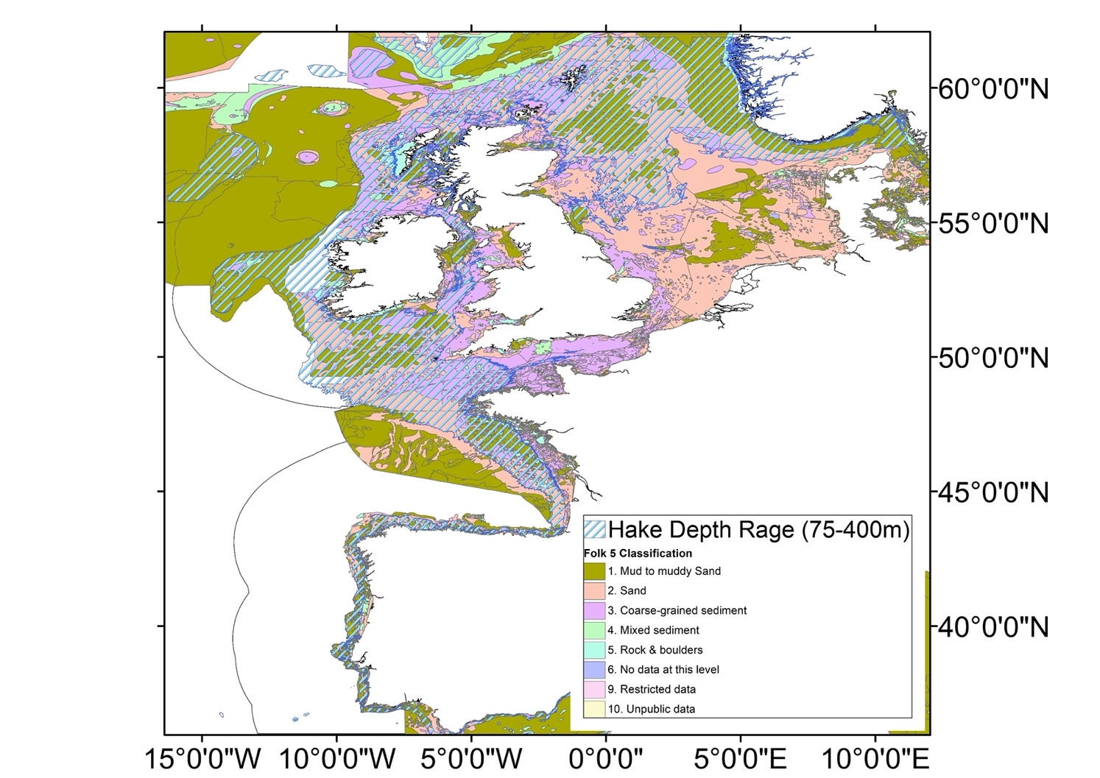

Supplementary Figure 1. Hake depth range overlaid with seabed substrate (EMODnet Geology, 2016).

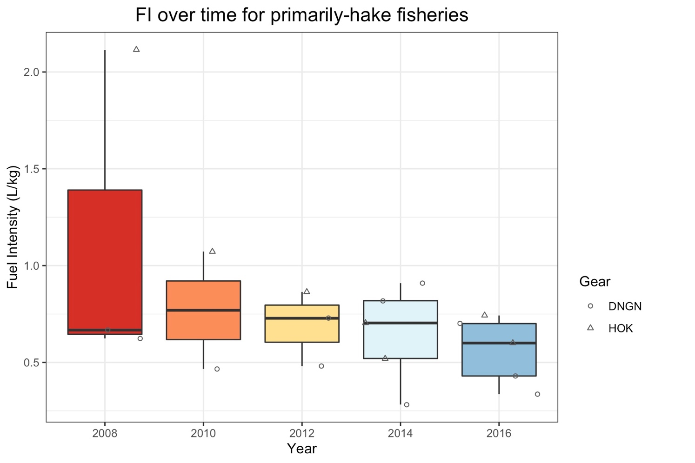

Supplementary Figure 2. Boxplot of Fuel Intensity (FI) estimates for every second year from 2008 to 2016 inclusive, where each point represents the annual FI generated by a particular segment of the EU fleet (e.g. Spanish longliners 18-24m in length), and the shape of each point denotes the gear type used by that fleet. DNGN = Polyvalent-, drift-, and fix-net gear types; HOK = Vessels using hooks. Note that “primarily-hake” fisheries refers to fisheries for which hake accounted for ≥ 50% of total landed annual catch, and therefore only include examples of DNGN and HOK fisheries.
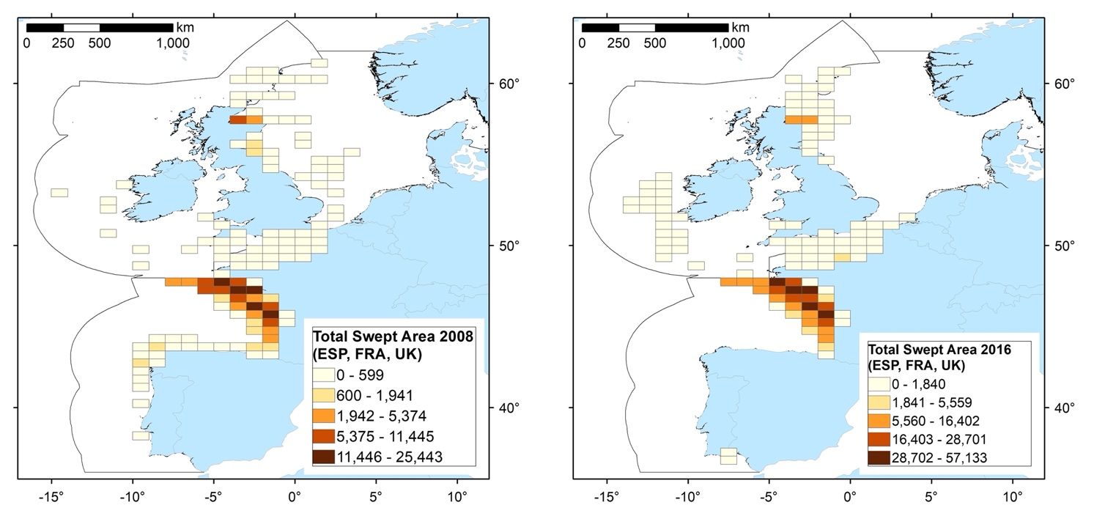
Supplementary Figure 3. Map of swept area (SA) estimates for all otter trawl effort that resulted in hake landings for France, Spain, and the UK in 2008 and 2016 respectively.

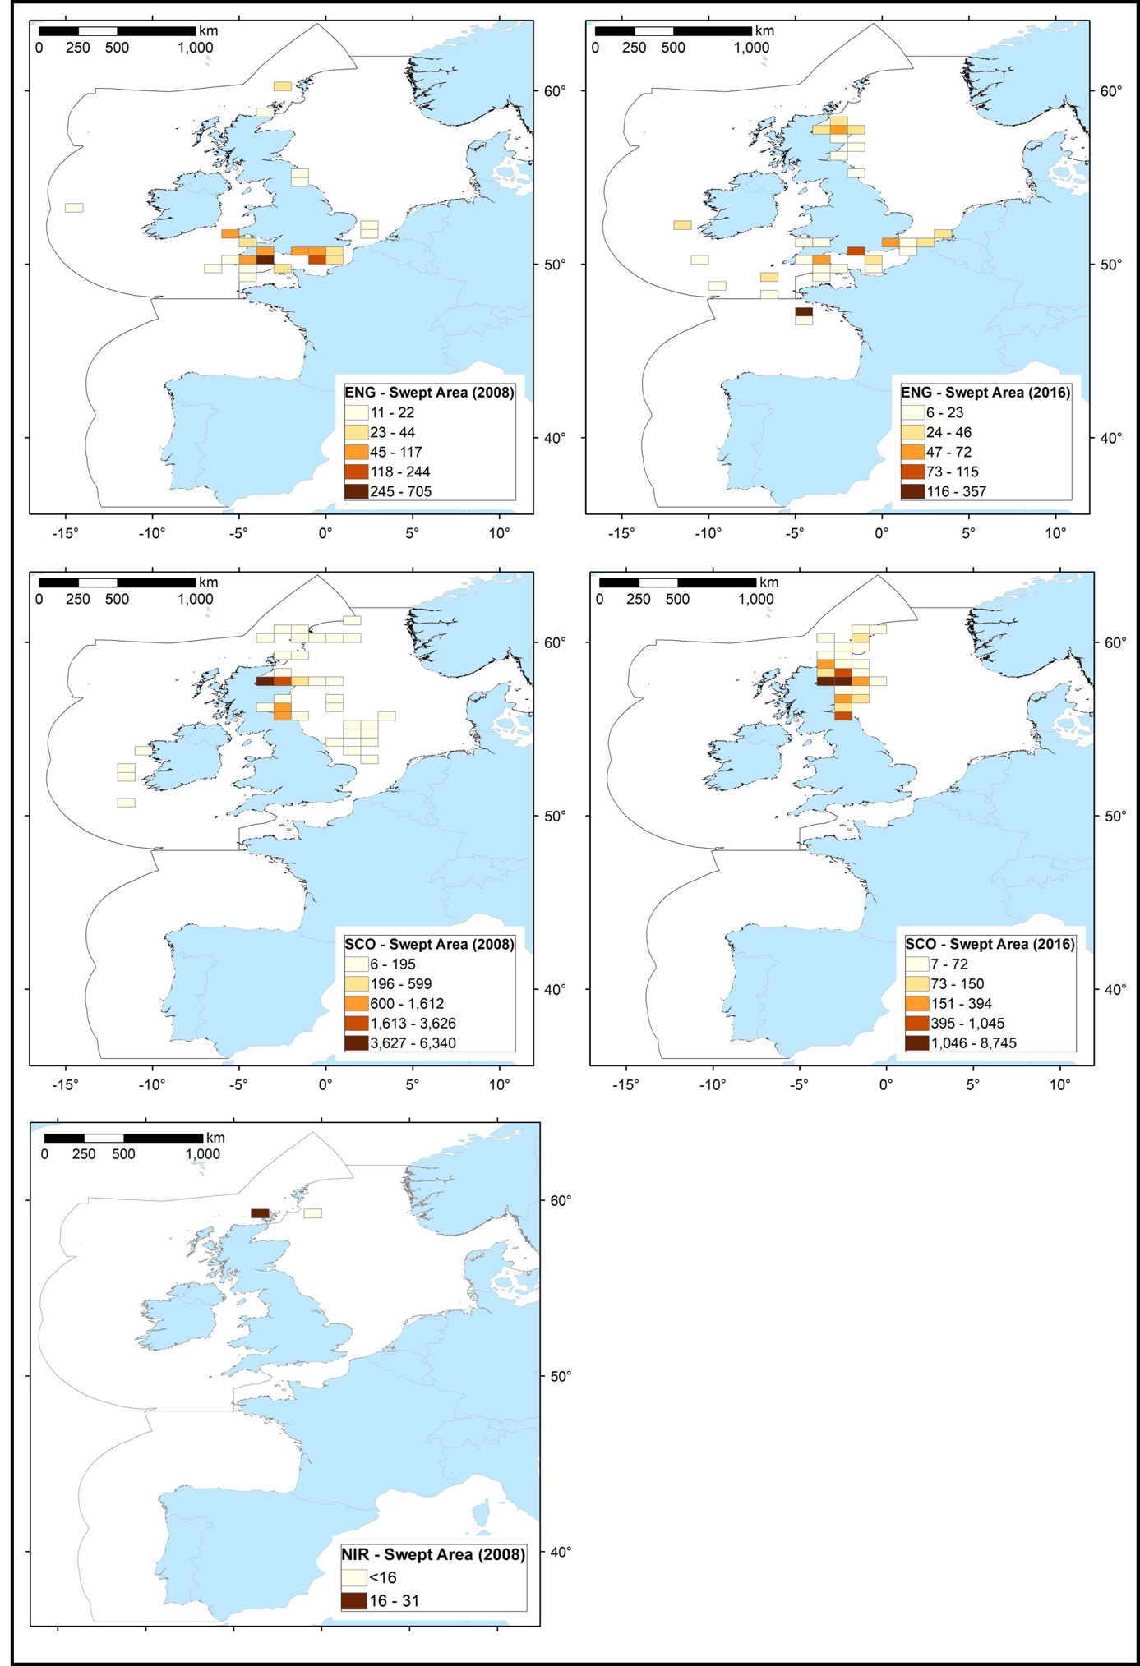

Supplementary Figure 4. The spatial distribution of SA estimates for all otter trawl effort that resulted in hake landings for France, Spain, and the UK per individual nation in 2008 and 2016 respectively.

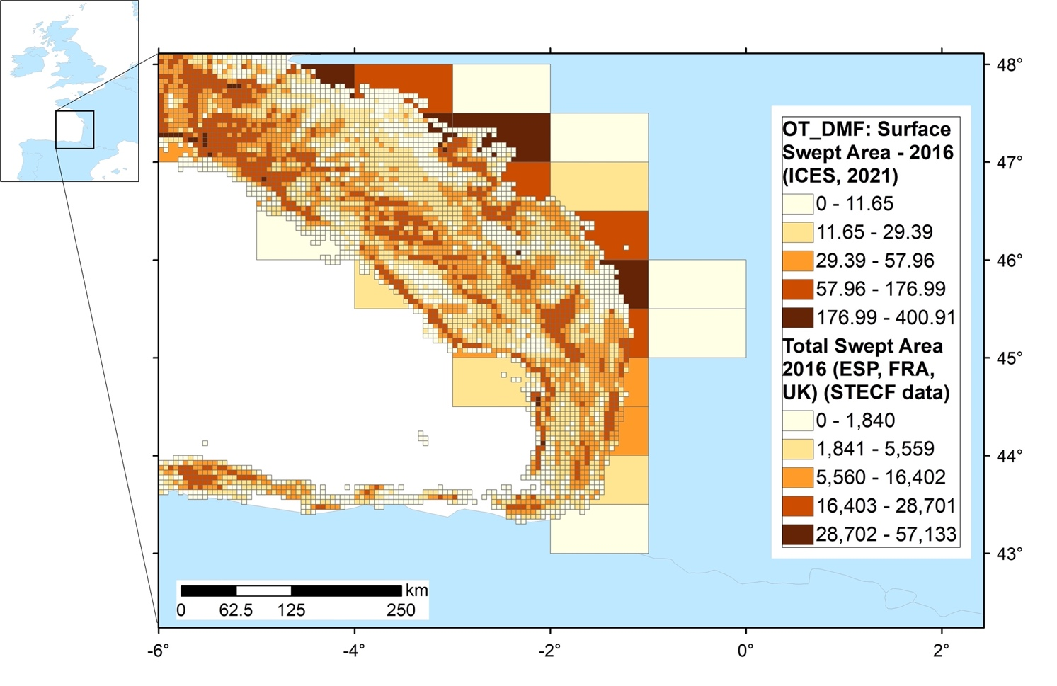

Supplementary Figure 5. Image to show difference in resolution of data available for BENTHIS métier code “OT_DMF” (ICES, 2021c) compared to that available for “OT_DMF_PEL” (STECF, 2017). Spatial comparison of Swept Area (SA) at varying spatial resolutions off the west coast of France, highlighted by the box in the inset map. The “OT_DMF”: ICES SA dataset are presented at 0.05° x 0.05° resolution and the ‘Total SA 2016’: STECF dataset are presented at the ICES rectangle 1° x 0.5° resolution. “OT_DMF” is the total activity for all countries and all species caught by the otter trawl category in 2016. The Total SA 2016 STECF data comprises fishing effort for France, Spain, and the UK in 2016 for hake species caught by demersal trawls and seines.

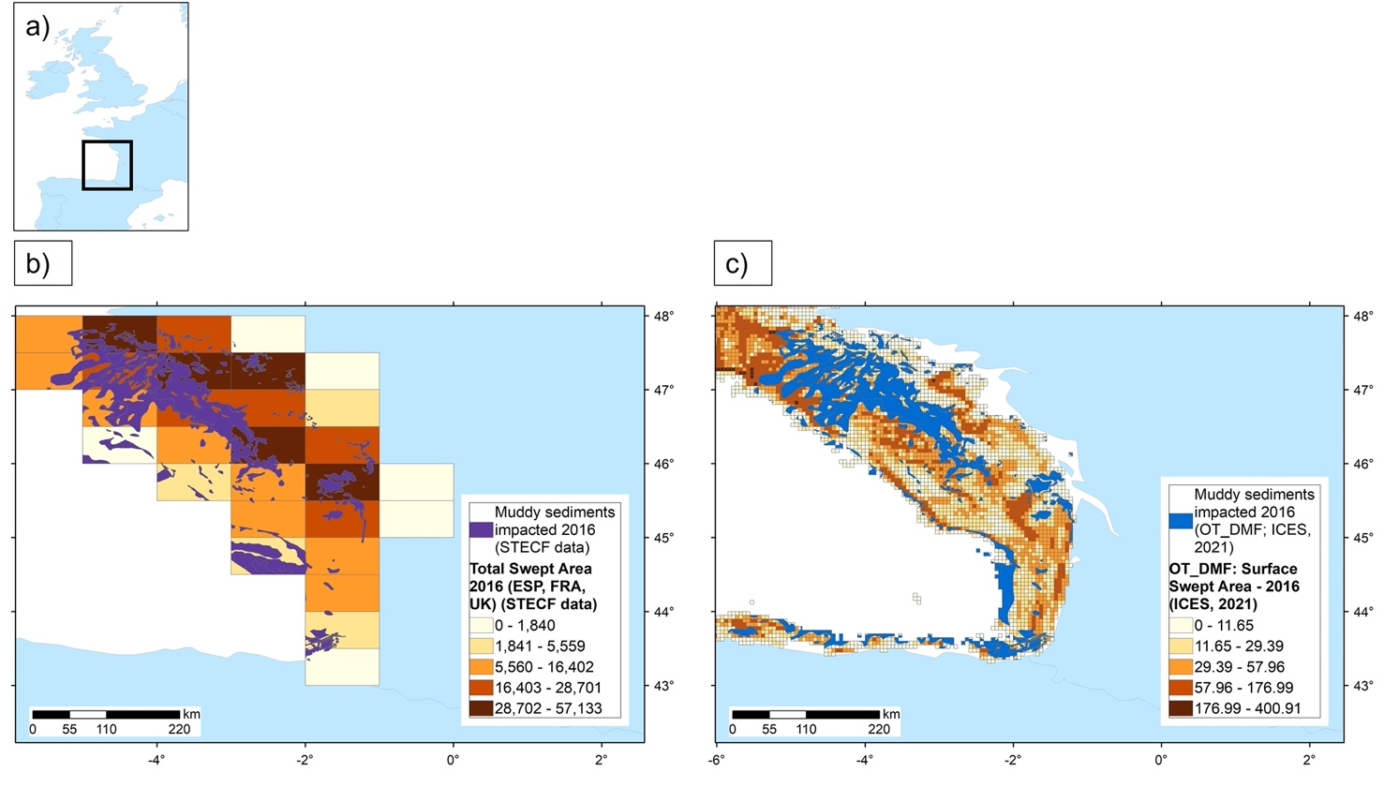
Supplementary Figure 6. Image to compare overlap of trawling activity with muddy sediment when data resolution available for BENTHIS Metier OT_DMF (ICES, 2021c) is used compared to that available for OT_DMF_PEL (STECF, 2017). a) Box denotes location of SA data being compared off the west coast of France; b) and c) show spatial comparison of the muddy sediments (Folk 5 Classification: Mud – muddy Sands) impacted by otter trawl activity for hake as part of a mixed fishery in 2016. Although the SA data resolutions are very different, i.e., b) ICES rectangle 1° x 0.5° and c) 0.05° x 0.05°, the area of mud impacted is similar (~ 5 km2). This highlights the importance of the spatial resolution of data layers for more accurate analyses.

Supplementary Tables

Supplementary Table 1. Estimates of swept area (km²), reported hake landings (kg), and the Swept Area per kg of hake landed by vessels for Spain, France* and the UK by otter-trawl in 2008 and 2016. Percentage of hake catch relative to total catch is provided. *Landings for France under code DTS may include 211.5 tonnes from demersal seiners, according to dataset 1 (STECF 2020b), but it was not possible to disaggregate between the two gear types in the landings data received.

Trawl estimates | Year | Country |  |  | Total
 |  | Spain | France | UK
Swept Area (km²) | 2008 | 6,550 | 206,890 | 16,661 | 230,103
 | 2016 | 27,066 | 472,224 | 21,566 | 520,856
Hake landings (tonnes) (% of total hake landings by all gears) | 2008 | 18,676 (75) | 5,850 (40) | 2,890 (50) | 27,416
 | 2016 | 8,634 (23) | 9,534 (21) | 5,596 (40) | 23,764
Area swept (km²) per kg (tonne) hake landings | 2008 | 0.00035 (0.35) | 0.0353 (35.37) | 0.006 (5.77) | 41.48
 | 2016 | 0.0031 (3.13) | 0.0495 (49.53) | 0.004 (3.85) | 56.52
 | Difference | 800% | 40% | -33% | 36%

