SUPPLEMENTARY MATERIALS

Figure S1. Breeding Bird Survey (BBS) routes where Ring-billed Gull were detected over time, in the four sub-population regions. By 1995, the number of routes had stabilized for the West Central, East Central and East regions, however, in the West region, the number of routes started to decline again, post 1995.

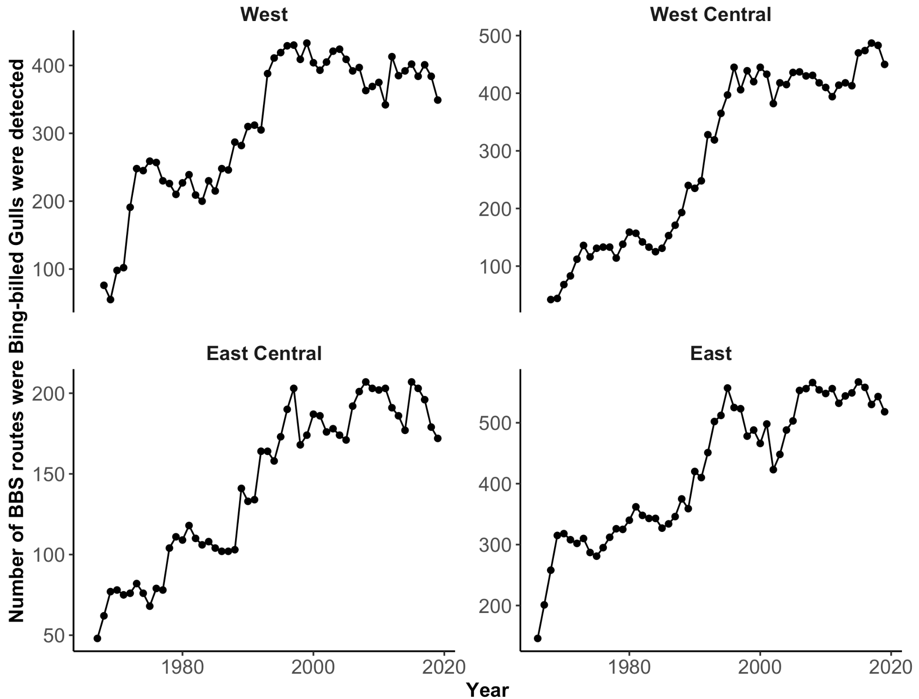

Figure S2. Bander effort for the Ring-billed Gull within-species analysis. Total bander days was calculated as the number of days that a bander spent banding, summed over all banders in a given year and region. Bander effort was significantly declining in East (p value<0.001) and West Central (p value = 0.009) regions, while it was not significantly changing in East Central or West regions.

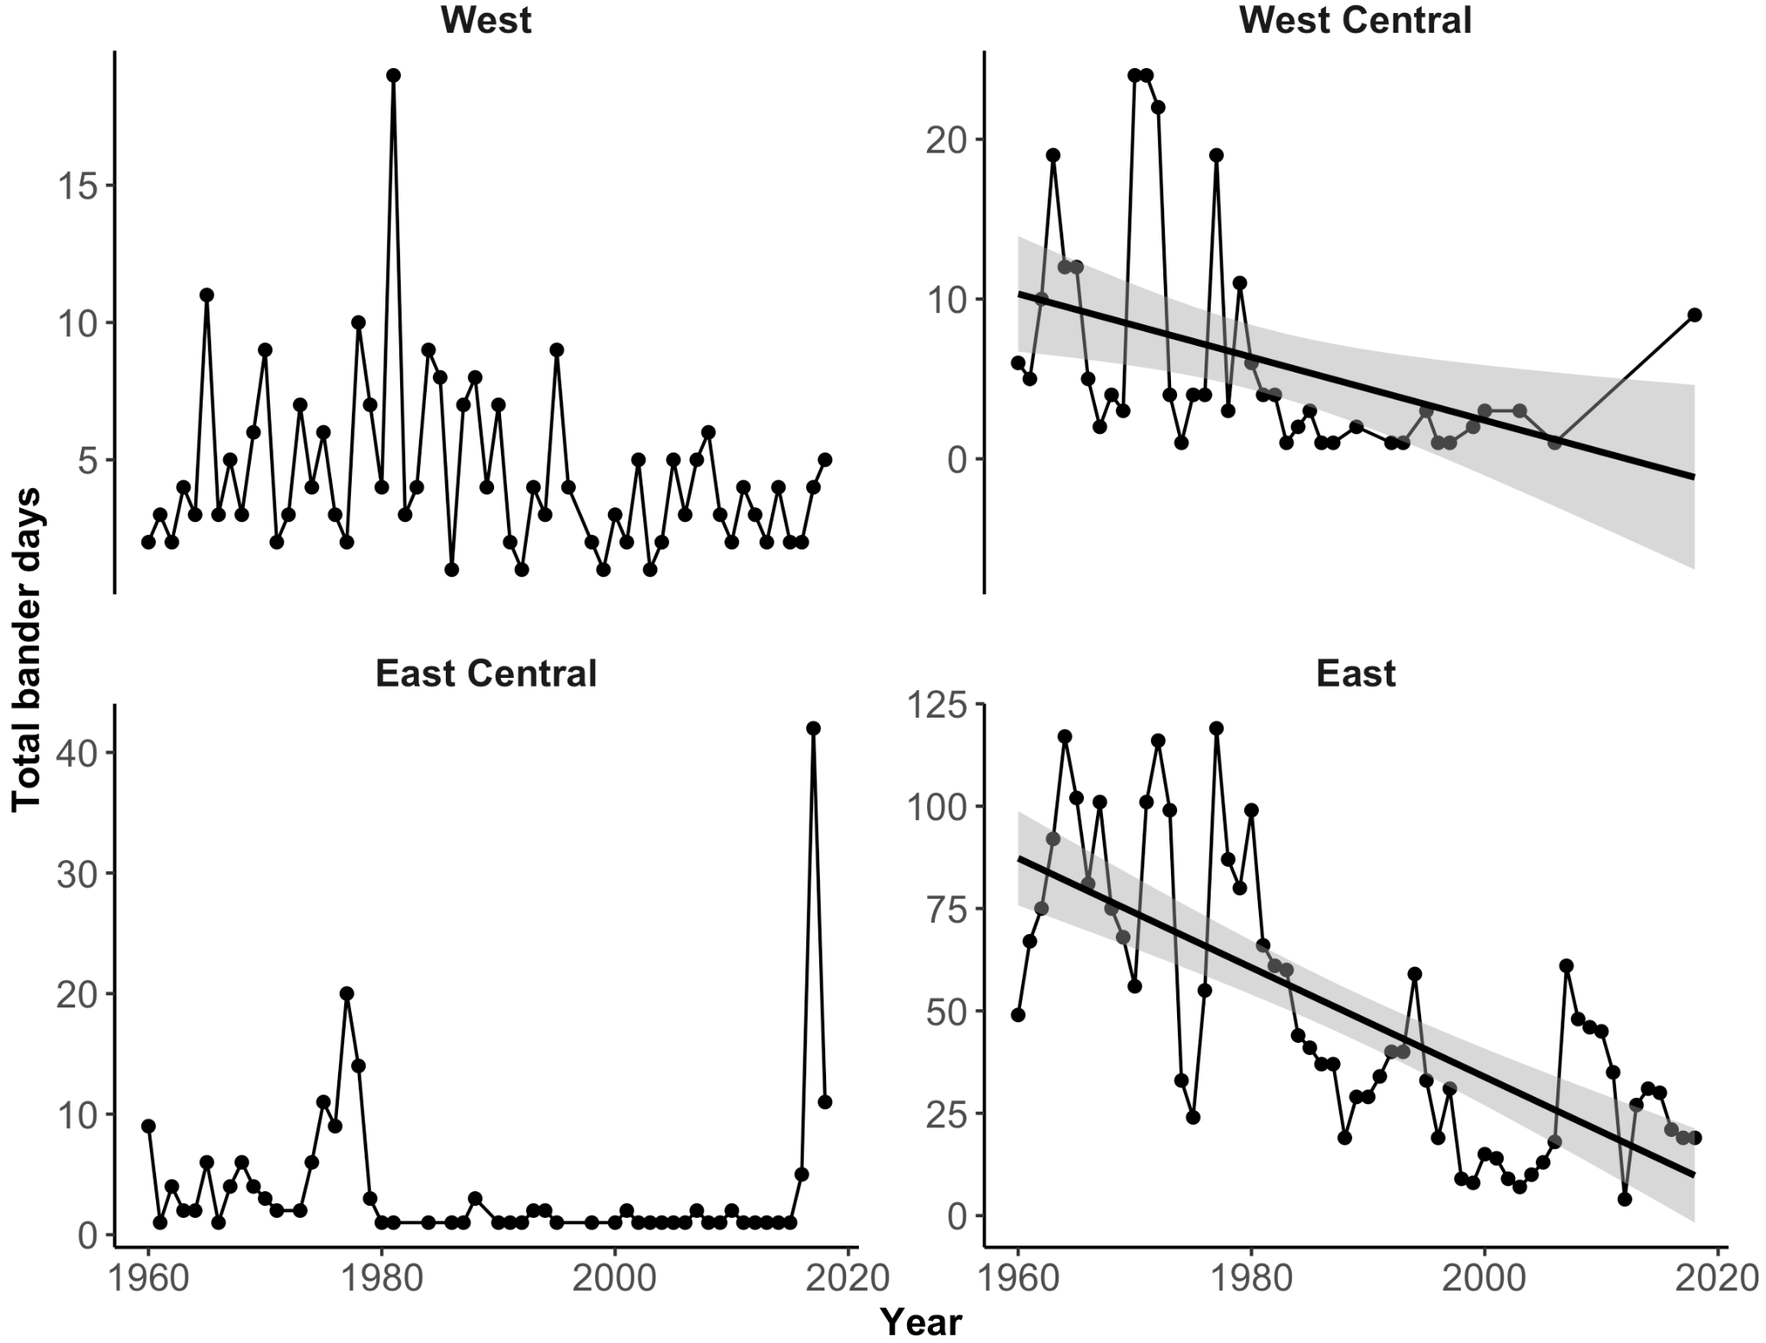

Table S1. British Breeding Seabird Census sites included in the analyses (28). These sites were censused in all years of the study period 1969-2009.

|  |  |  |  |
| --- | --- | --- | --- |
| **#** | **Country** | **Site** | **Site ID** |
| 1 | England | Chichester Harbour | 88776 |
| 2 | England | Rye Harbour SSSI | 90847 |
| 3 | England | Farne Islands | 89250 |
| 4 | England | Coquet Island | 88850 |
| 5 | England | Langstone Harbour (whole estuary) | 91735 |
| 6 | England | Holy Islands Sands | 83977 |
| 7 | England | Brownsea Island 1 | 84327 |
| 8 | England | South Walney | 85039 |
| 9 | England | Foulney | 85041 |
| 10 | England | Snettisham Wash | 85113 |
| 11 | England | Blakeney Point | 85287 |
| 12 | England | Hodbarrow RSPB | 85323 |
| 13 | England | Minsmere Scrape & Beach | 85625 |
| 14 | England | North Solent National Nature Reserve | 96812 |
| 15 | England | Burntwick | 96978 |
| 16 | England | Havergate Island | 97018 |
| 17 | Northern Ireland | Larne Lough RSPB | 100791 |
| 18 | Northern Ireland | Carlingford Lough RSPB | 100865 |
| 19 | Northern Ireland | Strangford Lough | 100809 |
| 20 | Republic of Ireland | Inish, Lady's Island Lake | 93484 |
| 21 | Scotland | Sands Of Forvie | 90877 |
| 22 | Scotland | Isle of May | 84986 |
| 23 | Scotland | Fair Isle | 84981 |
| 24 | Scotland | Loch of Strathbeg | 85820 |
| 25 | Scotland | Fidra | 96957 |
| 26 | Scotland | Horse Isle | 98029 |
| 27 | Wales | Ynys Feirig 1 | 85926 |
| 28 | Wales | Cemlyn Lagoon 1 | 97587 |

Table S2. North American Breeding Bird Survey routes included in the analyses (115). These routes were surveyed in all years of the study period 1969-2009.

|  |  |  |  |  |  |  |
| --- | --- | --- | --- | --- | --- | --- |
| **#** | **Country Number** | **Country Name** | **State/Prov.**  **Number** | **State/Prov. Name** | **Route** | **Route Name** |
| 1 | 124 | Canada | 4 | Alberta | 7 | Brooks |
| 2 | 124 | Canada | 4 | Alberta | 22 | Raven |
| 3 | 124 | Canada | 45 | Manitoba | 18 | Riverdale |
| 4 | 124 | Canada | 56 | New Brunswick | 41 | Hampton |
| 5 | 124 | Canada | 65 | Nova Scotia | 9 | Roman Valley |
| 6 | 124 | Canada | 68 | Ontario | 15 | Roblin |
| 7 | 124 | Canada | 68 | Ontario | 22 | Paisley |
| 8 | 124 | Canada | 68 | Ontario | 39 | North Bay |
| 9 | 124 | Canada | 76 | Quebec | 5 | Verch»Res |
| 10 | 124 | Canada | 76 | Quebec | 21 | St Antoine |
| 11 | 840 | United States | 2 | Alabama | 14 | Smyer Lake |
| 12 | 840 | United States | 2 | Alabama | 17 | Maytown |
| 13 | 840 | United States | 2 | Alabama | 27 | Warrior Std |
| 14 | 840 | United States | 2 | Alabama | 43 | Blocton |
| 15 | 840 | United States | 7 | Arkansas | 4 | Locust Bayou |
| 16 | 840 | United States | 7 | Arkansas | 5 | Stamps |
| 17 | 840 | United States | 7 | Arkansas | 20 | Rupert |
| 18 | 840 | United States | 14 | California | 21 | Hughson |
| 19 | 840 | United States | 17 | Colorado | 13 | Last Chance |
| 20 | 840 | United States | 18 | Connecticut | 8 | No Woodbury |
| 21 | 840 | United States | 21 | Delaware | 1 | Mt Pleasant |
| 22 | 840 | United States | 25 | Florida | 4 | Blountstown |
| 23 | 840 | United States | 25 | Florida | 10 | Covington |
| 24 | 840 | United States | 25 | Florida | 20 | San Antonio |
| 25 | 840 | United States | 25 | Florida | 26 | Sunniland Gr |
| 26 | 840 | United States | 34 | Illinois | 2 | Mill Creek |
| 27 | 840 | United States | 35 | Indiana | 10 | Fowler |
| 28 | 840 | United States | 36 | Iowa | 6 | Bryant |
| 29 | 840 | United States | 38 | Kansas | 13 | Olathe |
| 30 | 840 | United States | 38 | Kansas | 14 | Dover |
| 31 | 840 | United States | 38 | Kansas | 15 | Barclay |
| 32 | 840 | United States | 39 | Kentucky | 3 | Shiloh |
| 33 | 840 | United States | 39 | Kentucky | 6 | Cedar Grove |
| 34 | 840 | United States | 42 | Louisiana | 11 | Keystone |
| 35 | 840 | United States | 46 | Maryland | 3 | Vindex |
| 36 | 840 | United States | 46 | Maryland | 6 | Williamsport |
| 37 | 840 | United States | 46 | Maryland | 13 | Warfieldsbrg |
| 38 | 840 | United States | 46 | Maryland | 14 | Pleasant Val |
| 39 | 840 | United States | 46 | Maryland | 15 | Bachman Mill |
| 40 | 840 | United States | 46 | Maryland | 16 | Fowblesburg |
| 41 | 840 | United States | 46 | Maryland | 22 | Beltsville |
| 42 | 840 | United States | 46 | Maryland | 28 | La Plata |
| 43 | 840 | United States | 46 | Maryland | 30 | Pomonkey |
| 44 | 840 | United States | 46 | Maryland | 32 | Theodore |
| 45 | 840 | United States | 46 | Maryland | 33 | Northeast |
| 46 | 840 | United States | 46 | Maryland | 37 | Piney Neck |
| 47 | 840 | United States | 46 | Maryland | 47 | Cokesbury |
| 48 | 840 | United States | 47 | Massachusetts | 14 | Belchertown |
| 49 | 840 | United States | 47 | Massachusetts | 18 | Cummington |
| 50 | 840 | United States | 47 | Massachusetts | 22 | Sheffield |
| 51 | 840 | United States | 50 | Minnesota | 3 | Hartland |
| 52 | 840 | United States | 50 | Minnesota | 8 | Lakeville |
| 53 | 840 | United States | 50 | Minnesota | 9 | Minnetonka |
| 54 | 840 | United States | 50 | Minnesota | 15 | Princeton |
| 55 | 840 | United States | 50 | Minnesota | 17 | Knapp |
| 56 | 840 | United States | 50 | Minnesota | 34 | Hart Lake |
| 57 | 840 | United States | 52 | Missouri | 14 | Graydon |
| 58 | 840 | United States | 53 | Montana | 2 | Kalispell |
| 59 | 840 | United States | 54 | Nebraska | 12 | Gretna |
| 60 | 840 | United States | 58 | New Hampshire | 1 | Peterborough |
| 61 | 840 | United States | 58 | New Hampshire | 3 | Fitzwilliam |
| 62 | 840 | United States | 58 | New Hampshire | 7 | Concord |
| 63 | 840 | United States | 58 | New Hampshire | 9 | Canterbury |
| 64 | 840 | United States | 58 | New Hampshire | 10 | Gilmantn I W |
| 65 | 840 | United States | 58 | New Hampshire | 11 | Wilmot |
| 66 | 840 | United States | 58 | New Hampshire | 14 | Marlow |
| 67 | 840 | United States | 58 | New Hampshire | 15 | Lempster |
| 68 | 840 | United States | 59 | New Jersey | 10 | Sandbrook |
| 69 | 840 | United States | 61 | New York | 9 | Highland |
| 70 | 840 | United States | 61 | New York | 14 | W Shokan |
| 71 | 840 | United States | 61 | New York | 30 | Whitney Pt |
| 72 | 840 | United States | 61 | New York | 38 | Lisle |
| 73 | 840 | United States | 61 | New York | 45 | Phillips Cr |
| 74 | 840 | United States | 61 | New York | 47 | Orleans |
| 75 | 840 | United States | 61 | New York | 65 | E Youngstown |
| 76 | 840 | United States | 61 | New York | 111 | S Vandalia |
| 77 | 840 | United States | 63 | North Carolina | 2 | Merrimon |
| 78 | 840 | United States | 66 | Ohio | 2 | Napoleon |
| 79 | 840 | United States | 66 | Ohio | 73 | New Marshfld |
| 80 | 840 | United States | 66 | Ohio | 76 | Bolins Mills |
| 81 | 840 | United States | 66 | Ohio | 82 | Pomeroy |
| 82 | 840 | United States | 67 | Oklahoma | 7 | Ardmore |
| 83 | 840 | United States | 67 | Oklahoma | 11 | Baron |
| 84 | 840 | United States | 67 | Oklahoma | 17 | Noble |
| 85 | 840 | United States | 72 | Pennsylvania | 22 | Arnot |
| 86 | 840 | United States | 72 | Pennsylvania | 36 | Millville |
| 87 | 840 | United States | 72 | Pennsylvania | 88 | Jefferson |
| 88 | 840 | United States | 80 | South Carolina | 18 | Barton Creek |
| 89 | 840 | United States | 81 | South Dakota | 10 | Volga |
| 90 | 840 | United States | 82 | Tennessee | 5 | Tibbs |
| 91 | 840 | United States | 82 | Tennessee | 6 | Whiteville |
| 92 | 840 | United States | 82 | Tennessee | 9 | Sweetlips |
| 93 | 840 | United States | 82 | Tennessee | 16 | Wrigley |
| 94 | 840 | United States | 82 | Tennessee | 18 | Lewis Forest |
| 95 | 840 | United States | 82 | Tennessee | 20 | White House |
| 96 | 840 | United States | 82 | Tennessee | 23 | Bradyville |
| 97 | 840 | United States | 82 | Tennessee | 34 | Oliver Spgs |
| 98 | 840 | United States | 83 | Texas | 45 | Caledonia |
| 99 | 840 | United States | 83 | Texas | 74 | Rhome |
| 100 | 840 | United States | 83 | Texas | 98 | Raymondville |
| 101 | 840 | United States | 83 | Texas | 100 | Channing |
| 102 | 840 | United States | 88 | Virginia | 23 | Shipman |
| 103 | 840 | United States | 89 | Washington | 4 | Newhalem |
| 104 | 840 | United States | 91 | Wisconsin | 5 | Bayfield |
| 105 | 840 | United States | 91 | Wisconsin | 10 | Dresser |
| 106 | 840 | United States | 91 | Wisconsin | 12 | Loraine |
| 107 | 840 | United States | 91 | Wisconsin | 24 | Eagle River |
| 108 | 840 | United States | 91 | Wisconsin | 42 | Elderon |
| 109 | 840 | United States | 91 | Wisconsin | 44 | Manawa |
| 110 | 840 | United States | 91 | Wisconsin | 45 | Oconto Falls |
| 111 | 840 | United States | 91 | Wisconsin | 47 | Clintonville |
| 112 | 840 | United States | 91 | Wisconsin | 55 | N Freedom |
| 113 | 840 | United States | 91 | Wisconsin | 56 | Pardeeville |
| 114 | 840 | United States | 91 | Wisconsin | 63 | Pt Washingtn |
| 115 | 840 | United States | 91 | Wisconsin | 70 | Raymond |

Table S3 North American Christmas Bird Count circles included in the analyses (351). These circles were surveyed in all years of the study period 1969-2009.

|  |  |  |  |  |
| --- | --- | --- | --- | --- |
| # | **Country Name** | **State/ Prov. Name** | **Circle Abbreviature** | **Circle Name** |
| 1 | Canada | Alberta | ABCA | Calgary |
| 2 | Canada | Alberta | ABED | Edmonton |
| 3 | Canada | British Columbia | BCVA | Vancouver |
| 4 | Canada | British Columbia | BCVI | Victoria |
| 5 | Canada | New Brunswick | NBCT | Cape Tormentine |
| 6 | Canada | New Brunswick | NBSV | Sackville |
| 7 | Canada | Newfoundland and Labrador | NLSJ | St. Johns |
| 8 | Canada | Nova Scotia | NSKI | Kingston |
| 9 | Canada | Ontario | ONBL | Blenheim |
| 10 | Canada | Ontario | ONCP | Carleton Place |
| 11 | Canada | Ontario | ONDR | Deep River |
| 12 | Canada | Ontario | ONHA | Hamilton |
| 13 | Canada | Ontario | ONLO | London |
| 14 | Canada | Ontario | ONLP | Long Point |
| 15 | Canada | Ontario | ONMI | Manitoulin Island |
| 16 | Canada | Ontario | ONNA | Napanee |
| 17 | Canada | Ontario | ONNF | Niagara Falls |
| 18 | Canada | Ontario | ONOH | Ottawa-Gatineau |
| 19 | Canada | Ontario | ONPA | Pakenham-Arnprior |
| 20 | Canada | Ontario | ONPH | Peel-Halton Counties |
| 21 | Canada | Ontario | ONPT | Peterborough |
| 22 | Canada | Ontario | ONTB | Thunder Bay |
| 23 | Canada | Quebec | QCQU | Quebec |
| 24 | Canada | Saskatchewan | SKSA | Saskatoon |
| 25 | United States | Alabama | ALBH | Birmingham |
| 26 | United States | Alaska | AKAN | Anchorage |
| 27 | United States | Alaska | AKFA | Fairbanks |
| 28 | United States | Arizona | AZSC | Santa Catalina Mountains |
| 29 | United States | Arkansas | ARAR | Arkadelphia |
| 30 | United States | Arkansas | ARCO | Conway |
| 31 | United States | Arkansas | ARFS | Fort Smith-Moffett |
| 32 | United States | Arkansas | ARLO | Lonoke |
| 33 | United States | Arkansas | ARLR | Little Rock |
| 34 | United States | California | CACB | Centerville Beach to King Salmon |
| 35 | United States | California | CACC | Contra Costa County |
| 36 | United States | California | CAJT | Joshua Tree N.P. |
| 37 | United States | California | CAMP | Monterey Peninsula |
| 38 | United States | California | CAMR | Morro Bay |
| 39 | United States | California | CAOC | Orange County (coastal) |
| 40 | United States | California | CAON | Orange County (northeastern) |
| 41 | United States | California | CAOV | Oceanside-Vista-Carlsbad |
| 42 | United States | California | CAPA | Palo Alto |
| 43 | United States | California | CARM | Redlands (Mill Creek) |
| 44 | United States | California | CASB | Santa Barbara |
| 45 | United States | California | CASJ | San Jose |
| 46 | United States | California | CASR | Santa Rosa |
| 47 | United States | California | CASS | Salton Sea (south) |
| 48 | United States | California | CASV | San Fernando Valley |
| 49 | United States | California | CAWS | Western Sonoma County |
| 50 | United States | California | CAYO | Yosemite N.P. |
| 51 | United States | Colorado | COCS | Colorado Springs |
| 52 | United States | Colorado | CODE | Denver |
| 53 | United States | Colorado | COGJ | Grand Junction |
| 54 | United States | Colorado | COGU | Gunnison |
| 55 | United States | Colorado | COLO | Longmont |
| 56 | United States | Colorado | CONU | Nunn |
| 57 | United States | Colorado | CORM | Rocky Mountain N.P. |
| 58 | United States | Connecticut | CTGS | Greenwich-Stamford |
| 59 | United States | Connecticut | CTHA | Hartford |
| 60 | United States | Connecticut | CTLS | Lakeville-Sharon |
| 61 | United States | Connecticut | CTNL | New London |
| 62 | United States | Connecticut | CTOL | Old Lyme-Saybrook |
| 63 | United States | Connecticut | CTST | Storrs |
| 64 | United States | Delaware | DEBH | Bombay Hook N.W.R. |
| 65 | United States | Delaware | DECH | Cape Henlopen-Prime Hook |
| 66 | United States | Delaware | DEWI | Wilmington |
| 67 | United States | District of Columbia | DCDC | Washington |
| 68 | United States | Florida | FLBC | Bay County |
| 69 | United States | Florida | FLCO | Cocoa |
| 70 | United States | Florida | FLFL | Fort Lauderdale |
| 71 | United States | Florida | FLFM | Fort Myers |
| 72 | United States | Florida | FLGA | Gainesville |
| 73 | United States | Florida | FLJA | Jacksonville |
| 74 | United States | Florida | FLKL | Key Largo-Plantation Key |
| 75 | United States | Florida | FLLW | Lake Wales |
| 76 | United States | Florida | FLMR | Myakka River S.P. |
| 77 | United States | Florida | FLNA | Naples |
| 78 | United States | Florida | FLPE | Pensacola |
| 79 | United States | Florida | FLSP | St. Petersburg |
| 80 | United States | Florida | FLST | Stuart |
| 81 | United States | Florida | FLWP | West Palm Beach |
| 82 | United States | Georgia | GAAU | Augusta |
| 83 | United States | Georgia | GACG | Callaway Gardens |
| 84 | United States | Georgia | GACO | Columbus |
| 85 | United States | Idaho | IDNA | Nampa |
| 86 | United States | Idaho | IDPO | Pocatello |
| 87 | United States | Idaho | IDRE | Rexburg |
| 88 | United States | Illinois | ILBA | Barrington |
| 89 | United States | Illinois | ILCR | Calumet City-Sand Ridge |
| 90 | United States | Illinois | ILCU | Chicago (urban) |
| 91 | United States | Illinois | ILEN | Evanston (north shore) |
| 92 | United States | Illinois | ILFG | Forest Glen Preserve |
| 93 | United States | Illinois | ILPE | Peoria |
| 94 | United States | Illinois | ILQU | Quincy |
| 95 | United States | Illinois | ILSP | Springfield |
| 96 | United States | Illinois | ILSR | Starved Rock S.P. |
| 97 | United States | Illinois | ILWA | Waukegan |
| 98 | United States | Illinois | ILWM | Western Mercer County |
| 99 | United States | Indiana | INFW | Fort Wayne |
| 100 | United States | Indiana | ININ | Indianapolis |
| 101 | United States | Indiana | INLA | Lafayette |
| 102 | United States | Indiana | INSB | South Bend |
| 103 | United States | Indiana | INTH | Terre Haute |
| 104 | United States | Iowa | IACL | Clinton |
| 105 | United States | Iowa | IADA | Davenport |
| 106 | United States | Iowa | IADE | Decorah |
| 107 | United States | Iowa | IADU | Dubuque |
| 108 | United States | Iowa | IAIC | Iowa City |
| 109 | United States | Iowa | IAMU | Muscatine |
| 110 | United States | Iowa | IAPC | Princeton-Camanche |
| 111 | United States | Iowa | IASC | Sioux City |
| 112 | United States | Iowa | IAYR | Yellow River Forest |
| 113 | United States | Kansas | KSBA | Baldwin |
| 114 | United States | Kansas | KSEM | Emporia |
| 115 | United States | Kansas | KSHN | Halstead-Newton |
| 116 | United States | Kansas | KSTO | Topeka |
| 117 | United States | Kansas | KSWI | Wichita |
| 118 | United States | Kentucky | KYFR | Frankfort |
| 119 | United States | Kentucky | KYKL | Kleber W.M.A. |
| 120 | United States | Kentucky | KYLE | Lexington |
| 121 | United States | Kentucky | KYLO | Louisville |
| 122 | United States | Louisiana | LARB | Reserve-Bonnet Carre Spillway |
| 123 | United States | Louisiana | LASH | Shreveport |
| 124 | United States | Maine | MEBB | Bangor-Bucksport |
| 125 | United States | Maine | MECA | Calais |
| 126 | United States | Maine | MEEA | Eastport |
| 127 | United States | Maine | MEOO | Orono-Old Town |
| 128 | United States | Maine | MESP | Schoodic Point |
| 129 | United States | Mariland | MDAG | Annapolis-Gibson Island |
| 130 | United States | Mariland | MDCM | Catoctin Mountain |
| 131 | United States | Mariland | MDCR | Crisfield |
| 132 | United States | Mariland | MDOC | Ocean City |
| 133 | United States | Mariland | MDSA | Salisbury |
| 134 | United States | Mariland | MDSD | Southern Dorchester County |
| 135 | United States | Mariland | MDSE | Seneca |
| 136 | United States | Mariland | MDTR | Triadelphia Reservoir |
| 137 | United States | Massachusetts | MAAT | Athol |
| 138 | United States | Massachusetts | MACC | Cape Cod |
| 139 | United States | Massachusetts | MACO | Concord |
| 140 | United States | Massachusetts | MAMA | Marshfield |
| 141 | United States | Massachusetts | MAMV | Martha's Vineyard |
| 142 | United States | Massachusetts | MANA | Nantucket |
| 143 | United States | Massachusetts | MANF | New Bedford |
| 144 | United States | Massachusetts | MANO | Northampton |
| 145 | United States | Massachusetts | MAQU | Quincy |
| 146 | United States | Massachusetts | MASP | Springfield |
| 147 | United States | Michigan | MIAA | Ann Arbor |
| 148 | United States | Michigan | MIBS | Berrien Springs |
| 149 | United States | Michigan | MIDE | Detroit |
| 150 | United States | Michigan | MIDO | Dowagiac |
| 151 | United States | Michigan | MIGR | Grand Rapids |
| 152 | United States | Michigan | MIKA | Kalamazoo |
| 153 | United States | Michigan | MIMI | Midland |
| 154 | United States | Michigan | MIMQ | Marquette |
| 155 | United States | Michigan | MIMU | Muskegon |
| 156 | United States | Michigan | MIPH | Port Huron |
| 157 | United States | Michigan | MIWA | Waterloo State Recreation Area |
| 158 | United States | Minesota | MNAF | Afton |
| 159 | United States | Minesota | MNBL | Bloomington |
| 160 | United States | Minesota | MNCO | Cottonwood |
| 161 | United States | Minesota | MNCS | Crosby |
| 162 | United States | Minesota | MNEX | Excelsior |
| 163 | United States | Minesota | MNMI | Minneapolis (north) |
| 164 | United States | Minesota | MNSN | St. Paul (northeast suburban) |
| 165 | United States | Mississippi | MSJA | Jackson |
| 166 | United States | Missouri | MOCO | Columbia |
| 167 | United States | Missouri | MOMA | Maryville |
| 168 | United States | Missouri | MOML | Montrose Lake Wildlife Area |
| 169 | United States | Missouri | MOSJ | St. Joseph |
| 170 | United States | Missouri | MOSP | Springfield |
| 171 | United States | Missouri | MOWS | Weldon Spring |
| 172 | United States | Montana | MTBL | Billings |
| 173 | United States | Montana | MTBZ | Bozeman |
| 174 | United States | Nebraska | NELI | Lincoln |
| 175 | United States | Nebraska | NESC | Scottsbluff |
| 176 | United States | New Hampshire | NHCS | Coastal New Hampshire |
| 177 | United States | New Hampshire | NHHN | Hanover-Norwich |
| 178 | United States | New Hampshire | NHPI | Pittsburg |
| 179 | United States | New Jersey | NJBO | Boonton |
| 180 | United States | New Jersey | NJCC | Cumberland County |
| 181 | United States | New Jersey | NJCM | Cape May |
| 182 | United States | New Jersey | NJGS | Great Swamp-Watchung Ridges |
| 183 | United States | New Jersey | NJLA | Lakehurst |
| 184 | United States | New Jersey | NJLB | Long Branch |
| 185 | United States | New Jersey | NJNH | Northwestern Hunterdon County |
| 186 | United States | New Jersey | NJOC | Oceanville |
| 187 | United States | New Jersey | NJPR | Princeton |
| 188 | United States | New Jersey | NJRA | Ramsey |
| 189 | United States | New Jersey | NJRE | Raritan Estuary |
| 190 | United States | New Jersey | NJSO | Somerset County |
| 191 | United States | New Jersey | NJSU | Sussex County |
| 192 | United States | New Jersey | NJTM | Trenton Marshes |
| 193 | United States | New Jersey | NJWV | Walnut Valley |
| 194 | United States | New Mexico | NMES | Espanola |
| 195 | United States | New Mexico | NMFA | Farmington |
| 196 | United States | New Mexico | NMLO | Loving |
| 197 | United States | New Mexico | NMRO | Roswell |
| 198 | United States | New York | NYBI | Binghamton |
| 199 | United States | New York | NYCH | Conesus-Hemlock-Honeoye Lakes |
| 200 | United States | New York | NYCR | Cortland |
| 201 | United States | New York | NYCS | L.I.: Central Suffolk County |
| 202 | United States | New York | NYCT | Catskill-Coxsackie |
| 203 | United States | New York | NYDC | Dutchess County |
| 204 | United States | New York | NYEL | Elmira |
| 205 | United States | New York | NYGE | Geneva |
| 206 | United States | New York | NYHE | Hamburg-East Aurora |
| 207 | United States | New York | NYIT | Ithaca |
| 208 | United States | New York | NYMK | L.I.: Montauk |
| 209 | United States | New York | NYML | Mohonk Lake-Ashokan Reservoir |
| 210 | United States | New York | NYMT | Monticello |
| 211 | United States | New York | NYNN | L.I.: Northern Nassau County |
| 212 | United States | New York | NYOO | Oak Orchard Swamp |
| 213 | United States | New York | NYOR | L.I.: Orient |
| 214 | United States | New York | NYOS | Oswego-Fulton |
| 215 | United States | New York | NYPC | Putnam County |
| 216 | United States | New York | NYQU | L.I.: Queens |
| 217 | United States | New York | NYRH | Rochester |
| 218 | United States | New York | NYSI | Staten Island |
| 219 | United States | New York | NYSM | L.I.: Smithtown |
| 220 | United States | New York | NYSO | Scio |
| 221 | United States | New York | NYTR | Troy |
| 222 | United States | New York | NYWG | Watkins Glen |
| 223 | United States | North Carolina | NCBP | Bodie-Pea Island |
| 224 | United States | North Carolina | NCCP | Chapel Hill |
| 225 | United States | North Carolina | NCRA | Raleigh |
| 226 | United States | North Carolina | NCWI | Wilmington |
| 227 | United States | North Carolina | NCWS | Winston-Salem |
| 228 | United States | North Dakota | NDBM | Bismarck-Mandan |
| 229 | United States | North Dakota | NDFM | Fargo-Moorhead |
| 230 | United States | North Dakota | NDJC | J. Clark Salyer N.W.R. |
| 231 | United States | Ohio | OHAD | Ashland |
| 232 | United States | Ohio | OHBL | Buckeye Lake |
| 233 | United States | Ohio | OHBU | Burton |
| 234 | United States | Ohio | OHCA | Cadiz |
| 235 | United States | Ohio | OHCF | Cuyahoga Falls |
| 236 | United States | Ohio | OHCL | Cleveland |
| 237 | United States | Ohio | OHCO | Columbus |
| 238 | United States | Ohio | OHDA | Dayton |
| 239 | United States | Ohio | OHEL | Elyria-Lorain |
| 240 | United States | Ohio | OHGR | Grand Rapids-Waterville |
| 241 | United States | Ohio | OHHF | Hamilton-Fairfield |
| 242 | United States | Ohio | OHHR | Hoover Reservoir |
| 243 | United States | Ohio | OHKI | Kingston |
| 244 | United States | Ohio | OHLK | Lakewood |
| 245 | United States | Ohio | OHLN | Lancaster |
| 246 | United States | Ohio | OHMA | Mansfield |
| 247 | United States | Ohio | OHMO | Mohican State Forest |
| 248 | United States | Ohio | OHPL | Plymouth |
| 249 | United States | Ohio | OHPO | Portsmouth |
| 250 | United States | Ohio | OHTI | Tiffin |
| 251 | United States | Ohio | OHTO | Toledo |
| 252 | United States | Ohio | OHWO | Wooster |
| 253 | United States | Oklahoma | OKAN | Arnett |
| 254 | United States | Oklahoma | OKFG | Fort Gibson Reservoir |
| 255 | United States | Oklahoma | OKHR | Hulah Reservoir |
| 256 | United States | Oklahoma | OKNO | Norman |
| 257 | United States | Oklahoma | OKOC | Oklahoma City |
| 258 | United States | Oregon | ORCO | Corvallis |
| 259 | United States | Oregon | OREU | Eugene |
| 260 | United States | Oregon | ORME | Medford |
| 261 | United States | Oregon | ORPD | Portland |
| 262 | United States | Oregon | ORSA | Salem |
| 263 | United States | Pennsilvania | PABH | Bethlehem-Easton |
| 264 | United States | Pennsilvania | PABU | Butler County |
| 265 | United States | Pennsilvania | PACB | Central Bucks County |
| 266 | United States | Pennsilvania | PACH | Chambersburg |
| 267 | United States | Pennsilvania | PACL | Clarksville |
| 268 | United States | Pennsilvania | PACU | Culp |
| 269 | United States | Pennsilvania | PADA | Dallas Area |
| 270 | United States | Pennsilvania | PAEL | Elverson |
| 271 | United States | Pennsilvania | PAGL | Delaware County (Glenolden) |
| 272 | United States | Pennsilvania | PAHM | Hamburg |
| 273 | United States | Pennsilvania | PAHR | Harrisburg |
| 274 | United States | Pennsilvania | PALA | Lancaster |
| 275 | United States | Pennsilvania | PALB | Southern Bucks County |
| 276 | United States | Pennsilvania | PALG | Lewisburg |
| 277 | United States | Pennsilvania | PALH | Lock Haven-Jersey Shore |
| 278 | United States | Pennsilvania | PALN | Linesville |
| 279 | United States | Pennsilvania | PALV | Lehigh Valley |
| 280 | United States | Pennsilvania | PALZ | Lititz |
| 281 | United States | Pennsilvania | PAPL | Pleasantville |
| 282 | United States | Pennsilvania | PARD | Reading |
| 283 | United States | Pennsilvania | PASB | Southeastern Bradford County |
| 284 | United States | Pennsilvania | PASC | State College |
| 285 | United States | Pennsilvania | PASR | Scranton |
| 286 | United States | Pennsilvania | PAWC | West Chester |
| 287 | United States | Pennsilvania | PAWI | Williamsport |
| 288 | United States | Pennsilvania | PAWR | Warren |
| 289 | United States | Rhode Island | RINC | Newport County-Westport |
| 290 | United States | Rhode Island | RISK | South Kingstown |
| 291 | United States | South Carolina | SCAI | Aiken |
| 292 | United States | South Dakota | SDBR | Brookings |
| 293 | United States | South Dakota | SDMA | Madison |
| 294 | United States | South Dakota | SDRC | Rapid City |
| 295 | United States | South Dakota | SDWA | Waubay N.W.R. |
| 296 | United States | South Dakota | SDYA | Yankton |
| 297 | United States | Tennessee | TNCO | Columbia |
| 298 | United States | Tennessee | TNEL | Elizabethton |
| 299 | United States | Tennessee | TNHP | Hickory-Priest |
| 300 | United States | Tennessee | TNKN | Knoxville |
| 301 | United States | Tennessee | TNME | Memphis |
| 302 | United States | Tennessee | TNNA | Nashville |
| 303 | United States | Texas | TXAU | Austin |
| 304 | United States | Texas | TXBP | Bolivar Peninsula |
| 305 | United States | Texas | TXBS | Big Spring |
| 306 | United States | Texas | TXCC | Corpus Christi |
| 307 | United States | Texas | TXCF | Corpus Christi (Flour Bluff) |
| 308 | United States | Texas | TXDA | Dallas County |
| 309 | United States | Texas | TXFR | Freeport |
| 310 | United States | Texas | TXFW | Fort Worth |
| 311 | United States | Texas | TXHO | Houston |
| 312 | United States | Texas | TXLS | La Sal Vieja |
| 313 | United States | Texas | TXLV | Lewisville |
| 314 | United States | Texas | TXOR | Old River |
| 315 | United States | Texas | TXPS | Palestine |
| 316 | United States | Texas | TXSA | Santa Ana N.W.R. |
| 317 | United States | Texas | TXSG | San Angelo |
| 318 | United States | Texas | TXTY | Tyler |
| 319 | United States | Texas | TXWW | Welder Wildlife Refuge |
| 320 | United States | Vermont | VTBU | Burlington |
| 321 | United States | Vermont | VTFE | Ferrisburg |
| 322 | United States | Vermont | VTSR | Saxton's River |
| 323 | United States | Vermont | VTWI | Winhall |
| 324 | United States | Virginia | VABB | Back Bay N.W.R. |
| 325 | United States | Virginia | VABK | Brooke |
| 326 | United States | Virginia | VACC | Cape Charles |
| 327 | United States | Virginia | VACI | Chincoteague N.W.R. |
| 328 | United States | Virginia | VALC | Little Creek |
| 329 | United States | Virginia | VAMA | Mathews |
| 330 | United States | Virginia | VANN | Newport News |
| 331 | United States | Virginia | VARC | Rockingham County |
| 332 | United States | Virginia | VASL | Shenandoah N.P.-Luray |
| 333 | United States | Washington | WABG | Bellingham |
| 334 | United States | Washington | WASP | Spokane |
| 335 | United States | Washington | WATC | Tri-Cities |
| 336 | United States | Washington | WAWE | Wenatchee |
| 337 | United States | West Virginia | WVCT | Charles Town |
| 338 | United States | Wisconsin | WICF | Chippewa Falls |
| 339 | United States | Wisconsin | WIGB | Green Bay |
| 340 | United States | Wisconsin | WILC | La Crosse |
| 341 | United States | Wisconsin | WIMI | Milwaukee |
| 342 | United States | Wisconsin | WINR | New Richmond |
| 343 | United States | Wisconsin | WIOS | Oshkosh |
| 344 | United States | Wisconsin | WIPE | Peshtigo |
| 345 | United States | Wisconsin | WIRN | Randolph |
| 346 | United States | Wisconsin | WISI | Shiocton |
| 347 | United States | Wisconsin | WISP | Stevens Point |
| 348 | United States | Wisconsin | WIWK | Waukesha |
| 349 | United States | Wisconsin | WIWT | Wautoma |
| 350 | United States | Wyoming | WYCA | Casper |
| 351 | United States | Wyoming | WYSH | Sheridan |

Table S4. Results of the Shapiro-Wilk normality test for population density and transatlantic vagrants for European gull’s data and North American gull’s data. Statistically significant p values (i.e., p < 0.05) reflect data not normally distributed.

|  |  |  |
| --- | --- | --- |
|  | **Shapiro-Wilk normality test**  **p value** | |
| **Species** | **Population**  **Size** | **Number of Vagrants** |
| Black-Headed Gull | <0.001 | 0.0025 |
| Common Gull | <0.001 | 0.0023 |
| Lesser Black-Backed Gull | 0.0024 | <0.001 |
| Bonaparte's Gull | <0.001 | <0.001 |
| Franklin's Gull | <0.001 | <0.001 |
| Laughing Gull | <0.001 | <0.001 |
| Ring-billed Gull | 0.001 | 0.0202 |

Table S5. Mean and variance of the number of transatlantic vagrants per species.

|  |  |  |
| --- | --- | --- |
| **Species** | **Mean Number of vagrants** | **Variance Number of vagrants** |
| Black-Headed Gull | 198.2 | 21376.4 |
| Common Gull | 7.0 | 30.8 |
| Lesser Black-Backed Gull | 277.5 | 105498.1 |
| Bonaparte's Gull | 6.2 | 35.5 |
| Franklin's Gull | 2.1 | 6.2 |
| Laughing Gull | 5.9 | 140.2 |
| Ring-billed Gull | 47.9 | 1043.0 |

Table S6. Model selection for generalized additive models (GAMs) of the relationship between population size in the source area (explanatory variable) and the number of transatlantic vagrants in the receiving area in the following year (response variable).

|  |  |  |  |  |  |  |  |
| --- | --- | --- | --- | --- | --- | --- | --- |
| **Species** | **Model Type** | **Population size** | **p-value** | **df** | **n** | **AICc** | **R2** |
| Black-Headed Gull | Full* | 5.30 | 0.15 | 3 | 33 | 417.79 | 0.17 |
| Null | - | - | - | 515.16 | - |
| Common Gull | Full* | 1.99 | **0.02** | 3 | 32 | 191.75 | 0.28 |
| Null | - | - | - | 245.72 | - |
| Lesser Black-Backed Gull | Full* | 5.94 | 0.16 | 2 | 24 | 343.40 | 0.30 |
| Null | - | - | - | 547.01 | - |
| Bonaparte's Gull | Full* | 1.74 | **0.01** | 2 | 41 | 234.44 | 0.12 |
| Null | - | - | - | 240.87 | - |
| Franklin's Gull | Full* | 0.57 | **0.03** | 3 | 38 | 146.42 | 0.09 |
| Null | - | - | - | 164.80 | - |
| Laughing Gull | Full* | 1.63 | 0.07 | 3 | 41 | 230.26 | 0.01 |
| Null | - | - | - | 234.85 | - |
| Ring-billed Gull | Full* | 3.53 | **<0.001** | 4 | 41 | 382.06 | 0.52 |
| Null | - | - | - | 404.46 | - |

GAMs were run with negative binomial errors. Effect sizes are listed for each predictor.

*Best model as selected based on the lowest AICc value.

Significant p values of the explanatory variable are shown in bold (i.e. p < 0.05).

Table S7. Temporal trends of population size (1969 to 2009) and number of transatlantic vagrants (1970-2010) for European gull’s data and North American gull’s data. Temporal trends were calculated using a non-parametric Spearman test between the observations and time. Significant trends (i.e., p < 0.05) are shown in bold font.

|  |  |  |  |  |
| --- | --- | --- | --- | --- |
|  | **Temporal Trends** | | | |
| **Population**  **size**  **(1969-2009)** | | **Number of vagrants**  **(1970-2010)** | |
| **Species** | **Estimate** | **p value** | **Estimate** | **p value** |
| Black-Headed Gull | 0.45 | **0.01** | 0.15 | 0.36 |
| Common Gull | 0.87 | **<0.001** | 0.55 | **<0.001** |
| Lesser Black-Backed Gull | 0.10 | 0.65 | 0.96 | **<0.001** |
| Bonaparte's Gull | -0.25 | 0.11 | 0.79 | **<0.001** |
| Franklin's Gull | -0.61 | **<0.001** | 0.57 | **<0.001** |
| Laughing Gull | 0.79 | **<0.001** | 0.37 | **0.02** |
| Ring-billed Gull <1990 | 0.71 | **<0.001** | 0.93 | **<0.001** |
| Ring-billed Gull >1990 | -0.40 | 0.08 | -0.64 | **0.002** |