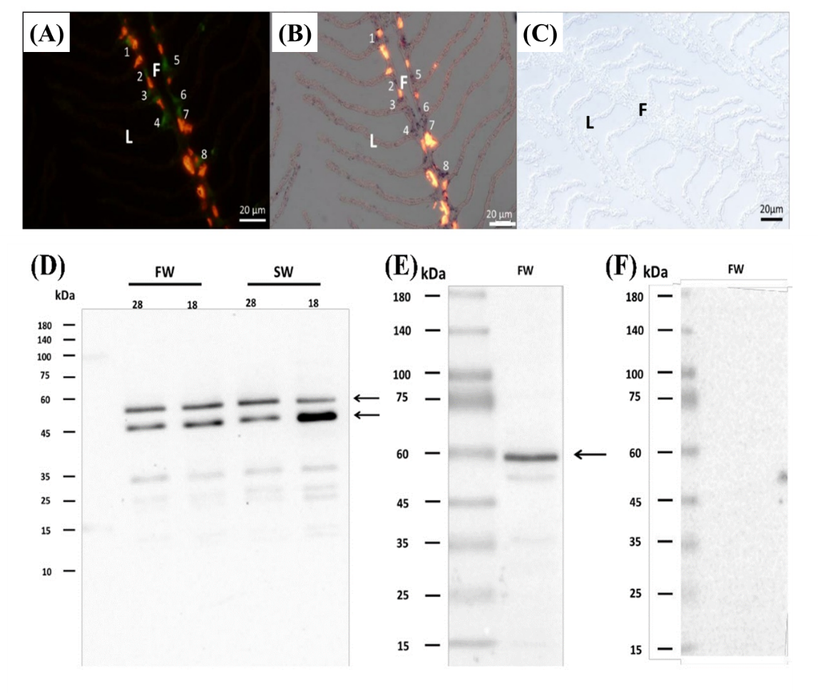

Supplementary Figure 1. Validation of the glucose transporter 1 (GLUT1) polyclonal antibody (Abcam, ab128033). Serial cryosectioning of the SW milkfish gill showed identical labeling location (number 1-8) of the GLUT1 antibody and Ccglut1 probe signals. (A) Double immunofluorescence staining of GLUT1 (green labeling with numbers) and Na⁺, K⁺-ATPase (NKA; red labeling). (B) In situ hybridization of Ccglut1 counterstained by the NKA antibody. (C) Negative control. (D) The immunoblot of GLUT1 with gill crude homogenates of FW and SW milkfish showed two major immunoreactive bands with the molecular mass at 55 kDa and 45 kDa (arrowheads), respectively. (E) The immunoblot of GLUT1 with gill membrane fraction showed a single major immunoreactive band with a molecular mass at 55 kDa (arrowhead). (F) The negative control of immunoblot with gill crude homogenates of FW milkfish using bovine serum albumin to replace the GLUT1 antibody showed no immunoreactive band. F, filament; L, lamella; FW, fresh water; SW, seawater.

