Supplementary Material

Supplementary Figures
Supplementary Figure 1. Correlation plots between mean cortical thickness of regions of interest and clinical characteristics in dystonia patients.
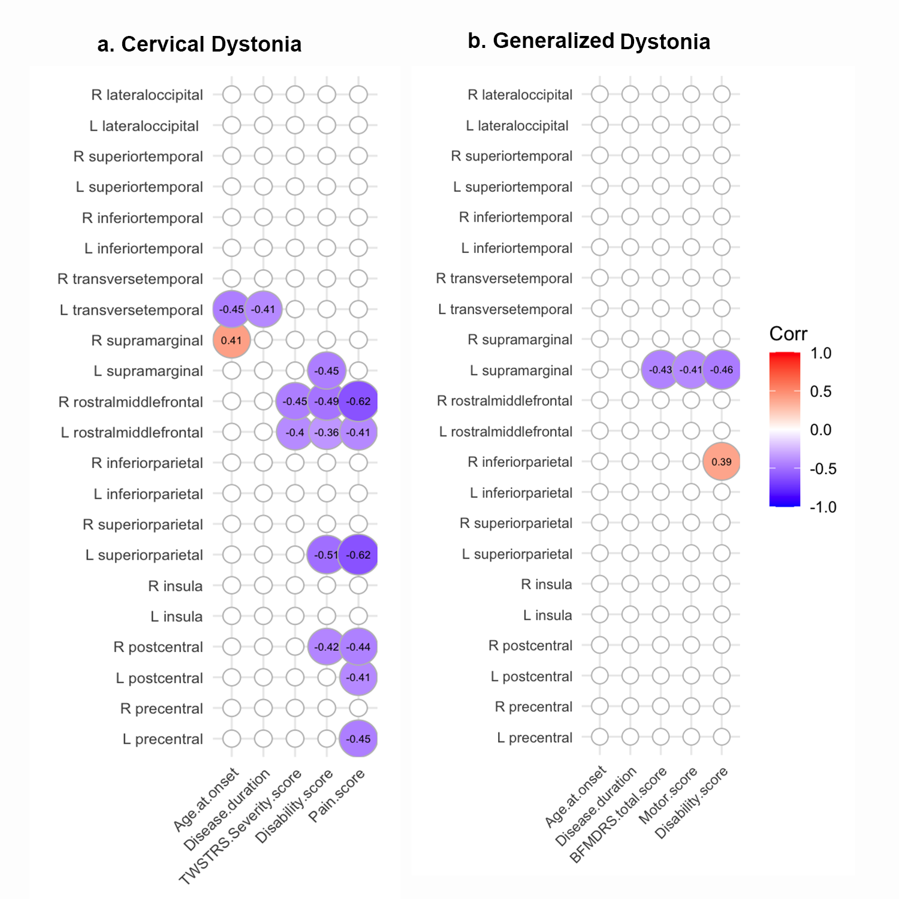

The mean values were extracted from regions of interest (ROIs) which mainly overlapped clusters with significant differences from previous vertex-wise comparisons, based on Desikan-Killiany Atlas (DK40). Cortical thickness of ROIs were correlated with patients’ clinical characteristics including age at onset, disease duration, and scores of rating scales. Significant statistical threshold was set at P<0.0025 after multiple comparisons correction, and Pearson correlation coefficients marked in the circles were present under a threshold of P<0.05 (trend level). BFMDRS, Burke-Fahn-Marsden Dystonia Rating Scale; TWSTRS, Toronto Western Spasmodic Torticollis Rating Scale.

Supplementary Tables
Supplementary Table 1. Cortical thickness alterations in dystonia patients.
a. Increased cortical thickness in CD patients compared to HC.
MNI coordinates
(maximum vertex, mm)
Cluster no. | Cluster size (vertices) | Cluster-wise P | x | y | z | T-Value (maximum vertex) | Overlap of atlas region
1 | 1000 | <0.001 | -9 | -49 | 32 | 11.55 | L lingual
2 | 630 | <0.001 | -10 | -59 | 45 | 11.04 | L precuneus
3 | 1397 | <0.001 | -57 | 25 | 65 | 8.30 | L postcentral
4 | 1527 | 0.001 | -11 | 58 | 21 | 7.75 | L pericalcarine, lateraloccipital
5 | 4275 | <0.001 | -19 | -36 | 88 | 7.55 | L superiorparietal
6 | 782 | <0.001 | -6 | 82 | 49 | 6.63 | L superiorfrontal
6 | 1779 | <0.001 | -21 | 86 | 47 | 6.97 | L rostralmiddlefrontal
7 | 891 | <0.001 | 4 | -51 | 47 | 9.44 | R pericalcarine, lateraloccipital
8 | 891 | <0.001 | 1 | -51 | 39 | 9.29 | R lingual
9 | 1006 | <0.001 | 7 | -22 | 93 | 9.09 | R precuneus
10 | 4528 | <0.001 | 30 | -13 | 87 | 7.42 | R superiorparietal
11 | 498 | <0.001 | 7 | 64 | 19 | 8.23 | R laterlorbitofrontal
12 | 1007 | 0.001 | 21 | 76 | 40 | 7.13 | R rostralmiddlefrontal
13 | 1580 | <0.001 | 56 | 23 | 49 | 6.10 | R postcentral

b. Decreased cortical thickness in CD patients compared to HC.
MNI coordinates
(maximum vertex, mm)
Cluster no. | Cluster size (vertices) | Cluster-wise P | x | y | z | T-Value (maximum vertex) | Overlap of atlas region
1 | 4613 | <0.001 | -38 | 8 | 45 | 8.29 | L insula, transversetemporal, superiortemporal
2 | 1663 | <0.001 | -3 | 9 | 67 | 7.93 | L posteriorcingulate, isthmuscingulate
3 | 848 | 0.002 | -43 | -23 | 56 | 5.78 | L inferiorparietal
4 | 925 | 0.001 | -30 | 27 | 9 | 6.25 | L entorhinal
5 | 776 | 0.006 | -36 | -26 | 31 | 5.17 | L fusiform
6 | 883 | <0.001 | 16 | 31 | 10 | 9.18 | R entorhinal
7 | 3729 | <0.001 | 33 | 31 | 20 | 8.82 | R insula, transversetemporal, superiortemporal
8 | 1867 | <0.001 | 3 | 12 | 68 | 7.30 | R posteriorcingulate, isthmuscingulate
9 | 1172 | <0.001 | 20 | 3 | 95 | 6.41 | R precentral
10 | 1072 | 0.001 | 27 | -9 | 18 | 6.14 | R fusiform

c. Increased cortical thickness in GD patients compared to HC.
MNI coordinates
(maximum vertex, mm)
Cluster no. | Cluster size (vertices) | Cluster-wise P | x | y | z | T-Value (maximum vertex) | Overlap of atlas region
1 | 1497 | <0.001 | -11 | -50 | 19 | 9.64 | L pericalcarine, lateraloccipital
2 | 981 | <0.001 | -16 | -41 | 13 | 8.77 | L lingual
3 | 4304 | <0.001 | -18 | -37 | 70 | 7.90 | L superiorparietal
4 | 1009 | 0.001 | -15 | 70 | 9 | 6.94 | L medialorbitofrontal
5 | 1363 | <0.001 | -63 | 29 | 56 | 6.05 | L postcentral
6 | 741 | <0.001 | -6 | 95 | 35 | 4.82 | L superiorfrontal
7 | 1482 | <0.001 | -25 | 88 | 50 | 4.78 | L rostralmiddlefrontal
8 | 890 | <0.001 | 5 | -44 | 32 | 10.86 | R pericalcarine, lateraloccipital
9 | 890 | <0.001 | 3 | -29 | 15 | 8.35 | R lingual
10 | 1062 | <0.001 | 8 | 78 | 2 | 9.54 | R medialorbitofrontal
11 | 4529 | <0.001 | 21 | -13 | 69 | 7.50 | R superiorparietal
12 | 1500 | <0.001 | 51 | 20 | 60 | 5.22 | R postcentral
13 | 1078 | <0.001 | 9 | -18 | 79 | 7.63 | L precuneus

d. Decreased cortical thickness in GD patients compared to HC.
MNI coordinates
(maximum vertex, mm)
Cluster no. | Cluster size (vertices) | Cluster-wise P | x | y | z | T-Value (maximum vertex) | Overlap of atlas region
1 | 1660 | <0.001 | -5 | 21 | 51 | 8.95 | L posteriorcingulate, isthmuscingulate
2 | 4483 | <0.001 | -38 | 41 | 18 | 7.92 | L insula, transversetemporal, superiortemporal
3 | 1834 | <0.001 | -36 | 15 | 37 | 5.8 | L supramarginal
4 | 934 | 0.001 | -32 | 36 | -6 | 6.54 | L entorhinal
5 | 891 | 0.003 | -27 | 11 | 85 | 5.79 | L precentral
6 | 832 | 0.002 | -50 | -14 | 37 | 4.57 | L inferiorparietal
7 | 8729 | <0.001 | 24 | 45 | -7 | 9.36 | R entorhinal
8 | 1194 | <0.001 | 32 | -2 | 0 | 9.01 | R fusiform
9 | 1869 | <0.001 | 3 | 22 | 54 | 7.97 | R posteriorcingulate, isthmuscingulate
10 | 1172 | <0.001 | 25 | 13 | 81 | 7.06 | R precentral
11 | 3686 | <0.001 | 35 | 41 | 11 | 7.44 | R insular, transversetemporal, superiortemporal
12 | 2037 | <0.001 | 34 | 12 | 26 | 7.40 | R supramarginal
Results of maximum vertices coordinates, T values, cluster sizes, and overlapped atlas regions. All results are considered significant at P<0.005 at cluster level (3 group comparisons for each hemisphere, 0.005 < 0.05/6), corrected for multiple comparisons with Family Wise Error (FWE). Coordinates are presented on standard MNI152 template (1.5mm*1.5mm*1.5mm). The clusters are listed in a random order. CD, cervical dystonia; GD, generalized dystonia; HC, healthy controls.

Supplementary Table 2. Correlations between mean cortical thickness of regions of interest and clinical characteristics in dystonia patients (P-value matrix).
a. Cervical dystonia
 | Age at onset | Disease duration | TWSTRS Severity score | Disability score | Pain score
L precentral | 0.330 | 0.197 | 0.958 | 0.421 | 0.013
R precentral | 0.212 | 0.086 | 0.942 | 0.400 | 0.118
L postcentral | 0.080 | 0.214 | 0.683 | 0.672 | 0.025
R postcentral | 0.596 | 0.233 | 0.186 | 0.022 | 0.014
L insula | 0.224 | 0.571 | 0.203 | 0.265 | 0.642
R insula | 0.262 | 0.069 | 0.283 | 0.338 | 0.797
L superiorparietal | 0.733 | 0.347 | 0.050 | 0.004 | <0.001
R superiorparietal | 0.614 | 0.434 | 0.386 | 0.124 | 0.227
L inferiorparietal | 0.237 | 0.438 | 0.125 | 0.102 | 0.473
R inferiorparietal | 0.533 | 0.719 | 0.153 | 0.245 | 0.803
L rostralmiddlefrontal | 0.359 | 0.903 | 0.027 | 0.049 | 0.026
R rostralmiddlefrontal | 0.637 | 0.687 | 0.012 | 0.006 | 0.001
L supramarginal | 0.174 | 0.780 | 0.073 | 0.012 | 0.198
R supramarginal | 0.025 | 0.756 | 0.056 | 0.248 | 0.535
L transversetemporal | 0.013 | 0.024 | 0.792 | 0.474 | 0.344
R transversetemporal | 0.501 | 0.154 | 0.724 | 0.612 | 0.640
L inferiortemporal | 0.976 | 0.339 | 0.773 | 0.519 | 0.806
R inferiortemporal | 0.989 | 0.824 | 0.958 | 0.913 | 0.268
L superiortemporal | 0.908 | 0.567 | 0.200 | 0.135 | 0.355
R superiortemporal | 0.905 | 0.889 | 0.781 | 0.787 | 0.990
L lateraloccipital | 0.570 | 0.892 | 0.167 | 0.166 | 0.074
R lateraloccipital | 0.244 | 0.626 | 0.754 | 0.890 | 0.933

b. Generalized dystonia
 | Age at onset | Disease duration | BFMDRS total score | Motor score | Disability score
L precentral | 0.553 | 0.781 | 0.681 | 0.587 | 0.769
R precentral | 0.517 | 0.919 | 0.337 | 0.279 | 0.764
L postcentral | 0.100 | 0.949 | 0.253 | 0.204 | 0.508
R postcentral | 0.313 | 0.569 | 0.704 | 0.576 | 0.836
L insula | 0.585 | 0.970 | 0.918 | 0.971 | 0.730
R insula | 0.084 | 0.690 | 0.100 | 0.062 | 0.166
L superiorparietal | 0.869 | 0.886 | 0.219 | 0.213 | 0.130
R superiorparietal | 0.638 | 0.573 | 0.452 | 0.488 | 0.416
L inferiorparietal | 0.810 | 0.429 | 0.654 | 0.517 | 0.772
R inferiorparietal | 0.843 | 0.766 | 0.147 | 0.157 | 0.049
L rostralmiddlefrontal | 0.288 | 0.153 | 0.773 | 0.800 | 0.641
R rostralmiddlefrontal | 0.287 | 0.179 | 0.911 | 0.925 | 0.770
L supramarginal | 0.472 | 0.633 | 0.026 | 0.037 | 0.019
R supramarginal | 0.244 | 0.866 | 0.958 | 0.972 | 0.469
L transversetemporal | 0.360 | 0.887 | 0.651 | 0.662 | 0.785
R transversetemporal | 0.189 | 0.946 | 0.720 | 0.628 | 0.715
L inferiortemporal | 0.370 | 0.237 | 0.998 | 0.990 | 0.861
R inferiortemporal | 0.471 | 0.559 | 0.467 | 0.473 | 0.854
L superiortemporal | 0.677 | 0.286 | 0.209 | 0.268 | 0.093
R superiortemporal | 0.542 | 0.968 | 0.897 | 0.953 | 0.567
L lateraloccipital | 0.172 | 0.649 | 0.268 | 0.287 | 0.140
R lateraloccipital | 0.197 | 0.574 | 0.272 | 0.277 | 0.159
Statistical P-value results in Pearson correlation analysis of cortical thickness and clinical characteristics.

