Supplemental Materials

Supplemental Figure 1: Explorys web-based search interface
Supplemental Figure 2: Odds ratio of various cancer for GLP1Ra vs sulfonylureas and GLP1Ra vs metformin
Supplemental Figure 3: Odds ratio of various cancer for GLP1Ra vs metformin developed within 10 years and 5 years after starting antidiabetic agents
Supplemental Figure 4: Odds ratio of various cancer for liraglutide and exenatide vs metformin
Supplemental Table 1: Cancer and control events for GLP1Ra vs control drugs
Supplemental Table 2: Change of unadjusted odds ratio with different exposure length of antidiabetic agents

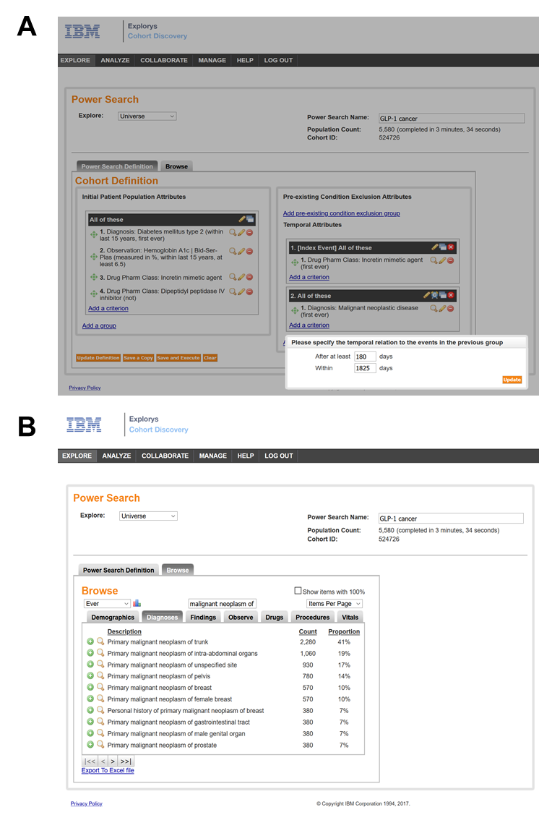
Supplemental Figure 1| Explorys web-based search interface. (A) In the “Initial Patient Population Attributes” section, characteristics of cohorts were entered. In this case, diabetic patients were identified with both a SNOMED Clinical Term “Diabetes mellitus type 2” and a Hemoglobin A1c at least 6.5%. In addition, the cohorts were required to have “incretin memetic agents” but not “Dipeptidyl peptidase IV inhibitor”. In the “Temporal Attributes” section, the first-ever use of incretin memetic agent was set as the index event. Any malignant neoplastic disease occurring after 180 days (6 months) and within 1825 days (5 years) of starting GLP1Ra was recorded. (B) In the browse tab, the characteristics of the cohort can be viewed in detail. SNOMED, Systematized Nomenclature of Medicine.

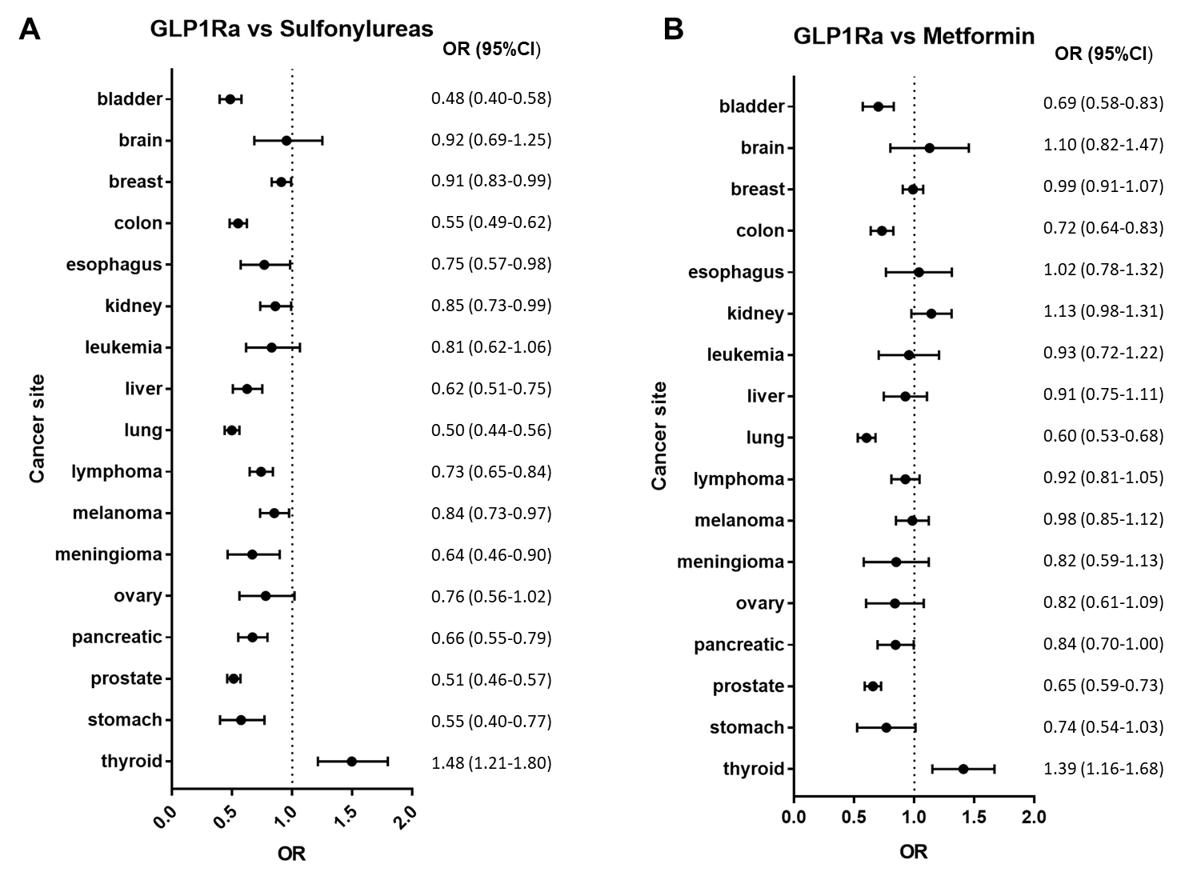
Supplemental Figure 2| Unadjusted odds ratio of various cancer for GLP1Ra vs sulfonylureas and GLP1Ra vs metformin. (A) When GLP1Ra was compared with sulfonylureas, similar to metformin (B), significantly lower risk for colon, lung, and prostate cancer was observed within 5 years of starting antidiabetic agents. The risk of thyroid cancer was significantly higher in GLP1Ra users, regardless comparing with metformin or sulfonylureas. OR, odds ratio.

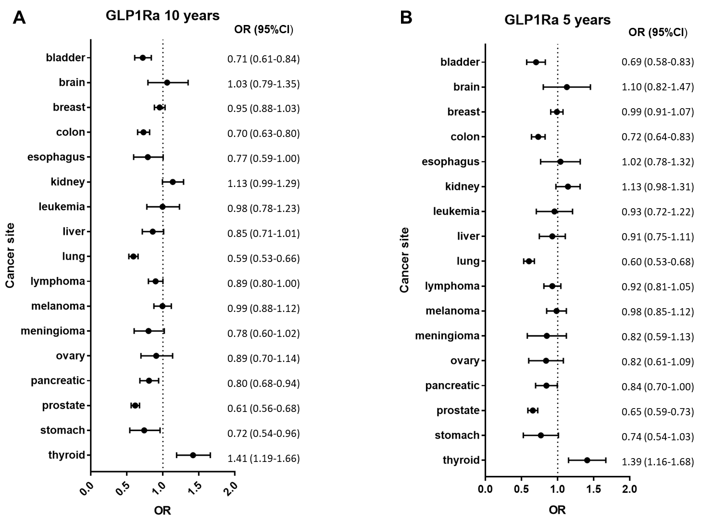
Supplemental Figure 3| Unadjusted odds ratio of various cancer for GLP1Ra vs metformin developed within 10 years and 5 years after starting antidiabetic agents. (A) When cancer developed within 10 years after starting antidiabetic agents was included, the odds ratios were similar to that only within 5 years were included (B).

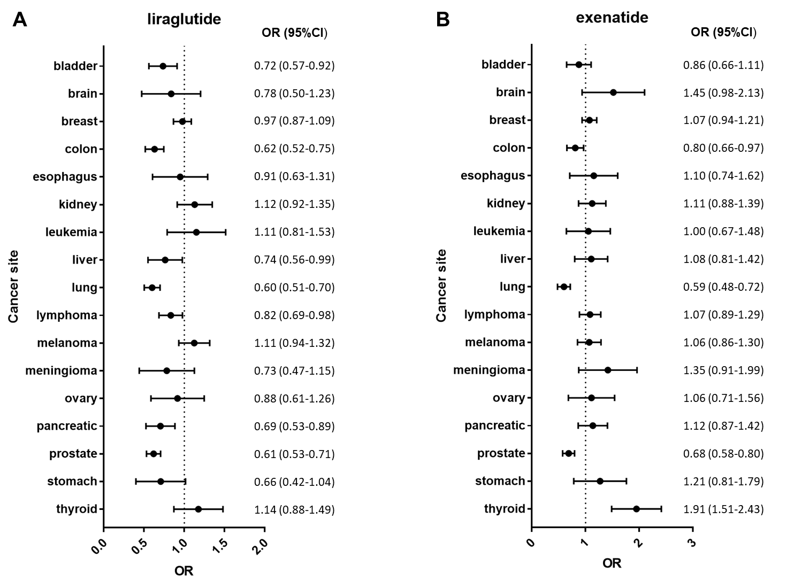
Supplemental Figure 4| Unadjusted odds ratio of various cancer for liraglutide and exenatide vs metformin. Both liraglutide (A) and exenatide (B) were associated with significantly lower risk for colon, lung and prostate cancer within 5 years of starting antidiabetic agents. Exenatide (B) was associated with significantly higher risk of thyroid cancer; liraglutide (A) was associated with higher risk of thyroid cancer, although it did not reach statistical significance.

Supplemental Table 1: Cancer and control events for GLP1Ra vs control drugs
GLP1Ra | Gender | Prostate cancer | Lung cancer | Colon cancer | Thyroid cancer | Back pain | Chest pain
Exenatide | Male | 53 | 23 | 25 | 59 | 221 | 198
Exenatide | Female | 0 | 23 | 17 | 159 | 474 | 399
Liraglutide | Male | 15 | 8 | 12 | 38 | 165 | 111
Liraglutide | Female | 0 | 11 | 13 | 66 | 284 | 157
Dulaglutide | Male | 5 | 5 | 4 | 5 | 71 | 48
Dulaglutide | Female | 0 | 0 | 4 | 10 | 97 | 54
Albiglutide | Male | 1 | 1 | 0 | 1 | 43 | 13
Albiglutide | Female | 0 | 0 | 2 | 1 | 53 | 5
Control
Metformin | Male | 66 | 50 | 38 | 8 | 285 | 276
Metformin | Female | 0 | 32 | 19 | 20 | 472 | 374

Reported cancer events number and control events number were derived from the FDA FARES database from 1/1/2005 to 7/1/2019. Methods of OR calculation: two levels of control were used for the comparative analysis of event rates. The count of events of interest (e.g., pancreatic cancer) in a test drug (e.g., exenatide) were compared to control drugs and to averaged control events (events for which there was the presumption of no drug-event relationship) using 2 x 2 tables. The premise on which the 2-level control is based is that under the null hypothesis of no elevated event rate for the test drugs, the odds ratio (OR) in the 2 x 2 table should be 1. Fisher’s exact test was used to test the null hypothesis that the OR was equal to 1.
Supplemental Table 2: change of unadjusted odds ratio with different exposure length of antidiabetic agents
Cancer location | <1 year  OR (95%CI) | 1-2 years  OR (95%CI) | 2-3 years  OR (95%CI) | 3-4 years  OR (95%CI) | 4-5 years  OR (95%CI)
Prostate | 0.83 (0.65-1.06) | 0.77 (0.59-1.00) | 0.66 (0.50-0.89) | 0.57 (0.41-0.78) | 0.61 (0.45-0.85)
Lung | 0.75 (0.60-0.95) | 0.54 (0.42-0.71) | 0.49 (0.36-0.68) | 0.47 (0.33-0.68) | 0.44 (0.28-0.68)
Colon | 0.83 (0.62-1.11) | 0.84 (0.63-1.12) | 0.72 (0.52-0.99) | 0.71 (0.49-1.02) | 0.55 (0.35-0.86)
Thyroid | 1.55 (0.96-2.52) | 1.51 (0.93-2.44) | 1.02 (0.53-1.96) | 1.11 (0.58-2.13) | 2.11 (1.32-3.40)
Bladder | 0.73 (0.46-1.16) | 1.08 (0.74-1.58) | 0.84 (0.53-1.32) | 0.53 (0.28-1.00) | 1.10 (0.70-1.74)
Pancreatic | 0.77 (0.56-1.07) | 1.01 (0.72-1.40) | 0.71 (0.45-1.11) | 0.48 (0.26-0.91) | 0.70 (0.37-1.33)

