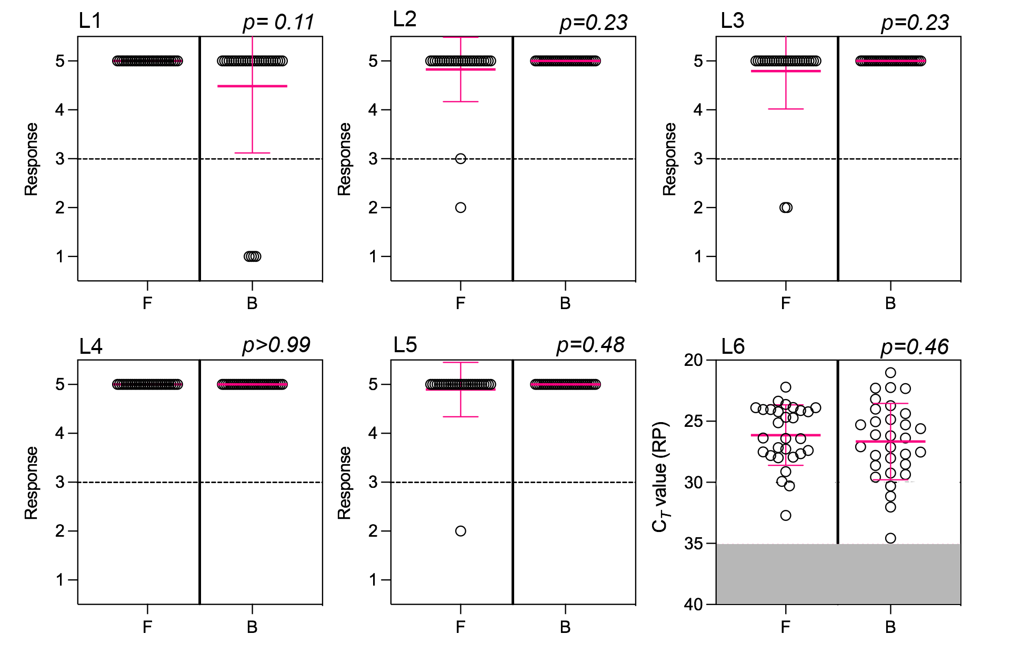

Additional file 5: Figure S5 Responses to laboratory survey for at-home collection kit. Mean and standard deviation are marked in pink. P-values are shown for questions that could be assessed using Mann-Whitney. For L6, samples outside of the unacceptable Ct range (Ct > 35) is highlighted in gray.

