Supplementary Material

Supplementary Figures and Tables

Supplementary Figures

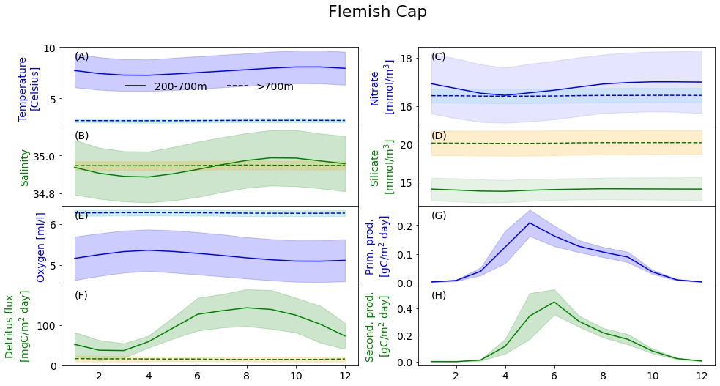
Supplementary Figure 1. The computed annual cycle of temperature, salinity, nitrate, silicate, oxygen, detritus flux to the bottom Flemish Cap. The solid lines are in areas with depth between 200 and 700 meters and the dashed lines in areas with bottom depth greater than 700m. (A) temperature, (B) salinity, (C) nitrate, (D) silicate, (E) oxygen, (F) detritus flux. The shading shows one standard deviation of the variability between years. (G) Primary and (H) secondary (green) production averaged over areas deeper than 200 meters.
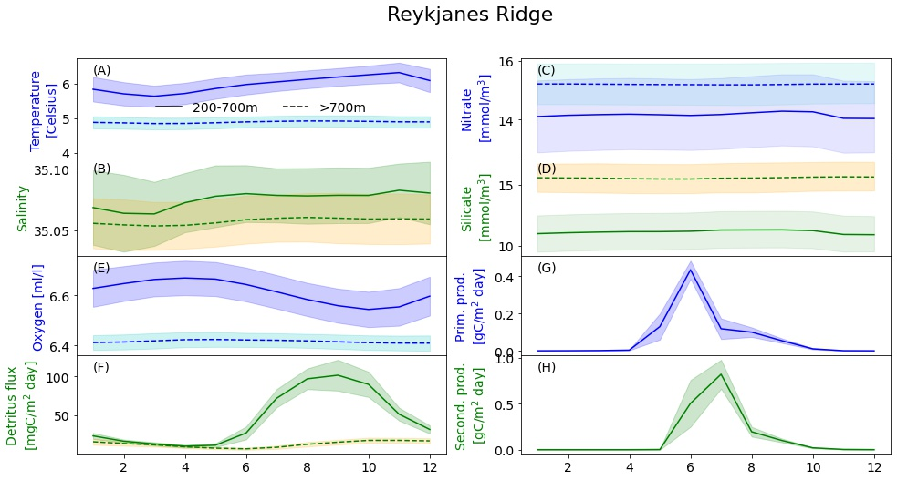
Supplementary Figure 2. The computed annual cycle of temperature, salinity, nitrate, silicate, oxygen, detritus flux to the bottom and primary and secondary production at the Reykjanes Ridge. The solid lines are in areas with depth between 200 and 700 meters and the dashed lines in areas with bottom depth greater than 700m. (A) temperature, (B) salinity, (C) nitrate, (D) silicate, (E) oxygen, (F) detritus flux. The shading shows one standard deviation of the variability between years. (G) Primary and (H) secondary (green) production averaged over areas deeper than 200 meters.

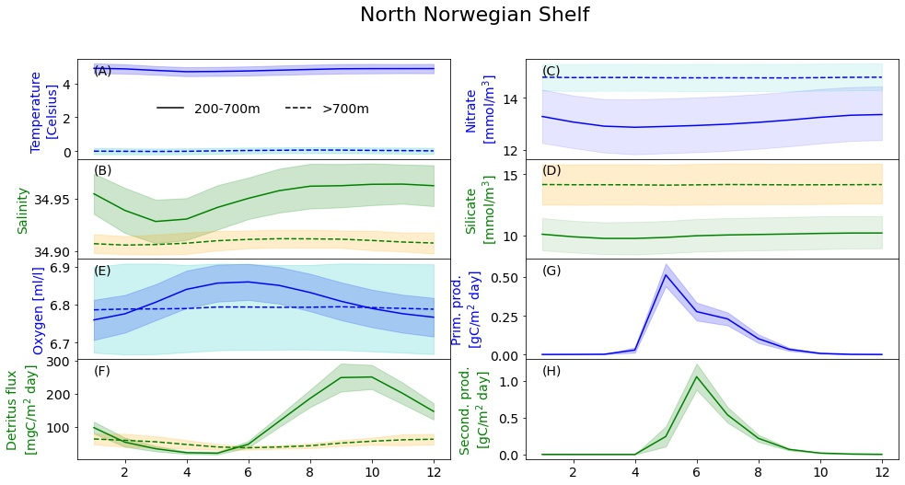
Supplementary Figure 3. The computed annual cycle of temperature, salinity, nitrate, silicate, oxygen, detritus flux to the bottom and primary and secondary production at the North Norwegian Shelf. The solid lines are in areas with depth between 200 and 700 meters and the dashed lines in areas with bottom depth greater than 700m. (A) temperature, (B) salinity, (C) nitrate, (D) silicate, (E) oxygen, (F) detritus flux. The shading shows one standard deviation of the variability between years. (G) Primary and (H) secondary (green) production averaged over areas deeper than 200 meters.
.

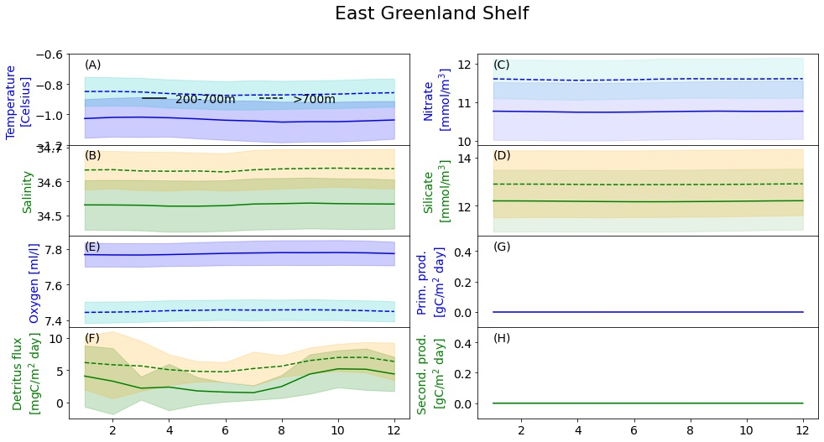
Supplementary Figure 4. The computed annual cycle of temperature, salinity, nitrate, silicate, oxygen, detritus flux to the bottom and primary and secondary production at the East Greenland Shelf. The solid lines are in areas with depth between 200 and 700 meters and the dashed lines in areas with bottom depth greater than 700m. (A) temperature, (B) salinity, (C) nitrate, (D) silicate, (E) oxygen, (F) detritus flux. The shading shows one standard deviation of the variability between years. (G) Primary and (H) secondary (green) production averaged over areas deeper than 200 meters.

Supplementary Tables
Supplementary Table 1. Validation statistics at the Flemish Cap for temperature [ºC], salinity, oxygen[ml/l], nitrate[mmol/m³], phosphate[mmol/m³], and silicate [mmol/m³].
Variable/Data set | Number of obs | Mean obs. | Mean model | RMSE | bias
Temperature/GLODAP | 68 | 2.48 | 3.39 | 3.48 | 0.91
Temperature/WOD | 1170 | 2.47 | 3.43 | 3.25 | 0.96
Salinity/GLODAP | 68 | 34.51 | 34.56 | 0.32 | 0.05
Salinity/WOD | 1171 | 34.27 | 34.43 | 0.48 | 0.15
Oxygen/GLODAP | 64 | 6.30 | 6.53 | 1.15 | 0.23
Oxygen/WOD | 357 | 6.50 | 6.80 | 1.09 | 0.30
Nitrate /GLODAP | 47 | 14.95 | 14.64 | 1.96 | -0.32
Phosphate/GLODAP | 52 | 1.07 | 0.97 | 0.16 | -0.10
Silicate/GLODAP | 59 | 11.09 | 14.13 | 3.74 | 3.04

Supplementary Table 2. Validation statistics at the Reykjanes ridge for temperature [ºC] and salinity.
Variable (Data set) | Number of obs | Mean obs. | Mean model | RMSE | bias
temperature/WOD (WOD) | 52 | 6.40 | 5.80 | 0.99 | -0.60
salinity/WOD | 52 | 35.11 | 35.09 | 0.08 | -0.03

Supplementary Table 3. Validation statistics at the North Norwegian Shelf for temperature [ºC],salinity, oxygen[ml/l], nitrate[mmol/m³], phosphate[mmol/m³], and silicate [mmol/m³].
Variable (Data set) | Number of obs | Mean obs. | Mean model | RMSE | bias
Temperature (WOD) | 2899 | 3.96 | 2.78 | 1.79 | -1.18
Salinity (WOD) | 2852 | 35.00 | 34.83 | 0.24 | -0.18
Oxygen (NMDC) | 26 | 6.94 | 7.29 | 0.41 | 0.36
Nitrate (NMDC) | 559 | 11.68 | 13.2 | 2.42 | 1.52
Phosphate (NMDC) | 526 | 0.84 | 0.88 | 0.12 | 0.04
Silicate (NMDC) | 563 | 5.81 | 10.91 | 5.41 | 5.10

Supplementary Table 4. Summary of nitrate variability at the four sponge habitats in waters with bottom depth 200-700m: period mean, decadal trend, the maximum change in the monthly mean over a period of 12 months, 36 months and 10 years, and the temporal mean of the spatial standard deviation.

 | Flemish Cap | Reykjanes Ridge | North Norwegian Shelf | East Greenland Shelf
Period mean [mmol/m3] | 16.815 | 14.201 | 13.131 | 10.786
Max annual change [mmol/m³] | 2.967 | 0.453 | 0.993 | 0.484
Max 3-year change [mmol/m³] | 4.034 | 0.649 | 1.398 | 0.814
Max 10-year change [mmol/m³] | 4.635 | 1.418 | 1.918 | 1.170
Spatial standard deviation | 1.966 | 0.073 | 0.505 | 0.322

Supplementary Table 5. Summary of nitrate variability at the four sponge habitats in areas with bottom deeper than 700m: period mean, decadal trend, the maximum change in the monthly mean over a period of 12 months, 36 months and 10 years, and the temporal mean of the spatial standard deviation.
 | Flemish Cap | Reykjanes Ridge | North Norwegian Shelf | East Greenland Shelf
Period mean [mmol/m3] | 16.447 | 15.227 | 14.794 | 11.613
Max annual change [mmol/m³] | 0.372 | 0.266 | 0.468 | 0.474
Max 3-year change [mmol/m³] | 0.634 | 0.395 | 0.818 | 0.776
Max 10-year change [mmol/m³] | 0.871 | 0.716 | 1.394 | 0.975
Spatial standard deviation | 1.437 | 1.150 | 1.310 | 0.082

Supplementary Table 6. Summary of silicate variability at the four sponge habitats in waters with bottom depth 200-700m: period mean, decadal trend, the maximum change in the monthly mean over a period of 12 months, 36 months and 10 years, and the temporal mean of the spatial standard deviation.

 | Flemish Cap | Reykjanes Ridge | North Norwegian Shelf | East Greenland Shelf
Period mean [mmol/m³] | 14.006 | 11.193 | 10.062 | 12.236
Max annual change [mmol/m³] | 2.247 | 0.776 | 1.008 | 0.397
Max 3-year change [mmol/m³] | 3.661 | 1.008 | 1.537 | 0.678
Max 10-year change [mmol/m³] | 4.064 | 1.979 | 2.038 | 1.413
Spatial standard deviation | 1.821 | 0.105 | 0.748 | 0.202

Supplementary Table 7. Summary of silicate variability at the four sponge habitats in areas with bottom deeper than 700m: period mean, decadal trend, the maximum change in the monthly mean over a period of 12 months, 36 months and 10 years, and the temporal mean of the spatial standard deviation.

 | Flemish Cap | Reykjanes Ridge | North Norwegian Shelf | East Greenland Shelf
Period mean [mmol/m³] | 20.163 | 15.615 | 14.186 | 12.946
Max annual change [mmol/m³] | 1.108 | 0.916 | 0.678 | 0.519
Max 3-year change [mmol/m³] | 1.770 | 1.108 | 0.862 | 0.676
Max 10-year change [mmol/m³] | 4.023 | 2.029 | 1.745 | 1.399
Spatial standard deviation | 4.620 | 4.453 | 1.623 | 0.077

Supplementary Table 8. Summary of oxygen variability at the four sponge habitats in waters with bottom depth 200-700m: period mean, decadal trend, the maximum change in the monthly mean over a period of 12 months, 36 months and 10 years, and the temporal mean of the spatial standard deviation.

 | Flemish Cap | Reykjanes Ridge | North Norwegian Shelf | East Greenland Shelf
Period mean [ml/l] | 5.214 | 6.614 | 6.810 | 7.774
Decadal trend [ml/l/decade] | 0.167 | -0.015 | 0.013 | -0.002
Max annual change [ml/l] | 1.540 | 0.231 | 0.165 | 0.145
Max 3-year change [ml/l] | 1.979 | 0.305 | 0.237 | 0.206
Max 10-year change [ml/l] | 1.979 | 0.350 | 0.288 | 0.276
Spatial standard deviation | 0.565 | 0.041 | 0.125 | 0.11

Supplementary Table 9. Summary of oxygen variability at the four sponge habitats in areas with bottom deeper than 700m: period mean, decadal trend, the maximum change in the monthly mean over a period of 12 months, 36 months and 10 years, and the temporal mean of the spatial standard deviation.

 | Flemish Cap | Reykjanes Ridge | North Norwegian Shelf | East Greenland Shelf
Period mean [ml/l] | 6.268 | 6.416 | 6.792 | 7.454
Decadal trend [ml/l/decade] | 3.503e-04 | -0.006 | -0.007 | 0.003
Max annual change [ml/l] | 0.099 | 0.053 | 0.172 | 0.121
Max 3-year change [ml/l] | 0.165 | 0.086 | 0.303 | 0.193
Max 10-year change [ml/l] | 0.274 | 0.146 | 0.488 | 0.220
Spatial standard deviation | 0.375 | 0.218 | 0.328 | 0.031

Supplementary Table 10. Summary of detritus flux variability at the four sponge habitats in waters with bottom depth 200-700m: period mean, decadal trend, the maximum change in the monthly mean over a period of 12 months, 36 months and 10 years, and the temporal mean of the spatial standard deviation.

 | Flemish Cap | Reykjanes Ridge | North Norwegian Shelf | East Greenland Shelf
Period mean [mg C/m² day] | 93.091 | 45.467 | 118.648 | 3.208
Decadal trend [mg C/m² day/decade] | 3.987 | -0.085 | 2.365 | 0.047
Max annual change [mg C/m² day] | 298.266 | 181.166 | 335.737 | 35.831
Max 3-year change [mg C/m² day] | 353.458 | 182.042 | 337.143 | 35.969
Max 10-year change [mg C/m² day] | 354.485 | 182.042 | 338.352 | 36.195
Spatial standard deviation | 89.437 | 17.836 | 57.311 | 3.276

Supplementary Table 11. Summary of detritus flux variability at the four sponge habitats in areas with bottom deeper than 700m: period mean, decadal trend, the maximum change in the monthly mean over a period of 12 months, 36 months and 10 years, and the temporal mean of the spatial standard deviation.

 | Flemish Cap | Reykjanes Ridge | North Norwegian Shelf | East Greenland Shelf
Period mean [mg C/m² day] | 14.731 | 13.270 | 51.498 | 5.802
Decadal trend [mg C/m² day/decade] | 1.538 | -0.389 | 2.650 | 0.316
Max annual change [mg C/m² day] | 17.191 | 23.667 | 139.384 | 37.417
Max 3-year change [mg C/m² day] | 24.693 | 24.904 | 139.384 | 38.245
Max 10-year change [mg C/m² day] | 25.780 | 25.963 | 141.472 | 39.562
Spatial standard deviation | 16.927 | 8.968 | 29.714 | 0.571

