Supplementary material:
Supplementary Table 1. Foraging trip features of the 80 Antarctic petrel trips (from 37 individuals). Data are from the chick-rearing period (Jan/Feb 2016) at Svarthamaren, Dronning Maud Land (see Methods for details).

Ring | Date_Deployment | Trip ID | Start | End | Nhours | DistanceTravelled | MaxRange | Farthest_Lon | Farthest_Lat | d13C_Plasma | d13C_Cells | d15N_Plasma | d15N_Cells | %Crustacean | %Fish
4165502 | 18.01.2016 | 1 | 21.01.2016 | 24.01.2016 | 87 | 2023 | 628 | 12.33 | -66.85
4165502 | 18.01.2016 | 2 | 25.01.2016 | 29.01.2016 | 114 | 1828 | 590 | 11.72 | -67.11
4165502 | 18.01.2016 | 3 | 29.01.2016 | 02.03.2016 |  |  | 599 | 14.44 | -67.57 | -26.44 | -26.37 | 9.46 | 9.34
4165836 | 18.01.2016 | 1 | 19.01.2016 | 22.01.2016 | 64 | 1717 | 667 | 5.88 | -65.91
4165836 | 18.01.2016 | 2 | 24.01.2016 | 29.01.2016 | 107 | 1888 | 491 | 4.86 | -67.48
4165836 | 18.01.2016 | 3 | 29.01.2016 | 02.01.2016 | 70 | 1783 | 492 | 6.5 | -67.5 | -27.17 | -26.46 | 9.1 | 9.28
4182402 | 18.01.2016 | 1 | 19.01.2016 | 23.01.2016 | 89 | 1970 | 597 | -7.56 | -68.67
4182402 | 18.01.2016 | 2 | 23.01.2016 | 31.01.2016 | 174 | 2291 | 419 | 4.5 | -68.13 | -27.06 | -26.39 | 8.77 | 9.21
4182618 | 18.01.2016 | 1 | 19.01.2016 | 24.01.2016 | 113 | 2333 | 686 | 7.49 | -65.79
4182618 | 18.01.2016 | 2 | 24.01.2016 | 29.01.2016 | 122 | 3020 | 908 | 23.87 | -66.99
4182618 | 18.01.2016 | 3 | 29.01.2016 | 02.02.2016 | 90 | 2334 | 699 | 17.84 | -67.4
4182618 | 18.01.2016 | 4 | 02.02.2016 | 02.07.2016 | 117 | 2123 | 575 | 13.49 | -67.6
4182619 | 18.01.2016 | 1 | 22.01.2016 | 25.01.2016 | 91 | 1890 | 492 | 9.55 | -67.74
4182619 | 18.01.2016 | 2 | 26.01.2016 | 29.01.2016 | 75 | 1601 | 575 | 11.43 | -67.21 | -26.80 | -26.30 | 9.33 | 9.41
4182634 | 19.01.2016 | 1 | 21.01.2016 | 25.01.2016 | 98 | 2434 | 625 | 3.27 | -66.32
4182634 | 19.01.2016 | 2 | 26.01.2016 | 30.01.2016 | 107 | 1914 | 485 | 6.44 | -67.56
4182634 | 19.01.2016 | 3 | 30.01.2016 | 02.02.2016 | 73 | 1702 | 464 | 4.53 | -67.73
4182635 | 19.01.2016 | 1 | 19.01.2016 | 23.01.2016 | 107 | 2231 | 627 | -3.2 | -67.08
4182635 | 19.01.2016 | 2 | 24.01.2016 | 30.01.2016 | 139 | 2225 | 491 | 6.05 | -67.49 | -27.01 | -26.21 | 8.55 | 9.02
4182637 | 19.01.2016 | 1 | 21.01.2016 | 26.01.2016 | 112 | 2438 | 656 | 10.92 | -66.37
4182637 | 19.01.2016 | 2 | 26.01.2016 | 31.01.2016 | 111 | 2347 | 638 | 12.15 | -66.72 | -26.61 | -26.30 | 8.87 | 9.32 | 50 | 50
4182638 | 19.01.2016 | 1 | 21.01.2016 | 24.01.2016 | 74 | 1334 | 409 | 5.28 | -68.21
4182638 | 19.01.2016 | 2 | 25.01.2016 | 29.01.2016 | 96 | 1258 | 396 | 6.88 | -68.38
4182638 | 19.01.2016 | 3 | 29.01.2016 | 02.01.2016 | 71 | 1384 | 395 | 5.6 | -68.35 | -25.76 | -25.91 | 11.06 | 9.68
4182639 | 19.01.2016 | 1 | 20.01.2016 | 23.01.2016 | 73 | 1579 | 540 | 3.06 | -67.1
4182639 | 19.01.2016 | 2 | 25.01.2016 | 29.01.2016 | 101 | 1547 | 524 | 11.87 | -67.79
4182639 | 19.01.2016 | 3 | 30.01.2016 | 02.01.2016 | 62 | 1229 | 452 | 10.78 | -68.31
4182642 | 19.01.2016 | 1 | 20.01.2016 | 26.01.2016 | 126 | 1896 | 390 | 5.76 | -68.4
4182643 | 19.01.2016 | 1 | 21.01.2016 | 25.01.2016 | 93 | 2039 | 725 | 16.55 | -66.76
4182643 | 19.01.2016 | 2 | 25.01.2016 | 29.01.2016 | 86 | 1948 | 689 | 15.58 | -66.89
4182644 | 19.01.2016 | 1 | 21.01.2016 | 25.01.2016 | 78 | 2188 | 770 | 15.73 | -66.09
4182644 | 19.01.2016 | 2 | 26.01.2016 | 30.01.2016 | 94 | 2402 | 669 | 14.73 | -66.91
4182644 | 19.01.2016 | 3 | 30.01.2016 | 02.02.2016 | 64 | 1990 | 690 | 14.78 | -66.7
4182645 | 19.01.2016 | 1 | 21.01.2016 | 25.01.2016 | 102 | 1636 | 573 | 8.31 | -66.86
4182645 | 19.01.2016 | 2 | 25.01.2016 | 29.01.2016 | 87 | 1700 | 554 | 12.56 | -67.62
4182645 | 19.01.2016 | 3 | 29.01.2016 | 02.01.2016 | 73 | 1826 | 606 | 11.88 | -66.98
4182647 | 19.01.2016 | 1 | 20.01.2016 | 23.01.2016 | 66 | 1611 | 679 | 5.15 | -65.8
4182647 | 19.01.2016 | 2 | 24.01.2016 | 28.01.2016 | 112 | 2322 | 584 | 11.12 | -67.07
4182647 | 19.01.2016 | 3 | 28.01.2016 | 02.01.2016 | 91 | 2444 | 712 | 18.51 | -67.46 | -26.65 | -26.17 | 9.54 | 9.45
4182649 | 19.01.2016 | 1 | 22.01.2016 | 26.01.2016 | 95 | 1763 | 558 | 9.19 | -67.08
4182649 | 19.01.2016 | 2 | 26.01.2016 | 02.01.2016 | 129 | 3833 | 1060 | -20.05 | -67.82
4182649 | 19.01.2016 | 3 | 02.01.2016 | 02.07.2016 | 158 | 4147 | 1016 | -15.49 | -66.4
4182650 | 19.01.2016 | 1 | 24.01.2016 | 27.01.2016 | 72 | 1188 | 483 | 6.68 | -67.58 | -26.98 | -26.17 | 8.95 | 9.32
4214701 | 19.01.2016 | 1 | 20.01.2016 | 24.01.2016 | 83 | 1952 | 566 | -3.06 | -67.67
4214702 | 19.01.2016 | 1 | 19.01.2016 | 26.01.2016 | 162 | 3757 | 1075 | -27.36 | -74.65
4214710 | 20.01.2016 | 1 | 24.01.2016 | 29.01.2016 | 124 | 2582 | 677 | -9.54 | -68.4 | -25.28 | -25.71 | 12.36 | 9.95
4214714 | 20.01.2016 | 1 | 21.01.2016 | 26.01.2016 | 117 | 1829 | 456 | 6.9 | -67.84
4214715 | 20.01.2016 | 1 | 20.01.2016 | 26.01.2016 | 133 | 2641 | 550 | 2.73 | -67.02
4214719 | 20.01.2016 | 1 | 25.01.2016 | 28.01.2016 | 79 | 2010 | 739 | -8.48 | -67.25
4214719 | 20.01.2016 | 2 | 29.01.2016 | 02.02.2016 | 86 | 1510 | 376 | -3.7 | -70.13 | -25.29 | -25.92 | 11.93 | 9.97 | 2 | 95
4214720 | 20.01.2016 | 1 | 22.01.2016 | 28.01.2016 | 131 | 2704 | 882 | -19.17 | -70.54
4214720 | 20.01.2016 | 2 | 28.01.2016 | 02.01.2016 | 98 | 2030 | 543 | -8.98 | -70.25 | -25.38 | -25.30 | 11.94 | 10.18 | 1 | 99
4214721 | 20.01.2016 | 1 | 21.01.2016 | 25.01.2016 | 79 | 1642 | 539 | -4.24 | -68.26
4214723 | 20.01.2016 | 1 | 24.01.2016 | 28.01.2016 | 107 | 2474 | 676 | 12.94 | -66.48
4214723 | 20.01.2016 | 2 | 28.01.2016 | 30.01.2016 | 58 | 1206 | 440 | 7.95 | -68.05
4214723 | 20.01.2016 | 3 | 30.01.2016 | 02.01.2016 | 43 | 924 | 346 | 6.04 | -68.79
4214723 | 20.01.2016 | 4 | 02.01.2016 | 02.04.2016 | 61 | 856 | 279 | 4.08 | -69.41 | -26.01 | -26.30 | 10.26 | 9.57
4214727 | 21.01.2016 | 1 | 22.01.2016 | 26.01.2016 | 94 | 2887 | 734 | 12.52 | -65.85
4214727 | 21.01.2016 | 2 | 27.01.2016 | 02.01.2016 | 99 | 2676 | 749 | 17.99 | -66.88
4214727 | 21.01.2016 | 3 | 02.01.2016 | 02.04.2016 | 80 | 1857 | 531 | 11.96 | -67.74 | -26.66 | -26.37 | 8.85 | 9.42 | 25 | 75
4214728 | 21.01.2016 | 1 | 22.01.2016 | 27.01.2016 | 117 | 2042 | 598 | 9.87 | -66.78 | -26.27 | -26.17 | 8.44 | 9.67
4214729 | 21.01.2016 | 1 | 22.01.2016 | 25.01.2016 | 71 | 1619 | 572 | 9.06 | -66.94
4214729 | 21.01.2016 | 2 | 27.01.2016 | 31.01.2016 | 105 | 2254 | 625 | 11.85 | -66.79 | -27.27 | -26.42 | 8.62 | 9.58
4214731 | 21.01.2016 | 1 | 23.01.2016 | 28.01.2016 | 116 | 1978 | 461 | 3.87 | -67.77
4214733 | 21.01.2016 | 1 | 22.01.2016 | 26.01.2016 | 110 | 2029 | 740 | 13.17 | -65.89
4214733 | 21.01.2016 | 2 | 27.01.2016 | 02.01.2016 | 104 | 2487 | 712 | 15.75 | -66.69 | -26.53 | -26.24 | 8.88 | 9.43 | 5 | 88
4214736 | 21.01.2016 | 1 | 21.01.2016 | 26.01.2016 | 111 | 2709 | 698 | -7.06 | -67.28
4214736 | 21.01.2016 | 2 | 27.01.2016 | 31.01.2016 | 103 | 2413 | 599 | -5.59 | -67.96 | -25.87 | -26.13 | 11.51 | 9.86
4214738 | 21.01.2016 | 1 | 22.01.2016 | 02.01.2016 | 218 | 3794 | 605 | 8.73 | -66.61
4214741 | 22.01.2016 | 1 | 22.01.2016 | 25.01.2016 | 83 | 1782 | 581 | -1.01 | -67.14
4214741 | 22.01.2016 | 2 | 25.01.2016 | 30.01.2016 | 100 | 2021 | 618 | -4.35 | -67.43
4214741 | 22.01.2016 | 3 | 30.01.2016 | 02.01.2016 | 55 | 1414 | 517 | 12.69 | -68.02
4214741 | 22.01.2016 | 4 | 02.01.2016 | 02.03.2016 | 48 | 1436 | 479 | 12.2 | -68.31 | -26.27 | -26.53 | 8.84 | 8.81
4214746 | 22.01.2016 | 1 | 24.01.2016 | 28.01.2016 | 96 | 2017 | 581 | 9.61 | -66.91
4214746 | 22.01.2016 | 2 | 28.01.2016 | 31.01.2016 | 66 | 1638 | 571 | 12.1 | -67.36 | -26.65 | -26.53 | 8.88 | 9.23
4214748 | 22.01.2016 | 1 | 24.01.2016 | 29.01.2016 | 119 | 2153 | 541 | -2.34 | -67.77
4214748 | 22.01.2016 | 2 | 29.01.2016 | 02.02.2016 | 96 | 1960 | 546 | 5.08 | -66.99
4214751 | 22.01.2016 | 1 | 23.01.2016 | 27.01.2016 | 79 | 1482 | 475 | 7.16 | -67.68
4214751 | 22.01.2016 | 2 | 27.01.2016 | 30.01.2016 | 70 | 1432 | 495 | 11.36 | -67.98
4214751 | 22.01.2016 | 3 | 30.01.2016 | 02.01.2016 | 43 | 1101 | 401 | 10.33 | -68.74 | -26.38 | -26.42 | 9.76 | 8.88

Supplementary Figure 1. Antarctic petrel tracks during the chick-rearing period at Svarthamaren, Dronning Maud Land. Each panel represents a specific adult breeding individual and each colour represents a specific foraging trip. The figure shows the trips of the 22 individuals tracked and sampled for stable isotope analyses (see Methods for details). The x- and y-axis represent the longitude and latitude, respectively.

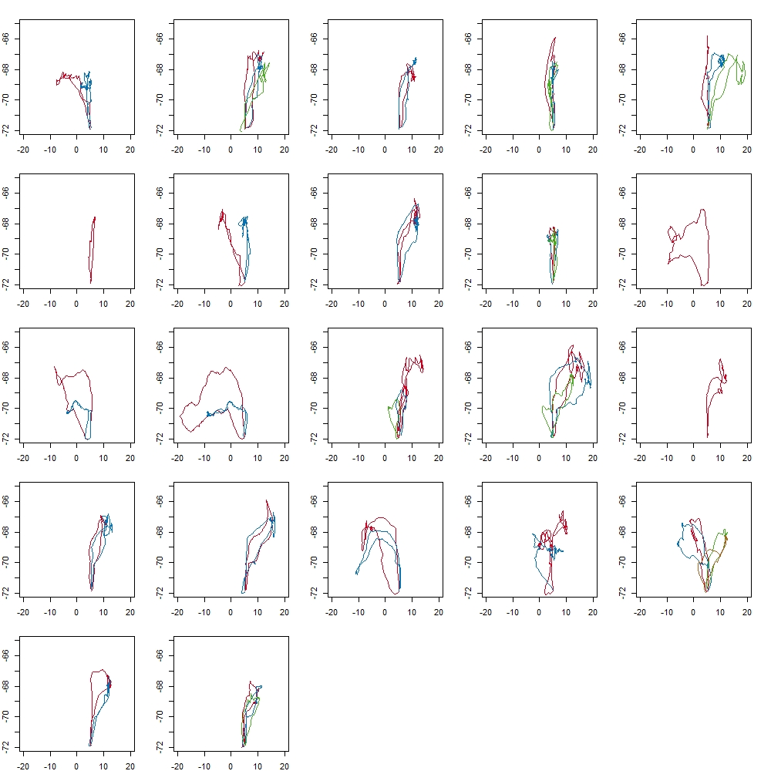

Supplementary Table 2. Overlap in foraging areas during consecutive trips in Antarctic petrel during the chick-rearing period at Svarthamaren, Dronning Maud Land. Only individuals tracked two or more consecutive trips were included. As a first step, we run a segmentation-clustering method (segClust2D; Patin et al. 2018) to distinguish between resting, transiting and foraging behaviours based on the individual’s movement speed and tortuosity. We used kernel density estimation (KDE) to estimate the utilization distribution (UD) for each individual based on foraging locations only. We refer as ‘foraging area’ the area accounting for 95% of the UD (i.e. UD 95) based on foraging locations. We then computed the % of overlap in the UDs 95 between successive foraging trips of the focal individual. These results show that 50% of the tracked Antarctic petrels foraged in completely different areas (i.e. overlap <1%) during consecutive trips, and only three individuals had an overlap in their foraging areas >20%.

Bird ID | Mean overlap_UD95 (%)
4165502 | 13.5
4165836 | 15.7
4182402 | 0.0
4182618 | 0.0
4182619 | 0.0
4182634 | 0.0
4182635 | 0.0
4182637 | 12.8
4182638 | 12.2ª
4182639 | 0.0
4182643 | 30.8
4182644 | 24.1
4182645 | 17.4
4182647 | 0.1
4182649 | 0.0
4214719 | 19.6
4214720 | 0.0
4214723 | 0.0
4214727 | 0.0
4214729 | 24.4
4214733 | 15.7
4214736 | 0.0
4214741 | 17.9
4214746 | 19.6
4214748 | 0.9
4214751 | 17.2

ª: Since the classification of behaviours for this individual during its trip n°2 was not reliable (according the segmentation-clustering analysis), the overlap (12.2%) represents the overlap of the foraging areas between trips 1 and 3

