Supplementary File 1. Home bowel screening test kits presented in consultations
# | Kit  (distributor and/or manufacturer) | Sourced | Self-Test vs Lab | Number of samples | Collection tool type | Specimen container type | Collection sheet included (Y//N)
1 | OC Sensor (FIT)  Current NBCSP kit  (Eiken Chemical) | Sample kit provided by NBCSP | Lab | 2 | Plastic stick with grooves | Tube | Y
2 | Second generation FIT  (Pinnacle Biolab) | Purchased online through pharmaceutical distributor | Self-Test | 2 | Plastic stick with grooves | Cassette | Y
3 | Prima Home Test (FIT)  (Prima Labs) | Purchased online through pharmaceutical distributor | Self-Test | 3 | Plastic stick with grooves | Cassette | Y
4 | Colovantage (FIT)  (Clinical Genomic) | Sample kit provided by manufacturer | Lab | 2 | Brush | Cardboard | N
5 | Laboquick (FIT)  (Koroglu Medikal) | Purchased online through pharmaceutical distributor | Self-Test | 2 | Plastic stick with grooves | Cassette | N
6 | Bowelscan gFOBT  (Helena Laboratories) | Sample kit provided by distributer | Lab | 2 | Wooden Spatula | Cardboard | N
7 | ColoScreen iFOBT  (Helena Laboratories) | Purchased online through pharmaceutical distributor | Self-Test | 1 | Plastic stick with grooves | Cassette | Y
8 | Hemtube (FIT)  Previous NBCSP kit  (Fujirebio Inc.) | Unused kit donated by NBCSP recipient | Lab | 2 | Plastic Stick  (no grooves) | Tube | Y
9 | ColoScreen (gFOBT)  (Helena Laboratories) | Sample kit provided by manufacturer | Lab | 3 | Wooden Spatula | Cardboard | N
FIT/iFOBT = Faecal Immunochemical Test; gFOBT = Guaiac Faecal Occult Blood Test

Kit Photographs
- OC Sensor (FIT) Current NBCSP kit (Eiken Chemical)

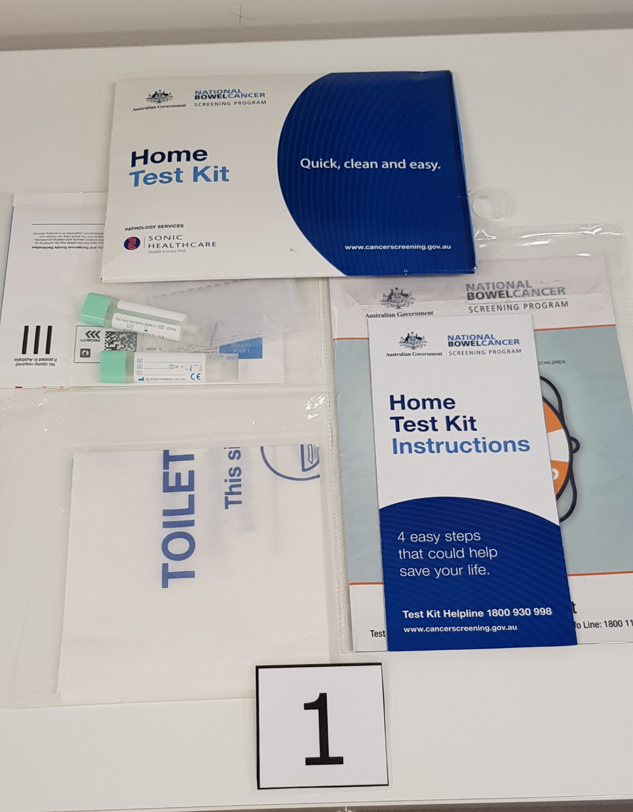

- Second generation FIT (Pinnacle Biolab)

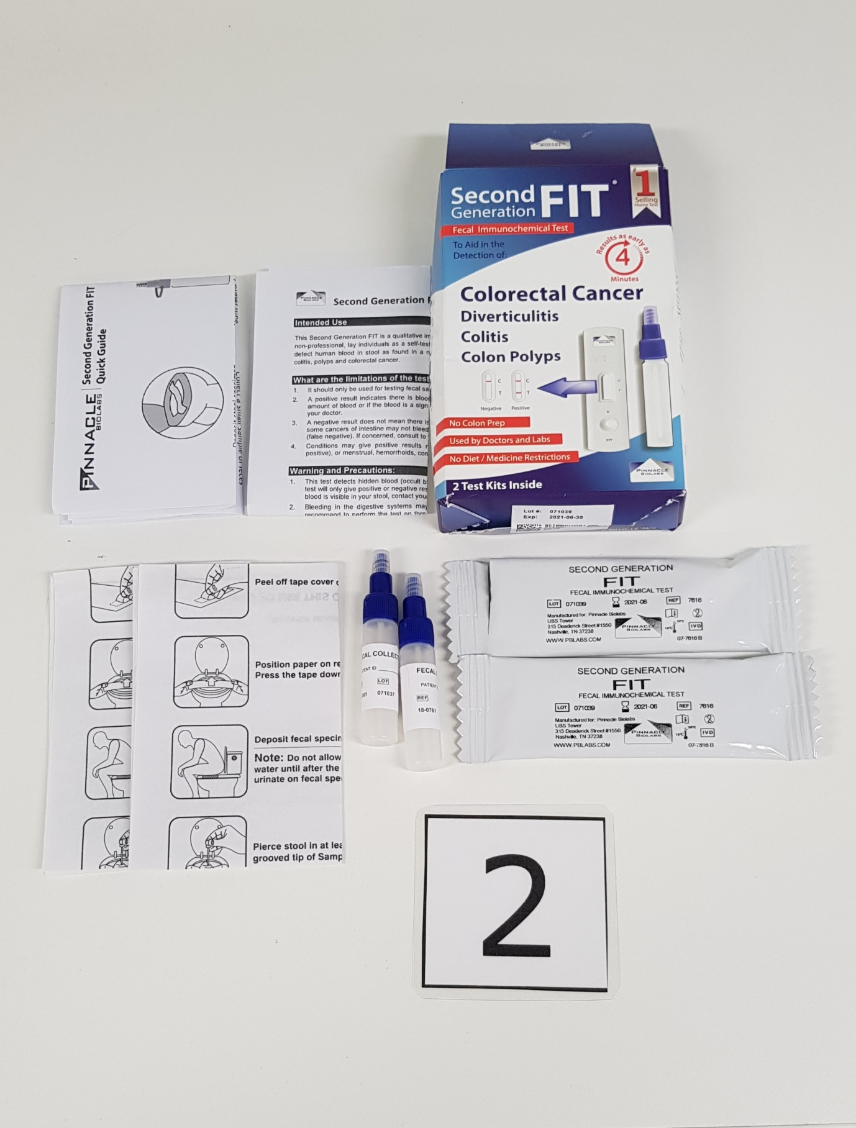

- Prima Home Test (FIT) (Prima Labs)

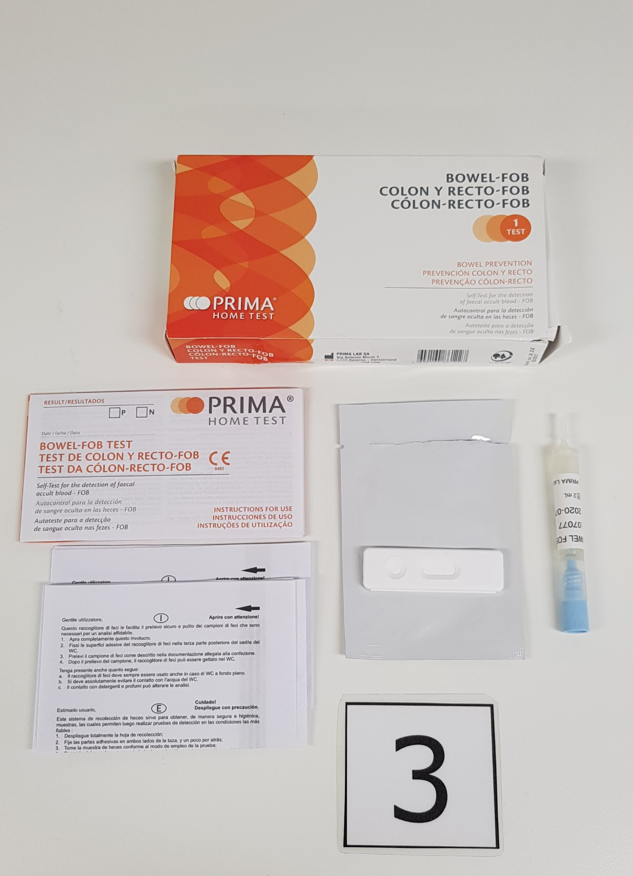

- Colovantage (FIT) (Clinical Genomic)

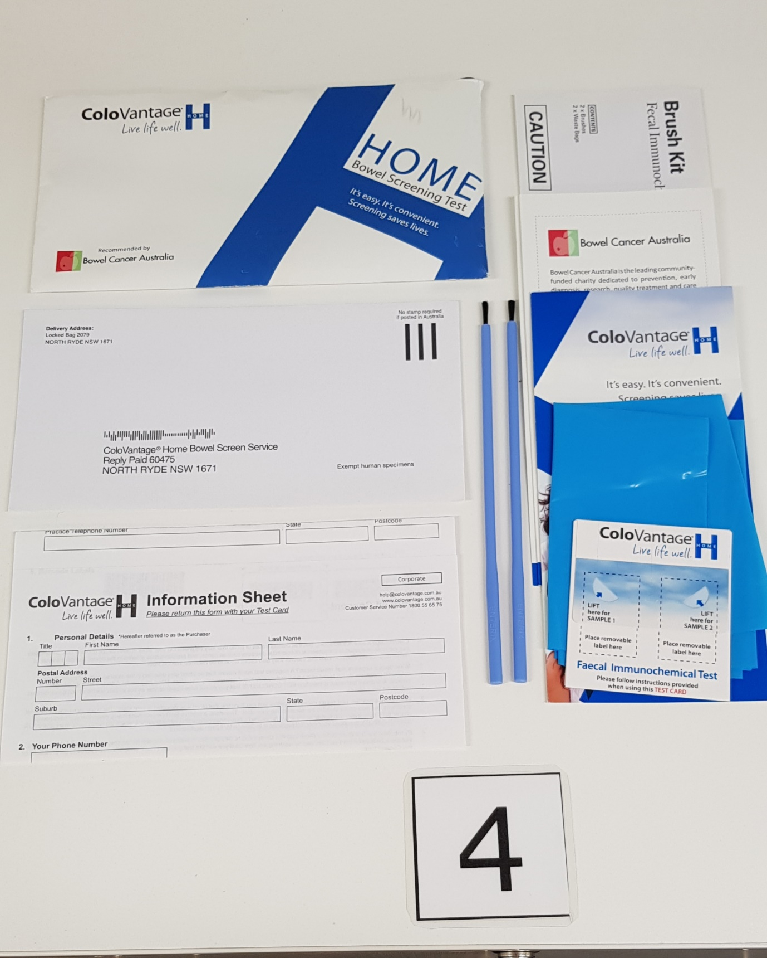

- Laboquick (FIT) (Koroglu Medikal)

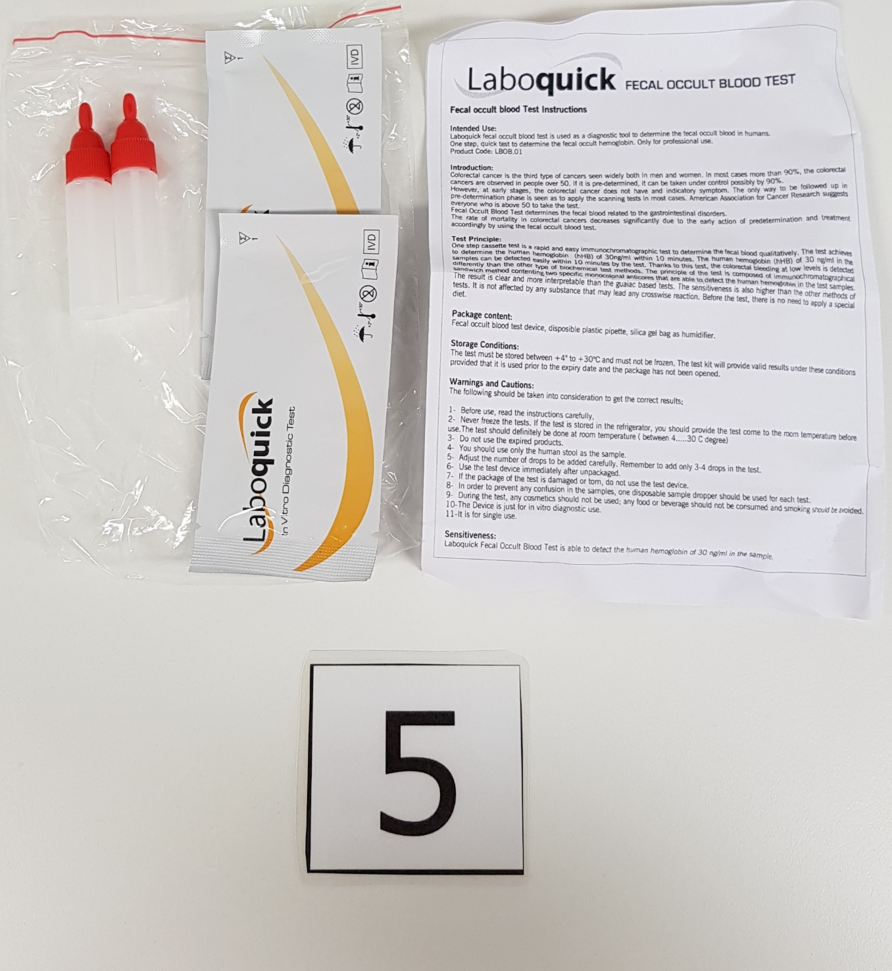

- Bowelscan gFOBT (Helena Laboratories)

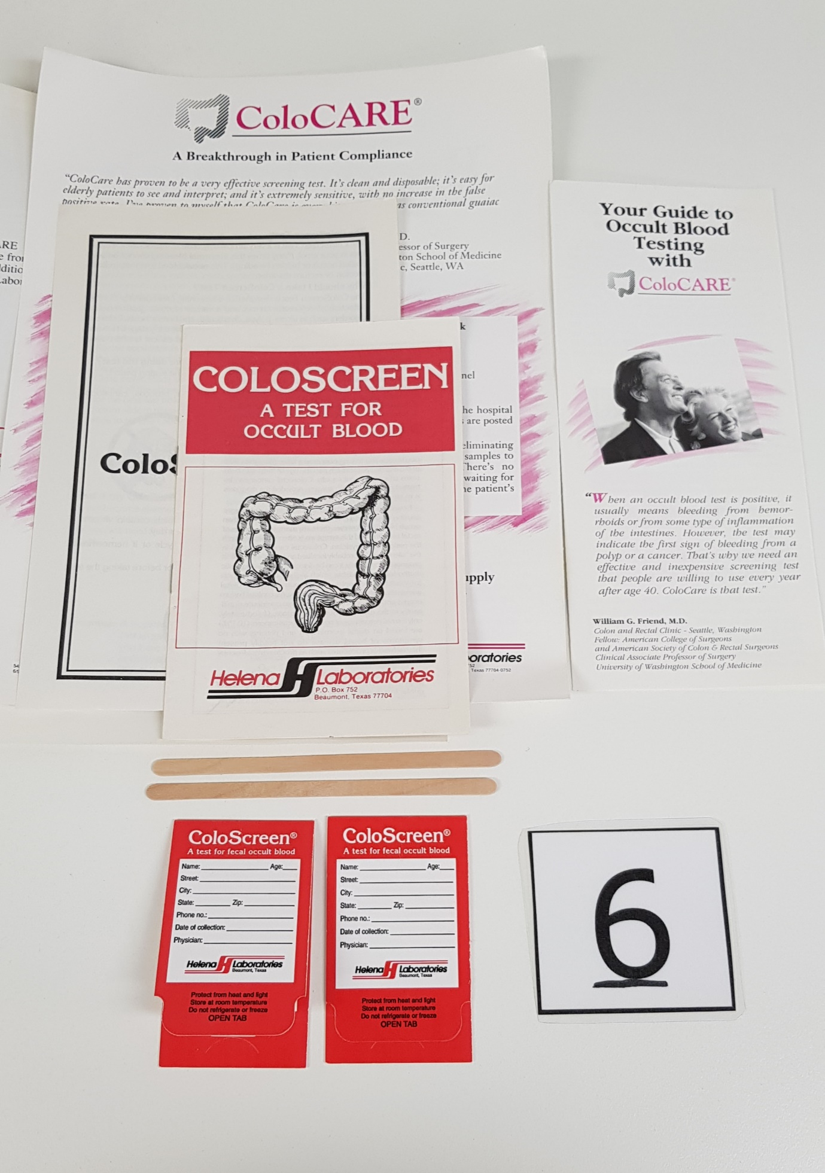
- ColoScreen iFOBT (Helena Laboratories)

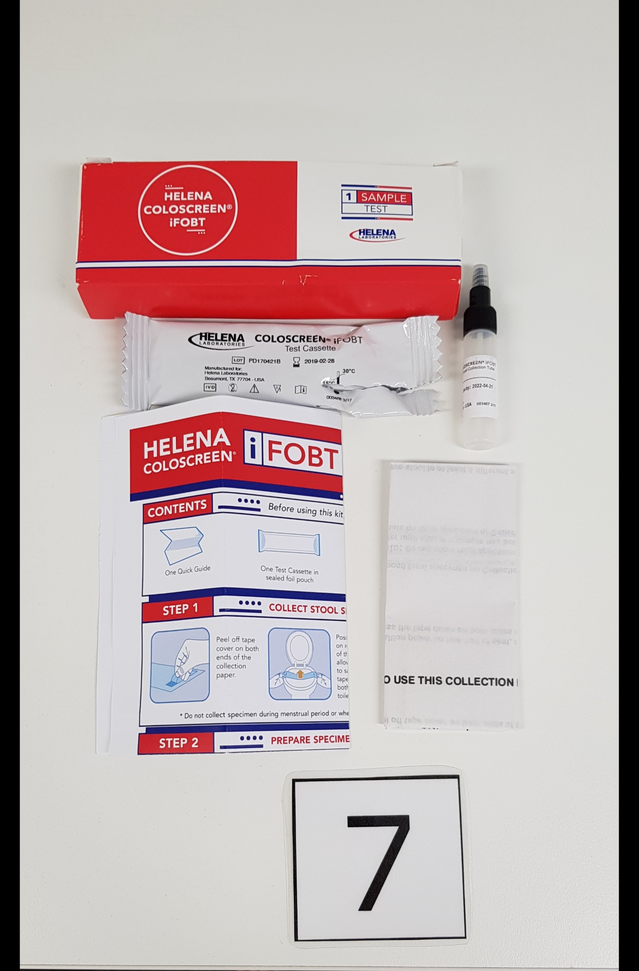

- Hemtube (FIT) Previous NBCSP kit (Fujirebio Inc.)

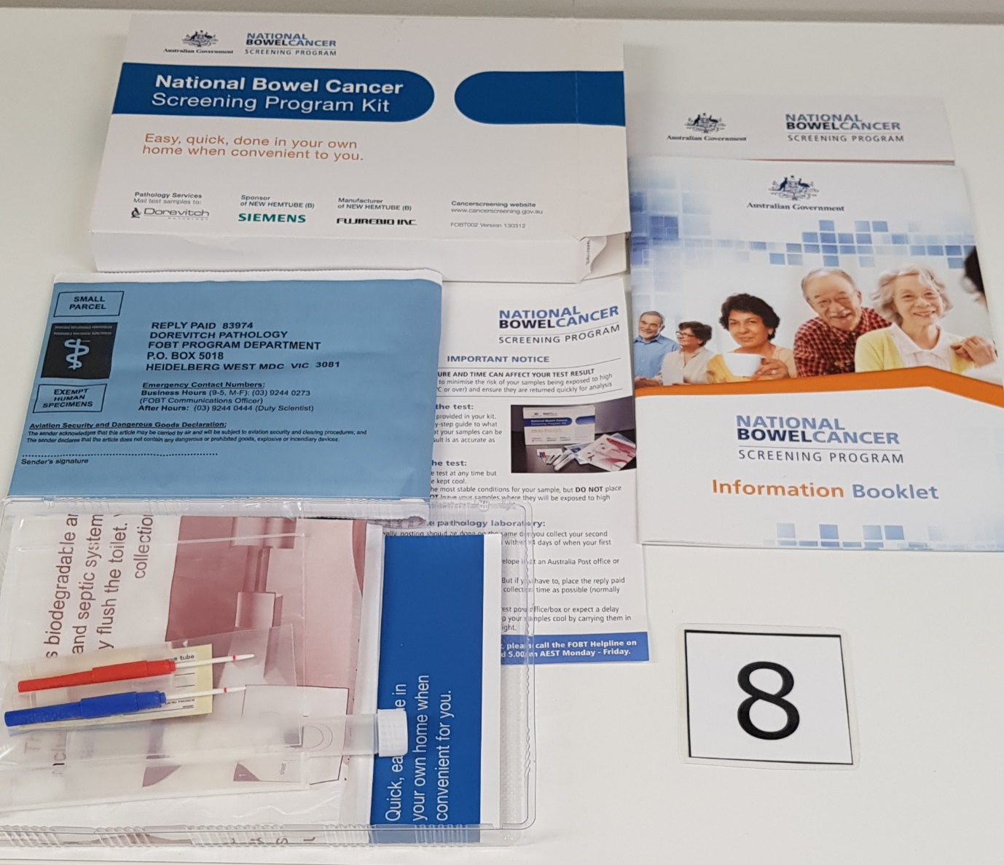

- ColoScreen (gFOBT) (Helena Laboratories)

