Figure S1. Distribution map showing a quality controlled dataset (after data cleaning) consist of 18,668 distribution records (green points) of benthic species used in this study.
Figure S2. Number of benthic distribution records (sampling effort) against 5-degree latitudinal bands. Different colors refer to different phyla.
Figure S3. Number of benthic species against 5-degree latitudinal bands (gamma species richness). Different colors refer to different phyla.

Figure S4. Number of benthic distribution records against 100 m depth intervals.
Figure S5. Number of benthic species against 100 m depth intervals (gamma species richness).

Figure S6. Benthic species distribution records against latitude and depth. Different colors refer to different phyla.
Figure S7. Rarefied expected number of species (ES50) (rarefaction curves) against the sample size per 5-degree latitudinal bands. Each number refers to each 5-degree latitudinal bands, where latitudes 10 and 15 showed the highest expected number of species.
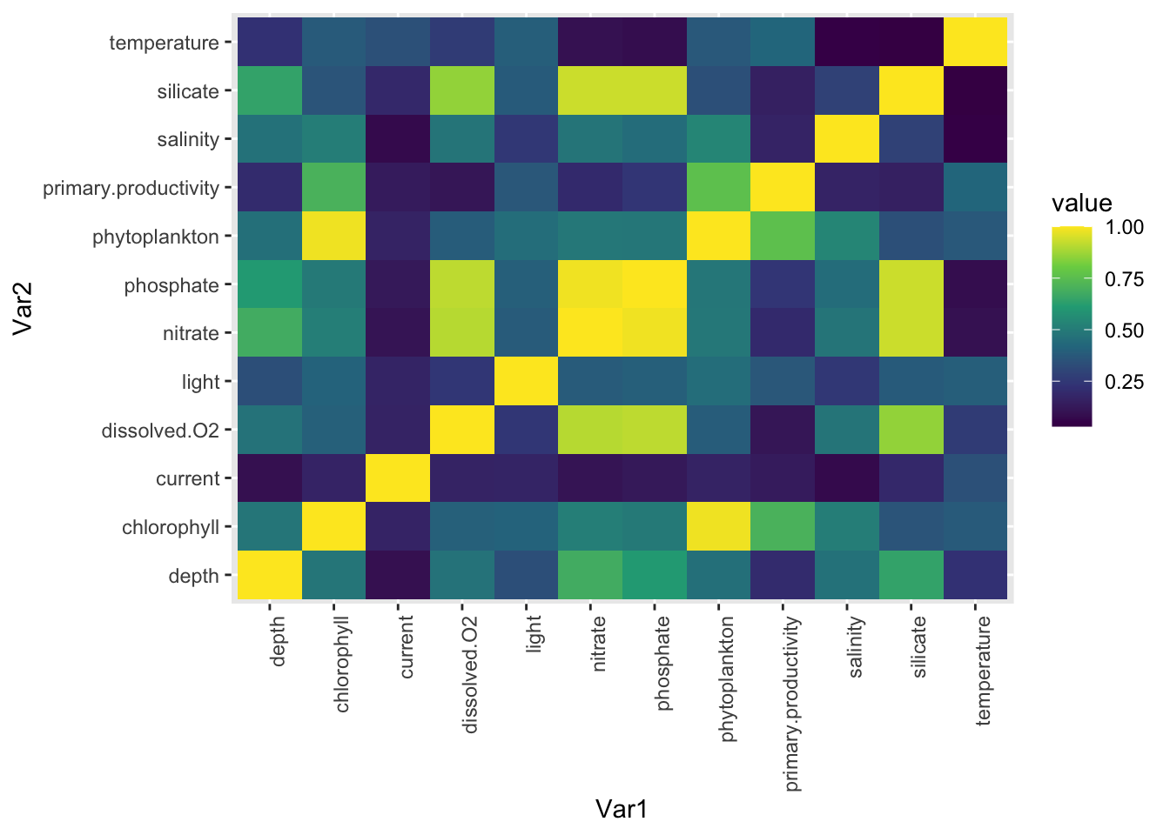

Figure S8. Correlation among different environmental variables used in this study. Values show the correlation coefficient from low (blue) to high (yellow).

