Migratory behavior and habitat utilization of the red king crab (Paralithodes camtschaticus) in a newly invaded fjord in northern Norway

Magnus Aune^{1,5}, Jenny L. A. Jensen¹, Sten I. Siikavuopio², Guttorm N. Christensen¹, Kåre Tormod Nilsen³, Benjamin Merkel¹, Paul E. Renaud^{1,4}

¹Akvaplan-niva AS, Fram Centre, 9007 Tromsø, Norway; ²NOFIMA, Muninbakken 9-13, 9291 Tromsø; ³K-To-9 AS, Fuglenesveien 101, 9601 Hammerfest; ⁴University Centre in Svalbard; 9071 Longyearbyen, Norway

Appendix B: Supplementary material

Figure B1. Water temperature conditions in Gamvikfjorden (Sørøya, northern Norway) during the study period 24th of May until the 1st of November 2016. A) Average water temperature as function of water depth. B) Position of water temperature sensors (black bubbles with white fill), where the bubble sizes reflect their order according to the average water temperature recorded over the entire study period (i.e., the smallest bubble indicate the position of the temperature sensor recording the lowest average water temperature, and vice versa).

Figure B2. Maximum daily wind speed (ms⁻¹) at Fruholmen lighthouse, northern Norway, during the period 24th of May to 1st of November 2016. Green, vertical lines show dates of water exchange in Gamvikfjorden (north-western Sørøya). Data on wind speed was obtained from https://seklima.met.no/observations.

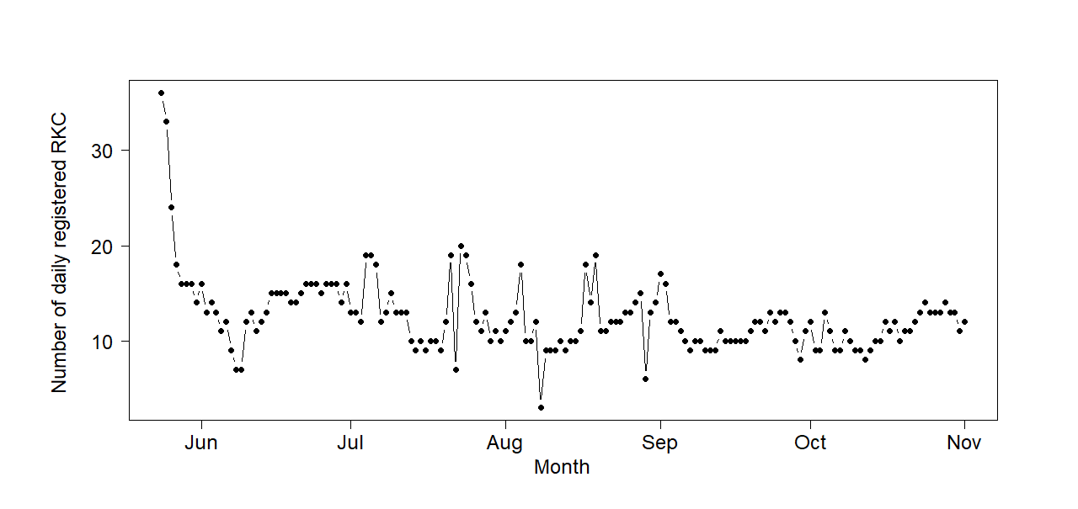
Figure B3. Number of daily registered individuals of tagged red king crab (RKC, Paralithodes camtschaticus) in Gamvikfjorden (Sørøya, northern Norway) during the period 24th of May until the 1st of November 2016.

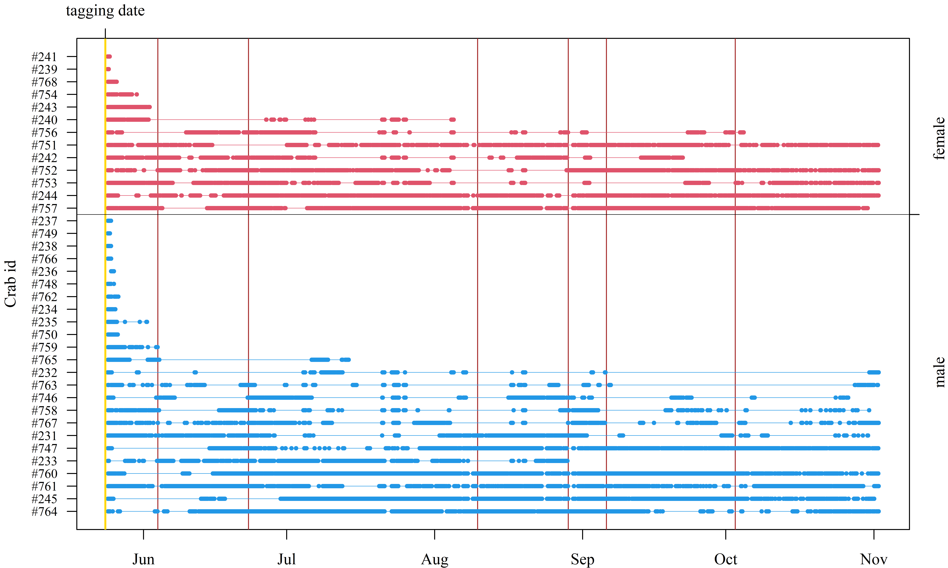
Figure B4. Overview of the days the individuals of tagged red king crab (RKC, Paralithodes camtschaticus) in Gamvikfjorden (Sørøya, northern Norway) were recorded during the period 24th of May until the 1st of November 2016. Red, vertical lines show dates of water exchange in Gamvikfjorden (north-western Sørøya).

Figure B5. Seasonal variation in daily mean latitude of of 37 acoustically tagged red king crab (Paralithodes camtschaticus) released in Gamvikfjorden, northern Norway, the 24th of May 2016, separated into males (blue) and females (red). Solid lines show the overall running median values, the dark shaded areas show the data between the 25th and the 75th percentiles, and the lightly shaded areas show the first and third quartiles.

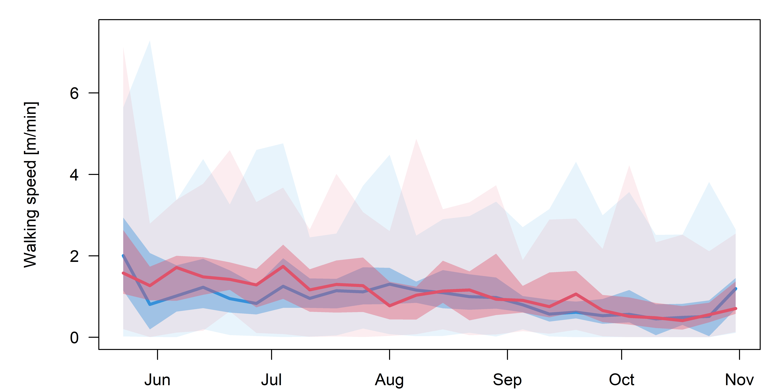
Figure B6. Seasonal variation in weekly mean walking speed of 37 acoustically tagged red king crab (Paralithodes camtschaticus) released in Gamvikfjorden, northern Norway, the 24th of May 2016, separated into males (blue) and females (red). Solid lines show the overall running median values, the dark shaded areas show the data between the 25th and the 75th percentiles, and the lightly shaded areas show the first and third quartiles.

