Journal of Vertebrate Paleontology
SUPPLEMENTAL CONTENT
Allometric analysis sheds light on the systematics and ontogeny of anurognathid pterosaurs
ZIXIAO YANG,¹ MICHAEL J. BENTON,² DAVID W. E. HONE,³ XING XU,⁴ MARIA E. McNAMARA,^{1,5} and BAOYU JIANG^{6,*}
¹School of Biological, Earth and Environmental Sciences, University College Cork, Cork T23 TK30, Ireland, zyang@ucc.ie; maria.mcnamara@ucc.ie;
²School of Earth Sciences, University of Bristol, Life Sciences Building, Tyndall Avenue, Bristol BS8 1TQ, UK, mike.benton@bristol.ac.uk;
³School of Biological and Behavioural Sciences, Queen Mary University of London, Mile End Road, London, E1 4NS, UK, d.hone@qmul.ac.uk;
⁴Key Laboratory of Vertebrate Evolution and Human Origins, Institute of Vertebrate Paleontology and Paleoanthropology, Chinese Academy of Sciences, Beijing 100044, China, xu.xing@ivpp.ac.cn;
⁵Environmental Research Institute, Lee Road, Cork T23 XE10, Ireland, maria.mcnamara@ucc.ie;
⁶Center for Research and Education on Biological Evolution and Environments, School of Earth Sciences and Engineering, Nanjing University, Nanjing 210023, China, byjiang@nju.edu.cn
*Corresponding author.

SUPPLEMENTAL METHODS

R Code to Calculate for Allometric Correlation
############### Bivariate allometric analysis ##############
rm(list=ls())
library(smatr)
library(dplyr)
library(purrr)
# Copy and paste a set of log-transformed measurements into a txt file using the name x_y.txt (x as the left column and y as the right), and then load the file into R
original<-read.table("x_y.txt")
# fit SMA to the original dataset
mod<-sma(V1~V2,data=original, method="SMA")
mod
# bootstrap with 1000 iterations
preds <- original %>%
# create new bootstrapped datasets
modelr::bootstrap(n = 1000, id = 'boot_num') %>%
# fit SMA to every bootstrap dataset
group_by(boot_num) %>%
mutate(., fit = map(strap, ~ sma(V1 ~ V2, data=data.frame(.), method="SMA"))) %>%
ungroup() %>%
# extract intercept and slope from each fit
mutate(., intercept = map_dbl(fit, ~coef(.x)[1]),
slope = map_dbl(fit, ~coef(.x)[2])) %>%
select(., -fit)
# one-tailed 95% confidence interval for the slope
(if(mod[["coef"]][[1]][["coef(SMA)"]][2]>1)
+ quantile(preds$slope,c(0.05,1))
else(quantile(preds$slope,c(0.00,0.95))))

############### PCA allometric analysis with missing data ##############
rm(list=ls())
library(missMDA)
library(boot)
# Copy and paste the log-transformed measurements into a csv file using the name using the name PCAdata.csv (each skeletal variable as a column; missing values marked as NA), and then load the dataset into R
originaldata<-read.csv("PCAdata.csv",header=TRUE)
originaldata
# estimate number of components for imputation
nc <- estim_ncpPCA(originaldata, ncp.min=0, ncp.max=5)
nc$ncp
# imputation to generate a complete dataset
imputation <- imputePCA(originaldata, ncp=nc$ncp)
# show the complete dataset
completedata<-imputation$completeObs
completedata
# proportion of variance explained by PC1
pca<-prcomp(completedata)
summary(pca)$importance[2,"PC1"]
# define a function to calculate the allometric scaling coefficient for each skeletal variable
bootdata = function(data,indices){
a<-data[indices,]
b<-prcomp(a)
c(abs(b$rotation[,1])/(ncol(completedata)^(-0.5)))
}
#bootstrap with 1000 iterations
bootresult<-boot(completedata,bootdata,R=1000)
# allometric scaling coefficient for each skeletal variable
bootresult$t0
# one-tailed 95% confidence interval for each allometric scaling coefficient
for(i in 1:ncol(completedata))
{if(bootresult$t0[i]>1)
{print(names(bootresult$t0[i]))
print(quantile(bootresult$t[,i],c(0.05,1)))}
else
{print(names(bootresult$t0[i]))
print(quantile(bootresult$t[,i],c(0.00,0.95)))}}

Character List
{0 Skull_aspect_ratio,_length_relative_to_height_at_most_posterior_point_preserved_between_anterior_margin_of_external_naris_or_nasoantorbital_fenestra_and_jaw_articulation_exclusive_of_cranial_crests:_continuous;
{1 (REVISED from Longrich et al., 2018) Skull,_length_to_squamosal_relative_to_humerus_length:_continuous;
{2 Mandble,_length_relative_to_skull_length_to_squamosal:_continuous;
{3 Rostrum,_length_to_external_naris_(or_nasoantorbital_fenestra)_relative_to_skull_length_to_squamosal:_continuous;
{4 External_naris,_length_relative_to_skull_length_to_squamosal:_continuous;
{5 External_naris,_length_relative_to_height:_continuous;
{6 Antorbital_fenestra,_length_relative_to_skull_length_to_squamosal:_continuous;
{7 Antorbital_fenestra,_length_relative_to_height:_continuous;
{8 Nasoantorbital_fenestra,_length_relative_to_skull_length_to_squamosal:_continuous;
{9 Nasoantorbital_fenestra,_length_relative_to_height:_continuous;
{10 Orbit,_length_relative_to_height:_continuous;
{11 Supratemporal_fenestra,_length_relative_to_skull_length_to_squamosal:_continuous;
{12 Subtemporal_fenestra,_length_relative_to_width:_continuous;
{13 Basipterygoid_processes,_angle_divided_by_100:_continuous;
{14 Rostral_tooth_row,_length_to_posterior_margin_relative_to_skull_length_to_squamosal:_continuous;
{15 Teeth,_maximum_number_divided_by_1000:_continuous;
{16 Mandibular_symphysis,_length_relative_to_mandible_length:_continuous;
{17 Mandible_length,_relative_to_ramus_mid-depth:_continuous;
{18 Mandibular_crest,_length_relative_to_mandible_length:_continuous;
{19 Mandibular_tooth_row,_length_relative_to_mandible_length:_continuous;
{20 Mid-cervical_vertebra,_maximum_length_relative_to_mid-width:_continuous;
{21 Mid-cervical_vertebra,_maximum_length_relative_to_dorsal_vertebra_length:_continuous;
{22 Dorsal_vertebra,_length_relative_to_maximum_diameter:_continuous;
{23 Synsacral_verebra,_number:_continuous;
{24 Caudal_vertebra,_length_relative_to_dorsal_vertebra_length:_continuous;
{25 Caudal_vertebra,_length_relative_to_diameter:_continuous;
{26 Scapula,_length_relative_to_coracoid_length:_continuous;
{27 Deep_coracoid_flange,_length_relative_to_coracoid_length:_continuous;
{28 Humerus,_length_relative_to_dorsal_vertebra_length:_continuous;
{29 Humerus,_deltopectoral_crest,_proximodistal_constriction_width_relative_to_anterior_terminus_proximodistal_width:_continuous;
{30 Ulna_or_radius,_length_relative_to_humerus_length:_continuous;
{31 Radius,_diameter_relative_to_ulna_diameter:_continuous;
{32 Pteroid,_length_relative_to_ulna_length:_continuous;
{33 Metacarpal_IV,_length_relative_to_humerus_length:_continuous;
{34 Metacarpal_IV_mid-width_relative_to_combined_ulna_and_radius_mid-width:_continuous;
{35 Metacarpal_IV_proximal_end,_dorsoventral_width_relative_to_mid-width:_continuous;
{36 Manual_digit_IV_first_phalanx,_length_relative_to_humerus_length:_continuous;
{37 Manual_digit_IV_second_phalanx,_length_relative_to_first_phalanx_length:_continuous;
{38 Manual_digit_IV_third_wing_phalanx,_length_relative_to_first_phalanx_length:_continuous;
{39 Manual_digit_IV_fourth_wing_phalanx,_length_relative_to_first_phalanx_length:_continuous;
{40 Prepubis,_length_relative_to_width:_continuous;
{41 Pubis,_dorsoventral_depth_relative_to_acetabulum_anteroposterior_length:_continuous;
{42 Ilium_anterior_process,_length_relative_to_posterior_process_length:_continuous;
{43 Femur,_length_relative_to_humerus_length:_continuous;
{44 Tibia,_length_relative_to_femur_length:_continuous;
{45 Fibula,_free_length_relative_to_tibia_length:_continuous;
{46 Metatarsal_III,_length_relative_to_tibia_length:_continuous;
{47 (NEW to Longrich et al., 2018; from Wang et al., 2002) First_phalanx_of_pedal_digit_V,_length_relative_to_metatarsal_III_length:_continuous;
{48 (NEW to Longrich et al., 2018; from Wang et al., 2002) Pedal_digit_V,_length_relative_to_pedal_digit_III_length:_continuous;
{49 (NEW to Longrich et al., 2018; from Wei et al., 2021)
Tail,_length_relative_to_humerus_length:_continuous;
{50 (NEW to Longrich et al., 2018; from Lü et al., 2018) Tibia, length relative to humerus length: continuous;
{51 (NEW to Longrich et al., 2018; from Lü and Hone, 2012)
Tibia, length relative to ulna length: continuous;
{52 Pedal_digit_III_second_phalanx_length,_relative_to_mid-width:_continuous;
{53 Pedal_digit_IV_first_phalanx,_length_relative_to_mid-width:_continuous;
{54 Pedal_digit_IV_second_phalanx,_length_relative_to_mid-width:_continuous;
{55 Pedal_digit_IV_third_phalanx,_length_relative_to_mid-width:_continuous;
{56 Rostrum_anterior_margin,_shape:_ordered flat_surface blunt sharp_tip rostral_process;
{57 Rostral_process_cross-section,_shape: triangular elliptical;
{58 Rostrum_anterior_end,_orientation:_ordered upturned straight downturned;
{59 Rostrum,_anterior_end,_lateral_expansion: absent present;
{60 Jaws,_anterior_expansion,_horizontal_outline_shape: elliptical triangular quadrangular;
{61 Rostrum,_anterior_occlusal_margins,_shape: rounded_edges sharp_or_ridged;
{62 Rostrum,_middle_expansion: absent present;
{63 Rostrum,_posterior_occlusal_margins,_shape: rounded sharp_or_ridged;
{64 Rostrum,_shape: laterally_attenuated anteroposteriorly_shortened dorsoventrally_depressed laterally_flattened;
{65 Rostrum,_dorsal_taper: subparallel attenuated;
{66 Jaws,_anterior_end,_lateral_taper: attenuated subparallel;
{67 Skull,_entire_margin,_lateral_shape: _ordered concave straight attenuated convex;
{68 Skull_dorsal_margin,_curvature_exclusive_of_cranial_crests:_ordered convex straight concave;
{69 External_naris_dorsal_and_ventral_margins,_orientation: acute_angle subparallel;
{70 External_naris_(or_nasoantorbital_fenestra)_anterior_margin,_position_relative_to_premaxillary_toothrow: dorsal posterior;
{71 Antorbital_(or_nasoantorbital)_fossa_on_jugal: present absent;
{72 Antorbital_fenestra_dorsal_and_ventral_margins,_orientation: subparallel acute_angle;
{73 Antorbital_fenestra_ventral_margin,_position_relative_to_external_naris_ventral_margin: same_level ventral;
{74 External_naris_and_antorbital_fenestra,_configuration: separate confluent;
{75 Antorbital_(or_nasoantorbital_fenestra)_posterior_margin,_shape: subangular beveled;
{76 Nasoantorbital_fenestra_dorsal_and_ventral_margins,_orientation: acute_angle subparallel;
{77 Orbit_outline,_shape: subcircular piriform inverted_triangle;
{78 Orbit,_dorsal_position: middle_of_the_skull_with_the_ventral_margin_of_the_orbit_below_the_middle_of_the_antorbital_(or_nasoantorbital)_fenestra_and_the_dorsal_margin_of_the_orbit_above_the_dorsal_margin_of_the_antorbital_(or_nasoantorbital)_fenestra high_in_the_skull_with_the_ventral_margin_of_the_orbit_the_same_level_or_above_the_middle_of_the_antorbital_(or_nasoantorbital)_fenestra low_in_the_skull_with_the_entire_orbit_lower_than_the_dorsal_margin_of_the_antorbital_(or_nasoantorbital)_fenestra;
{79 Infratemporal_fenestra,_shape: trapezoidal inverted_triangle upright_triangle oval elliptical;
{80 Infratemporal_fenestra,_position_relative_to_orbit: posterior_to_orbit reaches_under_orbit;
{81 Infratemporal_fenestra,_orientation: subvertical inclined;
{82 Premaxillary_bar_(internasal_process),_width: wide narrow;
{83 Premaxilla,_maxillary_process,_position:_ordered contacts_nasal reaches_posterior_half_of_external_naris anterior_to_middle_of_external_naris;
{84 Premaxilla,_posterior_process,_posterior_margin_position: terminate_between_nasals contacts_frontals;
{85 Premaxillary_crest: absent present;
{86 Premaxillary_crest_anterior_margin,_position_relative_to_skull_anterior_margin: level posterior;
{87 Premaxillary_crest_anterior_margin,_orientation:_ordered inclined_posteriorly subvertical curving_anterodorsally;
{88 Premaxillary_crest,_shape: tall_triangle_decreasing_in_height_posteriorly low_blade low_with_anterior_humped_margin comb-like_with_straight_dorsal_margin semicircular tall_triangle_increasing_in_height_posteriorly rectangular;
{89 Premaxillary_crest_posterior_margin,_position:_ordered anterior_to_external_naris_(or_nasoantorbital_fenestra)_anterior_margin between_external_naris_(or_nasoantorbital_fenestra)_anterior_margin_and_orbit above_orbit above_occipital_region;
{90 Premaxillary_crest_dorsal_spine: absent present;
{91 Premaxillary_crest,_thickness: single_plate two_plates_separated_by_trabeculae;
{92 Premaxillary_crest,_texture: striated smooth branching_system_of_grooves;
{93 Maxilla_posterior_end,_shape: narrow ventrally_expanded;
{94 Maxilla_ascending_process,_shape: broad tapered slender;
{95 Antorbital_fossa_on_maxilla: present absent;
{96 Maxilla_and_nasal_contact,_position: maxilla_contacts_main_body_of_nasal maxilla_contacts_only_descending_process_of_nasal;
{97 Maxilla,_premaxillary_and_jugal_processes,_shape: jugal_process_wider both_narrow premaxillary_process_wider both_wide;
{98 Nasal_descending_process: present absent;
{99 Nasal_descending_process,_position: lateral medial;
{100 Nasal_descending_process,_length: short elongate;
{101 Nasal_descending_process,_orientation:_ordered inclined_anteriorly ventral inclined_posteriorly;
{102 Nasal_process,_lateral_pneumatic_foramen: absent present;
{103 Frontal_crest: absent present;
{104 Frontal_crest,_shape: low_and_blunt low_and_elongated high_and_expanded;
{105 Frontal_crest_anterior_margin,_position:_ordered anterior_to_orbit above_orbit posterior_to_orbit;
{106 Frontal_anterior_margin,_position_relative_to_preorbital_bar_anterior_margin: anterior posterior;
{107 Lacrimal_foramen: absent present;
{108 Lacrimal_descending_process_posterior_margin,_shape: flat orbital_process;
{109 Parietal_crest: absent present;
{110 Parietal_crest,_shape: blunt expanded_into_rounded_margin tapered_into_triangular_process elongate_process;
{111 Squamosal,_shape: unexpanded rounded expanded;
{112 Squamosal,_position: above_base_of_lacrimal_process_of_jugal below_or_level_with_base_of_lacrimal_process_of_jugal;
{113 Jugal_posterior_process: present absent;
{114 Quadrate,_inclination_relative_to_ventral_margin_of_skull:_ordered anteriorly subvertical 120˚_posteriorly 150˚_posteriorly;
{115 Mandibular_articulation,_position_relative_to_center_of_orbit:_ordered posterior_to_orbit posterior_to_center_below_orbit underneath_center_below_orbit anterior_to_center_below_orbit anterior_to_orbit;
{116 Quadrate,_shape: wide thin_and_cylindrical;
{117 Jugal_ventral_margin,_shape: straight concave;
{118 Jugal_anterior_margin,_position_relative_to_nasoantorbital_fenestra_anterior_margin: posterior same_level_or_anterior;
{119 Jugal_maxillary_process: absent present;
{120 Jugal_postorbital_process_and_lacrimal,_configuration: do_not_contact contact_to_form_lower_orbital_bar;
{121 Jugal_ascending_and_postorbital_processes,_shape: separated_by_distinct_angle infilled_by_concave_flange;
{122 Jugal_ascending_process_base,_width: broad narrow;
{123 Jugal_ascending_process,_inclination:_ordered anterodorsal vertical posterodorsal;
{124 Jugal_postorbital_process_anterior_margin,_shape: flat orbital_process;
{125 Jugal_posterior_process,_orientation: posterior ventral;
{126 Occiput,_orientation:_ordered posterior posteroventral ventral;
{127 Basioccipital,_length_relative_to_width: shorter_than_wide longer_than_wide;
{128 Basisphenoid_body,_length: shorter_than_wide at_least_longer_than_wide;
{129 Elongate_basipterygoid_processes: absent present;
{130 Supraoccipital_crest: absent present;
{131 Supraoccipital,_pneumatic_foraminae: absent present;
{132 Palate,_posterior_end,_shape: concave convex;
{133 Palatal_ridge: absent present;
{134 Palatal_ridge,_position: tapering_anteriorly confined_posteriorly;
{135 Palatal_ridge_shape: narrow_strip strong_keel;
{136 Palatines,_shape: broad_and_flat thin_bars;
{137 Internal_nares_and_maxilla,_configuration: contact do_not_contact;
{138 Pterygoids,_ventral_position_relative_to_jaw_margin: level_or_dorsal ventral;
{139 Interpterygoid_opening,_length_relative_to_subtemporal_fenestra_length: at_least_subtemporal_fenestra shorter_than_subtemporal_fenestra;
{140 Mandible_articulation_condyles,_orientation: parasagittal oblique;
{141 Foramina_positioned_in_a_row_along_the_lateral_margin_of_the_jaws: present absent;
{142 Mandible_anterior_end,_orientation:_ordered upturned straight downturned;
{143 Mandible_anterior_margin,_shape:_ordered blunt sharp_tip prow;
{144 Mandible_anterior_end,_shape: compressed_laterally shortened_anteroposteriorly depressed_dorsoventrally;
{145 Mandible,_anterior_expansion: absent present;
{146 Mandible_anterior_end_dorsal_jaw_margins,_shape: level eminence;
{147 Mandible_anterior_end_distinct_eminence,_height: low high;
{148 Mandibular_symphysis,_fusion: unfused fused;
{149 Mandibular_symphysis,_orientation: subparallel_to_rami oblique_to_rami;
{150 Mandible,_anterior_end_lateral_surfaces,_texture: flat large_foramina pitted;
{151 Mandible,_anterior_occlusal_margins,_shape: rounded_edges sharp_or_ridged;
{152 Mandible,_distinct_middle_expansion: absent present;
{153 Mandible,_posterior_occlusal_margins,_shape: rounded sharp_or_ridged;
{154 Mandibular_rami_distinct_dorsal_eminence: present absent;
{155 Mandibular_rami_dorsal_eminence,_shape: rounded pointed;
{156 Mandibular_sulcus: absent present;
{157 Mandible_symphysis_occlusal_surface_anterior_end,_shape: flat_or_concave fossa keel;
{158 Mandible,_dorsal_surface,_parasagittal_ridges: absent present;
{159 Mandible,_symphyseal_cavity: absent present;
{160 Mandibular_symphyseal_cavity,_dorsal_shelf,_posterior_margin_relative_to_ventral_symphysis_posterior_margin: dorsal_shelf_posterior_margin_extends_posterior_to_ventral_symphysis_posterior_margin ventral_shelf_posterior_margin_extends_at_least_posterior_to_dorsal_symphysis_posterior_margin;
{161 Mandibular_rami_dorsal_margin,_shape:_ordered convex straight concave;
{162 Mandibular_rami,_orientation: straight_to_upturned downcurved;
{163 Retroarticular_process,_orientation_relative_to_mandible:_ordered posteroventral subhorizontal posterodorsal;
{164 Retroarticular_process,_shape: triangular subcircular elongate blunt;
{165 Mandible_ventral_margin,_shape: flat keel crest;
{166 Mandibular_crest,_shape: blade_like_and_low massive_and_deep;
{167 Mandibular_crest_anterior_margin,_position: posterior_to_mandible_anterior_margin mandible_anterior_margin;
{168 Dentary,_length: do_not_separate_angular_and_surangular separate_angular_and_surangular;
{169 Teeth: present absent;
{170 Teeth,_spacing_along_jaws:_ordered mesial_teeth_spaced_wider_apart even_along_the_jaws distal_teeth_spaced_wider_apart;
{171 Teeth,_variation_in_shape_along_tooth_row: isodont heterodont;
{172 Mesial_heterodont_teeth,_shape: recurved_triangle slender_needle recurved_spike;
{173 Teeth,_shape: recurved_triangle bulbous_triangle slender_needle recurved_cone labiolingually_compressed_triangle recurved_spike;
{174 Teeth,_texture: smooth striated sharp_mesial_and_distal_keels medial_carinae;
{175 Teeth,_maximum_crown_height_relative_to_basal_width: less_than_four_times_width at_least_four_times_width;
{176 Teeth,_lateral_orientation: vertical inclined_laterally;
{177 Mesial_teeth,_average_spacing_between_successive_teeth:_ordered nearly_touching at_most_diameter_of_teeth more_than_diameter_of_teeth;
{178 Cheek_teeth,_average_spacing_between_successive_teeth:_ordered nearly_touching at_most_diameter_of_teeth more_than_diameter_of_teeth;
{179 Teeth,_size_variation: transition_along_tooth_row disparity_in_size_between_mesial_and_distal_teeth;
{180 Upper_dentition,_size_relative_to_lower_dentition:_ordered upper_dentition_significantly_larger subequal upper_dentition_significantly_smaller;
{181 Teeth,_maximum_curvature: displacement_of_curvature_less_than_tooth_diameter displacement_of_curvature_at_least_tooth_diameter;
{182 Teeth,_curvature_orientation: posterior lingual;
{183 Teeth,_inclination:_ordered upright mesial_teeth_procumbent procumbent;
{184 Cheek_alveoli,_shape: set_in_grooves low undulating_occlusal_margins raised_rims inflated;
{185 Cheek_teeth,_denticles: present absent;
{186 Teeth_largest_denticles,_shape:_ordered serrations cuspules crenulations low_cusps tall_cusps;
{187 Teeth,_maximum_denticle_number:_ordered more_than_50 between_six_and_49 five;
{188 Rostral_tooth_row,_anterior_end,_position:_ordered posterior_to_tip_of_rostrum tip_of_rostrum anterior_surface_of_rostrum;
{189 Maxillary_teeth,_position_of_largest_teeth: mesial middle distal;
{190 Fifth_and_sixth_teeth,_distinctly_smaller_than_fourth_and_seventh_and_subequal_in_size: absent present;
{191 Mandibular_tooth_row,_anterior_end,_position: tip_of_mandible posterior_to_tip_of_mandible;
{192 Occlusal_margin,_orientation_with_respect_to_jaw_margin: parallel dorsally_reflected;
{193 Atlantoaxis,_fusion: unfused fused;
{194 Mid-cervical_vertebra_neural_arch_lateral_surface,_pneumatic_foramen: absent present;
{195 Mid-cervical_vertebra_centrum_lateral_surface,_pneumatic_foramen: absent present;
{196 Cervical_vertebra_lateral_to_neural_canal,_pneumatic_foramina: absent present;
{197 Mid-cervical_vertebra_neural_spines,_height:_ordered tall low extremely_reduced;
{198 Mid-cervical_vertebrae_neural_spines,_lateral_outline_shape: blade triangular ridge fan;
{199 Mid-cervical_vertebra,_postexapophyses: absent present;
{200 Mid-cervical_vertebra_neural_arch_and_centrum,_configuration: distinct confluent;
{201 (REVISED from Longrich et al., 2018) Mid-cervical_vertebra_ribs,_shape:_ordered elongate reduced absent;
{202 Cervical_8_neural_spine,_height: tall low;
{203 Cervical_9,_shape: similar_to_dorsal_vertebrae similar_to_cervicals;
{204 Notarium: absent present;
{205 Anterior_dorsal_vertebra_neural_spines,_shape: unfused supraneural_plate;
{206 Sacral_ribs,_configuration: contact_at_ilium contact_medial_to_ilium;
{207 Synsacral_supraneural_plate: absent present;
{208 Caudal_vertebra,_number: more_than_15 at_most_15;
{209 Caudal_vertebra_zygapophyses,_length:_ordered short elongate extremely_elongate;
{210 Caudal_vertebra_centrum,_shape: single duplex;
{211 Scapulocoracoid,_orientation_relative_to_vertebral_column: subparallel rotated_laterally;
{212 Scapula_proximal_end,_shape: elongate_and_compressed suboval_and_expanded;
{213 Scapula,_shape: elongate_process stout_with_constricted_shaft;
{214 Scapula_articulates_with_vertebral_column: absent present;
{215 Coracoid_ventral_margin,_shape: rounded broad_tubercle deep_flange;
{216 Coracoid,_shape:_ordered semicircular broad_shaft narrow_shaft;
{217 Sternocoracoid_articulations,_position_with_respect_to_one_another: lateral anterior_and_posterior;
{218 Sternum,_constriction_posterior_to_sternocoracoid_articulations: present absent;
{219 Cristopine,_shape: shallow deep;
{220 Cristospine,_length: stout elongate;
{221 Sternocoracoid_articulations,_shape: flattened oval;
{222 Sternocoracoid_articulations,_posterior_expansion: absent present;
{223 Sternum_plate,_shape: narrow quadrangular semicircular triangular laterally_expanded;
{224 Humerus_proximal_end_ventral_surface,_pneumatic_foramen: absent present;
{225 Humerus_proximal_end,_cross_section: crescent horseshoe;
{226 Humerus_proximal_end_dorsal_surface,_pneumatic_foramen: absent present;
{227 Humerus_shaft,_shape: straight bowed;
{228 Humerus,_mid-shaft,_shape: tapered subcylindrical;
{229 Humerus_entepicondyle,_anteroposterior_width_relative_to_ectepicondyle_anteroposterior_width: entepicondyle_wider_than_ectepicondyle entepicondyle_at_most_ectepicondyle_width;
{230 Humerus,_between_distal_condyles,_pneumatic_foramen: absent present;
{231 Humerus_distal_aspect,_pneumatic_foramen: absent present;
{232 Humerus_distal_aspect,_shape: hourglass crescentic_or_D-shape triangular trapezoidal;
{233 Deltopectoral_crest,_position_on_humerus: proximal more_distally_on_shaft;
{234 Humerus_deltopectoral_crest,_shape: subtriangular_with_proximal_apex proximally_leaning_trapezoid proximally_curving_hook oblong_process_with_constricted_neck low_and_rectangular elongate_and_proximally_expanded hatchet-shape distally_leaning_trapezoid tall_rectangular_process;
{235 Humerus_deltopectoral_crest,_curvature: parallel_to_shaft warped_distally;
{236 Ulnar_crest_of_humerus,_size: reduced developed;
{237 Humerus_ulnar_crest,_orientation: posterior ventral;
{238 Ulna_shaft_proximal_anterior_surface,_shape: flat longitudinal_ridge;
{239 Ulna_distal_tubercle,_position: middle_of_the_distal_end ventral_part_of_the_distal_end;
{240 Radius_distal_end_cross-section,_shape: suboval subtriangular_with_large_anterior_process;
{241 Distal_syncarpal_ventral_articular_facet_for_Metacarpal_IV,_size_relative_to_dorsal_facet: ventral_facet_larger subequal_in_size;
{242 Distal_syncarpal,_cross-section_shape: rectangular triangular;
{243 Pteroid,_shape: angled_at_midsection stout_hook straight_and_tapered_with_expanded_proximal_end straight_with_expanded_ends curved_slender_rod curved_and_subparallel-sided;
{244 Preaxial_carpal,_shape: longer_than_wide at_most_long_as_wide;
{245 Metacarpals,_number_articulating_with_carpus:_ordered four_or_more two one;
{246 Metacarpals_I_to_III_distal_ends,_positions: disparate approximate;
{247 Metacarpal_IV_proximal_cross-section,_shape: anteroposteriorly_compressed subrectangular;
{248 Metacarpal_IV_shaft_cross-section,_shape: rounded_rectangle anteroposteriorly_compressed_oval;
{249 Metacarpal_distal_end_between_condyles,_shape: flat median_ridge;
{250 Manual_unguals,_size_relative_to_pedal_unguals: less_than_twice_the_size_of_pedal_unguals at_least_twice_the_size_of_pedal_unguals;
{251 Manual_digit_IV_first_phalanx_proximal_end_ventral_surface,_pneumatic_foramen: absent present;
{252 Manual_digit_IV_second_or_third_phalanges_shaft_cross-sections,_shape: round_to_subtriangular concave_posteriorly oval ventral_ridge;
{253 Pubis_anterior_margin,_shape_in_lateral_view:_ordered convex straight slightly_concave deeply_concave;
{254 Pubis_and_ischium_contact,_shape: confluent_along_length partially_separated_by_oval_opening;
{255 Ischium_ventral_margin,_shape: straight convex;
{256 Prepubis_shaft,_constriction: absent present;
{257 Prepubis,_shape: elongate_paddle medially_curved_with_short_lateral_process triradiate expanded_fan;
{258 Ilium_preactetabular_anterior_margin,_shape: rounded pointed;
{259 Ilium_preacetabular_process,_orientation: straight dorsiflected;
{260 Ilium_postacetabular_process,_orientation: subhorizontal posterodorsal;
{261 Ilium_postacetabular_process_shaft,_constriction: absent present;
{262 Ilium_postacetabular_process,_terminal_expansion: absent present;
{263 Acetabulum,_shape: anteroposteriorly_ovate subcircular;
{264 Ilium_postacetabular_process_apex,_shape: flat torus;
{265 Femur,_shape: strongly_bowed slight_curvature;
{266 Femur_proximal_end,_pneumatic_foramen: absent present;
{267 Femoral_neck,_shape: indistinct constricted;
{268 Greater_trochanter,_shape:_ordered reduced distinct_process anteriorly-curved_hook;
{269 Femur_distal_end,_epicondyles_size: reduced_and_confluent_with_distal_condyles expanded_into_distinct_distal_flanges;
{270 Femoral_head,_angle_relative_to_shaft: at_most_145° greater_than_145°;
{271 Metatarsal_IV,_length_relative_to_metatarsals_I_to_III: subequal significantly_shorter;
{272 Pedal_digit_V,_number_of_phalanges:_ordered four three two one zero;
{273 Pedal_digit_V_ultimate_phalanx,_shape:_ordered straight curved bent_at_midsection nubbin;
{274 (NEW to Longrich et al., 2018; from Lü et al., 2018) Posterior_region_of_skull_rounded: absent present;
{275 (NEW to Longrich et al., 2018; from Lü et al., 2018) The_first_digit_of_the_pedes_reversed: absent present;
{276 (NEW to Longrich et al., 2018; from Hone, 2020) Metacarpal_IV_shape: straight curves_posteriorly_at_the_distal_end;
{277 (NEW to Longrich et al., 2018; from Hone, 2020) Manual_unguals_on_each_respective_digit_measured_along_the_dorsal_edge_of_the_ungula: approximately_as_long_as_the_penultimate_phalanx_or_shorter distinctly_longer;
{278 (NEW to Longrich et al., 2018; from Hone, 2020) Metatarsal_V_more_robust_than_metatarsal_I-IV: absent present;
{279 (NEW to Longrich et al., 2018; from Hone, 2020) Dorsoventral_height_of_pedal_ungual: more_than_twice_that_of_the_preceding_phalanx less_than_twice_that_of_the_preceding_phalanx;
{280 (NEW to Longrich et al., 2018; from Hone, 2020) Dorsal_ribs_in_the_anterior_portion_of_the_body: straight_or_gently_curved distinctly_curved;
{281 (NEW to Longrich et al., 2018; from Hone, 2020) Robust_first_phalanx_of_pedal_digit_V: absent present;
{282 (NEW to Longrich et al., 2018; from Wei et al., 2021) Deltopectoral_crest,_projection: scarcely_developed_(less_wide_than_humeral_shaft) well-developed_and_projecting;
{283 (NEW to Longrich et al., 2018; from Wei et al., 2021) Humerus_ulnar_crest,_shape: triangular trapezoidal rounded;
{284 (NEW to Longrich et al., 2018; from Wei et al., 2021) Broadness_of_the_jaws_in_occlusal_view: narrowing_to_a_point describing_a_semi-ellipse describing_a_semi-circle;
{285 (NEW to Longrich et al., 2018; from Wei et al., 2021) Deltopectoral_crest,_size_relative_to_humeral_head:_ordered longer_than_the_width_of_humeral_head subequal_to_the_width_of_humeral_head shorter_than_the_width_of_humeral_head extremely_reduced

SUPPLEMENTAL RESULTS

Supplemental Figures
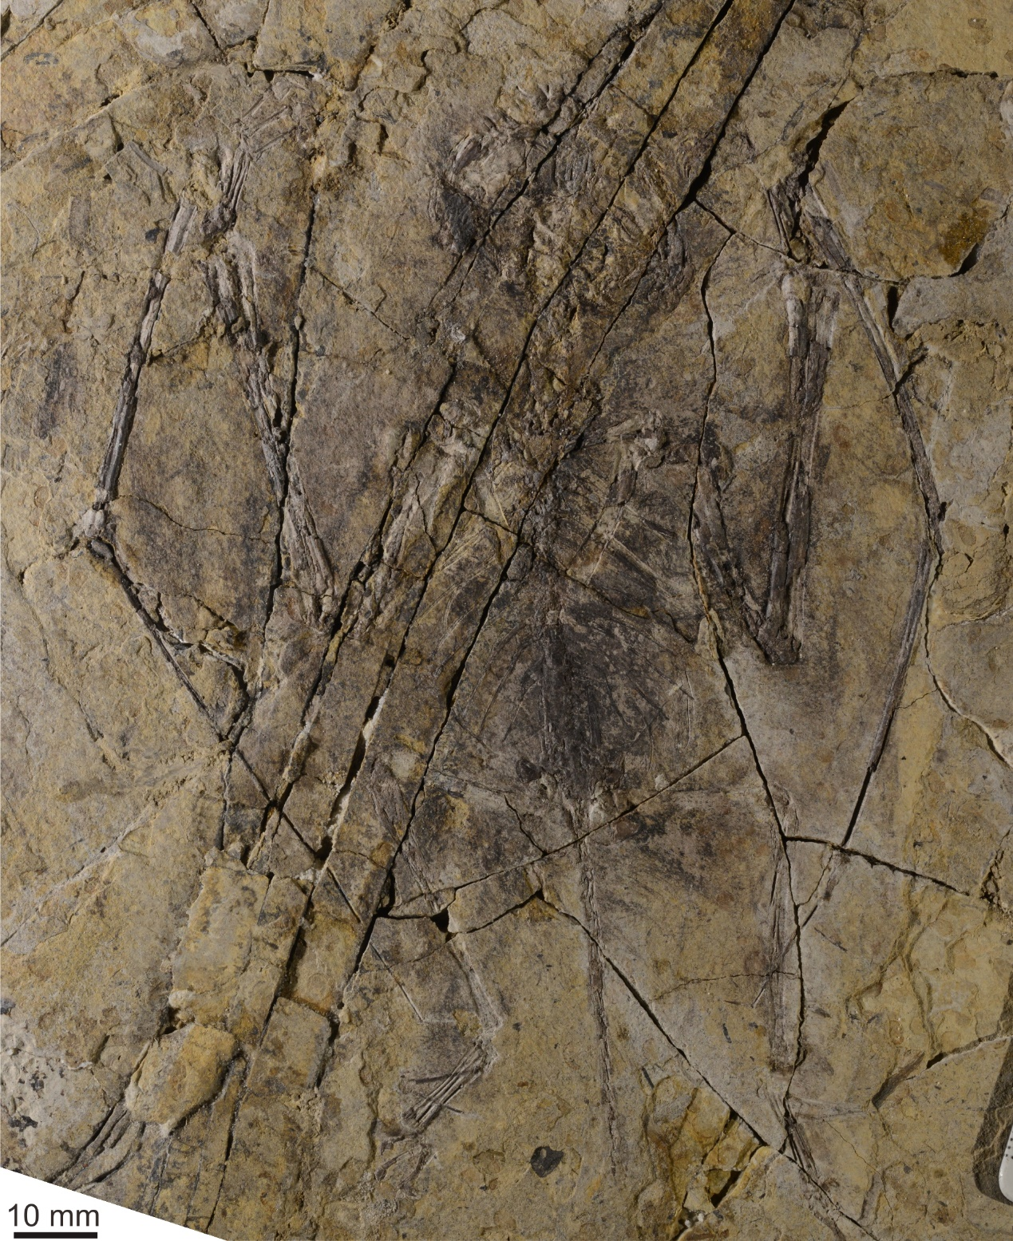
FIGURE S1. The counter-slab of NJU-57003.
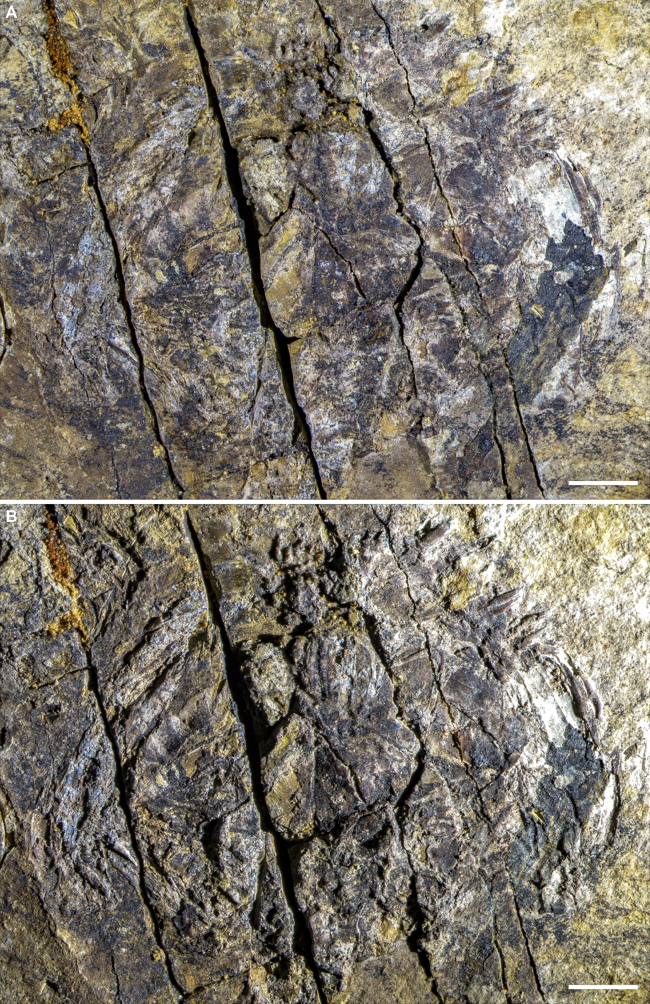
FIGURE S2 (previous page). Close-ups of the skull of NJU-57003 (main slab) under front lighting (A) and side lighting (B). Scale bars equal 5 mm.

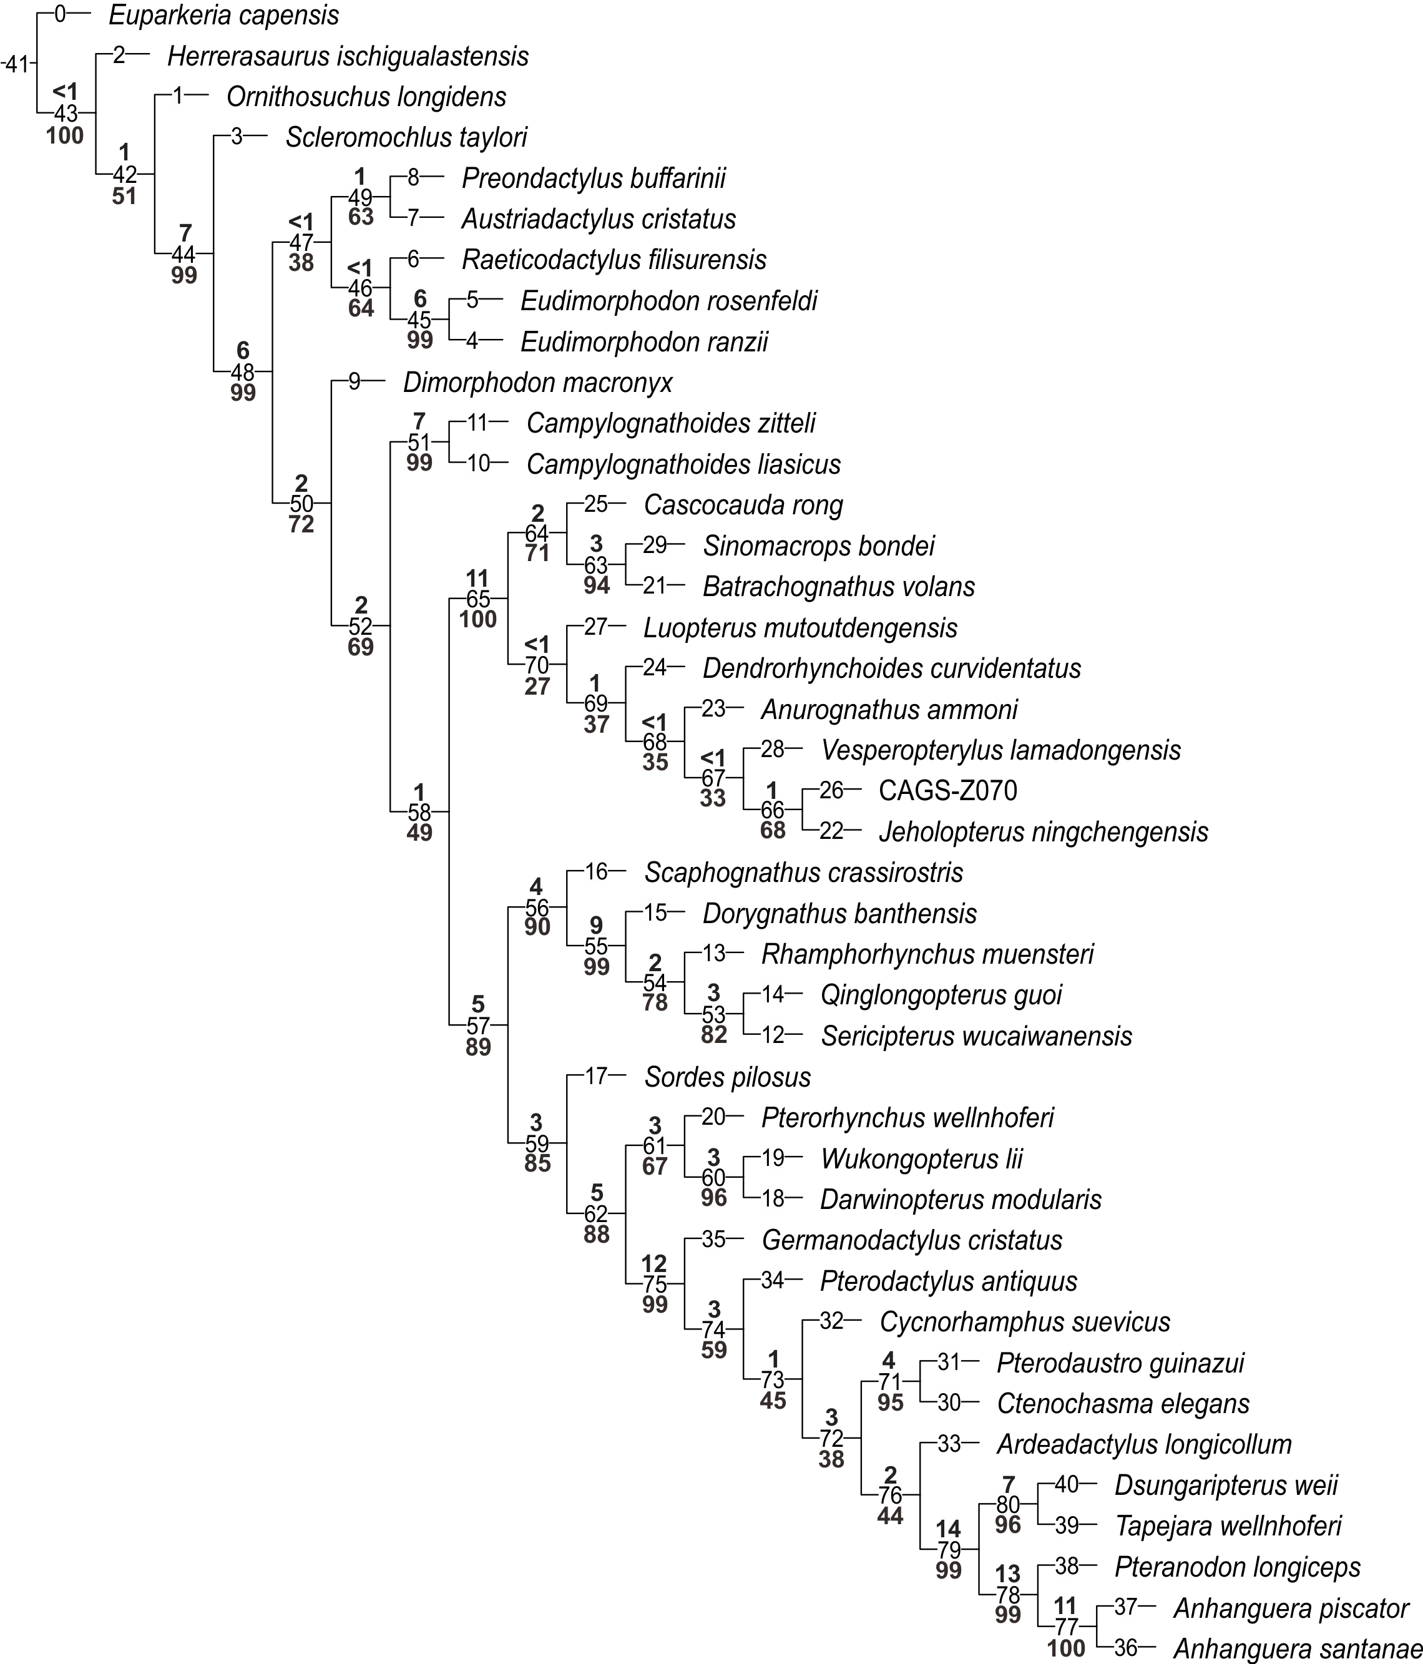
FIGURE S3. Single most parsimonious tree based on Supplemental Data 3 with a length of 850.283 steps (CI=0.442; RI=0.707). Bremer support and bootstrap values for the ingroup nodes are shown above and below branches, respectively.

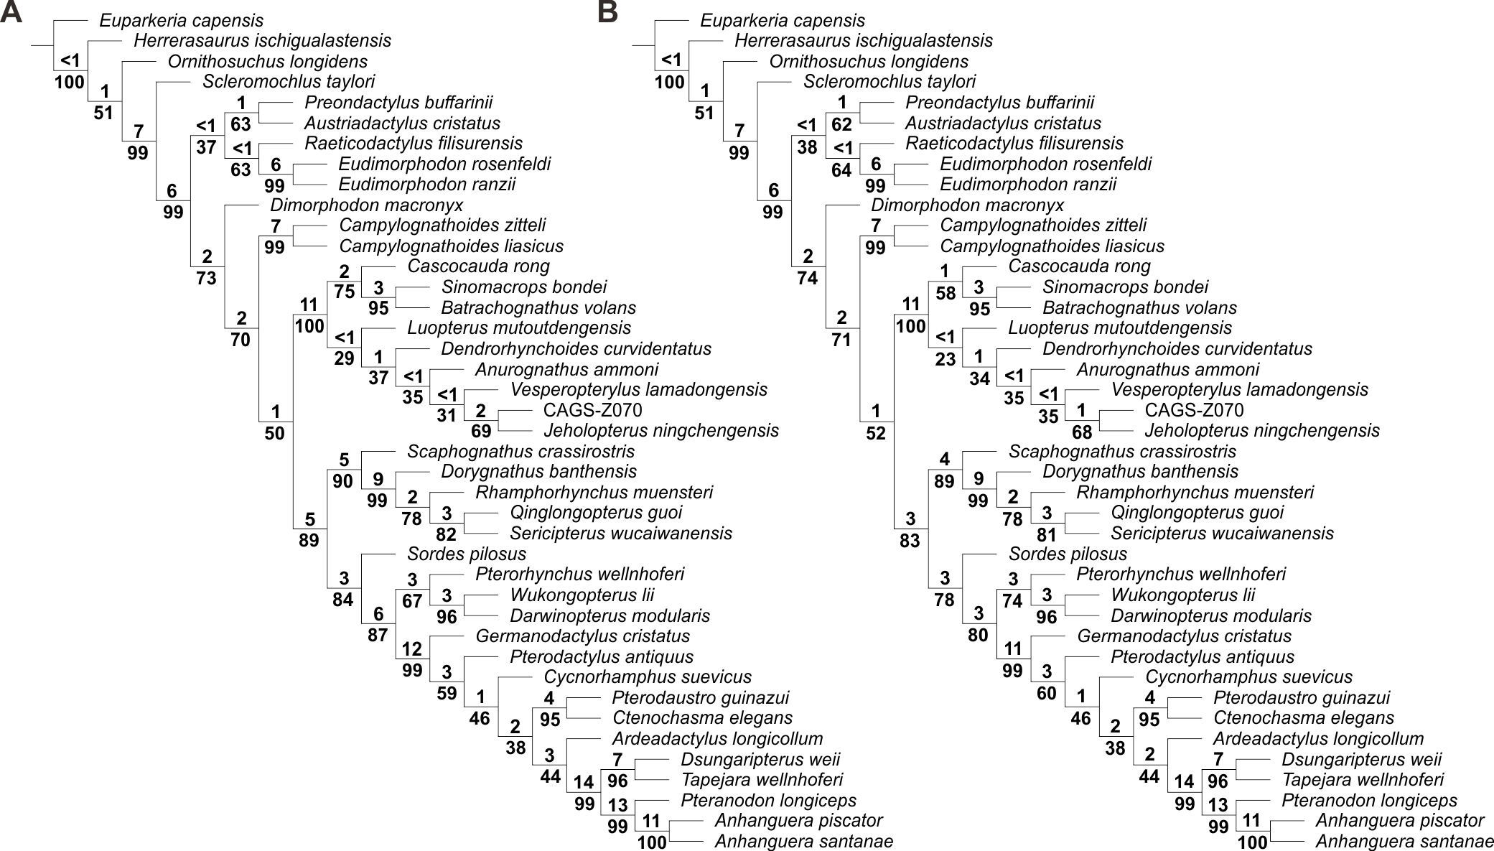
FIGURE S4. Single most parsimonious trees based on Supplemental Data 4 (A) (tree length=852.302 steps; CI=0.441; RI=0.707) and Supplemental Data 5 (B) (tree length=853.227 steps; CI=0.441; RI=0.707). Bremer support and bootstrap values for the ingroup nodes are shown above and below branches, respectively.

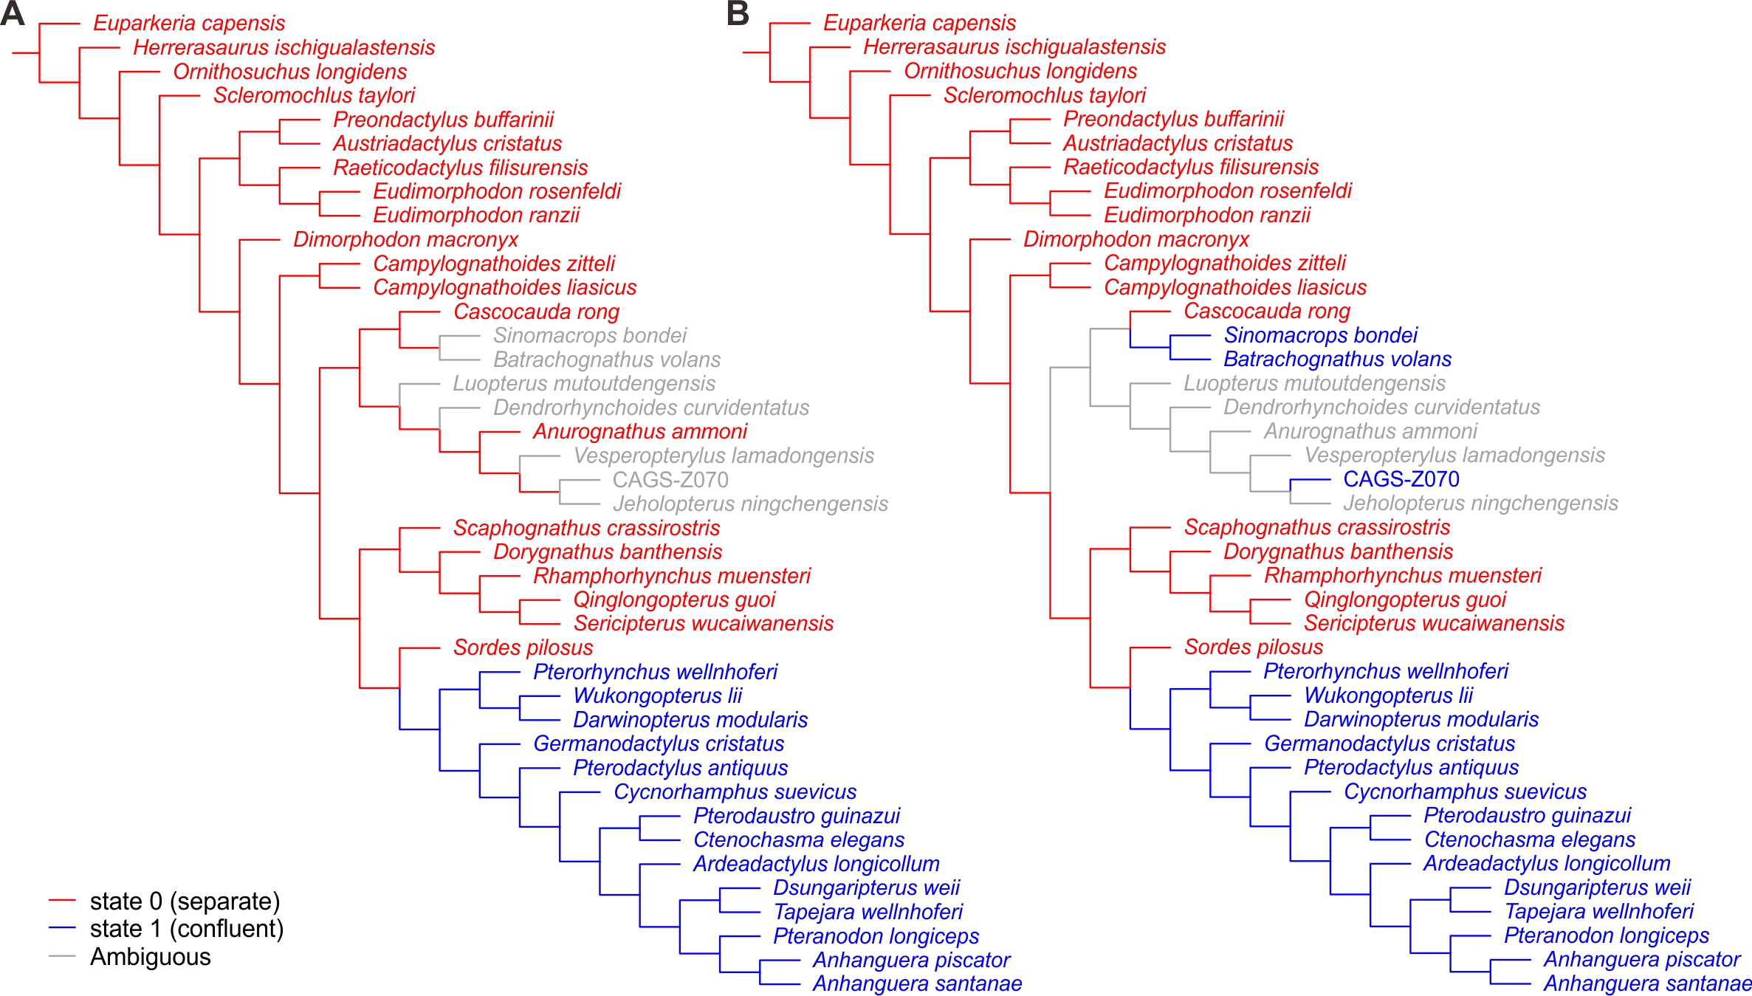
FIGURE S5 (previous page). Character mapping of Char. 74, configuration of external naris and antorbital fenestra, based on Supplemental Data 3 (A) and Supplemental Data 5 (B).

Supplemental Phylogenetic Results
Four synapomorphies support Batrachognathinae in our analysis (with character state given after each character): Char. 53 (0.017), ratio of length to mid-width of the first phalanx of pedal digit IV (1.7); Char. 282 (0), deltopectoral crest projection (less wide than humerus shaft); Char. 283 (2), humerus ulnar crest shape (rounded); and Char. 285 (2), deltopectoral crest size (shorter than the width of humeral head). The clade (Batrachognathus volans + Sinomacrops bondei) is supported by following six synapomorphies: Char. 3 (0.090), length ratio of rostrum to skull (0.09); Char. 14 (0.057), length ratio of rostral tooth row to skull (0.09); Char. 16 (0.053), length ratio of mandibular symphysis to mandible (0.09); Char. 234 (4), humerus deltopectoral crest shape (low and rectangular); Char. 279 (1), dorsoventral height of pedal ungual (less than twice that of the preceding phalanx); Char. 284 (1), broadness of the jaws in occlusal view (describing a semi-ellipse).
Anurognathinae is supported by three synapomorphies: Char. 25 (0.125), ratio of length to diameter of single caudal vertebra (2.0); Char. 49 (0.031), length ratio of tail to humerus (0.66); and Char. 50 (0.138–0.146), length ratio of tibia to humerus (about 1.0).
Within Anurognathinae, the clade separated from Luopterus mutoudengensis is supported by six synapomorphies: Char. 25 (0.005–0.015), ratio of length to diameter of single caudal vertebra (0.90–1.0); Char. 26 (0.206), length ratio of scapula to coracoid (1.2); Char. 30 (0.568–0.656), length ratio of ulna/radius to humerus (ca. 1.4); Char. 51 (0.141–0.144), length ratio of tibia to ulna (ca. 0.75); Char. 208 (1), number of caudal vertebrae (at most 15); and Char. 209 (0), length of caudal vertebra zygapophyses (short).
The clade composed of Anurognathus ammoni, Vesperopterylus lamadongensis, Jeholopterus ningchengensis and CAGS-Z070 is supported by the following synapomorphies: Char. 22 (0.241), ratio of length to diameter of single dorsal vertebra (1.3); Char. 24 (0.006), length ratio of single caudal vertebra to dorsal vertebra (0.47); Char. 34 (0.330), ratio of metacarpal IV mid-width to ulna and radius combined mid-width (0.42); Char. 35 (0.425), ratio of dorsoventral width to mid-width at the proximal end of metacarpal IV (2.0); Char. 234 (1), humerus deltopectoral crest shape (proximally leaning trapezoid); and Char. 278 (1), metatarsal V more robust than metatarsal I-IV (present).
Further, the monophyly of Vesperopterylus lamadongensis, Jeholopterus ningchengensis and specimen CAGS-Z070 is supported by four synapomorphies: Char. 15 (0.012–0.016), number of teeth (24–28); Char. 55 (0.129–0.137), ratio of length to mid-width of the third phalanx of pedal digit IV (about 0.90); Char. 280 (1), shape of dorsal ribs from the anterior portion of the body (distinctly curved); and Char. 281 (1), robust first phalanx of pedal digit V (present). The sister-group relationship between Jeholopterus ningchengensis and CAGS-Z070 is supported by 13 synapomorphies (see below for details).

Synapomorphies are listed below for the internal nodes of Fig. S3:
Node 42:
Char. 2: 0.611 --> 0.487-0.592
Char. 3: 0.034 --> 0.043
Char. 4: 0.093 --> 0.102-0.411
Char. 10: 0.270 --> 0.349-0.422
Char. 23: 0.000 --> 0.125
Char. 28: 0.068 --> 0.152
Char. 47: 0.075 --> 0.264
Char. 48: 0.150 --> 0.308
Char. 52: 0.334 --> 0.434
Char. 53: 0.081 --> 0.302
Char. 54: 0.139 --> 0.247-0.373
Char. 83: 0 --> 1
Char. 285: 2 --> 1
Node 43:
No synapomorphies
Node 44:
Char. 1: 0.491 --> 0.359-0.376
Char. 3: 0.043 --> 0.197
Char. 6: 0.642-0.725 --> 0.567
Char. 17: 0.132-0.210 --> 0.358-0.364
Char. 22: 0.051-0.379 --> 0.683-0.701
Char. 23: 0.125 --> 0.250
Char. 24: 0.084-0.103 --> 0.117
Char. 28: 0.152 --> 0.394
Char. 30: 0.055-0.060 --> 0.089
Char. 31: 0.575-0.758 --> 0.458
Char. 42: 0.024-0.083 --> 0.208-0.237
Char. 44: 0.016-0.067 --> 0.218
Char. 52: 0.434 --> 0.529
Char. 56: 0 --> 1
Char. 65: 0 --> 1
Char. 72: 0 --> 1
Char. 94: 0 --> 1
Char. 114: 0 --> 12
Char. 119: 0 --> 1
Char. 164: 0 --> 2
Char. 265: 0 --> 1
Char. 279: 1 --> 0
Node 45:
Char. 2: 0.382-0.407 --> 0.349
Char. 5: 0.521 --> 0.744
Char. 6: 0.525 --> 0.321
Char. 10: 0.349-0.422 --> 0.694
Char. 19: 0.601-0.662 --> 0.754
Char. 20: 0.064-0.084 --> 0.042
Char. 32: 0.128-0.177 --> 0.262
Char. 80: 0 --> 1
Char. 115: 0 --> 1
Char. 155: 0 --> 1
Char. 164: 2 --> 1
Char. 180: 0 --> 1
Char. 186: 3 --> 4
Node 46:
Char. 3: 0.204-0.251 --> 0.352
Char. 21: 0.169-0.248 --> 0.255-0.261
Char. 22: 0.683-0.701 --> 0.731-0.777
Char. 36: 0.375-0.402 --> 0.460
Char. 37: 0.529-0.618 --> 0.404
Char. 44: 0.474 --> 0.537
Char. 50: 0.329-0.389 --> 0.222
Char. 51: 0.341 --> 0.204
Char. 81: 0 --> 1
Char. 146: 0 --> 1
Char. 183: 0 --> 1
Char. 186: 1 --> 3
Char. 187: 1 --> 2
Char. 191: 0 --> 1
Node 47:
Char. 2: 0.438 --> 0.382-0.407
Char. 5: 0.375-0.455 --> 0.509-0.521
Char. 24: 0.222-0.236 --> 0.454-0.834
Char. 28: 0.426 --> 0.433-0.435
Char. 30: 0.494 --> 0.496-0.547
Char. 52: 0.529-0.712 --> 0.944
Char. 173: 0 --> 1
Node 48:
Char. 2: 0.487-0.592 --> 0.438
Char. 3: 0.197 --> 0.204-0.251
Char. 4: 0.102-0.411 --> 0.413-0.478
Char. 7: 0.604-0.626 --> 0.539-0.573
Char. 13: 0.697 --> 0.576-0.602
Char. 19: 0.398-0.417 --> 0.601-0.662
Char. 20: 0.158 --> 0.064-0.084
Char. 21: 0.065-0.088 --> 0.169-0.248
Char. 24: 0.117 --> 0.222-0.236
Char. 25: 0.209 --> 0.507-0.539
Char. 26: 0.530-0.795 --> 0.321-0.335
Char. 28: 0.394 --> 0.426
Char. 30: 0.089 --> 0.494
Char. 31: 0.458 --> 0.427
Char. 33: 0.001-0.030 --> 0.153
Char. 34: 0.085-0.109 --> 0.448
Char. 36: 0.001 --> 0.375-0.402
Char. 43: 0.681 --> 0.264-0.332
Char. 44: 0.218 --> 0.474
Char. 45: 0.994 --> 0.575
Char. 46: 0.873 --> 0.620-0.708
Char. 51: 0.669 --> 0.341-0.355
Char. 97: 0 --> 12
Char. 129: 0 --> 1
Char. 137: 0 --> 1
Char. 170: 1 --> 0
Char. 177: 0 --> 2
Char. 216: 0 --> 1
Char. 227: 0 --> 1
Node 49:
Char. 0: 0.157-0.180 --> 0.192
Char. 10: 0.349-0.422 --> 0.348
Char. 16: 0.115 --> 0.112
Char. 17: 0.358-0.364 --> 0.421
Char. 30: 0.496-0.547 --> 0.568
Char. 100: 0 --> 1
Node 50:
Char. 45: 0.575 --> 0.521-0.565
Char. 48: 0.561 --> 0.848-0.865
Char. 71: 0 --> 1
Char. 84: 0 --> 1
Char. 95: 0 --> 1
Char. 161: 0 --> 1
Char. 164: 2 --> 3
Char. 168: 0 --> 1
Char. 178: 0 --> 1
Char. 185: 0 --> 1
Char. 209: 0 --> 2
Char. 216: 1 --> 2
Char. 229: 0 --> 1
Char. 253: 0 --> 1
Char. 255: 0 --> 1
Char. 260: 0 --> 1
Char. 263: 0 --> 1
Node 51:
Char. 5: 0.375-0.455 --> 0.476
Char. 7: 0.514-0.573 --> 0.627
Char. 10: 0.411-0.431 --> 0.561
Char. 20: 0.064-0.084 --> 0.113
Char. 28: 0.426 --> 0.299
Char. 30: 0.494 --> 0.439
Char. 32: 0.100-0.177 --> 0.203
Char. 36: 0.398-0.564 --> 0.621
Char. 44: 0.474 --> 0.433
Char. 119: 1 --> 0
Char. 142: 1 --> 2
Char. 191: 0 --> 1
Char. 219: 0 --> 1
Char. 220: 1 --> 0
Char. 226: 0 --> 1
Char. 240: 0 --> 1
Char. 252: 0 --> 1
Char. 258: 0 --> 1
Node 52:
Char. 6: 0.525-0.567 --> 0.328-0.485
Char. 39: 0.737 --> 0.617-0.630
Char. 40: 0.173 --> 0.080-0.098
Char. 42: 0.237 --> 0.647-0.662
Char. 43: 0.264 --> 0.135-0.188
Char. 50: 0.329-0.389 --> 0.211-0.217
Char. 51: 0.341-0.355 --> 0.152
Char. 52: 0.529-0.712 --> 0.451-0.453
Char. 53: 0.302-0.328 --> 0.148-0.244
Char. 54: 0.247-0.459 --> 0.188-0.210
Char. 141: 0 --> 1
Char. 154: 0 --> 1
Char. 180: 0 --> 1
Char. 189: 1 --> 0
Char. 268: 0 --> 1
Char. 273: 0 --> 1
Node 53:
Char. 15: 0.020-0.024 --> 0.016
Char. 26: 0.198 --> 0.135
Char. 28: 0.273 --> 0.259
Char. 31: 0.536-0.582 --> 0.673
Char. 56: 2 --> 3
Char. 176: 0 --> 1
Char. 182: 0 --> 1
Char. 239: 1 --> 0
Node 54:
Char. 0: 0.211 --> 0.217
Char. 16: 0.441 --> 0.460
Char. 17: 0.364 --> 0.450
Char. 19: 0.649 --> 0.690
Char. 21: 0.287-0.333 --> 0.227-0.284
Char. 26: 0.266 --> 0.198
Char. 28: 0.361 --> 0.273
Char. 33: 0.186 --> 0.189
Char. 36: 0.409 --> 0.423-0.601
Char. 37: 0.645-0.661 --> 0.356-0.493
Char. 38: 0.696-0.711 --> 0.573
Char. 46: 0.598 --> 0.637
Char. 47: 0.630-0.729 --> 0.450
Char. 48: 0.746 --> 0.659
Char. 56: 1 --> 2
Char. 184: 1 --> 2
Char. 188: 1 --> 0
Node 55:
Char. 0: 0.157-0.202 --> 0.211
Char. 3: 0.353 --> 0.456-0.475
Char. 5: 0.375-0.455 --> 0.736
Char. 14: 0.736 --> 0.784-0.866
Char. 16: 0.249-0.406 --> 0.441
Char. 19: 0.570 --> 0.649
Char. 20: 0.064-0.084 --> 0.112
Char. 24: 0.222 --> 0.253-0.256
Char. 28: 0.394 --> 0.361
Char. 33: 0.183 --> 0.186
Char. 41: 0.524 --> 0.702
Char. 42: 0.647 --> 0.623
Char. 48: 0.848-0.865 --> 0.746
Char. 52: 0.258 --> 0.347-0.377
Char. 53: 0.148-0.244 --> 0.534-0.538
Char. 54: 0.051-0.109 --> 0.236-0.239
Char. 69: 0 --> 1
Char. 75: 0 --> 1
Char. 94: 1 --> 0
Char. 140: 0 --> 1
Char. 181: 0 --> 1
Char. 183: 0 --> 1
Char. 191: 0 --> 1
Char. 285: 1 --> 0
Node 56:
Char. 28: 0.426-0.471 --> 0.394
Char. 39: 0.630 --> 0.741-0.853
Char. 73: 0 --> 1
Char. 161: 1 --> 0
Char. 165: 0 --> 1
Char. 173: 3 --> 2
Char. 175: 0 --> 1
Char. 234: 0 --> 3
Char. 239: 0 --> 1
Node 57:
Char. 16: 0.115 --> 0.249-0.406
Char. 21: 0.173-0.248 --> 0.287-0.333
Char. 30: 0.719-0.786 --> 0.837-0.856
Char. 34: 0.448-0.563 --> 0.573-0.589
Char. 37: 0.572-0.618 --> 0.645
Char. 45: 0.521-0.565 --> 0.210-0.456
Char. 46: 0.620-0.708 --> 0.475-0.598
Char. 117: 0 --> 1
Char. 148: 0 --> 1
Char. 170: 1 --> 2
Char. 223: 1 --> 2
Char. 250: 0 --> 1
Char. 259: 0 --> 1
Char. 271: 0 --> 1
Char. 273: 1 --> 2
Char. 279: 0 --> 1
Node 58:
Char. 14: 0.760-0.814 --> 0.671-0.736
Char. 15: 0.044-0.054 --> 0.020-0.024
Char. 19: 0.601-0.694 --> 0.527-0.570
Char. 25: 0.507-0.539 --> 0.389-0.456
Char. 30: 0.494 --> 0.719-0.786
Char. 31: 0.427 --> 0.536-0.551
Char. 49: 0.641 --> 0.440-0.496
Char. 51: 0.152 --> 0.112-0.137
Char. 52: 0.451-0.453 --> 0.220-0.258
Char. 54: 0.188-0.210 --> 0.096-0.109
Char. 67: 0 --> 1
Char. 170: 0 --> 1
Char. 173: 0 --> 3
Char. 178: 1 --> 2
Char. 179: 1 --> 0
Char. 246: 0 --> 1
Node 59:
Char. 17: 0.358-0.364 --> 0.463-0.527
Char. 26: 0.266 --> 0.261
Char. 28: 0.426-0.471 --> 0.522-0.608
Char. 34: 0.573-0.589 --> 0.609
Char. 42: 0.647-0.662 --> 0.706-0.746
Char. 52: 0.220-0.258 --> 0.139-0.194
Char. 55: 0.357-0.591 --> 0.116-0.287
Char. 100: 0 --> 1
Char. 113: 0 --> 1
Char. 115: 0 --> 1
Char. 243: 2 --> 4
Node 60:
Char. 14: 0.671-0.686 --> 0.659
Char. 15: 0.026-0.040 --> 0.042
Char. 38: 0.830 --> 0.929
Char. 39: 0.674 --> 0.977
Char. 184: 1 --> 3
Char. 188: 1 --> 2
Char. 263: 1 --> 0
Node 61:
Char. 24: 0.222 --> 0.364
Char. 25: 0.389-0.456 --> 0.563-0.734
Char. 37: 0.645 --> 0.780-0.981
Char. 38: 0.696 --> 0.830
Char. 39: 0.630 --> 0.674
Char. 41: 0.627-0.689 --> 0.719
Char. 45: 0.188-0.201 --> 0.167
Char. 164: 3 --> 0
Char. 182: 0 --> 1
Char. 193: 0 --> 1
Char. 229: 1 --> 0
Node 62:
Char. 3: 0.256-0.353 --> 0.439
Char. 11: 0.384-0.492 --> 0.231
Char. 13: 0.508-0.602 --> 0.321
Char. 15: 0.020-0.024 --> 0.026-0.040
Char. 20: 0.064-0.084 --> 0.123-0.233
Char. 22: 0.683-0.841 --> 0.410-0.506
Char. 32: 0.109 --> 0.206
Char. 33: 0.153-0.183 --> 0.207-0.228
Char. 41: 0.484-0.524 --> 0.627-0.689
Char. 45: 0.210 --> 0.188-0.201
Char. 48: 0.848-0.865 --> 0.569-0.804
Char. 74: 0 --> 1
Char. 79: 2 --> 4
Char. 197: 0 --> 1
Char. 201: 0 --> 1
Char. 202: 0 --> 1
Char. 260: 1 --> 0
Node 63:
Char. 3: 0.093-0.124 --> 0.090
Char. 14: 0.060-0.092 --> 0.057
Char. 16: 0.057-0.093 --> 0.053
Char. 234: 0 --> 4
Char. 279: 0 --> 1
Char. 284: 2 --> 1
Node 64:
Char. 53: 0.021-0.193 --> 0.017
Char. 282: 1 --> 0
Char. 283: 0 --> 2
Char. 285: 1 --> 2
Node 65:
Char. 1: 0.359-0.376 --> 0.000
Char. 2: 0.438 --> 0.776-0.782
Char. 3: 0.251-0.307 --> 0.093-0.124
Char. 4: 0.422 --> 0.026
Char. 5: 0.375-0.455 --> 0.004
Char. 6: 0.328-0.485 --> 0.239
Char. 7: 0.514-0.573 --> 0.162
Char. 14: 0.671-0.736 --> 0.060-0.092
Char. 16: 0.115 --> 0.057-0.093
Char. 19: 0.527-0.570 --> 0.460-0.514
Char. 22: 0.683-0.708 --> 0.260-0.275
Char. 24: 0.222 --> 0.105
Char. 25: 0.389-0.456 --> 0.147-0.163
Char. 32: 0.087-0.109 --> 0.039
Char. 33: 0.153 --> 0.115
Char. 34: 0.448-0.563 --> 0.432
Char. 35: 0.527-0.604 --> 0.450
Char. 37: 0.572-0.618 --> 0.082
Char. 38: 0.577-0.696 --> 0.166
Char. 39: 0.617-0.630 --> 0.000
Char. 43: 0.135-0.188 --> 0.120
Char. 46: 0.620-0.708 --> 0.780
Char. 49: 0.440-0.496 --> 0.120-0.124
Char. 64: 0 --> 1
Char. 67: 1 --> 3
Char. 68: 1 --> 0
Char. 70: 1 --> 0
Char. 75: 0 --> 1
Char. 82: 0 --> 1
Char. 98: 0 --> 1
Char. 116: 0 --> 1
Char. 136: 0 --> 1
Char. 137: 1 --> 0
Char. 144: 0 --> 1
Char. 150: 0 --> 2
Char. 162: 0 --> 1
Char. 164: 3 --> 2
Char. 201: 0 --> 1
Char. 209: 2 --> 1
Char. 243: 2 --> 5
Char. 280: 1 --> 0
Char. 284: 0 --> 2
Node 66:
Char. 3: 0.094 --> 0.103
Char. 14: 0.062 --> 0.071
Char. 16: 0.058 --> 0.069
Char. 20: 0.064 --> 0.049
Char. 21: 0.173 --> 0.164
Char. 31: 0.530-0.555 --> 0.503
Char. 36: 0.558 --> 0.503
Char. 44: 0.454-0.474 --> 0.375
Char. 50: 0.138-0.146 --> 0.006
Char. 51: 0.141 --> 0.036
Char. 52: 0.220-0.224 --> 0.151
Char. 54: 0.096 --> 0.089
Char. 277: 0 --> 1
Node 67:
Char. 15: 0.018 --> 0.012-0.016
Char. 55: 0.357-0.501 --> 0.129-0.137
Char. 280: 0 --> 1
Char. 281: 0 --> 1
Node 68:
Char. 22: 0.260 --> 0.241
Char. 24: 0.016 --> 0.006
Char. 34: 0.432 --> 0.330
Char. 35: 0.450 --> 0.425
Char. 234: 0 --> 1
Char. 278: 0 --> 1
Node 69:
Char. 25: 0.125 --> 0.005-0.015
Char. 26: 0.266-0.321 --> 0.206
Char. 30: 0.719-0.786 --> 0.568-0.656
Char. 51: 0.112-0.137 --> 0.141-0.144
Char. 208: 0 --> 1
Char. 209: 1 --> 0
Node 70:
Char. 25: 0.147-0.163 --> 0.125
Char. 49: 0.120-0.124 --> 0.031
Char. 50: 0.211-0.212 --> 0.138-0.146
Node 71:
Char. 0: 0.342-0.443 --> 0.708
Char. 3: 0.700 --> 0.876
Char. 8: 0.453 --> 0.039
Char. 14: 0.637 --> 0.829
Char. 15: 0.046 --> 0.398
Char. 16: 0.605-0.657 --> 0.913
Char. 19: 0.527-0.672 --> 0.797
Char. 28: 0.564-0.596 --> 0.605
Char. 40: 0.035-0.037 --> 0.054
Char. 41: 0.685-0.690 --> 0.813
Char. 43: 0.301-0.407 --> 0.203
Char. 46: 0.186-0.478 --> 0.585
Char. 47: 0.078 --> 0.017
Char. 48: 0.151 --> 0.004
Char. 50: 0.413-0.433 --> 0.365
Char. 51: 0.325-0.338 --> 0.315
Char. 66: 0 --> 1
Char. 101: 1 --> 2
Char. 170: 2 --> 1
Char. 178: 2 --> 1
Node 72:
Char. 3: 0.561-0.641 --> 0.700
Char. 16: 0.569 --> 0.605-0.657
Char. 31: 0.489 --> 0.414-0.425
Char. 182: 0 --> 1
Char. 195: 0 --> 1
Char. 199: 0 --> 1
Node 73:
Char. 11: 0.192-0.231 --> 0.246-0.251
Char. 26: 0.261 --> 0.207
Char. 31: 0.492-0.551 --> 0.489
Char. 36: 0.435-0.461 --> 0.539-0.696
Char. 37: 0.358-0.363 --> 0.099-0.309
Char. 38: 0.437-0.455 --> 0.157-0.306
Char. 39: 0.516 --> 0.375-0.478
Char. 44: 0.501-0.543 --> 0.550-0.587
Char. 45: 0.188 --> 0.145
Char. 68: 1 --> 2
Char. 173: 3 --> 2
Char. 175: 0 --> 1
Node 74:
Char. 0: 0.292 --> 0.302-0.443
Char. 3: 0.545 --> 0.561-0.641
Char. 8: 0.564 --> 0.453-0.517
Char. 10: 0.411 --> 0.538-0.636
Char. 14: 0.671-0.686 --> 0.610-0.637
Char. 21: 0.448 --> 0.510-0.636
Char. 24: 0.009 --> 0.008
Char. 39: 0.593 --> 0.516
Char. 43: 0.275 --> 0.301
Char. 50: 0.394 --> 0.413
Char. 52: 0.110 --> 0.103-0.107
Char. 53: 0.165-0.377 --> 0.389-0.447
Char. 112: 0 --> 1
Char. 126: 1 --> 2
Char. 161: 1 --> 0
Char. 274: 0 --> 1
Node 75:
Char. 0: 0.202-0.273 --> 0.292
Char. 3: 0.439 --> 0.545
Char. 16: 0.249-0.406 --> 0.569
Char. 17: 0.463-0.527 --> 0.584
Char. 20: 0.123-0.233 --> 0.532
Char. 22: 0.410-0.506 --> 0.254-0.274
Char. 24: 0.222 --> 0.009
Char. 25: 0.389-0.456 --> 0.062-0.074
Char. 30: 0.837-0.856 --> 0.509-0.547
Char. 32: 0.206 --> 0.628-0.644
Char. 33: 0.207-0.228 --> 0.425-0.476
Char. 35: 0.527-0.604 --> 0.259
Char. 36: 0.391-0.409 --> 0.435-0.461
Char. 37: 0.645 --> 0.358-0.363
Char. 38: 0.696 --> 0.437-0.455
Char. 39: 0.630 --> 0.593
Char. 42: 0.706-0.746 --> 0.763-0.921
Char. 43: 0.168-0.226 --> 0.275
Char. 50: 0.217-0.294 --> 0.394
Char. 51: 0.112-0.199 --> 0.325-0.338
Char. 52: 0.139-0.194 --> 0.110
Char. 54: 0.051-0.109 --> 0.021-0.033
Char. 88: 1 --> 3
Char. 101: 0 --> 1
Char. 107: 0 --> 1
Char. 114: 2 --> 3
Char. 132: 0 --> 1
Char. 177: 2 --> 1
Char. 201: 1 --> 2
Char. 247: 0 --> 1
Char. 248: 1 --> 0
Char. 253: 2 --> 3
Char. 272: 2 --> 3
Char. 273: 2 --> 3
Node 76:
Char. 37: 0.099-0.309 --> 0.091
Char. 39: 0.375-0.478 --> 0.270-0.312
Char. 42: 0.763-0.921 --> 0.658-0.716
Char. 159: 0 --> 1
Char. 173: 2 --> 5
Char. 184: 1 --> 3
Char. 223: 2 --> 1
Char. 224: 0 --> 1
Char. 227: 1 --> 0
Node 77:
Char. 13: 0.153-0.321 --> 0.336
Char. 26: 0.081 --> 0.015
Char. 31: 0.302 --> 0.024
Char. 35: 0.210-0.255 --> 0.260
Char. 52: 0.103-0.107 --> 0.005
Char. 59: 0 --> 1
Char. 79: 4 --> 2
Char. 102: 0 --> 1
Char. 108: 0 --> 1
Char. 110: 2 --> 0
Char. 159: 1 --> 0
Char. 192: 0 --> 1
Char. 207: 1 --> 0
Char. 213: 0 --> 1
Char. 222: 0 --> 1
Char. 224: 1 --> 0
Node 78:
Char. 2: 0.250-0.278 --> 0.300-0.369
Char. 11: 0.246-0.251 --> 0.093-0.113
Char. 16: 0.621-0.657 --> 0.733-0.762
Char. 26: 0.207 --> 0.081
Char. 31: 0.410-0.425 --> 0.302
Char. 42: 0.658-0.716 --> 0.575
Char. 43: 0.301-0.407 --> 0.292
Char. 63: 0 --> 1
Char. 71: 1 --> 0
Char. 99: 0 --> 1
Char. 118: 0 --> 1
Char. 121: 0 --> 1
Char. 198: 0 --> 1
Char. 210: 0 --> 1
Char. 212: 0 --> 1
Char. 217: 1 --> 0
Char. 218: 1 --> 0
Char. 221: 0 --> 1
Char. 228: 1 --> 0
Char. 235: 0 --> 1
Char. 241: 0 --> 1
Char. 242: 0 --> 1
Char. 245: 0 --> 1
Char. 253: 3 --> 2
Char. 270: 0 --> 1
Node 79:
Char. 1: 0.625 --> 0.638
Char. 9: 0.365-0.419 --> 0.048-0.241
Char. 10: 0.538 --> 0.159-0.415
Char. 12: 0.430 --> 0.415
Char. 17: 0.584-0.919 --> 0.545
Char. 20: 0.532-0.739 --> 0.245-0.395
Char. 24: 0.006-0.008 --> 0.016-0.020
Char. 30: 0.509-0.547 --> 0.580-0.621
Char. 32: 0.644 --> 0.607
Char. 67: 1 --> 0
Char. 103: 0 --> 1
Char. 109: 0 --> 1
Char. 111: 1 --> 0
Char. 112: 1 --> 0
Char. 114: 3 --> 2
Char. 126: 2 --> 1
Char. 164: 2 --> 0
Char. 165: 0 --> 12
Char. 193: 0 --> 1
Char. 196: 0 --> 1
Char. 197: 1 --> 0
Char. 202: 1 --> 0
Char. 203: 0 --> 1
Char. 211: 0 --> 1
Char. 219: 0 --> 1
Char. 236: 0 --> 1
Char. 251: 0 --> 1
Char. 260: 0 --> 1
Char. 274: 1 --> 0
Node 80:
Char. 0: 0.342 --> 0.282
Char. 1: 0.638 --> 0.651
Char. 2: 0.250-0.278 --> 0.140
Char. 3: 0.700 --> 0.548
Char. 8: 0.453 --> 0.482
Char. 9: 0.048-0.241 --> 0.044
Char. 11: 0.246-0.251 --> 0.295
Char. 12: 0.415 --> 0.033
Char. 17: 0.545 --> 0.393
Char. 26: 0.207 --> 0.241
Char. 28: 0.564 --> 0.402
Char. 31: 0.410-0.425 --> 0.461
Char. 34: 0.673-0.703 --> 0.769
Char. 43: 0.301-0.407 --> 0.415
Char. 61: 0 --> 1
Char. 87: 0 --> 1
Char. 122: 0 --> 1
Char. 130: 0 --> 1
Char. 151: 0 --> 1
Char. 237: 0 --> 1
Char. 238: 0 --> 1
Char. 239: 0 --> 1
Char. 240: 0 --> 1
Char. 244: 0 --> 1
Char. 261: 0 --> 1
Char. 269: 0 --> 1

LITERATURE CITED

Hone, D. W. E. 2020. A review of the taxonomy and palaeoecology of the Anurognathidae (Reptilia, Pterosauria). Acta Geologica Sinica 94:1676–1692.
Longrich, N.R., D.M. Martill, and B. Andres. 2018. Late Maastrichtian pterosaurs from North Africa and mass extinction of Pterosauria at the Cretaceous-Paleogene boundary. PLoS Biology 16:e2001663.
Lü, J., and D. W. E. Hone. 2012. A new Chinese anurognathid pterosaur and the evolution of pterosaurian tail lengths. Acta Geologica Sinica 86:1317–1325.
Lü, J., Q. Meng, B. Wang, D. Liu, C. Shen, and Y. Zhang. 2018. Short note on a new anurognathid pterosaur with evidence of perching behaviour from Jianchang of Liaoning Province, China. Geological Society, London, Special Publications 455:95–104.
Wang, X., Z. Zhou, F. Zhang, and X. Xu. 2002. A nearly completely articulated rhamphorhynchoid pterosaur with exceptionally well-preserved wing membranes and “hairs” from Inner Mongolia, northeast China. Chinese Science Bulletin 47:226–230.
Wei, X., R.V. Pêgas, C. Shen, Y. Guo, W. Ma, D. Sun and X. Zhou. 2021. Sinomacrops bondei, a new anurognathid pterosaur from the Jurassic of China and comments on the group. PeerJ 9:e11161.

