Table S1. Viscosity and diffusion coefficients used in the 1/12° global ocean simulation
Parameters | Values
Laplacian coefficient for momentum | 20 m² s⁻¹
Biharmonic diffusive velocity for momentum | 1 cm s⁻¹
Biharmonic diffusive velocity for layer thickness | 1.5 cm s⁻¹
Laplacian diffusive velocity for tracers | 0.5 cm s⁻¹

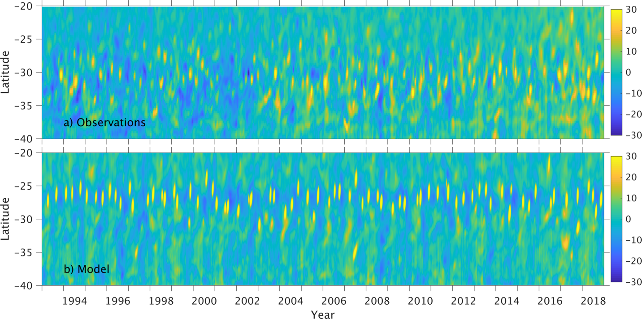
Figure S1: Observed and modeled sea-surface height (SSH) anomaly along the Prime Meridian in latitude range 20-40°S from 1993 to 2018. The high SSH anomaly denotes the west-/northwestward translation of the Agulhas Rings that pass the Prime Meridian.

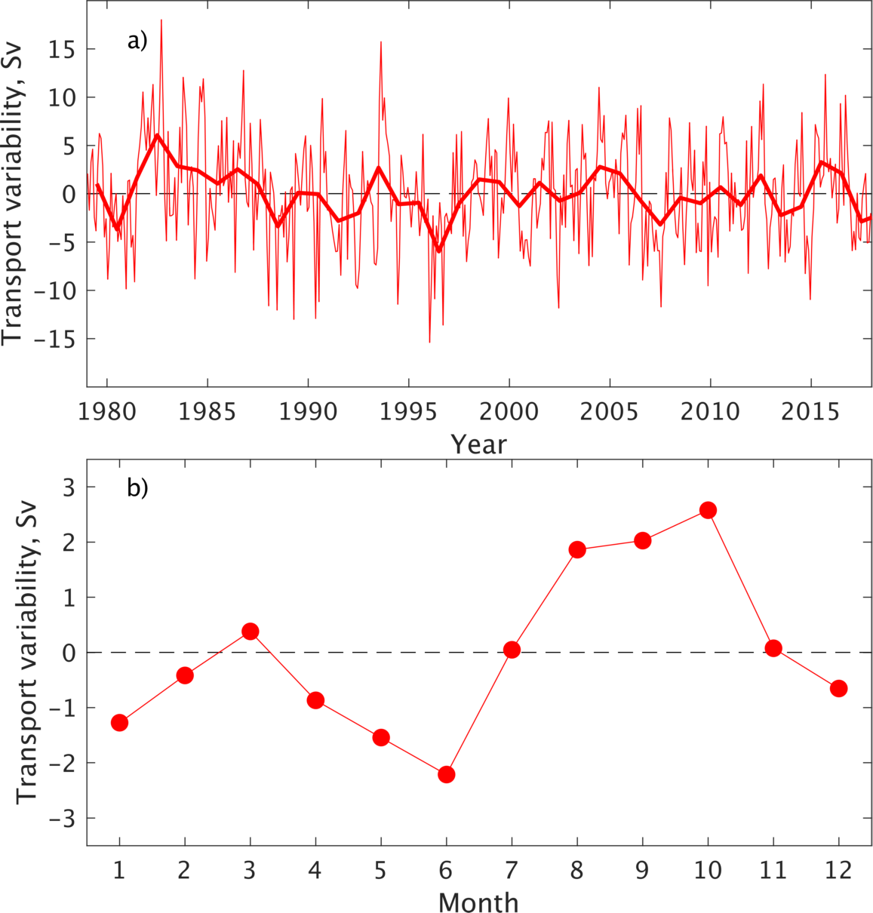

Figure S2: a) Variability of the modeled ACC transport through the Drake Passage at the 65°W, with thin and thick lines represent monthly means and annual means, respectively; b) Seasonal variability of the modeled ACC transports averaged over 1979-2018.

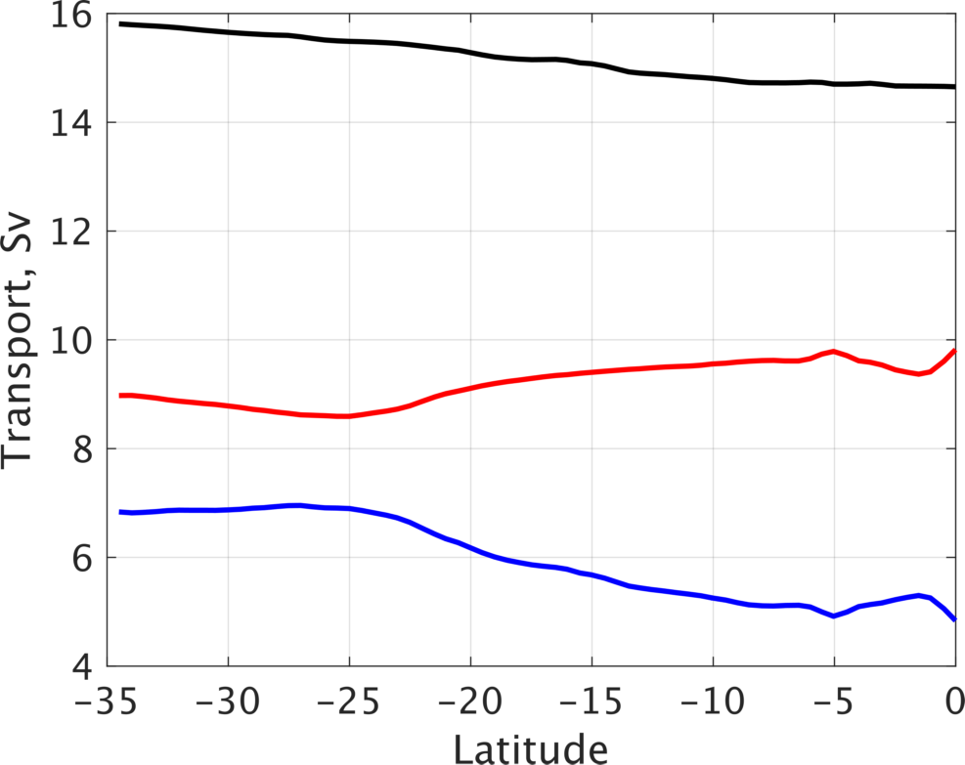

Figure S3. Latitudinal variability of the time averaged AMOC transports (black line), and contributions from the near surface Water ($σ_{2}$<35.65 kg m⁻³, red line) and the Antarctic Intermediate Water (35.65<$σ_{2}$<36.58 kg m⁻³, blue line) in the South Atlantic Ocean.

