Supplementary Material

Supplementary Figures
(A)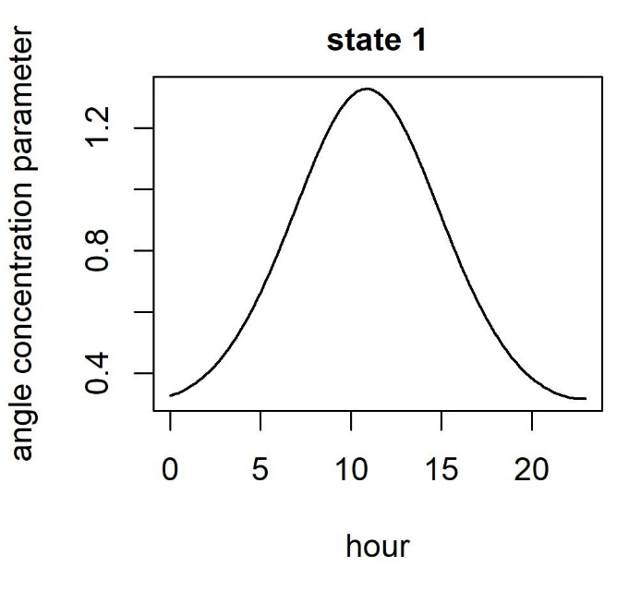(B)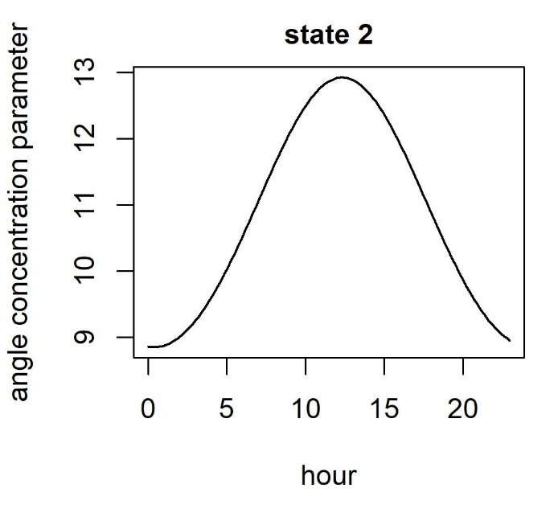
(C)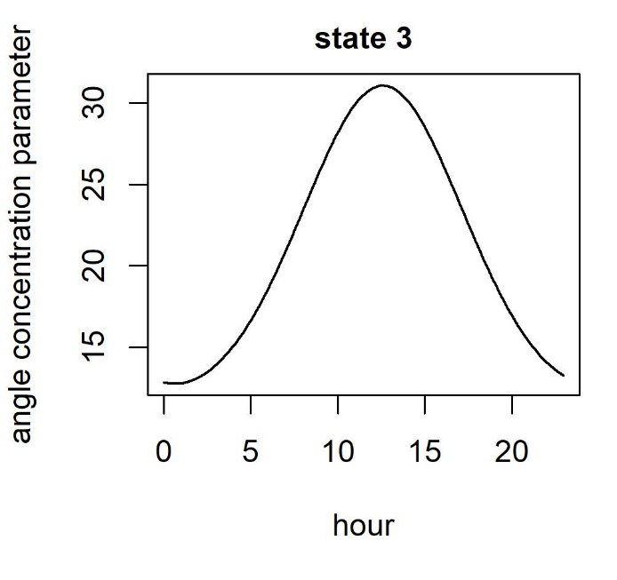
Figure S 1. Variation in the distribution of turning angle for each behavioural state with hour of day for (A) state 1 - intensive search, (B) state 2 - extensive search, and (C) state 3 - transiting.

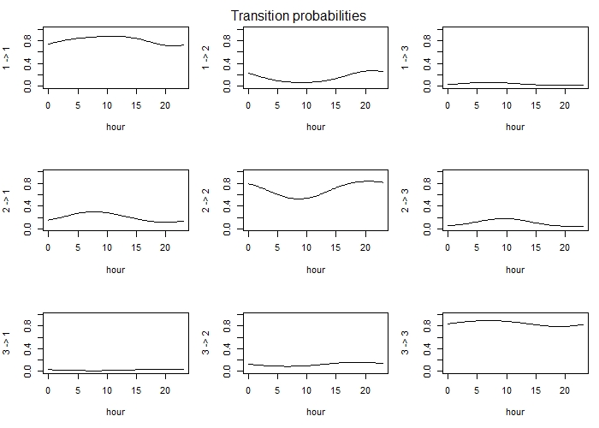
Figure S 2. The probability (y-axis) of transitioning between behavioural states for breeding Leach's Storm-Petrels with hour of the day. State 1 is intensive search, state 2 is extensive search, and state 3 is transiting.

(A)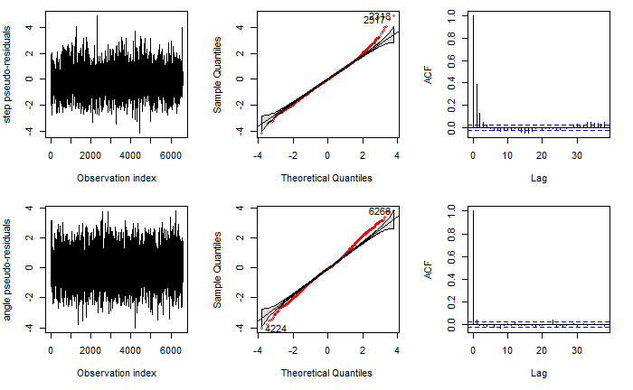
(B)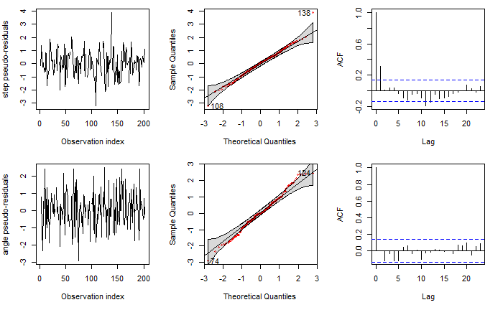
Figure S 3. Tests of assumptions of the Hidden Markov Models for GPS tracking from Leach’s Storm-Petrels from (A) 2016, 2018, 2020, 2021 (2-hour sampling interval) and (B) 2019 (3-hour sampling interval).

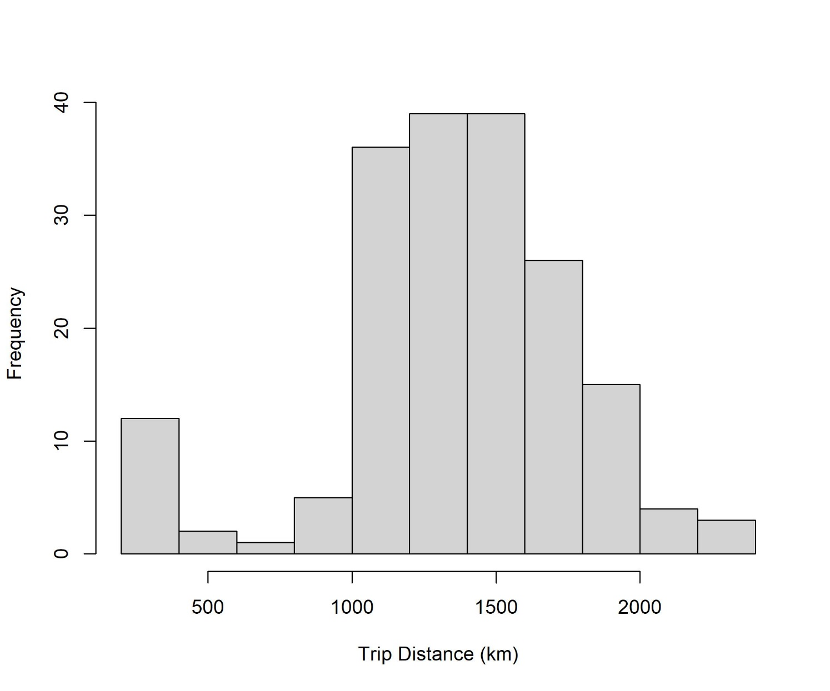
Figure S 4. Histogram of the trip distances of Leach’s Storm-Petrels breeding at Gull Island, Witless Bay, Newfoundland and Labrador, Canada from 2016 – 2021. Note the bimodal distribution indicating a small number of short trips.

Supplementary Tables
Table S 1. Summary information for all trips. Trips in which the bird flew within the average light catch basin are highlighted in yellow, and trips in which the bird flew within the maximum average light catch basin are highlighted in orange.
Please see Table_S1.xlsx
Table S 2. BAI and percent overlap for all groups of behavioural states, individuals, breeding phases, and years.
Transit or Forage | Comparison | Time | BAI | % Overlap | BAI sd | % Overlap sd
N/A | States | Extensive to Transit | 0.86 | 0.36 | N/A | 0.15
N/A | States | Intensive to Extensive | 0.96 | 0.75 | N/A | 0.10
N/A | States | Intensive to Transit | 0.73 | 0.00 | N/A | 0.00
Transit | Individuals | 2016 Incubation | 0.63 | 0.35 | 0.26 | 0.34
Forage | Individuals | 2016 Incubation | 0.22 | 0.08 | 0.25 | 0.22
Transit | Individuals | 2016 Chick-rearing | 0.83 | 0.56 | 0.10 | 0.22
Forage | Individuals | 2016 Chick-rearing | 0.55 | 0.33 | 0.23 | 0.32
Transit | Individuals | 2018 Incubation | 0.80 | 0.43 | 0.15 | 0.28
Forage | Individuals | 2018 Incubation | 0.25 | 0.15 | 0.24 | 0.32
Transit | Individuals | 2019 Incubation | 0.90 | 0.66 | 0.07 | 0.23
Forage | Individuals | 2019 Incubation | 0.84 | 0.53 | 0.07 | 0.25
Transit | Individuals | 2020 Incubation | 0.86 | 0.53 | 0.07 | 0.16
Forage | Individuals | 2020 Incubation | 0.39 | 0.11 | 0.36 | 0.17
Transit | Individuals | 2020 Chick-rearing | 0.76 | 0.48 | 0.17 | 0.29
Forage | Individuals | 2020 Chick-rearing | 0.43 | 0.17 | 0.27 | 0.30
Transit | Individuals | 2021 Incubation | 0.68 | 0.40 | 0.33 | 0.33
Forage | Individuals | 2021 Incubation | 0.40 | 0.18 | 0.30 | 0.29
Transit | Individuals | 2021 Chick-rearing | 0.77 | 0.45 | 0.14 | 0.27
Forage | Individuals | 2021 Chick-rearing | 0.42 | 0.20 | 0.29 | 0.32
Transit | Individuals | All Birds | 0.74 | 0.44 | 0.19 | 0.28
Forage | Individuals | All Birds | 0.36 | 0.18 | 0.29 | 0.30
Transit | Breeding Phase | 2016, 2020, 2021 | 0.95 | 0.76 | N/A | 0.21
Forage | Breeding Phase | 2016, 2020, 2021 | 0.87 | 0.67 | N/A | 0.26
Transit | Years | Chick-rearing | 0.97 | 0.84 | 0.01 | 0.08
Forage | Years | Chick-rearing | 0.93 | 0.77 | 0.01 | 0.06
Transit | Years | Incubation | 0.95 | 0.82 | 0.02 | 0.13
Forage | Years | Incubation | 0.87 | 0.64 | 0.04 | 0.21

Table S 3. Type III ANOVA table and random effects of the general linear mixed model for Leach’s Storm-Petrel foraging trip distance during the breeding season on Gull Island, Witless Bay, Newfoundland and Labrador, Canada.
Variable |  | Chi Squared | df |  | p value
Intercept |  | 242.65 | 1 |  | <0.001
Year |  | 6.32 | 4 |  | 0.18
Breeding Phase |  | 4.39 | 1 |  | 0.036
Random Effects | Groups |  |  | Name |  | Variance |  | Standard Deviation
 | ID |  |  | (Intercept) |  | 23702 |  | 154.0
 | Residual |  |  |  |  | 147367 |  | 383.9

Table S 4. Type III ANOVA table and random effects of the general linear mixed model for Leach’s Storm-Petrel foraging trip duration during the breeding season on Gull Island, Witless Bay, Newfoundland and Labrador, Canada.
Variable |  | Chi Squared | df |  | p value
Intercept |  | 201.30 | 1 |  | <0.001
Year |  | 3.99 | 4 |  | 0.41
Breeding Phase |  | 5.20 | 1 |  | 0.023
Random Effects | Groups |  |  | Name |  | Variance |  | Standard Deviation
 | ID |  |  | (Intercept) |  | 89.65 |  | 9.47
 | Residual |  |  |  |  | 486.36 |  | 22.05

Table S 5. Duration of time spent within an oil platform light catch basin by Leach’s Storm-Petrels breeding at Gull Island, Witless Bay, Newfoundland and Labrador, Canada from 2016-2021. The mean radius of the light catch basin is 5.3 km, and the maximum radius is 10.7 km (calculated from Gjerdrum et al. 2021). The mean flight speed of Leach’s Storm-Petrels, regardless of behavioural state, is 17.6 km/h (calculated from our data). The flight speeds of each behavioural state are transit: 28.6 km/h, extensive search: 16.2 km/h, intensive search: 7.4 km/h (calculated from our data).
Flight Speed | Light Catch Basin | Average Exposure Duration (mins) | Minimum Exposure Duration (mins) | Maximum Exposure Duration (mins)
mean | mean | 34 | 10 | 85
mean | max | 97 | 32 | 268
transit | mean | 21 | 6 | 52
transit | max | 60 | 19 | 164
extensive | mean | 37 | 10 | 93
extensive | max | 106 | 35 | 291
intensive | mean | 80 | 23 | 202
intensive | max | 230 | 75 | 634

Table S 6. Type III ANOVA table and random effects of the logistic mixed model for the odds of a Leach’s Storm-Petrel entering the light catch basin of an oil platform during a foraging trip from Gull Island, Witless Bay, Newfoundland and Labrador, Canada.
Variable |  | Chi Squared | df |  | p value
Intercept |  | 8.82 | 1 |  | 0.0030
Year |  | 1.46 | 4 |  | 0.83
Breeding Phase |  | 0.039 | 1 |  | 0.84
Time of Day |  | 1.35 | 1 |  | 0.25
Random Effects | Groups |  |  | Name |  | Variance |  | Standard Deviation
 | ID |  |  | (Intercept) |  | 1.39 |  | 1.18

