The raw images of WB were included in files. We also added WB summary to make it easy to follow. If any question, please do not hesitate to contract us.

WB summary

Fig. 2A actin (left A549, right PC-9)

Fig. 2A p-FAK (left A549, right PC-9)

Fig. 2A Total FAK (left A549, right PC-9)

Fig. 2A p-AKT (left A549, right PC-9)

Fig. 2A t-AKT (left A549, right PC-9)
Fig. 3C F-actin (left A549, right PC-9)

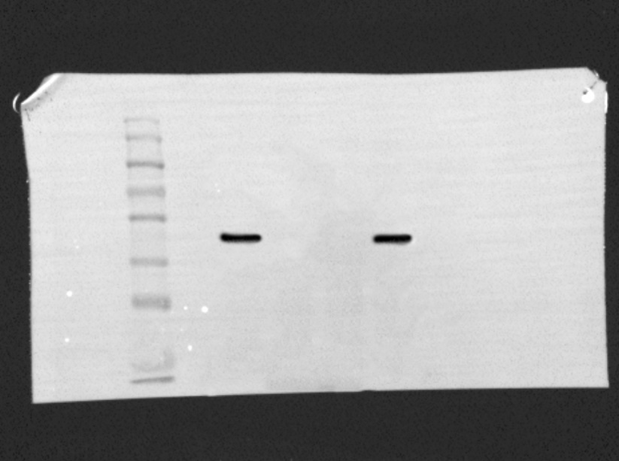
Fig. 3C TRIB3 (left A549, right PC-9)

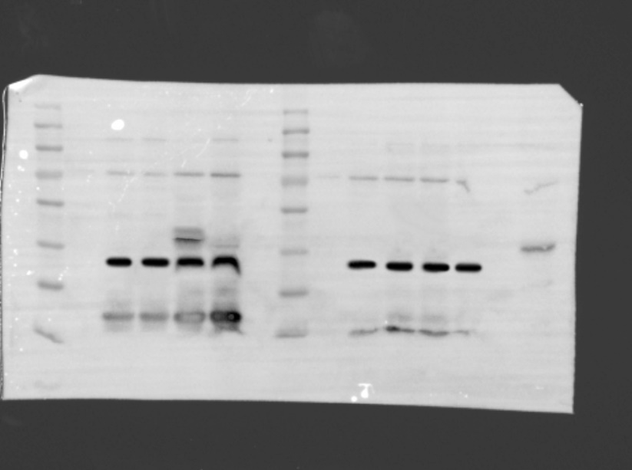
Fig. 4A actin (left A549, right PC-9)

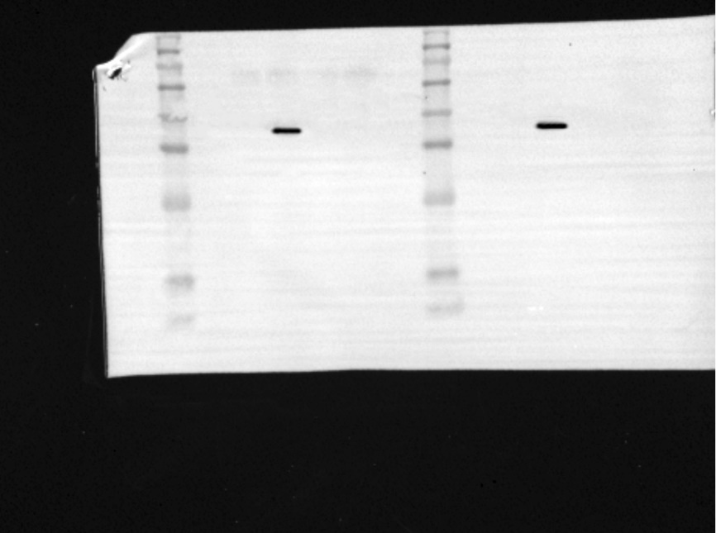\
Fig. 4A FOXO1 (left A549, right PC-9)

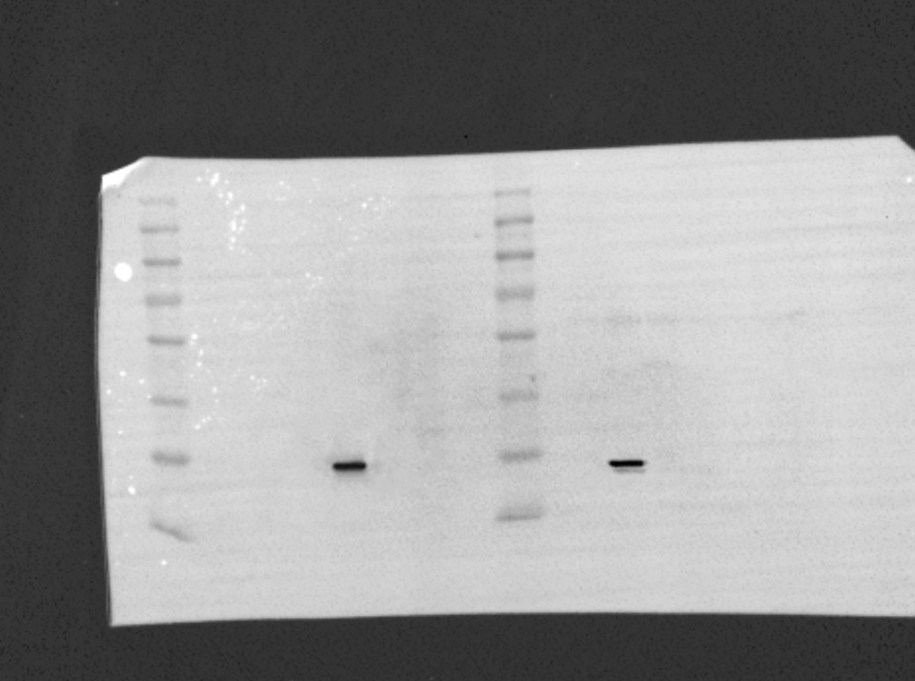
Fig. 4A SOX2 (left A549, right PC-9)

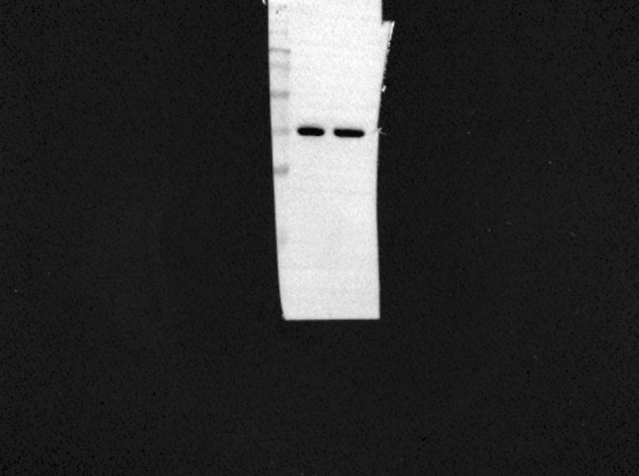
Fig. 4B actin A549

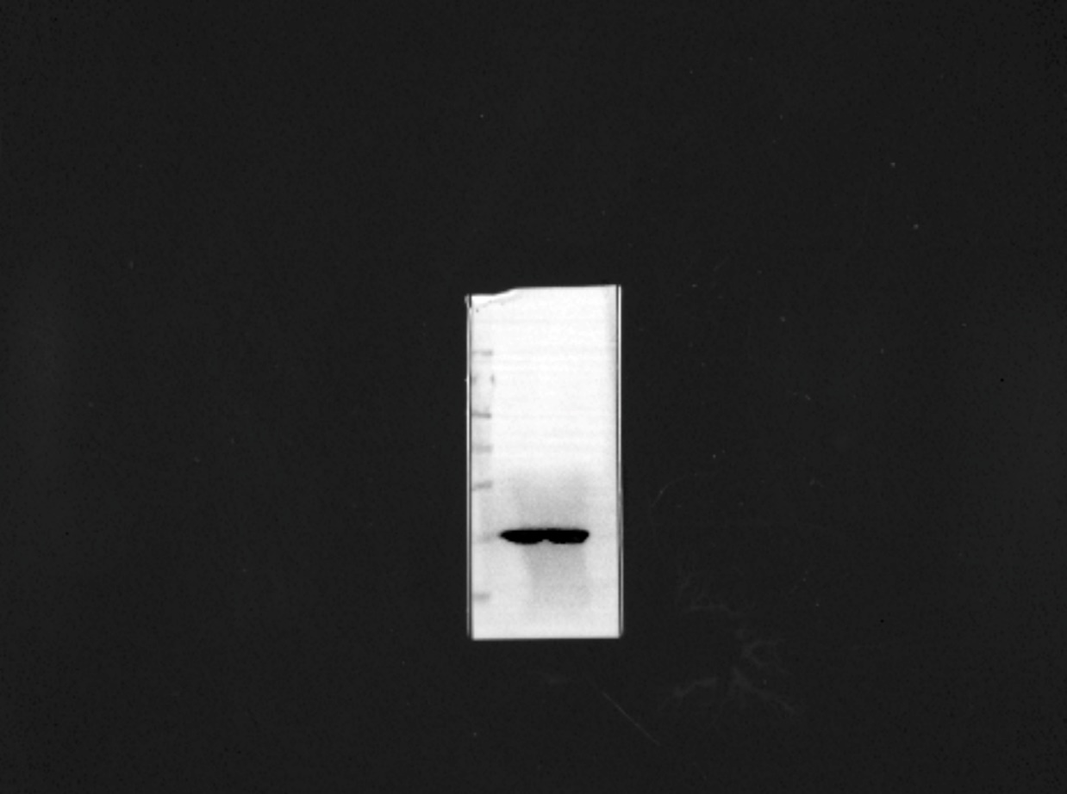
Fig. 4B actin PC-9

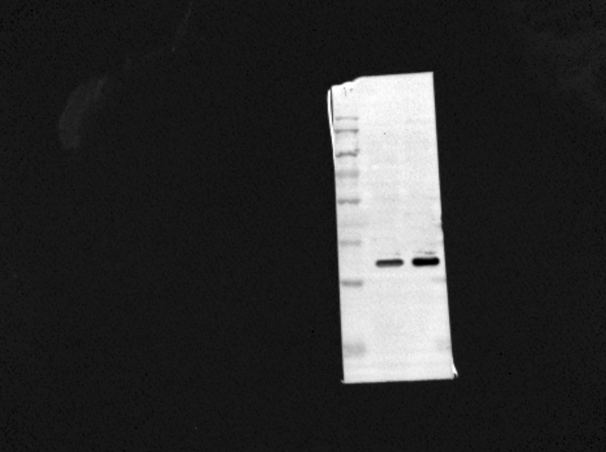
Fig. 4B input A549

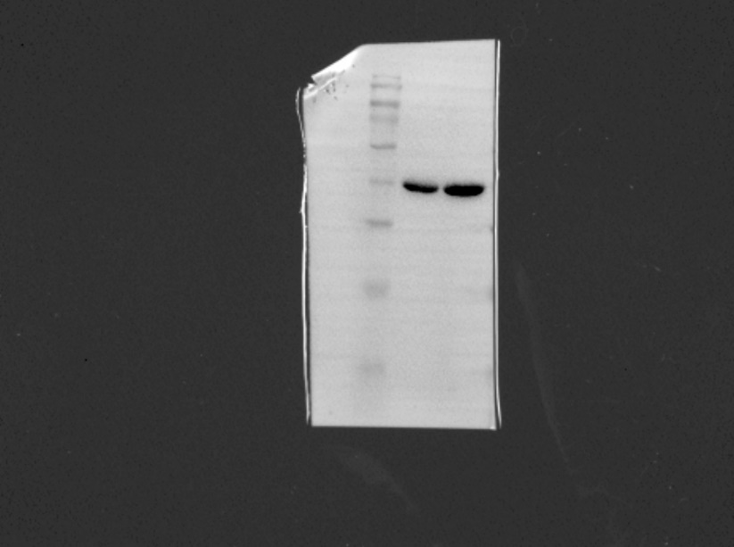
Fig. 4B input PC-9

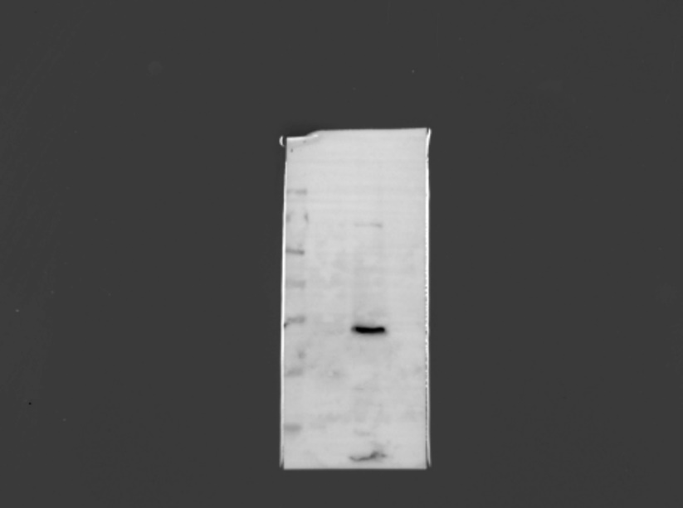
Fig. 4B IP A549

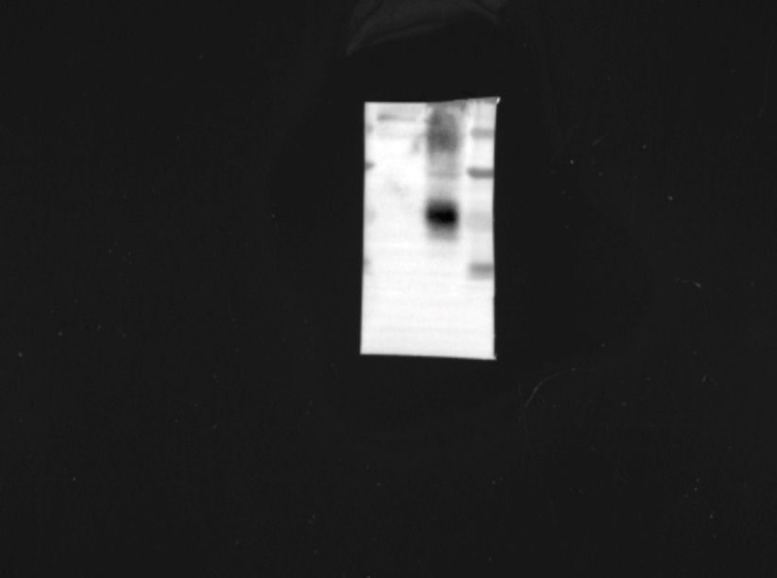

Fig. 4B IP PC-9

