Supplementary Material

Site | Pit surface picture | Core picture | Weather and surface condition | i0 and snow albedo
A1 |  | Top core picture:  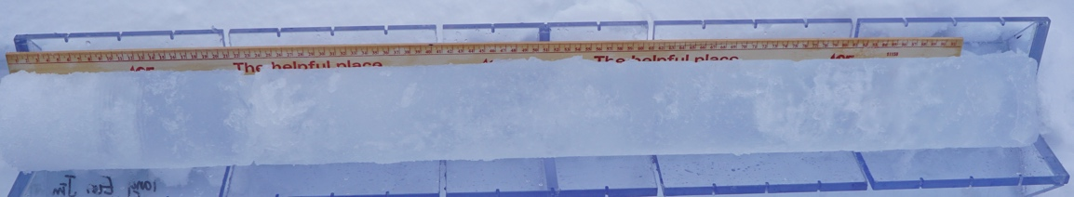  Bottom core picture: | Cloudy sky and melting white ice | i0 = 0.35  α_{snow} = 0.65
A2 | 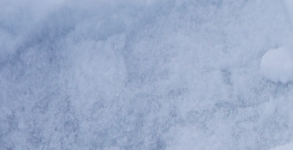 | Top core picture missing  Bottom core picture:  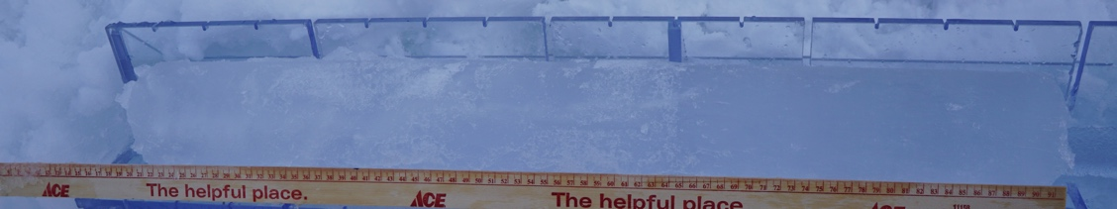 | Cloudy sky and melting white ice | i0 = 0.35  α_{snow} = 0.65
A3 | 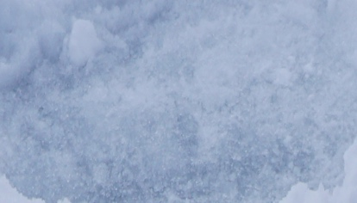 | Top core picture missing  Bottom core picture:  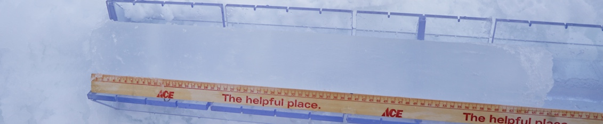 | Cloudy sky and melting white ice | i0 = 0.35  α_{snow} = 0.65
B1 | 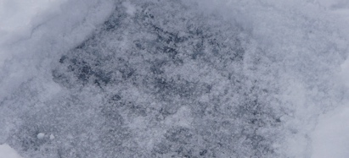 | Top core picture:  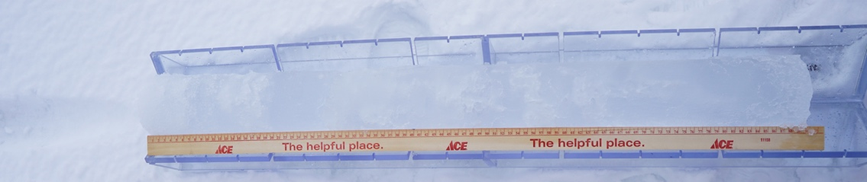  Bottom core picture: | Cloudy sky and melting white ice | i0 = 0.35  α_{snow} = 0.65
B2 |  | Top core picture:  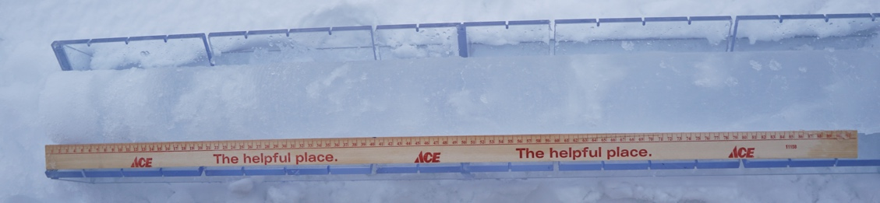  Bottom core picture: | Cloudy sky and melting white ice | i0 = 0.35  α_{snow} = 0.65
B3 | 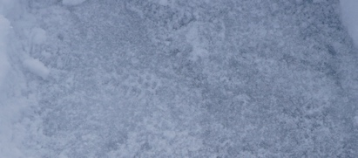 | Top core picture:  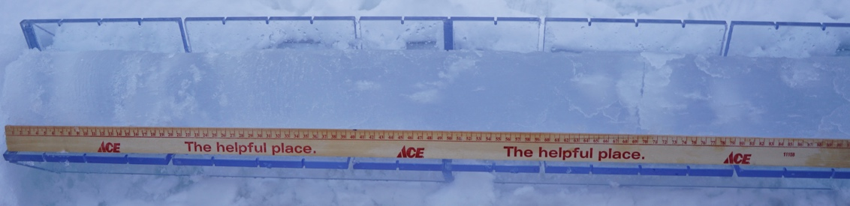  Bottom core picture: | Cloudy sky and melting white ice | i0 = 0.35  α_{snow} = 0.65
C1 | 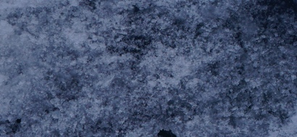 | Top core picture:  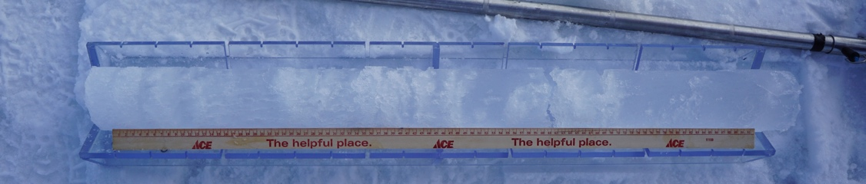  Bottom core picture:  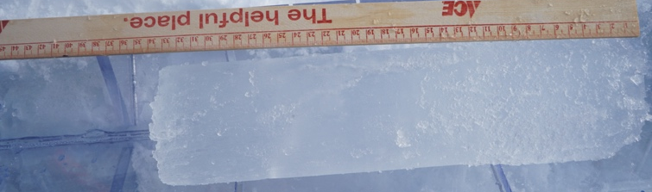 | Cloudy sky and white ice  (bare ice for pit surface) | i0 = 0.35  α_{snow} = 0.65
C2 | 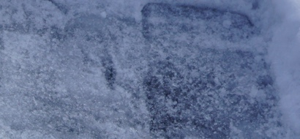 | Top core picture:  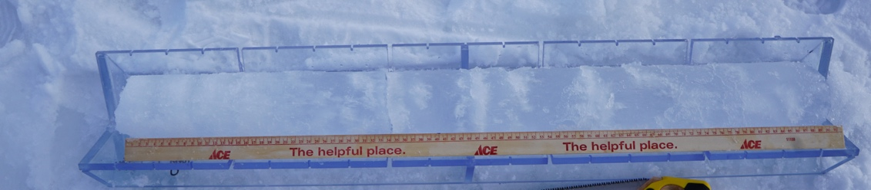  Bottom core picture: | Cloudy sky and white ice  (bare ice for pit surface) | i0 = 0.35  α_{snow} = 0.65
C3 | 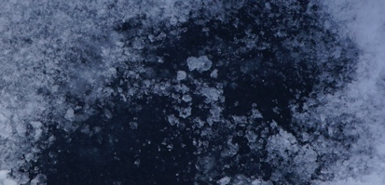 | 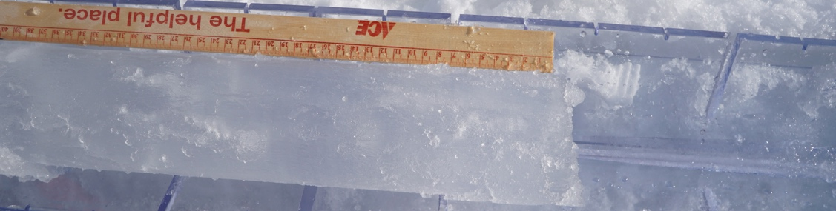 | Cloudy sky and white ice  (bare ice for pit surface) | i0 = 0.35  α_{snow} = 0.65
D1 | 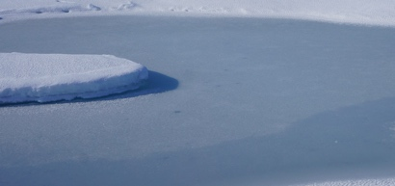 | Top core picture:  Bottom core picture: | Clear sky and refrozen MP | i0 = N/A  α_{ice} = 0.40  α_{snow} = N/A
D2 |  | Top core picture:  Bottom core picture: | Clear sky and refrozen MP | i0 = N/A  α_{ice} = 0.40  α_{snow} = N/A
D3 |  | Top core picture:  Bottom core picture: | Clear sky and refrozen MP | i0 = N/A  α_{ice} = 0.40  α_{snow} = N/A
E1 | 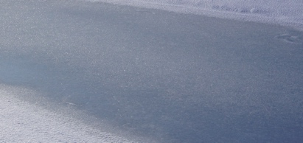 | Top core picture:  Bottom core picture: | Clear sky and refrozen MP | i0 = N/A  α_{ice} = 0.40  α_{snow} = N/A
E2 |  | Top core picture:  Bottom core picture: | Clear sky and refrozen MP | i0 = N/A  α_{ice} = 0.40  α_{snow} = N/A
E3 |  | Top core picture:  Bottom core picture: | Clear sky and refrozen MP | i0 = N/A  α_{ice} = 0.40  α_{snow} = N/A
F1 | 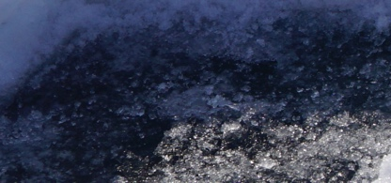 | 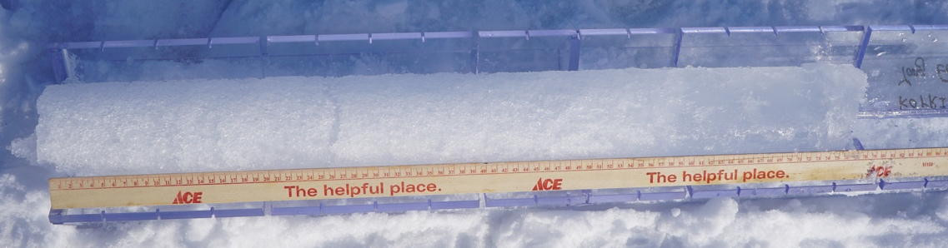 | Clear sky and blue ice | i0 = 0.43  α_{snow} = 0.65
F2 | 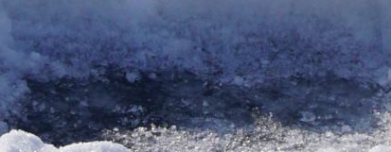 | 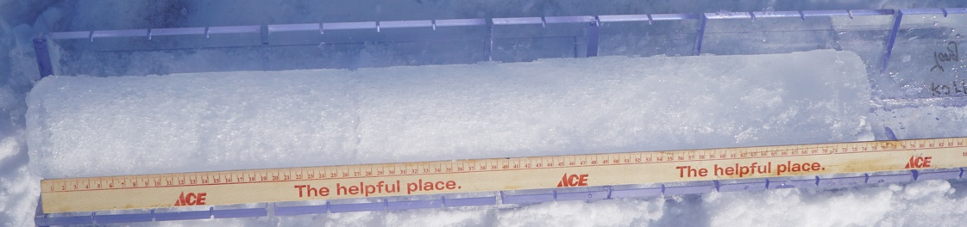 | Clear sky and blue ice | i0 = 0.43  α_{snow} = 0.65
F3 | 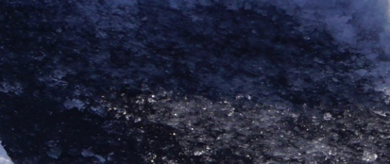 | 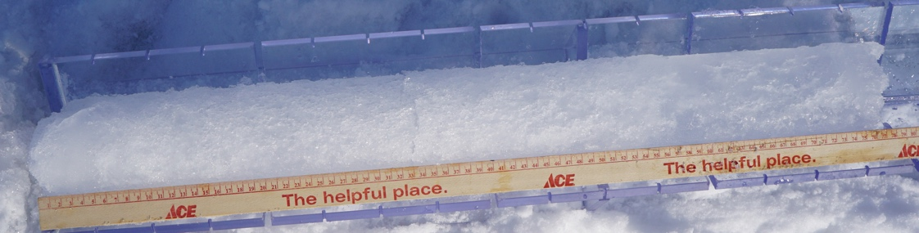 | Clear sky and blue ice | i0 = 0.43  α_{snow} = 0.65
G1 | 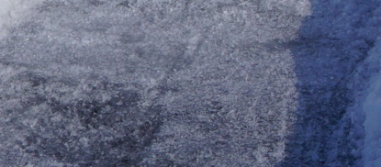 | 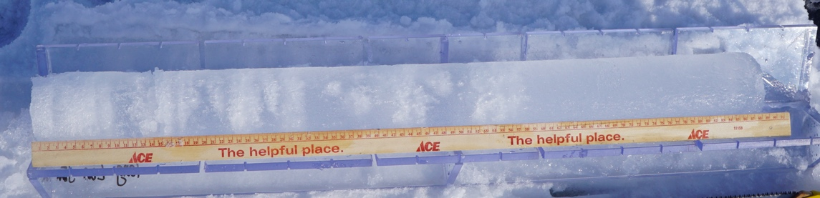 | Clear sky and white ice (bare ice for pit surface) | i0 = 0.18  α_{snow} = 0.65
G2 | 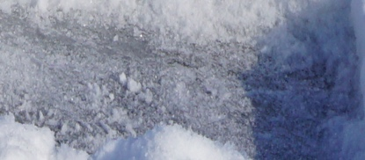 | 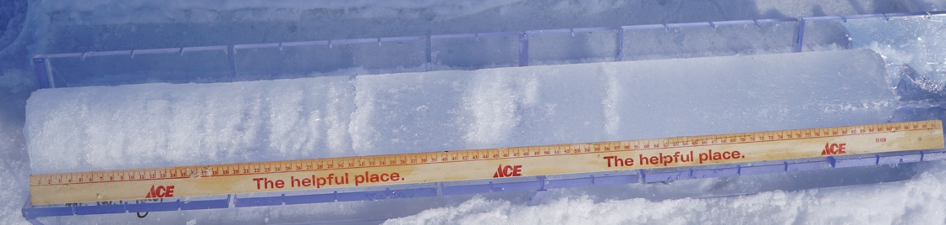 | Clear sky and white ice (bare ice for pit surface) | i0 = 0.18  α_{snow} = 0.65
G3 | 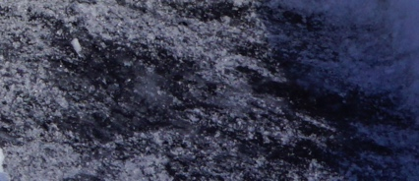 | 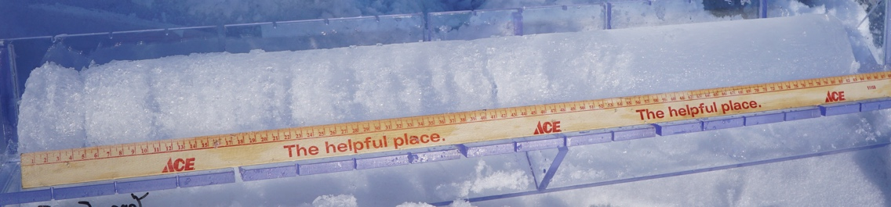 | Clear sky and white ice (bare ice for pit surface) | i0 = 0.18  α_{snow} = 0.65
H1 | 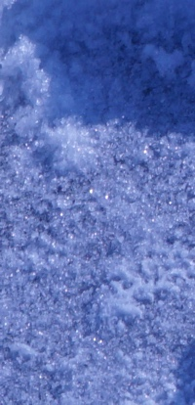 | 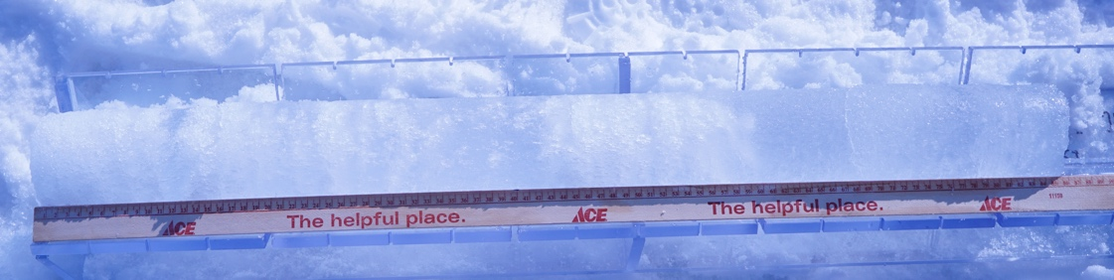 | Clear sky and white ice (bare ice for pit surface) | i0 = 0.18  α_{snow} = 0.65
H2 | 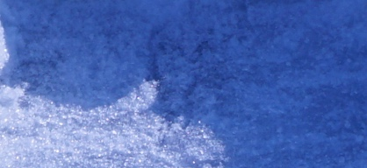 | 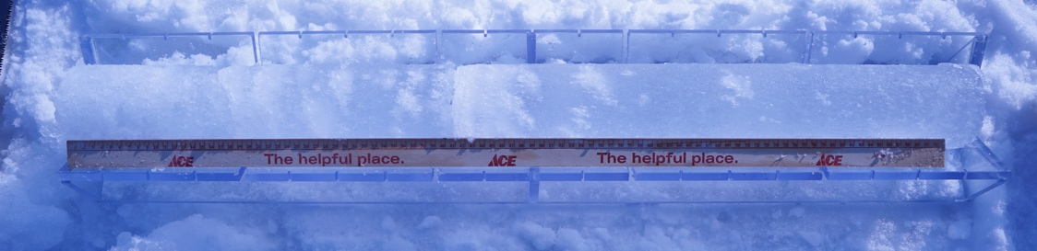 | Clear sky and white ice (bare ice for pit surface) | i0 = 0.18  α_{snow} = 0.65
H3 | 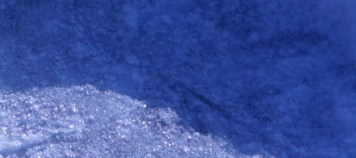 | 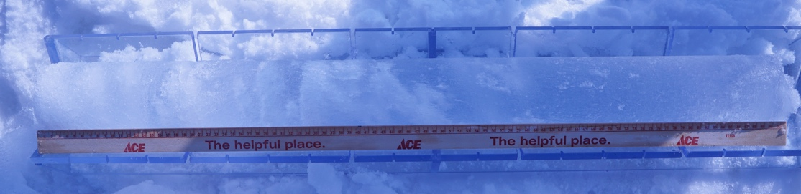 | Clear sky and white ice (bare ice for pit surface) | i0 = 0.18  α_{snow} = 0.65
I1 | 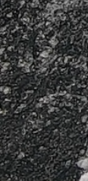 | 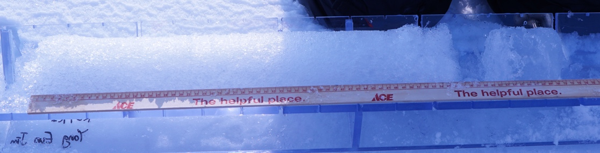 | Clear sky and blue ice | i0 = 0.43  α_{snow} = 0.65
I2 |  | 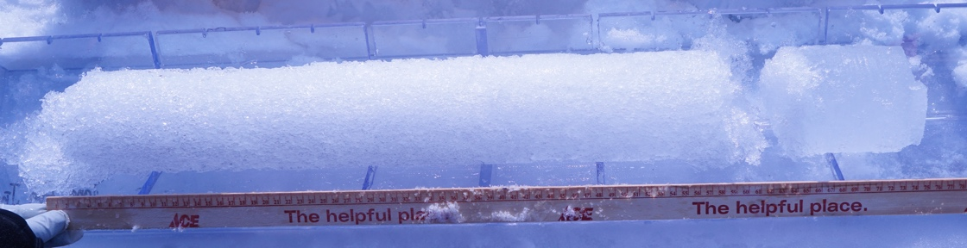 | Clear sky and blue ice | i0 = 0.43  α_{snow} = 0.65
I3 |  | 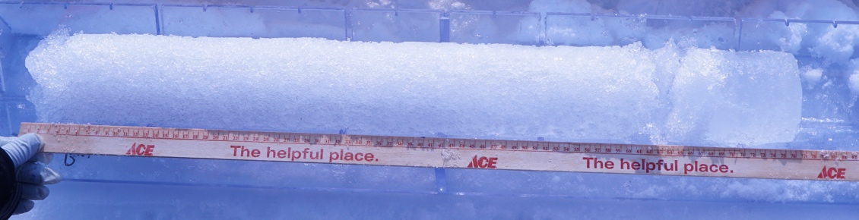 | Clear sky and blue ice | i0 = 0.43  α_{snow} = 0.65
J1 | 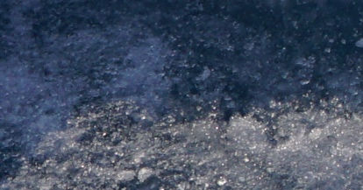 | Top core picture:  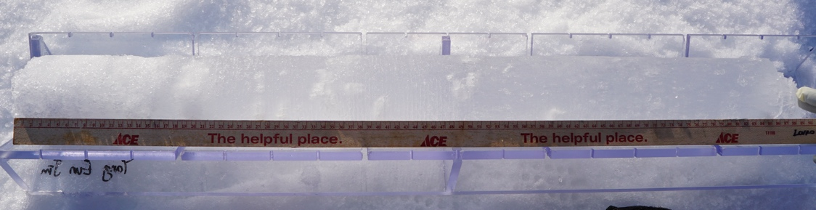  Bottom core picture: | Clear sky and white ice (bare ice for pit surface) | i0 = 0.18  α_{snow} = 0.65
J2 | 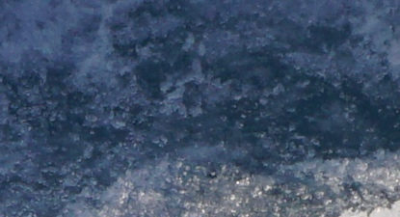 | Top core picture:  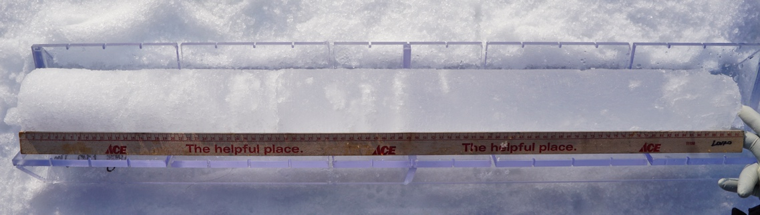  Bottom core picture: | Clear sky and white ice (bare ice for pit surface) | i0 = 0.18  α_{snow} = 0.65
J3 |  | Top core picture:  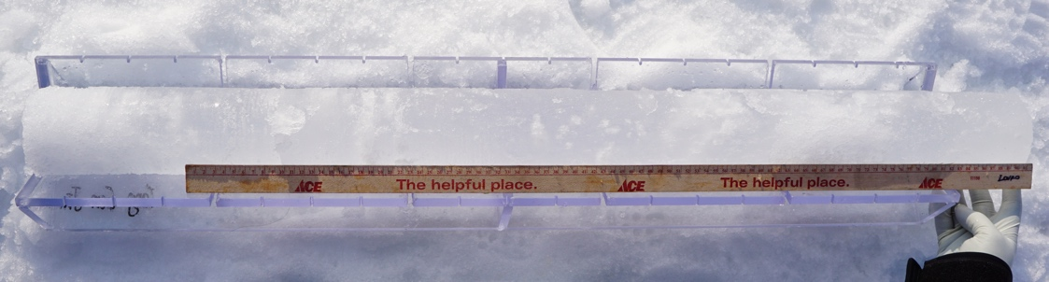  Bottom core picture: | Clear sky and white ice (bare ice for pit surface) | i0 = 0.18  α_{snow} = 0.65
K1 | 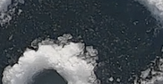 | 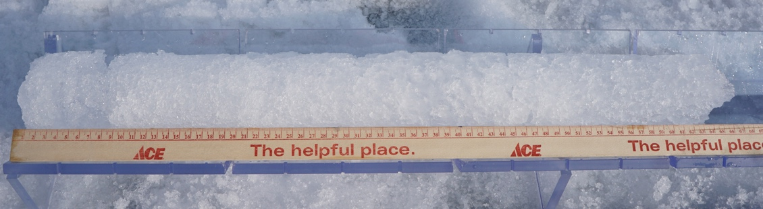 | Clear sky and blue ice | i0 = 0.43  α_{snow} = N/A
K2 |  | 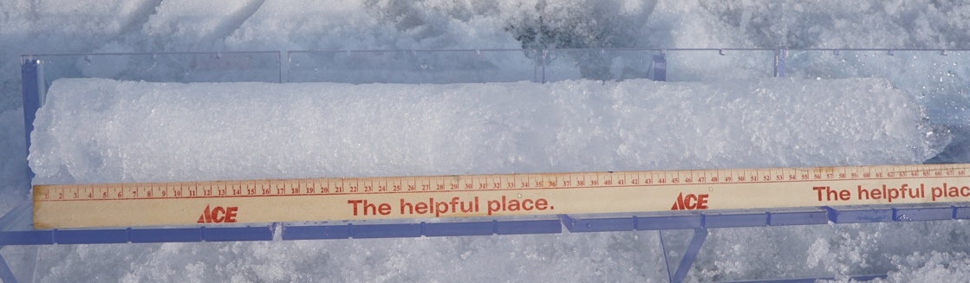 | Clear sky and blue ice | i0 = 0.43  α_{snow} = N/A
K3 |  | 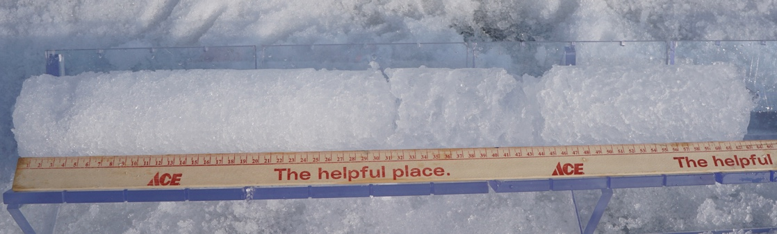 | Clear sky and blue ice | i0 = 0.43  α_{snow} = N/A
L1 |  | 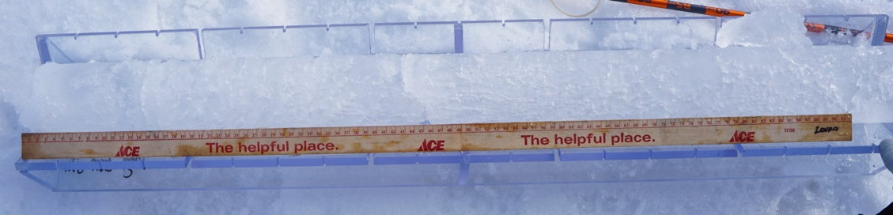 | Cloudy sky and white ice  (bare ice for pit surface) | i0 = 0.35  α_{snow} = N/A
L2 | 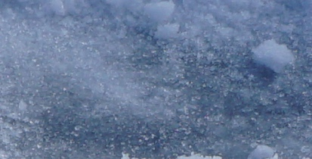 | 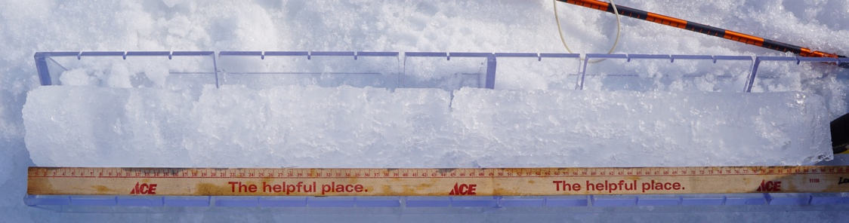 | Cloudy sky and white ice  (bare ice for pit surface) | i0 = 0.35  α_{snow} = N/A
L3 | 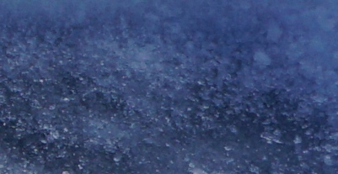 | 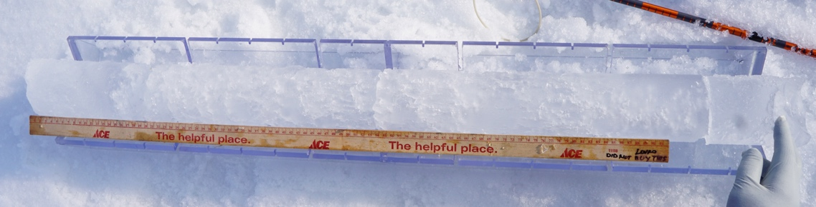 | Cloudy sky and white ice  (bare ice for pit surface) | i0 = 0.35  α_{snow} = N/A

Table S1. Pictures of the pit surface and ice core for each site and each point of measurements, weather and ice conditions as well as the bulk extinction coefficient in the surface scattering layer (i_{o}) and the ice (α_{ice}) and snow (α_{snow}) albedos associated when needed. The cores are displayed with the top of the core on the left and the bottom of the core on the right.

Optical parameter | surface | Cloudy sky | Clear sky
i₀ | White ice | 0.35 | 0.18
 | Blue ice | 0.63 | 0.43
α_{ice} | For melt ponds | 0.40
α_{snow} | Snow | 0.65

Table S2. i₀ and albedo values used in this study as a function of the surface type and weather conditions following [Grenfell and Maykut, 1977] and [Grenfell and Perovich, 1984].

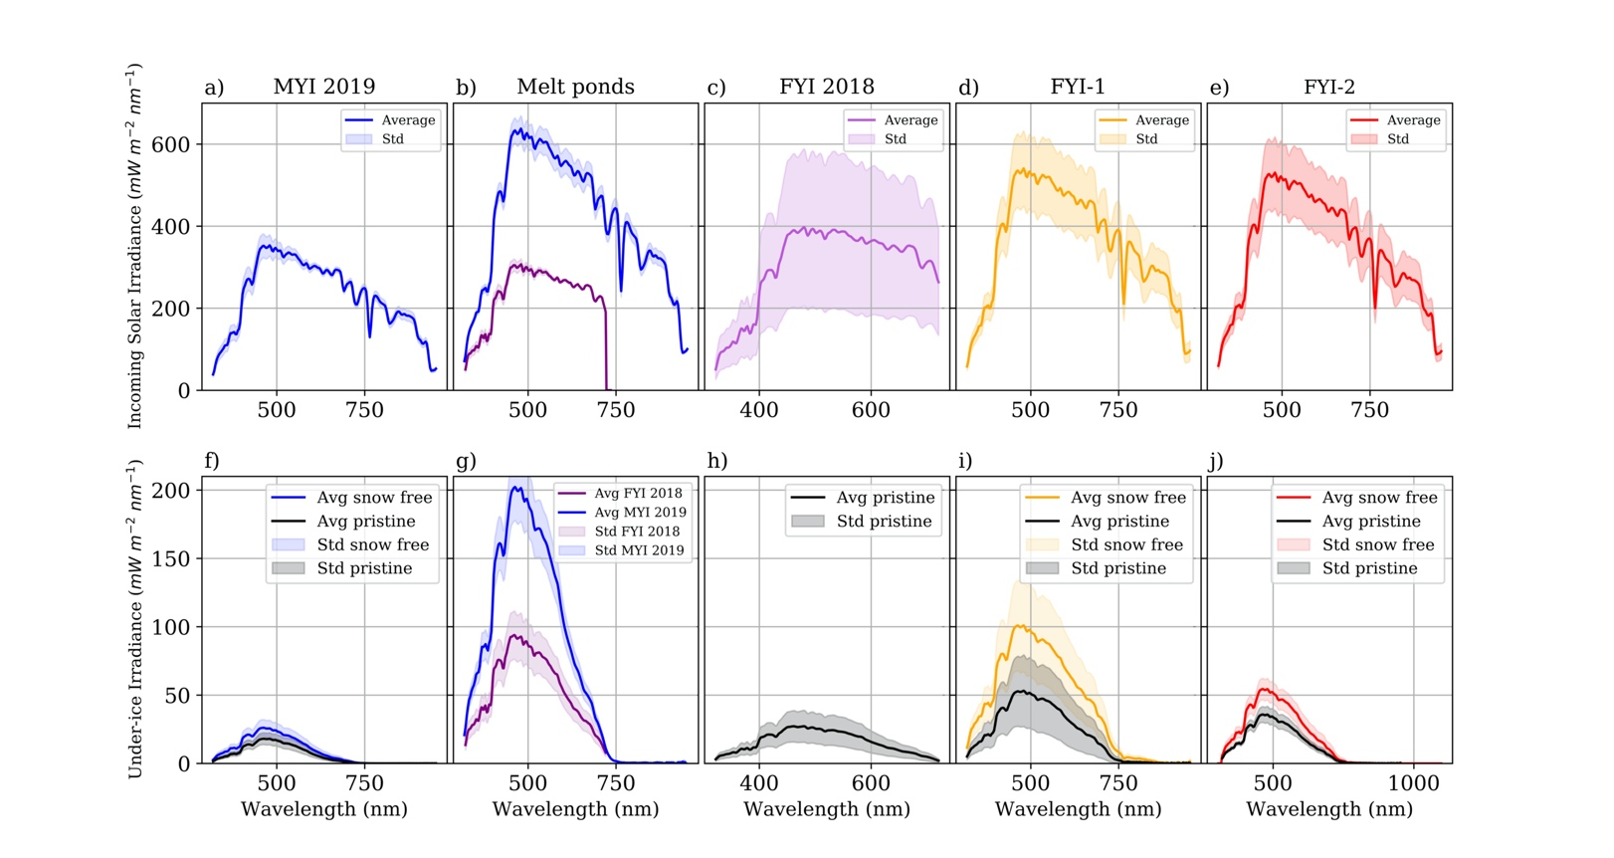
Figure S1. Above- and under-ice irradiance for (a) and (f) MYI in August 2019, (b) and (g) Melt ponds over FYI in 2018 (purple) and MYI in 2019 (blue), (c) and (h) FYI in August 2018, (d) and (i) FYI-1 and (e) and (j) FYI-2.

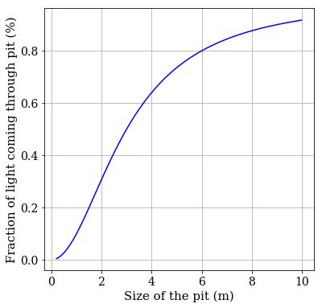

Figure S2. Fraction of the light coming through a pit dug for a 1.5 m thick sea ice compared to the radius of the pit (m).

