Table 1. Components of BB full (Tsoktouridis et al. 2019) culture medium for in vitro experiments (BB basal medium and BB vitamins solution).
BB basal medium (BBb) |  | BB vitamins solution (vit BB)
MACRONUTRIENTS | (mg L⁻¹) | VITAMINS | (mg L⁻¹)
KNO₃ | 1800 | Thiamine | 2.0
NH₄NO₃ | 400 | Nicotinic acid | 1.0
Ca(NO₃)·4H₂O | 1200 | Glycine | 2.0
KH₂PO₄ | 270 | Pyridoxine HCl | 0.5
Magnesium |  | Biotin | 0.1
MgSO₄ · 7H₂O | 360 | Folic acid | 0.5
MICRONUTRIENTS |  | p-aminobenzoic acid | 1.0
H₃BO₃ | 4.80 | Riboflabin | 0.1
CuSO₄·5H₂O | 0.25 | Ca-pantothenate | 0.5
MnSO₄·H₂O | 33.50
Na₂MoO₄·2H₂O | 0.39
ZnSO₄·7H₂O | 17.00
CoCl₂·6H₂O | 0.025
Fe-EDTA |  | Myo-inositol | 100.0
FeSO₄·7H₂O | 33.80 | Ascorbic acid | 75.0
Na-EDTA·2H₂O | 45.40 | Citric acid | 50.0

Table 2. Effect of different growth regulator-free basal media on Psidium guajava explants development. The number and length of proliferated shoots and roots were counted for each treatment. In addition, root induction was also observed during the experiment, therefore the number of the proliferated roots was noted as well. MS+vit BB; MS with BB vitamins solution, MS full; MS with its vitamin), WP+vit BB; WP with BB vitamins solution, WP full; WP with its vitamins, BB full; BB with its vitamins, as in Table 1. *Mean values in the same column followed by different letter(s) are statistically different at significance level a = 0.05 (P ≤ 0.05), according to the results of the Duncans’ multiple comparisons test. Every treatment was carried out with 4 jars and 4 explants per jar.
Substrate | Shoot Number | Shoot Length (cm) | Root Number | Root Length (cm)
MS+vit BB | 1.0 b | 2.6 ± 0.55 a | 1.5 ± 0.50 ab | 2.8 ± 1.03 b
MS full | 1.0 b | 2.1 ± 0.23 b | 1.1 ± 0.30 b | 2.7 ± 1.40 b
WP+vit BB | 1.0 b | 2.4 ± 0.44 ab | 1.7 ± 0.80 a | 3.9 ± 1.58 a
WP full | 1.0 b | 2.2 ± 0.31 b | 1.2 ± 0.52 bc | 2.6 ± 0.87 b
BB full | 1.2 ± 0.66 a | 2.4 ± 0.79 ab | 1.0 ± 0.75 c | 2.8 ± 1.80 b

Table 3. Effect of different BA concentration on the organogenesis of Psidium guajava explants, using BB full medium. The number and length of shoots was counted for each treatment. In addition, root induction was also observed in control treatment and callus formation in all the other treatments. BB full medium as in Table 1. 0 (Control), 1, 2, 3, 4 mg L⁻¹ BA. *Mean values in the same column followed by different letter(s) are statistically different at significance level a = 0.05 (P ≤ 0.05), according to the results of the Duncans’ multiple comparisons test. Every treatment was carried out with 4 jars and 4 explants/jar.
Treatments  ΒΑ (mg L⁻¹) | Shoot Number | Shoot Length (cm) | Root Number | Root Length (cm)
0 | 1.00 c | 2.1 ± 0.23 a | 1.1 ± 0.30 b | 2.7 ± 1.40 b
1 | 1.6 ± 0.59 b | 1.4 ± 0.39 b | callus | -
2 | 1.9 ± 0.70 b | 1.5 ± 0.51 b | callus | -
3 | 1.9 ± 0.70 b | 1.3 ± 0.42 b | callus | -
4 | 2.8 ± 0.40 a | 0.8 ± 0.09 c | callus | -

Table 4. Effect of different BA concentration combined with NAA on the organogenesis of Psidium guajava explants, using BB full medium. The number and length of shoots was counted for each treatment. In addition, root induction was also observed in control treatment and callus formation in all the other treatments. BB, modified basal medium as in Table 1. 0; no hormones (Control), 0.5 BA+0.1 NAA mg L⁻¹, 1.0 BA+0.1 NAA mg L⁻¹, 2.0 BA+0.1 NAA mg L⁻¹, 4.0 BA+0.1 NAA mg L⁻¹.
*Mean values in the same column followed by different letter(s) are statistically different at significance level a = 0.05 (P ≤ 0.05), according to the results of the Duncans’ multiple comparisons test. Every treatment was carried out with 4 jars and 4 explants/jar.
Treatments  ΒΑ + 0.1 ΝΑΑ (mg L⁻¹) | Shoot Number | Shoot Length (cm) | Root Number | Root Length (cm)
0 (Control) | 1.0 b | 3.1 ± 1.13 a | 2.2 ± 0.90 | 4.6 ± 2.50
0.5 | 1.0 b | 2.1 ± 0.68 b | callus | -
1.0 | 1.0 b | 1.7 ± 0.80 bc | callus | -
2.0 | 1.3 ± 0.43 a | 1.5 ± 0.41 c | callus | -
4.0 | 1.1 ± 0.33 ab | 1.5 ± 0.42 c | callus | -

Table 5. Effect of different IAA or IBA concentrations in combination with 0.5 mg L⁻¹ NAA. on rooting of Psidium guajava micro-plants, established in BB full culture medium. The number and length of roots was counted for each treatment. In addition, shoot proliferation was also observed during rooting, therefore the number and height of the proliferated shoots was noted as well. 0; no hormones (Control), 0.1 IAA+0.5 NAA mg L⁻¹, 0.5 IAA+0.5 NAA mg L⁻¹, 1.0 IAA+0.5 NAA mg L⁻¹, 1.5 IAA+0.5 NAA mg L⁻¹, 0.1 IBA+0.5 NAA mg L⁻¹, 0.5 IBA+0.5 NAA mg L⁻¹, 1.0 IBA+0.5 NAA mg L⁻¹, 1.5 IBA+0.5 NAA mg L⁻¹. *Mean values in the same column followed by different letter(s) are statistically different at significance level a = 0.05 (P ≤ 0.05), according to the results of the Duncans’ multiple comparisons test. Every treatment was carried out with 4 jars and 4 explants/jar.
Treatments  IAA or IBA + 0.5 ΝΑΑ (mg L⁻¹) | Shoot Number | Shoot Length (cm) | Root Number | Root Length (cm)
0 (Control) | 1.0 b | 4.0 ± 1.4 ab | 2.3± 0.8 a | 4.7 ± 2.6a
0.1 IAA | 1.0 b | 3.3 ± 1.9 abc | 3.0 ± 2.5 a | 3.0 ± 2.5 ab
0.5 IAA | 1.4 a | 3.4 ± 2.2 abc | 3.0 ± 1.9 a | 4.1 ± 2.5 ab
1.0 IAA | 1.0 b | 2.0 ± 0.1 c | 2.3 ± 0.9 a | 2.6 ± 0.6 b
1.5 IAΑ | 1.0 b | 3.2 ± 0.8 abc | 2.5 ± 1.2 a | 2.4 ± 1.1 b
0.1 IBA | 1.0 b | 3.8 ± 2.2 ab | 2.5 ± 0.9 a | 3.5 ± 2.7 ab
0.5 IBA | 1.0 b | 3.0 ± 0.8 bc | 3.0 ± 1.3 a | 2.4 ± 1.2 b
1.0 IBA | 1.0 b | 4.1 ± 1.1 ab | 2.5 ± 0.5 a | 3.5 ± 0.8 ab
1.5 IBΑ | 1.0 b | 4.8 ± 1.9 a | 3.4 ± 1.6 a | 5.0 ± 0.9 a

Table 6. Percent acclimatization success of Psidium guajava micro-plants derived from in vitro acclimatization in Magenta vessels and transferred to greenhouse. The numbers indicate the survived micro-plants and the percentage (%) of success acclimatization, in a substrate of peat-moss:vermiculite:perlite (1:1:1).
Stages of acclimatization |  | Number of the survived micro-plants | Percentage of the survived micro-plants/Phase | Percentage of the total survived micro-plants
Phase 0 | Initial (in vitro) | 144
Phase 1 | Nylon tunnel | 129 | 89.6 | 89.6
Phase 2 | Greenhouse bench | 120 | 93.0 | 83.3
Phase 3 | Outdoor | 120 | 100.0 | 83.3

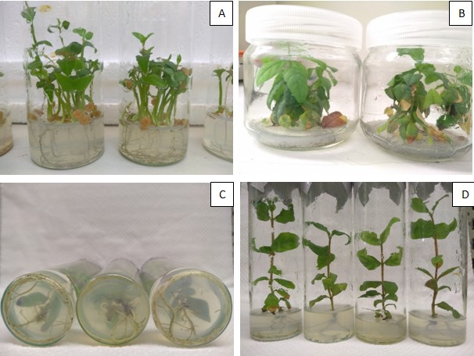
Figure 1. Micropropagation of P. guajava. Seed germination on MS medium (A), Shoot induction on BB full medium under 4 mg L⁻¹ BA (B), Rooting (C) and Shoot growth (D) on BB full medium with 1.5 IBA+0.5 NAA mg L⁻¹.

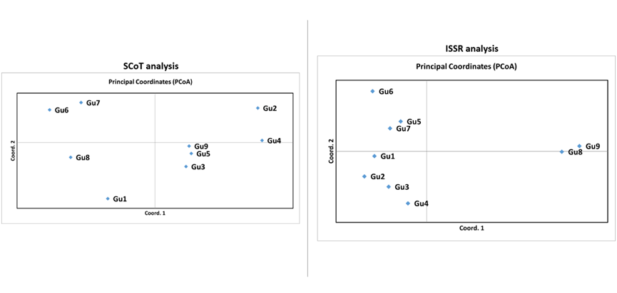
Figure 2. Principal Coordinate Analysis (PCoA) plot for 9 samples (Gu1-Gu9) of P. guajava.

