Supplementary File - Method 1: Standard Care – Acute Physiotherapy Post-LTx (Tarrant et al., 2018)

Principles (Spruit et al., 2013)
- Optimise ventilation: positioning, analgesia
- Clear retained and increased secretions: analgesia, formal reactive airway clearance when indicated, early weaning of low flow dry oxygen
- Promote independent physical function: education, environment, gait aid use as required
- Improve exercise tolerance/physical fitness: +/- gait aid use, family/friend/carer participation, acute progression
- Facilitate self-management: daily patient and carer education

Considerations and Complications (Main and Denehy, 2016)
- Graft dysfunction
- Acute rejection
- Pain control
- Nerve damage
  - Brachial plexus
  - Vocal cord
  - Diaphragm
  - Vagal
- Intercostal catheters
- Pre-operative frailty
- Existing co-morbidities
- Psychological adjustment
- Peri- and post-operative complications
  - Airway (structural)
  - Neurological
  - Systemic
  - Lower respiratory tract infections / microbial colonization

Setting
- Participants in the intensive care unit (ICU) completed all physiotherapy interventions in the bed space, or within the ICU
- Once discharged from ICU to the ward, participants completed intervention either at the bedspace (respiratory therapy, early mobility, flexibility, range of motion, body weight resistance, education), on the ward (mobilization), or in the ward-based gym (equipment-based resistance exercise, flexibility, exercise bike, treadmill)

Content
- Respiratory therapies: thoracic expansion exercises, cough, forced expiratory technique (FET), active cycle of breathing technique, positive pressure therapies, inhalational therapy
- Early mobility: sitting on edge of bed, sitting out of bed, marching on spot, sit to stand(Hodgson et al., 2013; TEAM Study Investigators et al., 2015; Tipping et al., 2017)
- Endurance: ambulation, treadmill, stationary exercise bike, step ups / stairs
- Upper limb: flexibility / range of motion, free weight / body weight resistance
- Lower limb: flexibility / range of motion, body weight resistance
- Trunk: flexibility / range of motion
- Education: respiratory care, self-assessment and monitoring, physical exercise recommendations

Progression
- ICU - ventilated / sedated: passive range of motion (shoulder flexion limited to 90 degrees with intercostal catheters / transverse sternotomy), suction, positioning. No ventilator-assisted hyperinflation maneuvers
- ICU – extubated / awake (Hodgson et al., 2014): upright positioning, supported FET, early mobilization once pulmonary artery catheter out and medically stable, sitting out of bed 1-2x per day, progression to chair based seated lower limb / trunk exercises, seated cycle, standing lower limb exercises, and ambulation away from the bedside with gait assistance as required once safe to leave the bedside. Respiratory therapies increased if respiratory compromise is amenable to PT input, including inhaled mucoactive agents, humidification, positive pressure devices. Early weaning of oxygen is supported during exercise if oxygen saturations >90%.
- Ward-based care: ongoing reactive respiratory care as indicated. Endurance exercise progressed from ambulation once independent +/- gait aid to treadmill (comfortable pace, no incline) and stationary cycle (level 1), aiming to build to 15 minutes continuous, 1-2x per day, with increases to speed and resistance guided by Borg scale ratings of shortness of breath (0-10) and rating of perceived exertion (6-20), targeting scores of moderate (3) and somewhat hard (13) respectively(Borg, 1982).
Upper limb active range of motion progressed once intercostal catheters out, within pain, with resistance added once full range of motion is pain free, beginning at 0.5kg, increasing to 2kg as able prior to inpatient discharge. Lower limb body weight strengthening progressed to include sit to stands / semi-squats / calf raises. Resistance exercises progressed from single sets of 5-10 to 2-3 sets of 10-12.
Patients are deemed safe for discharge once independently ambulant +/- gait aid with a minimum exercise tolerance of 150m (preferable 300m+ for community and outpatient access).
Supplementary File - Method 2: Sub-Acute, Outpatient Rehabilitation Protocol (Fuller et al., 2017).

Reprinted from Archives of Physical Medicine and Rehabilitation, Vol 98, Issue 2, Fuller et al, Longer Versus Shorter Duration of Supervised Rehabilitation After Lung Transplantation: A Randomized Trial, Pages 220-226, (2017), with permission from Elsevier. License # 5120570589199, License date Aug 02, 2021.

Aerobic training
The aerobic exercise component consisted of 30 minutes of aerobic exercise at each session, comprising 15 minutes each of stationary cycling and walking on the treadmill. The duration on each modality was adjusted if the participant had a comorbidity that limited their capability on one specific modality as long as the total time equated to 30 minutes.
In early sessions or when the participant had severe exercise deconditioning, interval training was used during the aerobic exercise if the participant was unable to complete 15 minutes of continuous exercise. If it was necessary for the participant to stop and have a short rest during the aerobic exercise, a total time of 30 minutes of exercising was still aimed for. The initial intensity of each modality was determined by the 6MWT, and the intensity of exercise was progressed according to the following protocol. When the participant required interval training, we still aimed to progress the intensity each week according to the protocol.

Treadmill
The initial walking intensity was set at a speed that was 70% of the peak walking speed (km/h) achieved on the 6MWT. The walking speed was increased each week. For initial walking speeds that were <3km/h, increments were made by .25km/h, and for initial walking speeds >3km/h, increments were made by 0.5km/h. Once the participant reached the maximal walking speed they could maintain (from a biomechanical aspect, not
dyspnea) for the 15 minutes, which was predominantly 4.5 to 5.5km/h, the gradient was introduced. The gradient was progressed at 1% to 2% per week depending on the capability of the participant. Monitoring of treadmill walking was made at the halfway mark (around 7min) and again on completing the treadmill exercise (at 15min). The Borg scales of shortness of breath, RPE, heart rate, and peripheral oxygen saturation from an oximeter were also recorded. If at the halfway measure the Borg scale score of 3 for shortness of breath and score of 13 for RPE had not been achieved, it was adjusted for the remainder of the treadmill time.

Cycle
The initial speed on the bike was set using a manual level and wattage of 20 to 25, with the intensity of the stationary cycle eliciting an RPE of 12 to 14 on the 6 to 20 Borg scale and a
dyspnea score of 3 to 4 on the modified Borg scale. If the initial intensity elicited a Borg score that was RPE <12 or dyspnea score <3, the work rate was increased until an RPE score of 12 to 14 or a dyspnea score of 3 to 4 was achieved. If the participant was unable to mount the stationary bike, usage of a recliner bike was offered. Once the participant had attained level 4 resistance, the electronic programs of hill and interval were used to continue to elicit an RPE of 12 to 14 on the 6 to 20 Borg scale and a dyspnea score of 3 to 4 on the modified Borg scale.

Resistance training
The resistance program was comprised of 4 lower limb exercises and 4 upper limb exercises. Each exercise was performed in a controlled manner using the correct technique. The ideal speed to perform the exercise should be 1 to 2 seconds each for the concentric and eccentric contractions. The exercises were modified if the participant was unable to perform the movement (eg, injury/musculoskeletal limitations). The initial load for both the upper and lower exercises was a weight the participant could lift a maximum of 10 to 12 times, or
10 to 12 repetition maximum. This was determined using the patient’s rating of perceived exertion score on the 6 to 20 Borg scale. The initial weight set should elicit a Borg score of 12 to 14 and be a weight that participants can lift no more than 2 more times after completing the 10 repetitions. If the Borg score was <12, or the participants indicate they could easily lift more, then the weight was increased. Alternatively, if the Borg score was
>15, or the participants struggled to complete 10 repetitions, the weight was decreased.
The following 2 key questions were asked after completing each set: (1) How hard was it for you to do that exercise using this scale?; and (2) How many more times could you lift the weight after we finished the tenth repetition? Or was it a struggle to lift the weight the last 1 or 2 times?

Lower limb
The lower limb exercises consisted of 1 set of 10 repetitions: wall squats, timed step-ups in 1 minute, leg press using a cable resistance machine, and quadriceps extension using a cable resistance machine. If the participant was unable to do any of these exercises, either the exercise was modified or they performed more sets of the modified exercise to ensure that a total of 4 sets of lower limb exercises were completed. The lower limb exercises of squats and step-ups were progressed by increasing the number of repetitions by 5 to ensure that
a Borg score of 12 to 14 was maintained. The lower limb exercises of leg press and quadriceps extension were progressed by both increasing the repetitions and the kilograms to attain a Borg score of 12 to 14.

Upper limb
Upper limb exercises were modified according to surgical incision to comply with the postoperative surgical precautions. For participants who had a clamshell incision, upper limb exercises were for range of movement and remained at a maximum load of 2kg for 6 weeks. This allowed for bony healing of the transverse sternotomy. For those participants with bilateral anterior thoracotomies, the only restriction on load limit was pain. The level of pain allowed was 1 to 2 (out of 10), with 10 being the worst pain. The upper limb exercises consisted of 1 set of 10 to 20 repetitions: shoulder press, shoulder flexion, shoulder rotations, and bicep curls. The upper limb exercises were progressed by an increase in weight and repetitions. Repetitions were increased by 5 each week starting from the second week until 20 repetitions was achieved. The weight was then increased by 0.5 to 1kg (each hand), and the number of repetitions was returned to 10.

Oxygen supplementation
Oxygen supplementation was applied to the participant if their SpO2 on room air was <90% while exercising on either the treadmill or bike. Oxygen supplementation was titrated to maintain an SpO2 >90%. Supplemental oxygen was provided initially via nasal prongs, and the transplant team was notified.
Supplementary File - Method 3: Standard Post-LTx Analgesia Regimen and Assessment

Regimen:
- a) Thoracic epidural to day 7 +/- bolus breakthrough (50% patients)
b) Continuous and/or patient-controlled opioid / dissociative as required
- TDS - QID paracetamol
- BD long-acting opioid
- PRN opioid breakthrough 4 hourly

Assessment:
Functional Activity Score (FAS)(The Victorian Quality Council, 2007)
Steps:
- Pain at rest: 0-10
- Pain during activity (i.e., deep breathing, coughing, getting out of bed) 0-10
Score:
- A: no limitation
- B: Mild-moderate limitation
- C: Severe limitation – prompting analgesia review and modification and/or cessation of intervention

Supplementary File - Method 4: Sit-to-Stand Test (STS) Protocol

- Participants were seated on a chair of standardized height with no arm rests (46cm).
- Knees were at approximately 90 degrees of flexion (in line with hips).
- Participants were allowed one to two stands in order to familiarize themselves with the task if required and were shown an example by the assessor present.
- One full repetition involved standing with lower limbs and trunk in full extension, returning to a seated position with an upright trunk. Only full repetitions were counted.
- Participants were asked to complete as many stands in 60 seconds with rests as required, without the use of arms for assistance.
- The test was timed via stopwatch and recorded on a study proforma.
- Standardized instructions and feedback were provided(Bohannon et al., 1995; Ozalevli, Ozden, Itil, and Akkoclu, 2007; Puhan et al., 2013).

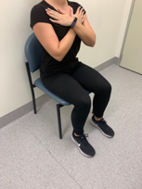
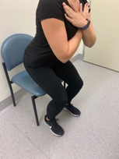
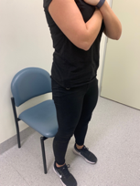

*Where possible, the chair was placed against a wall or bed to prevent risk of tipping backward.
Supplementary File - Method 5: Grip Strength Protocol

- Participants were seated in the same position as used for quadriceps testing.
- The HHD was held in the dominant hand, shoulder adducted and neutrally rotated, elbow at 90 degrees of flexion, forearm mid prone and wrist in neutral or slight extension (maximum 30 degrees).
- The participant was asked to grip at maximal effort for 3-5 seconds, repeated 3 times with 15-20 seconds rest between repetitions. The maximum score was recorded(Fess, 1992)

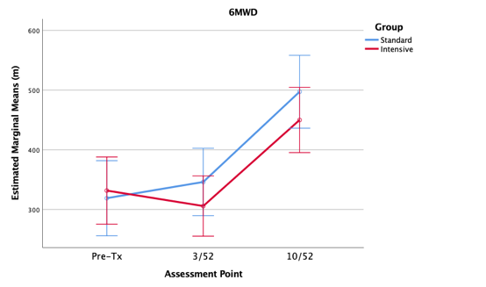
Supplementary File Figure 1. Six-Minute Walk Distance

Data are mean and 95% CI. Six-minute walk test. Legend: 6MWD: six-minute walk distance; m: meters; Tx: transplant; 3/52: 3-week; 10/52: 10-week; CI: confidence interval.

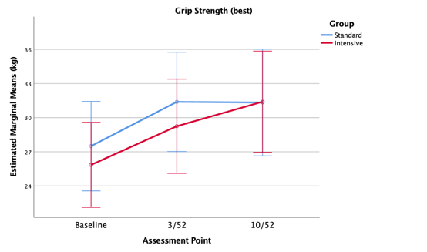
Supplementary File Figure 2. Grip Strength

Data are mean and 95% CI. kg: kilograms; 3/52: 3-weeks; 10/52: 10-weeks; CI: confidence interval.
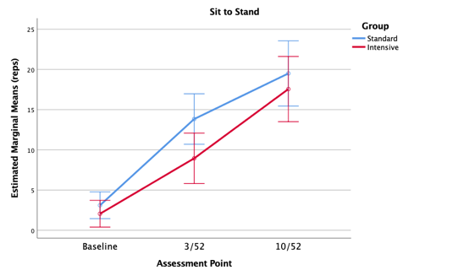
Supplementary File Figure 3. Sit to Stand Repetitions

Data are mean and 95% CI. reps: repetitions; 3/52: 3-weeks; 10/52: 10-weeks; CI: confidence interval.
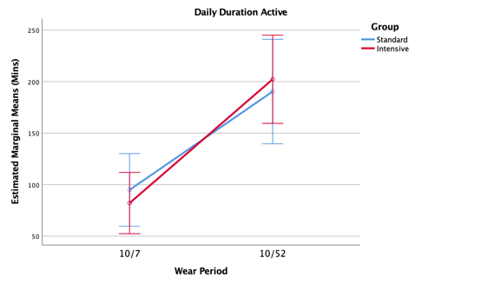
Supplementary File Figure 4. Active Duration

Data are mean and 95% CI. mins: minutes; 10/7: 10-day; 10/52: 10-week; CI: confidence interval.
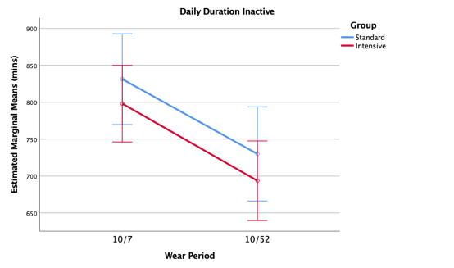
Supplementary File Figure 5. Inactive Duration

Data are mean and 95% CI. mins: minutes; 10/7: 10-day; 10/52: 10-week; CI: confidence interval.
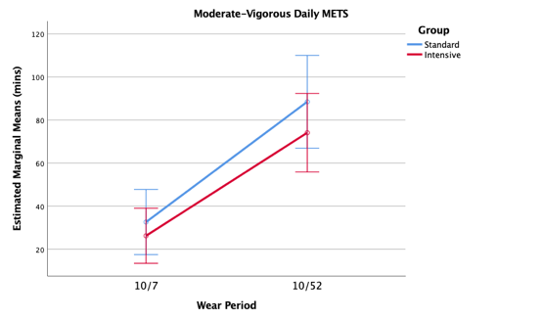
Supplementary File Figure 6. Metabolic Equivalents

Data are mean and 95% CI. METS: metabolic equivalents; moderate activity 3 to < 6 METS; vigorous activity ≥6 METS; mins: minutes; 10/7: 10-day; 10/52: 10-week; CI: confidence interval.
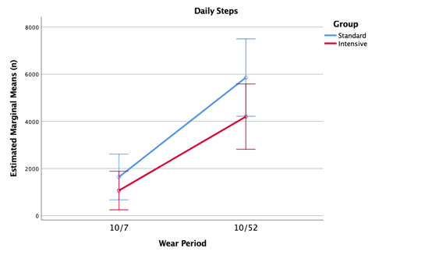
Supplementary File Figure 7. Daily Step Count

Data are mean and 95% CI. n: number; mins: minutes; 10/7: 10-day; 10/52: 10-week; CI: confidence interval.
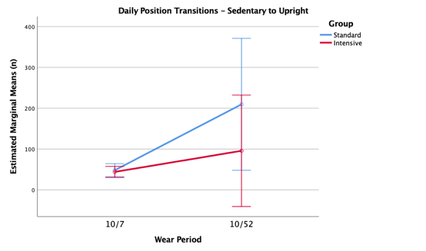
Supplementary File Figure 8. Sedentary to Upright Transitions

Data are mean and 95% CI. n: number; mins: minutes; 10/7: 10-day; 10/52: 10-week; CI: confidence interval.

Supplementary File Table 1. EQ-5D-5L Health Dimension

Mobility: n (%) |  | Baseline | 3-weeks | 10-weeks
Control (standard) n=19 | No problems | 0 (0) | 5 (26.3) | 12 (63.2)
 | Slight problems | 0 (0) | 10 (52.6) | 5 (26.3)
 | Moderate problems | 4 (21.1) | 4 (21.1) | 1 (5.3)
 | Severe problems | 4 (21.1) | 0 (0) | 1 (5.3)
 | Unable to | 11 (57.9) | 0 (0) | 0 (0)
Experimental (intensive) n=21 | No problems | 0 (0) | 4 (19.0) | 12 (57.1)
 | Slight problems | 0 (0) | 9 (42.9) | 8 (38.1)
 | Moderate problems | 3 (14.3) | 4 (19.0) | 1 (4.8)
 | Severe problems | 10 (47.6) | 0 (0) | 0 (0)
 | Unable to | 8 (38.1) | 0 (0) | 0 (0)
Self-care
Control (standard) n=19 | No problems | 0 (0) | 10 (52.6) | 17 (89.5)
 | Slight problems | 1 (5.3) | 7 (36.8) | 1 (5.3)
 | Moderate problems | 3 (15.8) | 1 (5.3) | 0 (0)
 | Severe problems | 4 (21.1) | 1 (5.3) | 1 (5.3)
 | Unable to | 11 (57.9) | 0 (0) | 0 (0)
Experimental (intensive) n=21 | No problems | 0 (0) | 8 (38.1) | 16 (76.2)
 | Slight problems | 0 (0) | 9 (42.9) | 5 (23.8)
 | Moderate problems | 1 (4.8) | 4 (19.0) | 0 (0)
 | Severe problems | 7 (33.3) | 0 (0) | 0 (0)
 | Unable to | 13 (61.9) | 0 (0) | 0 (0)
Usual activity
Control (standard) n=19 | No problems | 0 (0) | 1 (5.3) | 14 (73.7)
 | Slight problems | 0 (0) | 8 (42.1) | 2 (10.5)
 | Moderate problems | 1 (5.3) | 6 (31.6) | 2 (10.5)
 | Severe problems | 0 (0) | 0 (0) | 1 (5.3)
 | Unable to | 18 (94.7) | 4 (21.1) | 0 (0)
Experimental (intensive) n=21 | No problems | 0 (0) | 3 (14.3) | 10 (47.6)
 | Slight problems | 0 (0) | 1 (4.8) | 10 (47.6)
 | Moderate problems | 0 (0) | 7 (33.3) | 1 (4.8)
 | Severe problems | 5 (23.8) | 4 (19.0) | 0 (0)
 | Unable to | 16 (76.2) | 6 (28.6) | 0 (0)
Pain / discomfort
Control (standard) n=19 | No pain | 1 (5.3) | 1 (5.3) | 8 (42.1)
 | Slight pain | 6 (31.6) | 12 (63.2) | 7 (36.8)
 | Moderate pain | 8 (42.1) | 6 (31.6) | 4 (21.1)
 | Severe pain | 4 (21.1) | 0 (0) | 0 (0)
 | Extreme pain | 0 (0) | 0 (0) | 0 (0)
Experimental (intensive) n=21 | No pain | 0 (0) | 4 (19.0) | 8 (38.1)
 | Slight pain | 8 (38.1) | 8 (38.1) | 7 (33.3)
 | Moderate pain | 10 (47.6) | 8 (38.1) | 6 (28.6)
 | Severe pain | 3 (14.3) | 1 (4.8) | 0 (0)
 | Extreme pain | 0 (0) | 0 (0) | 0 (0)
Anxiety / depression
Control (standard) n=19 | Not anxious | 7 (36.8) | 11 (57.9) | 14 (73.7)
 | Slightly anxious | 6 (31.6) | 8 (42.1) | 3 (15.8)
 | Moderately anxious | 4 (21.1) | 0 (0) | 2 (10.5)
 | Severely anxious | 2 (10.5) | 0 (0) | 0 (0)
 | Extremely anxious | 0 (0) | 0 (0) | 0 (0)
Experimental (intensive) n=21 | Not anxious | 6 (28.6) | 10 (47.6) | 10 (47.6)
 | Slightly anxious | 6 (28.6) | 8 (38.1) | 8 (38.1)
 | Moderately anxious | 7 (33.3) | 2 (9.5) | 3 (14.3)
 | Severely anxious | 1 (4.8) | 1 (4.8) | 0 (0)
 | Extremely anxious | 1 (4.8) | 0 (0) | 0 (0)

n: number; %: percentage.

Supplementary File Table 2. Secondary Outcomes

 | Control (standard) | Experimental (intensive) | p
RFT: mean (SD) | n=19 | n=20
FEV₁ (%) | 79.05 (18.82) | 77.45 (16.67) | 0.78
FEV₁ (L) | 2.49 (0.54) | 2.38 (0.86) | 0.62
FVC (%) | 77.05 (14.16) | 71.60 (15.88) | 0.27
FVC (L) | 3.12 (0.63) | 2.84 (1.15) | 0.34
FER | 80.32 (12.98) | 85.10 (11.41) | 0.23
 | n=19 | n=21
Initial ICU LOS (d): mean (SD) | 4.32 (1.73) | 4.38 (2.04) | 0.91
Postoperative IP LOS (d): mean (SD) | 20.84 (7.74) | 24.29 (10.08) | 0.24
Acute IP readmissions (participants): n (%) | 8 (42) | 7 (33) | 0.71
Acute IP readmission days: mean (SD) | 8.00 (5.53) | 3.86 (1.57) | 0.08
Formal OP rehabilitation sessions (n): mean (SD) | 16.21 (3.68) | 15.43 (5.02) | 0.58

n: number; d: days; RFT: respiratory function test; FEV₁: forced expiratory volume in 1-second; FVC: forced vital capacity; FER: forced expiratory ratio; %: percentage; L: liters; SD: standard deviation; ICU: intensive care unit; IP: inpatient; OP: outpatient; LOS: length of stay.

Supplementary File References:

Bohannon RW, Smith J, Hull D, Palmeri D, Barnhard R 1995 Deficits in lower extremity muscle and gait performance among renal transplant candidates. Archives of Physical Medicine and Rehabilitation 76: 547-551.
Borg GA 1982 Psychophysical bases of perceived exertion. Medicine and Science in Sports and Exercise.14: 377-381.
Fess E 1992 Grip strength. In: Casanova J (Ed). Clinical Assessment Recommendations (2nd ed) pp. 41-45. Chicago: American Society of Hand Therapists.
Fuller LM, Button B, Tarrant B, Steward R, Bennett L, Snell G, Holland AE 2017 Longer versus shorter duration of supervised rehabilitation after lung transplantation: A randomized trial. Archives of Physical Medicine and Rehabilitation 98: 220-226 e223.
Hodgson CL, Berney S, Harrold M, Saxena M, Bellomo R 2013 Clinical review: Early patient mobilization in the ICU. Critical Care 17: 207.
Hodgson CL, Stiller K, Needham DM, Tipping CJ, Harrold M, Baldwin CE, Bradley S, Berney S, Caruana LR, Elliott D, et al 2014 Expert consensus and recommendations on safety criteria for active mobilization of mechanically ventilated critically ill adults. Critical Care 18: 658.
Main E, Denehy L 2016 Cardiorespiratory Physiotherapy: Adults and Paediatrics (5th ed). Elsevier.
Ozalevli S, Ozden A, Itil O, Akkoclu A 2007 Comparison of the sit-to-stand test with 6 min walk test in patients with chronic obstructive pulmonary disease. Respiratory Medicine 101: 286-293.
Puhan MA, Siebeling L, Zoller M, Muggensturm P, ter Riet G 2013 Simple functional performance tests and mortality in COPD. European Respiratory Journal 42: 956-963.
Spruit MA, Singh SJ, Garvey C, ZuWallack R, Nici L, Rochester C, Hill K, Holland AE, Lareau SC, Man WD, et al 2013 An official American Thoracic Society/European Respiratory Society statement: Key concepts and advances in pulmonary rehabilitation. American Journal of Respiratory and Critical Care Medicine 188: e13-64.
Tarrant BJ, Holland A, Le Maitre C, Robinson R, Corbett M, Bondarenko J, Button B, Thompson B, Snell G 2018 The timing and extent of acute physiotherapy involvement following lung transplantation: An observational study. Physiotherapy Research International 23: e1710.
TEAM Study Investigators, Hodgson C, Bellomo R, Berney S, Bailey M, Buhr H, Denehy L, Harrold M, Higgins A, Presneill J et al 2015 Early mobilization and recovery in mechanically ventilated patients in the ICU: A bi-national, multi-centre, prospective cohort study. Critical Care 19: 81.
Tipping CJ, Harrold M, Holland A, Romero L, Nisbet T, Hodgson CL 2017 The effects of active mobilisation and rehabilitation in ICU on mortality and function: A systematic review. Intensive Care Medicine 43: 171-183.
Victorian Quality Council 2007 Acute Pain Management Measurement Toolkit. Rural and Regional Health and Aged Care Services Division, Victorian Government, Department of Human Services. Melbourne. https://www.health.vic.gov.au/patient-care/managing-and-treating-pain.

