Table S1. List of potential keystone species determined by an MSR value > 0.8 and their characteristics, including habitat preferences and commercial utilization, in the three large marine fish communities of this study, i.e., the Eastern US Continental Shelf (E. US), the North Sea, and the Eastern Bering Sea (E. Bering Sea).
Fish community | Family | Scientific name | Common name | Habitat preference | Commercial utilization
E. US | Clupeidae | Alosa aestivalis | Blueback shad | pelagic-neritic | commercial
E. US |  | Alosa pseudoharengus | Alewife | pelagic-neritic | commercial
E. US |  | Alosa sapidissima | American shad | pelagic-neritic | commercial
E. US | Lophiidae | Lophius americanus | American angler | demersal | highly commercial
E. US | Merlucciidae | Merluccius bilinearis | Silver hake | demersal | highly commercial
E. US | Paralichthyidae | Citharichthys arctifrons | Gulf Stream flounder | demersal
E. US |  | Hippoglossina oblonga | American fourspot flounder | demersal
E. US |  | Paralichthys dentatus | Summer flounder | demersal | commercial
E. US | Phycidae | Urophycis chuss | Red hake | demersal | commercial
E. US |  | Urophycis regia | Spotted codling | demersal | minor commercial
E. US |  | Urophycis tenuis | White hake | demersal | highly commercial
E. US | Pleuronectidae | Pseudopleuronectes americanus | Winter flounder | demersal | commercial
E. US | Rajidae | Leucoraja erinacea | Little skate | demersal
E. US |  | Leucoraja ocellata | Winter skate | demersal
E. US | Scophthalmidae | Scophthalmus aquosus | Windowpane flounder | demersal | commercial
E. US | Sparidae | Stenotomus chrysops | Scup | demersal | commercial
E. US | Stromateidae | Peprilus triacanthus | Atlantic butterfish | benthopelagic | commercial
E. US | Triglidae | Prionotus carolinus | Northern sea robin | demersal | minor commercial
E. US/North Sea | Clupeidae | Clupea harengus | Atlantic herring | benthopelagic | highly commercial
E. US/North Sea | Gadidae | Gadus morhua | Atlantic cod | benthopelagic | highly commercial
E. US/North Sea | Pleuronectidae | Glyptocephalus cynoglossus | Witch flounder | demersal | commercial
E. US/North Sea | Scombridae | Scomber scombrus | Atlantic mackerel | pelagic-neritic | highly commercial
E. US/North Sea | Squalidae | Squalus acanthias | Picked dogfish | benthopelagic | commercial
North Sea | Agonidae | Agonus cataphractus | Hooknose | demersal | no interest
North Sea | Anarhichadidae | Anarhichas lupus | Atlantic wolffish | demersal | highly commercial
North Sea | Argentinidae | Argentina sphyraena | Argentine | bathydemersal | minor commercial
North Sea | Bothidae | Arnoglossus laterna | Mediterranean scaldfish | demersal | no interest
North Sea | Callionymidae | Callionymus lyra | Dragonet | demersal | minor commercial
North Sea |  | Callionymus maculatus | Spotted dragonet | demersal | subsistence fisheries
North Sea | Carangidae | Trachurus trachurus | Atlantic horse mackerel | pelagic-neritic | highly commercial
North Sea | Clupeidae | Sprattus sprattus | European sprat | pelagic-neritic | highly commercial
North Sea | Cottidae | Myoxocephalus scorpius | Shorthorn sculpin | demersal
North Sea | Cyclopteridae | Cyclopterus lumpus | Lumpfish | benthopelagic | commercial
North Sea | Gadidae | Melanogrammus aeglefinus | Haddock | demersal | highly commercial
North Sea |  | Merlangius merlangus | Whiting | benthopelagic | highly commercial
North Sea |  | Pollachius virens | Saithe | demersal | highly commercial
North Sea |  | Trisopterus minutus | Poor cod | benthopelagic | commercial
North Sea |  | Trisopterus esmarkii | Norway pout | benthopelagic | highly commercial
North Sea | Lophiidae | Lophius piscatorius | Angler | bathydemersal | highly commercial
North Sea | Lotidae | Enchelyopus cimbrius | Fourbeard rockling | demersal | minor commercial
North Sea |  | Molva molva | Ling | demersal | highly commercial
North Sea | Merlucciidae | Merluccius merluccius | European hake | demersal | highly commercial
North Sea | Pleuronectidae | Hippoglossoides platessoides | American plaice | demersal | highly commercial
North Sea |  | Limanda limanda | Common dab | demersal | commercial
North Sea |  | Microstomus kitt | Lemon sole | demersal | commercial
North Sea |  | Platichthys flesus | European flounder | demersal | commercial
North Sea |  | Pleuronectes platessa | European plaice | demersal | highly commercial
North Sea | Rajidae | Amblyraja radiata | Starry ray | demersal | minor commercial
North Sea | Scophthalmidae | Scophthalmus maximus | Turbot | demersal | commercial
North Sea |  | Scophthalmus rhombus | Brill | demersal | commercial
North Sea | Scyliorhinidae | Scyliorhinus canicula | Lesser spotted dogfish | demersal | minor commercial
North Sea | Soleidae | Buglossidium luteum | Solenette | demersal | minor commercial
North Sea | Sternoptychidae | Maurolicus muelleri | Silvery lightfish | bathypelagic | minor commercial
North Sea | Triglidae | Eutrigla gurnardus | Gray gurnard | demersal | commercial
E. Bering Sea | Agonidae | Aspidophoroides bartoni | Alligatorfish | demersal
E. Bering Sea |  | Leptagonus frenatus | Sawback poacher | demersal
E. Bering Sea |  | Podothecus accipenserinus | Sturgeon poacher | demersal
E. Bering Sea | Clupeidae | Clupea pallasi | Pacific herring | pelagic-neritic | highly commercial
E. Bering Sea | Cottidae | Hemilepidotus jordani | Yellow Irish lord | bathydemersal | commercial
E. Bering Sea |  | Icelus spiniger | Thorny sculpin | demersal
E. Bering Sea |  | Myoxocephalus polyacanthocephalus | Great sculpin | demersal | commercial
E. Bering Sea | Gadidae | Gadus chalcogrammus | Alaska pollock | benthopelagic | highly commercial
E. Bering Sea |  | Gadus macrocephalus | Pacific cod | demersal | highly commercial
E. Bering Sea | Pleuronectidae | Atheresthes stomias | Arrow-tooth flounder | demersal | highly commercial
E. Bering Sea |  | Hippoglossoides elassodon | Flathead sole | demersal | commercial
E. Bering Sea |  | Hippoglossus stenolepis | Pacific halibut | demersal | highly commercial
E. Bering Sea |  | Limanda aspera | Yellowfin sole | demersal | highly commercial
E. Bering Sea |  | Pleuronectes quadrituberculatus | Alaska plaice | bathydemersal | commercial
E. Bering Sea | Stichaeidae | Lumpenus maculatus | Daubed shanny | demersal

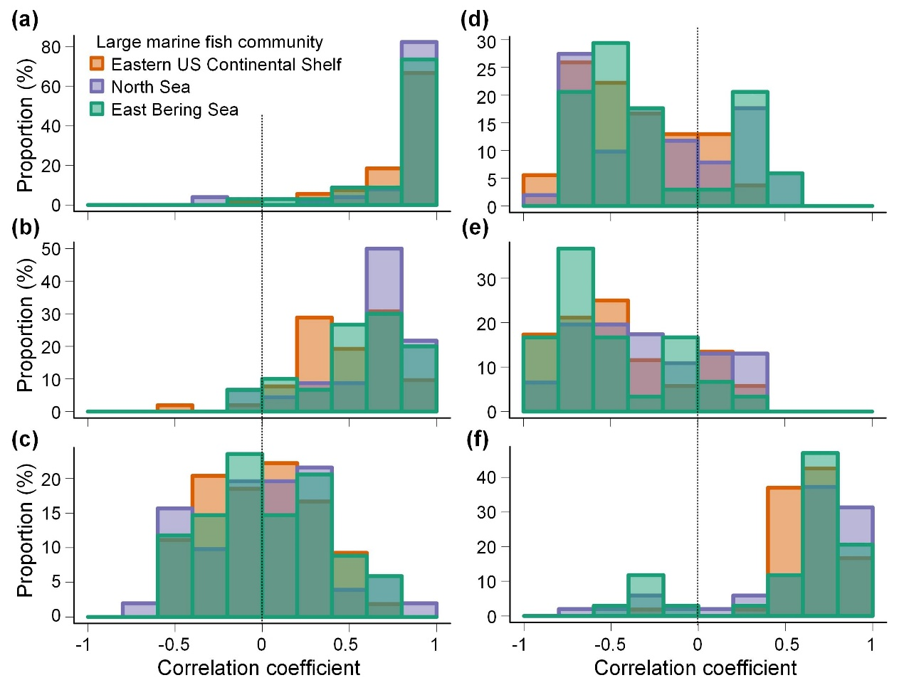
Figure S1. Frequency distributions of correlation coefficients between species' mean spatial robustness and species’ range sizes (a), the number of interacting species (b), and the median overlap proportion with interacting species (c) and correlation coefficients between species' mean spatial sensitivity and species’ range sizes (d), the number of interacting species (e), and the median overlap proportion with interacting species (f) in the Eastern US Continental Shelf (orange), the North Sea (purple), and the Eastern Bering Sea (green). The vertical dashed lines indicate correlations equal to 0.

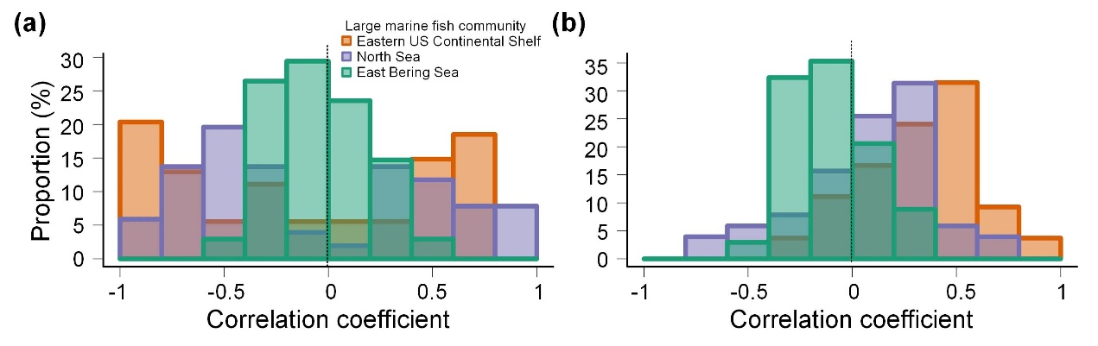
Figure S2. Frequency distributions of correlation coefficients of species' mean spatial robustness (a) and mean spatial sensitivity (b) with latitudinal shifts according to the centroid spatial distributions of individual species in the Eastern US Continental Shelf (orange), the North Sea (purple), and the Eastern Bering Sea (green). The vertical dashed lines indicate correlations equal to 0.

