Supplementary Material

Using raw catch data in tonnes per km² per 0.5-degree cell of the ocean, resulted in skewed Zonation outputs, therefore normalising the data was necessary. A standard equation was used to normalise across a range of values, giving resulting values from 0 - 1. The formula used was:

zi = (xi – min(x)) / (max(x) – min(x))

Table S1: Weightings of feature layers and the ocean area analysed per Zonation scenario. Catch was not considered during Zonation analysis in Scenarios 4 and 5. Brackets indicate the number of feature layers within each Zonation component. Where a feature layer was given ‘no weighting’ its area was defined as spatially preferable for protection using hierarchical masking.
 | Representative Biodiversity Areas (1) | Threatened Species (974) | Catch (1) | Ocean area considered
Scenario 1 | No weighting | 1 | No weighting | Entire ocean
Scenario 2 | 575 | 1 | -83 | Entire ocean
Scenario 3 | 800 | 1 | -720 | Entire ocean
Scenario 4 | No weighting | 1 | NA | High Seas only
Scenario 5 | No weighting | 1 | NA | Exclusive Economic Zones only

Table S2. Breakdown of increasing ocean protection benefits in Scenarios 1, 2 and 3.
Ocean Protected (%) | # Cells | Catch (tonnes) | Displaced catch (%) | Threatened Species Protected (%) | Biodiversity Protected (%)
Scenario 1
5 | 8604 | 18951213.5 | 1.8 | 41.0 | 19.4
10 | 17209 | 23010235.1 | 2.1 | 42.4 | 38.9
15 | 25813 | 27403206.8 | 2.5 | 43.9 | 58.3
20 | 34417 | 31137069.6 | 2.9 | 44.2 | 77.8
25 | 43022 | 44723922.7 | 4.1 | 58.5 | 84.7
30 | 51626 | 55465546.5 | 5.1 | 72.7 | 84.7
Scenario 2
5 | 8604 | 5182.1 | 0.0 | 0.1 | 19.3
10 | 17209 | 239061.4 | 0.0 | 9.3 | 37.9
15 | 25813 | 3303998.4 | 0.3 | 24.3 | 55.7
20 | 34417 | 17003476.0 | 1.6 | 42.7 | 73.5
25 | 43022 | 69707229.8 | 6.4 | 77.2 | 85.1
30 | 51626 | 121820043.4 | 11.3 | 88.8 | 89.0
Scenario 3
5 | 8604 | 31351392.8 | 2.9 | 23.7 | 13.3
10 | 17209 | 61560363.5 | 5.7 | 37.6 | 24.9
15 | 25813 | 92040610.0 | 8.5 | 55.5 | 35.5
20 | 34417 | 124382198.4 | 11.5 | 77.5 | 46.8
25 | 43022 | 154293897.0 | 14.3 | 87.3 | 56.9
30 | 51626 | 182810793.2 | 16.9 | 94.6 | 65.3

Table S3: Displaced catch per exploited species in Scenarios 1, 2 and 3. Exploited species listed from highest catch in weight (top) to lowest (bottom). Only those exploited species with the largest catch by weight which when combined equal the majority of global catch (50.1 %) are displayed.
Exploited species | Scenario 1 displaced catch (%) | Scenario 2 displaced catch (%) | Scenario 3 displaced catch (%)
Engraulis ringens | 0.0 | 2.4 | 2.5
Theragra chalcogramma | 0.8 | 3.8 | 4.3
Katsuwonus pelamis | 22.8 | 21.2 | 24.3
Clupea harengus | 6.1 | 9.6 | 7.3
Thunnus albacares | 22.6 | 24.4 | 29.1
Gadus morhua | 34.5 | 27.1 | 13.4
Sardina pilchardus | 1.7 | 3.4 | 14.7
Sardinella spp. | 4.2 | 13.7 | 21.1
Trichiurus lepturus | 0.3 | 4.7 | 13.1
Scyphozoa | 0.6 | 7.8 | 20.2
Rastrelliger kanagurta | 2.5 | 11.6 | 18.3
Carangidae | 3.8 | 12.4 | 17.1
Engraulis japonicus | 0.3 | 9.9 | 23.0
Nemipteridae | 0.9 | 5.0 | 12.3
Sciaenidae | 0.5 | 4.3 | 10.6
Leiognathidae | 2.9 | 9.9 | 16.7
Scomber japonicus | 4.6 | 13.3 | 19.7
Scomber scombrus | 1.1 | 2.0 | 8.1
Engraulidae | 2.4 | 12.4 | 18.0
Clupeidae | 6.1 | 13.8 | 17.0
Sardinops sagax | 4.6 | 20.8 | 28.9
Engraulis encrasicolus | 5.8 | 8.5 | 13.9
Micromesistius poutassou | 1.1 | 12.5 | 14.2
Dosidicus gigas | 0.8 | 3.9 | 5.4
Synodontidae | 0.4 | 1.9 | 5.5
Cololabis saira | 0.5 | 8.6 | 16.0
Oncorhynchus gorbuscha | 8.4 | 9.0 | 8.8
Clupea pallasii pallasii | 4.6 | 6.7 | 6.2
Sardinella longiceps | 0.3 | 5.6 | 20.5
Decapterus spp. | 0.3 | 5.1 | 15.5
Teuthida | 6.8 | 12.5 | 19.5
Acetes japonicus | 0.0 | 4.7 | 14.1
Penaeidae | 2.2 | 5.1 | 11.4
Todarodes pacificus | 0.8 | 9.7 | 19.0
Sprattus sprattus | 1.5 | 5.0 | 7.1
Trachurus murphyi | 12.2 | 16.6 | 13.7
Decapoda | 4.1 | 12.0 | 23.4
Mollusca | 3.6 | 10.3 | 20.8

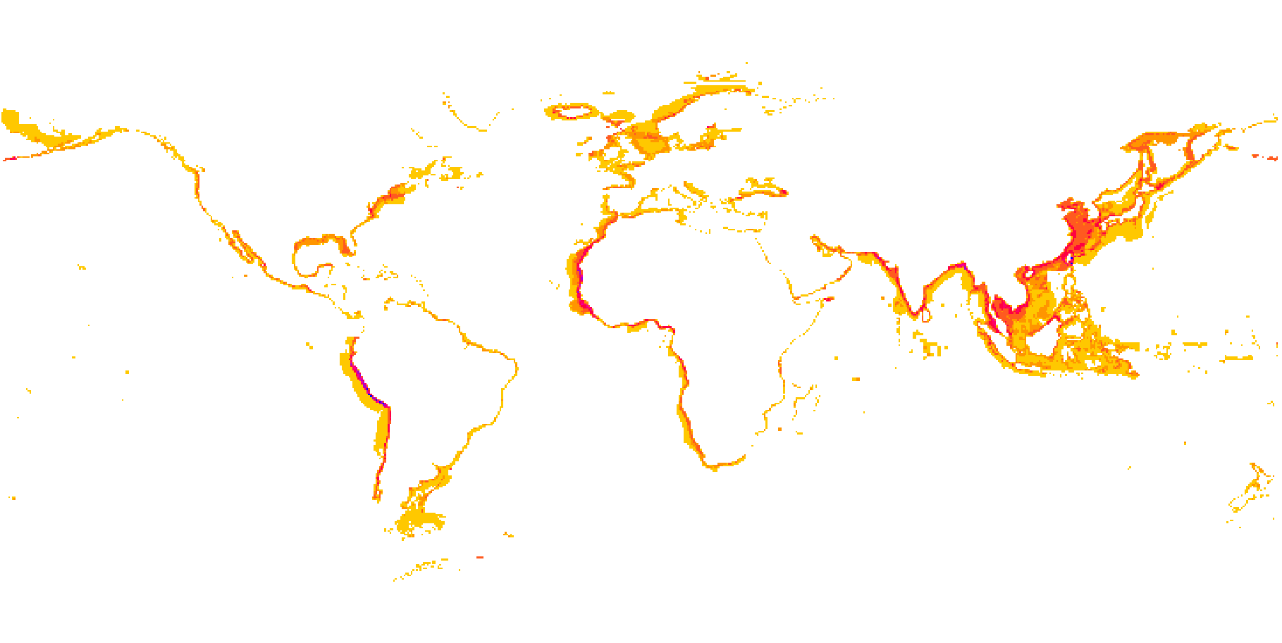
Tonnes per km²
Figure S1. Global distribution of catch by weight, limited to the highest catch cells that equal 90 % of catch. Displayed without terrestrial limits for clarity. Areas of highest catch (blue) are about 100 times greater in catch than areas of smallest catch (yellow).

