Figures and Caption

Photoclick Reaction Constructs Glutathione-Responsive Theranostic System for Anti-Tuberculosis

Jundun Zheng2,‡, Xun Long1,‡, Hao Chen3,‡, Zhisheng Ji4,‡, Bowen Shu2, Rui Yue2, Yechun Liao1, Shengchao Ma7*, Kun Qiao6*, Ying Liu1* and Yuhui Liao2,5,7*

1Department of Science and Education, The Third People’s Hospital of Bijie City, Bijie, 551700 (P.R. China).

2Molecular Diagnosis and Treatment Center for Infectious Diseases, Dermatology Hospital, Southern Medical University, Guangzhou 510091 (P.R. China).

3Division of Gastrointestinal Surgery, Department of General Surgery, Nanfang Hospital, Southern Medical University, Guangzhou 510091 (P.R. China).

4Department of Orthopedics, the First Affiliated Hospital of Jinan University, Jinan University, Guangzhou 510630 (P.R. China).

5Department of Infectious Disease, the Fifth Affiliated Hospital, Sun Yat-sen University, Guangzhou 510091 (P.R. China).

6Department of Thoracic Surgery, Shenzhen Third People’s Hospital, Shenzhen 518110, (P.R. China).

7NHC Key Laboratory of Metabolic Cardiovascular Diseases Research, Ningxia Key Laboratory of Vascular Injury and Repair Research, Ningxia Medical University, Yinchuan 750004, China

‡ These authors contributed equally.

**\* Correspondence:**

Corresponding Author

Shengchao Ma, E-mail: [solarmsc@163.com](mailto:solarmsc@163.com)

Kun Qiao, E-mail: [szqiaokun@163.com](mailto:szqiaokun@163.com)

Ying Liu, E-mail: [LX13985359719@163.com](mailto:LX13985359719@163.com)

Yuhui Liao, E-mail: [liaoyh8@mail.sysu.edu.cn](mailto:liaoyh8@mail.sysu.edu.cn)

Keywords: Tuberculosis1, Theranostic System2, Photoclick Reaction3, Microenvironment4, Glutathione5.



Figure S1. Synthetic route of HA-Cys-MA.

HA-Lys-Tet

Figure S2. Synthetic route of HA-Lys-Tet.

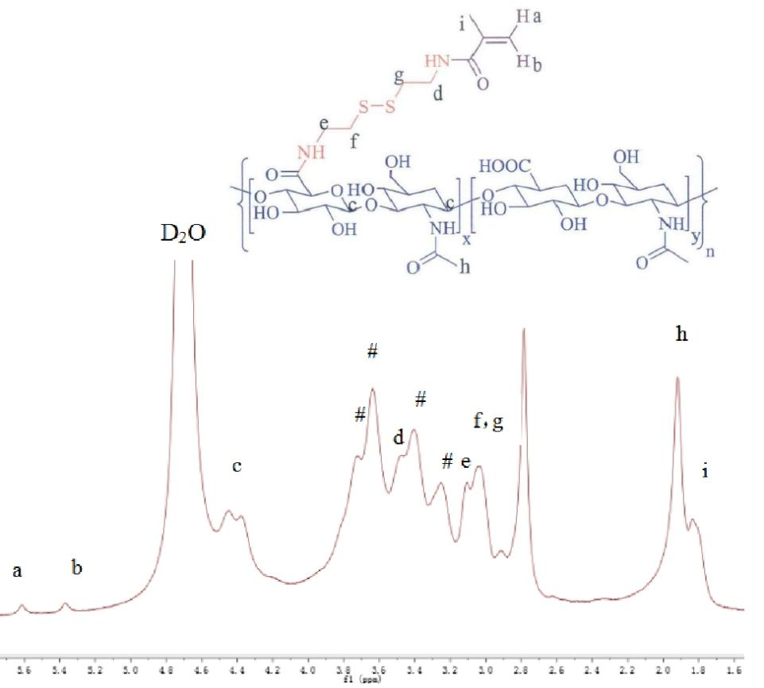

Figure S3. The 1H-NMR of HA-Cys-MA.

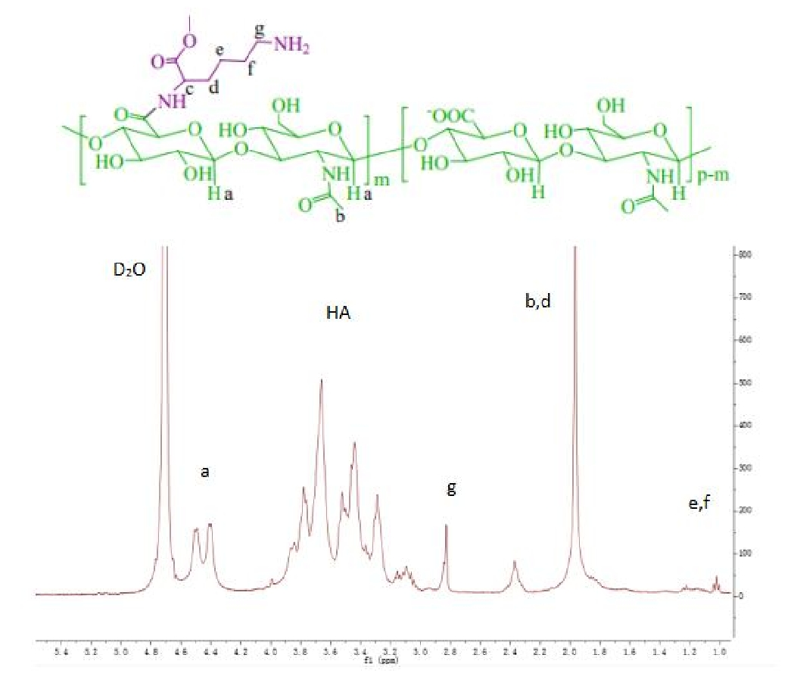

Figure S4. The 1H-NMR of HA-Lys-NH2.

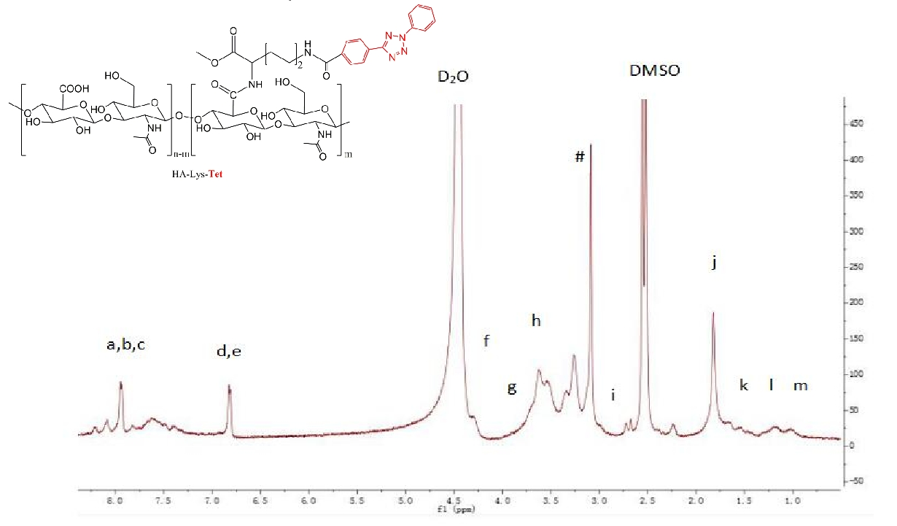

Figure S5. The 1H-NMR of HA-Lys-Tet.

**Reference**

[1] Y. Liao, B. Li, Z. Zhao, Y. Fu, Q. Tan, X. Li, W. Wang, J. Yin, H. Shan, B. Z. Tang, X. Huang, *ACS Nano* **2020**, *14*, 8046-8058