Supplementary Material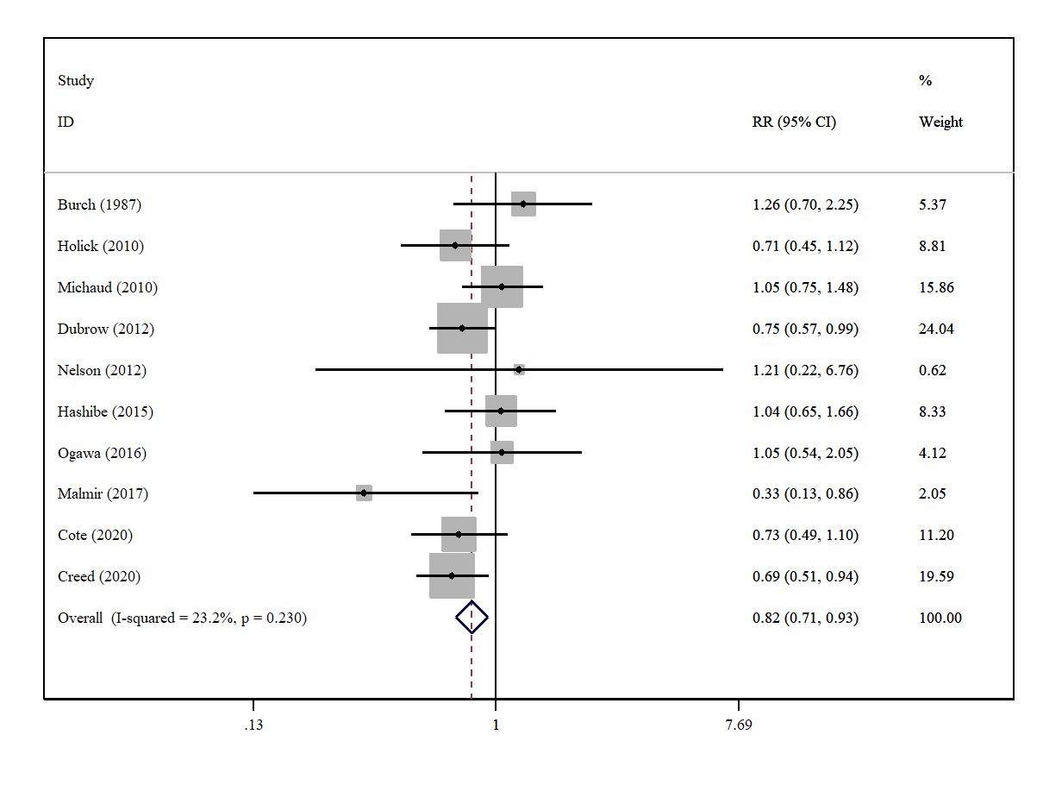Supplementary Figure 1 | A forest plot showing risk estimates of the association between tea intakes and glioma.
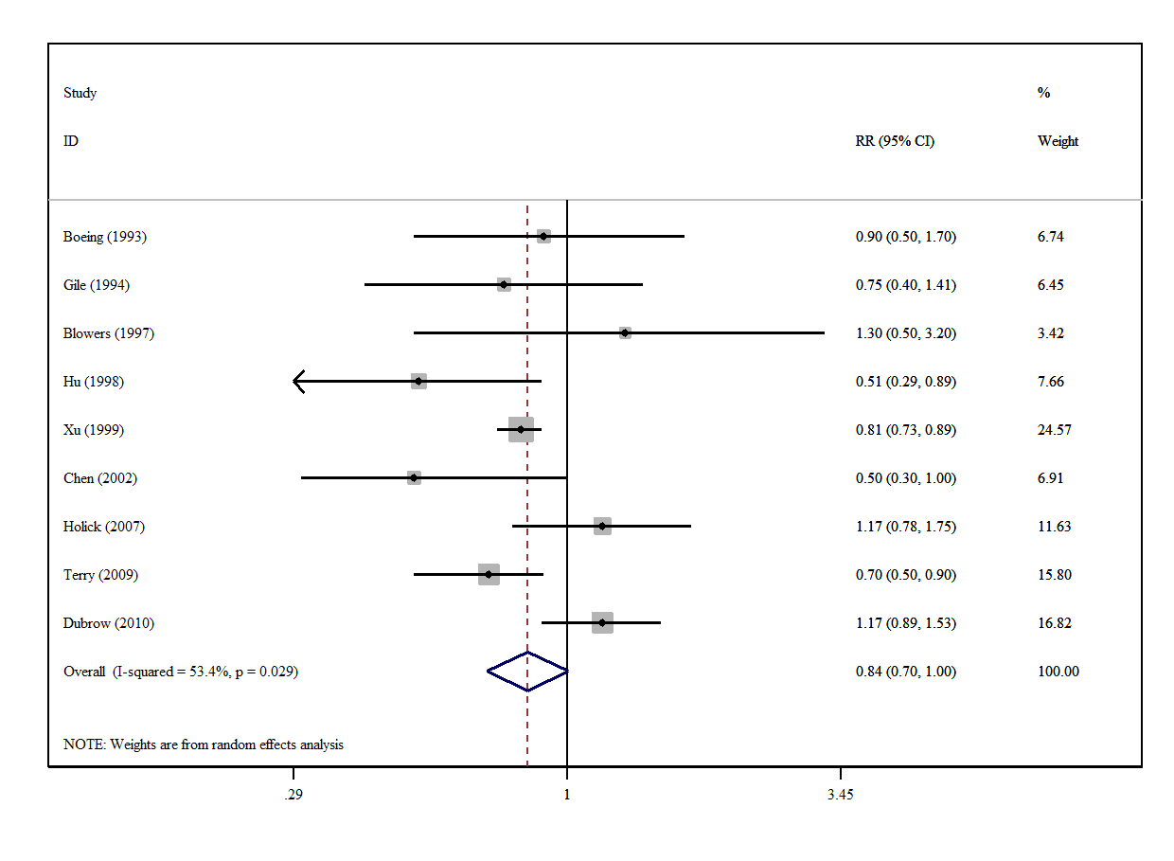Supplementary Figure 2 | A forest plot showing risk estimates of the association between total vegetables intakes and glioma.

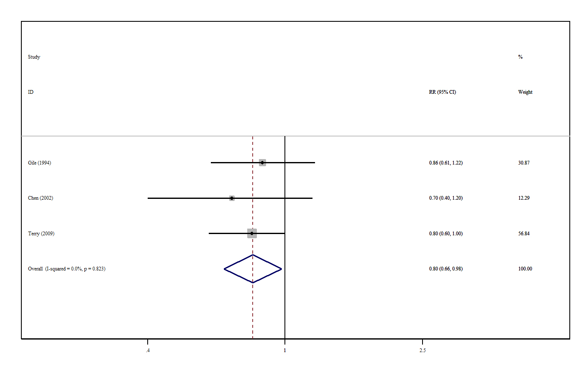
Supplementary Figure 3 | A forest plot showing risk estimates of the association between green vegetables intakes and glioma.
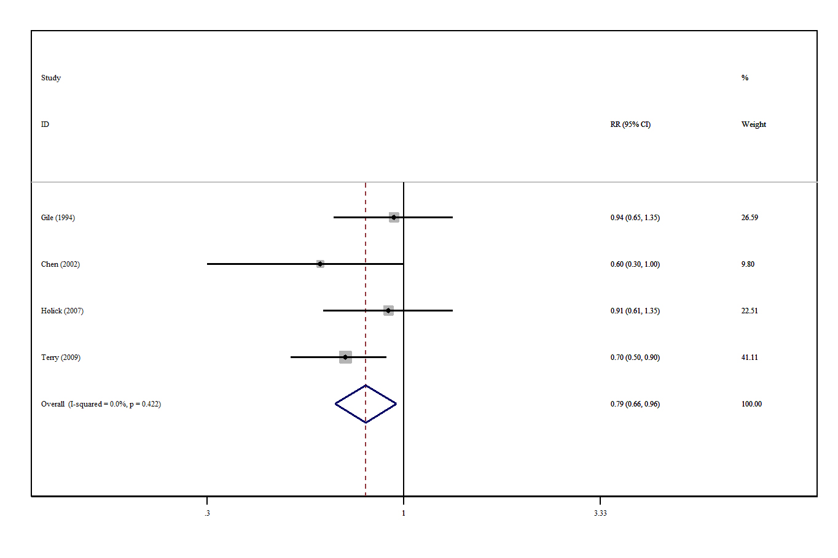
Supplementary Figure 4 | A forest plot showing risk estimates of the association between orange vegetables intakes and glioma.

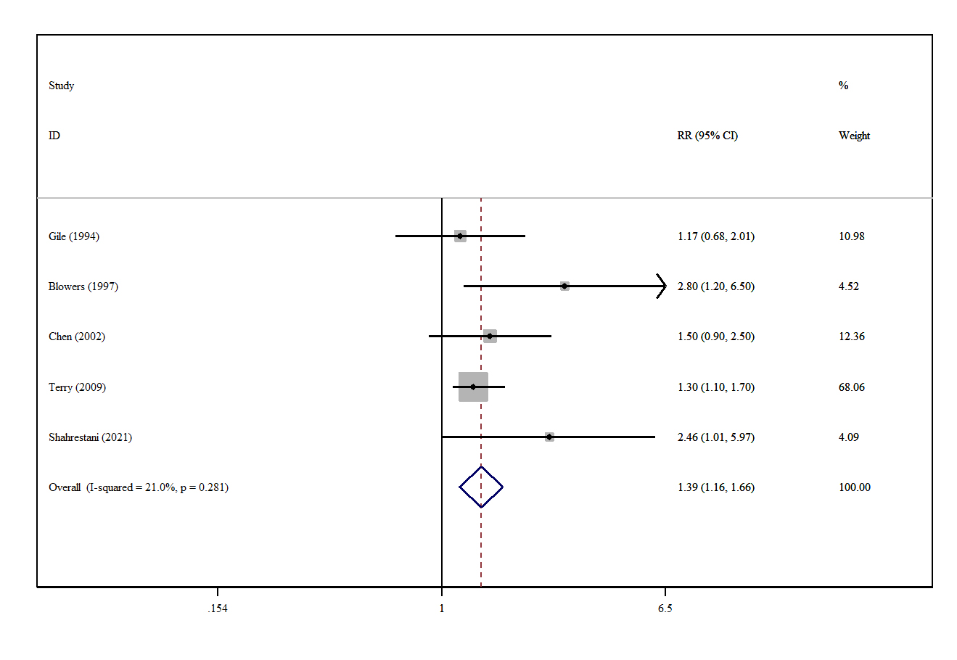
Supplementary Figure 5 | A forest plot showing risk estimates of the association between grains intakes and glioma.

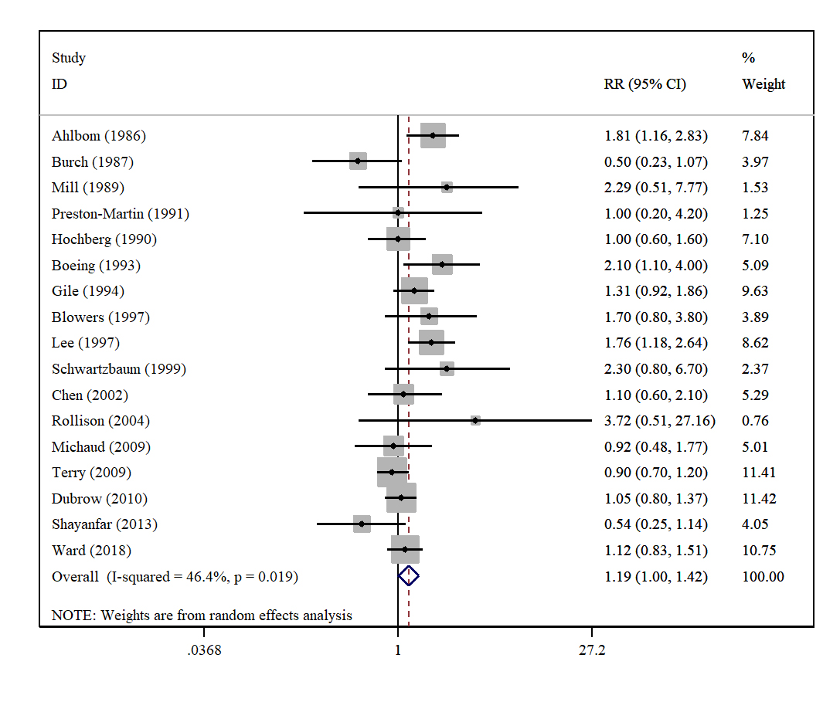
Supplementary Figure 6 | A forest plot showing risk estimates of the association between processed meats intakes and glioma.
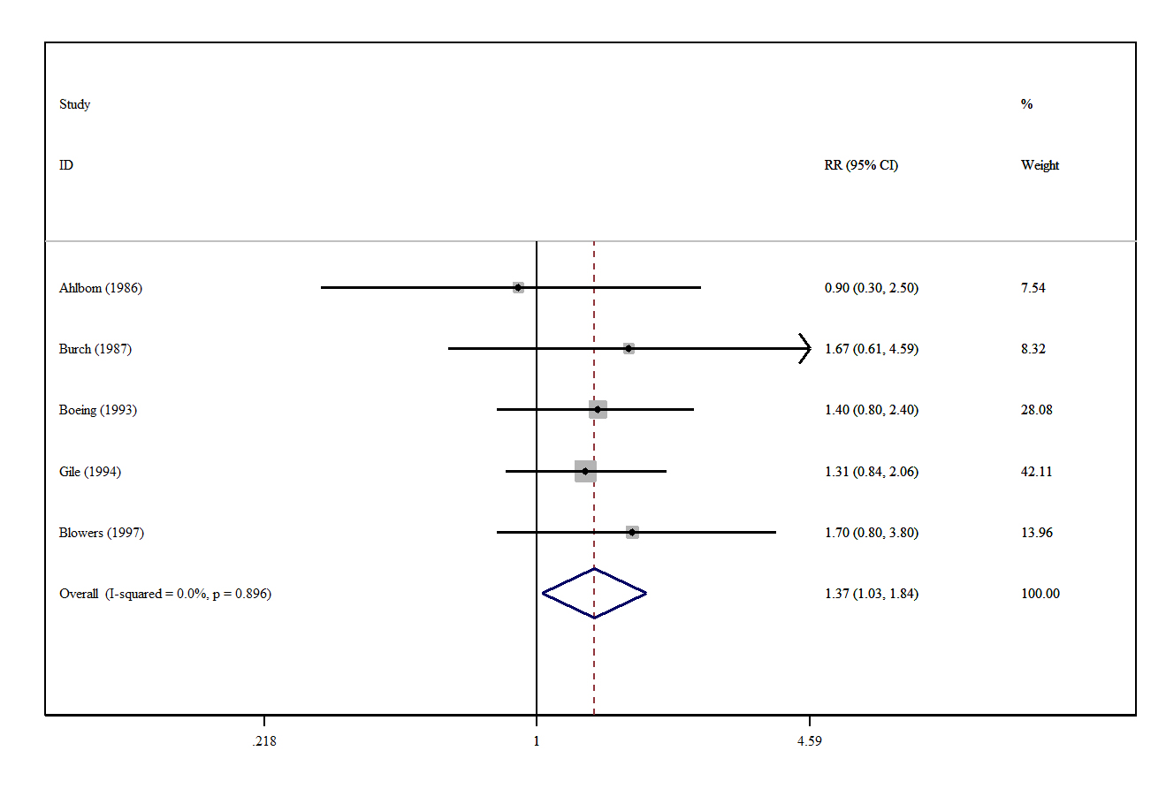
Supplementary Figure 7 | A forest plot showing risk estimates of the association between processed fish intakes and glioma.

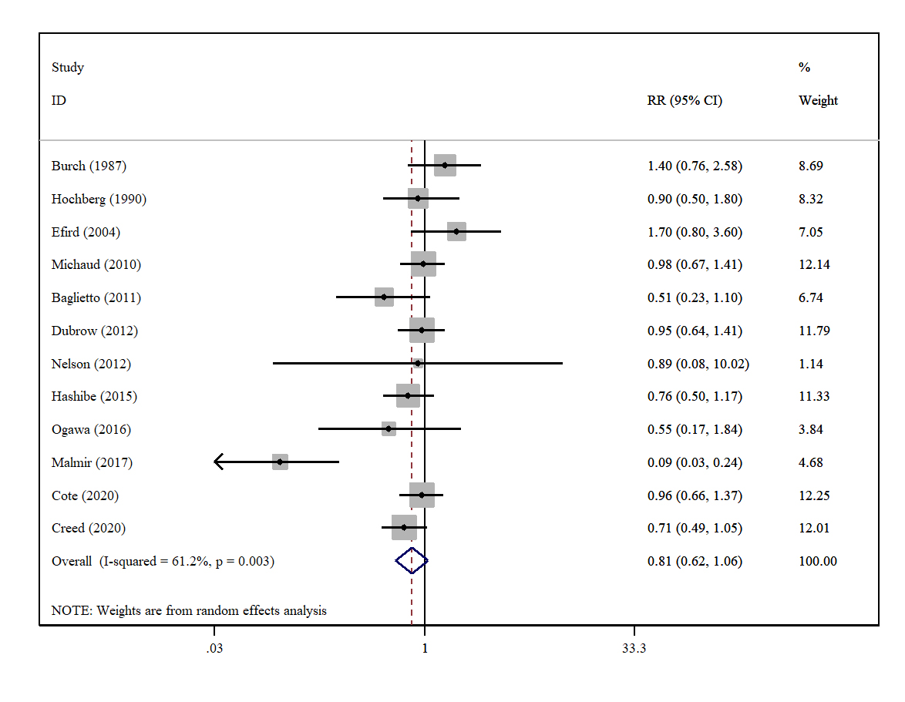
Supplementary Figure 8 | A forest plot showing risk estimates of the association between coffee intakes and glioma.
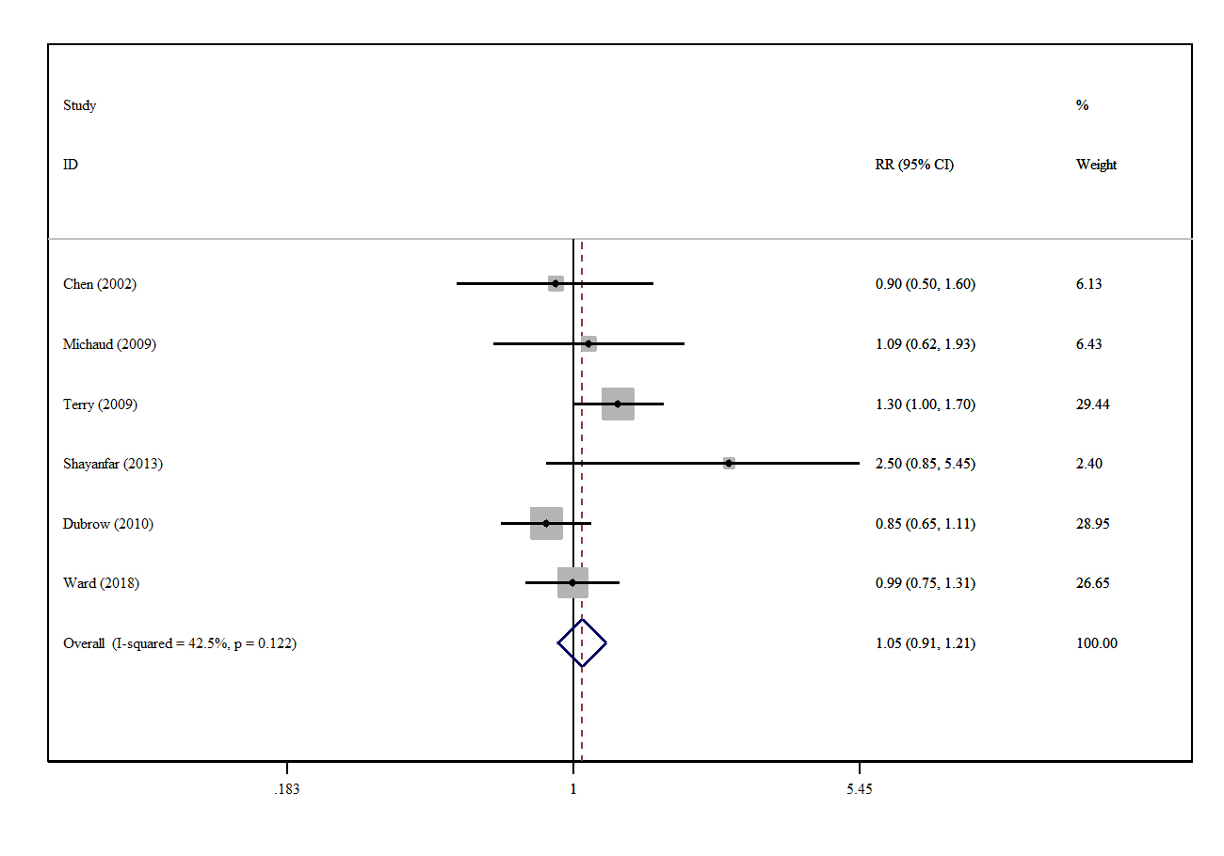
Supplementary Figure 9 | A forest plot showing risk estimates of the association between red meats intakes and glioma.

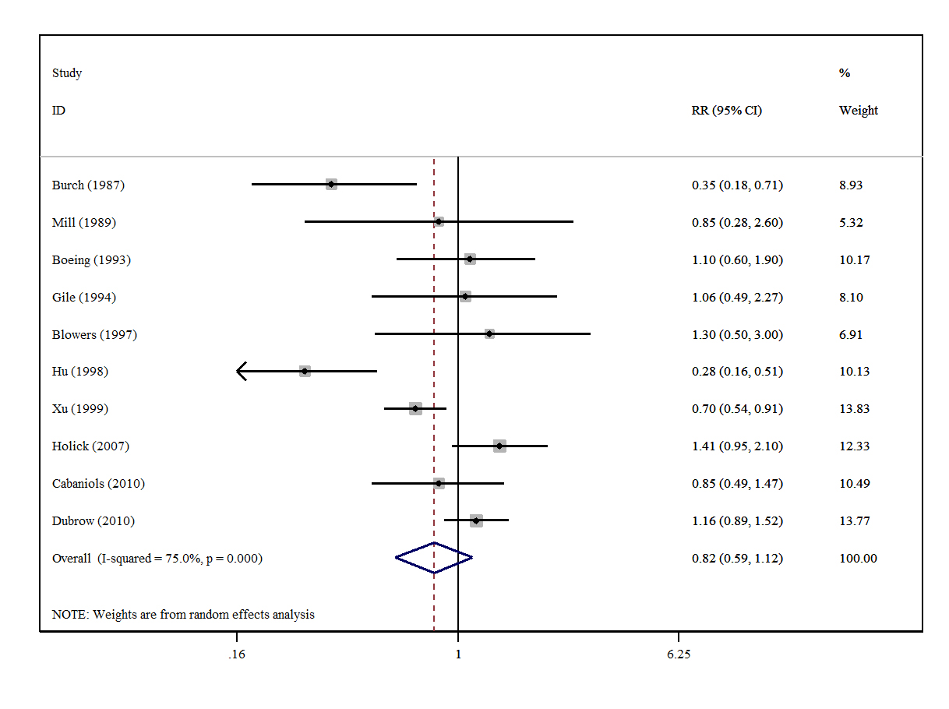
Supplementary Figure 10 | A forest plot showing risk estimates of the association between total fruits intakes and glioma.

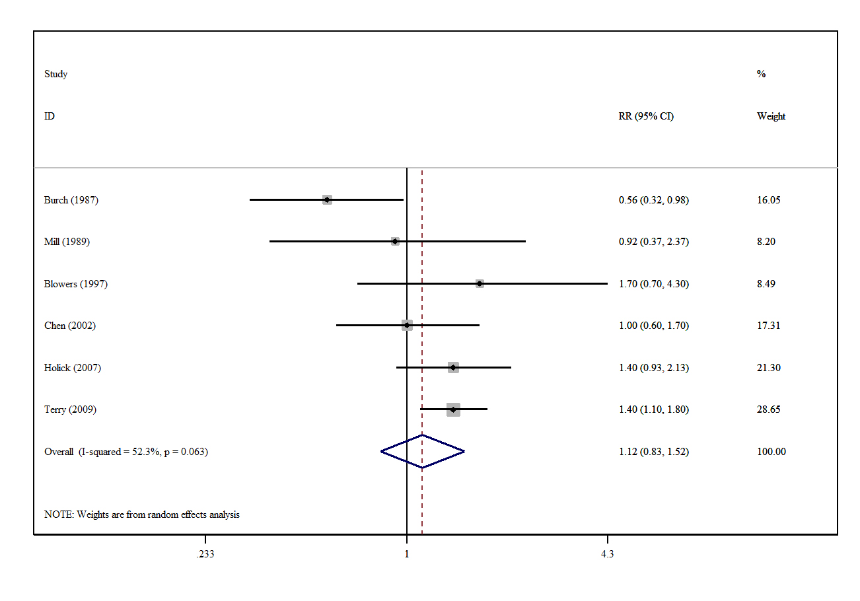
Supplementary Figure 11 | A forest plot showing risk estimates of the association between citrus fruits intakes and glioma.

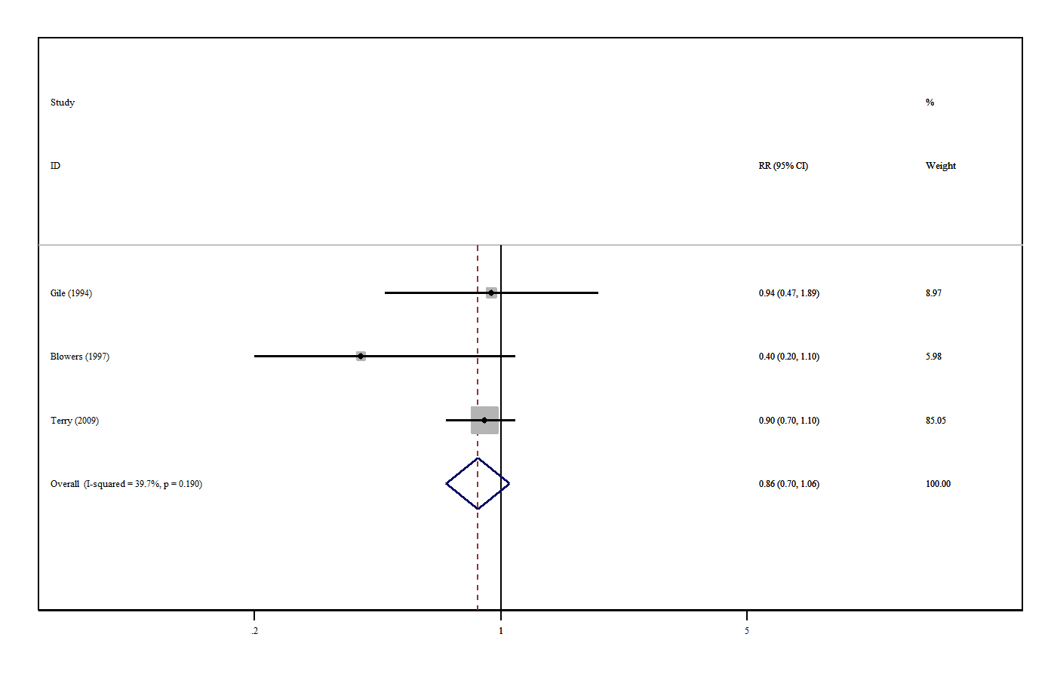
Supplementary Figure 12 | A forest plot showing risk estimates of the association between fresh fish intakes and glioma.

