Supplementary Data – Journal of Vertebrate Paleontology

The phylogenetic relationships of the European trilophosaurids Tricuspisaurus thomasi and Variodens inopinatus

SOFIA A. V. CHAMBI-TROWELL*,, DAVID I. WHITESIDE^{1, 2}, MATTHEW SKINNER¹, MICHAEL J. BENTON¹, and EMILY J. RAYFIELD¹.

¹School of Earth Sciences, University of Bristol, Bristol, BS8 1TF, United Kingdom;
²Palaeontology Section, Earth Science Department, Natural History Museum, Cromwell Road, London, SW7 5BD, United Kingdom.

CHAMBI-TROWELL ET AL.—PHYLOGENY OF EUROPEAN TRILOPHOSAURIDS

1. Character list
Reference abbreviations: Dilkes 1998 (D98); Ezcurra et al., 2010 (E10); Gower & Sennikov 1996 (GS96); Gower & Sennikov 1997 (GS97); Juul 1994 (J94); Kligman et al. 2020 (K20); Pritchard et al., 2015 (P15); Nesbitt et al., 2009 (N09); Nesbitt et al., 2011 (N11); Nesbitt et al., 2015 (N15), Sereno 1991 (S91).
“*” New characters indicated by an asterisk.
- Premaxilla, orientation of ventral margin: horizontal, roughly in line with maxillary ventral margin (0); slight downturn, such that the margin trends anteroventrally (1); extensive downturn, premaxilla extends to ventral margin of dentary (2). (P15, N15, K20) ORDERED.
- Premaxilla, anterodorsal process (5 nasal process): present, separating the nares (0); absent or reduced, creating a confluent external naris (1). (P15, N15, K20)
- Premaxilla, posterodorsal process (5 maxillary process 5 subnarial process): absent, such that premaxilla contributes a small ventral margin for the naris (0); posterodorsal process present, framing the posteroventral margin of the naris (1). (P15, N15, K20)
- Premaxilla, length of posterodorsal process (5 maxillary process 5 subnarial process): short, failing to exclude maxilla from narial margin (0); long, excluding maxilla from narial margin (1); extremely long, reaching the anteriormost part of the prefrontal (2). (P15, N15, K20) ORDERED
- Premaxilla, posterodorsal process/maxilla contact: contact is a simple, straight margin (0); knob on the posterior margin of the posterodorsal process of the premaxilla fits into notch in the anterior surface of the maxilla (1). (P15, N15, K20)
- Maxilla, orientation of ventral margin: ventral margin of maxilla is horizontal (0); ventral margin of maxilla is convex (1). (P15, N15, K20)
- Maxilla, posterolateral surface: directly adjacent to alveolar margin (0); lateral process of maxilla present, creating distinct space between maxillary alveoli and posterolateral surface of the maxilla (1). (P15, N15, K20)
- Nasal, orientation of contact with prefrontal: oriented parasagitally (0); oriented anterolaterally (1). (P15, N15, K20)
- Prefrontal, contact with contralateral prefrontal: no contact, due to frontonasal contact (0); prefrontals approach medially, constricting frontonasal contact (1); contact present (2). (P15, N15, K20) ORDERED
- Lacrimal, facial contribution: forms a portion of lateral surface of the face, reaching anteriorly to the external naris (0); forms a portion of the lateral surface of the face, but does not reach naris (1); limited to orbital margin (2). (P15, N15, K20) ORDERED
- Lacrimal, anterior extension: lacrimal extends dorsally to reach the ventral margin of the nasal externally (0); lacrimal fails to reach nasal (1). (P15, N15, K20)
- Antorbital fenestra: absent (0); present (1). (P15, N15, K20)
- Frontals, degree of fusion: frontals unfused to one another (suture patent) (0); frontals fused in the midline (1). (P15, N15, K20)
- Frontals, shape: frontal maintains transverse width throughout its anteroposterior length (0); frontals expand transversely posteriorly (1). (P15, N15, K20)
- Frontal, shape of contact with parietal in dorsal view: roughly transverse in orientation (0); frontal exhibits posterolateral processes, forming anteriorly curved U-shaped contact (1).
- Frontal and postfrontal, surface texture: dorsal surface relatively smooth (0); dorsal surface exhibits distinct pitting (1). (P15, N15, K20)
- Postfrontal, medial contact with frontal and parietal: postfrontal forms broad contact with midline skull elements, without bifurcation (0); postfrontal bifid, fitting broadly across both parietal and frontal (1). (P15, N15, K20)
- Parietals, degree of fusion: parietals unfused to one another (patent suture) (0); parietals fused at the midline (1). (P15, N15, K20)
- Parietal, dorsal surface: parietal skull table flattened (0); dorsal exposure of parietal forms a raised margin, elevated above lateral excavation for jaw adductor musculature (1); thin, bladelike sagittal crest (2). (P15, N15, K20) ORDERED
- Parietal, orientation of posttemporal process: roughly transverse (0); strong posterolateral angling (1). (P15, N15, K20)
- Pineal foramen: present (0); absent (1). (P15, N15, K20)
- Pineal foramen, position: entirely surrounded by parietals (0); situated within the frontoparietal suture (1). (P15, N15, K20)
- Postparietals: absent (0); present (1). (P15, N15, K20)
- Postparietals, degree of fusion: unfused to one another (0); fused as a midline interparietal (1). (P15, N15, K20)
- Postorbital, presence of medial process: medial process absent, with contributions of the frontal, parietal or postfrontal forming the posterodorsal orbital margin (0); present, postorbital contributing to posterodorsal orbital margin (1). (P15, N15, K20)
- Postorbital, location of medial process: situated deep to postfrontal (0); dorsally excludes postfrontal from supratemporal fenestra margin (1). (P15, N15, K20)
- Postorbital, length of posterior process: contributes to less than one-half the length of the supratemporal bar (0); contributes to more than one-half the length of the supratemporal bar (1). (P15, N15, K20)
- Infratemporal fenestrae, conformation: present, distinct opening framed by squamosal, postorbital, and jugal (0); postorbital, jugal, and squamosal fit against one another as a “lateral temporal plate” present, with squamosal extending anteriorly to slot into a notch on the jugal (1). (P15, N15, K20)
- Jugal, ornamentation of lateral surface: unornamented (0); distinct anteroposteriorly trending shelf present (1). (P15, N15, K20)
- Jugal, ascending process relative to supratemporal bar: process terminates ventral to bar (0); process intersects between postorbital and squamosal within bar (1). (P15, N15, K20)
- Jugal, posterior process: absent (0); present, but failing to contact the quadratojugal posteriorly (1); present, contacting the quadratojugal posteriorly (2). (P15, N15, K20) ORDERED
- Squamosal, descending process: present (0); absent (1). (P15, N15, K20)
- Squamosal, size of descending process: forms massive flange that covers the quadrate almost entirely or entirely in lateral view (0); anteroposteriorly slender (1). (P15, N15, K20)
- Squamosal, posterior process: no posterior process (0); posterior process, extending beyond quadrate contact (1). (P15, N15, K20)
- Supratemporals: absent (0); present (1). (P15, N15, K20)
- Quadratojugal: present (0); absent (1). (P15, N15, K20)
- Quadratojugal, extent of dorsal process: process tall (0); weakly developed or absent dorsal process (1). (P15, N15, K20)
- Quadrate, shape of posterior margin: straight, vertical posterior margin (0); concave, excavated posterior margin (1). (P15, N15, K20)
- Quadrate foramen/quadratojugal foramen, position: foramen positioned between quadrate and quadratojugal (0); foramen positioned within the quadrate (1). (P15, N15, K20)
- Quadrate, tympanic crest: absent, quadrate has no lateral expansion (0); present, flattened tympanic crest projects from lateral surface of quadrate (1). (P15, N15, K20)
- Palatal teeth: present (0); absent (1). (P15, N15, K20)
- Vomerine teeth: present (0); absent (1). (P15, N15, K20)
- Vomer, contact with maxilla: absent, vomer only contacts premaxilla (0); present, vomer-premaxilla contact expands onto maxilla (1). (P15, N15, K20)
- Palatine teeth: present (0); absent (1). (P15, N15, K20)
- Pterygoid, anterior process, number of dentition fields: one field (0); two fields (1); three fields (2). (P15, N15, K20)
- Pterygoid, transverse process dentition: absent (0); present (1). (P15, N15, K20)
- Pterygoid, midline contact with contralateral pterygoid: absent (0); present, small contact anteriorly (1); present, broad contact throughout length (2). (P15, N15, K20) ORDERED
- Pterygoid, orientation of transverse process in ventral view: lateral (0); anterolateral (1). (P15, N15, K20)
- Supraoccipital, texture of posterior surface: smooth (0); distinct dorsoventrally running crest in the midline (1). (P15, N15, K20)
- Supraoccipital, shape: consists of a flattened posterior lamina (0); pillarlike (1). (P15, N15, K20)
- Opisthotic, shape of ventral ramus: slender process (0); distinct club-shaped expansion ventrally (1). (P15, N15, K20)
- Exoccipital, dorsal contact with occipital elements: exoccipital columnar throughout dorsoventral height, forming transversely narrow dorsal contact with more dorsal occipital elements (0); dorsal portion of exoccipital exhibits dorsomedially inclined process that forms transversely broad contact with more dorsal occipital elements (1). (P15, N15, K20)
- Exoccipital, contralateral contact dorsal to foramen magnum: absent, supraoccipital contributes to foramen magnum (0); present, excluding supraoccipital from foramen magnum (1). (P15, N15, K20)
- Exoccipital, contralateral contact on floor of foramen magnum: absent, basioccipital contributes to floor of foramen magnum (0); present, excluding basioccipital from floor of the foramen magnum (1). (P15, N15, K20)
- Exoccipitals, fusion with opisthotic: absent (0); present (1). (P15, N15, K20)
- Opisthotic, paroccipital process morphology: unflattened and tapered (0); anteroposteriorly flattened distally (1). (P15, N15, K20)
- Parabasisphenoid, parasphenoid crests: absent such that there is no ventral floor for the vidian canal (0); present as prominent ventrolateral extensions of the caudoventral processes, framing the ventromedial floor of the vidian canal (1). (P15, N15, K20)
- Parabasisphenoid, passage for internal carotid arteries: within lateral wall of braincase (0); within ventral surface of the parabasisphenoid (1); passage of the internal carotids do not enter the braincase (2). (P15, N15, K20)
- Braincase, conformation of ventral surface: roughly planar (0); distinct depression at the suture between the basioccipital and the parabasisphenoid (1); distinct depression within the parabasisphenoid (2). (P15, N15, K20)
- Parabasisphenoid, basipterygoid process orientation in transverse plane: anterolateral (0); lateral (1). (P15, N15, K20)
- Parabasisphenoid, location of abducens foramina: within the dorsum sella (0); track across dorsal surface of dorsum sella, between it and the prootic (1). (P15, N15, K20)
- Laterosphenoid ossification: absent (0); present but fails to reach the ventral surface of frontals (1); present and reaches the frontals (2). (P15, N15, K20) ORDERED
- Prootic, crista prootica: present (0); absent (1). (P15, N15, K20)
- Prootic, anterior inferior process: process present, sitting anterior to trigeminal foramen (0); absent, trigeminal foramen unframed anteriorly (1). (P15, N15, K20)
- Prootic, paroccipital contribution: does not contribute to anterior surface of paroccipital process (0); contributes laterally tapering lamina to the anterior surface of the prootic (1).
- Stapes, dorsal process: absent (0); present (1). (P15, N15, K20)
- Stapes, foramen for stapedial artery: present (0); absent (1). (P15, N15, K20)
- Dentary, anterior portion, symphyseal region of mandible: dentaries do not diverge, thus contributing to symphysis (0); dentaries diverge, and only splenials contribute to symphysis (1). (P15, N15, K20)
- Coronoid process: absent (0); present (1). (P15, N15, K20)
- Surangular, lateral surface, foramen positioned near surangular-dentary contact: absent (0); present (1). (P15, N15, K20)
- Surangular, lateral surface, foramen positioned directly anterolateral to glenoid fossa: absent (0); present (1). (P15, N15, K20)
- Angular, exposure on lateral mandibular surface: broadly exposed (0); limited to posteroventral sliver by dentary and surangular (1). (P15, N15, K20)
- Angular, exposure on lateral mandibular surface: terminates anterior to the glenoid (0); extends to the glenoid (1). (P15, N15, K20)
- External mandibular fenestra (EMF): absent (0); present (1). (P15, N15, K20)
- Splenial, contribution to mandibular symphysis: splenials contribute to symphysis (0); splenials fail to contribute (1). (P15, N15, K20)
- Retroarticular process: present (0); absent (1). (P15, N15, K20)
- Retroarticular process, composition: articular only (0); fused articular-prearticular (1). (P15, N15, K20)
- Marginal dentition on anteriormost portions of premaxilla and dentary: present (0); absent (1). (P15, N15, K20)
- Marginal dentition, enlarged caniniform teeth in maxilla: present (0); absent, maxillary teeth subequal in size (1). (P15, N15, K20)
- Marginal dentition, serrations: nonserrated (0); serrated (1). (P15, N15, K20)
- Marginal dentition, shape of the posterior margin of tooth: convex or straight (0); concave (1). (P15, N15, K20)
- Marginal dentition, arrangement: single row of marginal teeth (0); multiple Zahnreihen in maxilla (1). (P15, N15, K20)
- Marginal dentition, morphology of crown base: single, pointed crown (0); flattened platform with pointed cusps (1); mesiodistally arranged cusps (2). (P15, N15, K20)
- Marginal dentition, lingual surface: teeth walled by minimal lingual wall (0); no lingual wall (5 pleurodonty) (1). (P15, N15, K20)
- Marginal dentition, lingual surface: teeth walled by minimal lingual wall only (0); interdental plates are present (1). (P15, N15, K20)
- Marginal dentition, rooting: tooth crowns are not attached to dentigerous bones (0); teeth ankylosed to bones of attachment (1). (P15, N15, K20)
- Marginal dentition, tooth shape at crown base: circular (0); labiolingually compressed (1); labiolingually wider than mesiodistally long (2). (P15, N15, K20)
- Palatal dentition, morphology: small, buttonlike teeth (0); small, conical teeth (1). (P15, N15, K20)
- Presacral vertebrae, shape of anterior articular surface: planar (0); concave (1). (P15, N15, K20)
- Presacral vertebrae, shape of posterior articular surface: planar (0); concave (1); convex (2). (P15, N15, K20)
- Presacral vertebrae, development of posterior articular surface convexity: moderate (0); ball-like (1). (P15, N15, K20)
- Anterior cervical ribs, shaft shape: tapering rapidly, roughly triangular in lateral view (0); ribs taper gradually, elongate and splintlike in lateral view (1). (P15, N15, K20)
- Cervical ribs, anterior process: absent (0); present (1). (P15, N15, K20)
- Intercentra in the cervical column: present (0); absent (1). (P15, N15, K20)
- Anterior postaxial cervical vertebrae, shape of anterior articular surface: subcircular, roughly equivalent in dorsoventral height and transverse width (0); compressed, with a greater transverse width than dorsoventral height (1). (P15, N15, K20)
- Cervical vertebrae, ventral keel: present (0); absent (1). (P15, N15, K20)
- Anterior postaxial cervical vertebrae, shape of ventral surface excluding keel: ventrally rounded (0); ventral face flattened (1). (P15, N15, K20)
- Cervical vertebrae, number of costal facets: one (0); two (1). (P15, N15, K20)
- Anterior postaxial cervical vertebrae, position of diapophysis (or dorsal margin of synapophyses): at or near dorsoventral level of pedicles (0); further ventrally, near the dorsoventral midpoint of the centrum (1). (P15, N15, K20)
- Anterior postaxial cervical vertebrae, relative location of costal facets: facets distinctly offset from one another (0); facets very closely appressed to one another with little or no finished bone separation (1). (P15, N15, K20)
- Anterior postaxial cervical vertebrae, shape of neural spine base: elongate, subequal in length to the neural arch (0); short, spine restricted to posterior half of neural arch (1). (P15, N15, K20)
- Anterior postaxial cervical vertebrae, neural spine shape in cross section: transversely narrow (0); elliptical or circular (1). (P15, N15, K20)
- Anterior postaxial cervical vertebrae, shape of anterior margin of neural spine in lateral view: straight and linear (0); anterodorsal process present forming an anterior notch (1). (P15, N15, K20)
- Anterior postaxial cervical vertebrae, anterior margin of neural spine, direction of inclination: inclined posterodorsally (0); inclined anterodorsally (1). (P15, N15, K20)
- Cervical vertebrae, relative location of dorsal margin of midcervical neural spines: spines are equivalent in height and length to other cervical neural spines (0); spines are dorsoventrally depressed at their anteroposterior midpoints, leaving them little more than midline dorsal ridges (1). (P15, N15, K20)
- Cervical vertebra, dorsal surface of postzygapophyses: smooth and rounded (0); posteriorly pointed projections (epipophyses) present (1). (P15, N15, K20)
- Anterior trunk vertebrae, position of parapophysis (or ventral margin of dorsal synapophysis): positioned partially on lateral margin of centrum (0); positioned entirely on neural spine (1). (P15, N15, K20)
- Posterior trunk vertebra, position of parapophysis (or ventral margin of dorsal synapophysis) in trunk vertebrae: positioned partially on lateral margin of centrum (0); positioned entirely on neural spine (1). (P15, N15, K20)
- Anterior trunk vertebra, number of pectoral costal facets: one (holocephaly) (0); two (dichocephaly) (1); three (tricephaly) (2). (P15, N15, K20)
- Posterior trunk vertebrae, costal facets: single rib facet (0); “inverse-L” (inverted-L) rib facet (suggesting partial confluence of diapophysis and parapophysis) (1); double rib facet (2). (P15, N15, K20)
- Posterior trunk vertebra, ribs, and vertebrae: unfused (0); fused (1). (P15, N15, K20)
- Trunk vertebrae, neural spine, dorsal portion: similar width as the more distal portion of the neural spine (0); expanded transversely into a flattened tip (5 spine table) (1). (P15, N15, K20)
- Trunk vertebra, breadth of neural spine expansion: little lateral expansion relative to the neural spine base (0); transversely broad, much wider than neural spine base (1). (P15, N15, K20)
- Trunk vertebra, texturing on dorsum of neural spine expansion: marked by irregular rugosities (0); marked by transverse striations (1). (P15, N15, K20)
- Trunk vertebrae, intercentra: present (0); absent (1). (P15, N15, K20)
- Trunk vertebrae, height of neural spines: tall, greater in dorsoventral height than anteroposterior length (0); long and low, lesser in dorsoventral height than anteroposterior length (1). (P15, N15, K20)
- Trunk vertebra, accessory zygosphene-zygantrum articulations: absent (0); present (1). (P15, N15, K20)
- Second sacral rib, shape: rib is a single unit (0); rib bifurcates posteriorly into anterior and posterior processes (1). (P15, N15, K20)
- Second sacral rib, morphology of posterior process: terminally blunted (0); sharp distally (1). (P15, N15, K20)
- Anterior caudal vertebrae, orientation of transverse processes: base of process perpendicular to the long axis of the vertebra (0); processes angled posterolaterally from base (1). (P15, N15, K20)
- Caudal vertebrae, autotomic septa within the centrum: absent (0); present (1).
- Gastralia, pairs of lateral gastralia: two (0); one (1). (P15, N15, K20)
- Epiphyses of limb elements, secondary ossification centers: absent (0); present (1).
- Clavicle, portion articulated with the interclavicle, shape: broader than distal portion of clavicle (0); similar in narrowness to the distal portion of the clavicle (1). (P15, N15, K20)
- Interclavicle, shape: transversely robust, forming broad diamond anteriorly (0); transversely gracile anteriorly, forming anchorlike shape anteriorly (1). (P15, N15, K20)
- Interclavicle, shape of anterior surface anteromedial to clavicular articulations: smooth margin (0); prominent notch in margin (1). (P15, N15, K20)
- Interclavicle, shape of posterior stem: slender, tapering (0); marked expansion (1). (P15, N15, K20)
- Scapula, scapular blade, orientation of the long axis: blade oriented directly dorsally (0); curves posterodorsally (1). (P15, N15, K20)
- Scapula, supraglenoid morphology: prominent tubercle developed distal to glenoid fossa (0); smooth bone dorsal to glenoid, lacking tubercle (1). (P15, N15, K20)
- Coracoid, infraglenoid morphology: no development of coracoid posteroventral to glenoid (0); prominent postglenoid process on coracoid, terminating in thickened margin (1). (P15, N15, K20)
- Sternum, ossification of sternal plates: absent (0); present (1). (P15, N15, K20)
- Humerus, ectepicondyle, presence of radial nerve groove: absent (0); present (1). (P15, N15, K20)
- Humerus, ectepicondyle preaxial crest: prominent (0); absent (1). (P15, N15, K20)
- Humerus, entepicondylar foramen: absent (0); present (1). (P15, N15, K20)
- Humerus, entepicondyle morphology: smooth margin between shaft and postaxial condyle (0); prominent entepicondylar crest present (1). (P15, N15, K20)
- Humerus, entepicondylar crest: exhibits a curved proximal margin (0); exhibits a prominently angled proximal margin (1). (P15, N15, K20)
- Humerus, distal condyle morphology: distinct trochlear and capitular articulations (0); low, double condyle (1). (P15, N15, K20)
- Ulna, ossified olecranon process: present (0); absent (1). (P15, N15, K20)
- Medial centrale of manus: absent (0); present (1). (P15, N15, K20)
- Distal carpal five: absent (0); present (1). (P15, N15, K20)
- Manual intermedium: present (0); absent (1). (P15, N15, K20)
- Ulnare and intermedium, perforating foramen between elements: present (0); absent (1). (P15, N15, K20)
- Manual digit four, phalangeal formula: five phalanges (0); four phalanges (1). (P15, N15, K20)
- Puboischiadic plate, fenestration: no fenestra (0); thyroid fenestra within plate (1). (P15, N15, K20)
- Ilium, orientation of long axis of orientation for iliac blade: horizontal orientation (0); posterodorsal orientation (1). (P15, N15, K20)
- Ilium, anteroventral process extending from anterior margin of pubic peduncle: absent (0); present, process draping across anterior surface of pubis (1). (P15, N15, K20)
- Ilium, supraacetabular crest: crest absent, posterodorsal margin of acetabulum similar in development of anterodorsal margin (0); prominent anterodorsal bony lamina frames the anterodorsal margin of the acetabulum (1). (P15, N15, K20)
- Ilium, shape of supraacetabular margin: dorsalmost margin of acetabulum unsculptured (0); prominent, bulbous rugosity superior to acetabulum (1). (P15, N15, K20)
- Ilium, anterior margin of iliac blade, anterior process or tuber: absent, smooth anterior margin (0); process or tuber present (1). (P15, N15, K20)
- Ilium, anterior process/tuber of ilium: anterior process/tuber small, with anterodorsal margin of ilium curving smoothly into dorsal margin of iliac blade (0); large and anteriorly projecting tuber, with dorsal margin of tuber nearly continuous with dorsal margin of iliac blade (1). (P15, N15, K20)
- Ilium, development of posterior process: weakly developed, failing to extend well posterior of acetabulum (0); strongly developed, extending well posterior to the acetabulum (1). (P15, N15, K20)
- Ilium, dorsal blade margin: smoothly textured dorsal border (0); distinct dorsoventral striations running from acetabulum to dorsal margin of iliac blade (1). (P15, N15, K20)
- Pubis, morphology of symphysis, pubic apron: pubic apron present, with distinct anteroventral downturn of the symphyseal region (0); pubic apron absent, symphyseal region only in coronal plane (1). (P15, N15, K20)
- Ischium, shape of posterior margin: linear posterior margin (0); posterior process extends from posterodorsal ischiadic margin (spina ischii sensu El-Toubi, 1949) (1). (P15, N15, K20)
- Femur, profile in preaxial view: femoral shaft exhibits sigmoidal curvature (0); femoral shaft linear with slight ventrodistal curvature (1). (P15, N15, K20)
- Femur, morphology of proximal end of head: well-ossified convex head, hemispherical (0); concave surface with groove (1). (P15, N15, K20)
- Femur, development of internal trochanter crest: trochanteric crest does not reach femoral head (0); trochanteric crest reaches far proximally, continuous with the femoral head (1). (P15, N15, K20)
- Femur, size of distal condyles (medial and lateral), comparison: about equal in size (0); unequal, lateral condyle larger than the medial condyle (1). (P15, N15, K20)
- Femur, expansion of distal condyles relative to femoral shaft: distinct expansion beyond the circumference of the femoral shaft (0); limited expansion beyond the circumference of the femoral shaft (1). (P15, N15, K20)
- Femur, shape of tibial condyle in distal view: medial surface is rounded and moundlike (0); medial surface is triangular and sharply pointed (1). (P15, N15, K20)
- Femur, fibular (5 medial) condyle, shape of ventral surface: flattened and planar (0); rounded and moundlike (1). (P15, N15, K20)
- Pedal centrale: absent as distinct ossification, fused to astragalus (0); present as distinct ossification (1). (P15, N15, K20)
- Astragalus-calcaneum, extent of coossification: present as distinct ossifications (0); coossified (1). (P15, N15, K20)
- Astragalus-calcaneum, perforating foramen at contact: distinct foramen situated between astragalus and calcaneum (0); no foramen evident between astragalus and calcaneum (1). (P15, N15, K20)
- Calcaneum, lateral margin: calcaneum terminating in unthickened margin (0); roughened tuberosity present laterally (1). (P15, N15, K20)
- Calcaneum, expansion of lateral margin: calcaneum has little postaxial expansion (0); lateral wing of calcaneum is twice as broad as or broader than the distal calcaneal facet (1). (P15, N15, K20)
- Calcaneum, lateral projection: ventrolateral margin of calcaneum projection coplanar with dorsolateral margin of projection (0); ventrolateral margin of calcaneum “curls” externally (1). (P15, N15, K20)
- Distal tarsal four, morphology of proximal contact: smooth contact surface for proximal tarsals (0); prominent process for contact with proximal tarsals (1). (P15, N15, K20)
- Pedal centrale, contact with tibia: absent (0); present (1). (P15, N15, K20)
- First distal tarsal: present (0); absent (1). (P15, N15, K20)
- Second distal tarsal: present (0); absent (1). (P15, N15, K20)
- Fifth distal tarsal: present (0); absent (1). (P15, N15, K20)
- Metatarsal five, shape of proximal postaxial margin: smooth, curved margin (0); prominent, pointed process (outer process sensu Robinson, 1975) (1). (P15, N15, K20)
- Metatarsal five, angling of primary shaft with proximal tarsal articulation: metatarsal is straight, with proximal tarsal articulation forming straight line with primary shaft (0); metatarsal is hooked, with proximal tarsal articulation forming right angle with primary shaft (1). (P15, N15, K20)
- Metatarsal five, concavity along preaxial margin: prominent concavity present (0); concavity absent, creating blocky metatarsal five (1). (P15, N15, K20)
- Pedal digits, morphology of digit five: proximal phalanx shorter than proximal phalanx of digit four (0); proximal phalanx elongate, longer than all other proximal phalanges (1). (P15, N15, K20)
- Heterotopic ossifications: absent in a minimum of 5 individuals (0); present (1). (P15, N15, K20)
- Maxilla, medial surface dorsal to tooth row: smooth (0); prominent anteroposteriorly oriented ridge present (1). (P15, N15, K20)
- Maxilla, dorsal portion, shape: simply tapers to point dorsally (0); the dorsal apex of the maxilla is a separate, distinct process that has a posteriorly concave margin (1). (N15, K20)
- Maxilla, anterolateral surface, large anteriorly opening foramen: present, positioned just anterodorsal to primary row of neurovascular foramina (0); absent (1). (N11, N15, K20)
- Maxilla, anteromedial surface, palatal process: absent (0); present but fails to reach the midline (1); present and touches its antimere at the midline (2). (N09, N15, K20) ORDERED
- Jugal, anterior process: slender and tapering (0); broad and expanded anteriorly (1). (GS97, N09, N15, K20)
- Ectopterygoid, articulation with the pterygoid: contacts part of the lateral edge of the pterygoid (0); contacts the entire lateral edge of the pterygoid (1). (N09, N15, K20)
- Quadrate, proximal portion, posterior side: continuous with the shaft (0); expanded and hooked (1). (N15, K20)
- Parabasisphenoid, orientation: horizontal (0); more vertical (1). (N11, N15, K20)
- Parabasisphenoid, semilunar depression on the lateral surface of the basal tubera: present (0); absent (1). (GS96, N11, N15, K20)
- Dentary, posteroventral portion: just meets the angular (0); laterally overlaps the anteroventral portion of the angular (1). (N11, N15, K20)
- Dentition, crown height of the upper dentition compared with lower dentition: similar tooth crown height (0); the upper dentition is shorter relative to the taller lower dentition (1). (N15, K20)
- Antorbital fossa: restricted to the lacrimal (0); restricted to the lacrimal and dorsal process of the maxilla (1); present on the lacrimal, dorsal process of the maxilla and the dorsal margin of the posterior process of the maxilla (the ventral border of the antorbital fenestra) (2). (N11, N15, K20) ORDERED
- Anterior cervical vertebrae (presacral vertebrae 3–5), postzygapophyses: separated posteriorly (0); connected through a horizontal lamina (5 transpostzygapophyseal lamina) with a notch at the midline (1). (N15, K20)
- Cervical centra 3–5, length versus height: length greater than height (0); subequal (1). (N9, N15, K20)
- Trunk vertebrae, diapophysis, position: anterior portion of the neural arch/centrum (0); anteroposterior middle of the neural arch/centrum (1). (N15, K20)
- Sacral ribs, anteroposterior length of the first primordial sacral rib versus the second primordial sacral rib, dorsal view: primordial sacral rib one is longer anteroposteriorly than primordial sacral rib two (0); primordial sacral rib two is about the same length or longer anteroposteriorly than primordial sacral rib one (1). (N15, K20)
- Anterior caudal vertebrae, neural spines: inclined posteriorly (0); vertical (1). (D98, N15, K20)
- Caudal vertebrae, length of the anterior caudal vertebrae (caudal vertebrae 1–10) relative to posterior caudal vertebrae (25+): nearly the same length (0); posterior caudal vertebrae much longer (1). (N15, K20)
- Scapula, entire anterior margin: straight/convex or partially concave (0); markedly concave (1). (N11, N15, K20)
- Scapula, constriction distal to the glenoid: anteroposterior length greater than one-quarter the proximodistal length of the scapula (0); anteroposterior length less than one-quarter the proximodistal length of the scapula (1). (N15, K20)
- Humerus, distal end, transverse width: less than 2.5 times the minimum width of the shaft (0); equal or greater than 2.5 times the minimum width of the shaft (1). (E10, N15, K20)
- Manual ungual, length: about the same length or shorter than the last phalanx of the same digit (0); distinctly longer than the last phalanx of the same digit (1). (N15, K20)
- Ilium, ventral margin of the acetabulum: convex (0); concave (1). (N11, N15, K20)
- Ilium, iliac blade, maximum length: less than 3 times its maximum height (0); more than 3 times its maximum height (1). (E10, N15, K20)
- Ischium length: about the same length or shorter than the dorsal margin of iliac blade (0); markedly longer than the dorsal margin of iliac blade (1). (J94, N11, N15, K20)
- Femur, ridge of attachment of the M. caudifemoralis: bladelike with a distinct asymmetric apex located medially (0); low and without a distinct medial asymmetrical apex (5 fourth trochanter) (1). (N09, N15, K20)
- Femur, anterior trochanter (M. iliofemoralis cranialis insertion): absent (0); present (1). (N11, N15, K20)
- Astragalus, tibial and fibular articulations: separated by a gap (or notch of Gower, 1996) (0); continuous (1). (N11, N15, K20)
- Calcaneum, calcaneal tuber, shaft proportions at the midshaft of the tuber: taller than broad (0); about the same or broader than tall (1). (N11, N15, K20)
- Calcaneum, articular surfaces for fibula and distal tarsal IV: separated by a nonarticular surface (0); continuous (1). (Sereno, 1991; Nesbitt, 2011: char. 380) (S91, N11, N15, K20)
- Metatarsal IV: longer than metatarsal III (0); about the same length or shorter than metatarsal III (1). (N11, N15, K20)
- Pes, unguals, ventral tubercle: absent or small (0); well developed and extended ventral to the articular portion of the ungual (1). (N15, K20)
- Distal nonterminal pedal phalanges, distal articular portion: lateral and medial sides parallel or near parallel (0); lateral and medial sides converging anteriorly (1). (N15, K20)
- Pes, penultimate phalanges (last phalanx before the ungual): shorter than the more proximal phalanges (0); significantly longer than the more proximal phalanges (1). (N15, K20)
- Osteoderms: absent (0); present (1). (J94, N15, K20)
- Prefrontal, orbital margin, lateral surface: smooth or slight grooves present (0); rugose sculpturing present (1). (N15, K20)
- Gastralia: abundant, with individual gastral elements nearly contacting (0); small in number (5 well separated) or unossified (1). (N15, K20)
- Astragalus, margin between tibial and fibular facets: margin grades smoothly into anterior hollow (0); prominent ridge separates margin from anterior hollow (1). (N15, K20)
- Dentary, anterior portion in lateral view: in the same horizontal plane as the middle portion of the dentary (0); anteroventrally deflected (1). (N15, K20)
- Quadrate, posterior margin, distal half, lateral view: concave (0); convex (1). (N15, K20)
- Atlas, centrum: separate from axial intercentrum (0); fused to axial intercentrum (1). (N15, K20)
- Axis, neural spine, shape: dorsal margin inclined anteroventrally (0); dorsal margin inclined anterodorsally (1). (N15, K20)
- Presacral vertebrae, fifth vertebra to the sacrum, neural arch, posterior edge: spinopostzygapophyseal laminae absent (0); spinopostzygapophyseal laminae present (1). (N15, K20)
- Dentary, lateral exposure, posterior extent: posteriormost extent of dentary on dorsal margin of mandible (0); posteriormost extent of dentary positioned ventral to surangular (1). (N15, K20)
- Premaxilla, medial surface, palatal process: absent (0); present (1). (Nesbitt et al., 2015)
- *Marginal dentition, number of mesial and/or distal cingula on mid dentary teeth: none (0); one (1); two (2); three or more (3). Supplementary Fig. 2 C, F.
- * Marginal dentition, position of cingula on dentary teeth: one anywhere (1); two, one mesial and one distal (2); multiple cingula and/or in other positions (3). Supplementary Fig. 2 C, F.
- * Marginal dentition, positions of cusps on dentary teeth: only one or up to three cusps touching or overlapping (0); significant space between the two cusps present (1); three or more cusps, equally or sub-equally spaced (2); two cusps close together out of three or more cusps (3). Supplementary Fig. 2A, C, G.
- * Marginal dentition, relative transverse cusp size compared to other cusps on same dentary tooth: non-transversely placed cusps (0); equal or sub-equal sized cusps in a multiple cusped taxon (1); at least one cusp significantly larger than the others in a multiple cusped taxon (2). Supplementary Fig. 2 B, C, G.
- * Dentary, shape, transversely thin but dorsally greatly expanded laterally as well as medially behind the toothed mid-region: dentary thickness mostly consistent or gradual increase in thickness without great dorsal medial and lateral expansion (0); dentary noticeably (greater than 2x mid dentary) abruptly thicker dorsally (1). Supplementary Fig. 2 E.
- * Marginal dentition, in lateral view the observed posterior-most dentary tooth base: posterior-most tooth base similar position as preceding tooth (0); posterior-most tooth is noticeably more dorsally positioned than the penultimate tooth, placed about half the height of the penultimate tooth cusp up anterior of coronoid process (1). Supplementary Fig. 2H, I.
- *Dentary, anterior vascularisation of dentary: anterior of dentary (in labial and ventral view) marked by many pits and foramina but no suggestion of a beak (0); with many pits and foramina and rugosity suggesting a beak (1). Figs. 2A, B, C, J; 3E.
- * Marginal dentition, position of bone of attachment of dentary teeth: not pronounced above dorsal dentary margin (0); bone of attachment forms a pronounced height above the dentary margin (1). Figs. 1A; 3 A, C, D.
- * Marginal dentition, relative position of large teeth: variable positions on bone, no consistent position (0); largest is penultimate or antepenultimate tooth (1). Figs. 1C; 3A.

2. Uninformative character list
Parsimoniously uninformative characters were removed prior to final analyses.
1. Premaxilla, external sculpturing: surface is smoothly sculptured (0); premaxilla is marked by anteroventral striations (1). (P15, N15, K20)
37. Tabulars: absent (0); present (1). (P15, N15, K20)
39. Quadratojugal, shape of anterior process: paralleling dorsal and ventral borders (0); anteriorly tapering anterior process (1). (P15, N15, K20)
48. Pterygoid, anterior process dentition: present (0); absent (1). (P15, N15, K20)
51. Pterygoid, number of tooth rows on transverse process: multiple rows (0); one row (1). (P15, N15, K20)
54. Pterygoid, shape of interpterygoid vacuity: pterygoids meet to form anteriorly tapering space (0); pterygoids meet to form anteriorly curved space (1). (P15, N15, K20)
58. Opisthotic, paroccipital process contact with squamosal: absent, ends freely (0); present (1). (P15, N15, K20)
64. Basioccipital, basal tubera: absent (0); present (1). (P15, N15, K20)
65. Parabasiphenoid, dentition on cultriform process: absent (0); present (1). (P15, N15, K20)
69. Parabasisphenoid, cultriform process: extremely elongate, reaching to the level of the nares (0); shorter, failing to reach nares (1). (P15, N15, K20)
94. Marginal dentition, implantation: teeth situated in shallow groove (pleurodonty + thecodonty) (0); teeth on dorsal surface of tooth-bearing bones (acrodonty) (1). (P15, N15, K20)
100. Marginal dentition, procumbency: anteriormost marginal teeth have similar apicobasal orientation to posterior teeth (0); anteriormost teeth are procumbent (1). (P15, N15, K20)
117. Cervical vertebra, transverse width of dorsal tip of neural spine: transversely slender (0); expanded transversely with a midline cleft (1). (P15, N15, K20)
133. Anterior caudal vertebrae, shape of transverse processes: processes curve posterolaterally (0); processes straight (1). (P15, N15, K20)
136. Chevron, shape of hemal spine: tapers along its anteroposterior length (0); maintains breadth along its length (1); broadens distally, forming inverted-T shape (2); broadens distally, forming subcircular expansion (3). (P15, N15, K20)
137. Gastralia, ossification: present (0); absent (1). (P15, N15, K20)
140. Cleithrum: present (0); absent (1). (P15, N15, K20)
147. Coracoid, number of ossifications: two (0); one (1). (P15, N15, K20)
151. Humerus, ectepicondyle, radial nerve groove: groove has no roof (0); groove roofed, forming ectepicondylar foramen (1). (P15, N15, K20)
168. Ilium, acetabulum shape: irregular, marked by posterodorsal invasion by finished bone (0); roughly circular, no posterodorsal invasion (1). (P15, N15, K20)
174. Pubis, pubic tubercle: absent (0); present (1). (P15, N15, K20)
175. Pubis, lateral surface, development of a lateral tubercle (sensu Vaughn, 1955): present (0); absent (1). (P15, N15, K20)
176. Ischium, shape of posterior margin: linear posterior margin (0); posterior process extends from posterodorsal ischiadic margin (spina ischii sensu El-Toubi, 1949) (1). (P15, N15, K20)
187. Calcaneum, distal facet: distal facet is little broader than is the proximal facet (0); distal facet is markedly expanded, more than twice the breadth of the distal facet (1). (P15, N15, K20)
231. Calcaneum, calcaneal tuber, orientation relative to the transverse plane: lateral, less the 20u posteriorly (0); deflected between 21u–49u posterolaterally (1); between 50u–90u posteriorly (2). (P15, N11, N15, K20)
240. Midcaudal chevrons, anterior process: absent, hemal spine only exhibits posteroventral projection (0); present, hemal spine T-shaped (1). (N15, K20)

3. Supplementary figures

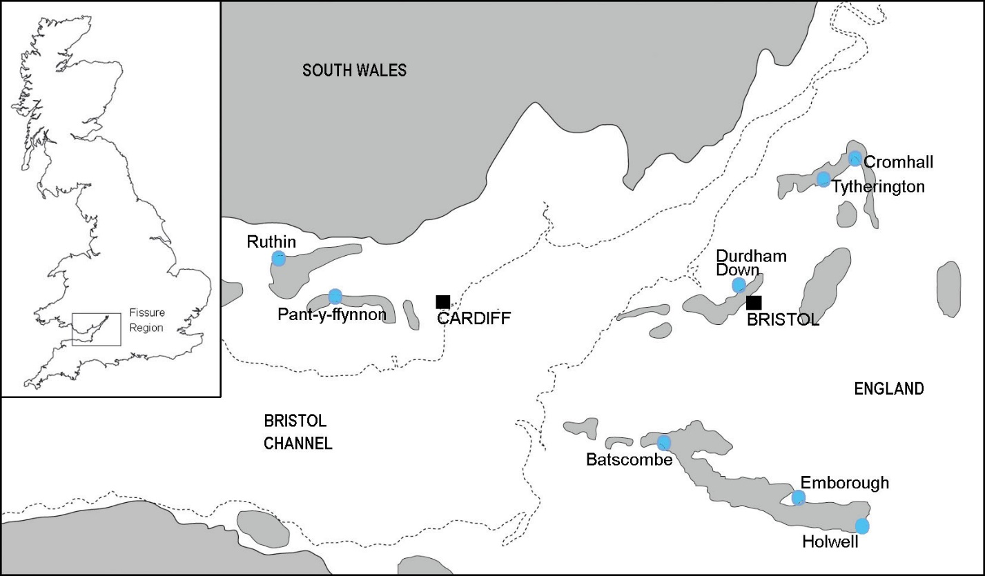
FIGURE S1. Localities (blue circles) of some of the key Late Triassic fissure deposits, including Emborough and Ruthin, of the southwest UK. The outlined areas show an approximation of island landmasses in the early Rhaetian paleo-archipelago of the Bristol and South Wales area. Modified from Whiteside et al. (2016). The region shown is about 110 km across.

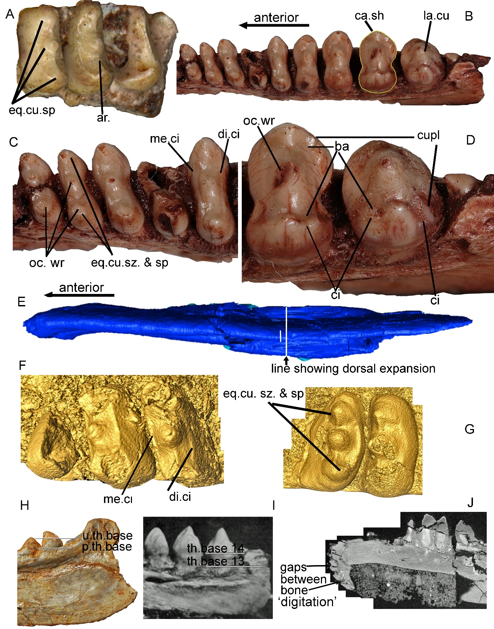
FIGURE S2. The new characters 223-228 and 231 and other key features shown in Tricuspisaurus thomasi and Variodens inopinatus. A, T. thomasi jaw fragment showing equal cusp spacing (Ch. 225-2) and arête (cutting ridge between cusps). B, V. inopinatus showing cassinoid shape of antepenultimate tooth and large cusp in penultimate tooth (Ch. 226-2); also shows Ch. 231-1. C, V. inopinatus with equal cusp size (Ch. 226-1) and spacing (Ch. 225-2) annotated on anterior teeth, occlusal wear, and mesial and distal cingula (Ch. 223-2 and Ch. 224-2) shown. D, V. inopinatus showing examples of accessory cusps, additional cingula and basins on large posterior teeth. E, surface model of ventral view of T. thomasi dentary showing relative sizes of lower ventral and dorsal transverse widths (Ch. 227-1). F, surface model of anterior dentary teeth of T. thomasi with mesial and distal cingula (Ch. 223-2 and Ch. 224-2) labelled. G, surface model of posterior dentary teeth of T. thomasi with (sub)equal cusp size (Ch. 226-1) and spacing (Ch. 225-2) labelled. H, lateral view of dentary of T. thomasi showing relative tooth base positions of the ultimate and penultimate teeth (Ch. 228-1). I, lateral view of posterior dentary of V. inopinatus showing relative tooth base positions of the ultimate (tooth 14) and penultimate (tooth 13) teeth (Ch. 228-1). J, CT sagittal scan slice of inner lateral view of dentary of T. thomasi showing digitation (or ‘feathering out’) of anteriormost region. Abbreviations: ar, arrete; ba, basin; ca, cassinoid; ci, cingulum; cu, cusp; cupl, accessory cusp; di, distal; eq, equal; la, large; me, mesial; oc, occlusal; p, penultimate; sp, spacing; sz, size; th, tooth; u, ultimate; wr, wear.
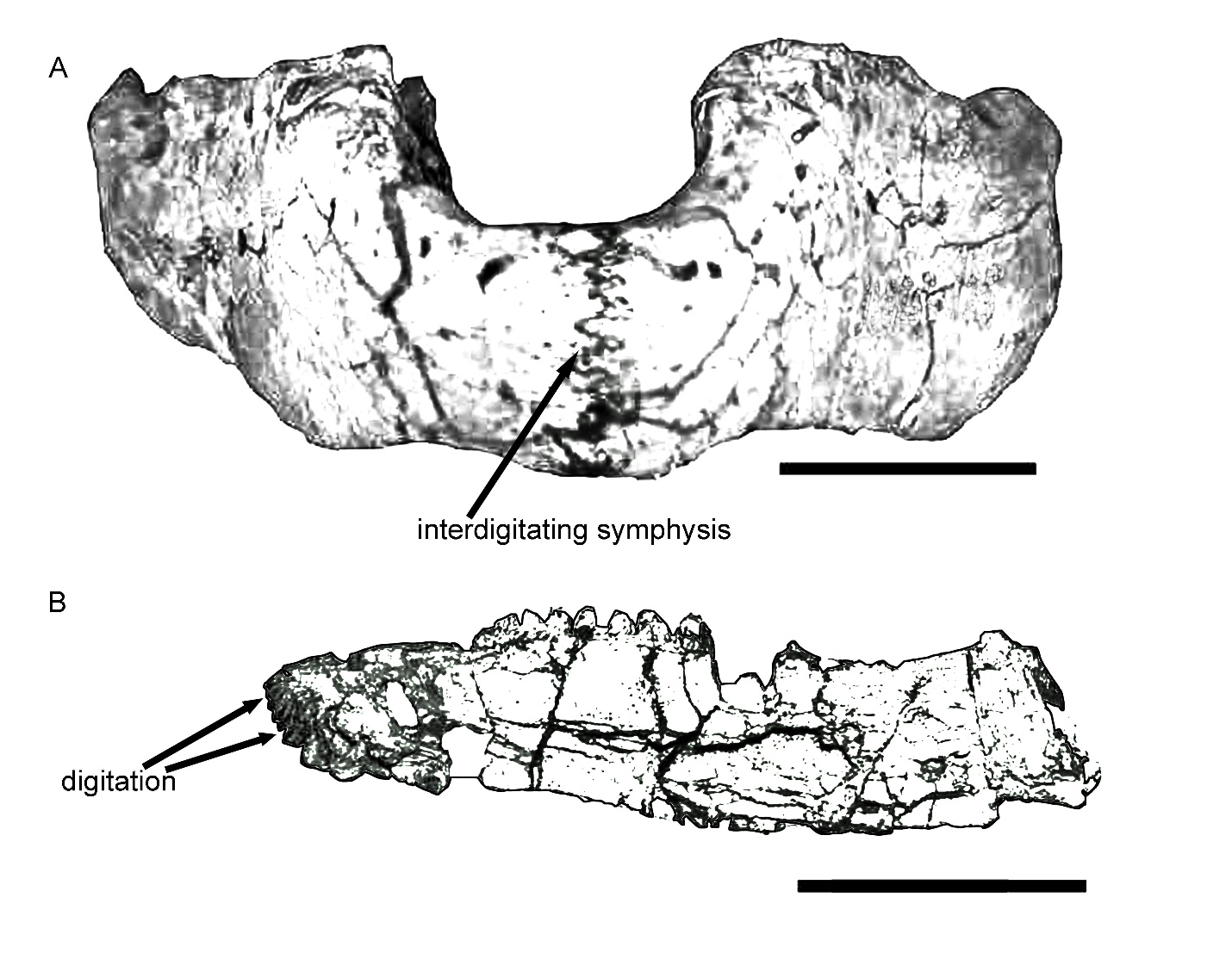Figure S3. Sketch drawings modified from photographs in Spielman et al. (2008) of A, an anterior view of the mandible of Trilophosaurus buettneri (TMM 31025-125), and B, a medial view of the dentary of Trilophosaurus jacobsi (NMMNH P-41400), showing the digitation and interdigitation at the anterior of the dentary.
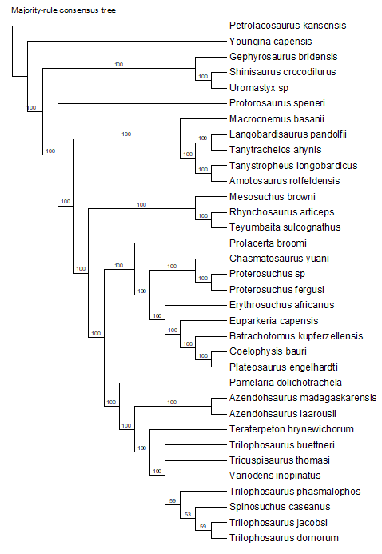
FIGURE S4. Phylogeny of Neodiapsida, 50% majority-consensus tree demonstrating the relationships within Trilophosauridae, and with other related clades. Clade credibility values that fall below 100 collapse to form a polytomy in the parsimonious strict consensus tree.

4. Character matrix
Petrolacosaurus_kansensis 000??0000000001000000010110000201010100000000110000000011000?0???10000000011?0000000000011?00000010?100000000100??0000?00?0010001?010110001100?010000?0?1000010??10000000000?0?0?00100000?00?0000100000000000?0000000?00?010000?0?00000
Youngina_capensis 000??0000100001010000010101000200010100000001110000000001000001101000????0?000101000000010???00?000?0101000??000??0001000??11000?011111?0001??0110?00?0?1?01?0???1000?000000?0?0??0100000?00?00001?0000000000?000?010?00???0?10?0?00000
Gephyrosaurus_bridensis 000??00002?0100011010000100000100000110100001010???0000?100000?????01?0??0?010100001?00010?00?0?000?0000?000?000???111011??1100000?1011????????111001?101?000000?0110?01????110??00000000?10?0111??001?000000?0?1?????000100?00?0?00000
Shinisaurus_crocodilurus 000??00101?011001101000???000001?011?11101010001100000111001000010101111001010101001?00012100001000?100000000000??1100?011111000100101110011010110000?1010000100001110?1?001010000?1?0100100?000?0011010000?0?01000101000100?00?0?00000
Uromastyx_sp 000??00102?01100?101010?0??00101?001?1111?0???011100?0101000001100101101?0101010000???0?02100000000?100000000000??1110?0111110001011011100110101110?1?101100001000110001?1111100000100?00?0??010010?000?000?0?00000001000000000?0?00000
Protorosaurus_speneri 000??0000100000001101??011000010001011010???????10?00010???????????001?000?000100000?00?10?1110??111000000???000??0000?00???11000?0110001010000000????1?1?011????10000000001?1000?0100?0??00??000100000000000?000?000000000?0?0?0?00000
Langobardisaurus_pandolfii 00???00????0???????????????00??????????????????????????????????????0?????0???1100020?00?1211111?1111001?01????1???1?01110001110???01100?11??0?010??1111??11110??01001?001??10111??????????????0?0?0??0000?0?0??1??00?00????0??0?0000000
Tanystropheus_longobardicus 0011000?01100000001001??11000011??1?11?1000000101??00010??01?00???100??0?010001000{0 2}0100111?111001111001?1101?11111100111000111011101100?11000011001110111101100000001000?1110111101100000?00?1011000000000000?01?00000010010000?0000000
Tanytrachelos_ahynis 001?000?01?00000000?01??110?001??????1?1000?0010??????0????????????????0?0?0?0100000?000121111101??1001101????11?110?0?0000????1?101100?11????1100?111111111100??000??1??11?0111100?00?????0??00010000?0000?0001??00?0?0??1???0?00?0000
Macrocnemus_basanii 001100010110001000111???1100001000??11?100?010?????????????1?0?????00??0?010?0101000000111?1110?0111001100????01?0100111000111011101100?11?00?01001110111101100?01000?0010110100100?00?00?00??00?1000000100?0??0?0000000001?000?0?00000
Amotosaurus_rotfeldensis 0????0?????0???????????????0001?????????01?0?????????????????????????????????010000????101?1110??11100??11??????????011?0??????1?1?????????????100??101?10???????000??0??101???1??11?0????????0????00??010??0?00???0??????????0?0???00?
Mesosuchus_browni 0112?00111?000010{0 1}11000?1110001000100101001010201010000111011000???00?01100000100100?10010??1101011?11000110?000??00010100?11100?10?1010110000?100??0011100110000100110010011100?00000000000?0001001100000000000000010000000000?0?00?00
Rhynchosaurus_articeps 1112010111?0000101101?0?11101020001001011?????20???????10101100????11??0?0000110010??10?10???00?010011010011?000???000?000?1111010011010110?000000?011111001??0??100??0010010100??0000100?00?0101001100000000000000000000??0000?0?00100
Teyumbaita_sulcognathus 1112010111?0000001201?0?1010102010?001011?1???2011010001???1?000???1001100?00110010??10?11???10001001?000101?0?0??100???0?0????010?1100?1??????????????????1010??10?????1?????????0000100?00?011???111????000??????00?00000?000?0?00100
Pamelaria_dolichotrachela ?1???00?0??0???0??0?????1??0001????0???000?0???????00?????2????????01??0?01000110000010111????0001100001010011?0????00??0?0????000?1101000????00001?101??0011001110011??????010??????0?10?00?00000?000100000000?0?001??0?000000?0?0?000
Azendohsaurus_madagaskarensis 01110000010000000010010?1010001010000000000000?01?11011112201100101001100011?0010000110011?111000110000101001110??1100?10?011110010110100010000000111?11000000011000?11010010100011000011001?00000011110{0 1}0000000110011111100000?0?00010
Azendohsaurus_laarousii 0111?00?????????????????????????????????????????????????????????????0????????0110000110??????????????????????????????????????????????????????????????????????????????????????????1100??????1?????????????????????????1?1????000?0?0???0
Trilophosaurus_buettneri 0011001102?0000000201?0?100101?00000?1011?0???100111011?0111100010101?10100001100010?12?120111000111000101011110??0000?00?011010010110110010000000111011000110011100110010011100?00100011000?101011110100000000011101101110001212111110
Trilophosaurus_jacobsi ?0???01002?000?000101??010?101?000?00??1???????????????????????????01??0?00??1100010?12?120???000111000101???????????0??0??????0?1?1101100??00?00010101??00110011?001100?????????0010?0???00?10?0?1??0?00000000?1110??01?1?1??3232????0
Teraterpeton_hrynewichorum 0010000101?000000001??0?0?0101?00000?1010?000???10?00010???1?00????00?1000?001100010?10?11??1101010?000101????0???100??????11?00??????????????????????????????????????????????????01?0010?00???0???11?1????????????01??10?????100?1?11?
Prolacerta_broomi 00110001010000100010{0 1}00?110000100010110100001110{0 1}01110011111100000100110001000101000111011?11100011000010000?100??0001010??101001001100?11????0000100010000110011100110010011100?00000000000?0001100000000000000???00?101000110?0?00000
Chasmatosaurus_yuani 201100000101010000111?1?11?0002001?001010?0????0???????????????????00??0?1?0???11000?11?11????0?01?0????0000??0100?0?0?0??000?101101111100??00?00010101100011001110?11001??11100?0100010??00?00010000110000000001?000??01???110?0?00000
Proterosuchus_sp 201100000101010000111?1011100020001001010000110010111111111112000??0011001?000111000111010?110010110000000??2?0110?0010000?0011010011010?1?????00011?111100100011100110010011100?01000100000?00010?000?0000000000000?0101000110?0?00000
Proterosuchus_fergusi 2????0000101010000?11?101110?020001001010???11?01011?111??11?2000??00??001?00001100??1101??110010110000000????0110?00100?000011010011010?0?????00011?11100?10????10011001001110???1??0?00000?00010?00??000000000???00010?00?1?0?0?00000
Erythrosuchus_africanus 001111000101010000111?111100002000100100??0???1000111111010112001??00110011000111000101?10?0?0000110100000012100??0000?000011100?001101011?????00011111100010000100?1000???1??00?0111110101010101?0101?010000000???0???00??0110?0?00000
Euparkeria_capensis 0011100001010010001?1?1111100020110001010?001010??11?111?1111210?010011011?000111000101011?010000100?00?00??2??1100000??0??1??00?0??1?0?11?????0001?1111??01?01110001100?111110000101110101010101101100011101101000100?00??01?0?0?00000
Batrachotomus_kupferzellensis 001011010101000000111?0?11000020110001011?0??010101101010011020?1??00?10010000111000101?11?011000110{0 1}00101112101001000??0001???00001100010?????0001011110001?01?100111?0????110??01121101110201011?110?01110?111?0?1?0?00?10110?0?00000
Coelophysis_bauri 101?10000101000000111?0?11001020110001?011?1?01010010011?011?20?10100??0011000111000101?11?111000111000101111100??1100?00?0????010001000100011?0001011100000?01110{0 1}1???0?11100??00112010111020001?11101111111?11000001?00010??0?0?00000
Plateosaurus_engelhardti 001?10000101000000111?0?110010201100010011?1?0?01001001100110{1 2}0010100?10011000110000100?11?111000110000101111100??1100?00?0????010001000100011?0001011100?00?0111001???0?11100??00112010111020001001111111111?11000011?00000110?0000000
Tricuspisaurus_thomasi ???????????????????????????????????????????????????????????????????01????????1?00010112????????????????????????????????????????????????????????????????????????????????????????????????????0???????????????????????????1??????212111111
Trilophosaurus_phasmalophos ???????????????????????????????????????????????????????????????????????????????00?1???2???????????????????????????????????????????????????????????????????????????????????????????????????????????????????????????????????????3311?????
Trilophosaurus_dornorum ?????0????????????????????????????????????????????????????????????????????????000010012????????????????????????????????????????????????????????????????????????????????????????????????????0??????????????????????????????????3322?????
Variodens_inopinatus ???????????????????????????????????????????????????????????????????01????????0?0{0 1}010112???????????????????????????????????????????????????????????????????????????????????????????????????????????????????????????????????????2{2 3}2{1 2}11?11
Spinosuchus_caseanus ????????????????????????????????????????????????????????????????????????????????????????120???00011100??01001100???00????????????????????????????????????????????????????????????????????????101?0?????????????????0???????1???????????

LITERATURE CITED
.
Dilkes, D.W. 1998. The Early Triassic rhynchosaur Mesosuchus browni and the interrelationships of basal archosauromorph reptiles. Philosophical Transactions of the Royal Society of London Series B 353:501–541.
Ezcurra, M.D., A. Lecuona, and A. Martinelli. 2010. A new basal archosauriform diapsid from the Lower Triassic of Argentina. Journal of Vertebrate Paleontology 30:1433–1450.
Gower, D.J. 1996. The tarsus of erythrosuchid archosaurs (Reptilia), and implications for early diapsid phylogeny. Zoological Journal of the Linnean Society 116:347–375.
Gower, D.J., and A.G. Sennikov. 1996. Braincase morphology in early archosaurian reptiles. Palaeontology 39:883–906.
Gower, D., and A. Sennikov. 1997. Sarmatosuchus and the early history of the Archosauria. Journal of Vertebrate Paleontology. Journal of Vertebrate palaeontology 17:60-73. 10.1080/02724634.1997.10010954.
Juul, L. 1994. The phylogeny of basal archosaurs. Palaeontologia Africana 31:1–38.
Kligman, B. T., A. D. Marsh, S. J. Nesbitt, W. G. Parker, and M. R. Stocker. 2020. New trilophosaurid species demonstrates a decline in allokotosaur diversity across the Adamanian-Revueltian boundary in the Late Triassic of western North America. Palaeodiversity 13:25–37.
Nesbitt, S.J., M.R. Stocker, B. Small, and A. Downs. 2009. The osteology and relationships of Vancleavea campi (Reptilia: Archosauriformes). Zoological Journal of the Linnean Society 157:814–864.
Nesbitt, S.J., J. Liu, and C. Li. 2011. A sail-backed suchian from the Heshanggou Formation (Early Triassic: Olenekian) of China. Earth and Environmental Science Transactions of the Royal Society of Edinburgh 101:271–284.
Nesbitt, S. J., J. J. Flynn, A. C. Pritchard, J. M. Parrish, L. Ranivoharimanana, and A. R. Wyss, 2015. Postcranial osteology of Azendohsaurus madagaskarensis (? Middle to Upper Triassic, Isalo Group, Madagascar) and its systematic position among stem archosaur reptiles. Bulletin of the American Museum of Natural History 398:1–126.
Pritchard, A.C., A.H. Turner, S.J. Nesbitt, R.B. Irmis, and N.D. Smith. 2015. Late Triassic tanystropheids (Reptilia, Archosauromorpha) from northern NewMexico (Petrified Forest Member, Chinle Formation) and the biogeography, functional morphology, and evolution of Tanystropheidae. Journal of Vertebrate Paleontology: e911186.
Sereno, P.C. 1991. Basal archosaurs: phylogenetic relationships and functional implications. Journal of Vertebrate Paleontology 10 (3):1–53.
Spielmann, J.A., S.G. Lucas, L.F. Rinehart, and A.B. Heckert. 2008. The Late Triassic archosauromorph Trilophosaurus. New Mexico Museum of Natural History and Science Bulletin 43:1–177.
Whiteside, D. I., C. J. Duffin, P. G. Gill, J. E. A. Marshall, and M. J. Benton. 2016. The Late Triassic and Early Jurassic fissure faunas from Bristol and South Wales: stratigraphy and setting. Palaeontologia Polonica 67:257–287. doi:10.1111/zoj.12458

* Corresponding author.

