Supplement
Evaluating the cost utility of racecadotril in addition to oral rehydration solution versus oral rehydration solution alone for children with acute watery diarrhea in four low middle-income countries: Egypt, Morocco, Philippines and Vietnam.
Rautenberg, Tamlyn Anne¹; Downes, Martin¹; Kiet, Pham Huy Tuan²; Ashoush, Nermeen^{3,} Dennis, Antonio Rosete⁴; Kim, Kyoo⁵.
- Centre for Applied Health Economics, Griffith University, Australia
- Department of Health Economics, Hanoi Medical University, Vietnam
- Department of Clinical Pharmacy Practice, Faculty of Pharmacy, Newgiza University, Egypt.
- Abbott Laboratories Philippines
- Abbott Products Operations AG, Switzerland

Clinical Evidence
Table 1: Clinical parameters from original core model and retained in all country adaptations.
Parameter | Mean | Source
Outpatient care
Proportion on ORS whose diarrhea resolves at 48 hrs | 26% | Lehert
Proportion on ORS whose diarrhea does not resolve at 48 hrs | 74% | Calculated
Proportion on R+ORS whose diarrhea resolves at 48 hrs | 58% | Lehert
Proportion on R+ORS whose diarrhea does not resolve at 48 hrs | 42% | Calculated
Inpatient care
Proportion on ORS referred for inpatient stay at 48 hrs | 36% | Alvarez Calatayud
Proportion on ORS not referred for inpatient stay at 48 hrs | 64% | Calculated
Proportion on R+ORS referred for inpatient stay at 48 hrs | 6% | Alvarez Calatayud
Proportion on R+ORS not referred for inpatient stay at 48 hrs | 94% | Calculated
Adverse events
Proportion on ORS experiencing adverse events | 16% | Baumer
Proportion on R+ORS experiencing adverse events | 12% | Baumer
Quality of Life (Utility)
Average utility under 5 yrs, primary care/outpatient setting | 0.7345 | Martin
Average utility under 5 yrs, secondary care/inpatient setting | 0.6145 | Martin
Average utility "well" child (no diarrhea) | 0.9400 | Kind

The reader is referred to a full description and justification of this evidence in Rautenberg 2012.

Sensitivity Analysis
The reader is referred to a full description of the robustness of the model in Rautenberg 2017 and Rautenberg 2018.
Figure 1: Tornado diagram of univariate sensitivity analysis, Egypt
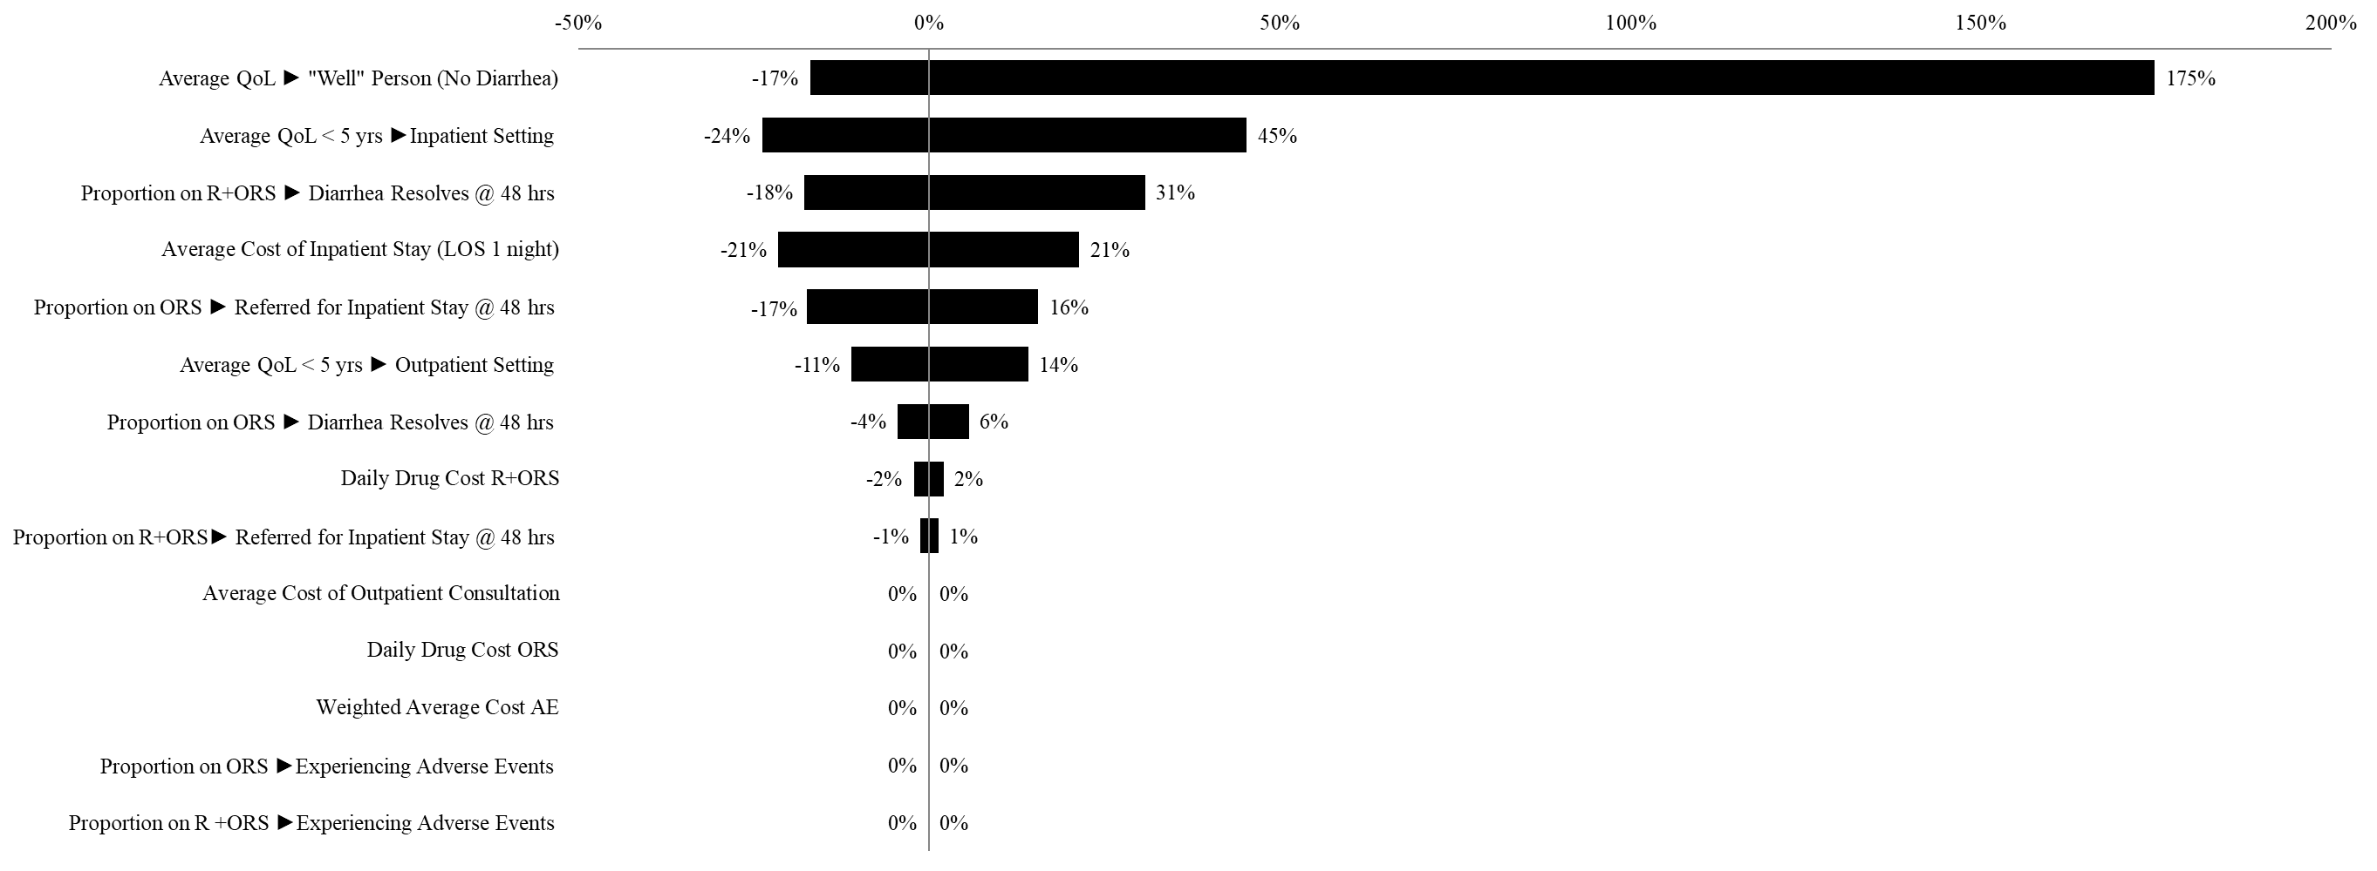

Figure 2: Tornado diagram of univariate sensitivity analysis, Philippines
The cost of an outpatient consultation has been set to 250 PHP and 500 PHP respectively for this sensitivity analysis.
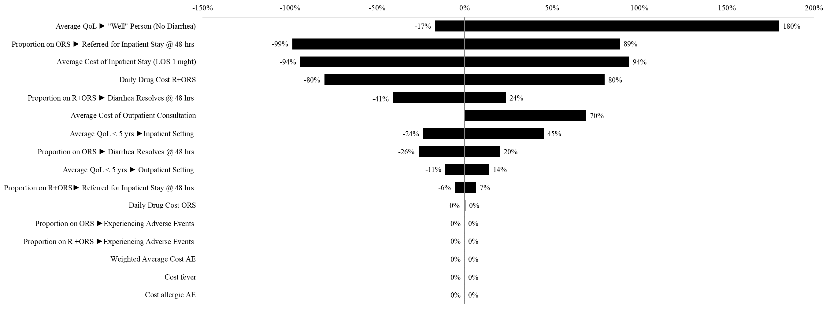

Figure 3: Tornado diagram of univariate sensitivity analysis, Morocco
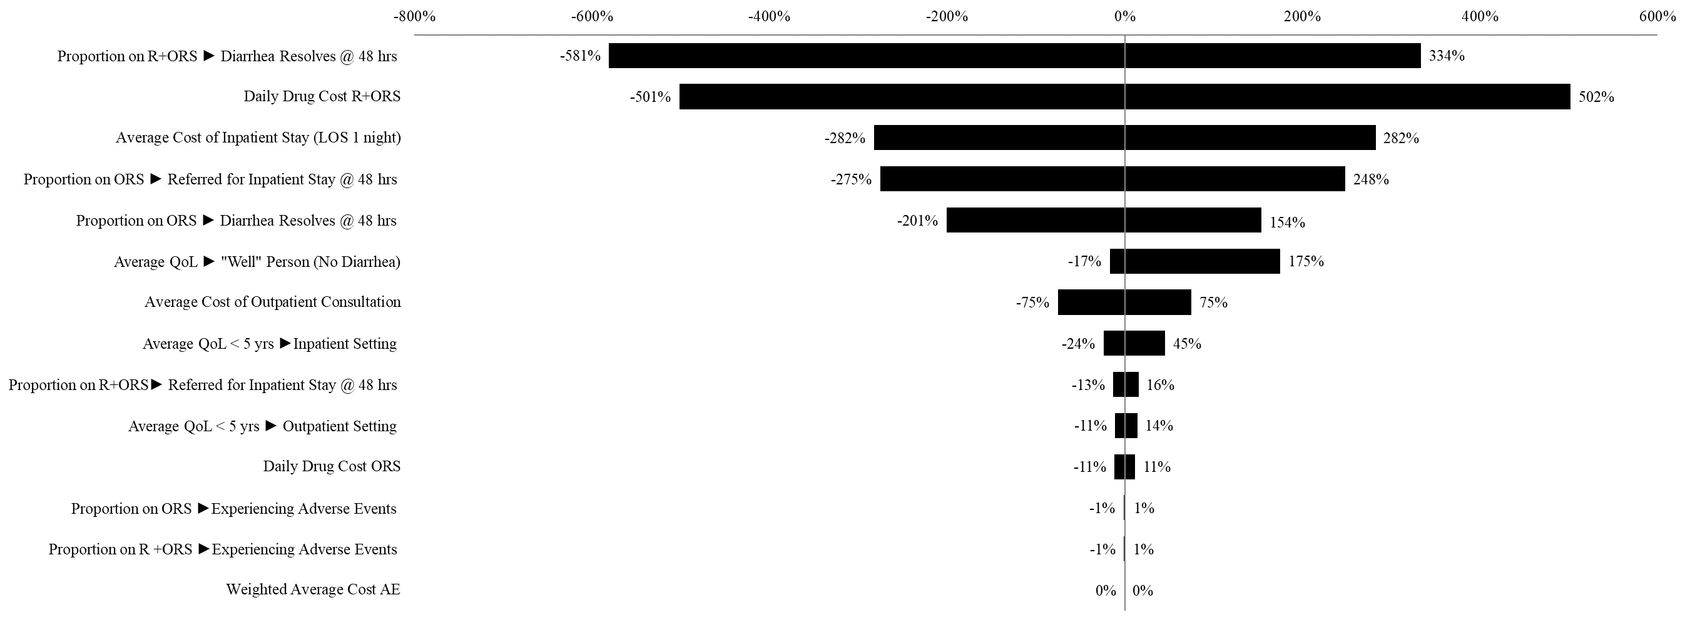

Figure 4: Tornado diagram of univariate sensitivity analysis, Vietnam
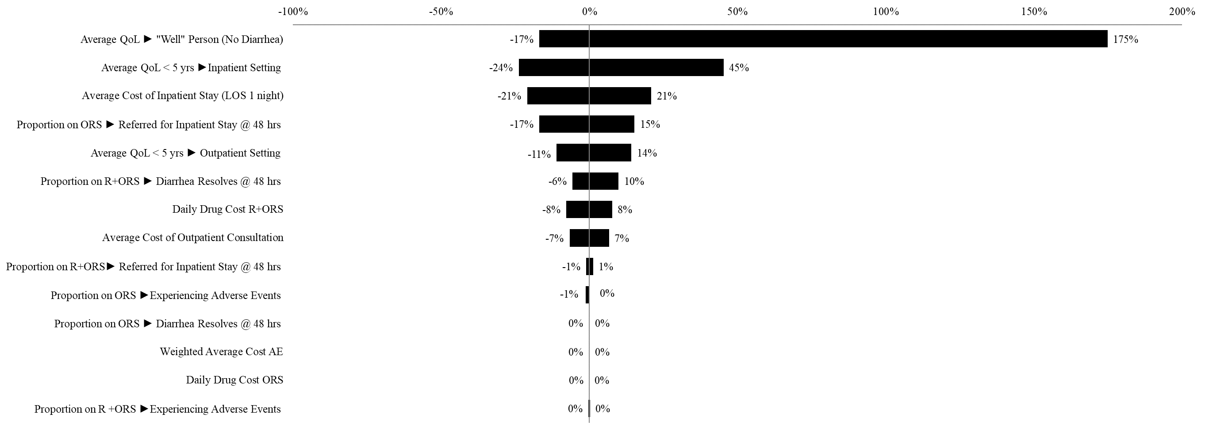

Reference List
Alvarez Calatayud E, Pinei Simon G, Taboada Castro L, et al. Efectividad de racecadotrilo en el tratamiento de la gastroenteritis aguda [The effectiveness of racecadotril in the treatment of acute gastroenteritis]. Acta Pediatr.Esp. 2009;67(3):117–122. Spanish.
Baumer P, Joulin Y. Pre- and postmarketing safety profiles of Racecadotril sachets, a “new” antidiarrhoeal drug. J Pediatr Gastroenterol Nutr. 2009;48(Suppl 3):E99. [Google Scholar]
Kind P, Hardman G, Macran S. UK Population Norms for EQ-5D, Discussion Paper 172. Centre for Health Economics York University; 1999. [Google Scholar]
Martin A, Cottrell S, Standaert B. Estimating utility scores in young children with acute rotavirus gastroenteritis in the UK. J. Med Econ, 2008;11(3):471-484.
Lehert P, Cheron G, Alvarez Calatayud G, et al. Racecadotril for childhood gastroenteritis: an individual patient data meta-analysis. Dig. Liver Dis. 2011;43(9):707-713.
Rautenberg TA, Zerwes U, Foerster D, Aultman R. Evaluating the cost utility of racecadotril for the treatment of acute watery diarrhea in children: the RAWD model. Clinicoecon Outcomes Res. 2012;4:109-116. doi:10.2147/CEOR.S31238
Rautenberg TA, Zerwes U. The cost utility and budget impact of adjuvant racecadotril for acute diarrhea in children in Thailand. Clinicoecon Outcomes Res. 2017;9:411-422. Published 2017 Jul 17. doi:10.2147/CEOR.S140902
Rautenberg TA, Zerwes U, Lee WS. Cost utility, budget impact, and scenario analysis of racecadotril in addition to oral rehydration for acute diarrhea in children in Malaysia. Clinicoecon Outcomes Res. 2018; 10:169-178. Published 2018 Mar 15. doi:10.2147/CEOR.S157606

