Subgroup analysis of VAS outcome of the included studies based on their duration of follow-up

Short-term (≤ 3 months)
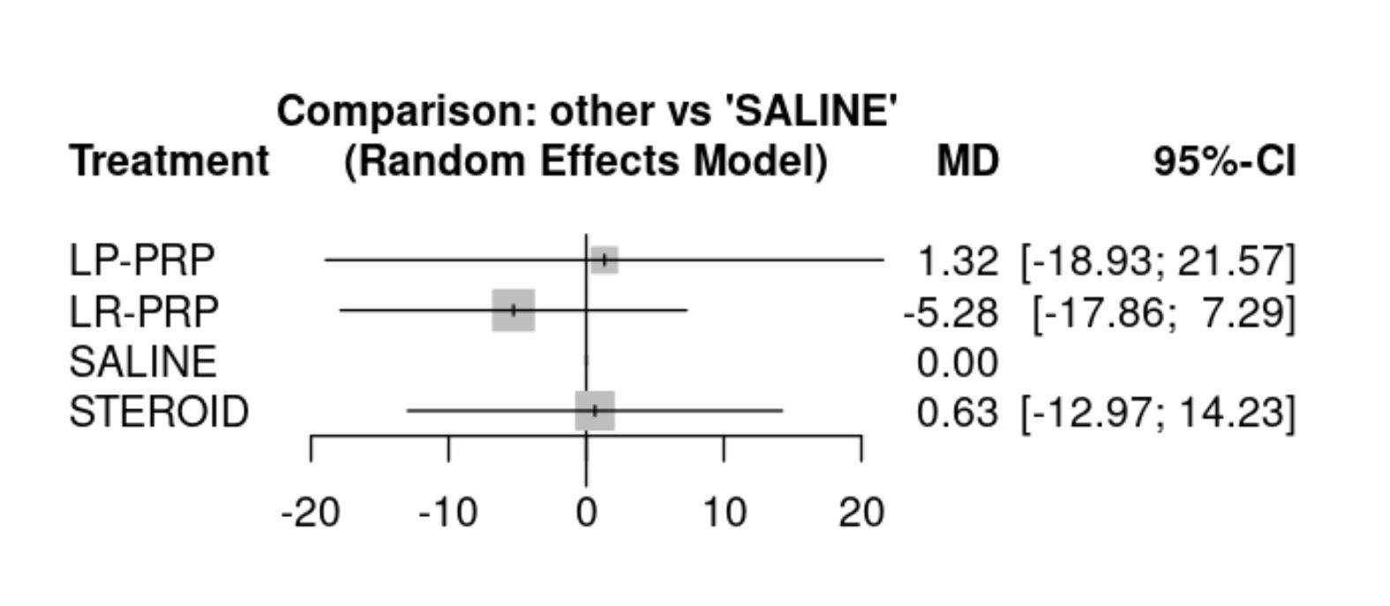

Mid-term (3-6 months)

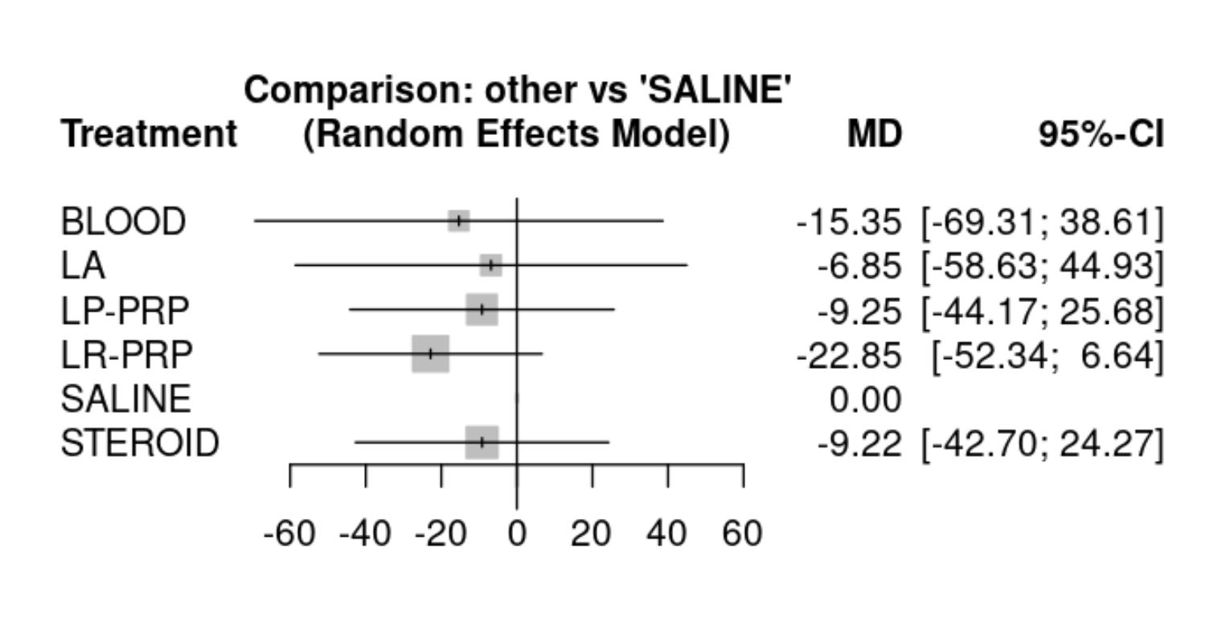

Long-term (≥12 months)

