Appendix 1A: COVER covariate descriptions
In the Observational Medical Outcomes Partnership Common Data Model (OMOP-CDM) diagnoses are classified in hierarchies. This means that a certain diagnosis, or condition occurrence in the context of this document, has a number of descendants. Diabetes mellitus, for example, is a descendant of diabetes and has numerous, more detailed descendants such as type 1 diabetes mellitus, which can be illustrated like this:
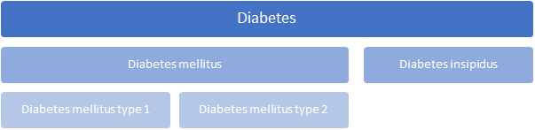
The actual hierarchical structure of SNOMED-CT, one of the classifications on which the OMOP-CDM rests, is more complex but the notion remains.
For most diseases, we cannot know the exact time of onset, and must use the point in time on which the condition was recorded (condition occurrence) as the proxy. Thus, within each of the following groups, a history of the condition in question is operationalised as at least one occurrence of the listed conditions at any time prior to index. The concept id's uniquely identify conditions and are made as hyperlinks taking the reader to the ATHENA interface (https://athena.ohdsi.org/) facilitating perusal of their hierarchical positions.
Condition occurrences | Examples | Concept id’s
History of cancer
Any malignant neoplastic disease or descendants | - Leukaemia  - Large-cell carcinoma in lung | 443392
Except squamous cell carcinoma |  | 4111921
Except basal cell carcinoma |  | 4112752
History of COPD
Chronic obstructive pulmonary disease or descendants | - Pulmonary emphysema  - Acute exacerbation of COPD | 255573
History of diabetes mellitus
Diabetes mellitus (including type 1 or 2) or descendants | - Type 1 diabetes mellitus  - Type 2 diabetes mellitus | 201820
Documented poor glycaemic control with/without complications | - Type 1 diabetes mellitus uncontrolled | 443238
Complication due to diabetes mellitus |  | 442793
History of heart disease
Heart disease or descendants | - Disease of coronary artery  - Endocarditis | 321588
History of hyperlipidaemia
Hyperlipidaemia or descendants | - Hypercholesterolemia  - Hypertriglyceridemia | 432867
History of hypertension
Hypertension or any descendants | - Essential hypertension  - Benign hypertension | 316866
History of kidney disease
Kidney disease or descendants. We consider both chronic and acute kidney disease together for a broader cohort definition. | - Acute nephropathy  - Hypertensive renal disease | 198124

The phenotypes for each COVER predictor are available in Appendix 2.

Appendix 1B: Full results
Due to differing data collection methods and policies not all databases could run all the models. For instance, IPCI, a GP database, does not contain information on intensive services, so we were able to make predictions of patients being hospitalised, but we were unable to make predictions of whether they would go on to receive intensive services. Some of the databases chose only to validate the models with limited covariates.
Supplementary Table 1 External validation of the models on the target population of patients with influenza or flu-like symptoms any time prior to 2020 (N/A indicates this result is not available)
Outcome | Database | Conditions/drugs + age/sex |  | Age/sex |  | COVER
 |  | AUC | AUPRC | AUC | AUPRC | AUC | AUPRC
Hospitalization with pneumonia | AUSOM | N/A | N/A | 0.760 | 0.056 | 0.768 | 0.061
 | AU-ePBRN | N/A | N/A | N/A | N/A | 0.756 | 0.031
 | CCAE | 0.769 | 0.073 | 0.690 | 0.024 | 0.728 | 0.040
 | IPCI | 0.686 | 0.002 | 0.681 | 0.008 | 0.683 | 0.002
 | JMDC | 0.686 | 0.007 | 0.645 | 0.002 | 0.660 | 0.003
 | MDCD | 0.804 | 0.191 | 0.757 | 0.153 | 0.779 | 0.167
 | MDCR | 0.681 | 0.225 | 0.633 | 0.195 | 0.660 | 0.207
 | Optum EHR | 0.815 | 0.087 | 0.777 | 0.73 | 0.804 | 0.090
Hospitalization with pneumonia requiring intensive services or death | AUSOM | 0.896 | 0.216 | 0.770 | 0.010 | 0.783 | 0.028
 | AU-ePBRN | N/A | N/A | N/A | N/A | 0.923 | 0.007
 | CCAE | 0.816 | 0.020 | 0.718 | 0.004 | 0.774 | 0.009
 | IPCI | N/A | N/A | N/A | N/A | N/A | N/A
 | JMDC | 0.778 | 0.002 | 0.708 | 0.000 | 0.750 | 0.001
 | MDCD | 0.802 | 0.048 | 0.741 | 0.030 | 0.773 | 0.037
 | MDCR | 0.689 | 0.035 | 0.556 | 0.019 | 0.652 | 0.026
 | Optum EHR | 0.832 | 0.024 | 0.770 | 0.014 | 0.814 | 0.020
Fatality | AUSOM | 0.812 | 0.017 | 0.793 | 0.007 | 0.798 | 0.008
 | AU-ePBRN | N/A | N/A | N/A | N/A | 0.893 | 0.007
 | CCAE | 0.833 | 0.016 | 0.780 | 0.001 | 0.806 | 0.002
 | IPCI | 0.866 | 0.020 | 0.856 | 0.008 | 0.859 | 0.008
 | JMDC | 0.766 | 0.001 | 0.723 | 0.000 | 0.724 | 0.001
 | MDCD | 0.842 | 0.027 | 0.823 | 0.022 | 0.829 | 0.022
 | MDCR | 0.678 | 0.014 | 0.598 | 0.008 | 0.627 | 0.009
 | Optum EHR | 0.889 | 0.024 | 0.867 | 0.018 | 0.872 | 0.016

Supplementary Table 2 COVID-19 validation of the COVER-H, COVER-I, and COVER-F scores (N/A indicates this result is not available)
Outcome | Database | Patients with COVID-19, influenza or flu-like symptoms |  |  | Patients with COVID-19, influenza or flu-like symptoms in 2020 |  |  | Patients with COVID-19 or symptoms in 2020 |  |  | Patients with COVID-19 in 2020
 |  | Number of participants (Outcome rate %) | AUC | AUPRC | Number of participants (Outcome rate %) | AUC | AUPRC | Number of participants (Outcome rate %) | AUC | AUPRC | Number of participants (Outcome rate %) | AUC | AUPRC
Hospitalization with pneumonia (COVER-H) | CUIMC | N/A | N/A | N/A | N/A | N/A | N/A | N/A | N/A | N/A | N/A | N/A | N/A
 | HIRA | 58,072  (4.61) | 0.767 | 0.132 | 48,057  (5.25) | 0.762 | 0.143 | 47,594  (5.18) | 0.763 | 0.142 | 1,985  (4.48) | 0.806 | 0.134
 | SIDIAP | 415,119 (0.12) | 0.697 | 0.005 | 72,337  (1.82) | 0.789 | 0.054 | 38,254  (3.21) | 0.747 | 0.071 | 37,950 (3.22) | 0.748 | 0.072
 | TRDW | 6,725  (2.51) | 0.723 | 0.064 | 1,062 (3.01) | 0.769 | 0.100 | 725  (3.72) | 0.734 | 0.112 | 395 (5.32) | 0.731 | 0.132
 | VA | N/A | N/A | N/A | 23,960  (4.93) | 0.769 | 0.138 | 5,990  (8.11) | 0.728 | 0.168 | 1,446 (10.30) | 0.689 | 0.179
Hospitalization with pneumonia requiring intensive services ore death  (COVER-I) | CUIMC | 27,356 (1.46) | 0.778 | 0.043 | 4,337 (3.25) | 0.777 | 0.081 | 3,354 (4.11) | 0.756 | 0.093 | 2,731 (4.907) | 0.734 | 0.100
 | HIRA | 58,072 (0.85) | 0.858 | 0.035 | 48,057 (1.00) | 0.854 | 0.039 | 47,594 (1.01) | 0.856 | 0.040 | 1,985 (1.11) | 0.910 | 0.053
 | SIDIAP | 415,119 (0.03) | 0.775 | 0.003 | N/A | N/A | N/A | N/A | N/A | N/A | N/A | N/A | N/A
 | TRDW | 6,725 (0.46) | 0.769 | 0.018 | 1,062 (0.47) | 0.816 | 0.083 | 725 (0.69) | 0.807 | 0.222 | 395 (1.27) | 0.779 | 0.230
 | VA | N/A | N/A | N/A | 23,960  (1.22) | 0.805 | 0.043 | 5,990  (2.02) | 0.780 | 0.056 | 1,446 (2.63) | 0.763 | 0.058
Fatality (COVER-F) | CUIMC | 27,356 (1.58) | 0.847 | 0.082 | 4,337 (7.89) | 0.843 | 0.320 | 3,354 (10.05) | 0.834 | 0.377 | 2,731 (12.27) | 0.82 | 0.400
 | HIRA | 58,072 (2.28) | 0.851 | 0.099 | 48,057 (2.75) | 0.846 | 0.113 | 47,594 (2.78) | 0.846 | 0.114 | 1,985 (2.17) | 0.898 | 0.150
 | SIDIAP | 415,119 (0.04) | 0.885 | 0.010 | 72,337 (0.60) | 0.919 | 0.068 | 38,254 | 0.895 | 0.082 | 37,950 (1.07) | 0.895 | 0.083
 | TRDW | 6,725 (0.07) | 0.819 | 0.002 | 1,062 (0.09) | 0.970 | 0.015 | 725 (0.14) | 0.971 | 0.023 | 395 (0.25) | 0.959 | 0.030
 | VA | N/A | N/A | N/A | 23,960 (0.72) | 0.809 | 0.036 | 5,990 (1.77) | 0.765 | 0.058 | 1,446 (2.97) | 0.717 | 0.068

Appendix 1C: Receiver operating characteristic and calibration plots
The figures below show the receiver operating characteristic and calibration plots for patients with COVID-19 in 2020, all plots are available online: http://evidence.ohdsi.org/Covid19CoverPrediction.

Model | Database
COVER-H | HIRA
 | 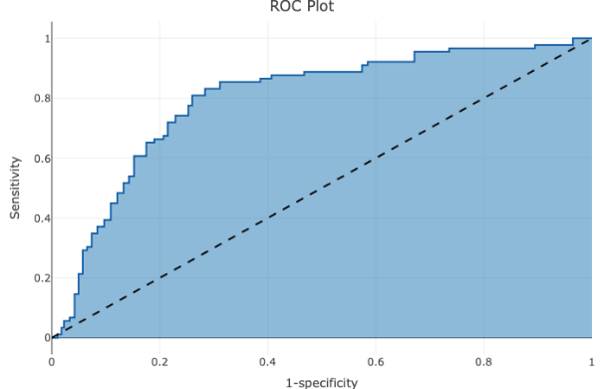 | 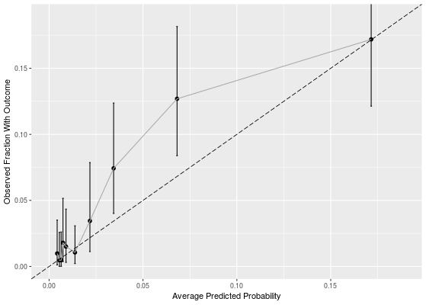
 | SIDIAP
 | 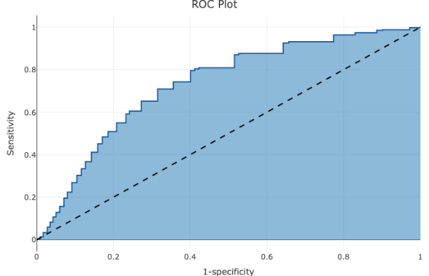 | 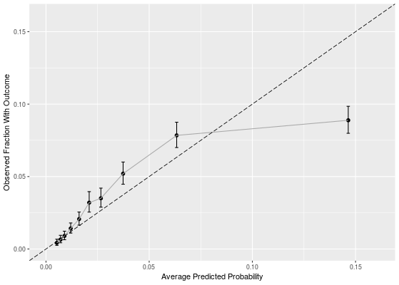
 | TRDW
 | 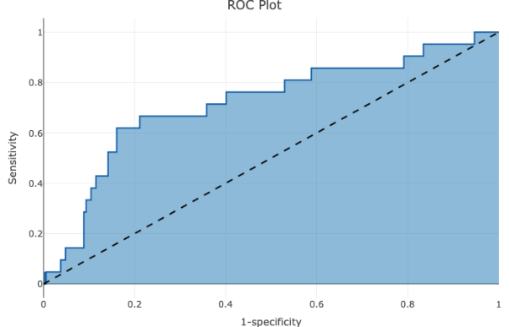 | 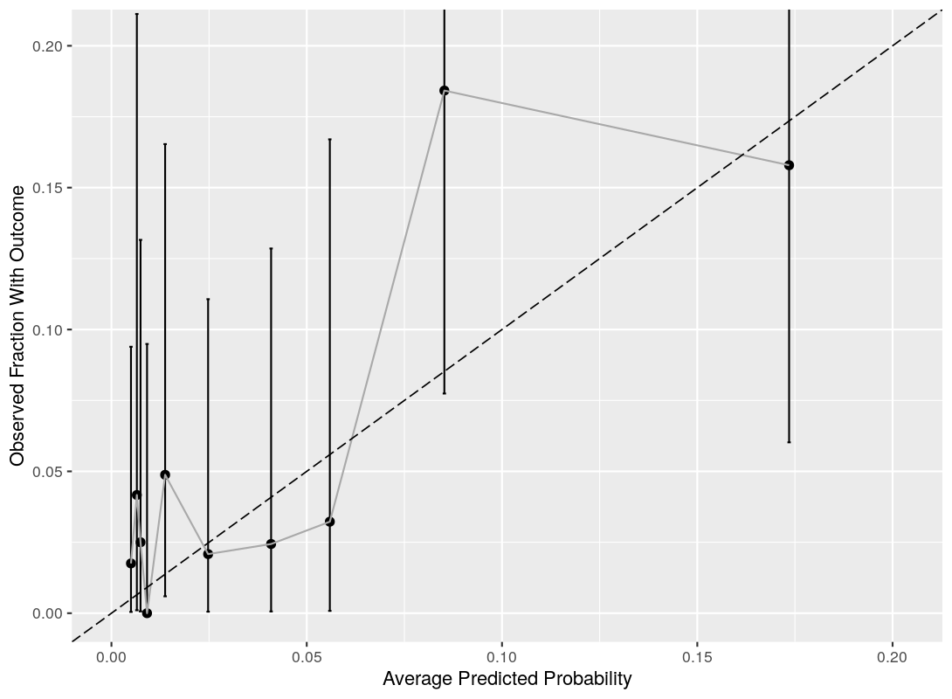
 | VA
 | 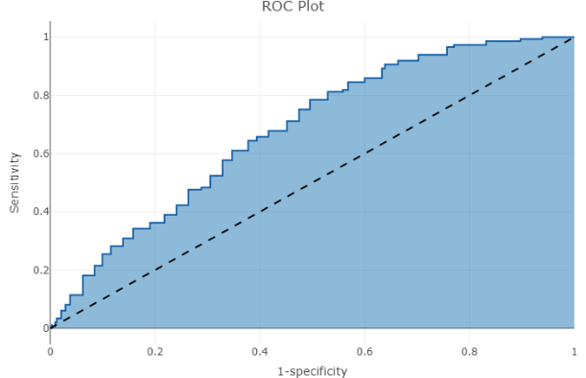 | 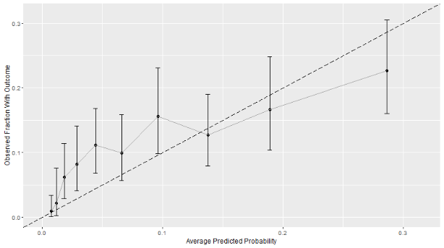
COVER-I | CUIMC
 | 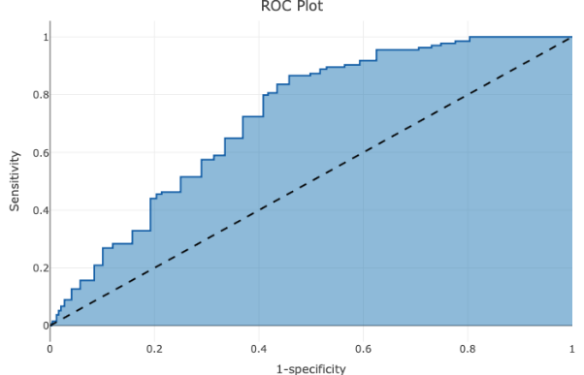 | 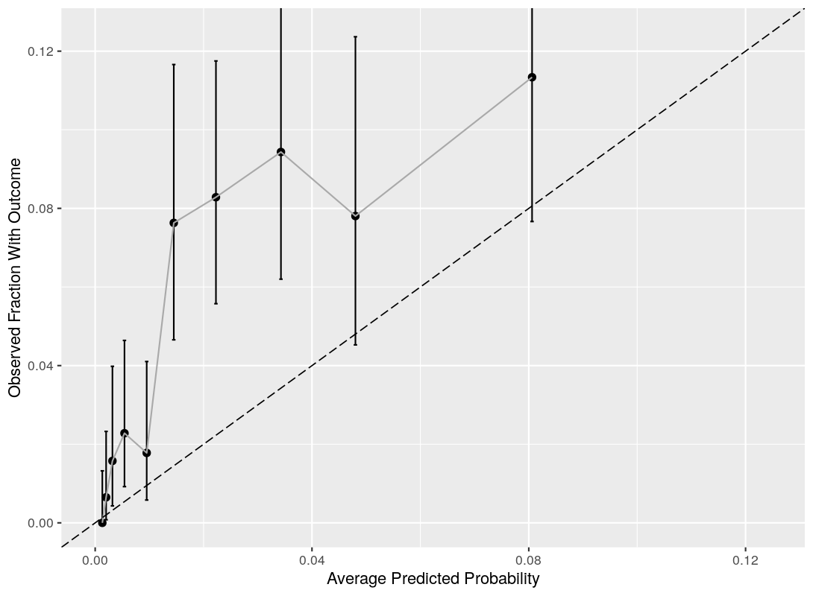
 | HIRA
 | 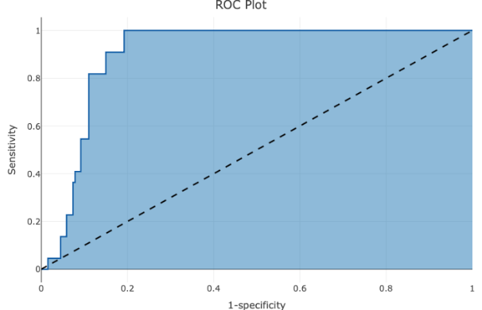 | 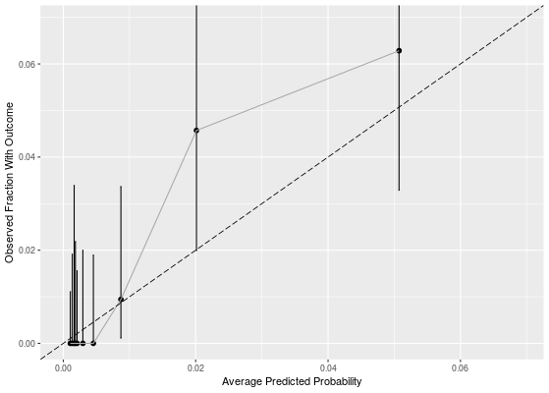
 | VA
 | 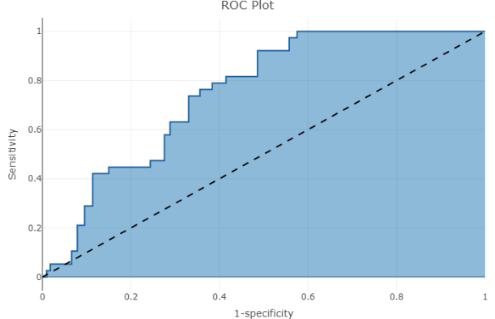 | 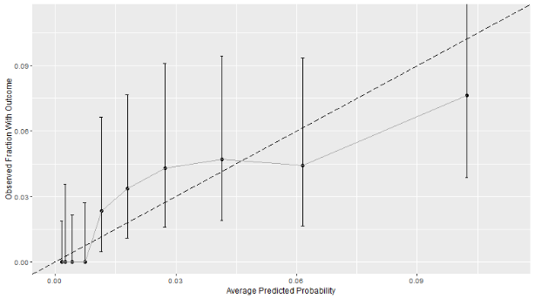
COVER-F | CUIMC
 | 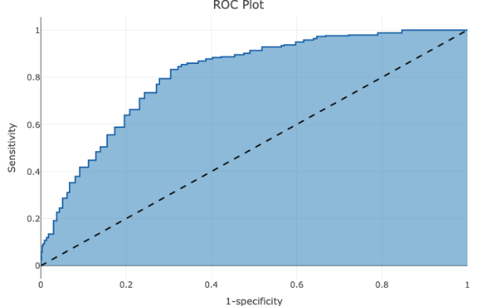 | 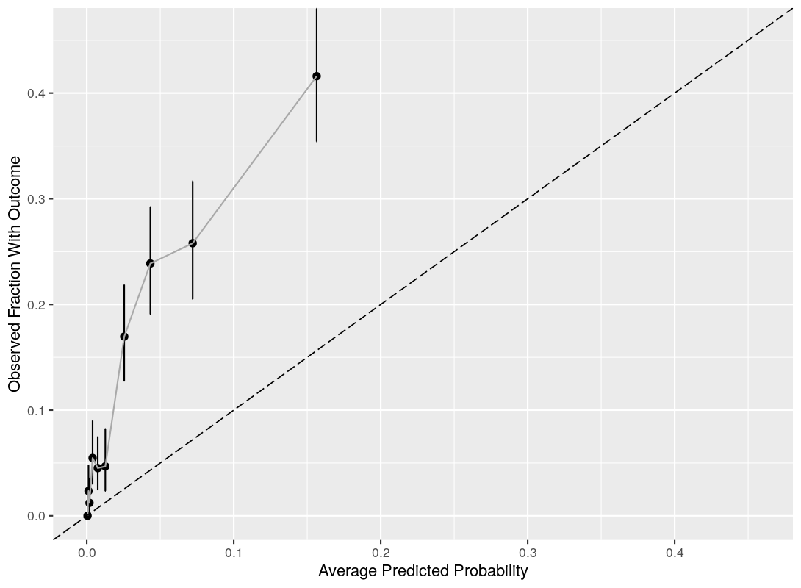
 | HIRA
 | 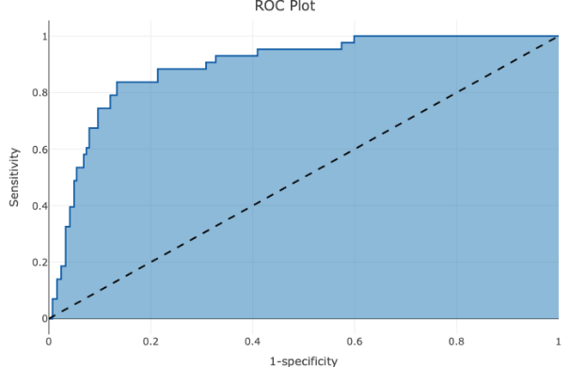 | 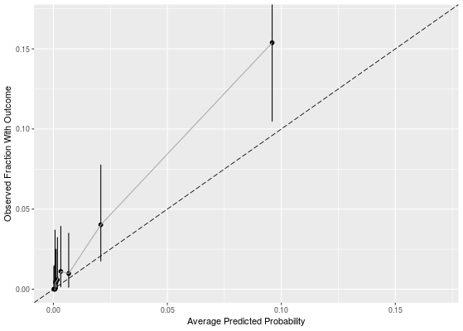
 | SIDIAP
 | 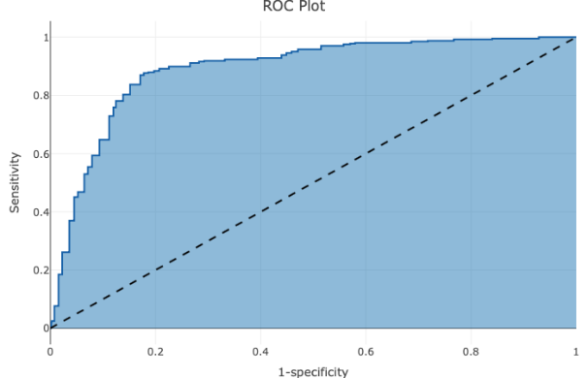 | 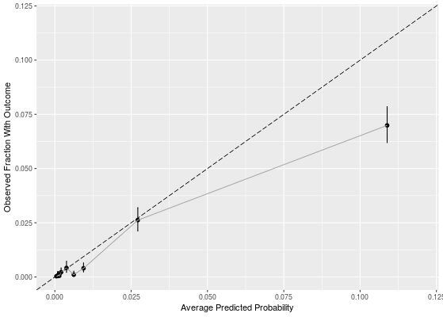
 | VA
 | 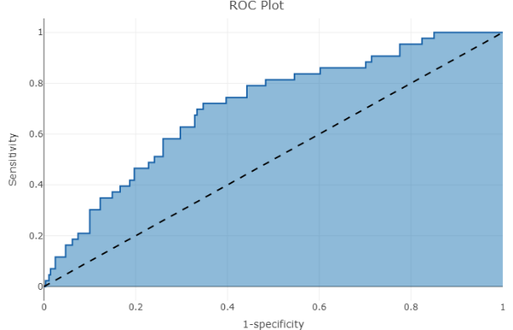 | 